Φύλλο Εργασίας 7

Ανάγνωση - Εγγραφή Καρτών RFID

Πηγή: https://lastminuteengineers.com/how-rfid-works-rc522-arduino-tutorial/

Υλικά
Αναγνώστης RFID - MFRC-522 | 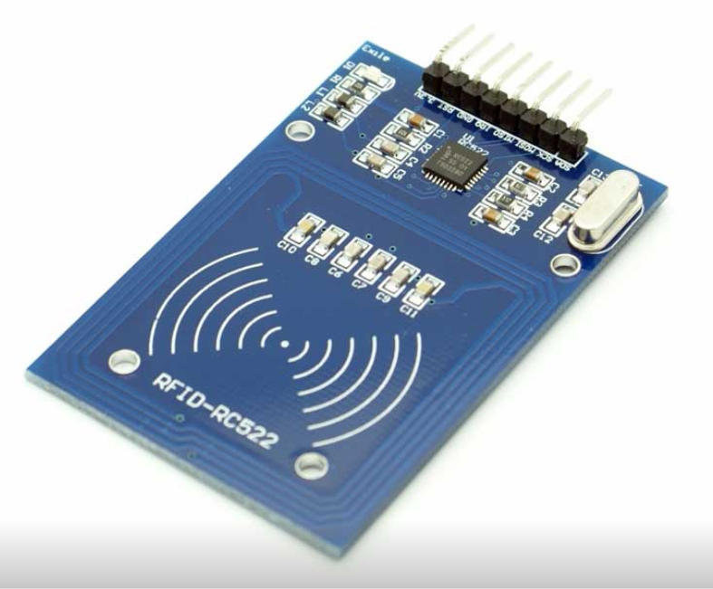
Κάρτες RFID 13.56MHz | 

Συνδεσμολογία
RC522 πλακέτα | Arduino
Vcc | 3.3V
GND | GND
RST | Pin 5
MISO / SCL / Tx | Pin 12
MOSI | Pin 11
SCK | Pin 13
SS / SDA / Rx | Pin 10

Κύκλωμα
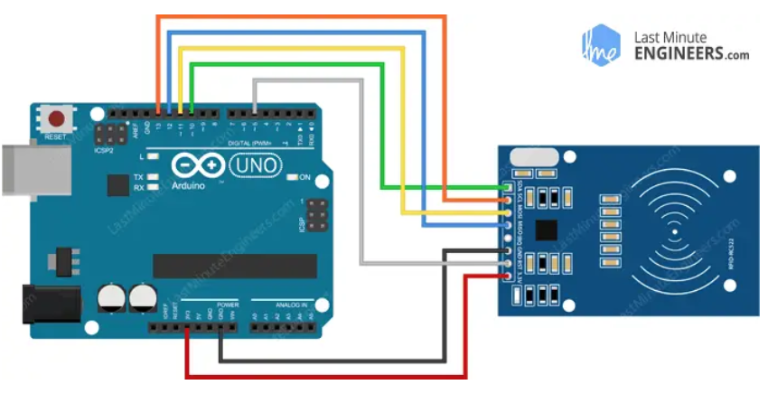

Βιβλιοθήκη
Στο Arduino IDE εγκαταστήστε τη βιβλιοθήκη MFRC522 by GithubCommunity.

Πρόγραμμα 1: Ανάγνωση όλων των δεδομένων από την κάρτα

#include <SPI.h>
#include <MFRC522.h>

#define RST_PIN 5
#define SS_PIN 10

MFRC522 mfrc522(SS_PIN, RST_PIN);

void setup()
{
Serial.begin(115200); // για serial monitor
while (!Serial); // Do nothing if no serial port is opened
SPI.begin(); // Init SPI bus
mfrc522.PCD_Init(); // Init MFRC522 card reader
delay(4);
mfrc522.PCD_DumpVersionToSerial(); // Show details of MFRC522
Serial.println("Scan PICC to see UID, SAK, type, and data blocks...");
}

void loop()
{
// Check for new card present on the reader.
if ( ! mfrc522.PICC_IsNewCardPresent() )
return;

// Select one of the cards
if ( ! mfrc522.PICC_ReadCardSerial() )
return;

// Dump debug info about the card; PICC_HaltA() is automatically called
mfrc522.PICC_DumpToSerial(&(mfrc522.uid));
}

Πρόγραμμα 2: Έλεγχος πρόσβασης με κάρτες RFID
#include <SPI.h>
#include <MFRC522.h>

#define RST_PIN 5
#define SS_PIN 10

byte readCard[4];
String MasterTag = "931A9628"; // REPLACE this Tag ID with your Tag ID!!!
String tagID = "";

MFRC522 mfrc522(SS_PIN, RST_PIN);

void setup()
{
Serial.begin(115200); // Serial monitor
SPI.begin(); // SPI bus
mfrc522.PCD_Init(); // MFRC522

Serial.println(" -- Access Control -- ");
Serial.print("MasterTag:");
Serial.println(MasterTag);
Serial.println("Scan Your Card>>>");
}

void loop()
{
// Wait until new tag is available
while( getID() )
{
if( tagID == MasterTag )
{
Serial.println("Access Granted!");
}
else
{
Serial.println("Access Denied...");
}

Serial.print("ID: ");
Serial.println(tagID);
delay(500);
Serial.println(" -- Access Control -- ");
Serial.print("MasterTag:");
Serial.println(MasterTag);
Serial.println("Scan Your Card>>>");
}
}

// Read new tag if available
boolean getID()
{
// Getting ready for Reading PICCs
if( !mfrc522.PICC_IsNewCardPresent() )
{
return false;
}
if( !mfrc522.PICC_ReadCardSerial() )
{
return false;
}

tagID = "";
for( int i = 0; i < mfrc522.uid.size; i++ )
{
tagID.concat(String(mfrc522.uid.uidByte[i], HEX)); // Adds the bytes in a single String variable
}
tagID.toUpperCase();
mfrc522.PICC_HaltA(); // Stop reading
return true;
}

