Sexual dimorphism in *Fringilla coelebs*

Emma Rand

# Introduction

The chaffinch, *Fringilla coelebs*, is one of the most widespread and common passerine bird species (Wickham 2017)(Cramp 1994). It is sexually dimorphic in plumage with males being brightly coloured with a blue-grey cap and rust-red underparts and females being grey-brown with paler underparts (see Figure 1). This study aimed to determine whether *F.coelebs* were also sexually dimorphic in size.

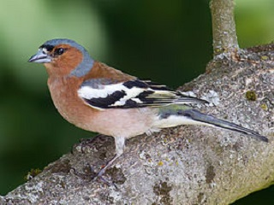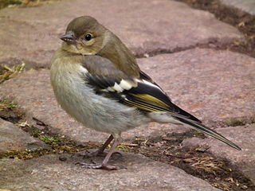

# Methods

We randomly sampled 20 male and 20 female birds on the stray and determined their mass with spring scales. Analysis was carried out with R version 4.1.1 (R Core Team 2021) and tidyverse packages (Wickham 2017).

# Results

We wouldn’t normally report the sum of the squared deviations ($SS\left(x\right)$) but we do so here to make use of a function. For males, the $SS\left(x\right)$ = 87.9 and for females, the $SS\left(x\right)$ = 86.83

Males ($\overset{‾}{x}±s.e.$: 22.27 $±$ 0.48 g) have significantly higher mass than females (20.48 $±$ 0.48 g)( $t$ = 2.65; $d.f.$ = 38; $p$ = 0.012). See figure 3.

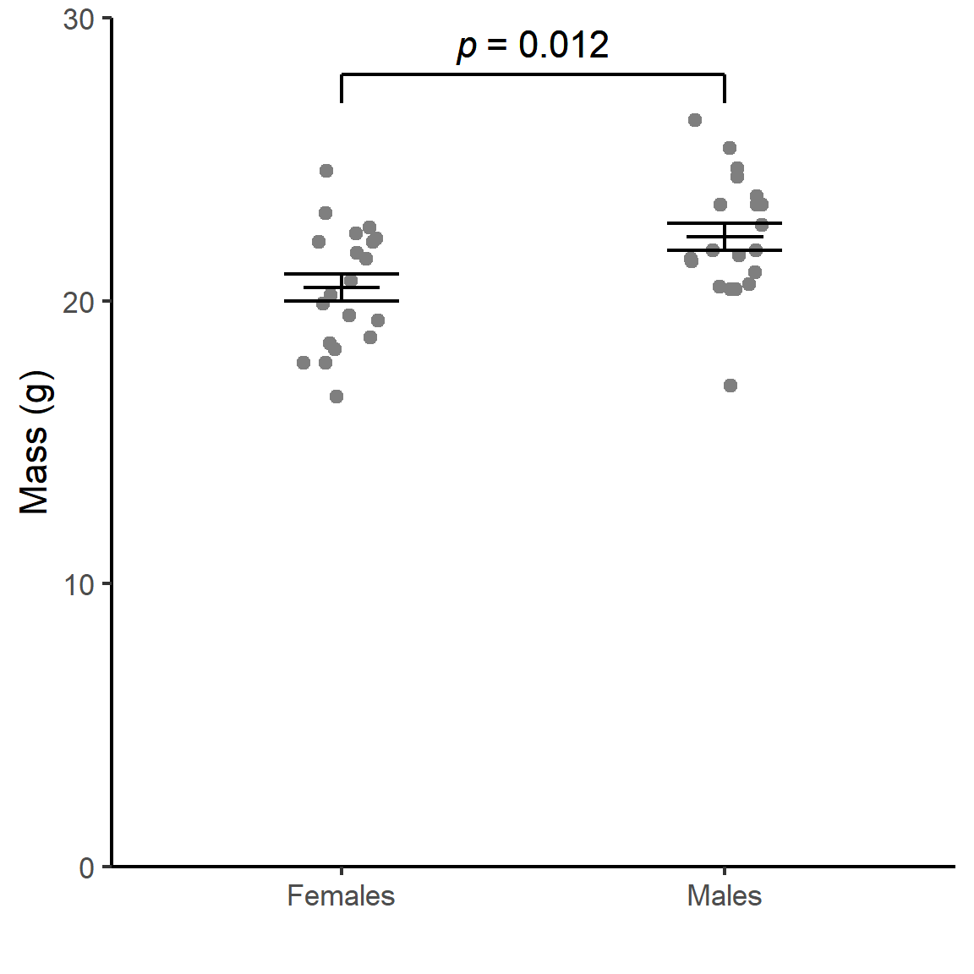

Figure 3: (ref:chaff-fig)

(ref:chaff-fig) Mass of adult chaffinches caught on the Stray. Error bars are $\overset{‾}{x}±1s.e.$

I’ve also gratuitously included a table with the same information just for the sake of including a table. See Table 1.

Table 1: A summary of the data.

| sex | mean | std | n | se | ssx |
| --- | --- | --- | --- | --- | --- |
| females | 20 | 2.1 | 20 | 0.48 | 87 |
| males | 22 | 2.1 | 20 | 0.48 | 88 |

# Discussion

Here we pick up points from the introduction.

## Word count

Word count calculated with package **wordcountaddin** (Marwick 2020)

This doc: 273  
The README: 609  
Total: 882

# References

Cramp, Stanley. 1994. *Handbook of the Birds of Europe the Middle East and North Africa. The Birds of the Western Palearctic, Volume 8: Crows to Finches*. Vol. 8 Crows to Finches. Oxford University Press.

Marwick, Ben. 2020. *Wordcountaddin: Word Counts and Readability Statistics in r Markdown Documents*.

R Core Team. 2021. *R: A Language and Environment for Statistical Computing*. Vienna, Austria: R Foundation for Statistical Computing. <https://www.R-project.org/>.

Wickham, Hadley. 2017. *Tidyverse: Easily Install and Load the ’Tidyverse’*. <https://CRAN.R-project.org/package=tidyverse>.