Variation in myoglobin content of skeletal muscle of seal species.

Emma Rand

# Introduction

Aquatic and marine mammals are able to dive underwater for extended periods as a result of having a higher muscle myoglobin concentration than terrestial mammals. Seal species are known to vary in dive length. We investigated whether the concentration of myoglobin differed between species.

# Methods

We measured the myoglobin content of the skeletal muscle of 30 individuals in each of three species. We used R (R Core Team 2019) with tidyverse packages (Wickham 2017) for all analyses.

# Results

There is a significant difference in myoglobin concentration between species (*F* = 5.35; *d.f.*=2, 87; *p* = 0.006). Post-hoc testing revealed that difference to be between the Harbour seal with the highest myoglobin concentrations ($\overline{x}±s.e.$: 49.01 $±$ 1.51 g Kg-1) and the Bladdernose seal with the lowest (42.32 $±$ 1.46 g Kg-1). See Figure 1.

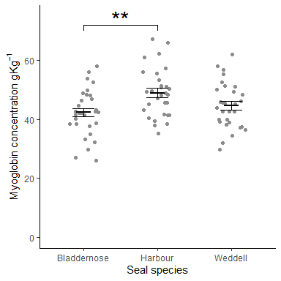

Figure 1 Mean Myoglobin content of skeletal muscle

R Core Team. 2019. *R: A Language and Environment for Statistical Computing*. Vienna, Austria: R Foundation for Statistical Computing. <https://www.R-project.org/>.

Wickham, Hadley. 2017. *Tidyverse: Easily Install and Load the ’Tidyverse’*. <https://CRAN.R-project.org/package=tidyverse>.