**Specimen question**

A chemical company has developed a new herbicide and is testing it against the leading brand. Field trials on plots are randomly assigned to one of three treatments: treated according to the manufacturer’s instructions for the leading brand (here called ‘brand’); treated by the advised protocol for the new chemical (here called ‘new’); or treated with a procedural control (‘control’). There were 30 plots for each treatment. Data are counts of numbers of weed species found in a quadrat six weeks after application of the treatment (one quadrat within each trial plot) and are provided as a text file in ‘specimen.txt’ without column headings.

*Your role is to choose and apply analyses of the provided data appropriately, produce suitable figure(s) and table(s), provide reproducible R code and a report of your findings.*

**Specimen answer**

There were 30 valid weed species counts from each of the three treatments with a range of 0 to 15 weed species found in each quadrat. The mean and median numbers of weed species are highest for the control and lowest for the leading brand. Summary data are shown in table 1 and visualised in figure 1.

A Kruskal-Wallis test showed a significant effect of treatment on the number of weed species recorded (chi-squared 34.19, d.f. = 2, p < 0.001). A *post hoc* Dunn test showed that the control had significantly more weeds recorded than either the leading brand or the new chemical (p < 0.001 in control versus brand). The new chemical had 1.53 more weeds per quadrat than the leading brand, but any difference was not significant in the Dunn test (p = 0.051).

This trial has confirmed that the new chemical is a very effective herbicide and, although not quite as good at keeping weed species down, has similar efficacy to the leading brand.

***Table 1****. Descriptive statistics for number of weed species per quadrat, n = 30 observations for each treatment. “Control” was a procedural control with no chemical added, “Brand” is the leading brand and “New” is the new chemical being trialled.*

|  |  |  |  |  |  |
| --- | --- | --- | --- | --- | --- |
| Treatment | Mean | Median | Min | Max | Range |
| Control | 8.67 | 9 | 3 | 15 | 12 |
| Brand | 4.13 | 4 | 0 | 7 | 7 |
| New | 5.17 | 5.5 | 1 | 9 | 8 |

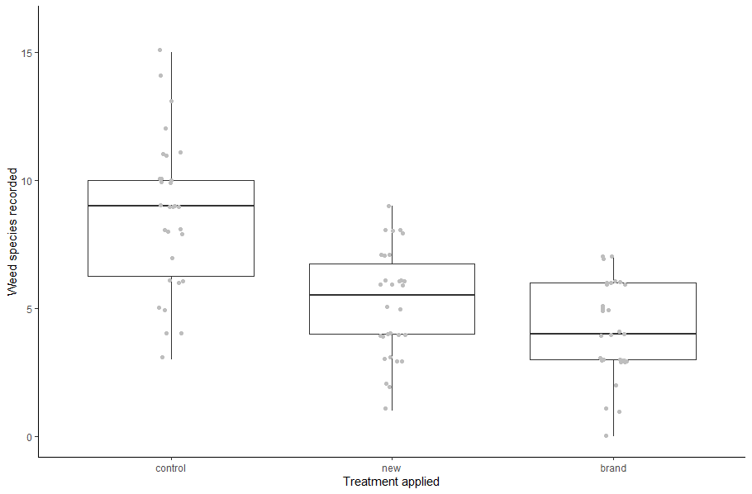

***Figure 1****. Number of weed species recorded in a quadrat for each of the three treatments (as described in table 1). Box shows the interquartile range, heavy line shows the median value and the whiskers extend to the range limits. The raw data are shown in light grey with jitter to avoid overplotting.*