Design input: Suggested names, focus group and prototype evaluation

Emma Rand

25/07/2019

# Methods

## Call for focus group participants.

A call for participants to take part in a focus group was sent in the first week of the Autumn term 2018 to stage 2 students. This cohort of students had taken Data Analysis in R in the Spring term 2018, during their first year. Respondents were also able to suggest a name for the app, ask a question or make a comment.

## Focus group

The focus group was held over 90 mins. Three main questions were addressed:

1. In learning R, what things were most confusing or caused most difficulty right at the start?
2. How should topics be defined and organised?
3. What level of advertising is acceptable?

Participants were divided into three groups and considered one question at a time, recording their discussion on paper provided then moving on to the next question. This was followed by a moderated discussion amongst the whole group based on sharing the comments made by the smaller groups.

## Evaluation of the Prototype

Prototype evaluation was designed and carried out by two student members of the LDT during a scheduled Data Analysis in R workshop . Workshop participants were asked to spend 10 - 15 minutes using the prototype and respond to sixteen Likert questions. These concerned Ease of navigation, Content or Aesthetic appeal.

# Results

## Response to the call for focus group participants.

There were 39 respondents with an approximately 1:1:0 male: female:non-binary gender ratio which compares to ## 88:139:x for the cohort. A total of 29 suggestions for App names were received and these were classified as expressing one or more of a set of X ideas concerned with outcomes for the user, the user experience, another app persona not related to either of those or left unclassified. See table 1

**Supplementary material**

| Table 1. Suggestions for the name of the App received through the call for focus-group participation | |
| --- | --- |
| Name suggested | Categorisations |
| Rap | personaX |
| Learn R-apidly | learn, quick |
| Pocket R | simple, quick |
| leaRn | learn |
| HelpeR | teach |
| easyR | simple |
| TeachR | teach |
| ProgramR | outcome |
| Riddle | fun |
| grrrrrrR | unclassified |
| staR | personaX |
| lab-R-tory | personaX |
| Rapper | personaX |
| AdventR (adventure) | fun |
| InventR | personaX |
| Dat->R | outcome |
| R-ccelerator | quick |
| R-beginners assistant | teach, learn |
| Making R clear and simple for all | simple, teach |
| R-chitect | personaX |
| R-pool | unclassified |
| R-right | unclassified |
| Quick TrainR | quick, teach |
| Stats TrainR | outcome, teach |
| Stats PlayR | outcome, fun |
| RUOK | teach |
| leaRn | learn |
| leaRn | learn |
| LearnR | learn |

**Figure for inclusion**

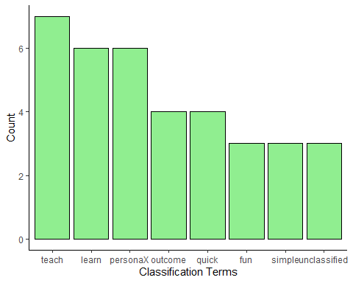

Frequency of classification terms for suggested App names. A suggested name had one or more terms assoicated with it or was left unclassified.

## Focus group

to be completed

## Evaluation of the Prototype

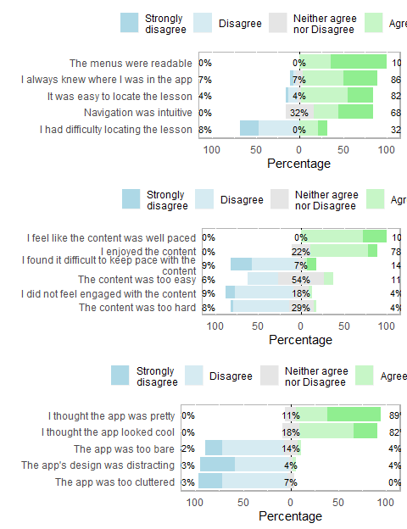

Evaluation of the App Prototype for ease of navigation, content and aesthetics