App names suggested by Stage 2 students

Emma Rand

25/07/2019

# Survey 1

## Method

A call for participants to take part in a focus group was sent in the first week of the Autumn term 2018 to stage 2 students. This cohort of students had taken Data Analysis in R in the Spring term 2018, during their first year. Respondents were also able to suggest a name for the app, ask a question or make a comment.

## Results

There were 39 respondents with an approximately 1:1:0 male: female:non-binary gender ratio which compares to ## 88:139:x for the cohort. A total of 29 suggestions for App names were received and these were classified as expressing one or more of a set of X ideas concerned with outcomes for the user, the user experience, another app persona not related to either of those or left unclassified. See table 1

**Supplementary material**

| Table 1. Suggestions for the name of the App received through the call for focus-group participation | |
| --- | --- |
| Name suggested | Categorisations |
| Rap | personaX |
| Learn R-apidly | learn, quick |
| Pocket R | simple |
| leaRn | learn |
| HelpeR | teach |
| easyR | simple |
| TeachR | teach |
| ProgramR | outcome |
| Riddle | fun |
| grrrrrrR | unclassified |
| staR | personaX |
| lab-R-tory | personaX |
| Rapper | personaX |
| AdventR (adventure) | fun |
| InventR | personaX |
| Dat->R | outcome |
| R-ccelerator | quick |
| R-beginners assistant | teach, learn |
| Making R clear and simple for all | simple, teach |
| R-chitect | personaX |
| R-pool | unclassified |
| R-right | unclassified |
| Quick TrainR | quick, teach |
| Stats TrainR | outcome, teach |
| Stats PlayR | outcome, fun |
| RUOK | teach |
| leaRn | learn |
| leaRn | learn |
| LearnR | learn |

**Figure for inclusion**

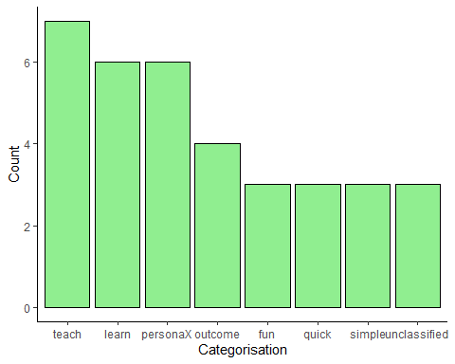

Frequency of categories for suggested App names