Variation in myoglobin content of skeletal muscle of seal species.

Emma Rand

# Introduction

Aquatic and marine mammals are able to dive underwater for extended periods as a result of having a higher muscle myoglobin concentration than terrestrial mammals (Kanatous and Mammen 2010) found that 83% of the variation in Toothed whale species (odontocetes) dive capacity was accounted for by body mass and myoglobin content. Seal species are also known to vary in dive length. We investigated whether the concentration of myoglobin differed between three species of seal: Weddell Seal, Harbour Seals and Bladdernose Seals. See Figure 1

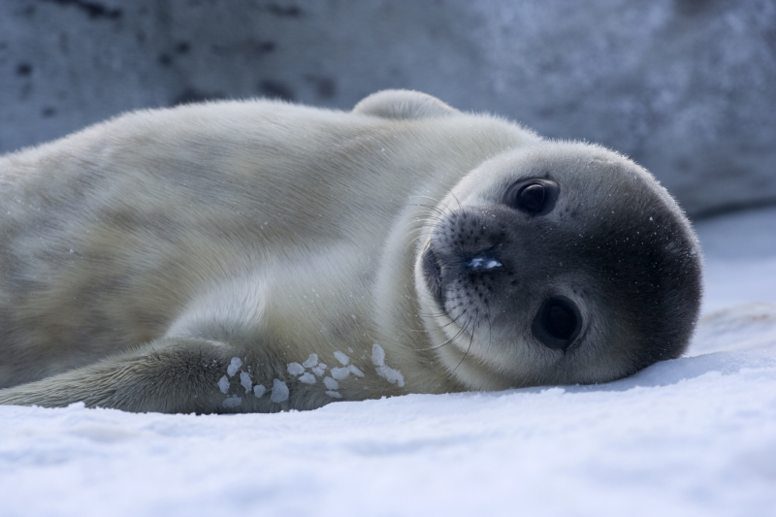

Figure 1: Baby Weddell Seals are very cute. By Photo © Samuel Blanc, CC BY-SA 3.0, <https://commons.wikimedia.org/w/index.php?curid=3877642>

# Methods

We measured the myoglobin content of the skeletal muscle of 28 individuals in each of three species. We used R (R Core Team 2021) with tidyverse packages (Wickham 2017) for all analyses and the rmarkdown (Allaire et al. 2019) and bookdown (Xie 2016) packages for manuscript preparation.

# Results

There is a significant difference in myoglobin concentration between species (*F* = 5.88; *d.f.* =2, 81; *p* = 0.004). Post-hoc testing revealed that difference to be between the Weddell seal with the highest myoglobin concentrations (: 48.91 1.61 g Kg-1) and the Harbour seal with the lowest (41.6 1.46 g Kg-1). See Figure 2. I’ve also gratuitously included a table with the same information just for the sake of including a table. See Table 1.

Table 1: A summary of the data.

|  |  |  |  |  |
| --- | --- | --- | --- | --- |
| species | mean | std | n | se |
| Bladdernose | 44.44 | 7.82 | 28 | 1.48 |
| Harbour | 41.60 | 7.75 | 28 | 1.46 |
| Weddell | 48.91 | 8.54 | 28 | 1.61 |

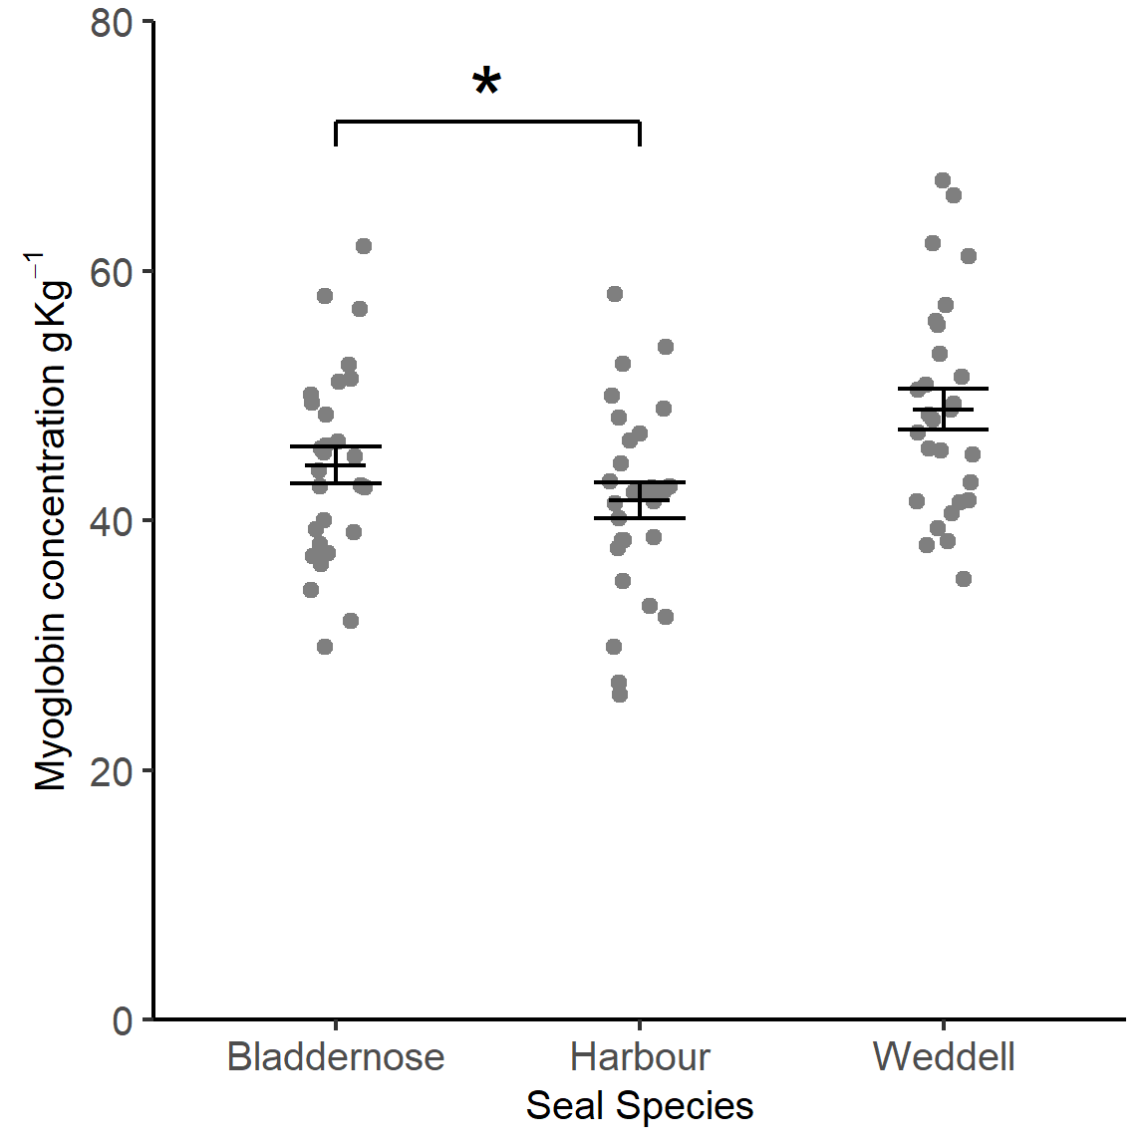

Figure 2: Mean Myoglobin content of skeletal muscle. Error bars are

# Discussion

See Table 2.

Table 2: A summary of the data.

|  |  |  |  |  |
| --- | --- | --- | --- | --- |
| species | mean | std | n | se |
| Bladdernose | 44.44 | 7.82 | 28 | 1.48 |
| Harbour | 41.60 | 7.75 | 28 | 1.46 |
| Weddell | 48.91 | 8.54 | 28 | 1.61 |

Here we pick up points from the Introduction.

# References

Allaire, JJ, Yihui Xie, Jonathan McPherson, Javier Luraschi, Kevin Ushey, Aron Atkins, Hadley Wickham, Joe Cheng, Winston Chang, and Richard Iannone. 2019. *Rmarkdown: Dynamic Documents for R*. <https://github.com/rstudio/rmarkdown>.

Kanatous, Shane B., and Pradeep P. A. Mammen. 2010. “Regulation of Myoglobin Expression.” *Journal of Experimental Biology* 213 (16): 2741–7. <https://doi.org/10.1242/jeb.041442>.

R Core Team. 2021. *R: A Language and Environment for Statistical Computing*. Vienna, Austria: R Foundation for Statistical Computing. <https://www.R-project.org/>.

Wickham, Hadley. 2017. *Tidyverse: Easily Install and Load the ’Tidyverse’*. <https://CRAN.R-project.org/package=tidyverse>.

Xie, Yihui. 2016. *Bookdown: Authoring Books and Technical Documents with R Markdown*. Boca Raton, Florida: Chapman; Hall/CRC. <https://github.com/rstudio/bookdown>.