Variation in myoglobin content of skeletal muscle of seal species.

Emma Rand

# Introduction

Aquatic and marine mammals are able to dive underwater for extended periods as a result of having a higher muscle myoglobin concentration than terrestial mammals. Seal species are known to vary in dive length. We investigated whether the concentration of myoglobin differed between species.

# Methods

We used R Core Team (2018) and tidyverse packages (Wickham, 2017) for all analyses.

# Results

There is a significant difference in myoglobin concentration between species (*F* = 5.35; *d.f.*=2, 87; *p* = 0.006). Post-hoc testing revealed that difference to be between the Harbour seal with the highest myoglobin concentrations (49.01 ) and the Bladdernose seal with the lowest (42.32 ). (see Figure @ref(fig:myo-fig) )

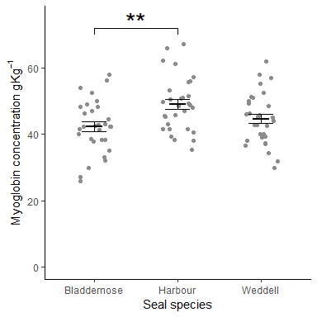

Mean Myoglobin content of skeletal muscle