


Global Asthma Analytics
Project Documentation
Population-Level GBD Analytics + Patient-Level ML Prediction Platform
DEPI Round 4 · AST Company · ONL4_DAT1_S4

Table of Contents
Table of Contents 2
1. Executive Summary 5
2. Project Objectives & Scope 5
3. Data Sources 5
3.1 Global Burden of Disease (GBD 2023) 5
3.2 Patient-Level Clinical Dataset 5
4. System Architecture 5
5. Database Design 6
5.1 GBD Schema Tables 7
5.2 Patient Schema Tables 7
5.3 Views & Stored Procedures 7
6. Data Cleaning & Feature Engineering 7
7. Exploratory Data Analysis — Highlights 8
8. Machine Learning 8
8.1 Methodology 8
8.2 Results 9
9. Dashboards 10
9.1 GBD Dashboard (Excel) 10
9.2 Patient Dashboard (Excel) 11
9.3 Tableau Dashboard 11
9.4 Patient Dashboard (Power BI) 14
9.5 GBD Dashboard (Power BI) 17
10. AI Chatbot — AsthmAI 19
11. Key Insights & Recommendations 19
12. Known Limitations & Data Notes 19
13. Future Work 19
14. Appendix — Technology Stack 20

1. Executive Summary
Asthma is one of the most common chronic respiratory diseases worldwide, affecting millions of people across all age groups. This project builds a unified analytics platform that combines two very different views of the disease: population-level burden data from the Global Burden of Disease study (GBD 2023), and patient-level clinical records suitable for machine-learning risk prediction.
The platform spans a SQL Server data warehouse, a Python data-science pipeline (cleaning, EDA, ML training, evaluation), interactive Excel/Power BI/Tableau dashboards, and an AI chatbot layer for natural-language questions about the data.

2. Project Objectives & Scope
- Quantify global asthma burden across 204 countries and 33 years (1990-2023) using GBD 2023 data.
- Build a patient-level risk model that predicts asthma diagnosis from demographic, lifestyle, environmental, and clinical features.
- Provide a queryable, relational home for both datasets that BI tools and an AI chatbot.
- Surface actionable insights for healthcare decision-makers: high-burden countries, vulnerable age groups, and key patient risk factors.

3. Data Sources

3.1 Global Burden of Disease (GBD 2023)
Source: IHME (Institute for Health Metrics and Evaluation). 304,776 rows covering 204 countries, 5 measures (Deaths, Prevalence, Incidence, DALYs, YLDs), 2 sexes, 6 age bands, and 3 metric types (Number, Percent, Rate), across 9 reference years from 1990 to 2023.
Another Source help to Insights : ourworldindata.org

3.2 Patient-Level Clinical Dataset
2,392 individual patient records with 28 features spanning demographics, lifestyle, environmental exposure, medical history, lung function, and symptoms, with a binary Diagnosis target (0 = No Asthma, 1 = Asthma).
Note: this working dataset has a 49.0% asthma-positive rate (1,171 of 2,392), which is considerably more balanced than the original Kaggle reference dataset it is modeled on (~5.2% positive).

4. System Architecture
The diagram below shows how data flows from the two source files through the SQL Server warehouse, the Python analytics layer, and out to the dashboards and chatbot.
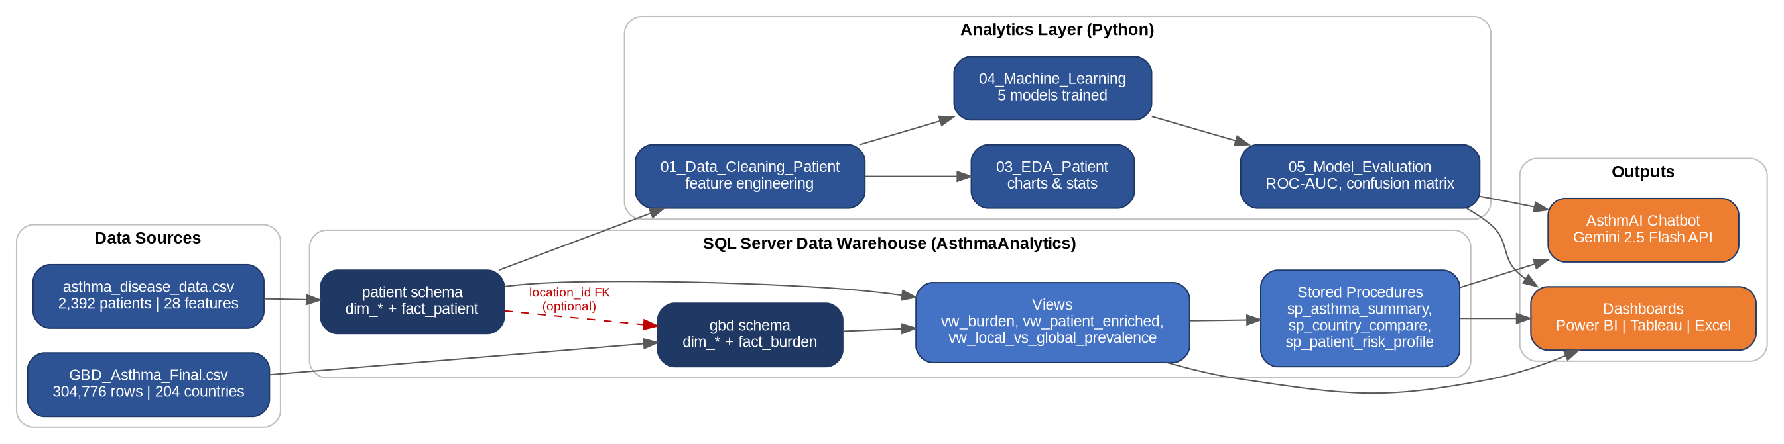
Figure 1 — End-to-end system architecture

5. Database Design
The warehouse uses one SQL Server database (AsthmaAnalytics) with two schemas — gbd and patient — rather than two separate databases. This keeps BI tool connections simple (one connection string covers both domains), keeps backup/maintenance to a single job, and still gives clean logical and permission separation via schemas and per-schema reader roles.
A nullable location_id foreign key links patient.fact_patient to gbd.dim_location. This does not let patient records change GBD's published figures — GBD estimates remain IHME's authoritative numbers. Instead, it enables a side-by-side comparison view (patient.vw_local_vs_global_prevalence) between your own patient sample's diagnosis rate and the official GBD prevalence for the same country.

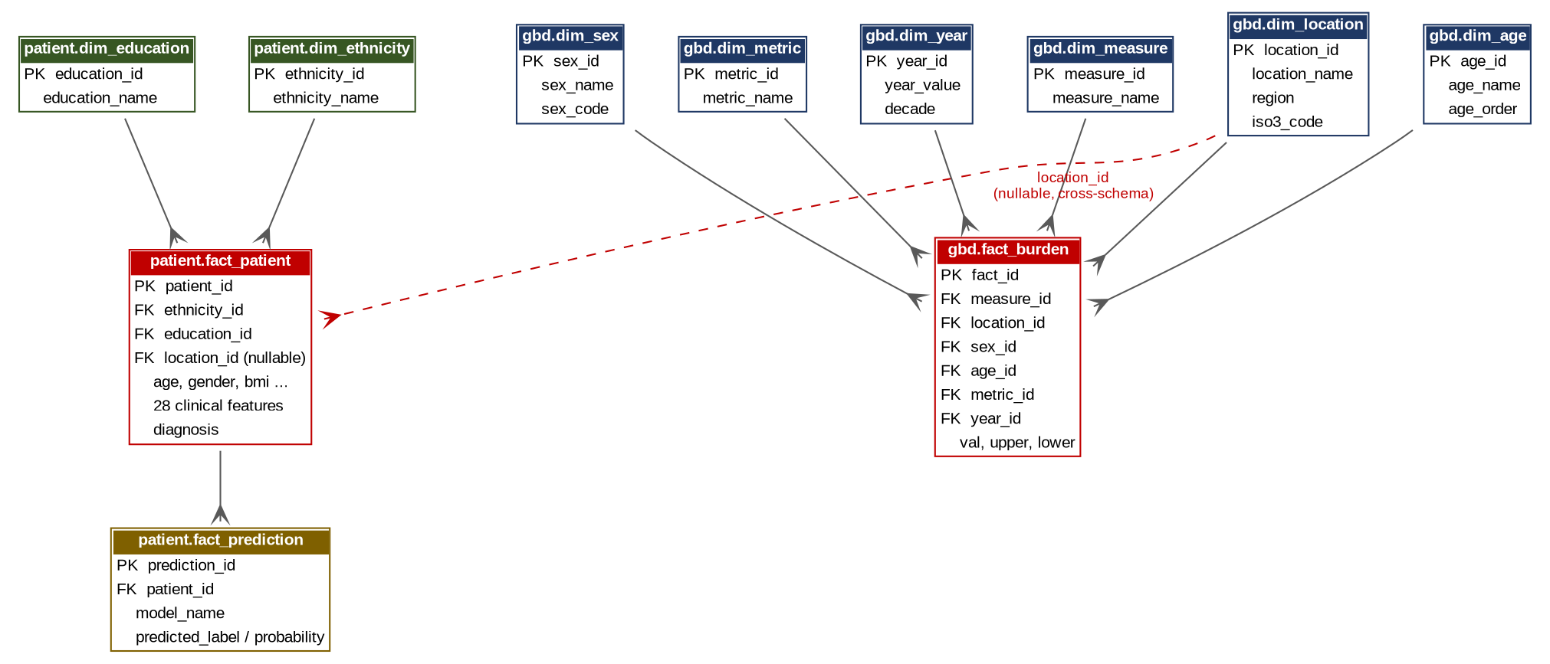
Figure 2.1 — Entity-relationship diagram Draw

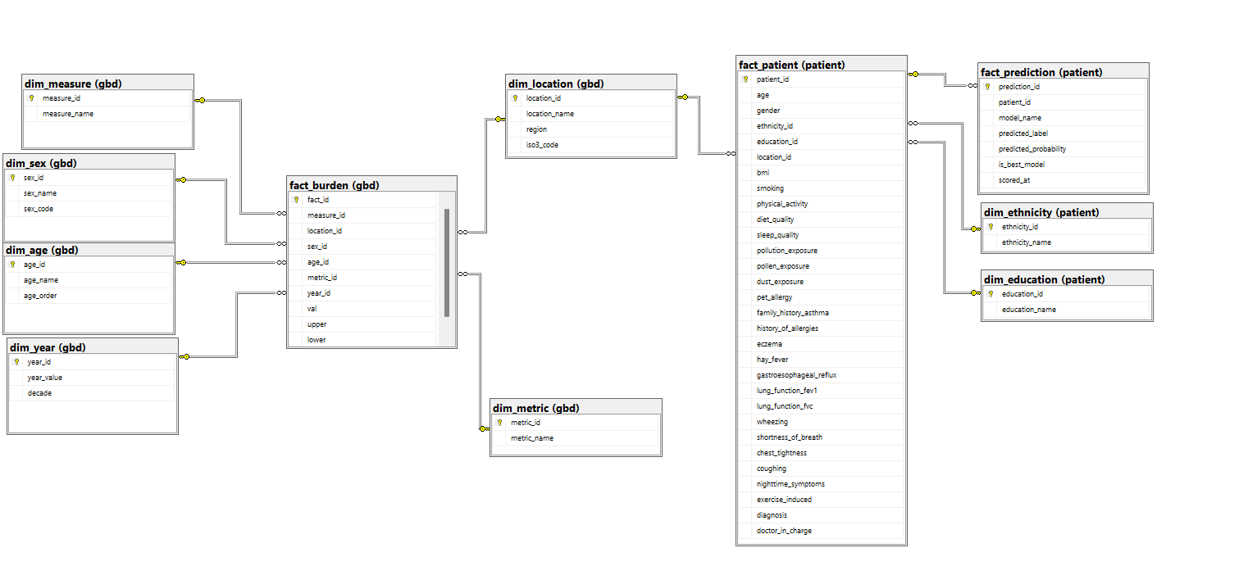
Figure 2.2 — ERD in SQL Server

5.1 GBD Schema Tables
Table | Grain / Key | Purpose
gbd.dim_measure | measure_id (PK) | Deaths / Prevalence / Incidence / DALYs / YLDs
gbd.dim_location | location_id (PK) | 204 countries
gbd.dim_age | age_id (PK) | 6 age bands, ordered for charting
gbd.dim_sex | sex_id (PK) | Male / Female
gbd.dim_metric | metric_id (PK) | Number / Percent / Rate
gbd.dim_year | year_id (PK) | 1990-2023, bucketed by decade
gbd.fact_burden | 1 row per measure x location x sex x age x metric x year | 304,776 GBD estimates (val / upper / lower)

5.2 Patient Schema Tables
Table | Grain / Key | Purpose
patient.dim_ethnicity | ethnicity_id (PK) | Caucasian / African American / Asian / Other
patient.dim_education | education_id (PK) | None / High School / Bachelor's / Higher
patient.fact_patient | patient_id (PK) | 2,392 patients, 28 clinical features + diagnosis
patient.fact_prediction | prediction_id (PK) | ML model scores per patient, per model

5.3 Views & Stored Procedures
- gbd.vw_burden — flat, display-ready GBD fact table (auto-applies the ×100 rule when metric = Percent, adds a risk_category bucket)
- gbd.vw_country_latest — latest-year KPIs per country, for map/KPI-card visuals
- patient.vw_patient_enriched — patient fact + engineered features (AgeGroup, BMICategory, FEV1/FVC ratio, SymptomCount, RiskFactorCount)
- patient.vw_risk_factor_summary — prevalence + diagnosis rate per medical-history risk factor
- patient.vw_local_vs_global_prevalence — patient sample vs. official GBD prevalence, side by side
- dbo.sp_asthma_summary — headline stored procedure: GBD summary + patient summary + combined KPIs in one call
- gbd.sp_country_compare and patient.sp_patient_risk_profile — support the chatbot's example questions directly

6. Data Cleaning & Feature Engineering
The raw patient CSV is cleaned and enriched with: human-readable labels for every coded categorical/binary field, 5 age-group bands, a WHO-standard BMI category, an FEV1/FVC lung-function ratio, a symptom count (0-6), and a medical-history risk-factor count (0-5). This step is fully reproducible in 01_Data_Cleaning_Patient.ipynb and mirrored in the patient.vw_patient_enriched SQL view.

7. Exploratory Data Analysis — Highlights
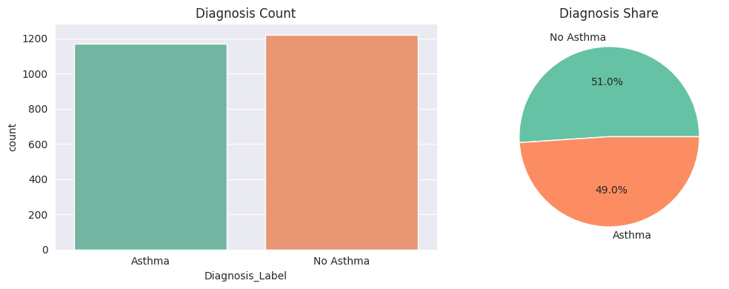
Figure 3 — Diagnosis distribution across the patient sample
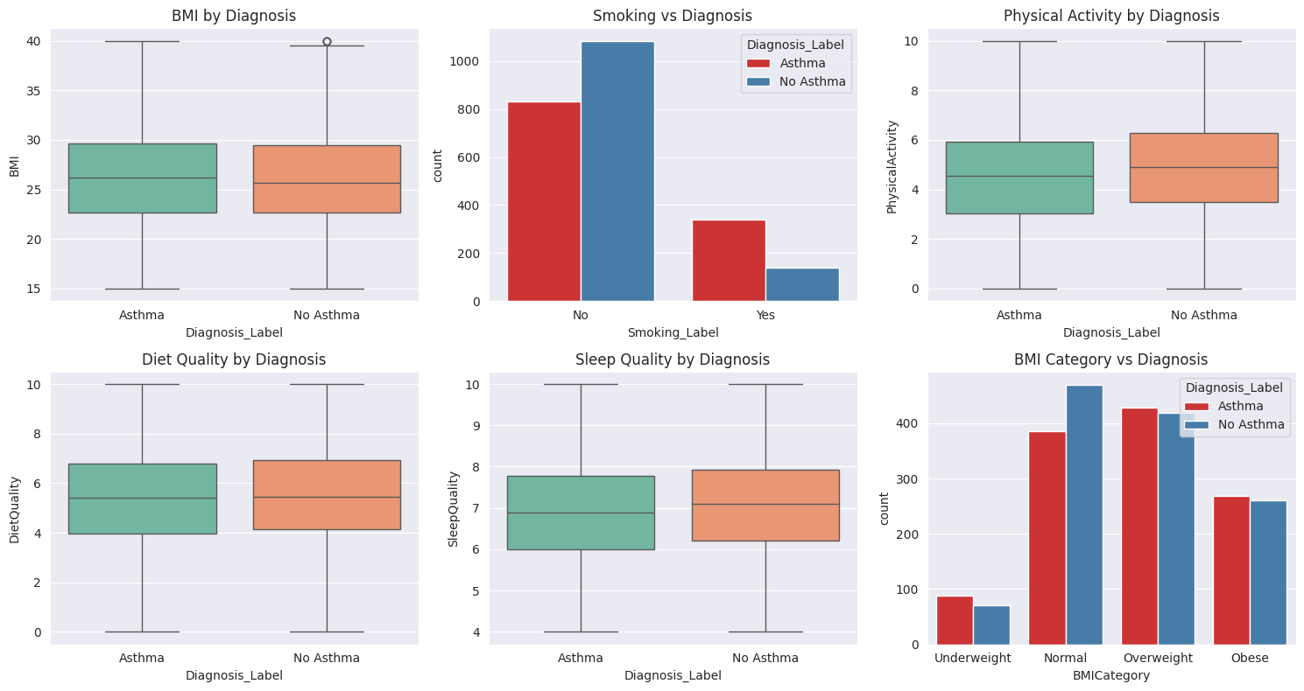
Figure 4 — Patient feature relationships explored during EDA

8. Machine Learning

8.1 Methodology
Five classification algorithms were trained on the same engineered feature set to predict Diagnosis: Logistic Regression, Decision Tree, Random Forest, XGBoost, and SVM. Models were evaluated with Accuracy, Precision, Recall, F1-Score, and ROC-AUC on a held-out test split.
Class imbalance is handled via class-weighting (class_weight='balanced' or XGBoost's scale_pos_weight) rather than oversampling, so the rare positive class contributes proportionally more to the loss function without altering the original 2,392 rows. A stratified 80/20 train/test split (stratify=y, random_state=42) preserves the positive rate in both sets; Logistic Regression and SVM use StandardScaler, tree-based models use unscaled features.
Algorithm | Key settings
Logistic Regression | class_weight='balanced', max_iter=1000, on scaled features
Decision Tree | class_weight='balanced', max_depth=6, min_samples_leaf=10
Random Forest | 300 trees, max_depth=8, min_samples_leaf=5, class_weight='balanced'
XGBoost | 300 estimators, max_depth=4, learning_rate=0.05, scale_pos_weight ≈ class ratio
SVM (RBF kernel) | class_weight='balanced', probability=True, on scaled features

8.2 Results
Model | Accuracy | Precision | Recall | F1-Score | ROC-AUC
Logistic Regression | 0.701 | 0.738 | 0.603 | 0.664 | 0.777
Random Forest | 0.712 | 0.755 | 0.607 | 0.673 | 0.775
XGBoost | 0.691 | 0.709 | 0.624 | 0.664 | 0.767
SVM | 0.704 | 0.742 | 0.603 | 0.665 | 0.761
Decision Tree | 0.656 | 0.677 | 0.564 | 0.615 | 0.697
Logistic Regression achieved the best ROC-AUC (0.777) and was selected as the best model; Random Forest was close behind (0.775) with the best F1-Score (0.673). All five models comfortably beat a random-guess baseline (ROC-AUC 0.5), with Decision Tree the weakest performer, as expected for a single unpruned tree.
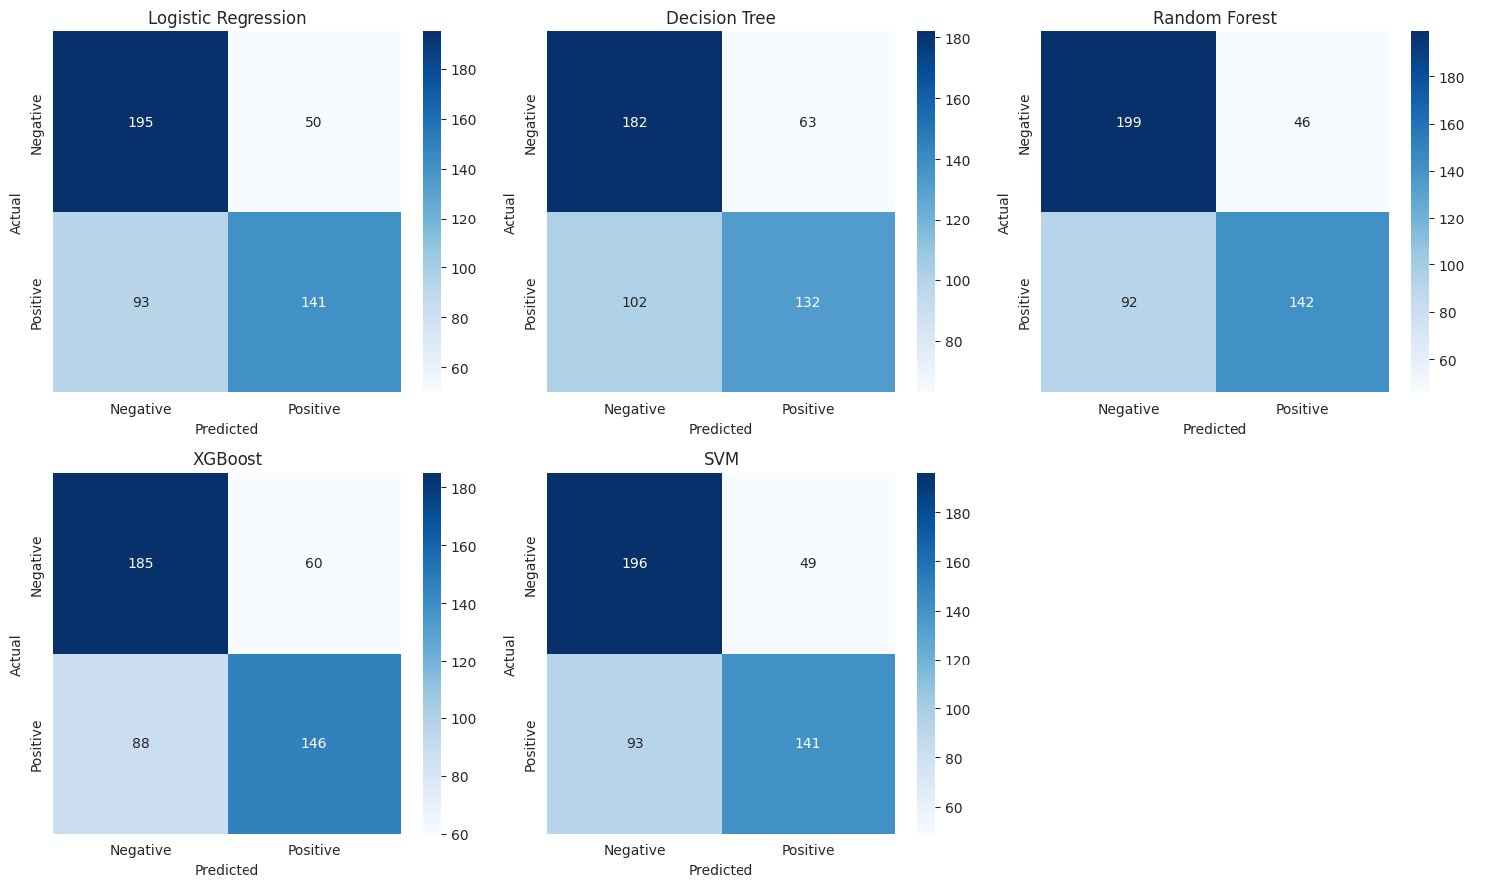
Figure 5 — ROC curve comparison across all five models
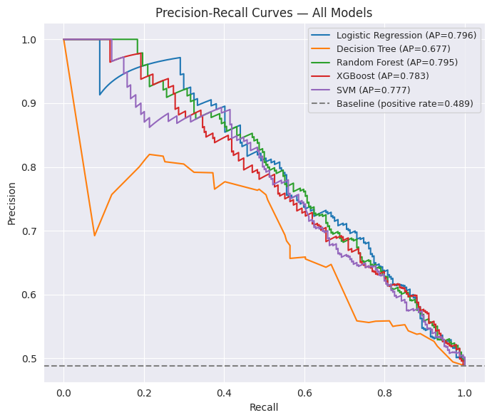
Figure 6 — Confusion matrix / feature importance detail

9. Dashboards

9.1 GBD Dashboard (Excel)
World map of prevalence by country, deaths trend 1990-2023, top-10 countries, DALYs by age group, male vs. female comparison, and KPI cards, all driven by slicers for Year, Measure, Metric, Sex, Age, and Location.

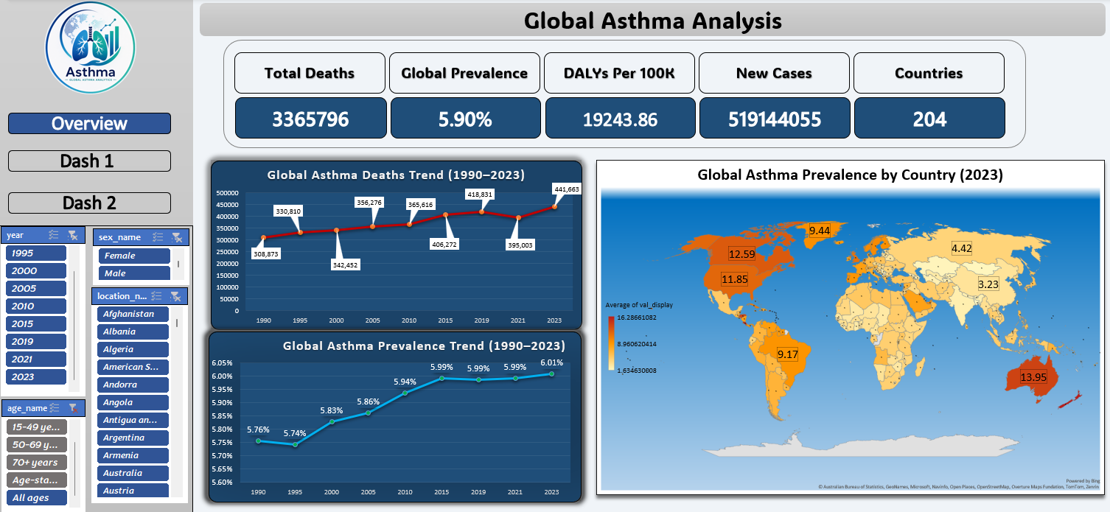
gFigure 7.1 — GBD Dashboard layout

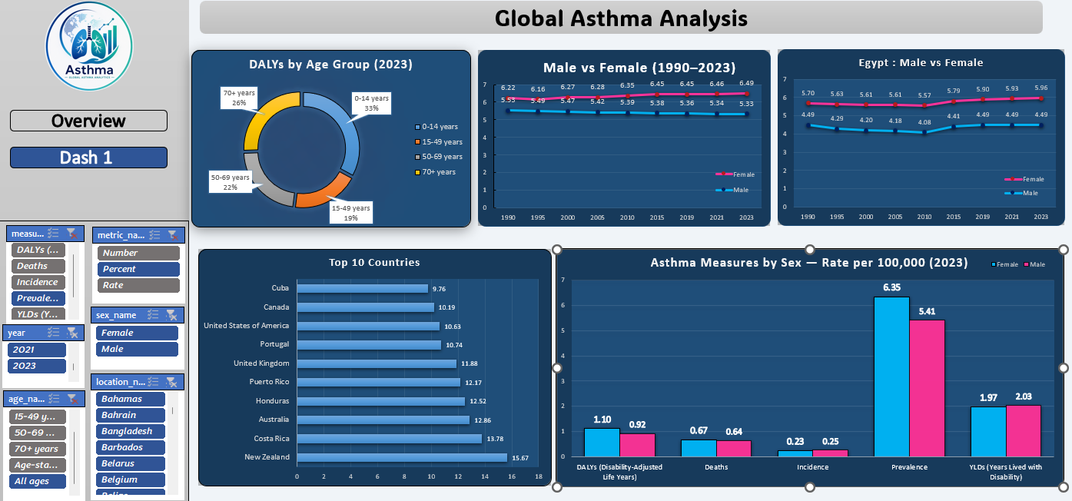
gFigure 7.2 — GBD Dashboard layout

9.2 Patient Dashboard (Excel)
Diagnosis rate by age group, patient-count breakdowns, overall diagnosis distribution, environmental-exposure comparison, and symptom/lifestyle prevalence, built from native Excel pivot tables against the cleaned patient dataset.
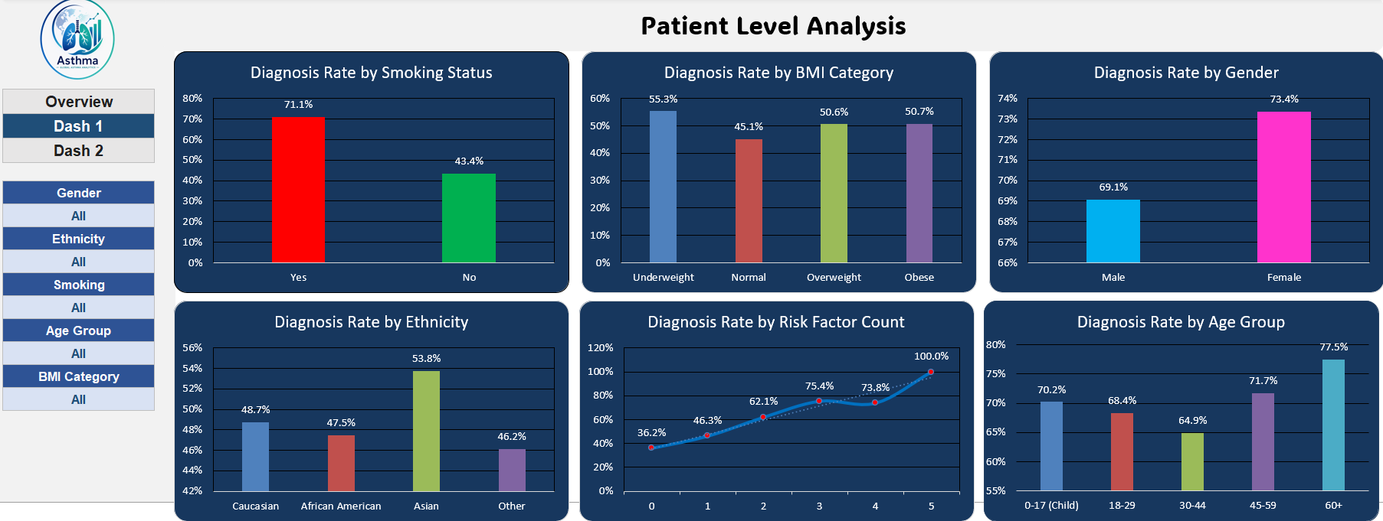
Figure 8 — Patient Dashboard layout

9.3 Tableau Dashboard
A nine-dashboard interactive Tableau workbook built on the GBD fact table (Section 5.1), using plain Quick Filters (not Parameters) for measure, metric, and year selection, and LOD expressions to correctly handle the dataset’s mixed aggregate/detail age bands and its lack of a combined-sex row. Each box below is a placeholder — replace it with your own exported Tableau dashboard screenshot.
KPI cards (Deaths, Prevalence, Incidence, DALYs, YLDs), global trend line, and Top-N country bar, all driven by Measure Name / Metric Name Quick Filters.
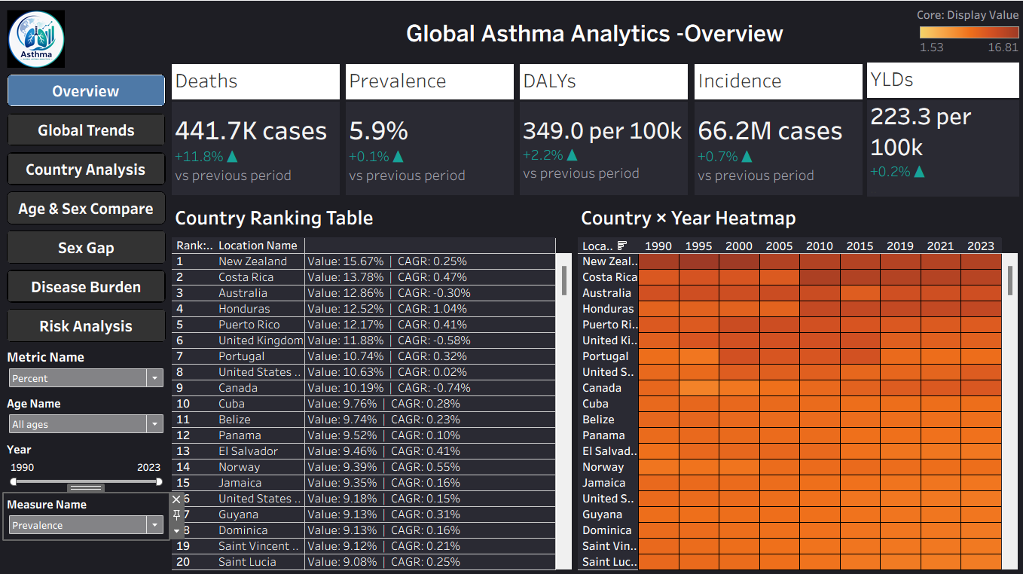Dashboard 1 — Executive Overview

Full 1990-2023 trend line across all five measures plus a year-over-year growth bar chart, with reference lines and an optional forecast.
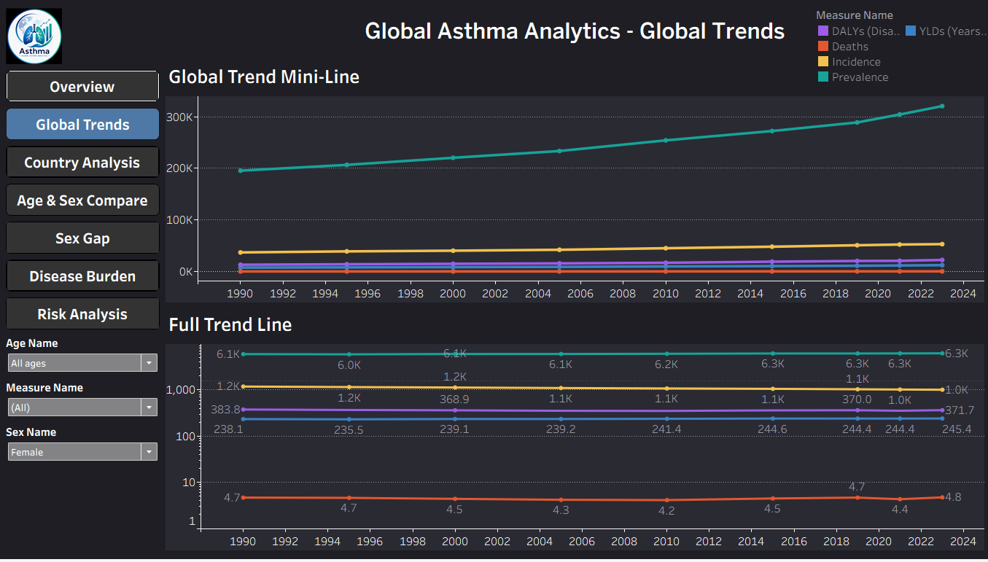Dashboard 2 — Global Trends

Filled choropleth map, a ranked country table (Rank, Value, CAGR), and a Country x Year heatmap, cross-filtered by clicking the map.
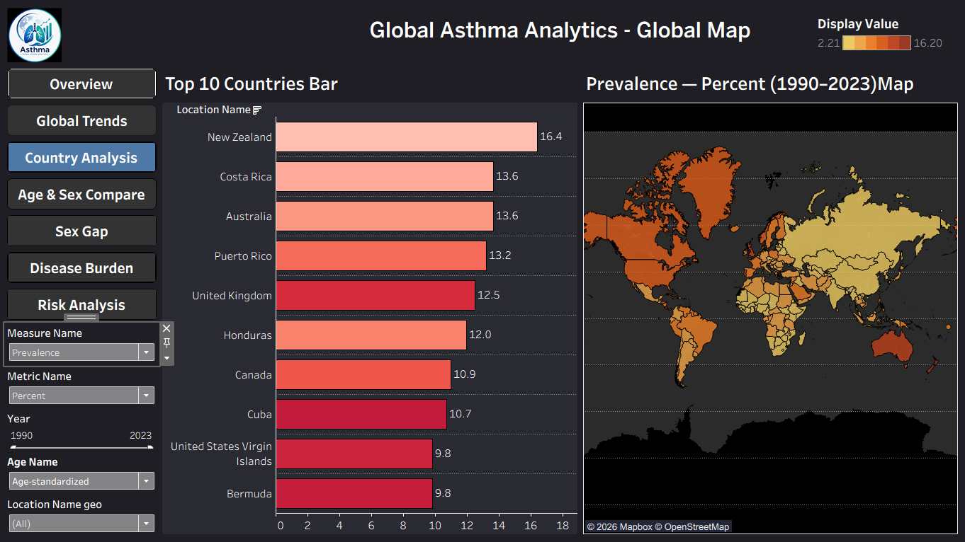Dashboard 3 — Country Analysis

Population pyramid by age band and sex, a 100% stacked age-band bar, and a male-vs-female dumbbell chart, filtered to exclude aggregate age rows.
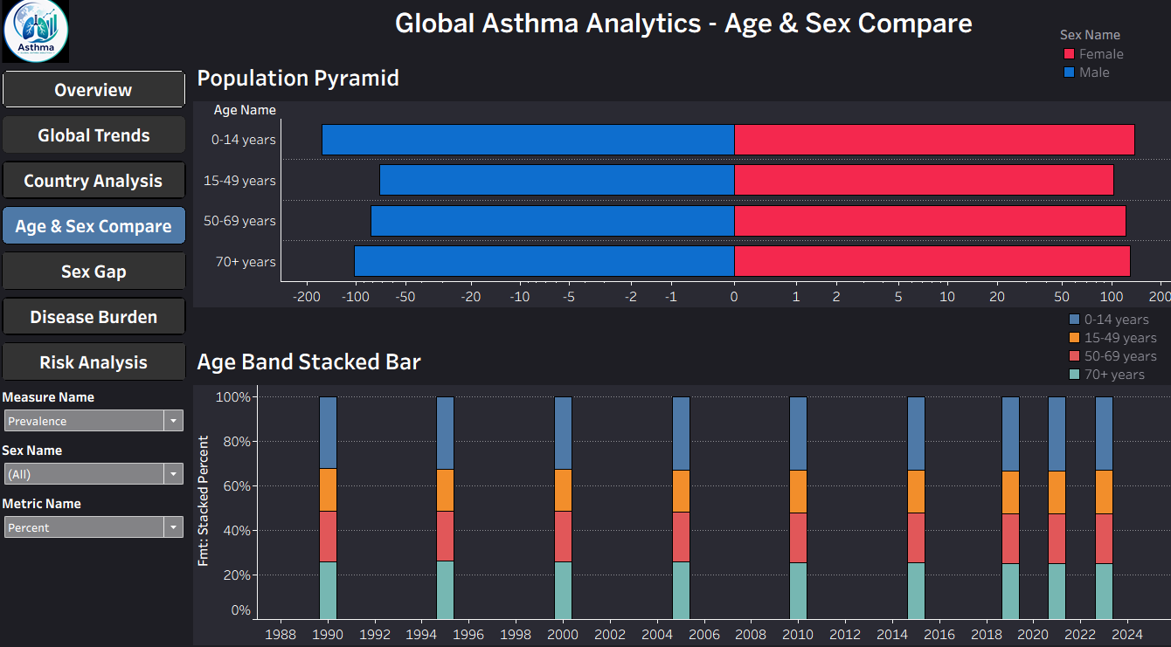Dashboard 4 — Age & Sex Analysis

Small-multiples trend line comparing all five measures side by side, plus a Rate-vs-Number scatter sized by value.
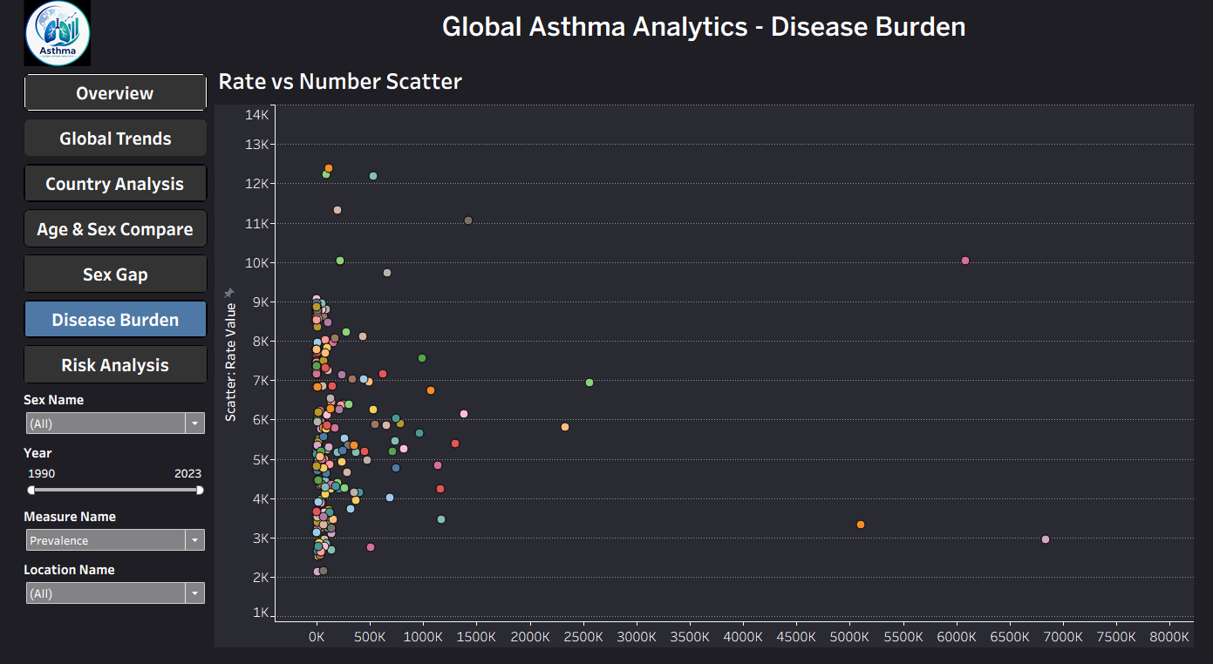Dashboard 5 — Disease Burden

Z-score outlier bar chart flagging countries whose burden sits meaningfully above or below the global average.
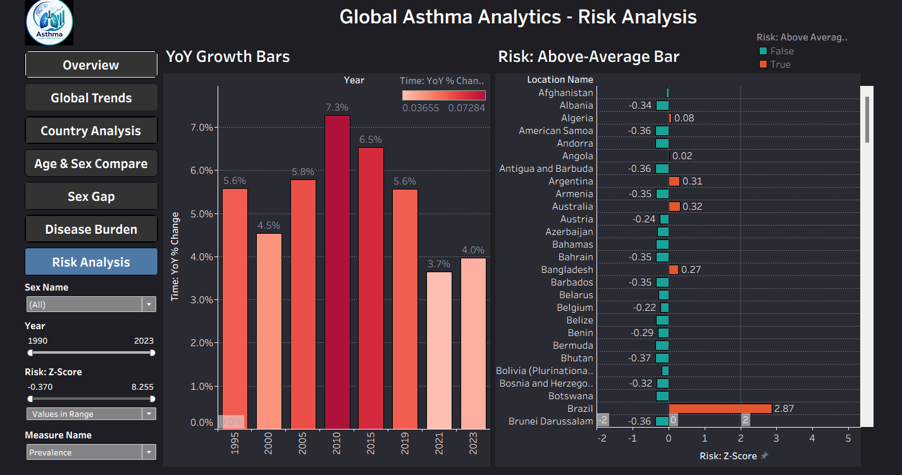Dashboard 6 — Risk Analysis
Single-country profile view Gap between Male and Female.
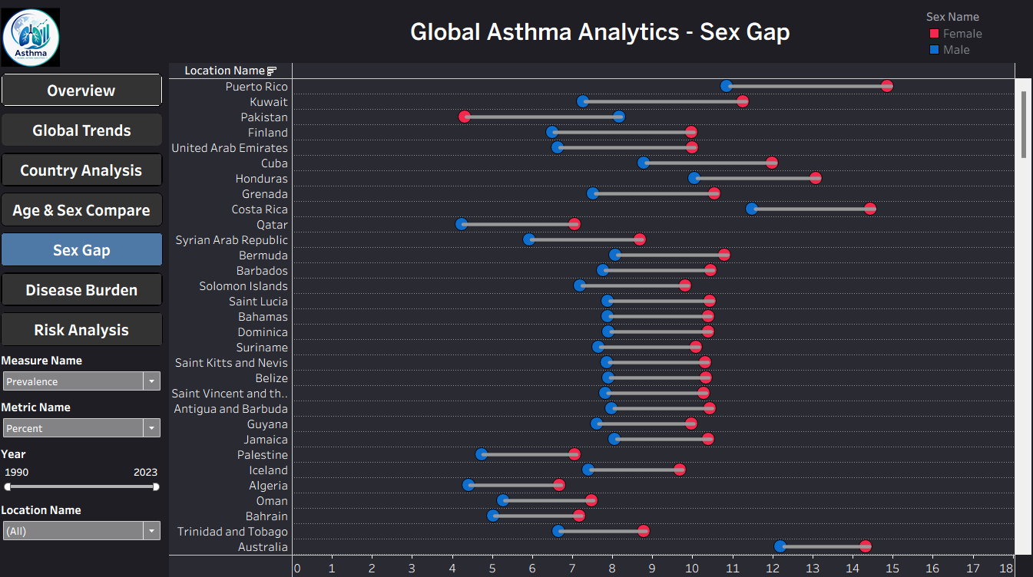Dashboard 7 — Sex Gap

9.4 Patient Dashboard (Power BI)
KPI Cards: Total Patients (2,392), Smokers Diagnosed (80.02%), Diagnosis Rate (48.95%), Avg FEV1 (2.86)
Filters: Education Level (Higher Education, No Education, Primary School, Secondary School), Age Group, Gender (female/male), Ethnicity (Caucasian, African American, Asian, Other), BMI Group (Underweight, Normal, Overweight, Obese)

Page 1 : OVERVIEW
Patients by ethnicity (donut): Caucasian dominates the patient base (55.77%), useful for spotting demographic skew/representation bias.
Selected Symptom by Symptom (bar): Ranks symptom frequency (coughing highest, chest tightness lowest) — a Top-N style ranking chart.
Risk profile radar: Compares diagnosed vs. non-diagnosed exposure across 5 risk axes (pollution, dust, pollen, family history, lung function) — the green (diagnosed) polygon visibly outsizes red (not diagnosed).
Diagnosis rate trend by age group (line chart): Shows two intersecting trend lines — diagnosed vs. not-diagnosed rates fall/rise as age increases, highlighting an age-related crossover around 46-60.
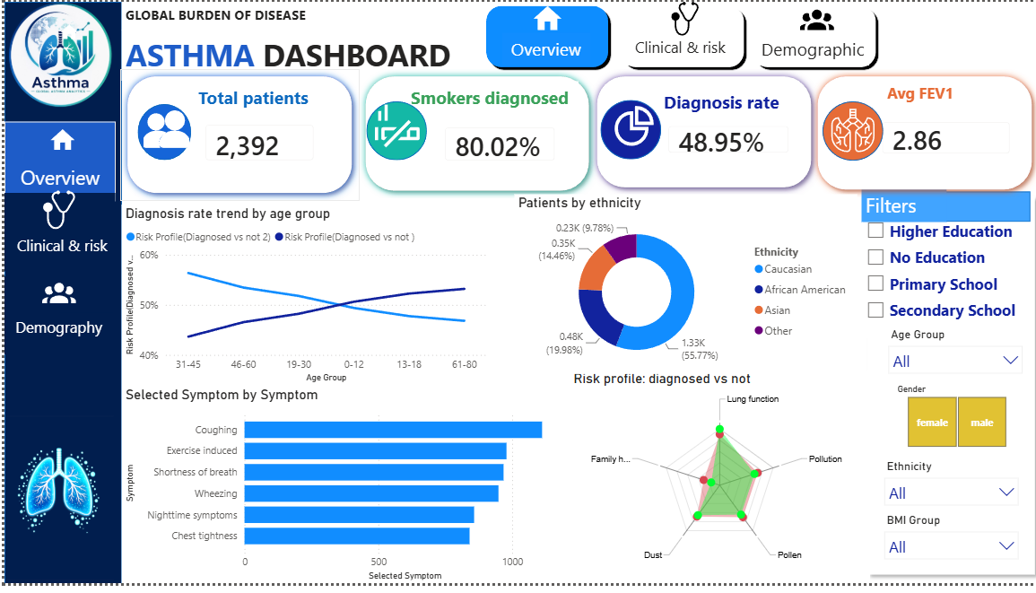

Page 2: Clinical & Risk
Environmental exposure radar: Compares diagnosed vs. non-diagnosed exposure to pollution, dust, and pollen — diagnosed patients show a visibly larger exposure footprint.
Avg lung function (grouped bar): Compares FVC and FEV1 averages between diagnosed and non-diagnosed groups — diagnosed patients show slightly lower values, consistent with reduced lung function in asthma.
Diagnosis rate by allergy-related condition (horizontal bar): Ranks comorbidities (History of allergies, Pet allergy, Eczema, Hay fever, GERD reflux) by association strength with diagnosis — history of allergies and pet allergy are the strongest.
Function: This page is the clinical-risk deep dive, connecting biometric lung function data with allergy/environmental risk factors to explain why patients get diagnosed, complementing the who (Demographic) and what (Overview) pages.

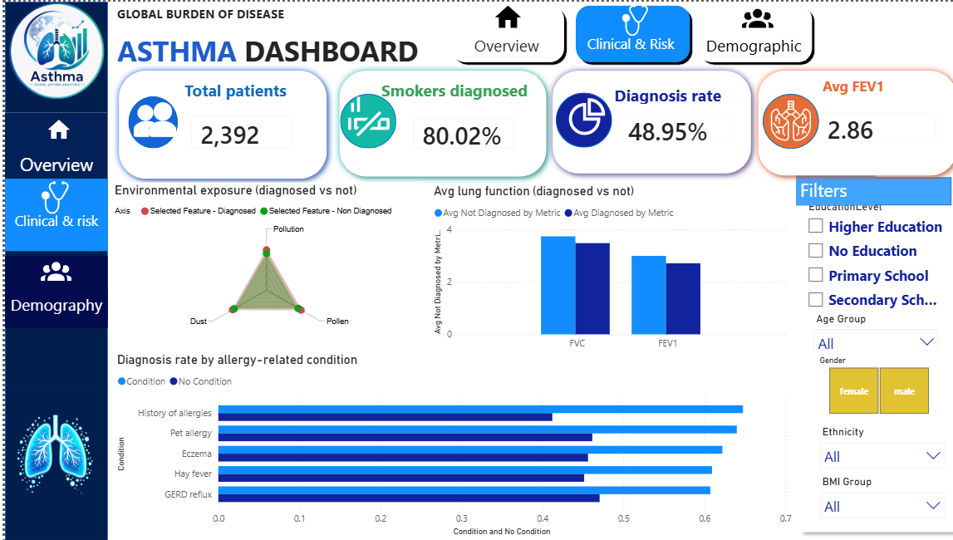
Page 3: Demography
Count by Gender (pie): Near-even split (51.67% female / 48.33% male) — confirms no major gender skew in the sample.
Patients by Ethnicity (bar): Same ranking as Image 1 but in bar form — Caucasian far outweighs African, Asian, and Other combined.
Diagnosis rate by BMI category (line): Two BMI-based trend lines intersect around "Obese/Overweight," suggesting BMI category interacts with diagnosis likelihood.
Education Level Distribution (pie): Fairly balanced across Higher Education, Primary, No Education, and Secondary School (~23-25% each) — rules out education as a major confounder.
Function: This page isolates demographic/socioeconomic segmentation to check whether diagnosis patterns vary meaningfully by population subgroup, using the same filter panel as Overview.

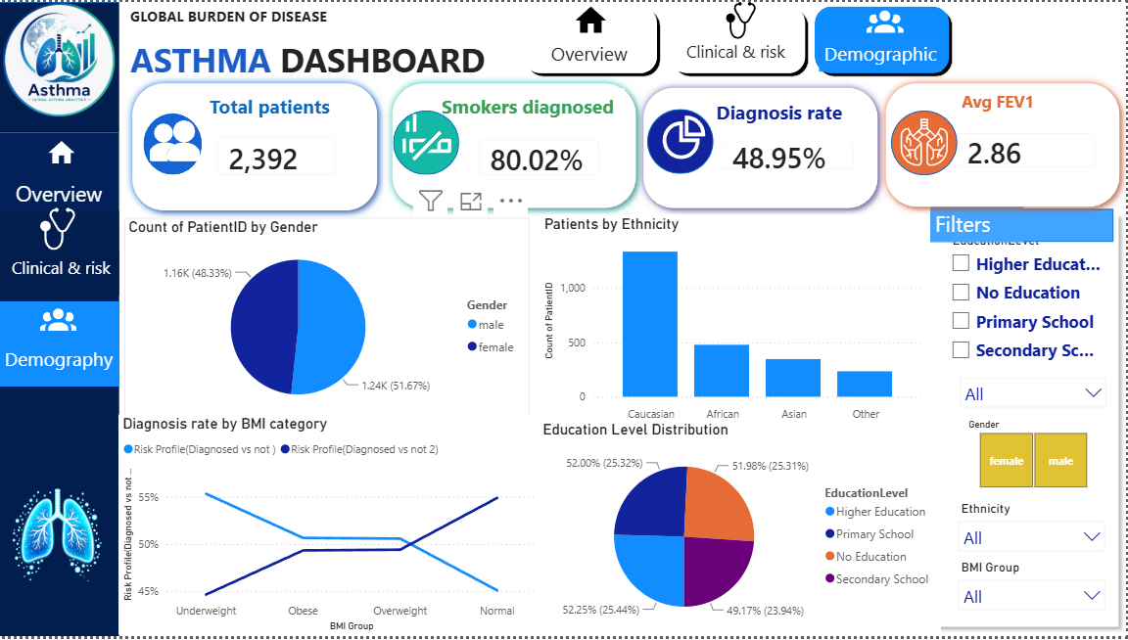

9.5 GBD Dashboard (Power BI)
KPI Cards: Total Death (59K — All Ages, Both Sexes), Average Prevalence (6.20% — Age-Standardized), Total DALYs (59K — All Ages, Both Sex), New Cases (62.424K — All Age, Both Sex)
Filters: Year (range slider, 1990–2023), Measure Name (dropdown), Age Name (dropdown), Sex Name (Female/Male toggle), Metric Name (dropdown), Location Name (dropdown)

Page 1 : Overview
Death Trend (line chart): Female vs. Male death averages across age groups, both dropping sharply from "All ages" then leveling off toward "Age-standardized."
Prevalence % by Country (map): Choropleth map shading countries by asthma prevalence rate, giving an instant global hotspot view.
Top 10 Countries by Prevalence % (bar): Ranks the highest-prevalence countries (New Zealand, Australia, Costa Rica, Puerto Rico, UK, etc.).
Male vs Female by Measure (bar): Compares Prevalence, Incidence, DALYs, YLDs, and Deaths side-by-side by sex — Prevalence dominates in scale over the other measures.
DALYs by Age Group (donut): Splits disability-adjusted life years fairly evenly across age bands (0-14, 15-49, 50-69, 70+, All ages, Age-standardized).
Function: This is the landing/summary page — it pulls one representative visual from each of the other three tabs (Trends, Geography, Demography) into a single consolidated snapshot.

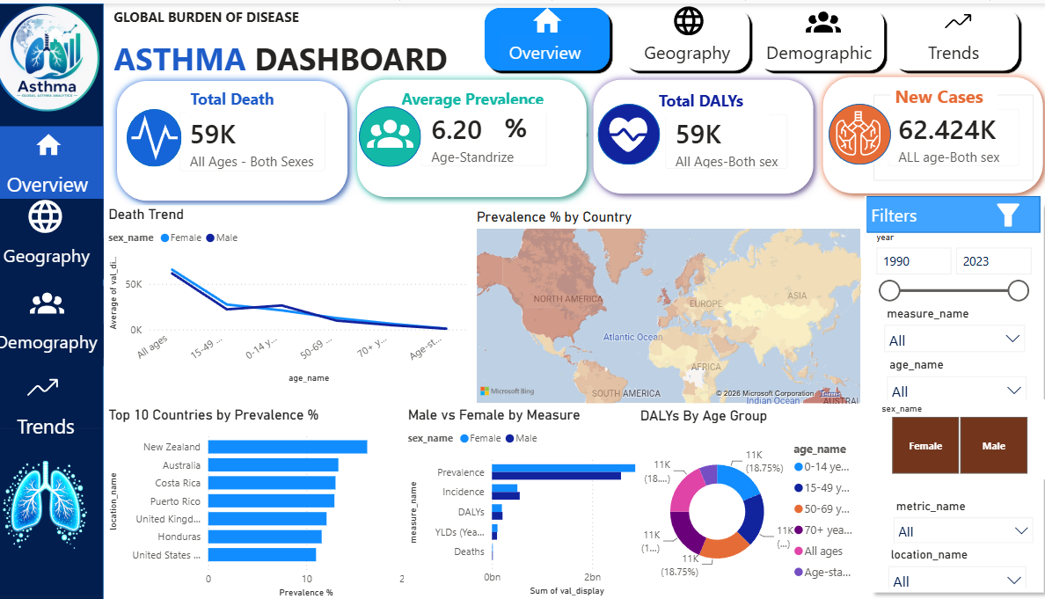

Page 2 : Geography
Top 10 Countries by Prevalence % (horizontal bar): Ranked list from New Zealand (highest) down through Saint Lucia, isolating which countries carry the greatest asthma burden.
Prevalence % by Country (world map): Color-coded global map for spatial pattern-spotting — useful for identifying regional clusters (e.g., high burden in North America/Oceania vs. lower in parts of Asia/Africa).
Function: Focused entirely on spatial analysis — where in the world asthma burden is concentrated, filterable by year, age, sex, measure, and metric.

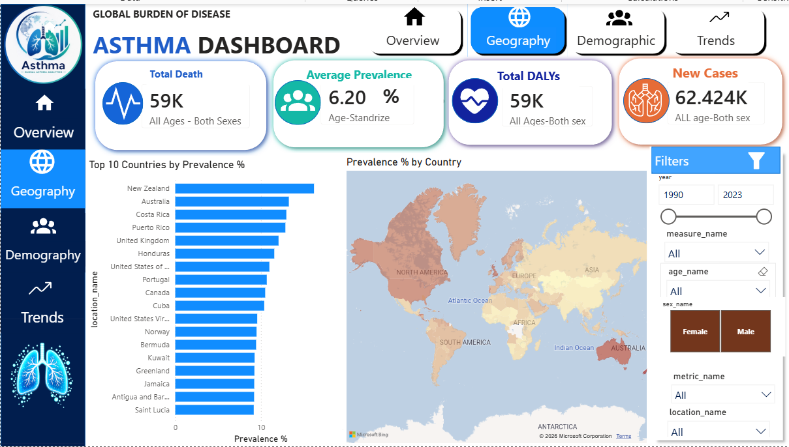

Page 3 : Demography
DALYs by Age Group (donut): Even distribution (~18.75% each) across 0-14, 15-49, 50-69, 70+, All ages, and Age-standardized — shows DALYs aren't concentrated in one age bracket.
Male vs Female by Measure (bar): Prevalence is by far the largest measure (~2bn), followed by Incidence, DALYs, YLDs, and Deaths — comparing male vs. female bars per measure.
Function: Breaks down disease burden by demographic dimensions (age and sex) rather than geography, letting users see which age/sex combinations drive the biggest share of each burden measure.

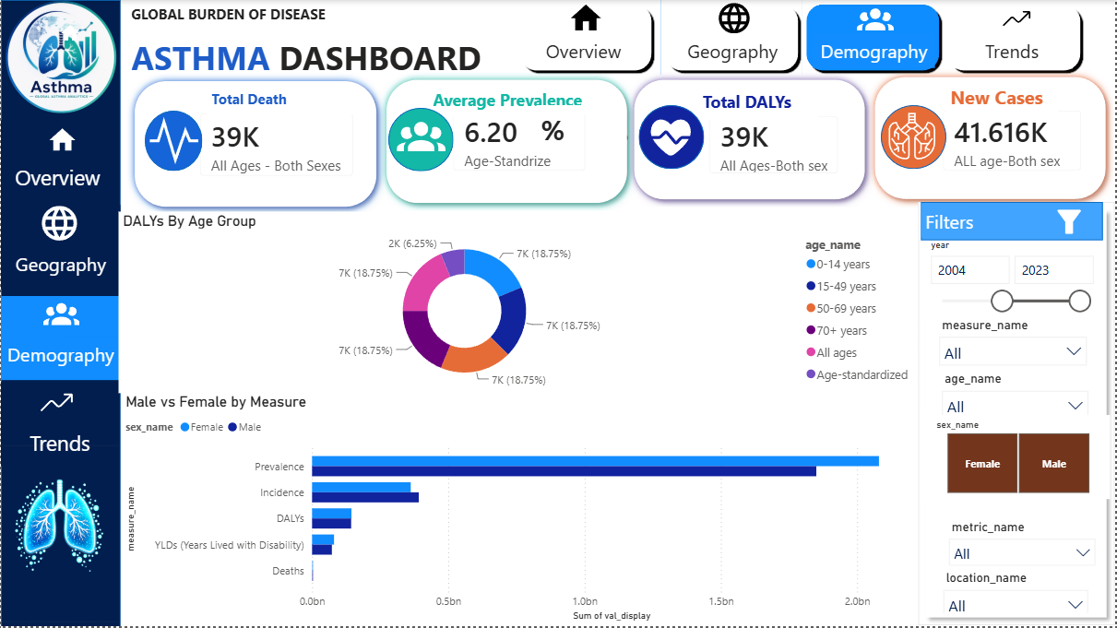

Page 4 : Trends
Death Trend (line chart): Tracks average death values across age groups (All ages, 15-49, 0-14, 50-69, 70+, Age-standardized) for Female vs. Male — sharp decline from "All ages," slight rebound mid-chart, then steady decline toward "Age-standardized."
Function: The time/age-based trend view — combined with the year slider (1990–2023), it lets users see how burden measures evolve over the study period rather than just a static snapshot.

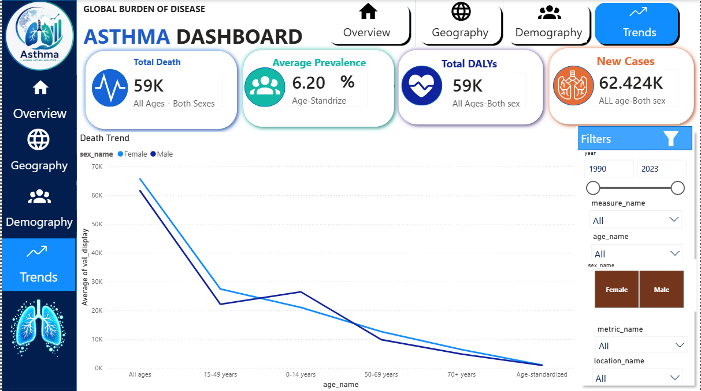

10. AI Chatbot — AsthmAI
A Gemini 2.5 Flash-powered assistant answers questions such as “Which country has the highest asthma prevalence?”, “Compare asthma burden between Egypt and Saudi Arabia”, and “Why was this patient classified as high risk?” — the last two map directly onto the gbd.sp_country_compare and patient.sp_patient_risk_profile stored procedures documented in Section 5.3.

11. Key Insights & Recommendations
- Identify and prioritize countries and age groups carrying the highest GBD burden for targeted awareness campaigns.
- Use the patient risk model's top features (symptom count, family history, lung-function ratio, environmental exposure) to guide early-screening criteria.
- Strengthen healthcare access in regions flagged as high-risk by gbd.vw_burden's risk_category bucket.
- Use patient.vw_local_vs_global_prevalence to sanity-check how representative a local patient sample is relative to national GBD estimates, once location data starts being collected.

12. Known Limitations & Data Notes
- The patient dataset's 49% diagnosis rate differs materially from the ~5.2% rate in the original Kaggle reference — treat this working dataset as a more class-balanced variant, not a direct stand-in for population prevalence.
- The patient dataset does not currently include a country/location field; the location_id foreign key exists in the schema for future data collection but is NULL for all current records.
- GBD figures are independent published estimates and are never recalculated or overwritten by patient data — the two datasets are joined for comparison only.

13. Future Work
- Deep-learning prediction models and explainable-AI methods (SHAP/LIME) for individual risk explanations.
- Real-time healthcare monitoring integration.
- Collect patient location data to populate location_id and activate the local-vs-global prevalence comparison.
- Mobile application and public-facing web dashboard.

14. Appendix — Technology Stack
- Language: Python 3.10+
- Data Analysis: Pandas, NumPy
- Visualization: Matplotlib, Seaborn, Plotly
- Machine Learning: Scikit-Learn, XGBoost
- BI Tools: Power BI, Tableau, Excel
- Database: Microsoft SQL Server
- AI: Google Gemini 2.5 Flash API, FastApi
- Dev Tools: Jupyter Notebook, VS Code, Git, GitHub

