APPENDIX C
AI Detection Engine (Out-of-Band ML Pipeline)
XGBoost and Isolation Forest over CICFlowMeter telemetry, with Wazuh Active Response

1. Role and out-of-band principle
The AI Detection Engine (serve_ai_engine.py) is an analysis plane that runs beside the data path on the wazuhelk monitoring node. It reads network-flow features that CICFlowMeter extracts passively from packet captures, scores them with machine-learning models, and writes a verdict to a file that Wazuh Active Response acts on.
The core design rule is simple: the engine is not on the packet path and does not drop packets itself. It only reads features, scores them, and hands the verdict to Wazuh Active Response (the gwsec-drop script), which does the actual blocking. Because of this, the machine-learning work adds no latency to the web-serving path and cannot become a bottleneck or a single point of failure on the data plane.
Four model artifacts are trained offline on the team's training node and then copied to the serving node: xgboost_model.json, iforest_model.pkl, scaler.pkl, and feature_list.json. Keeping training separate from serving keeps the monitoring node light and stable.

2. Feature pipeline and train-serve consistency
The models use 78 flow features defined in feature_list.json, which is the single source of truth for column names and order. The hardest engineering problem here is train-serve consistency: the feature-extraction tool used at serving time must match the one used at training time, or the features drift apart and the verdicts become meaningless.
The CICIDS2017 training set was generated with CICFlowMeter V3, but the online extractor is V4. V4 renames 13 columns compared to V3 (singular versus plural, reordered words, a relabeled CWR/CWE flag) even though the computed values are identical. The engine handles this with two deterministic steps:
# Step 1: deterministic rename V4 -> V3 (13 columns)
RENAME_V4_TO_2017 = {
"Dst Port": "Destination Port",
"Total Fwd Packet": "Total Fwd Packets",
"CWR Flag Count": "CWE Flag Count",
"FWD Init Win Bytes": "Init_Win_bytes_forward",
... # 13 columns total
}

# Step 2: norm() collapses column names to a comparable key
def norm(col): # 'Tot Fwd Pkts' and 'Total Fwd Packets' -> same key
c = col.strip().lower().replace('/',' ')...
return ''.join(ABBREV.get(w,w) for w in c.split())

After the rename and normalization, the engine matches all but one of the 78 features from the live CSV; the only gap is Fwd Header Length.1, a duplicate column that CICFlowMeter emits once, so it is filled with zero with no real effect. Any feature the online tool does not provide is filled with zero and logged; a large number of missing features would mean the wrong tool version, and the verdict would not be trustworthy. This keeps the model input in the exact names and order seen during training.

3. Two-model ensemble
The engine combines two models with complementary jobs:
- XGBoost is the main supervised classifier. It outputs an attack probability and is the model that decides whether to block.
- Isolation Forest is the secondary unsupervised model. It catches zero-day anomalies the supervised model has not seen. It only contributes to the alert score and never triggers a block on its own.
The Isolation Forest anomaly score is mapped to [0,1] with a sigmoid based on the model's offset, rather than a per-batch min-max, so no information leaks between serving batches:
raw = iforest.score_samples(Xs) # high = normal, low = anomalous
anomaly = if_offset - raw # >0 = anomalous
p_if = 1 / (1 + exp(-if_scale * anomaly)) # sigmoid -> [0,1]

Known limitation: the sigmoid scale (if_scale) is fixed at 20, which is enough to separate anomalies but is not calibrated to the score distribution on the benign training set. This is one reason Isolation Forest is limited to the alert role, and calibrating it (by saving the training score min-max to a separate file) is future work.

3.1 Training results (measured on the CICIDS2017 test set)
The models were evaluated on a test set of 565,576 samples. The table below reports each model and the ensemble:
Model | Accuracy | Precision | Recall | F1 | ROC-AUC
XGBoost (primary) | 0.9989 | 0.9967 | 0.9977 | 0.9972 | 0.9999
Isolation Forest (secondary) | 0.8235 | 0.6005 | 0.3076 | 0.4068 | —
Ensemble | 0.9986 | 0.9975 | 0.9951 | 0.9963 | 0.9998

The Isolation Forest numbers are the quantitative reason for the alert-only policy. With recall 0.3076 it catches about 31% of attack samples, and with precision 0.6005 about 40% of its alerts are false positives. Letting it block on its own would produce a high wrong-block rate. So it is limited to alerting, while XGBoost, with precision and recall above 0.99, is the only model allowed to drive an automatic block. Note that the 0.9989 XGBoost accuracy is measured on CICIDS2017 and is not the same as the end-to-end detection rate against live attacks; the two measurements should be reported separately.

3.2 Validating the fusion weights with a grid search
The 0.6 weight for XGBoost and 0.4 for Isolation Forest were set initially from the relative reliability of the two models: XGBoost has precision and recall above 0.99 and takes the higher weight, while Isolation Forest has precision 0.60 and recall 0.31 and takes the lower one. To check that choice, the team ran a grid search over weight pairs and measured precision, recall, and F1 of the alert tier on the CICIDS2017 test set. The results are shown below.
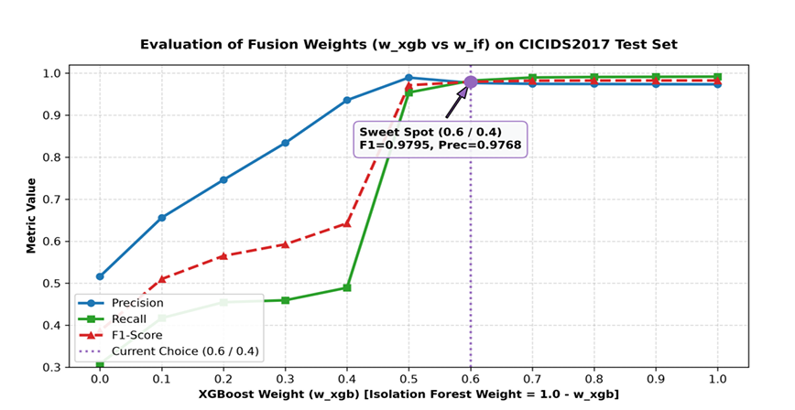
Figure 3.1: Alert-tier F1 across fusion weight pairs
Table 3.1: Grid-search results over the CICIDS2017 test set (565,576 samples)
w_xgb | w_if | Precision | Recall | F1
1.00 | 0.00 | 0.9736 | 0.9918 | 0.9826
0.70 | 0.30 | 0.9746 | 0.9898 | 0.9821
0.60 | 0.40 | 0.9768 | 0.9822 | 0.9795
0.50 | 0.50 | 0.9895 | 0.9540 | 0.9714
0.40 | 0.60 | 0.9358 | 0.4894 | 0.6427
0.00 | 1.00 | 0.5162 | 0.3085 | 0.3862

The highlighted row is the deployed pair (0.6/0.4). Here w_xgb is the XGBoost weight and w_if the Isolation Forest weight, with w_xgb + w_if = 1.
F1 peaks in the XGBoost-heavy region (1.0/0.0 down to 0.7/0.3) at about 0.982, and the differences there are small. The team chose 0.6/0.4 rather than pure XGBoost because it gives higher precision (0.9768 versus 0.9736): adding Isolation Forest at weight 0.4 reduces false alerts in the alert tier, at a negligible cost in recall (0.9822 versus 0.9918). Since this tier is a human-reviewed alert, favouring precision is the right trade-off. The grid search also confirms that Isolation Forest must not dominate: once w_if passes 0.5, F1 collapses below 0.65 because of the low recall of Isolation Forest. So 0.6/0.4 keeps XGBoost as the primary model while still using the anomaly signal from Isolation Forest. The fusion weights affect only this human-reviewed alert tier and play no part in the automatic block decision, which depends solely on XGBoost's 0.90 threshold.

4. Tiered decision policy
This is the part that needs the most care. The system does not use one fused score to both block and alert. There are two parallel mechanisms with separate jobs:
Tier | Trigger | Action
malicious (block) | p_xgb ≥ 0.90 (XGBoost only) | Auto-block via Active Response (rule 100400)
suspicious (alert) | fused ≥ 0.50, fused = 0.6·p_xgb + 0.4·p_if | Alert only, sent to HITL (rule 100401), no block
benign | otherwise | Not logged, no alert

block = (p_xgb >= 0.90) # XGBoost gate decides the block
if block: verdict = 'malicious'
elif fused >= 0.50: verdict = 'suspicious' # fused only ranks alerts
else: verdict = 'benign'

On the 0.6/0.4 weights (the committee's question): these weights apply only to the suspicious alert tier, where they rank how suspicious a flow is when both models give a weak signal. They take no part in the block decision. Blocking rests entirely on XGBoost's high-confidence threshold of 0.90. So the fused score never drives the highest-risk automatic action; it only sorts alerts for a human to review. This is a deliberate, conservative choice: only the supervised model, at a high threshold, is allowed to trigger an automatic block.

5. Real-time flow monitoring (incremental read)
The engine runs in watch mode, polling the CSV that CICFlowMeter writes continuously. An earlier version loaded the whole file each cycle, so the cost grew with file size. The current version reads incrementally by byte offset: each cycle reads and parses only the data written since the last read, and it handles the case where the file is rotated.
def run_watch(engine, path, poll=2.0):
header = None; offset = 0
while True:
with open(path) as f:
if header is None:
header = f.readline(); offset = f.tell()
f.seek(0, os.SEEK_END)
if f.tell() < offset: # rotated -> reset
offset = len(header.encode())
f.seek(offset) # jump to last cursor
new_lines = f.readlines() # read only new lines
offset = f.tell()
if new_lines and header:
df = pd.read_csv(StringIO(header + ''.join(new_lines)))
engine.emit(engine.score(df))
time.sleep(poll)

Measured effect: the process CPU load dropped from about 85% of one core to about 9% of one core, close to a tenfold reduction, and it no longer re-scores flows it has already handled. Scoring and verdict writing were verified to still work correctly after the change.

6. Active Response and XAI integration
Only non-benign verdicts are written to /var/log/ai-engine/verdict.json, in compact JSON so they match the gwsec-drop regex. Wazuh reads this file through localfile, raises alerts by rule, and for the malicious tier triggers Active Response to block the source IP. The src_ip field in the verdict is metadata used for blocking, not a feature fed to the model.
For alerts, an XAI node (Qwen2.5:3b via Ollama, with RAG over a MITRE knowledge base) writes Vietnamese-language explanations to help the analyst, with a time-window deduplication so it does not repeat explanations for the same source.

7. Boundary with the WAF/IPS
It helps to be clear about how the AI Engine differs from the WAF/IPS layer, so no one assumes every layer does the same thing:
- The AI Detection Engine works on network-flow features (packet statistics, flow duration, byte rates). It fits attacks that show up at the network layer: denial of service, port scans, automated probing, and botnet behavior, which are the attack classes in CICIDS2017.
- The WAF (ModSecurity) works on application-layer payload content. It catches semantic attacks like SQL injection, XSS, and path traversal through libinjection and the CRS ruleset.
Because the AI Engine works on flow features and does not read HTTP payload content, it is not the primary detector for SQL injection or XSS; the WAF handles those payload attacks. The two planes complement each other at different layers of the defense-in-depth model and do not overlap.

8. Limitations and future work
- The Isolation Forest calibration uses a fixed scale and does not yet match the training score distribution; calibrating it from the benign training set is the next step.
- The XGBoost offline accuracy on CICIDS2017 is not the same as the end-to-end detection rate against live attacks, and the two should be reported separately.
- Defending the feature pipeline against data poisoning and adversarial input is a further research direction and needs a retraining process with validation.

