CSE261 | Algorithms and Data Structure | Dr. Ahmed Ayoub

Department of Computer Systems Engineering, MSA University

September 2025

Project Title: Binary Guessing Game.
Team Members:-
• Mohamed Hany Saleh
ID: 247795 email:Mohamed.hany31@msa.edu.eg
• Amr Ahmed Elnouby Mansour
ID: 248801
email: amr.ahmed33@msa.edu.eg
• Mahmoud Mohamed Mahmoud Mohamed ID: 246235
email: mahmoud.mohamed111@msa.edu.eg

Abstract
This project implements a Binary Guessing Game where the computer attempts to guess a number chosen by the user using the binary search algorithm. The program efficiently narrows down the possible range based on user feedback (Higher, Lower, Correct) until the correct number is found.

1. Introduction
The Binary Guessing Game demonstrates binary search as an efficient algorithm for decision-making. The computer guesses a number between predefined limits (1–1000) and adjusts its range based on feedback from the user. This project showcases algorithmic thinking, search optimization, and object-oriented programming in C++.

2. Literature Review
Binary search is a classic algorithm used to efficiently locate an item in a sorted range by repeatedly dividing the search interval in half. This method reduces time complexity from O(n) to O(log n), making it highly effective in guessing games and interactive systems.

3. Methodology
The game uses a binary search approach implemented within a ComputerGuesser class. The algorithm computes the midpoint of the current range as the next guess, and adjusts the range based on user feedback (higher or lower). Input validation ensures that inconsistent user responses are handled.

4. Implementation
The implementation consists of:
- A ComputerGuesser class handling search bounds and guess logic.
- A main game loop controlling interactions and feedback.
- Tracking of guess count to ensure correctness within optimal bounds.

Below is a diagram representing the program workflow:
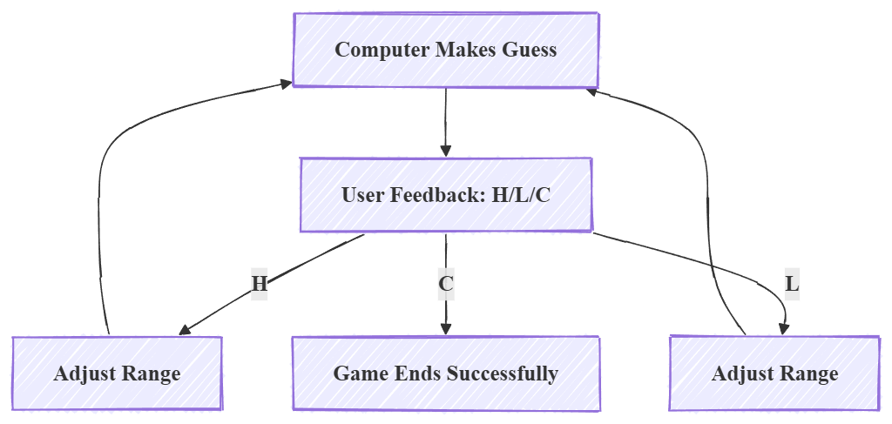

The full code implementation is provided in the appendix.

5. Analysis
Binary search guarantees finding the number in at most log2(1000) ≈ 10 steps, but the program constrains this further to 7 guesses. This emphasizes the efficiency of narrowing the search range systematically. Handling inconsistent feedback prevents logical contradictions.

6. Challenges and Solutions
Challenges included handling inconsistent user feedback and ensuring the search boundaries remain valid. These were solved by verifying range integrity and detecting situations where min > max.

7. Results and Discussion
The computer consistently guesses the correct number within an optimal number of attempts. The program demonstrates the robustness of binary search and highlights the importance of user feedback accuracy.

8. Conclusion
This project effectively applies binary search to create an efficient guessing game. It demonstrates algorithmic efficiency, strong program structure, and user-interactive problem solving.

9. References
- Cormen, T. H., Leiserson, C. E., Rivest, R. L., & Stein, C. (2009). *Introduction to Algorithms*.
- Knuth, D. E. (1998). *The Art of Computer Programming, Volume 3: Sorting and Searching*.

10. Appendix

Includes & Namespace
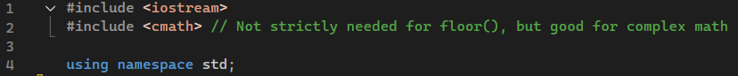
These lines import essential libraries and allow using standard functions without prefixing 'std::'.

Computer Guesser Class Definition
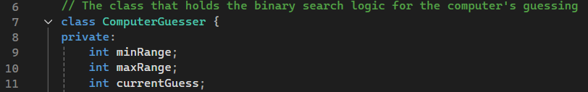
minRange : Stores the lowest possible value the secret number could be. Initially 1, it is updated when the user says the guess is too Low ('L').
maxRange : Stores the highest possible value the secret number could be. Initially 1000, it is updated when the user says the guess is too High ('H').
currentGuess : Stores the last number the computer guessed.

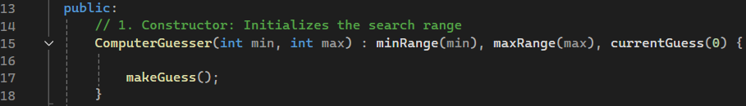
This is the constructor. It is called when a ComputerGuesser object is created (in main). It initializes minRange and maxRange with the starting limits (e.g., 1 and 1000) and immediately calls makeGuess() to generate the very first guess (which is the midpoint of the initial range).

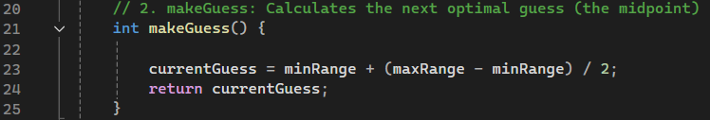
This is the heart of the binary search. It calculates the new guess by finding the midpoint of the current valid range (minRange to maxRange). It stores this value in currentGuess and returns it. Using (maxRange - minRange) / 2 prevents potential integer overflow compared to (minRange + maxRange) / 2.

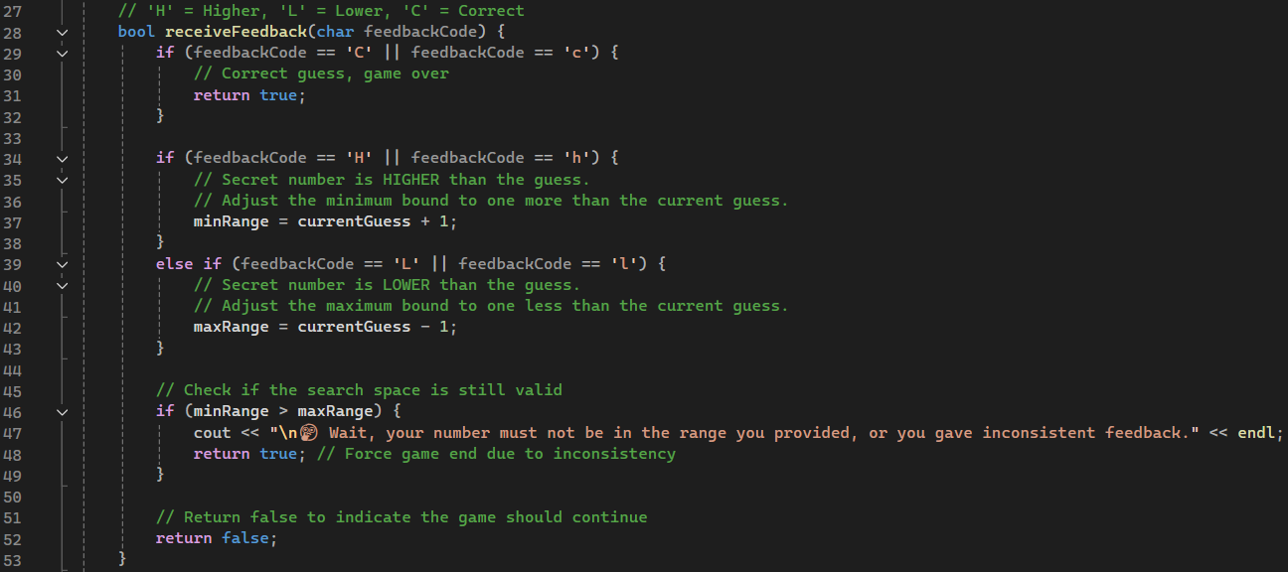
This method processes the user's feedback ('H', 'L', or 'C') and updates the search range accordingly. It returns true if the game should stop (either 'C' or inconsistent feedback), and false otherwise.

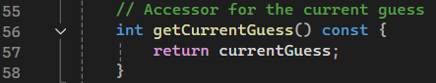
Accessor (getter) method to safely retrieve the last guess. The const keyword ensures the method does not modify the object's state.

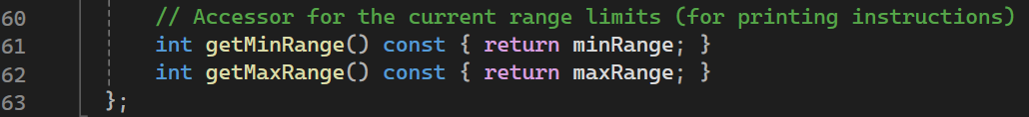
getMinRange() : Accessor (getter) method to safely retrieve the current minimum range.
getMaxRange() : Accessor (getter) method to safely retrieve the current maximum range.

Main Function
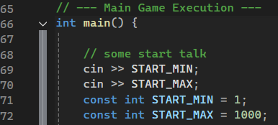
Defines the initial range for the secret number as constants.

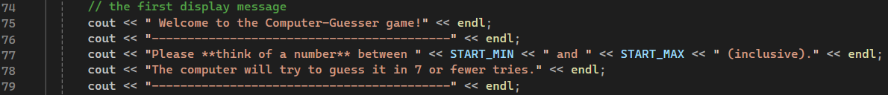
Displays a welcome message and prompts the user to pick a number.

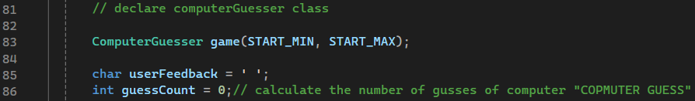
Creates an instance of the ComputerGuesser class, starting the game with the range 1 to 1000. The first guess is generated immediately in the constructor.

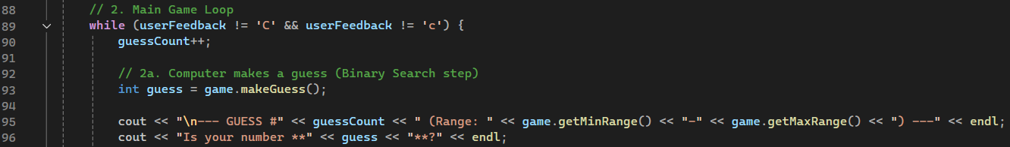
Increments the counter and calls game.makeGuess() to calculate the next guess based on the current range.

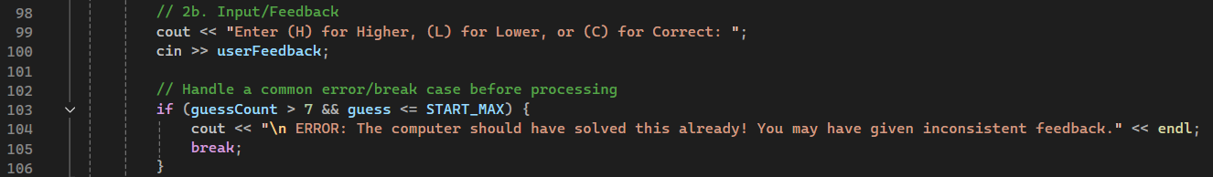
Efficiency Check: Since 2^10 = 1024, and the maximum range is 1000, the binary search is guaranteed to find the number in a maximum of 10 guesses (log_2(1000) = 10). The project code uses a lower limit of 7 guesses. If the limit is exceeded, it suggests inconsistent feedback and stops the game. Note: This is a soft check, and a range of 1000 theoretically needs 10 guesses.

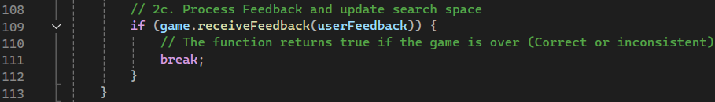
Calls the receiveFeedback method to process the input and potentially update the range. If the method returns true (meaning 'C' or inconsistent range was detected inside the class), the loop breaks.

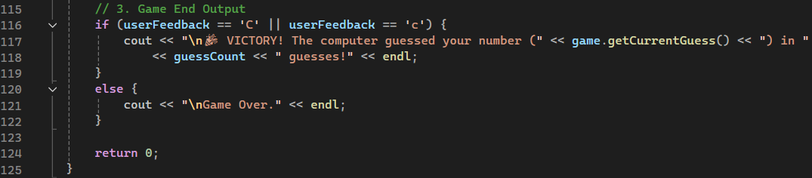
This Success Condition checks if the loop terminated because the user confirmed the computer's guess was 'C' (Correct). If true, it prints a success message and tells the user how many attempts (guessCount) the computer needed to find the number.
Sample Output:
