12/9/2020

Cohort 4.2

TECHCAREERS 2020

Installation Instructions

AZLearn Capstone Project

Contents

**No table of contents entries found.**

# **Prerequisites:**

* This application requires [Visual Studio 2019](https://visualstudio.microsoft.com/downloads/) (VS 2019) and [ASP.NET Core 3.1](https://docs.microsoft.com/en-us/aspnet/core/introduction-to-aspnet-core?view=aspnetcore-3.1)
* This application uses [ReactJS.NET](https://docs.microsoft.com/en-us/aspnet/core/client-side/spa/react?view=aspnetcore-3.1&tabs=visual-studio) on ASP.NET Core and requires a few packages installation through [NuGet](https://docs.microsoft.com/en-us/nuget/what-is-nuget)
* [Entity Framework (EF) Core](https://docs.microsoft.com/en-us/ef/core/) is used in this application to perform data access against the [MySQL](https://dev.mysql.com/doc/refman/5.7/en/) database ([MariaDB](https://mariadb.org/)) and server ([Apache](https://httpd.apache.org/))
* This application requires the use of [Code First Migrations](https://docs.microsoft.com/en-us/ef/core/managing-schemas/migrations/?tabs=dotnet-core-cli) using EF in .NET Core to set up databases with dummy data
* This application requires a fundamental knowledge of [SQL](https://dev.mysql.com/doc/refman/5.7/en/) Syntax
* Developers tools such as [XAMPP](https://www.apachefriends.org/index.html) and [Postman](https://www.postman.com/) are recommended to engage, test, and use this application.
* Version Control system like [Git](https://git-scm.com/) is recommended to keep track of changes that were made during the project

# **Installation:**

To get started, select a folder where you would like to download the project, right click anywhere in the folder and open Git Bash terminal and within [Git](https://git-scm.com/) run the following commands:

* $ git clone <https://github.com/TECHCareers-by-Manpower/capstone-project-a-to-z.git>
* Go to the project folder capstone-project-a-to-z and select AZLearn.sln file in Visual Studio
* $ cd capstone-project-a-to-z
* $ code . (When using Visual Studio Code)
* It is not necessary to install packages and libraries after cloning the project, however depending on computer and software, at times packages need to be installed manually.
* Installations of Entity Framework Core can be done either through [NuGet Package Manager for Solution...](https://docs.microsoft.com/en-us/nuget/consume-packages/install-use-packages-visual-studio) or through Visual Studio 2019 [NuGet Package Manager Console](https://docs.microsoft.com/en-us/ef/core/get-started/install/) (Package Manager)
* Following commands can be used to restore the packages through NuGet Package Manager Console (Note: Ensure your current working directory is same as Program.cs )

PM>cd capstone-project-a-to-z

PM> dotnet restore

* If you have encountered issues running the application, you may proceed with the instructions below:
* In Package Manager console run following commands:

PM> dotnet add package Microsoft.EntityFrameworkCore.Design

PM> dotnet add package Microsoft.EntityFrameworkCore.SqlServer

PM> dotnet add package Pomelo.EntityFrameworkCore.MySql

PM> dotnet add package Microsoft.AspNetCore.SpaServices

PM> dotnet add package Microsoft.AspNetCore.Mvc.NewtonsoftJson

Installations of packages relating to ReactJS.NET libraries can be done through the Package Manager by running these [commands](https://docs.microsoft.com/en-us/aspnet/core/client-side/spa/react?view=aspnetcore-3.1&tabs=visual-studio):

* PM> cd ClientApp
* PM> npm install
* PM>  npm install react-bootstrap
* PM> npm install --save axios

(Check anything for redux)

To establish a database connection (within MariaDB) use XAMPP:

* In XAMPP, Click on MYSQL and Apache Start buttons to start the server.

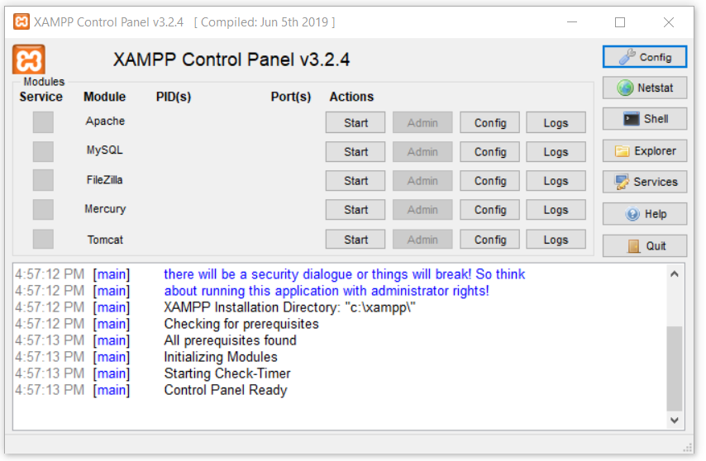

Figure 1 XAMPP Control Panel

* Click on Admin in MySQL as shown below to redirect you to phpMyAdmin

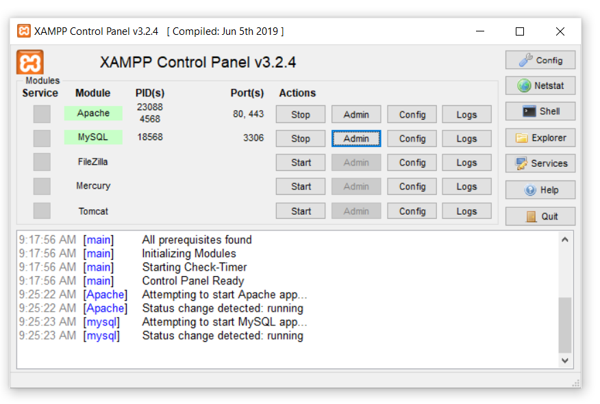

Figure 2 Setup of Server

To test the database with pre-populated test data requires the execution of Code First Migrations. Run these commands in Package Manager Console to initiate migration within the Program.cs file directory

PM> dotnet ef migrations add firstMigration --context AZLearn.Data.AppDbContext -o Data/Migrations

PM> dotnet ef database update

Once the Build is Succeed Go to phpMyAdmin and you should see a Database called as azlearndb database structure created as shown below:

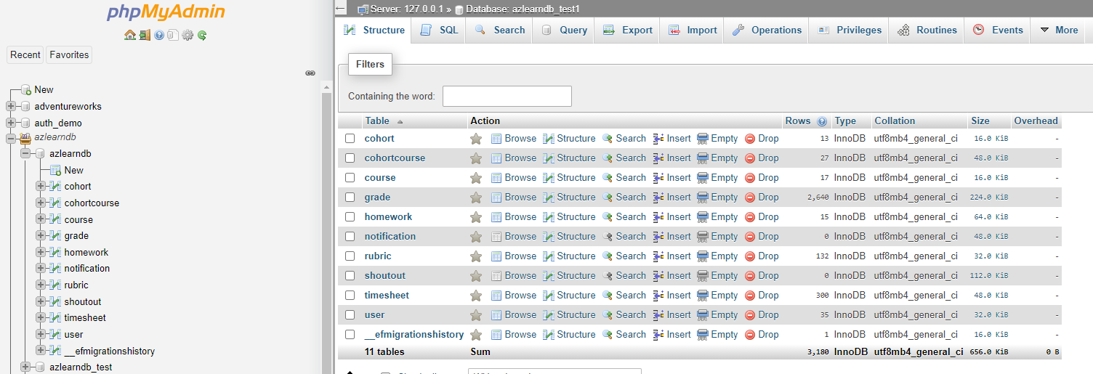

Figure 3 Database Structure

Select the database azlearndb and select Import tab on the taskbar as highlighted below:

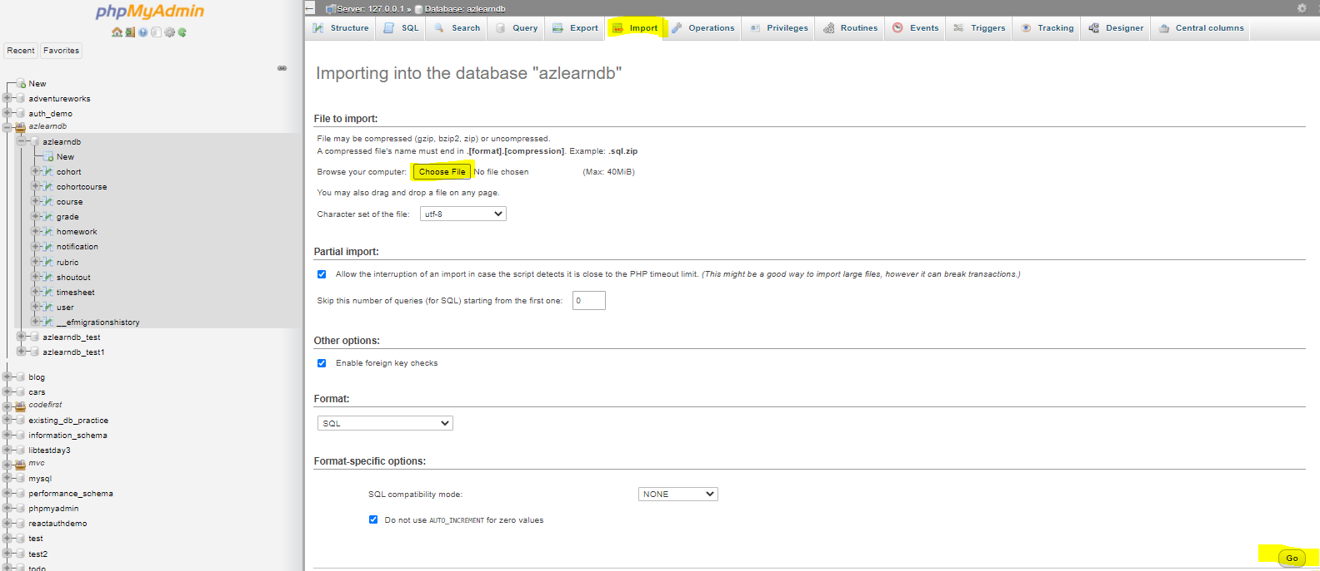

Figure 4 Import Seed Data

Select choose file and navigate to: capstone-project-a-to-z\Data\SeedData and select azlearndb.sql to seed the test data and press Go

You should receive a message showing: Import has been successfully finished, 20 queries executed. (azlearndb.sql)

Following tables should be populated with the seed data:

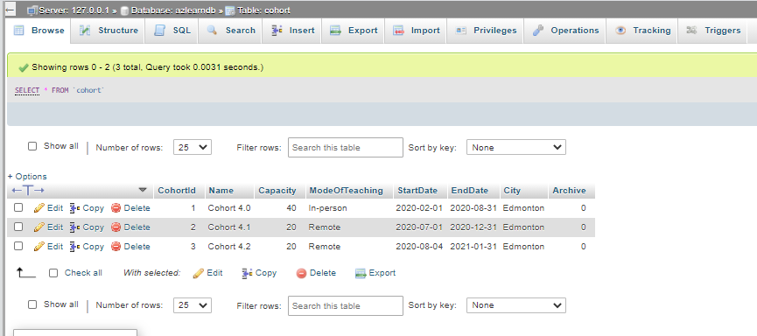

Figure 5 Cohort Table

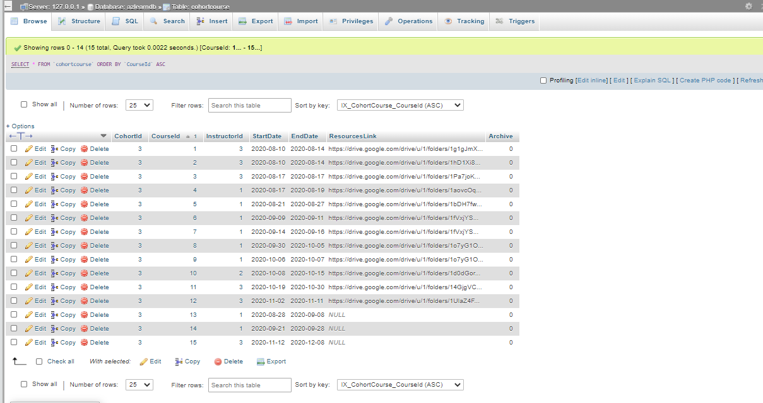

Figure 6 Cohort and Course Meta Table

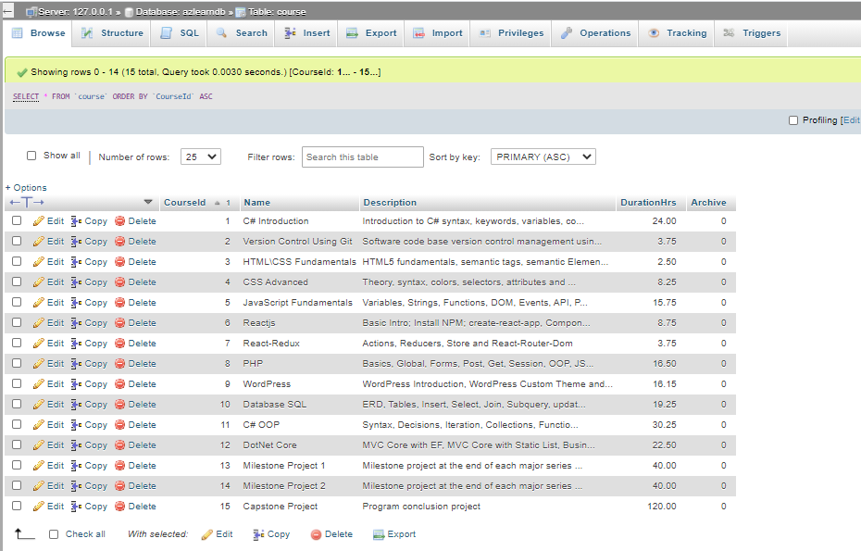

Figure 7 Course Table

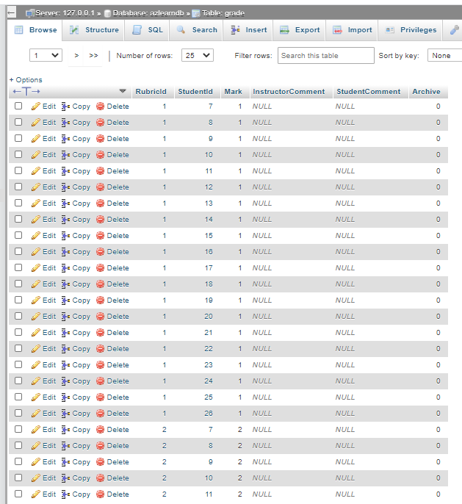

Figure 8 Grade Table

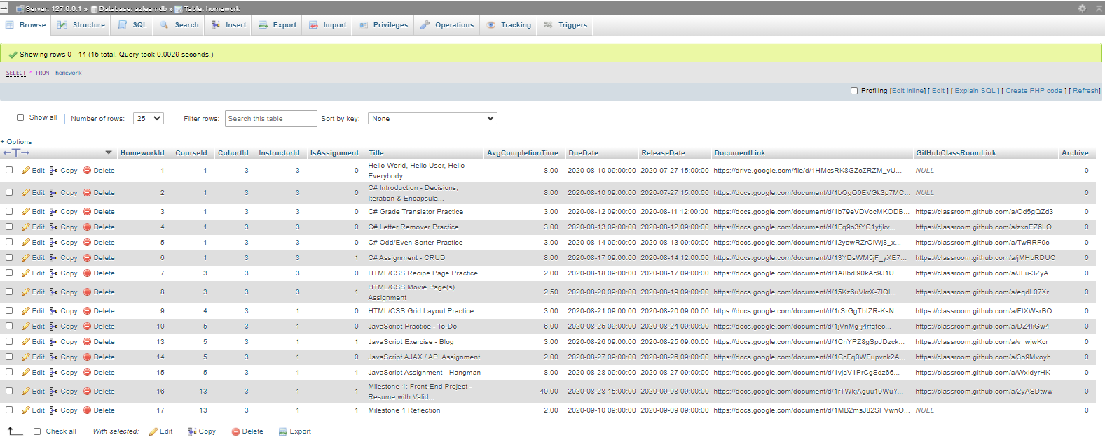

Figure 9 Homework Table

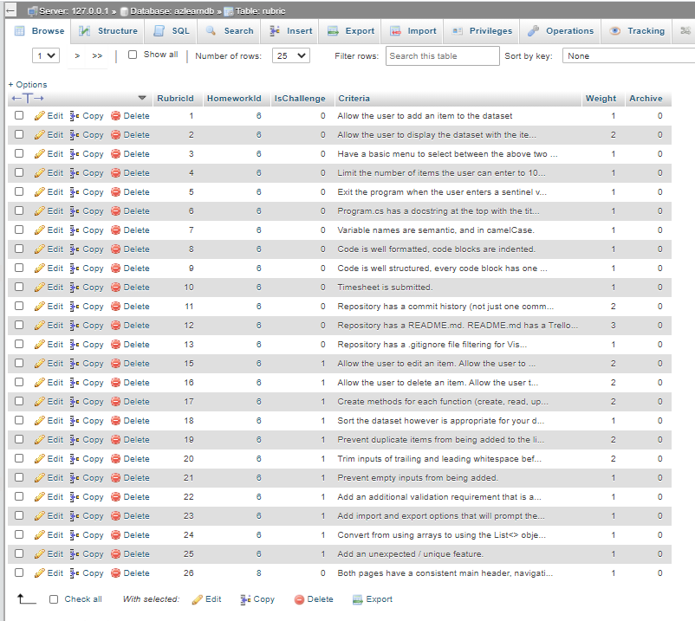

Figure 10 Rubric Table

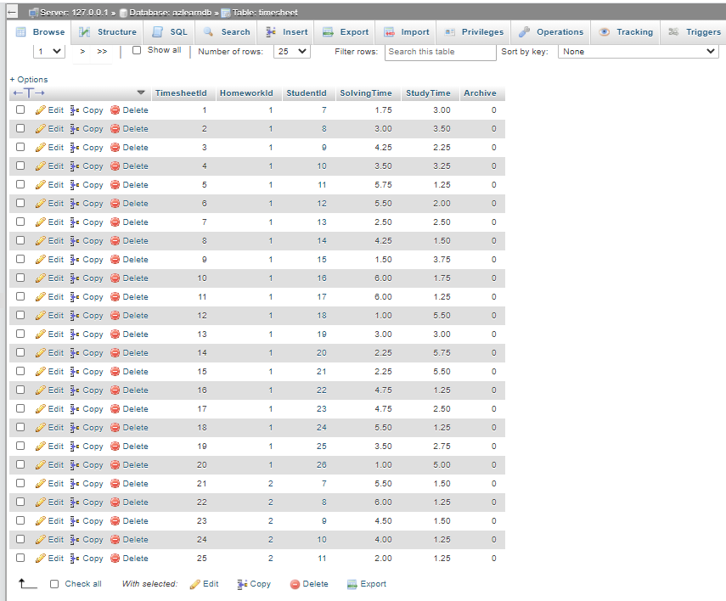

Figure 11 Timesheet Table

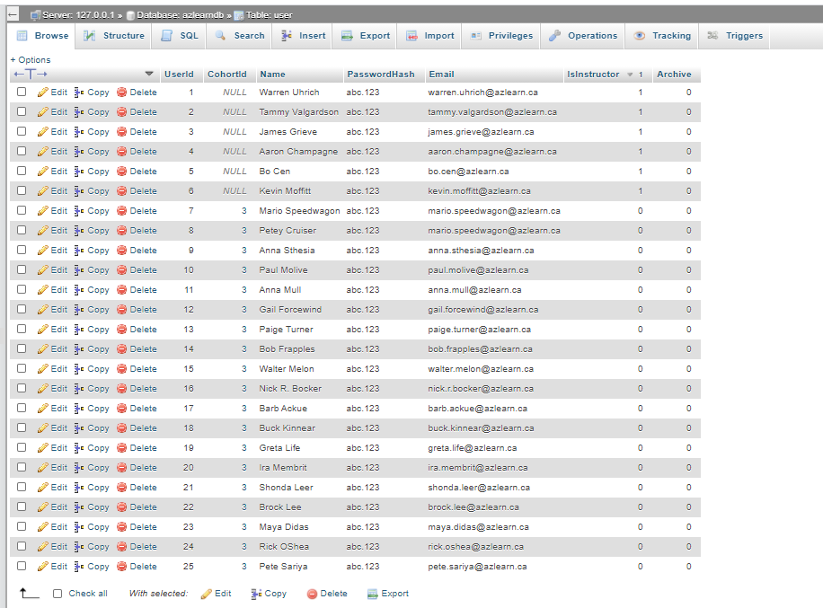

If there are any errors that occur during the migrations, kindly refer to the [EF Core tools reference](https://docs.microsoft.com/en-us/ef/core/miscellaneous/cli/dotnet) to troubleshoot. The server should be populated with the database named **azlearndb** as shown below: