## **Introduction**

This document will guide the user to operate the usage of one stop shop for course and assignment management application within the ASP.NET Core application. Installation instructions and guides are provided within README.md repository on GitHub.

## **Start Up**

Once the required packages and libraries has been installed as per Installation guide (found in capstone-project-a-to-z\Project_Documentation\AppInstallation_Instructions folder),debug the application within Visual Studio Community by Clicking AZLearn. It may take a couple of minutes for the application to start due to the npm installations and its dependencies.

This application has two main dashboards:

* Instructor/Admin Dashboard
* Student Dashboard

## **Instructor Dashboard**

### **Login Screen**

The figure shows the application homepage, in this page, the user can sign-in an account using instructors email address and password (Ex: Email: [bo.cen@azlearn.ca](mailto:bo.cen@azlearn.ca) Password: abc.123) as shown in Fig1.

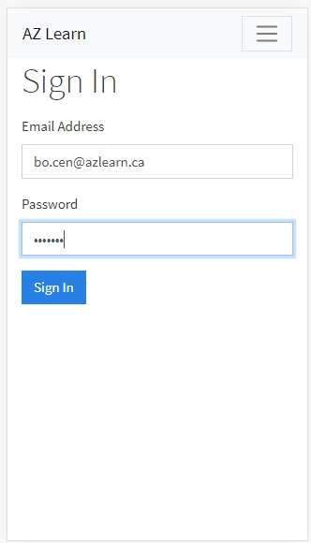

Figure Log in Screen for Instructor

Once the instructor is Logged in the instructor has several privileges that can be accessed from this main dashboard i.e., Cohort Summary Screen

* **Cohort Summary Screen (Read)**

The instructor can view here list of active cohorts with there details like capacity, location, start date and end date, mode of teaching. On this screen instructor have privileges to create ,read, update ,archive a cohort, manage courses for a particular cohort and register an instructor or student. The functionality of each action have been described in below sections.

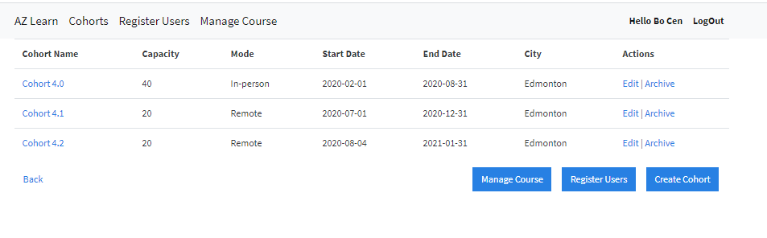

Figure Cohort Summary

**Register Users**

The instructor can register a new instructor or a student from this view and assign them to a respective cohort by clicking Register Button or clicking Register users from navigation bar.

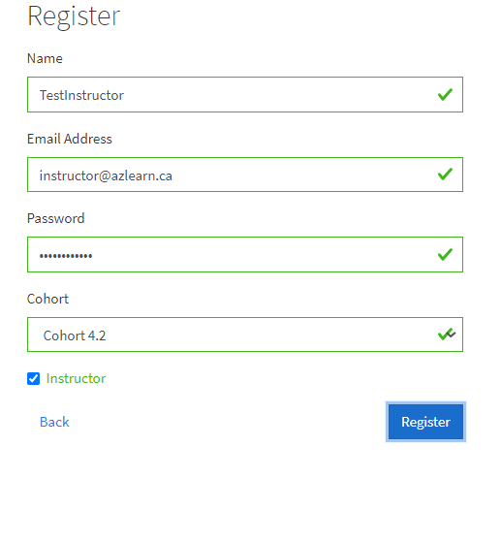

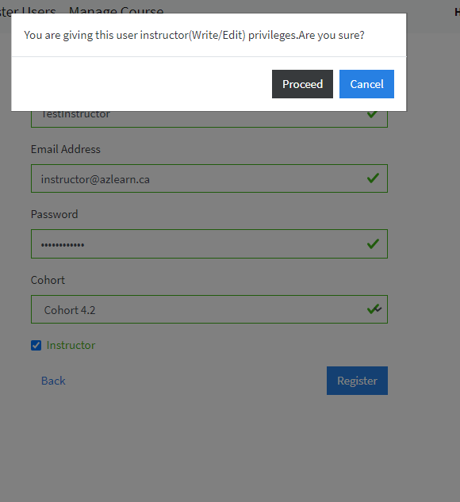

**Cohort Create:** The instructor can also create a new cohort by clicking Create Cohort button which will ask the user to input the mandatory fields like cohort name ,mode of teaching, start date, end date ,city as shown below:

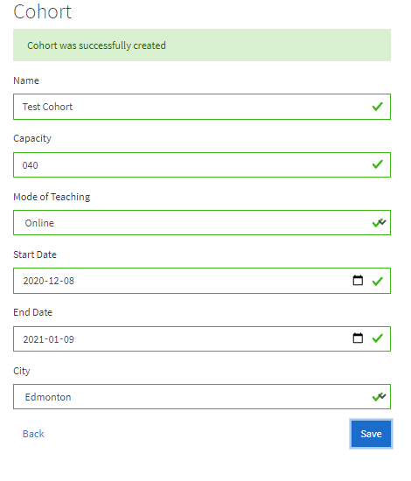

Figure Cohort Successfully created

Once the cohort has been created it is displayed in the Cohort Summary list and the instructor can go back to the Cohort Summary view by clicking Back button or hit Cohort in Navigation Bar.

**Cohort Update:**

The instructor can select the cohort name and can update cohort information by clicking Edit button which is present in Action column of cohort summary Screen as shown below:

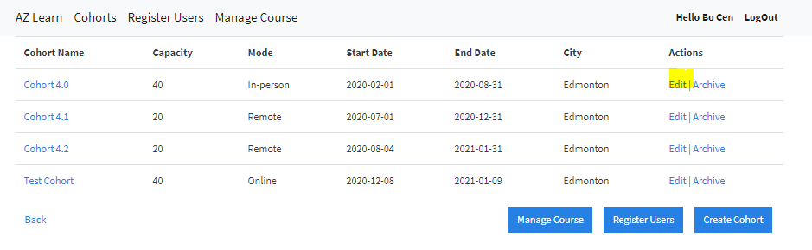

Once Edit is clicked the existing details of the cohort are prepopulated and user can update the cohort information and submit. The below screen would appear once cohort information is updated.

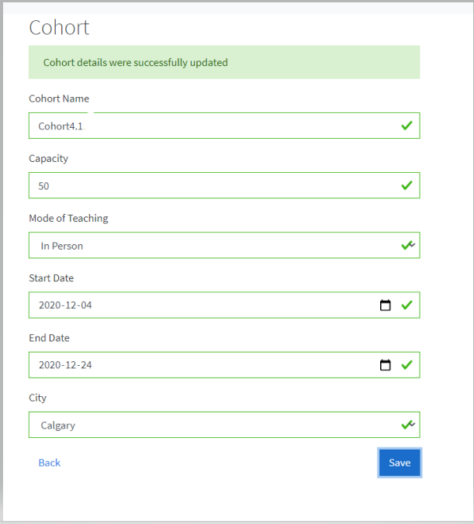

**Cohort Archived:** The user can also archive a particular cohort that does not exist anymore to keep the view clean for other instructors by simply selecting Archive action beside Cohort name. once the Archive button is selected the instructor will receive a warning for confirmation to Retire. If user selects Yes, the cohort is retired/disappeared from cohort summary screen.

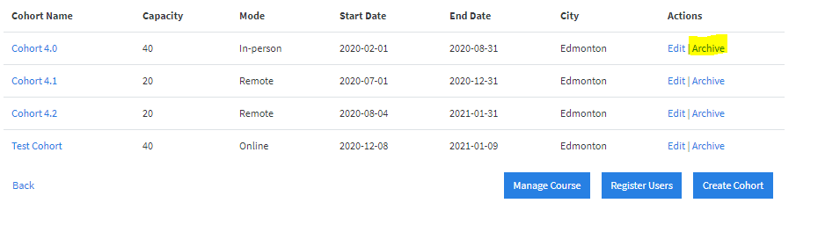

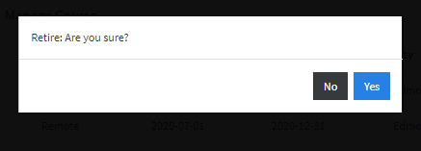

**Manage Course:** The manage course button in cohort summary screen allows the instructors to read the list of all courses offered by the organization .From this view the instructor can create a course, edit a course and archive a course which are explained in below sections.

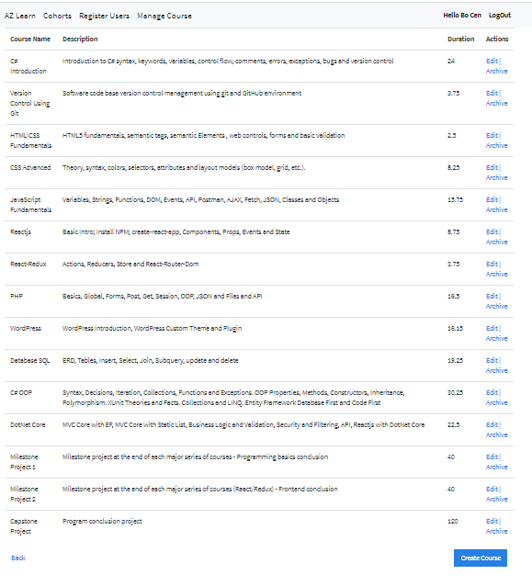

**Course Create:** The instructor can create a courseby clicking create course button and add a course that will be offered by the institute. The user will be asked to input fields like course name, course description, duration as shown below and click create course to generate a new course in the manage course screen. The user can return back by clicking back button to view the course was successfully added to the screen.

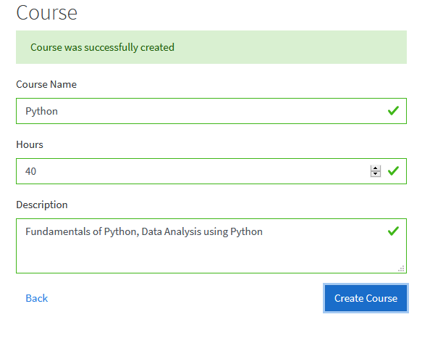

**Course Update:**

The instructor can select the course name and can update course information by clicking Edit button which is present in Action column of manage course screen as shown below:

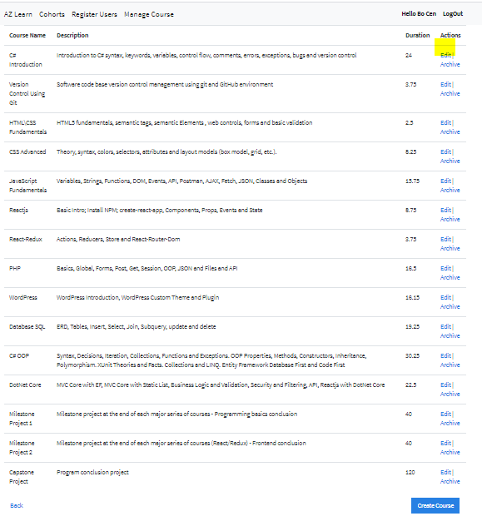

Once Edit is clicked the existing details of the course are prepopulated and user can update the course information and submit. The below screen would appear once course information is updated.

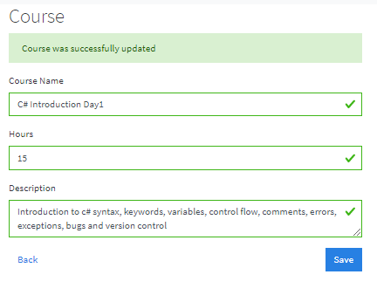

**Course Archived:** The user can also archive a particular course that does not exist anymore to keep the view clean for other instructors by simply selecting Archive action beside Course name. as shown below:

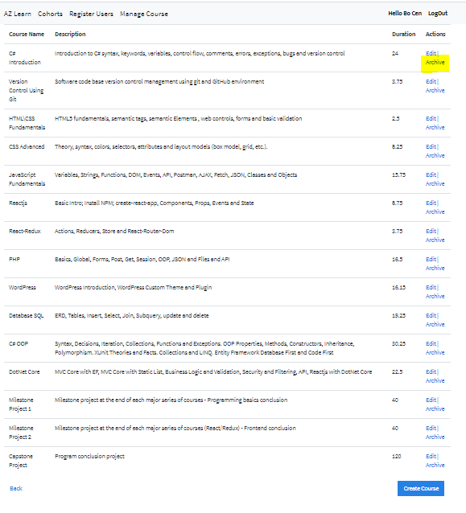

once the Archive button is selected the instructor will receive a warning for confirmation to Retire. If user selects Yes, the course is retired/disappeared from manage course screen.

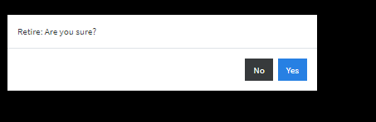

**Course Assign (Create):**

The instructor can also assign a particular course to a specific cohort by selecting cohort from cohort summary screen and selecting Add Course .

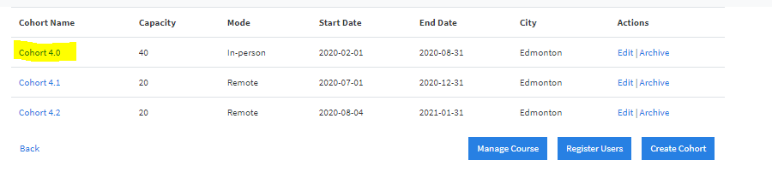

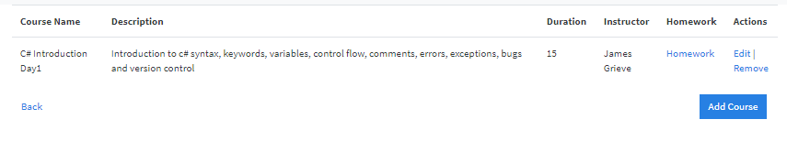

Note: Course assign will display only the active course such that user can only assign existing courses without having to worry about the retired courses.

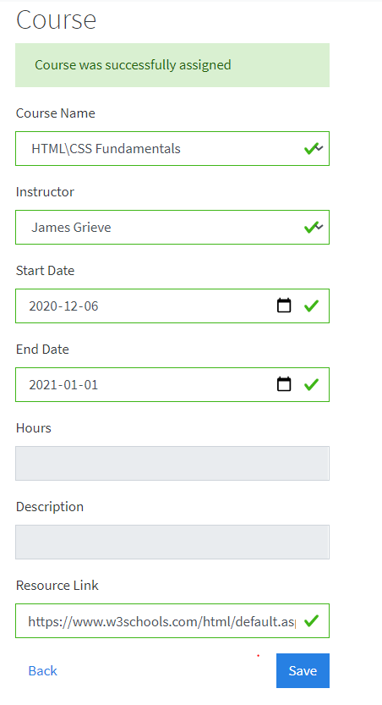

**Course Assign Update:**

The instructor needs to first select a particular cohort name where he/she would like to update,

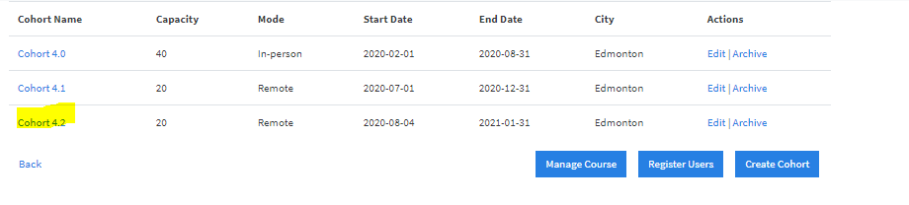

A list of courses (course summary) that were assigned for that cohort would be displayed. The user can select edit button for whichever course that he/she would like to update by clicking edit button which is present in Action column of that screen as shown below:

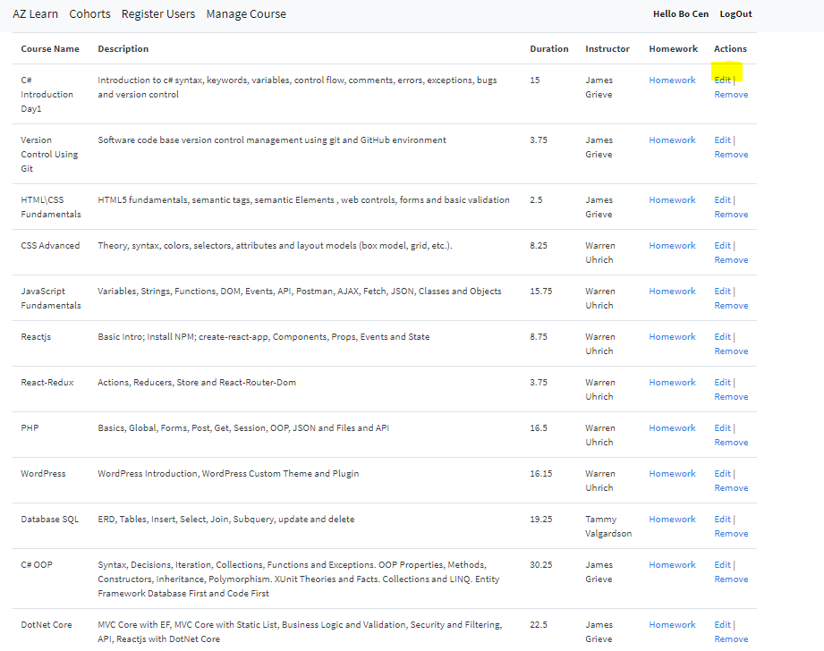

Existing details of the course will be prepopulated, and user can update the required fields such as dates, instructor name, description and resource link and save to update the details of the course as shown below:

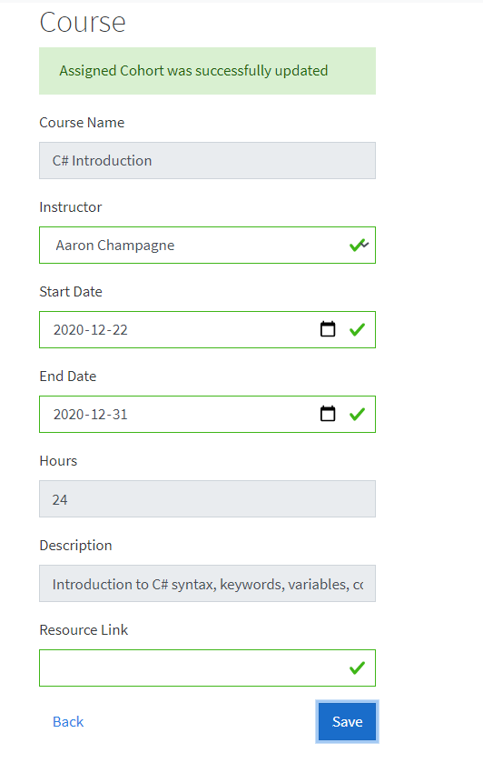

**Course Assign (Archive):**

The user can also archive a particular course that does not exist anymore to keep the view clean for other instructors by simply selecting Archive action beside Course name. as shown below:

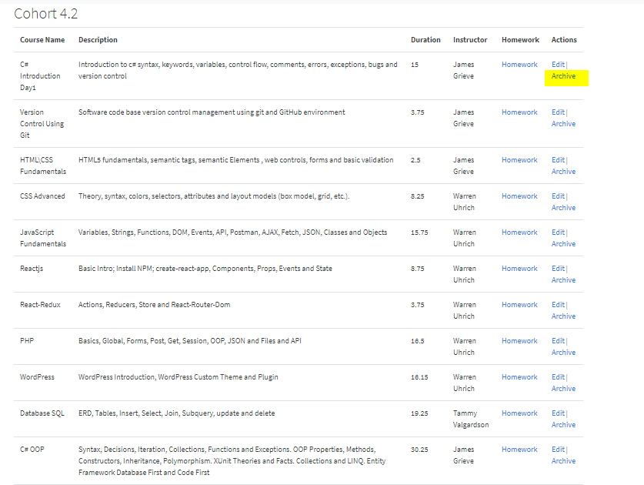

once the Archive button is selected the course is archived from the view..

**Homework View/Read:**

The instructor has also privileges to create, read ,update, archive a homework (whether it is a practise or graded assignment) by first selecting the cohort from the main dashboard (cohort summary) for which he want to assign/check a homework as shown below:



Once cohort is selected, the user need to select the homework for a course he wants to assign a homework.

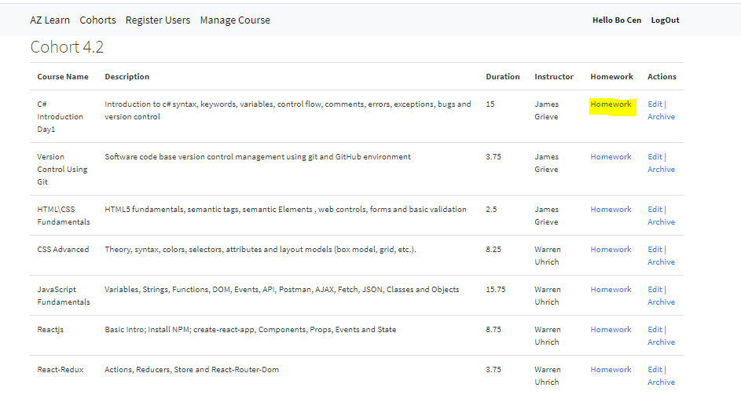

A list of all homework related to the selected course is displayed as shown below:

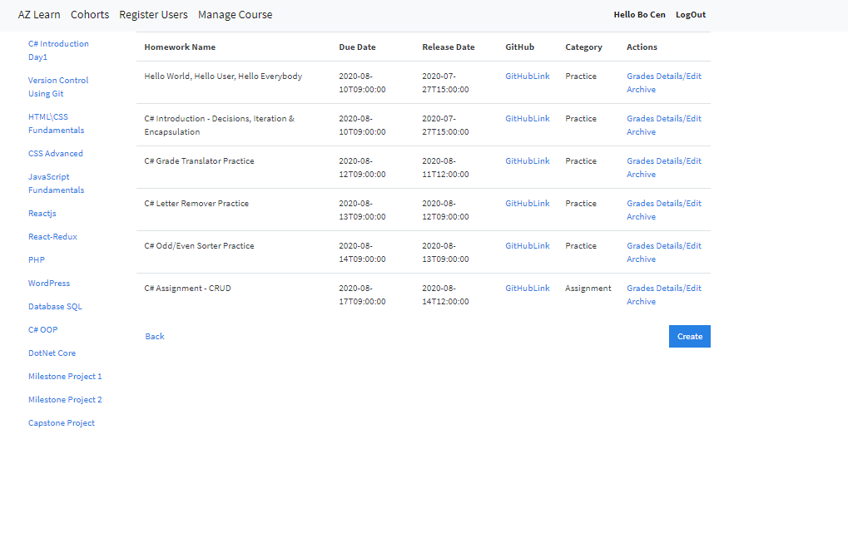

**Homework Create:**

The user can also create a homework from the same screen by Clicking create option and input the required fields.

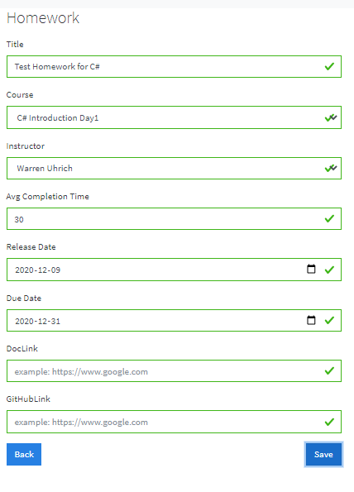

The homework would be added to the list of homework’s for that course as shown below:

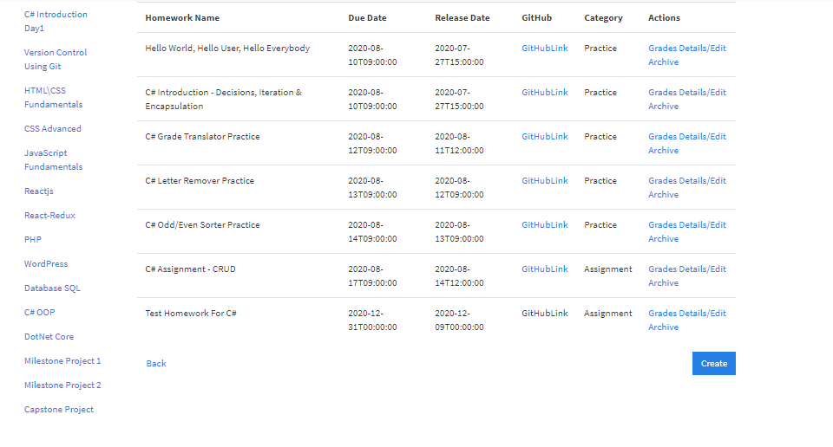

**Homework Read/Update:**

The instructor can also update the homework details by clicking Details / Edit button which is in the action column for the desired homework.

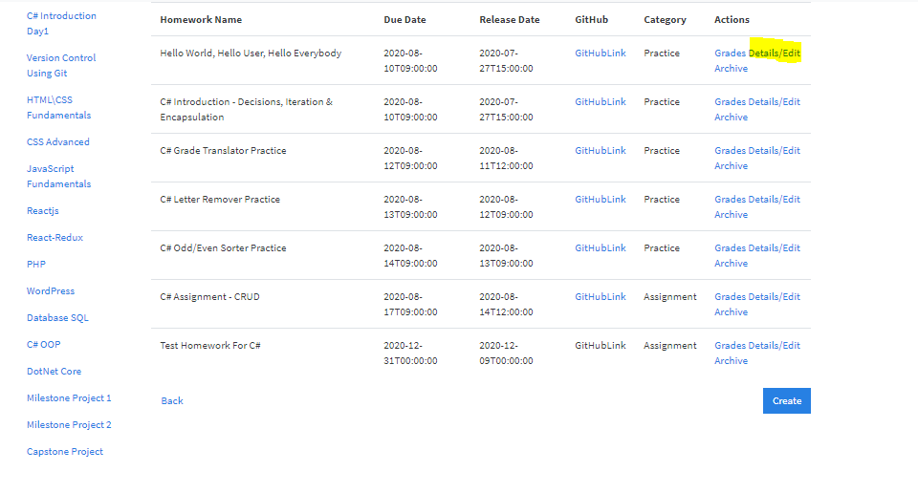

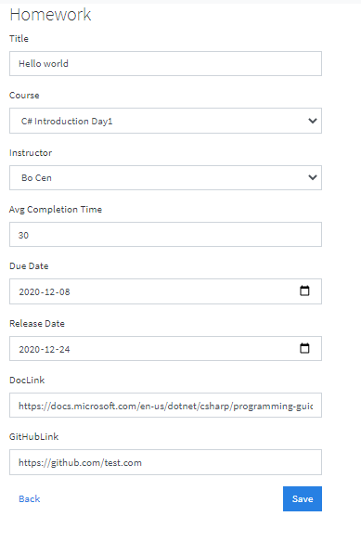

**Homework Archive:** The user can also archive a particular homework that does not exist anymore to keep the view clean for other instructors/students by simply selecting Archive action beside the homework name. as shown below: ()

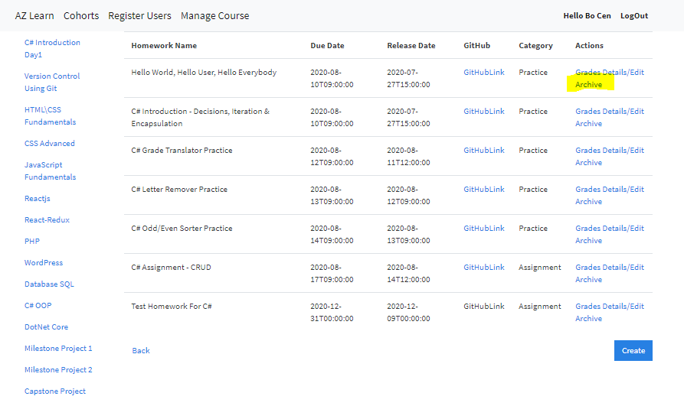

once the Archive button is selected the instructor will receive a warning for confirmation to archive the course. If user selects Yes, the homework is archived/disappeared from the view.



**Grade /Timesheet View:**

The instructor has privileges to also view the Grades for each student and average time spent on a particular assignment to determine the analytics and difficulty level of the assignment to determine which student has performed exceptionally well and which student needs help and support. This view can be generated by first selecting the cohort from main dashboard:

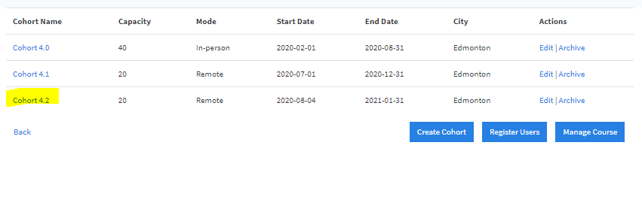

Selecting the Homework for the particular course from various courses.

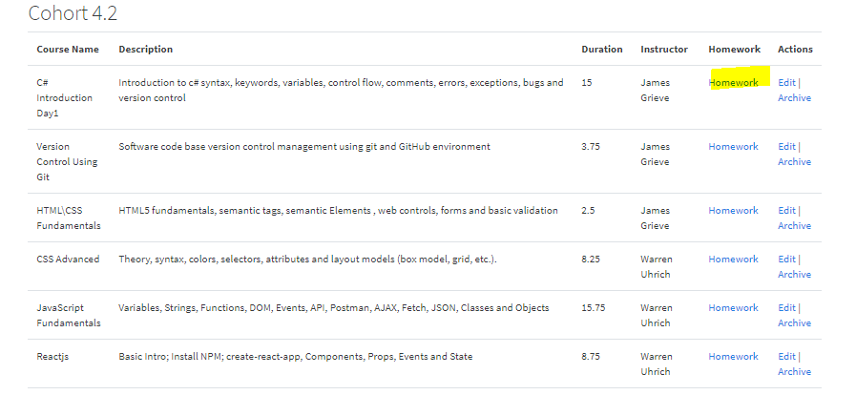

From the list of homework’s for a particular course, select a particular homework and click Grades for which you would like to see the grades or average time spent by each student.

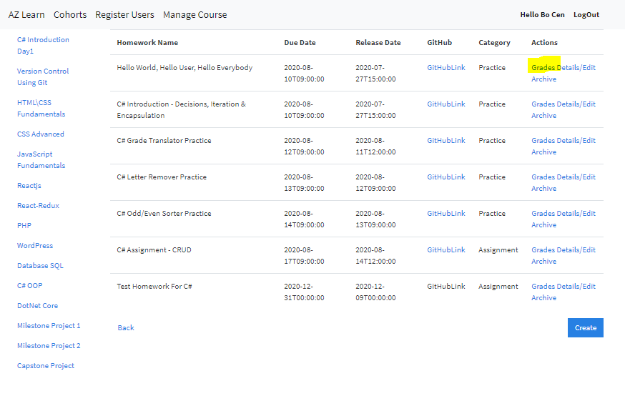

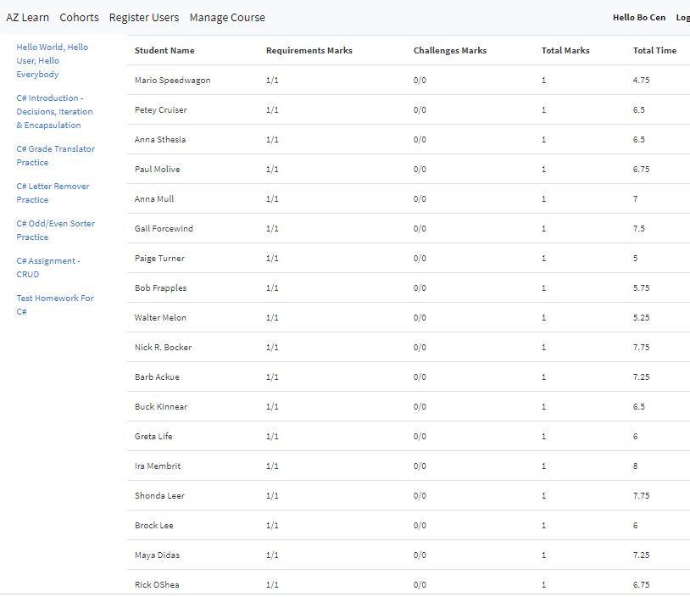

## **Student Dashboard:**

**Login Screen:**

The figure shows the application homepage, in this page, the user can sign-in an account using student email address and password (Ex: Email: [walter.melon@azlearn.ca](mailto:walter.melon@azlearn.ca)

Password: abc.123 ) as shown below

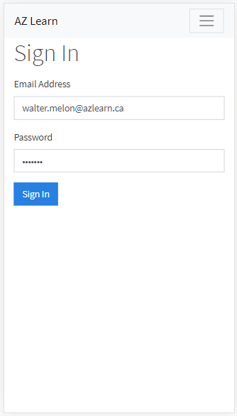

Once the student is Logged in , the student has very limited privileges that can be accessed from this main dashboard i.e., Course Summary Screen

**Course Summary Screen (Read) :** The student can view here list of courses that are offered for their cohort with details like approximate duration for the course ,instructor details, and homework’s pertaining to that course. The functionality of each action has been described in below sections.

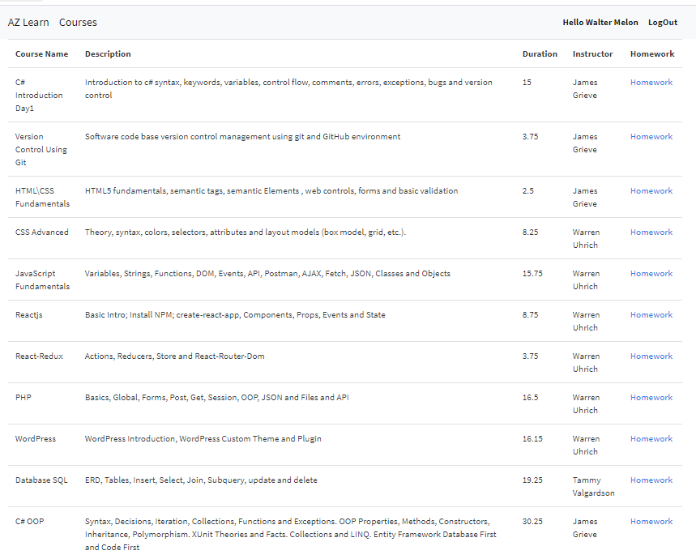

**Homework Read:**

The student can select the Homework option for a particular course and see the list of homework’s that were assigned as shown below:

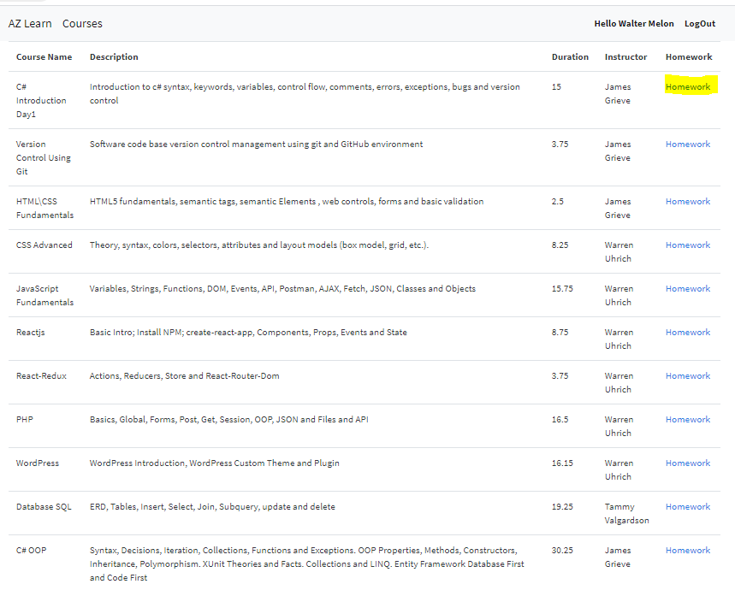

The student can also check in the view whether the homework is a practise or a graded assignment and can access the document by clicking the Github link.

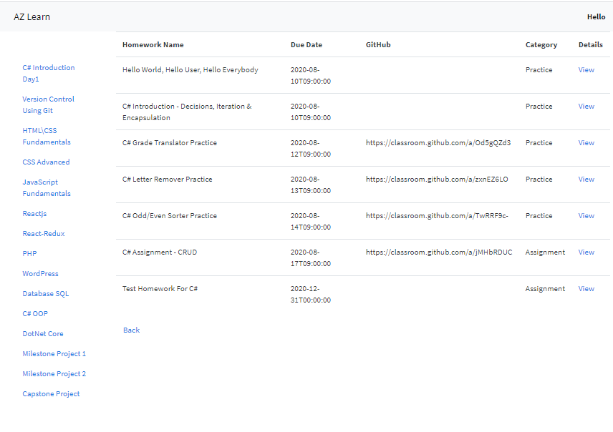

The student can also click View button to see the brief description of that Homework as shown below.

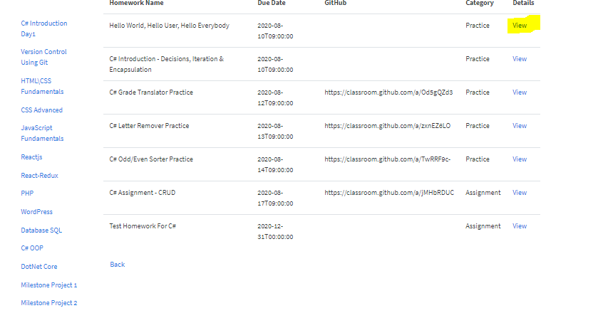

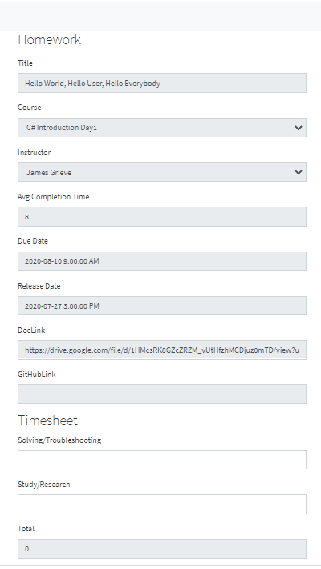

**Timesheet Update:**

Once the student have submitted the assignment the student can return to the same screen (course summary screen as shown below) and update the timesheet for that particular homework by selecting the homework which was assigned and Clicking view and entering the time taken including solving time and study time.





