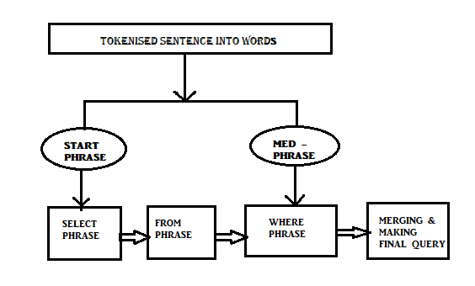

Fig : Parsing Phrase to analyse query type

APPENDICES

CODE SNIPPETS

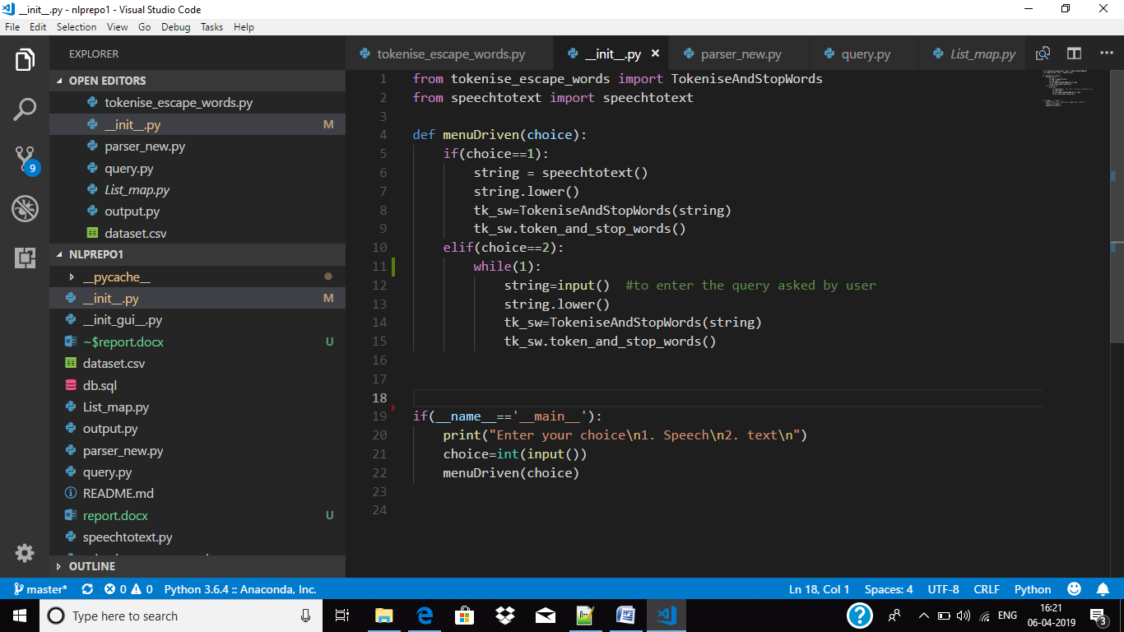

This is the initial file “__init__.py” which starts with asking the choice to enter query by typing or by speaking. It takes the query as string then passes on to the other module or class where it gets its further computation.

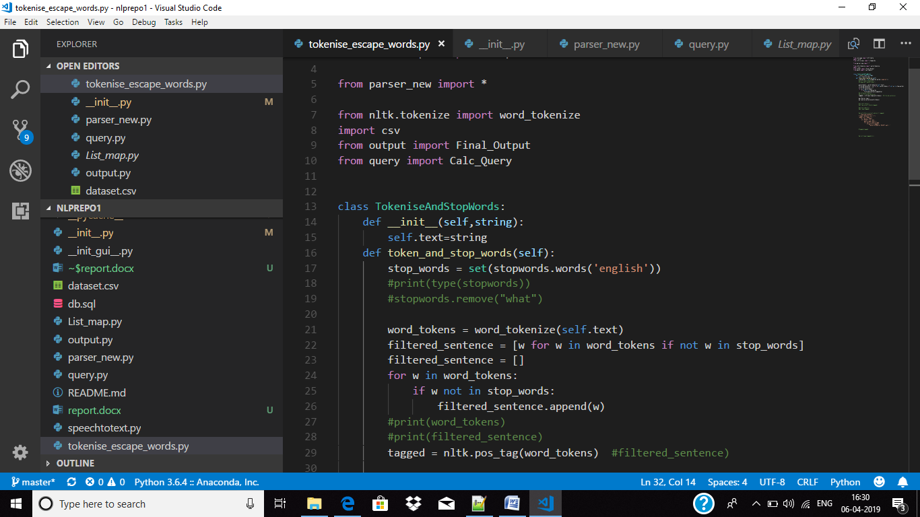

In this module (class) the sentence gets tokenised and done part-of-speech tagging. After which the escape words are taken out from the tokenised list and the filtered sentence is then passes to parsing to convert it into desired query.

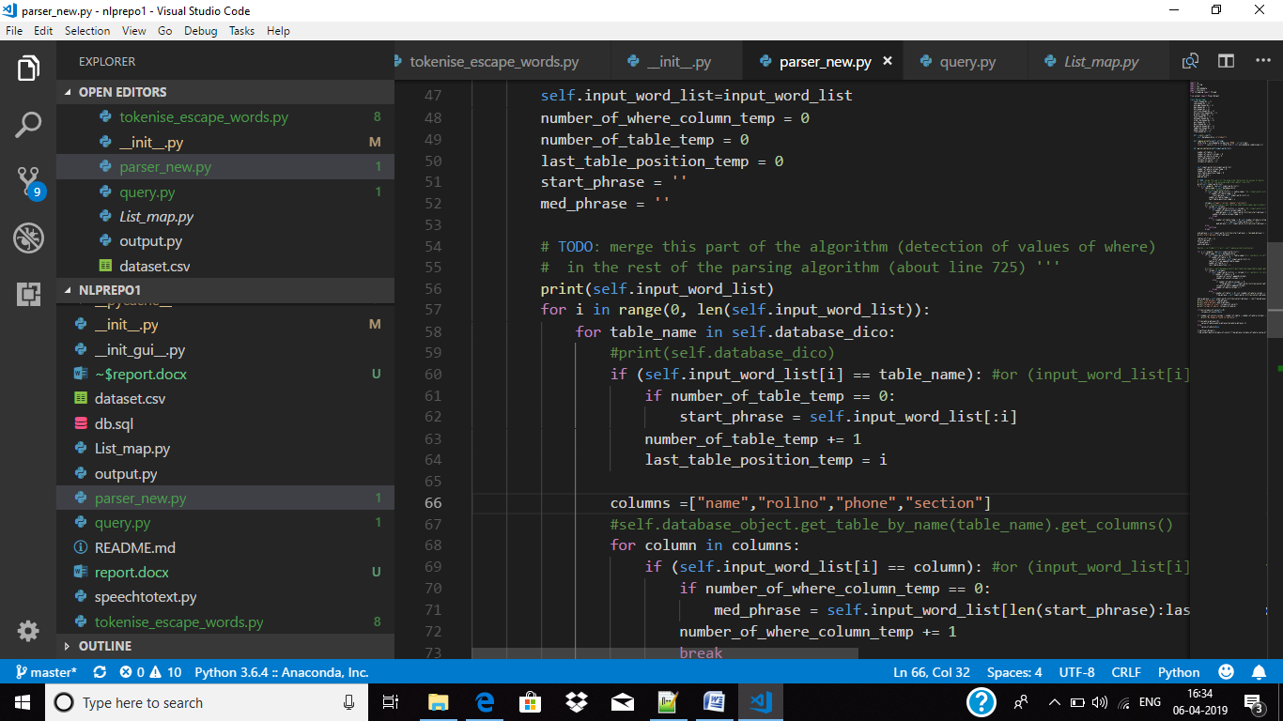

In this code class , the tokenised sentence is broken into two parts the start phrase and the med phrase where the start phrase is the SELECT phrase and then concatenated the FROM phrase(which has the table name, from which the data to be retrieved) and then the med- phrase contains the WHERE phrase. This broken query is passed onto the output file.

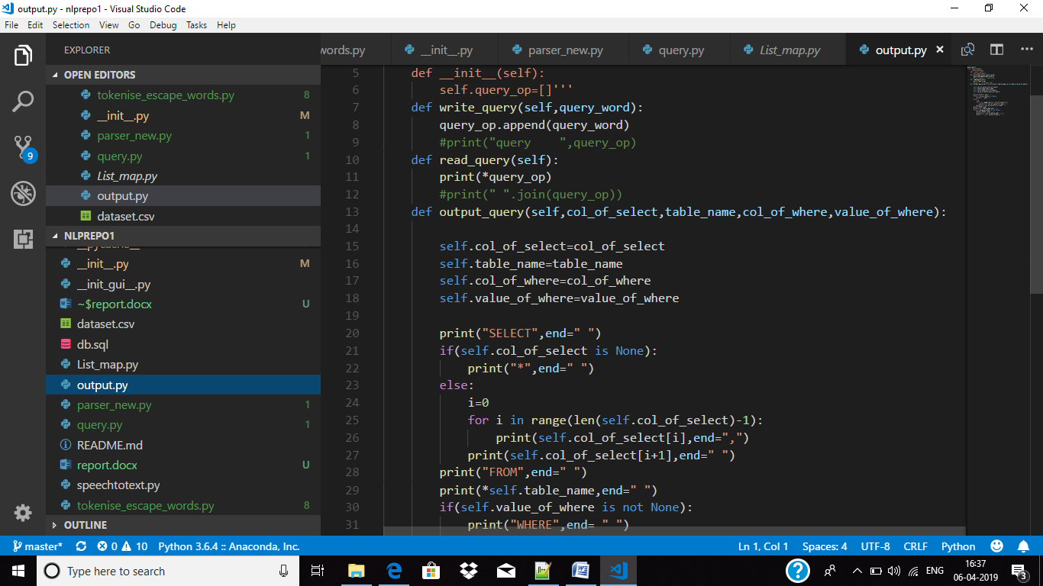

This is the output file r the last module which generates the output for the entered sentence. This takes the broken query from parsing file and joins it to make the desired or the final query.