ORGANİSATOR

This class is our organizer. Here, we read a text file and create ArrayLists as needed. We use the findMissingParenthesis method to print parenthesis errors. In the createType method, we add elements to the lists. In the check methods, we fix errors and print them to the screen. We use the getTaskTypes getter method in the main to access the list. Now let's look in more detail.

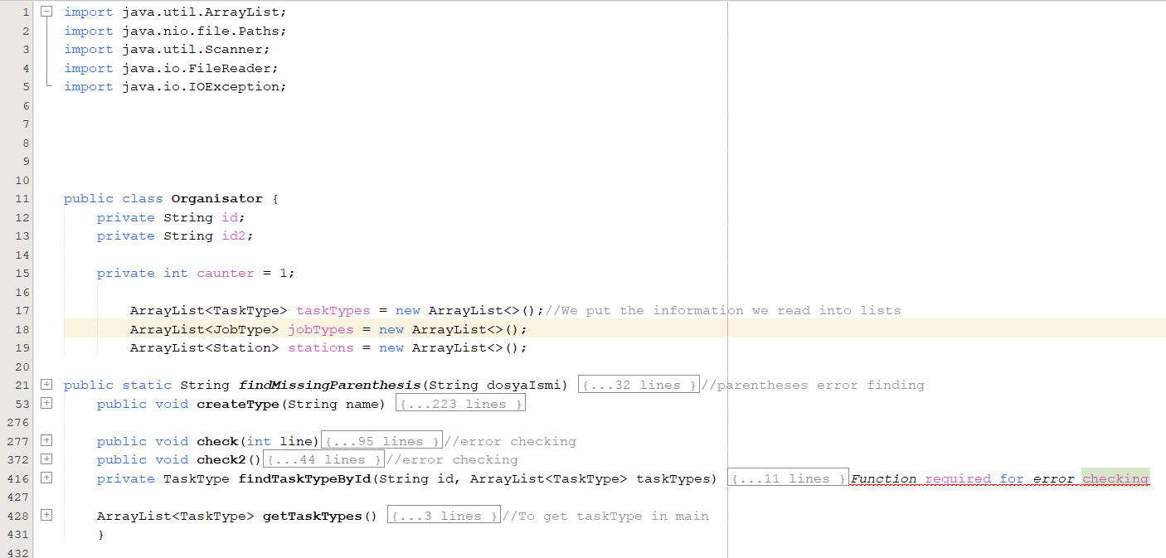

In the findMissingParenthesis method, I used the FileWriter object to read the file. We read the file character by character and there are different situations depending on the type of parentheses. Finally, we finished reading with fileReader.close

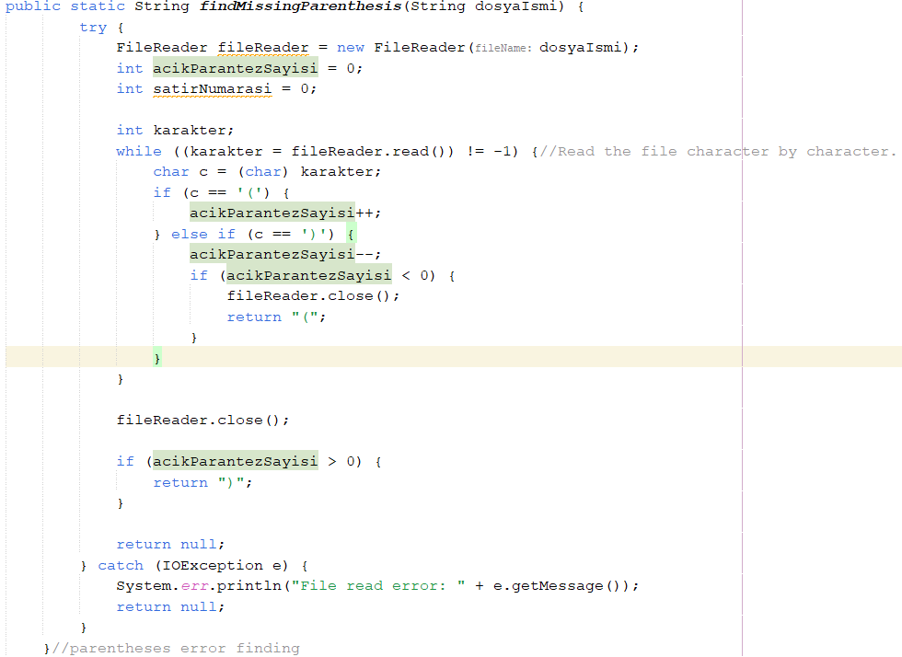

We did the printing part of findMissingParenthesis at the beginning of the createType class.

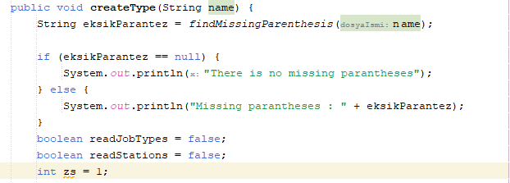

Here we removed the spaces and replaced the parentheses with spaces. We broke the line down word by word and if the line starts with jobType, we assigned its value correctly and skipped the loop. If jobType and Station are not written, we said this is tasktype. We got the properties of tasktype

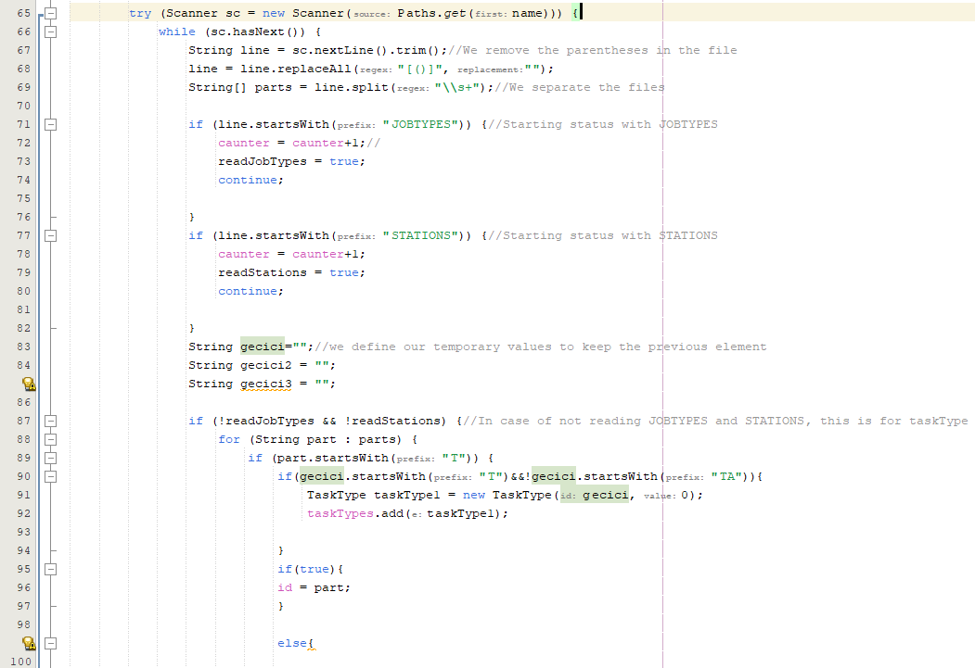

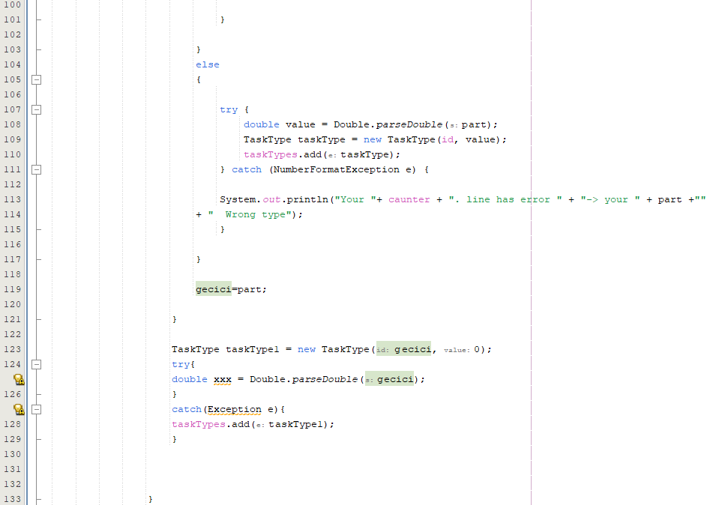

Here we added the properties of jobtype

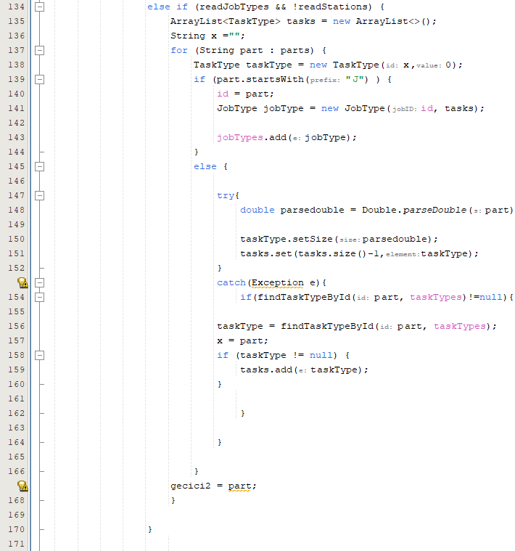

Here we took the properties of the station and assigned them to Fifo and MultiFlag according to the N and Y values.

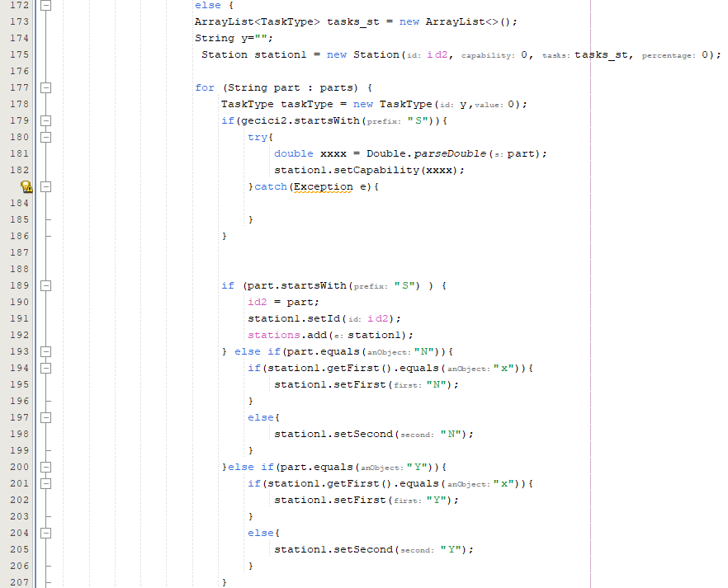 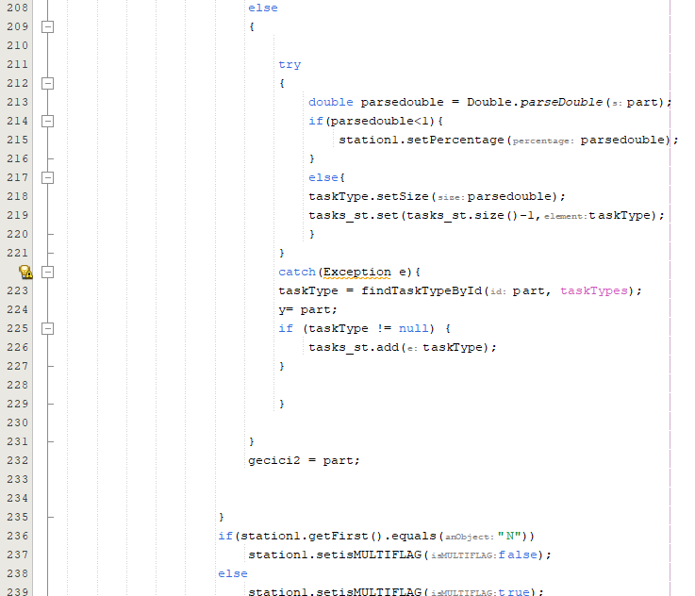

We printed TaskType JobType and Station here.

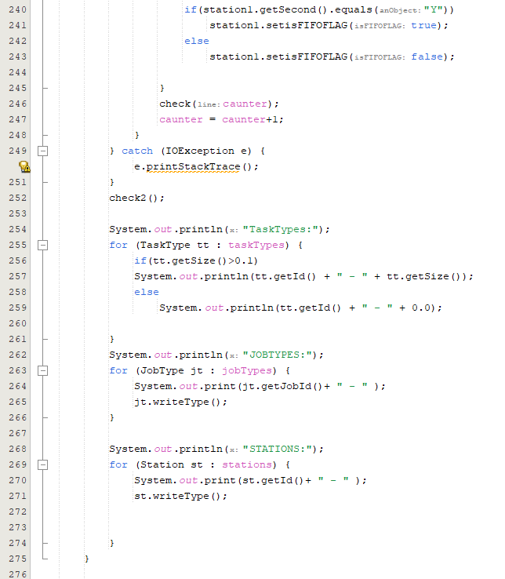

Here we print the errors in the loop.

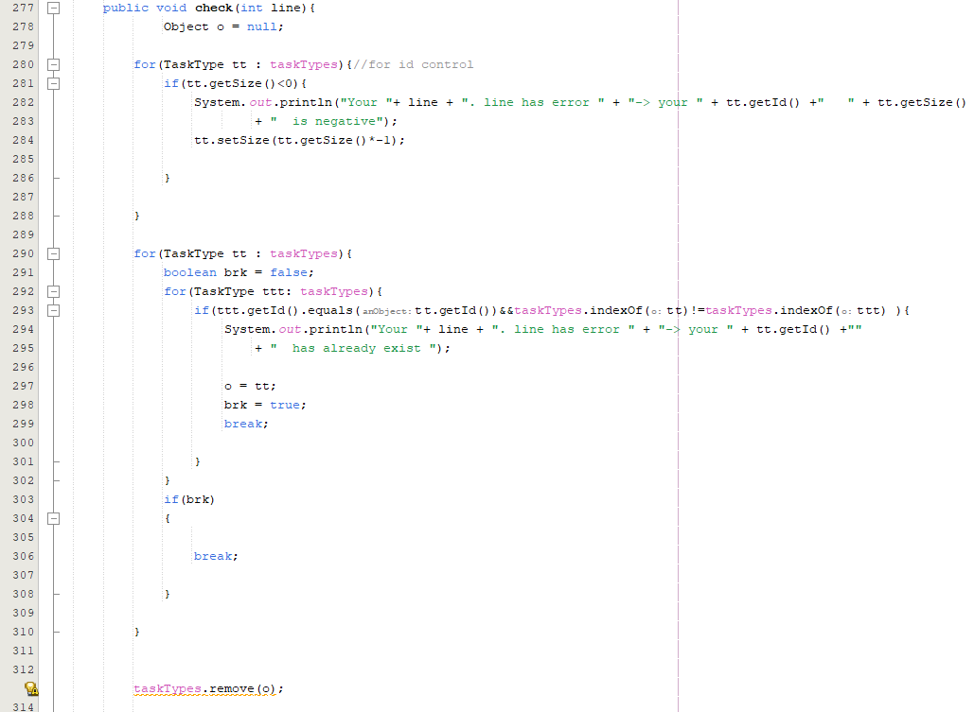

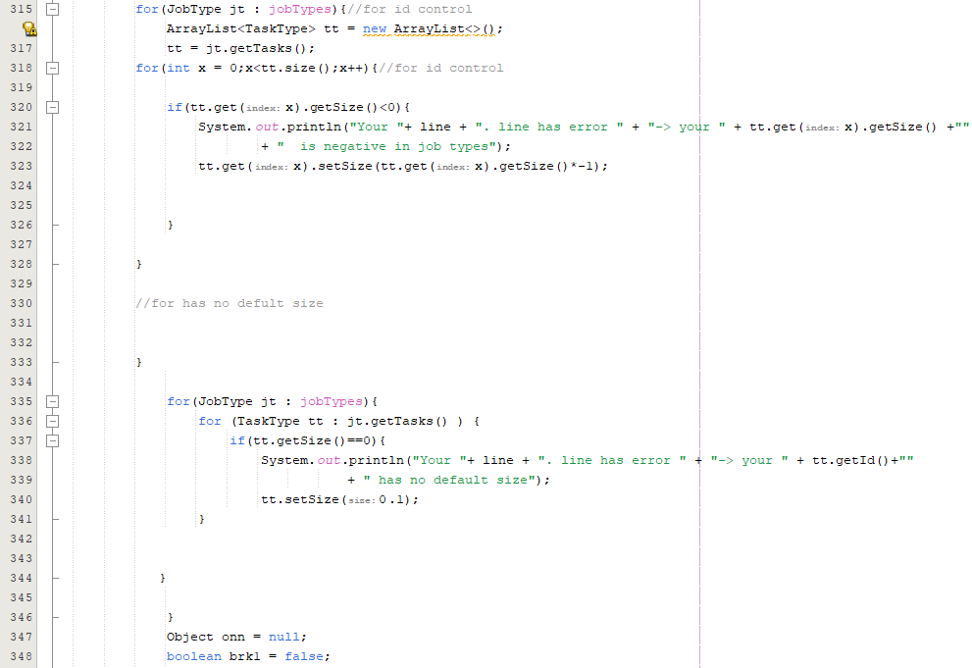

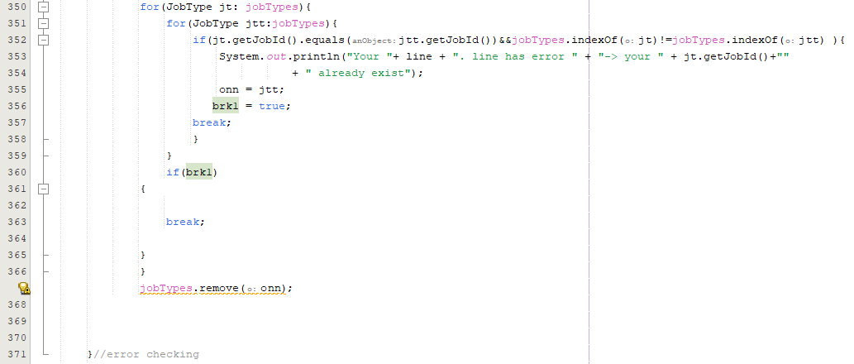

In check2, we only check errors outside the loop and these are errors between lines 9-12

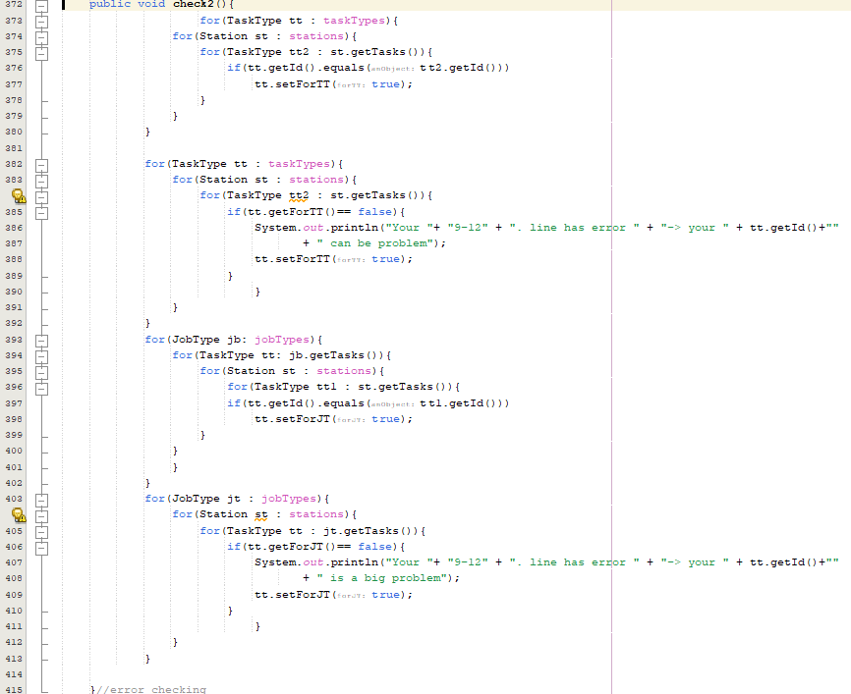

Find TaskType object with ID.

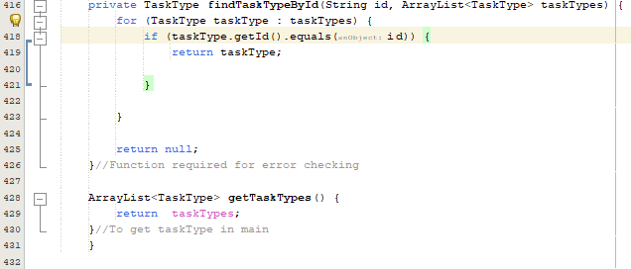

The output of the code we wrote is like this

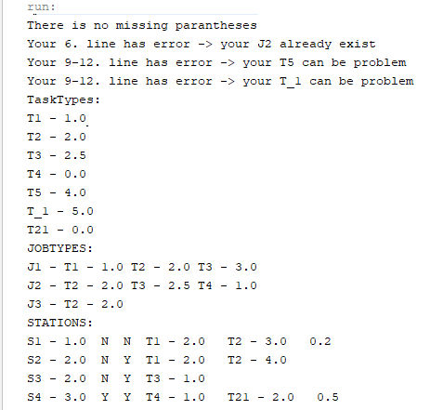

Enes Deniz 20220601017 Barış Dursun 20220601022