1st December 2018

Document issue: 1

Universal Joystick Programming Software:

UJPS C++

V2.11.0

MANUAL

**CONTENTS**

1 Introduction 5

2 The main principles 6

3 Setup 7

3.1 External tools setup 7

3.2 Building the tool 7

4 A quick tour of the repository content 8

5 The main app 9

5.1 The main window 9

5.2 Pre-fill the main window from console 11

5.3 Run UJPS from console 11

6 Dealing with dual inputs 12

6.1 Input repeater 12

6.2 Devreorder 12

6.3 AutoWhitelister and ViGEm 12

7 Controllers plugins and monitoring app 14

8 Remote controllers 18

8.1 The theory 18

8.2 A non-trivial example of what can be done 19

8.3 Provided examples about MFD 19

9 Create a profile 20

9.1 Profile creation (by manual copy of a provided example) 20

9.2 Profile coding 20

9.3 Profile compilation 22

10 What is under the hood 23

11 Layers and LayersCombos 24

11.1 LayersCombos as mapping filters 24

11.2 Definition of a layer 24

11.3 Registering shift buttons 24

11.4 How is computed the current layer 25

11.5 Constructing LayersCombo 25

12 Button / axis / pov mapping basics 27

13 Pre-defined actions 28

13.1 Actions about buttons 28

13.2 Actions about axes 29

13.3 Actions about keyboard 30

13.4 Actions about povs 31

13.5 Actions Chain, Delay and Sequence 31

13.6 Executing a custom function 32

13.7 Regularly execute an action or a function 33

14 Pre-defined mappings 34

14.1 MappingStandard 34

14.2 MappingTempo 34

14.3 MappingAxis1 34

14.4 MappingAxis2 35

14.5 MappingAxisRelative 35

14.6 MappingMergeAxes 35

14.7 MappingSplitAxis 36

15 Pre-defined triggers for "standard mapping" 37

15.1 Triggers about buttons 37

15.2 Triggers about axes 38

15.3 Triggers about povs 38

16 Other features 39

16.1 Axis trim and curves 39

16.2 Button, axis and pov locking 41

16.3 Axes rotation 42

16.4 DoAction 42

17 Limitations and possible improvements 43

18 Dependencies, credits, useful links 44

19 Changes notes 45

20 Annexes 50

20.1 List of pre-defined triggers 50

20.2 List of pre-defined actions 50

20.3 List of pre-defined mappings 50

20.4 Keyboards keys names (Windows) 51

# Introduction

**Raw joysticks**

By "raw joysticks" we mean joysticks used the simplest way: you plug your joystick, the system detects it and recognizes its buttons and axes. Then you go in the control options of your software / game and map the buttons and axes to "in-game actions / controls".

**Programmable or programmed joysticks?**

Beyond that there is also what we could call the "programmed joysticks". Many manufacturers call them "programmable joysticks", but I don't like this word as their joysticks are no more programmable as any other ones: they are programmable only because the manufacturer provides a software especially to program them, but there is nothing intrinsically related to the joystick. With UJPS C++ you will be able to program any joystick recognized by the system as a game controller.

**Raw joysticks vs programmed joysticks**

With raw joysticks you are limited to bind a button or axis to an "action" provided in the game control options menu. You cannot for example use one button for different actions without interference. Moreover the list of actions provided is not always suited for all types of controls, and with programmed joysticks you can do ~~almost~~ what you want between the physical joysticks and what sees the game. You can also make different joysticks interact with each other. This way you can create more ergonomic controls than just with raw joysticks. You can even sometimes fill gaps in the game controls by "programming" your joysticks.

**The state of art**

The manufacturers that do the most for "programmable" joysticks are CH and Thrustmaster (among general public joysticks). They both provide 2 different ways to program joysticks:

* One first and easier way using graphical interfaces (e.g. with CH Control Manager Programming Software, or Thrustmaster TARGET GUI)
* Another more advanced and less easy way using real programming or scripting (with CH scripts, or Thrustmaster scripts that are written in C programming language using a Thrustmaster provided functions library)

On the other side some free software exist to do so with joysticks of any brand but they are mainly based on graphical interfaces:

* UCR (Universal Control Remapper) : https://github.com/evilC/UCR
* Joystick Gremlin : https://whitemagic.github.io/JoystickGremlin (+Python scripting)

**UJPS C++**

The present software allows to program joysticks of any brand, on Windows only, by programming in C++. Even if some knowledge of C++ is needed to get the best out of it, only basic C++ knowledge should be necessary to obtain good results. Anyway this software is quite similar to Thrustmaster scripts, is not harder than it, is a little more flexible and mostly allows to program any joystick.

# The main principles

As all other software of this kind, UJPS relies on virtual joysticks. These virtual joysticks are seen by the system just as real joysticks. The principle of UJPS is that the inputs of your joysticks are read by the software and the profile you programmed transforms these inputs into virtual joysticks actions or keyboard keystrokes. The profile is interchangeable and is chosen in the main window.

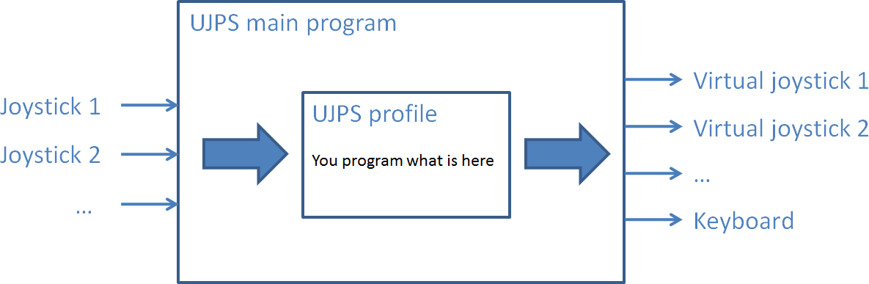

Figure 1: UJPS main principle

As a comparison, the Thrustmaster scripts allow only one virtual joystick and supports mouse inputs. UJPS profiles are in fact plugins (dll that can be load dynamically at runtime) that must be compiled before running them. Creating a profile is described in §6.

Since V2.0.0 you can also use remote controllers along the real joysticks. A remote controller is an application that connects (via network) to UJPS main app and exchange information with it. This application can be run on your local computer or on a mobile device, but you will have to write it yourself! It is comparable to Roccat Power grids or LEA extended input, but without the GUI editor, which makes this part of UJPS really less accessible to non-programmers users. More details are available in §.

UJPS software uses external tools:

* Qt 5, a general C++ library
* vJoy, for virtual joysticks: http://vjoystick.sourceforge.net/site/
* QtGameController, a non-official Qt module from “openforeveryone”, that I modified

When you use such joysticks programming tools, there is the usual issue of the dual inputs: the system and your game will see an event on both a real joystick and a virtual joystick. This should not be a problem when playing the game, but it can be really annoying when trying to assign the controls. To remedy to that I currently recommend you to use WhiteKnight from evilC to hide real joysticks to the game. The necessary files are provided in the download of this tool, but here is the link for more information. Read §3before installing anything.

I would like to thank "Shaul" for vJoy that allowed this software and many others (among them UCR and joystick Gremlin) to exist.

# Setup

## External tools setup

You will need to install Qt 5 and vJoy. For Qt 5 I will even recommend you to use Qt 5.11 with the MinGw C++ compiler (5.3.0 32 bits version) provided along with Qt, as this is exactly the one used to code this software. Hereafter I list the necessary Qt 5.11 components you will need to install to build and use all the tools available in UJPS:

* "Preview" section: nothing needed
* "Qt / Qt 5.11.0" section: MinGW 5.3.0 32 bits and Qt charts
* "Tools" section: MinGW 5.3.0

Download the last version of vJoy. This software has been developed with the 2.1.8 release from November 2016, which still was the last release in beginning of 2018. If a new version is released, updating the "vJoy218SDK-291116" directory may be necessary and anyway advised. I would provide an update in this case.

https://www.qt.io/download-qt-installer http://vjoystick.sourceforge.net/site/index.php/download-a-install

## Building the tool

Once these 2 steps are done, do the following:

* Verify if Qt paths are included the "PATH" environment variable. To do so you can open a Windows console (cmd.exe) and type "set PATH".
  + if yes, open the "build_all.bat" file as text (don't double-click on it) and remove the lines 3 to 6
  + if not, modify the line 5 with the 2 Qt paths matching your own Qt setup. You should find a "qtenv.bat" file in the Qt directories that contains them
* Close the "build_all.bat" and run it (double-click on it). It will compile and deploy all the components of the tool. It will not compile the provided profiles.

The "cleanAll.bat" allows you to clean all the binaries generated during the build process (.o, .exe files, makefiles, …). You will come back in the same state after you downloaded the content of the repository. So the tool will not be runnable anymore except if you build the tool again.

# A quick tour of the repository content

CleanQtProjects: a small home-made utility program that cleans (deleting binary files, makefiles, … and all files that are created when building the project) a Qt project

StaticLibs: the source code shared by the different programs (UJPS, Monitoring and AxesCurves) and the profiles plugins is centralized here to avoid code repetition

UjpsMainApp: the main application, UJPS.exe, the one that runs profiles (§5)

Monitoring: a program that shows joysticks inputs (§7)

ControllersInfo: a small program that provides info about connected controllers (name, system id, number of buttons, axes and povs and hardware id)

ControllersPlugins: the source code of the provided controllers plugins. These plugins brings the following services (§7):

* Definition of buttons and axes names
* Re-ordering of axes or buttons
* Addition of additional (“virtual”) buttons, in addition of the ones added from POV
* Other services such as led support for Warthog throttle

AxesCurves: a utility program very useful to fine-tune the curves and dead-zones of the joysticks axes (see §16.1 for more details)

HidingJoysticks: 2 different ways to hide real joysticks from the game and even the system:

* Devreorder (§6.1)
* WhiteKnight (ViGEm) (§6.3)

vJoy218SDK-291116: the dll and lib files of vJoy. Useful for the compilation of the tool

Profiles: the example profiles I provide. You don’t have to necessarily put yours there

RemoteControllers: examples of remote controllers (§)

# The main app

The main app can be used different ways:

* Double-click on UJPS.exe or call it with no argument from the command line or a bat file to open the GUI window (§5.1)
* Call UJPS.exe with additional arguments (from command line or a bat file) to open the GUI window and to pre-fill the path to the profile and the time step. It is also possible to run the profile directly (§5.2)
* Call UJPS_console.exe to run a profile with the provided time step without the GUI (§5.3)

## The main window

The main window pops up when running "UJPS.exe". It is quite basic and provides the following functionalities:

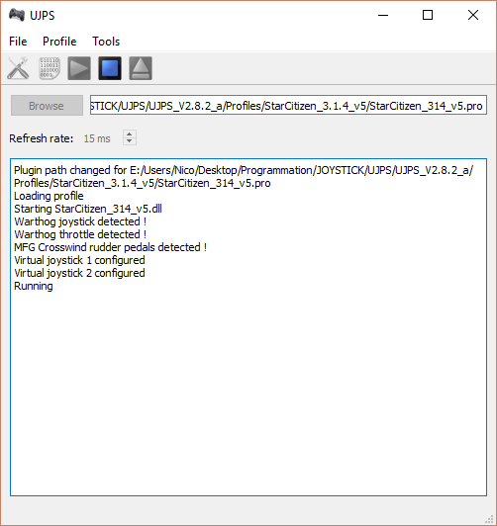

Figure 2: UJPS main window

* browse to select the profile to run. You have to select the .pro file. The profile is not loaded right away
* select a time step. The default one is 15 ms. At each time step the data of real joysticks is read, transformed by the profile and the result is sent to virtual joysticks and / or keyboard
* show the settings menu which allows to:
  + define a custom starting directory for browsing to select a profile
  + define a default profile (automatically selected - not loaded - at startup)
  + define a default time step at startup
  + about the other features (input repeater and ViGEm), please refer to §6
* compilation: if you installed Qt with the MinGw compiler, you can use directly this feature to compile your profile without using an IDE or compile with the command line. But UJPS does not provide a text editor to modify the profile source code

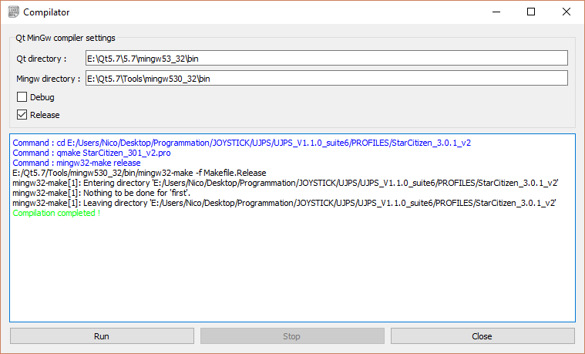

Figure 3: compiler widget

* play button: run the profile / plugin. It is loaded when it is played if it is not already loaded. If another one is already loaded, it is unloaded before loading the new one
* stop button: stops the profile (the virtual will not be fed anymore) but does not unload it
* unload button: unloads the profile. It is not needed before selecting a new profile. It is useful to be able to recompile the profile currently loaded after a code modification (otherwise the profile compilation will fail because the dll cannot be rewritten) or to make the program aware that you connected a new joystick
* the tools menu: it allows to start other UJPS apps
* a text zone to display messages and errors

Here are a few probable errors you could encounter:

* an error when loading the profile. It can be due to several reasons:
  + the file does not exist anymore or you don't have read access on it
  + the dll file specified is not a UJPS profile
* an error due to the initialization of the profile: if you activated “vJoyConfig.exe” in the settings menu and you did not run the program as an administrator
* any error due to programming issues in the profile that passed the compilation

## Pre-fill the main window from console

If you call UJPS.exe from the command line, a bat file, ... and that you provide additional arguments you can:

* set the profile path, the path to the .pro file, not the dll (mandatory)
* set the time step (optional, 15 ms if not provided)
* run the profile, using "-play" (optional, not played by default)

Hereafter is the example provided in "UjpsMainApp/gui_test1.bat":

echo off

set UJPSGUIEXE=%~dp0\release\UJPS.exe

set PROFILESPATH=%~dp0\..\Profiles

%UJPSGUIEXE% %PROFILESPATH%\ProfileTest\profileTest.pro 25 -play

echo.

pause

The instruction "%~dp0" is useful in a bat file. It designates the directory that contains the bat file. It is practical if you run the bat file from the command line and that the current directory is not the one that contains the bat file. Two other bat files examples are provided with small variants. Another interesting way to do it would be to add the directory that contains UJPS.exe to the PATH environment variable:

echo off

set PATH=%~dp0\release;%PATH%

set PROFILESPATH=%~dp0\..\Profiles

UJPS.exe %PROFILESPATH%\ProfileTest\profileTest.pro 25 -play

echo.

pause

Obviously the profile and time step you provide this way has priority upon the default profile and time step you may have provided in the main app settings menu.

## Run UJPS from console

You can also run UJPS without opening the GUI: to do so you have to call the second binary "UJPS_console.exe". You can provide 2 arguments:

* the profile path, the path to the dll contrary to the GUI version (mandatory)
* the time step (optional, 15 ms if not provided)

You can run it similarly as in §5.2:

echo off

set UJPSCONSOLEEXE=%~dp0\release\UJPS_console.exe

set PROFILESPATH=%~dp0\..\Profiles

%UJPSCONSOLEEXE% %PROFILESPATH%\ProfileTest\release\ProfileTest.dll 25

echo.

pause

# Dealing with dual inputs

When a UJPS profile is running, if you perform a real joystick input that is mapped in your profile, it may generate an output to a vJoy device or to keyboard (according to what you coded in your profile). Let's consider only the vJoy device / virtual joystick events and use the point of view of the game: for the game, the virtual joysticks are inputs just like real joysticks. And when you perform this action on your real joystick, the game will see 2 inputs: one from a real joystick and another one from a virtual joystick. It may be a real pain when trying to assign the controls in the game controls menu.

There is 2 main ways to solve the problem:

* repeat the vJoy event a second time (see input repeater below)
* hide the real joysticks (see devreorder and ViGEm)

## Input repeater

This feature just repeat any vJoy event sent by the profile during a few seconds to be sure that the game controls menu takes into account the virtual joystick. Don't forget to disable it when leaving the game controls menu... or you will have a surprise when starting to play!

## Devreorder

This method is the simpler one to hide real joysticks but it works only for the games that use the library Direct Input 8. You have to:

* copy the file "dinput8.dll" next to the game executable. Use the x64 version if the game executable is 64 bits compatible, otherwise use the x86 version
* copy the "devreorder.ini" file next to it to and edit it by placing the names of the joysticks you want to hide just after "[hidden]"

## AutoWhitelister and ViGEm

Run AutoWhitelister.exe by clicking the link in the menu. The first time you will have to install HidGuardian and HidCerberus (ViGEm components) using the dedicated buttons in the GUI. It is fully done by AutoWhitelister (no additional download or setup) and it only takes a few seconds. Then start the service and close AutoWhitelister.

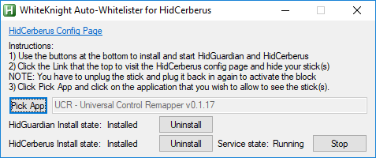

Figure 4: AutoWhitelister GUI

You can now open the configuration (html) page by clicking the link. It opens in your default internet browser. Select the joysticks to hide, unplug and replug them. If you don’t modify these settings, you will not need to redo all the previous steps each time.

And check "White-list this application". This way UJPS will be allowed to see the hidden joysticks, i.e. UJPS has been white-listed. When you will start the application, it will be automatically white-listed. If a profile was loaded before you checked "White-list this application", you need to unload and reload it so that it can see the joysticks that were white-listed.

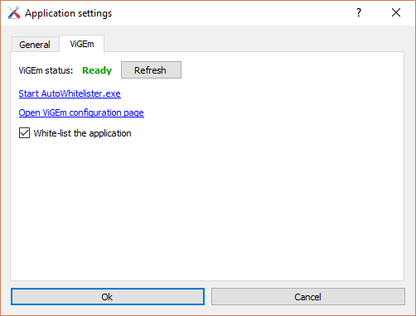

Figure 5: main app settings menu (ViGEm tab)

# Controllers plugins and monitoring app

The base class for ~~real~~ input* joysticks is "AbstractRealJoystick". "RealJoystick" is the standard class for real joysticks and contains a pointer to a QGameController object from the QtGameController module. "EnhancedJoystick" is a decorator class and add several features to an existing real joystick:

* axes curves and trims (see §16.1)
* buttons and axes locking (see §16.2)

You will not have to bother with all these classes as you will only have access to EnhancedJoystick objects.

*as you can also use remote controllers or virtual joysticks as inputs for UJPS.

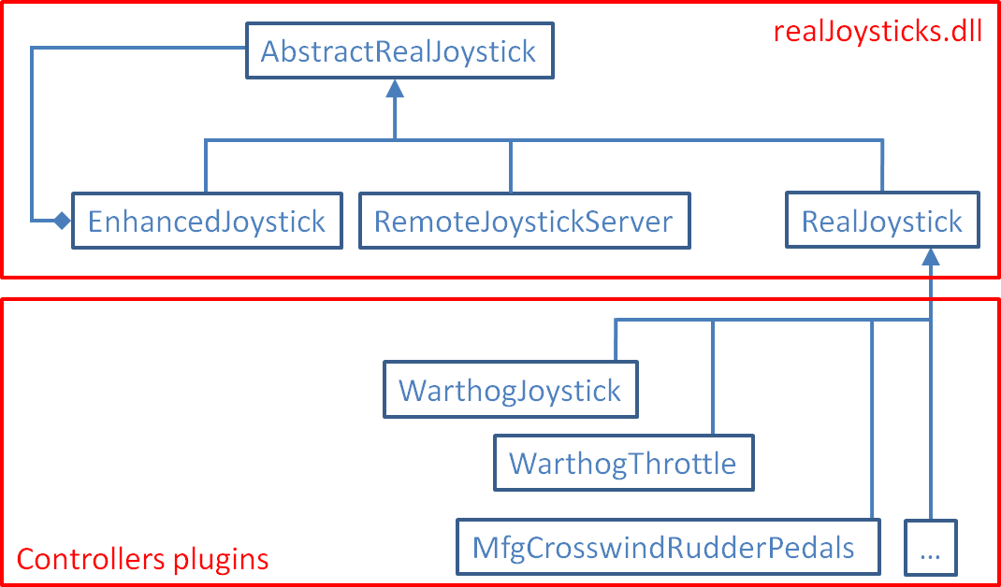

Figure 6: real joysticks classes

The RealJoystick class provides 2 important features:

* It creates 4 virtual buttons for each real POV. It means that when the position of your real POV is not centered, you can see both inputs: one from the POV and another from one of the 4 virtual buttons. It is useful if you want to use a real POV as 4 separate buttons. But it is not a good idea to apply mappings to both the POV and the related buttons (unless you know exactly what you do)
* The same way it also implements a function "addVirtualPov" to create a virtual POV from a 4 buttons-hat. But as it is not possible to know generally what buttons form a hat, virtual POVs creations are done in the controllers plugins

These 2 features give more flexibility: when you have one POV, you can directly use it as 4 buttons, and if you have a 4 buttons-hat you can use it as a POV.

The controllers plugins provide:

* In the INCLUDE directory: a name for each button, axis and POV to be used in your profiles for having a more understandable profile code
* In the SOURCES directory: a name for the each button, axis and POV for display in Monitoring app and AxesCurves (must be in sync with the previous names)
* It is possible to re-order axes, buttons and POVs
* It is possible to add other “virtual” buttons (in addition of the ones added from POV), axes or POVs
* It is possible to reimplement RealJoystick::setData (that does nothing by default), to send data to the joystick. It was useful for led support for Warthog throttle, and it can be for remote joysticks
* … (anything useful I didn't think yet that I or you could implement)

For now I provide only a few plugins, because it needs to be tested to be sure that the names and the buttons or axes matches and I and my friends only own a few of them. But don’t hesitate to contact me if you want that I do one for your controller. Just tell me with no ambiguity which physical axis/button matches which axis/button in Monitoring app (using mode "RealJoystick with no plugin") and what names you want, I will do the plugin and share with everyone. In the meantime you should not be blocked.

The UJPS monitoring app provides 3 different modes:

* 1st: Using DirectInput / XInput: shows what sees the system (XInput is used instead of DirectInput only for Xbox 360 gamepad)
* 2nd: Using RealJoystick class with no plugin: what is seen after the transformations done by RealJoystick class with no controllers plugin
* 3rd: Using RealJoystick class with plugins: what is seen after the transformations done by RealJoystick class with controllers plugins

The following table and images illustrate what can be seen for the Thrustmaster Warthog joystick with each of the 3 modes of the monitoring app. On each of the 3 screenshots, the pov position is pressed up (hat 1 and virtual button 20) and the button 18 is pressed (also virtual hat 4 on left position).

|  |  |  |  |  |
| --- | --- | --- | --- | --- |
| #Mode | What sees | Buttons | Povs | Axes |
| 1st | DirectInput / Windows | 19 real buttons | 1 real pov | 2 |
| 2nd | RealJoystick with no plugin | 19 real buttons + 1 x 4 virtual buttons | 1 real pov | 2 |
| 3rd | RealJoystick with plugins | 19 real buttons + 1 x 4 virtual buttons | 1 real pov + 3 virtual povs | 2 (reordered) |

Figure : Warthog Joystick seen by Monitoring app in the 3 different modes

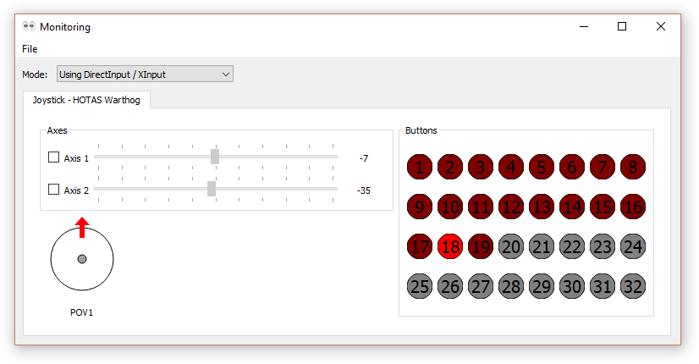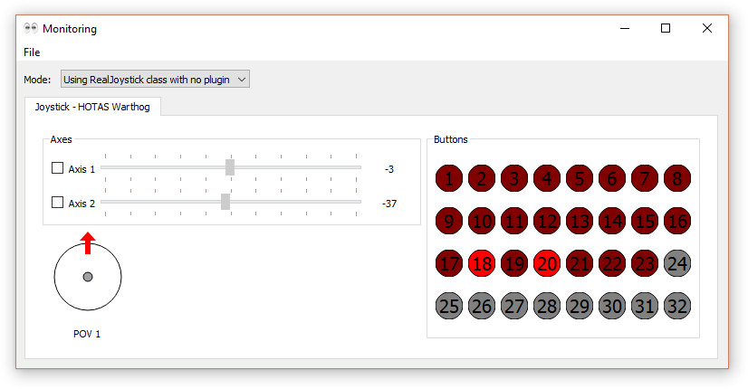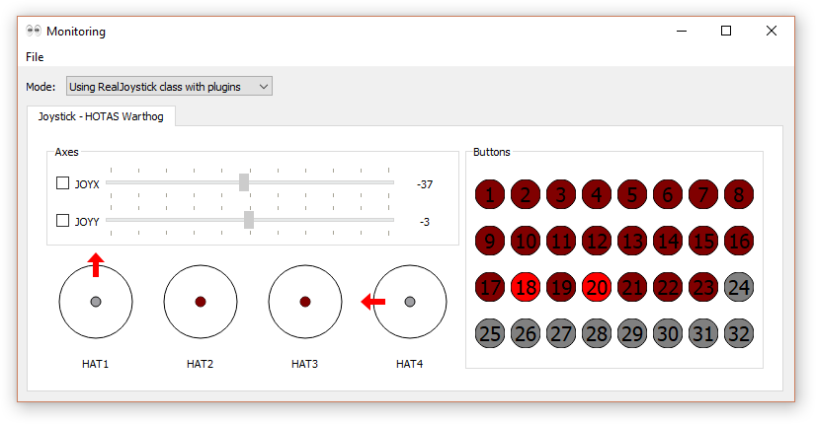

Figure 8: Warthog Joystick seen by Monitoring app in the 3 different modes

**Temporal plot**

If you check the boxes on the left hand of the axes names, a temporal plot will appear with the history of all the values of the checked axes over the last 15 seconds.

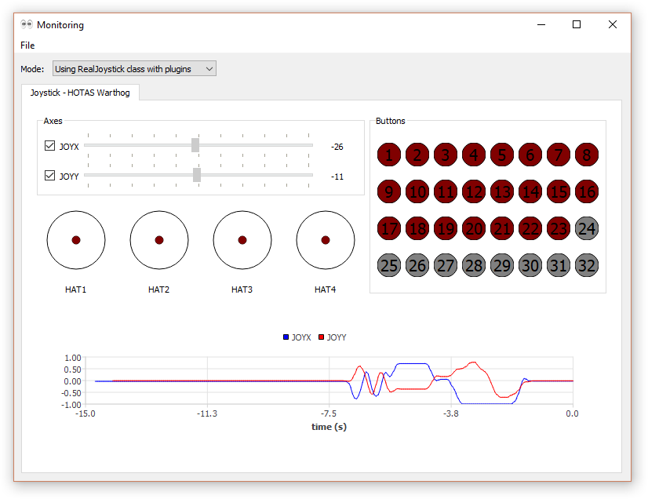

**The setData function**

The AbstractRealJoystick::setData(const QString &s, QVariant v) function is very useful for remote joysticks (see §8) and real joystick that can receive inputs such as leds states, backlight intensity, lcd screen text, ... The first argument is the "property name" and the second one is the associated value.

For now, among the available controllers plugins, only 2 plugins use it, the Warthog throttle for leds and the Xbox 360 gamepad plugin for vibration. Here are the possible properties for the Warthog throttle:

* LED1: provide a Boolean (true to light the led up): tmwt->setData("LED1",false);
* Same for LED2, LED3, LED4 and LED5
* BRIGHTNESS: provide an integer from 0 (off) to 5 (full): tmwt->setData("BRIGHTNESS",1);
* BACKLIT: it controls the backlighting of everything except the 5 leds. A Boolean is expected

The Xbox 360 gamepad has 2 motors, one on the left and one on the right, to create vibrations. The 2 motors generate 2 different types of vibrations. Note that when the profile is stopped, the vibration will be stopped automatically. The 2 useful properties are the following:

* LEFT_MOTOR_SPEED: a double between 0 and 100% is expected
* RIGHT_MOTOR_SPEED: same

**ControllersInfo app**

This app provides basic information about the connected game controllers (using only DirectInput or XInput, not the RealJoystick class). After connecting or disconnecting a controller, you need to use the update action (in the file menu or using the F5 shortcut).

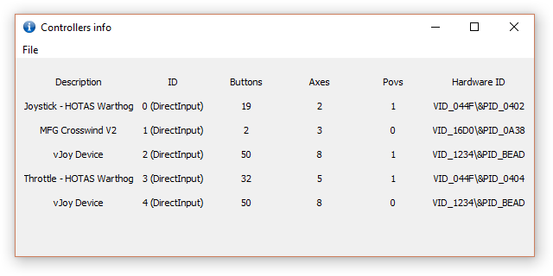

# Remote controllers

## The theory

Remote controllers are a way to further customize one’s setup using screens. It is an application that can run on the same computer or on a tablet or mobile phone connected to the PC. The application uses the provided class “RemoteJoystickClient” to exchange data with the “RemoteJoystickServer” created in the UJPS profile. It often consists in touch-screens used as input-only devices. Remote controllers are also used by Roccat Power Grid or LEA extended input.

Just as any AbstractRealJoystick, such an object can send inputs as buttons and axes, and receive data from the function setData.

To implement one, on the profile side, you have to:

* Define an EnhancedJoystick pointer in the private section of Profile.h:

EnhancedJoystick *erj;

* In setupJoysticks, create the RemoteJoystickServer object. The function will block here waiting for you to connect the client (see further). To construct one you have to provide 4 arguments:
  + Its name. It must be the same as the one sent by the client after it gets connected (see RemoteJoystickClient::description), otherwise it will produce an error… it is done to check that the connected app is the expected one
  + The port to use for the connection. It must be in sync with the one set in the client
  + The id of the joystick. I recommend you to use an index greater than 16 to avoid to use one already used by a real joystick
  + The time (in milliseconds) you let to the user to connect the remote joystick application before sending an error message. You can ignore this argument, in this case the default value will be 10 seconds

emit message("Now connect the client application for the remote controller", Qt::black);

RemoteJoystickServer *rjs = new RemoteJoystickServer{"TouchScreen2",32241,100};

erj = this->registerRealJoystick(rjs);

* Then you just have to use it like any other real joystick

On the client side you have to create your own GUI application, and I do not provide any GUI editor as Roccat or LEA extended input do... but I provide example inspired of "Thrustmaster MFD". So, yes, it is not as easy as the rest of the tool, you have to program your own widget. On the joystick and network side, you just have to reuse the classes I provided in the example:

* Copy as it is RemoteJoystickClient and RemoteJoystickMessageTypes
* Use ConnectionWidget to parameterize connection

## A non-trivial example of what can be done

This example is here to illustrate the possibilities of UJPS when coupling real and remote joysticks, but this is only an example. So imagine you have one (yes, let’s say only one, it will be hard enough ☺) Thrustmaster MFD bezel, one screen behind (with no touch function) and you have no feedback from the game to display on the screen… but this does not mean that each button of the MFD must have only one function.

The screen (on which the remote joystick application is running) will display menus in which we will navigate using the bezel buttons. The profile will send the necessary info to the client so that it knows exactly what it has to render. And function of what the client displays, the profile must know that the inputs from the bezel does not have the same meaning. In fact, we could have an object in the profile that “synchronizes” the bezel and the screen. To simplify, we could do that with a state machine where one state matches a client MFD page and a bezel button action matches a transition or a virtual joystick action (depending on the state).

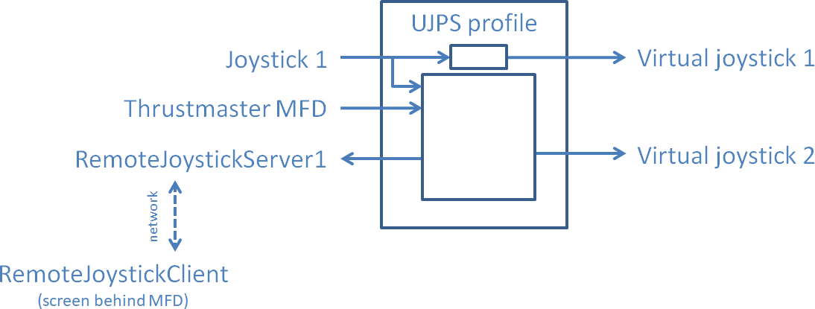

Figure 9: example of profile structure

We could even go further and when a shift button is pressed (see §11) on Joystick 2, use button of Joystick 1 to navigate the MFD page, for example with a 4 direction HAT with a press function.

## Provided examples about MFD

In the "RemoteControllers" sub-directory, 2 examples of MFD remote joysticks are available. Contrary to §8.2, these 2 app implement a "MFD widget". Any of these 2 ones can be run using the profile "ProfileMfd":

* MFD_dumb which just simulates the bezel and send the buttons changes to the profile
* MFD_smart which is more evolved than the first one. It includes a few MFD pages with basic graphics (only text). It does not send button changes, but actions requests which can be different for the same button on different MFD pages

I hope I convinced you that even with no feedback from the game it is possible to do interesting things with remote controllers. But obviously it can now be accessible only to the most courageous or geek ones.

*And I hope I did not lost you, the rest of the manual is really easier!*

# Create a profile

## Profile creation (by manual copy of a provided example)

This step is not yet automated by the main window, so for now you will need to do it manually:

* create a new directory next to the provided example. If you create it somewhere else, you will need to modify some paths in the .pro file
* copy the .pro file for the example. Rename it as you want. Open it and replace the line 2 (the one with "TARGET = ..."), by "TARGET = theNameYouWantForTheProfileDll"
* also copy the CODE directory of the example

## Profile coding

The easier way to do it is to use one of the provided examples as a starting base. You have to create a class derived from AbstractProfile and implement the pure virtual functions "setupJoysticks" and “runFirstStep” and probably reimplement the virtual function "stop". Programmatically speaking, that is the only requirement.

**function setupJoysticks**

This function is executed every time the play button is pressed in the main window. It can be executed several times on the same object (but you have to press stop between 2 presses on play). Your implementation of this function should do the following operations:

* 1. Common to real and virtual joysticks:
  + a. In a private section of Profile.h, declare an EnhancedJoystick pointer for each real joystick (or remote one) and a pointer to a VirtualJoystick for each virtual joystick you will use in your profile.

EnhancedJoystick *tmwj; // for Thrustmaster Warthog Joystick

EnhancedJoystick *tmwt; // for Thrustmaster Warthog Throttle

VirtualJoystick *vj1; // virtual joystick #1

VirtualJoystick *vj2; // virtual joystick #2

* + b. Initialize them at nullptr in the Profile constructor.

tmwj = nullptr;

tmwt = nullptr;

vj1 = nullptr;

vj2 = nullptr;

* 2. Setup the real joysticks:
  + a. In the setupJoysticks function, use the registerRealJoystick function to retrieve an EnhancedJoystick pointer to the real joysticks you are interested in. If you have no joystick with this description currently connected and recognized by the system, nullptr will be returned. To be sure to make a mistake in the spelling of the description, you can use the variable "Description" contained in the namespace corresponding to the controller you are interested in:

tmwj = this->registerRealJoystick("Joystick - HOTAS Warthog");

tmwt = this->registerRealJoystick(TMWT::Description);

* + b. It is a good idea to send a message in the main window to keep the user aware of what is happening.

if (tmwj) {emit message("Warthog joystick detected !",Qt::black);}

else {emit message("Warthog joystick not detected !",Qt::red);}

if (tmwt) {emit message("Warthog throttle detected !",Qt::black);}

else {emit message("Warthog throttle not detected !",Qt::red);}

if (!tmwj || !tmwt) {return false;}

* 3. Setup the virtual joysticks: it is done just as real ones. The difference is that we just need to provide the id of the virtual joystick:

vj1 = this->registerVirtualJoystick(1);

if (vj1) {emit message("Virtual joystick 1 acquired",Qt::black);}

else {emit message("Virtual joystick 1 failed to configure",Qt::red);}

vj2 = this->registerVirtualJoystick(2);

if (vj2) {emit message("Virtual joystick 2 acquired",Qt::black);}

else {emit message("Virtual joystick 2 failed to configure",Qt::red);}

return (tmwj && tmwt && vj1 && vj2);

**function runFirstStep**

The first time step is dedicated to the definition of your mappings. To do so, process this way:

* 1. Register shift buttons for layers. For details about layers see §11.

this->registerLayerDim1(Layers::In, tmwt, TMWT::MSD);

this->registerLayerDim2(Layers::Up, tmwt, TMWT::BSF);

this->registerLayerDim2(Layers::Down, tmwt, TMWT::BSB);

* 2. It is advised to initialize the virtual joysticks buttons and axes taking into account the position of real joysticks buttons and axes so that they are in sync at the start. Otherwise maybe a movement will be needed to get them in sync. Here is a simple example:

vj1->resetReport();

vj1->setButton(VJOY::DX1,tmwj->buttonPressed(TMWJ::TG1));

vj1->setAxisValue(VJOY::Y,tmwt->axisValue(TMWT::THR_LEFT));

* 3. Create the initial mappings using the functions Map, MapButton, MapAxis,MapAxis1, … that are explained further.

**function stop**

The default implementation of the stop function (AbstractProfile::stop) does the following:

* deletes all mappings and mappings modifications pending requests
* deletes info about layers configuration
* clear joystick changes
* delete all registered real and virtual joysticks

There is no strict need to reimplement the stop function, but you might want to do some additional things than the default implementation. In the next example, the stop function do the following:

* set the brightness of the Warthog throttle leds to 0
* call the default implementation to do the necessary cleaning (it is mandatory)
* reinitialize the deleted pointers to nullptr

// set led brightness at 0

if (tmwt)

{

tmwt->setData("BRIGHTNESS",0);

tmwt->flush();

}

// UnmapAll, delete real and virtual joysticks

this->AbstractProfile::stop();

// it is a good idea to set them to nullptr

tmwj = nullptr;

tmwt = nullptr;

vj1 = nullptr;

vj2 = nullptr;

## Profile compilation

Programmers may not need advices on this point, especially if you use an IDE and that you integrated Qt into it. For others, if you use Qt 5 with a MinGw compiler (only slight adjustments should be needed for other compilers) you can:

* use the compilation widget of the main window (§5)
* compile your profile with a bat file (examples are provided for MinGw compiler)

# What is under the hood

This part is essential for a full comprehension of the tool if you want to write your own triggers, actions or mappings.

UJPS relies on what we call "mappings". A mapping is a sort of connection between a real joystick event and a virtual joystick event. A profile includes a whole set of mappings and each mapping is tested at each time step. The different pre-defined mappings are explained in §14.

At each time step, the run function of AbstractProfile is run. It performs exactly the following steps:

* A. Read the events coming from every registered real joystick
* B. Compute the current layer given the shift buttons positions (see §11)
* C. For each real joystick event, look which mappings it triggers (only among the mappings that can be triggered by events), and for each triggered mapping, perform the associated action (only post events in a queue)
* D. Look for all triggered mappings (only among the mappings that can be triggered by "states", as contrary to "events") and for each triggered mapping, perform the associated action (only post events in a queue)
* E. Perform all the keyboard events (available only for Windows for now), and call setAxis and setButton functions of VirtualJoystick
* F. Call sendReport function of each registered virtual Joystick to send the new buttons and axes positions to the vJoy driver
* G. Process pending events. If a callback, from an ActionCallback (see §13.6), is called at step C or D, and if the callback contains calls to some Map or Unmap functions, the mappings are not deleted (only disabled) or added during C or D step, but now

Additional custom mappings, triggers and actions classes can be added to add new features to the software. To do so you have to sub-class respectively AbstractMapping, AbstractTrigger or AbstractAction. Before doing so, take a look at the existing one to understand how it works.

# Layers and LayersCombos

## LayersCombos as mapping filters

Each mapping is given only for a set of layers, called a "layers combo". It means that if the current layer is included in the layers combo of the mapping, the mapping can be triggered, otherwise it is not possible. The layer combo of the mapping acts as a filter.

The definition of a layer is the same of in Thrustmaster TARGET, but the way we use it is a bit different. In TARGET, when you map a button (for example), you have to specify the action for each layer and puts 0 for the layers where you want to do nothing. The following example should be clearer than a long speech:

In TARGET: MapKeyIOUMD(&Joystick, TG1, DX1, DX1, DX1, DX2, DX2, 0);

In UJPS:

MapButton(tmwj, TMWJ::TG1, {"i"}, vj1, VJOY::DX1);

MapButton(tmwj, TMWJ::TG1, {"od|om"}, vj1, VJOY::DX2);

## Definition of a layer

The ones that are not used to Thrustmaster concept of layers should not have understand anything of the previous lines, this is perfectly normal. Now is time for more explanations. The layers in UJPS is implemented just as in TARGET and is not customizable profile by profile in the current version V1.0.0.

Layers can be seen as a way to give different functions to a same button / axis. It can be seen different ways: as shifting (as the shift or control keys of a keyboard) or as different "modes" (e.g. air/air or air/ground modes for military aircraft simulations). The implementation of the layers is 2-dimensional: one dimension with 2 possibilities "In" and "Out", another with 3 possibilities "Down", "Middle" and "Up". Don't focus on the names they are not really meaningful!

|  |  |  |  |
| --- | --- | --- | --- |
| Layers | | Dim 1 | |
| **Out** | In |
| Dim 2 | Down | OD | ID |
| **Middle** | **OM** | IM |
| Up | OU | IU |

Figure 10: built-in fixed layers as in Thrustmaster TARGET

The default layer is Out / Middle. It is generally used as the layer when none of the "shift buttons" are pressed.

## Registering shift buttons

To register a shift button, you have specify the dimension, the sub-layer, a pointer the real joystick and the number of the button. Usually you do so in the play function of the profile (Profile.cpp):

this->registerLayerDim1(Layers::In, tmwt, TMWT::MSD);

this->registerLayerDim2(Layers::Down, tmwt, TMWT::BSB);

this->registerLayerDim2(Layers::Up, tmwt, TMWT::BSF);

It is also perfectly possible to define buttons for Out and Middle sub-layers, but to understand what can be the interest of it, look at the next part.

## How is computed the current layer

The current layer is computed using the registered shift buttons, their associated sub-layer and the current state of these buttons. The exact algorithm, in pseudo-code, is the following:

// initialize with default

subLayer1 = Out;

subLayer2 = Middle;

for each d1 in dim1ShiftButtons // one item per call of registerLayerDim1

if d1.button.isPressed

subLayer1 = d1.subLayer1; break;

for each d2 in dim2ShiftButtons // one item per call of registerLayerDim2

if d2.button.isPressed

subLayer2 = d2.subLayer2; break;

currentLayer = (subLayer1,subLayer2);

So the priority is given to the shift button registered first. And if none of the registered buttons is pressed, the default sub-layer is used. If you understand exactly how the algorithm works, you can try to play more with "registerLayerDim1 and 2".

## Constructing LayersCombo

To specify a LayersCombo to a mapping, you have to construct one. Simple first: if you want that your mapping is activated for all layers, you can just provide "AllLayers". It is a global variable that covers all layers. To do so you can also provide a default-constructed LayersCombo. The 3 next lines are equivalent:

MapButton(tmwj, TMWJ::TG1, AllLayers, vj1, VJOY::DX1);

MapButton(tmwj, TMWJ::TG1, LayersCombo{}, vj1, VJOY::DX1);

MapButton(tmwj, TMWJ::TG1, {}, vj1, VJOY::DX1);

If you don't want to specify all layers in your LayersCombo, you have to initialize it with a string. The accepted characters are "i", "o", "d", "m", "u", "|" and you can spaces wherever you want. Please refer to table 1 when reading the following lines:

* "i" means ID, IM and IU (the "In" column)
* "o" means OD, OM and OU (the "Out" column)
* "io" means AllLayers
* "u" means OU and IU (the "Up" line)
* "m" means OM and IM (the "Middle" line)
* "d" means OD and ID (the "Down" line)
* "md" means OD, ID, OM and IM (the "Middle" and "Down" lines)
* "umd" means AllLayers
* ...

And you can also combined several ones with a "|":

* "od | im" means OD and IM
* "od | id" is equivalent to "d"
* "md" is equivalent to "m|d"
* "im" means IM and is not equivalent to "i|m" that means ID, IM, IU and OM

# Button / axis / pov mapping basics

**MapButton, MapAxis and MapPov**

To perform the simplest bindings, i.e. reproduce the state / value of a button / axis / pov from a real joystick to a virtual one, you can simply call the "MapButton", "MapAxis" or "MapPov" functions:

MapButton(tmwj, TMWJ::H2L, AllLayers, vj1, VJOY::DX32);

MapAxis(tmwj, TMWJ::JOYX, AllLayers, vj1, VJOY::X, AxisDirection::Reversed);

MapPov(tmwj, TMWJ::HAT1, AllLayers, vj1, VJOY::POV1);

Where tmwj is a pointer to the EnhancedJoystick embedding the Warthog joystick and vj1 a pointer to the virtual joystick 1. The first line links the H2L button of the Warthog joystick with the button 32 of the virtual joystick 1. The second one links the JOYX axis to the X axis but reversed. To not reverse, just specify "Normal" instead of "Reversed". And the third line maps the HAT1 of the Warthog to the first pov of the virtual joystick.

Be aware that if your profile only uses these 2 functions, there is strictly no interest to use UJPS... or any software for joystick programming.

**Unmapping**

You can also delete bindings by calling the following functions (from class AbstractProfile):

UnmapAll();

UnmapButton(tmwj,TMWJ::TG1);

UnmapAxis(tmwj,TMWJ::JOYX);

UnmapPov(tmwj,TMWJ::HAT1);

**Very important:** these unmapping functions are very useful, as by default in UJPS, when you map a button / axis / pov to a virtual joystick control, it does not replace any existing mapping. So if you do:

MapButton(tmwj, TMWJ::H2L, AllLayers, vj1, VJOY::DX31);

MapButton(tmwj, TMWJ::H2L, AllLayers, vj1, VJOY::DX32);

when the button H2L is pressed, both DX31 and DX32 buttons of the virtual joystick 1 will be pressed.

**Get functions:** real and virtual joysticks has the following functions available:

* bool buttonPressed(uint buttonNumber) that returns a Boolean
* float axisValue(uint axisNumber) that returns a float between -1 and +1
* float povValue(uint povNumber) that return a float which is:
  + -1 for center position
  + a value between 0 (included) and 360 (excluded) that represents the direction of the pov: 0 is for north, 90 for east, ... the maximum accuracy is 0.01°.

**Set functions:** virtual joysticks has the following functions available. These are used internally by the mappings, but they are also very useful for custom callbacks (for "axes switching" for example). See §13.6 for details on ActionCallback.

* void VirtualJoystick::setButton(uint buttonNumber, bool bPressed);
* void VirtualJoystick::setAxis(uint axisNumber, float axisValue);
* void VirtualJoystick::setPov(uint povNumber, float povValue);

# Pre-defined actions

All action classes inherit from the AbstractAction class.

## Actions about buttons

**ActionButtonSetChange**

The action ActionButtonSetChange reacts only to changes (on real joysticks) and uses the new real joystick button state to reproduce it on the button of the virtual joystick. It is useful to do a "simple button binding". To construct one you have to specify a pointer to the virtual joystick and the number of the button.

ActionButtonSetChange(VirtualJoystick*,uint)

To perform a "simple button binding", you can use one of the 2 following lines, they are exactly equivalent:

MapButton(tmwj, TMWJ::H2L, AllLayers, vj1, VJOY::DX128);

Map(tmwj, ControlType::Button, TMWJ::H2L, AllLayers,

new TriggerButtonChange{},

new ActionButtonSetChange{vj1,VJOY::DX128}

);

Any of these 2 instructions links directly the button H2L of the Warthog Joystick (pointed by tmwj in this example) to the button 128 of the first virtual joystick (pointed by vj1 in this example) for all layers.

**ActionButtonSetChangeOpposite**

The action ActionButtonSetChangeOpposite do the same but the value of the button of the virtual joystick will be the opposite of the value of the real joystick button.

Map(tmwj, ControlType::Button, TMWJ::H2L, AllLayers,

new TriggerButtonChange{},

new ActionButtonSetChangeOpposite{vj1,VJOY::DX128}

);

**ActionButtonToggle**

The action ActionButtonToggle is constructed using the same arguments but when activated this action inverts a virtual joystick button. This action is not meant to be activated so often (i.e. not at each time step for example) as otherwise the virtual joystick button will be toggled at each time step.

Map(tmwj, ControlType::Button, TMWJ::H2L, AllLayers,

new TriggerButtonPress{},

new ActionButtonToggle{vj1,VJOY::DX128}

);

**ActionButtonPulse**

The action ActionButtonPulse is constructed using an additional argument, the number of cycles of the pulse. You can easily transform a time interval in milliseconds into a number of cycles using the ms2cycles function. This way, whatever the time step is (it is the time step specified in the main window) the pulse will last the same duration.

Map(tmwj, ControlType::Button, TMWJ::H2L, AllLayers,

new TriggerButtonPress{},

new ActionButtonPulse{vj1,VJOY::DX128,ms2cycles(500)}

);

With the above line, when the H2L button is pressed (passes from up to down position, not is in the down position), a pulse of 500 ms on the 128th button of virtual joystick 1 is performed.

**ActionButtonPress** and **ActionButtonRelease**

These 2 actions are used to press or release a button of a virtual joystick when activated. With this you can for example press a virtual button when one real button is pressed and release it when another real button is pressed:

Map(tmwj, ControlType::Button, TMWJ::H2L, AllLayers,

new TriggerButtonPress{},

new ActionButtonPress{vj1,VJOY::DX128}

);

Map(tmwj, ControlType::Button, TMWJ::H2R, AllLayers,

new TriggerButtonPress{},

new ActionButtonRelease{vj1,VJOY::DX128 }

);

## Actions about axes

**ActionAxisSetChange**

The action ActionAxisSetChange reacts only to changes (on real joysticks) and uses the new real joystick axis state to reproduce it on the axis of the virtual joystick. It is useful to do a "simple axis binding". Curves and trims are defined separately (see §16.1) but with this action you can reverse the direction. To construct one you have to specify a pointer to the virtual joystick, the number of the axis and the direction ("Normal" or "Reversed").

ActionAxisSetChange(VirtualJoystick*,uintvAxis, uintaxisDirection)

To perform a "simple axis binding", you can use one of the 2 following lines, they are exactly equivalent:

MapAxis(tmwj, TMWJ::JOYX, AllLayers, vj1, VJOY::X, Reversed);

Map(tmwj, ControlType::Axis, TMWJ::JOYX, AllLayers,

new TriggerAxisChange{},

new ActionAxisSetChange{vj1,VJOY::X,AxisDirection::Reversed}

);

Any of these 2 instructions links directly the axis JOYX of the Warthog Joystick (pointed by tmwj in this example) to the axis X of the first virtual joystick (pointed by vj1 in this example) for all layers.

**ActionAxisIncrement**

The action ActionAxisIncrement is useful to create an axis from buttons.

Map(tmwj, ControlType::Button, TMWJ::H1L, AllLayers, new TriggerButtonPress{}, new ActionAxisIncrement(vj1,VJOY::Z, 0.05f));

Map(tmwj, ControlType::Button, TMWJ::H1L, AllLayers, new TriggerButtonState{true}, new ActionAxisIncrement(vj1,VJOY::Z, 0.01f));

Map(tmwj, ControlType::Button, TMWJ::H1R, AllLayers, new TriggerButtonPress{}, new ActionAxisIncrement(vj1,VJOY::Z,-0.05f));

Map(tmwj, ControlType::Button, TMWJ::H1R, AllLayers, new TriggerButtonState{true}, new ActionAxisIncrement(vj1,VJOY::Z,-0.01f));

With this example, the buttons H1L and H1R are used to control the axis Z of the virtual joystick 1. When H1L is pressed the value of the axis increases of 0.06, then it increases of 0.01 until the Z axis reaches the maximal value of 1 or until the H1L button is released.

**ActionAxisSetValue**

This action allows to set a given value to a virtual joystick axis when it is triggered. Contrary to ActionAxisSetChange, the value is fixed at the definition of the mapping. In the following example, when the H2R button of the Warthog is pressed, the X axis value of the virtual joystick is set to 0.5.

Map(tmwj, ControlType::Button, TMWJ::H2R, AllLayers,

new TriggerButtonPress{},

new ActionAxisSetValue{vj1,VJOY::X,0.5}

);

## Actions about keyboard

As much as possible, you should prefer to use virtual joystick instead of keyboard actions. Indeed, if you have many keyboard actions, you will need to use modifiers, and some issues can arise. For example if you generates LCtrl+A and LShift+B, the game could also see more inputs: LCtrl+B and/or LShift+A. Keyboard actions are only supported on Windows for now.

**ActionKeySetChange** and **ActionKeySetChangeOpposite**

Just like ActionButtonSetChange and ActionButtonSetChangeOpposite, these 2 actions react only to changes. When a change is noticed on the source button, the key is changed accordingly (or oppositely). Modifiers can be used. The prototypes of the constructors are the following:

ActionKeySetChange(uint key, uint modifier = 0)

ActionKeySetChangeOpposite(uint key, uint modifier = 0)

In the file WindowsKeys.h, also available in the Annex (§20.4) you can find all the available keys names. Here is an example of code:

Map(tmwj, ControlType::Button, TMWJ::H2L,

new TriggerButtonChange{},

new ActionKeySetChange{Key_Alt}

);

**ActionKeyPress**, **ActionKeyRelease** and **ActionKeyPulse**

Just like ActionButtonPress, ActionButtonRelease and ActionButtonPulse, there are the analog actions for keyboard keys: ActionKeyPress, ActionKeyRelease and ActionKeyPulse. Modifiers can be used. There is no modifier by default. The prototypes of the constructors are the following:

ActionKeyPress(uint key, uint modifier = 0)

ActionKeyRelease(uint key, uint modifier = 0)

ActionKeyPulse(uint key, uint modifier = 0, uint cycles = 4)

Here is an example of code:

Map(tmwj, ControlType::Button, TMWJ::H3U, AllLayers,

new TriggerButtonPress{},

new ActionKeyRelease(Key_Tab,Key_LShift)

);

Map(tmwj, ControlType::Button, TMWJ::H3R, AllLayers,

new TriggerButtonPress{},

new ActionKeyPulse(Key_M,0,ms2cycles(60))

);

With this example, when the H3U button is pressed, the "Left Shift + Tab" keystroke is release. And when the H3R button is pressed, a pulse of 60 ms on the "M" key is performed.

## Actions about povs

**ActionPovSetChange** and **ActionPovSetValue**

They work exactly as ActionAxisSetChange and ActionSetValue but for povs. If the value provided to ActionPovSetValue is not between 0 (included) and 360 (excluded), the pov position is set as centered.

## Actions Chain, Delay and Sequence

The users of Thrustmaster TARGET scripts should recognize these actions. The definition is exactly the same as in Thrustmaster.

**ActionChain and Delay**

A chain action is useful to perform several actions at the same time. The actions are not done at the same only if you use a delay in the chain:

Map(tmwj, ControlType::Button, TMWJ::H1U, AllLayers, new TriggerButtonPress{}, new ActionChain({

new ActionKeyPulse(Key_A,0,ms2cycles(60)),

new Delay{ms2cycles(150)},

new ActionKeyPulse(Key_B,0,ms2cycles(60))})

);

The above code performs a pulse on the "A" key and 150 ms later another one on the "B" key. If the time of the delay is smaller than the time of the first pulse, the "B" key gets pressed before the "A" key gets released.

**ActionSequence**

An sequence is used to generate different actions each time it is activated. Once all sub-actions have been performed, it starts again with the first one.

Map(tmwj, ControlType::Button, TMWJ::H1D, AllLayers, new TriggerButtonPress{}, new ActionSequence{

new ActionKeyPulse(Key_C,0,ms2cycles(60)),

new ActionKeyPulse(Key_D,0,ms2cycles(60))}

);

When you press several times the H1D button, it will generate pulses on "C" key the first time, "D" key the second time, "C" key the third time, ...

And you can combine chains with sequences at will...

## Executing a custom function

**ActionCallback**

The ActionCallback is used to execute a custom function when it is activated. It is the equivalent of the "EXEC" feature of Thrustmaster scripts. To construct one, you must provide a std::function object (or something that can be converted to, such as a pointer to a function that takes no argument and has no return, or a compatible lambda).

ActionCallback(std::function<void()>)

Here is an example of use with both std::bind and a lambda for a Profile member function. Of course the same can be done with non-members functions be it has less interest:

void Profile::myMemberFunction()

{

// just a few random instructions for the example

DoAction(new ActionButtonPulse{vj1,VJOY::DX13,ms2cycles(50)});

UnmapButton (tmwj, TMWJ::S4);

MapButton (tmwj, TMWJ::S4, vj1, VJOY::DX1);

vj1->setAxis(VJOY::Z,0f);

}

// with std::bind

Map(tmwj, ControlType::Button, TMWJ::TG1, AllLayers,

newTriggerButtonPress{},

newActionCallback(std::bind(&Profile::myMemberFunction,this))

);

// with a lambda

Map(tmwj, ControlType::Button, TMWJ::TG1, AllLayers,

newTriggerButtonPress{},

newActionCallback([this](){this->myMemberFunction();})

);

When the TG1 button gets pressed the member function "myMemberFunction" is executed. Here is another example with a lambda:

auto trimRandomY = [this](){tmwj->setAxisTrim(TMWJ::JOYY,((float)rand()/(float)RAND_MAX)*2.0f-1.0f);};

Map(tmwj, ControlType::Button, TMWJ::TG2, AllLayers, new TriggerButtonPress{}, new ActionCallback(trimRandomY));

In the above example, when the TG2 button gets pressed, the axis JOYY of the Warthog joystick is trimmed with a random value.

## Regularly execute an action or a function

This feature, that we will call "Rexec" allows to execute an action or a function at constant intervals. For users that have already used Thrustmaster scripts, it is equivalent to the REXEC function with the RNOSTOP optional flag. This feature relies on 2-3 functions of "AbstractProfile": one function to start it and another to stop it. Here are their prototypes:

bool startRexec(uint id, uint cycles, AbstractAction *action);

bool startRexec(uint id, uint cycles, std::function<void()> fct);

bool stopRexec(uint id);

Each "rexecuted action / function" is linked to a unique id: if we call "startRexec" with an id that is owned by another "rexecuted action / function" which is already running, it will return false. The same way if you call "stopRexec" with an id that is not "currently used / running", it will return false. Here is a first example with an action:

actionTestRexec = new ActionButtonPulse{vj2,VJOY::DX1,ms2cycles(100)};

Map(tmwj, ControlType::Button, TMWJ::H2L, AllLayers, new TriggerButtonPress{}, new ActionSequence{{

new ActionCallback{[this](){this->startRexec(0,ms2cycles(1000),actionTestRexec);}},

new ActionCallback{[this](){this->stopRexec(0);}}

}});

Remark: "actionTestRexec" is a member of the profile class and must be deleted into the destructor to avoid memory leak. Look at the example "ProfileTest" for more details.

When H2L is pressed the first time, the action starts repeating every 1000 ms, and the second time it stops. The third time it restarts, ... The following example uses a function object (using a lambda) and different buttons for starting and stopping. The resulting behavior of this example is equivalent to Thrustmaster REXEC function without the RNOSTOP flag:

auto sendMessage = [this](){emit message("Test Rexec",Qt::cyan);};

Map(tmwj, ControlType::Button, TMWJ::H2L, AllLayers, new TriggerButtonPress{}, new ActionCallback{[this,sendMessage](){this->startRexec(1,ms2cycles(1000),sendMessage);}});

Map(tmwj, ControlType::Button, TMWJ::H2R, AllLayers, new TriggerButtonPress{}, new ActionCallback{[this](){this->stopRexec(1);}});

# Pre-defined mappings

## MappingStandard

A "standard mapping" uses one trigger and one action. When the current layer is in the mapping's layers combo and that the "trigger is triggered", the mapping performs its action. This is a very versatile mapping that can cover most of our needs, as they are already many different pre-defined triggers and actions and as you can easily create new ones. To use standard mapping, you have to use the "Map" function of the AbstractProfile class:

void Map(AbstractRealJoystick *rj, ControlType type, uintrnum, LayersCombo, AbstractTrigger*, AbstractAction*);

The "ControlType" argument must be "Button" or "Axis" and "rnum" is the number of the button or axis.

## MappingTempo

But we cannot do everything with a standard mapping. The "tempo" mapping can be only linked to real buttons, not axes. The principle is that if the button is pressed less than a given Δt the action1 is performed, otherwise once the button has been pressed during Δt the action2 is performed. To create one and append it to existing mappings, you have to use the "MapButtonTempo" function of AbstractProfile class:

voidMapButtonTempo(AbstractRealJoystick *rj, uintrButton, LayersCombolc, uint cycles, AbstractAction*act1, AbstractAction *act2);

## MappingAxis1

The "MappingAxis1" is equivalent to the "AXMAP1" of Thrustmaster TARGET. It is used to map one real axis to 2 virtual buttons. The axis is split in a given number of areas and:

* each time the axis changes of area for the one above, actionPlus is performed
* each time the axis changes of area for the one below, actionMinus is performed

To define the areas you can provide:

* a number: the areas will be distributed uniformly
* breakpoints defining the limits between the areas: N points means N+1 areas

MapAxis1(tmwj, TMWJ::JOYY, AllLayers, 5, actionPlus, actionMinus);

MapAxis1(tmwj, TMWJ::JOYY, AllLayers, {-0.9,-0.3,0.3,0.9}, actionPlus, actionMinus);

The following figure shows what is obtained when you ask for 5 points. You obtain the same thing if you provide the values {-0.8, -0.4, 0, 0.4, 0.8}.

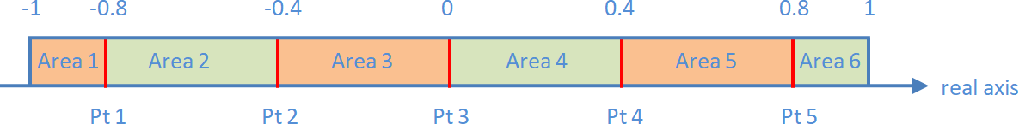

Figure 11: definition of areas

## MappingAxis2

The "MappingAxis2" uses the same splitting into areas than the "MappingAxis1" but there is no just 2 actions function of the direction of the movement, but one action per area: when the axis enters this area, the action of the area is performed. As for "MappingAxis1" you can provide the number of points or a list of breakpoints. If the number of points is different than the number of actions plus 1, an exception is thrown. It will be caught by the main window and everything that should have been done after is skipped.

MapAxis2(tmwj, TMWJ::JOYY, AllLayers, {-0.9,-0.3,0.3,0.9},{

newActionKeyPulse(Key_Numpad1,0,ms2cycles(30)),

newActionKeyPulse(Key_Numpad2,0,ms2cycles(30)),

newActionKeyPulse(Key_Numpad3,0,ms2cycles(30)),

newActionKeyPulse(Key_Numpad4,0,ms2cycles(30)),

newActionKeyPulse(Key_Numpad5,0, ms2cycles(30))

});

## MappingAxisRelative

This mapping makes an integration (mathematically speaking) of the real joystick axis to compute the virtual joystick axis value: when the real axis value is positive the virtual one increases and vice-versa. The virtual axis deflection is limited between -1 and 1. To use it you proceed as follows. The last argument is the time (in milliseconds) needed for the virtual axis to go from one extreme value to the other when the real joystick axis is at its extreme value.

MapAxisRelative(tmwj, TMWJ::JOYY, AllLayers, vj1, VJOY::Z, 4000.0f);

It performs exactly the following computation:

$$vAxisValue= \lim_{-1→1}\left(vAxisValue+2\frac{Δt}{T}rAxisValue\right)$$

$$where Δt is the time step and T the last parameter$$

## MappingMergeAxes

This mapping merges 2 axes into one, using a weighted sum. In the following example, when at least one of the 2 brake pedals of the MFG crosswind moved, the Y axis of the first virtual joystick is set with the difference between the axes values of the 2 brake pedals (BRK_LEFT and BRK_RIGHT). A 0.5 factor is applied because we want the output to be in the range [-1,1] with no saturation.

MapMergeAxes(mfgx, MFGX::BRK_LEFT, 0.5f, mfgx, MFGX::BRK_RIGHT, -0.5f, AllLayers, vj1, VJOY::Y);

It is even possible to define an axis curve for the "resulting virtual merged axis", using an additional (and optional) argument.

MapMergeAxes(mfgx, MFGX::BRK_LEFT, 0.5f, mfgx, MFGX::BRK_RIGHT, -0.5f, AllLayers, vj1, VJOY::Y,

new MyAxisCurve{}

);

It is indeed not equivalent to apply a curve to the 2 input axes ( $y= k_{1}f\left(x_{1}\right)+k_{2}f(x_{2}))$ than applying it to the merged axis ($y=f(k_{1}x_{1}+k_{2}x_{2}))$. See §16.1 for more info about axes curves.

## MappingSplitAxis

This mapping is the contrary than the previous one: it splits one real axis into 2 virtual ones, the first virtual one for the negative part and the second one for the positive part. Here is an example:

MapSplitAxis(tmwj, TMWJ::JOYY, AllLayers, vj1, VJOY::ROTX, vj1, VJOY::ROTY);

To go more into the details and better understand how it works exactly, here are the calculations that are made:

* if the real axis position (that we will call x) is negative:
  + the first virtual axis position (y1) equals -2x-1
  + the second virtual axis position (y2) is -1, i.e. the minimum
* if x is positive
  + y1 = -1
  + y2 = 2x-1

# Pre-defined triggers for "standard mapping"

All trigger classes inherit from AbstractTrigger. The triggers does not know what button or axis they are watching, only the mapping has that information and give the trigger that info when calling the isTriggered function of the triggers. That is why we don't specify the real joystick and the axis / button number when creating a trigger.

## Triggers about buttons

**TriggerButtonChange**

Such objects are triggered when the button is pressed or released. The constructor takes no argument. It reacts only to changes.

Map(tmwj, ControlType::Button, TMWJ::H2L, AllLayers,

newTriggerButtonChange{},

newActionButtonSetChangeOpposite{vj1,VJOY::DX128}

);

**TriggerButtonPress** and **TriggerButtonRelease**

Such objects are triggered when the button is pressed / released. The constructor takes no argument. It reacts only to changes.

Map(tmwj, ControlType::Button, TMWJ::H2L, AllLayers,

newTriggerButtonPress{},

newActionButtonPulse{vj1, VJOY::DX127,ms2cycles(500)}

);

Map(tmwj, ControlType::Button, TMWJ::H2L, AllLayers,

newTriggerButtonRelease{},

newActionButtonPulse{vj1,VJOY::DX128,ms2cycles(500)}

);

**TriggerButtonState**

Such objects are triggered when the button is down (if true is provided to the constructor) or up (if false is provided to the constructor). The condition is evaluated at each time step. The constructor takes one argument, a Boolean.

Map(tmwj, ControlType::Button, TMWJ::H1L, AllLayers, new TriggerButtonPress{}, new ActionAxisIncrement(vj1,VJOY::Z, 0.05f));

Map(tmwj, ControlType::Button, TMWJ::H1L, AllLayers, new TriggerButtonState{true}, new ActionAxisIncrement(vj1,VJOY::Z, 0.01f));

Map(tmwj, ControlType::Button, TMWJ::H1R, AllLayers, new TriggerButtonPress{}, new ActionAxisIncrement(vj1,VJOY::Z,-0.05f));

Map(tmwj, ControlType::Button, TMWJ::H1R, AllLayers, new TriggerButtonState{true}, new ActionAxisIncrement(vj1,VJOY::Z,-0.01f));

## Triggers about axes

**TriggerAxisChange**

Such objects are activated every time a physical axis moves. A trigger of this type is created when the "simple axis mapping" function "MapAxis" is called. The constructor takes no argument.

Map(tmwj, ControlType::Axis, TMWJ::JOYX, AllLayers,

newTriggerAxisChange{},

newActionAxisSetChange{vj1,VJOY::X,AxisDirection::Normal}

);

**TriggerAxisChangeComparison**

Such objects are activated every time a physical axis moves and that the comparison test is passed. The constructor is the following:

TriggerAxisChangeComparison(bool bGreaterThan, float threshold)

If "bGreaterThan" is true the comparison test is "> threshold", otherwise it is "< threshold".

## Triggers about povs

**TriggerPovChange**

This object is activated anytime the source pov value changes. It is analog to TriggerAxisChange. It is internally used by the MapPov function, but you can also use it yourself in a standard mapping.

# Other features

## Axis trim and curves

The provided utility program "AxesCurves.exe" allows you to tune your curves and trims.

The function EnhancedJoystick::axisValue, which implements the pure virtual function AbstractRealJoystick::axisValue, returns the position of the axis taking the curve and the trim into account. If you need to access to the raw position of the axis, you can use the function EnhancedJoystick::rawAxisValue.

**Axis trimming**

The curve is applied to the EnhancedJoystick objects. Their axes can also be trimmed but the virtual joysticks axes too. To better understand how it works, the final virtual joystick axis value is:

$$v2=k*f\left(v1+trim1\right)+ trim2$$

Where:

* v1 is the raw (no curve no trim) position of the real axis
* trim1 is the trim of the real axis
* trim2 the trim of the virtual axis
* f the curve
* k is 1 or -1 function of the axes mapping direction (1 if Normal, -1 if Reversed).

So real axis trimming and virtual axis trimming are not the same thing. If you visualize the curve in a plot with the raw value v1 in abscissa and v2 in ordinate:

* real axis trimming moves the curve left/right
* virtual axis trimming moves the curve up/down

Real axis trimming is for example useful to compensate for a stick non perfectly centered. The function takes 3 arguments:

tmwj->setAxisTrim(TMWJ::JOYX,0.01f,AbsoluteOrRelative::Absolute); // set the trim at 0.01

vj1->setAxisTrim(VJOY::X,-0.2f,AbsoluteOrRelative::Relative); // subtract 0.2 to the trim

For example, to compensate for Warthog joystick centering inaccuracy you can use the 2 following code lines in a callback (see §13.6). This way, the current position of the joystick becomes the new zero position:

tmwj->setAxisTrim(TMWJ::JOYX,-tmwj->axisRawValue(TMWJ::JOYX));

tmwj->setAxisTrim(TMWJ::JOYY,-tmwj->axisRawValue(TMWJ::JOYY));

**Curves**

The curves are applied to the real joystick objects axes (whose class is EnhancedJoystick). You can add your own curves by sub-classing "AbstractCurve". To set a curve to the axis, you just have to:

tmwj->setCurve(TMWJ::JOYX,pointerToTheCurve);

And you can remove the curve by doing one of the 2 following:

tmwj->removeCurve();

tmwj->setCurve(nullptr);

If you set a curve, the previous one (if any) will be deleted.

**Pre-defined curves**

6 curves are pre-defined:

* Custom curves defined by breakpoints
* 2nd degree polynomial curve (equivalent to Thrustmaster J curve)
* 3rd degree polynomial curve in 2 versions: centered and not centered
* Exponential curve in 2 versions: centered (equivalent to TM S curve) and not centered

You can use the provided program "AxesCurves.exe" to tune the parameters of your curves. You can also add new curves to the program (C++ and Qt code for the GUI).

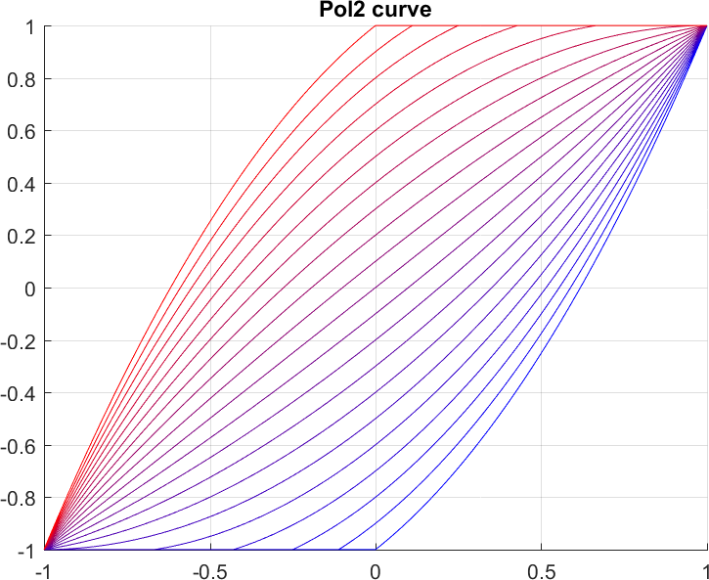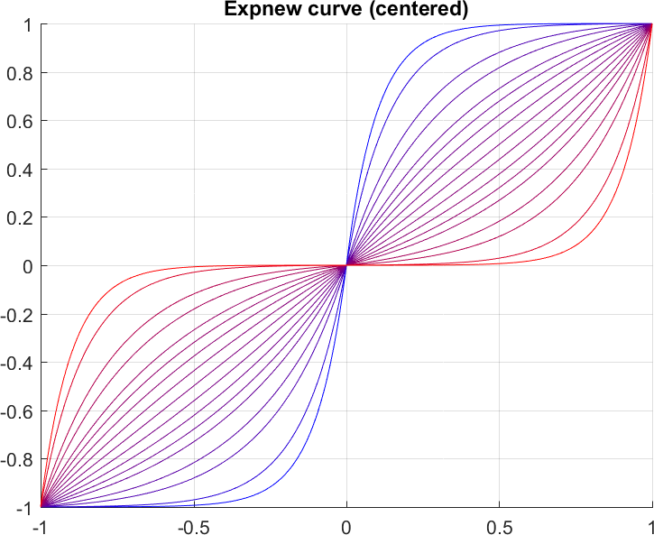

Figure 12: Thrustmaster J curves (left) and S curves (right) with different parameters

To create and affect a curve to an axis, you have to proceed this way:

tmwj->setCurve(TMWJ::JOYX, new CustomCurve{-1,-1, 0,0.2, 1,1});

tmwj->setCurve(TMWJ::JOYX, new CurvePolynomial2{zoom});

tmwj->setCurve(TMWJ::JOYX, new CurvePolynomial3Centered{lowerDZ, centerDZ, upperDZ, c});

tmwj->setCurve(TMWJ::JOYX, new CurvePolynomial3NotCentered{lowerDZ, upperDZ, c});

tmwj->setCurve(TMWJ::JOYX, new CurveExpCentered{lowerDZ, centerDZ, upperDZ, c, zoom});

tmwj->setCurve(TMWJ::JOYX, new CurveExpNotCentered{lowerDZ, upperDZ, c, zoom});

Also for practical reasons, to create the custom curve, you have to specify a std::vector of floats. If the number of values is odd, an exception is thrown (it will be caught by the main window that will display an error message and of course no curve will be applied).

**The "AxesCurves" additional program**

This program allows you to finely tune the parameters of your curves using a GUI. Using the current position of you joystick (the purple point) and the "real joystick trim", you can also re-center your controllers that need it. Only the J and S Thrustmaster curves are implemented for now.

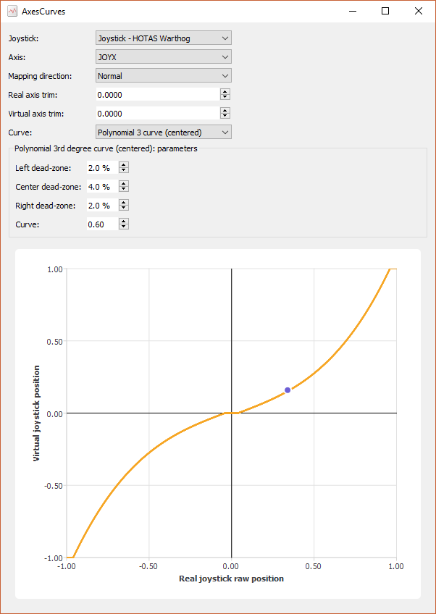

Figure 13: AxesCurves main window

## Button, axis and pov locking

Both real and virtual joysticks can have their buttons, axes or povs locked. In many cases it will not make any difference to lock the real or virtual button / axis / pov, but in other cases it can be really useful. So not to limit the possibilities of the software, both are possible.

When you lock a real joystick button or axis, the software will not see any modification of the button state or the axis value even if the real one has changed and if you call the function "buttonPressed", "axisValue", or "povValue", you will get the last value before locking.

tmwj->setButtonLocked(TMWJ::TG1,true);

tmwj->setAxisLocked(TMWJ::JOYX,true);

tmwj->setPovLocked(TMWJ::HAT1,true);

If you lock a button or an axis of a virtual joystick, it will be frozen. Once unlock, if nothing is sent to this button / axis, its state remains the same.

vj1->setButtonLocked(VJOY::DX1,true);

vj1->setAxisLocked(VJOY::X,true);

vj1->setPovLocked(VJOY::POV1,true);

## Axes rotation

UJPS also allows virtual axes rotation. It is for example useful if you place your stick in a center position and that you don't want to rotate it physically. This feature is similar to the Thrustmaster "RotateDXAxis" function. The angle must be expressed in degrees and it is positive if you are right-handed:

tmwj->rotateAxes(TMWJ::JOYX, TMWJ::JOYY, 30);

## DoAction

The function "DoAction" of the class AbstractProfile is useful to perform an action, from a callback from example. It is quite equivalent to the "ActKey" function of Thrustmaster TARGET but really more powerful as it can perform any action. But for some actions, there is no need to use DoAction. Here is an example:

DoAction(new ActionButtonPress{vj1, VJOY::DX1});

vj1->setButton(VJOY::DX1, true);

By default the action is deleted after performed. If you don't want to delete it, provide false as a second argument.

Using a chain action and a delay, it can replace the "DeferCall" function of Thrustmaster TARGET. In the following example, the function "myCallback" will be executed 1 second after this call to DoAction.

DoAction(new ActionChain{

Delay{ms2cycles(1000)},

ActionCallback{&myCallback}

});

# Limitations and possible improvements

* Tool only works on Windows, mostly because vJoy is only available on Windows. Moreover ViGEm will only work on Windows too.
* Full integration of ViGEm into the UJPS main app. I will wait for the next version of it before doing anything. In the meantime WhiteKnight works really fine.
* Add new settings in the settings menu to ease the use of the main program.
* Add new features, new mappings, triggers, actions... but don't forget that you can define your own ones!
* For now the creation of new profiles is done manually. It would be possible to automate it more in future versions.
* Currently the possible layers are fixed (2 dimensions with I/O and U/M/D). Even if I see no need to add give the choice for more dimensions, it may be possible to need more than 3 possibilities for a given sub-layer... even if too much complexity on this ground should harm ergonomics of the profile.

# Dependencies, credits, useful links

vJoy, the tool that makes all this possible, from ShaulEizikovich.

<http://vjoystick.sourceforge.net/site/index.php/download-a-install>

<https://github.com/shauleiz/vJoy>

Qt 5, a C++ general library. It was really helpful for GUIs, network (for remote controllers), static libs and plugins creation.

<https://download.qt.io/archive/qt/5.7/5.7.1/>

QtGameController, a non-official Qt module from Matthew Wellings:

<https://github.com/openforeveryone/QGameController>

Devreorder from Brian Kendall, for hiding joysticks (DirectInput8 only):

<https://github.com/briankendall/devreorder>

WhiteKnight from evilC, an integration of the current version of ViGEm:

<https://autohotkey.com/boards/viewtopic.php?t=34890>

ViGEm from Benjamin Höglinger:

<https://github.com/nefarius/ViGEm> (current version)

<https://github.com/ViGEm/HidGuardian> (next version in progress)

UCR (Universal Control Remapper) from Snoothy and evilC:

<https://github.com/Snoothy/UCR>

<https://autohotkey.com/boards/viewtopic.php?t=12249>

Joystick Gremlin from WhiteMagic:

<https://github.com/WhiteMagic/JoystickGremlin>

<https://whitemagic.github.io/JoystickGremlin/>

FreePIE from Anders Malmgren:

<https://github.com/AndersMalmgren/FreePIE>

<http://andersmalmgren.github.io/FreePIE/>

Damien, my tester for TWCS throttle and Logitech Extreme 3D plugins.

# Changes notes

**V1.1.0**

* renaming of the tool for "UJPS C++"
* addition of the "AxesCurves" program to tune axes curves
* change of icons to use only free icons
* S curve computation correction
* addition of the "unload profile" feature in the main program
* few minor code changes

**V1.2.0** (17th March 2018)

* addition of "devreorder" release files (tool from Brian Kendall to hide real joysticks)
* addition of a compilation tool in the main program (only if QtMinGw compiler installed)
* now you have to provide the path to the .pro file when opening a profile, instead of to the dll file. This way you can open a profile before it has been compiled for the first time
* addition of a settings menu in the main program
* specifying the path to vJoyConfig.exe in the main program (instead of in profiles)
* solved a bug where the profile did not want to load again after unloading
* addition of the "Merge Axes" mapping
* a few minor code changes

**V2.0.0** (22th April 2018)

* centralize the repeated code for real joystick into the “realJoysticks.dll” lib and the “Controllers plugins”
* split “Monitoring” into “Monitoring1” and “Monitoring2”
* first iteration of the “remote controllers”
* possibility not to use “vJoyConfig.exe” in the main program (recommended)
* another correction in the loading / unloading process for profiles. Now you choose the profile by providing the path to the .pro, not the .dll
* addition of the “relative axis” mapping
* automatic creation of shortcuts in the deployment bat file

**V2.0.1** (23th April 2018)

* Important correction of curves and trim in AxesCurves

**V2.1.0** (2nd May 2018)

* Modification of QtGameController to directly transform a POV into 4 buttons. The controllers plugins have been modified accordingly
* Added release files of WhiteKnight.exe, a little program from evilC that integrates HidCerberus and HidGuardian. It was added in the “HidingJoysticks” directory where was also moved the “devreorder” release files
* Improvement in deployment file

**V2.1.1** (4th May 2018)

* Modification of QtGameController to fully support POV (see this in the new Monitoring0). Now this is the class RealJoystick that transform a POV into 4 additional buttons. The controllers plugins have been modified accordingly

**V2.1.6 (skipping the intermediate versions)** (9th May 2018)

* Addition of LED support for Warthog throttle using the setData member function. It uses the Windows HID library. Windows setupapi.lib and hid.lib have been added so that you can build the Warthog throttle plugin without needing to install the Windows SDK
* Move Warthog throttle LED support to another thread to avoid slowing down the main loop
* Modification of RealJoysticksManager to be able to use several joysticks with the same name
* Important modification in the profile initialization to solve initialization issues. Before that a call to “buttonPressed” or “axisValue” on a RealJoystick in Profile::init could send false results. Moreover incorrect joysticks changes were sent between at the second time step only because the joystick state at the first step was not correct. This modification includes a modification of the interface of AbstractProfile

**V2.2.0** (26th May 2018)

* elevation of programming level (so it involves modifications in the profile interface) for real and virtual joysticks setup

**V2.2.1** (28th May 2018)

* deployment fixes and documentation update (Qt 5.11 instead of Qt 5.7): more details about the needed components of the Qt installation

**V2.3.0** (2nd June 2018)

* improvements in build bat files
* minor modifications in code to remove compilation warnings
* addition of tooltips for buttons names in Monitoring apps
* removal of code repetition in controllers plugins (you will to make a few modifications in your profiles if you coded some before this modification. Look at provided examples)
* addition of T16000M and Xbox 360 controller plugins
* addition of the Description variable in "controllers plugins namespaces" to avoid to make an error in joystick description name when calling AbstractProfile::registerRealJoystick
* VirtualJoystick construction modification: only 1 argument needed (the vJoy device index) if you configure your vJoy devices outside of UJPS using vJoyConfig (recommended). Default values of 128 and 8 are provided for numbers of buttons and axes (only if "use vJoyConfig.exe" is checked in the settings menu, not recommended)

**V2.3.1** (3rd June 2018)

* addition of 2 new actions that allow to link a real button to a keyboard key: ActionKeySetChange and ActionKeySetChangeOpposite

**V2.3.2** (7th June 2018)

* correction of a bug in RealJoystick::buttonPressed for "virtual buttons" of real joysticks, i.e. generated from a real pov
* modification in vJoy device controller plugins to ignore povs (and only see the 4 virtual buttons)
* virtual joysticks povs now initialized at center position instead of north position

**V2.4.0** (10th June 2018)

* support of POV (except with discrete pov in vJoy device config). It includes a lot of modifications: addition of povs in real and virtual joysticks classes (locking included), addition of the MapPov function and the related trigger and actions

**V2.5.0** (12th June 2018)

* add the possibility to generate a real joystick virtual pov from 4 buttons
* add such "4 buttons to pov" transformation in controller plugins and names for povs

**V2.6.0** (13th June 2018)

* also support vJoy devices configured with discrete povs. In fact, the user don't need to care whether the vJoy device is using discrete or continuous povs, UJPS automatically adapts to it
* addition of names for predefined pov values: Center, North, NorthEast, ...
* addition of actions ActionAxisSetValue and ActionPovSetValue

**V2.6.1** (14th June 2018)

* correction (and renaming) of VirtualJoystick priorities. Before the second call by the user (i.e. high priority, compared to low priority for mappings) to setButton, setAxis or setPov on a virtual joystick at the same time step was ignored
* correction in monitoring apps about axes widgets alignment

**V2.6.2** (17th June 2018)

* first iteration of console version of UJPS for running a profile with no GUI

**V2.6.3** (18th June 2018)

* correction in TWCS controller plugin (about pov orders)
* add a second optional argument (time step) in the UJPS console version

**V2.6.4** (20th June 2018)

* the UJPS GUI version can be run from command line with several arguments in order to pre-select a profile, pre-select a time step, and / or run the pre-selected profile
* console version improvements so that all the messages are received in the console
* correct the issue with some profile relative paths

**V2.6.5** (8th July 2018)

* Addition of plugins for Logitech X56 stick and throttle
* Addition of "split axis" mapping
* Addition of "axes rotation" feature

**V2.7.0** (14th July 2018)

* Full support for Xbox 360 controllers (use of XInput lib in addition of DirectInput)
* Addition of vibration feature for Xbox 360 gamepad
* Code simplification in remote controller client app

**V2.7.1** (19th July 2018)

* Renaming of existing axes curves and addition of new curves
* Removing of setSCurve and setJCurve functions. Now use the generic setCurve function
* For the "merge axes" mapping, addition of an optional curve to apply to the resulting axis
* Changes in the formula of exponential axes curves (differences only if non-null dead zones)

**V2.7.2** (22th July 2018)

* Correction in key strokes generation (but less keys available)

**V2.8.0** (6th August 2018)

* Addition of ControllersInfo app
* Addition of "starting profile" and "default time step" settings in UJPS main app
* GUI modifications in UJPS main app + can start other apps
* Merge of the 3 monitoring apps in 1

**V2.8.1** (8th August 2018)

* Addition of "update" feature in monitoring app (no need to change mode 2 times)
* Addition of temporal curves in monitoring app

**V2.8.2** (8th August 2018)

* Temporal curves: solved an issue with temporal curves colors + reduction of CPU usage
* Update of example profile "Star_Citizen_3.1.4_v5" according to available keys for keystrokes
* Addition of dates in these changes notes

**V2.9.0** (11th August 2018)

* Addition of the Rexec feature
* Faster deployment using bat files (parallel execution)

**V2.10.0** (13th August 2018)

* Build of the tools accelerated (running in parallel)
* Improved .pro files to run with MSVC compiler too
* Integration of ViGEm in UJPS main app settings menu

**V2.10.2** (7th October 2018)

* Removal of vJoyConfig from settings menu
* Addition of "input repeater" feature
* Solve monitoring tempo plot height issue

**V2.10.4** (24th November 2018)

* Bug fix: now RemoveJoystickServer releases the prot when connection failed
* Addition of Thrustmaster MFD buttons names (in header file)
* Addition of 2 examples of remote controllers (about MFD) and one profile to run them
* Bug fix: some events where skipped when using DoAction in an ActionCallback

**V2.11.0** (30th November 2018)

* Change in the way to create virtual joystick objects to match the way already used for real joystick

# Annexes

## List of pre-defined triggers

* TriggerAxisChange
* TriggerAxisChangeComparison
* TriggerButtonChange
* TriggerButtonPress
* TriggerButtonRelease
* TriggerButtonState
* TriggerPovChange

## List of pre-defined actions

* ActionAxisIncrement
* ActionAxisSetChange
* ActionAxisSetValue
* ActionButtonPulse
* ActionButtonPress
* ActionButtonRelease
* ActionButtonSetChange
* ActionButtonSetChangeOpposite
* ActionButtonToggle
* ActionKeyPress
* ActionKeyRelease
* ActionKeyPulse
* ActionKeySetChange
* ActionKeySetChangeOpposite
* ActionPovSetChange
* ActionPovSetChangeOpposite
* ActionCallback
* ActionChain
* ActionSequence
* Delay

## List of pre-defined mappings

* MappingStandard → Map, MapButton, MapAxis, MapPov
* MappingTempo → MapTempo
* MappingAxis1 → MapAxis1
* MappingAxis2 → MapAxis2
* MappingAxisRelative → MapAxisRelative
* MappingMergeAxes → MapMergeAxes
* MappingSplitAxis → MapSplitAxis

## Keyboards keys names (Windows)

This list has been established using the values available here:

https://msdn.microsoft.com/fr-fr/library/windows/desktop/dd375731(v=vs.85).aspx

Then the list has been restricted to the keys that can be converted into hardware scan key codes with no issue. For example "Right Control" has been removed because when converted into an hardware scan key code, the result is the same as for "Left Control".

namespace Keys

{

// modifiers

const uint Key_LShift = 0xA0;

const uint Key_RShift = 0xA1;

const uint Key_LCtrl = 0xA2;

const uint Key_LAlt = 0xA4;

// special keys

const uint Key_Backspace = 0x08;

const uint Key_Tab = 0x09;

const uint Key_Return = 0x0D;

const uint Key_CapsLock = 0x14;

const uint Key_Escape = 0x1B;

const uint Key_Space = 0x20;

// digits (the ones that are above letters)

const uint Key_0 = 0x30;

const uint Key_1 = 0x31;

const uint Key_2 = 0x32;

const uint Key_3 = 0x33;

const uint Key_4 = 0x34;

const uint Key_5 = 0x35;

const uint Key_6 = 0x36;

const uint Key_7 = 0x37;

const uint Key_8 = 0x38;

const uint Key_9 = 0x39;

// letters

const uint Key_A = 0x41;

const uint Key_B = 0x42;

const uint Key_C = 0x43;

const uint Key_D = 0x44;

const uint Key_E = 0x45;

const uint Key_F = 0x46;

const uint Key_G = 0x47;

const uint Key_H = 0x48;

const uint Key_I = 0x49;

const uint Key_J = 0x4A;

const uint Key_K = 0x4B;

const uint Key_L = 0x4C;

const uint Key_M = 0x4D;

const uint Key_N = 0x4E;

const uint Key_O = 0x4F;

const uint Key_P = 0x50;

const uint Key_Q = 0x51;

const uint Key_R = 0x52;

const uint Key_S = 0x53;

const uint Key_T = 0x54;

const uint Key_U = 0x55;

const uint Key_V = 0x56;

const uint Key_W = 0x57;

const uint Key_X = 0x58;

const uint Key_Y = 0x59;

const uint Key_Z = 0x5A;

// F keys

const uint Key_F1 = 0x70;

const uint Key_F2 = 0x71;

const uint Key_F3 = 0x72;

const uint Key_F4 = 0x73;

const uint Key_F5 = 0x74;

const uint Key_F6 = 0x75;

const uint Key_F7 = 0x76;

const uint Key_F8 = 0x77;

const uint Key_F9 = 0x78;

const uint Key_F10 = 0x79;

const uint Key_F11 = 0x7A;

const uint Key_F12 = 0x7B;

}