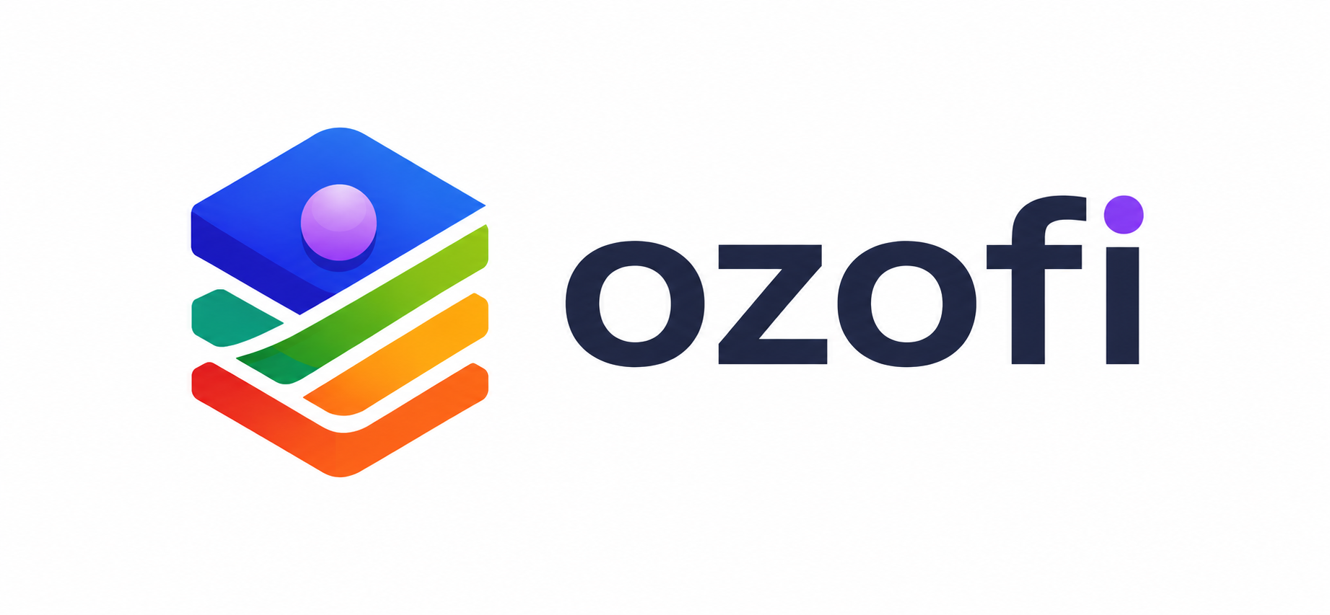 | OFFER LETTER  Building Intelligent Digital Systems
Date: [DD Month YYYY] | Ref: OZO/HR/OFFER/[YEAR]/[NUMBER]
To,
[Candidate Full Name]
[Candidate Address / Email / Phone]
Subject: Offer of Employment / Internship with Ozofi
Dear [Candidate First Name],
We are pleased to offer you the position of [Position Title] at Ozofi. Your selection reflects your skills, potential, attitude, and alignment with our mission to build intelligent digital systems for modern businesses.
This offer letter outlines the key terms of your association with Ozofi. The detailed appointment agreement, company policies, confidentiality obligations, and operational guidelines may be shared separately and will form part of your engagement with the company.
Offer Summary
______________
Position | [Position Title] | Department | [Department]
Work Location | [Office / Remote / Hybrid] | Reporting To | [Manager / Mentor Name]
Joining Date | [DD Month YYYY] | Engagement Type | [Full-time / Internship]
Compensation | [Amount / Stipend] | Probation / Internship Duration | [Duration]
Work Schedule | [Days & Timing] | Offer Valid Till | [DD Month YYYY]

Role Expectations
______________
• You will be responsible for supporting product development, project execution, documentation, research, testing, client deliverables, and other duties aligned with your assigned role and department.
• You are expected to maintain professional discipline, timely communication, ownership of assigned tasks, confidentiality of company and client information, and a learning-first mindset throughout your engagement.
Terms and Conditions
______________
1. Documentation: This offer is subject to successful submission and verification of identity, qualification, address, experience, and any other documents requested by Ozofi.
2. Confidentiality: You must not disclose company, client, product, code, operational, pricing, or business information to any unauthorized person or platform.
3. Company Policies: You will be required to follow all current and future company policies, security practices, attendance expectations, communication guidelines, and work protocols.
4. Intellectual Property: All work, code, designs, documents, strategies, systems, and deliverables created during your engagement will remain the property of Ozofi unless agreed otherwise in writing.
5. Termination: Either party may end the engagement as per the applicable notice period or company policy. Ozofi may withdraw this offer if any information provided is found to be false or incomplete.
Acceptance
______________
Please sign and return a copy of this offer letter on or before [Offer Valid Till] to confirm your acceptance. We are excited to welcome you to Ozofi and look forward to building meaningful work together.
For Ozofi  Authorized Signatory  Name: [Founder / HR Name]  Designation: [Designation]  Date: [DD Month YYYY] | Accepted and Agreed By  Candidate Signature  Name: [Candidate Full Name]  Date: [DD Month YYYY]
Ozofi | AI Solutions • SaaS Platforms • Business Automation • Digital Products
This is a confidential offer document issued by Ozofi.

