DEPI 2026 · ADVANCED MARKETING AUTOMATION WITH AI
Graduation Project #5
Multi-Source Paid Media & UTM Planning System
IKEA Egypt · New Home Starter Bundle · Project documentation
Item | Detail
Prepared by | Ahmed ElMaghraby,  Ahmed EmadEldin,  Esraa Elshahat,  Christena Nabil,  Samar Ibrahim
Track | DEPI Advanced Marketing Automation with AI
Project | Standard Project 5: Multi-Source Paid Media and UTM Planning Project
Brand (case study) | IKEA Egypt, New Home Starter Bundle concept offer
Live landing page | https://new-home-starter-bundle.lovable.app
Deliverables | This document · Presentation deck (19 slides) · Excel planning workbook (13 sheets) · Live landing page + lead workflow + CRM
Date | October 2026

IKEA Egypt is used as a case-study brand for coursework. The landing page is a clearly labelled student concept and is not affiliated with or operated by IKEA. All performance figures are illustrative or simulated and labelled as such.
Contents

Executive summary
1. Project Planning & Management
2. Business Model & Strategic Review
3. Requirements Gathering
4. System Analysis & Design
5. Implementation
6. Final Presentation, Testing & Reports
Appendix A · AI usage log and prompt library
Appendix B · Submission checklist
Appendix C · Sources and verification

Executive summary
This project builds a complete paid media planning system for one campaign objective: sell IKEA Egypt's New Home Starter Bundle profitably to first-apartment compound couples in New Cairo and 6th of October. It connects strategy, audiences, budget, UTM tracking, a live landing page, an automated lead workflow with AI follow-up, attribution and data-driven optimisation into one system.
Headline | Result
Plan | 250,000 EGP / month across 8 campaigns on 7 paid sources + Email/WhatsApp, split by funnel stage (20/25/50/5) and by certainty (70/20/10)
Test month (simulated) | 249,997 EGP spend → 1,027,510 EGP revenue, 219 purchases, blended ROAS 4.11x vs 3.5x target, 109,632 EGP left after ads at 35% margin
Diagnosis | Search, retargeting and CRM close; TikTok opens journeys (20% of position-based credit at 0.36x last-click ROAS); YouTube and Snapchat fail as openers and closers; Meta prospecting shows creative fatigue (CTR -34%)
Decision | Move 32,500 EGP to proven closers. Projected blended ROAS 4.1x → 4.8x (+163,514 EGP revenue on the same budget)
Automation + AI | Landing page form → validation → UTM attribution → lead scoring → AI WhatsApp draft → CRM row → protected team view, live on Lovable Cloud
Testing | 25 of 25 test scenarios passed; 1 defect(s) found and fixed during testing

1. Project Planning & Management

1.1 Selected business
IKEA Egypt (Al-Futtaim franchise): three stores (Cairo Festival City in New Cairo, North Coast Sahel, Hurghada Senzo Mall) plus ikea.com/eg, with a free room-planner tool, IKEA Family loyalty, click-and-collect and home delivery. The project designs the paid media system for one concept offer built in Sessions 13-18: the New Home Starter Bundle (bedroom, living room and kitchen essentials in one order, from an illustrative 4,500 EGP, with a delivery-date guarantee).

1.2 Objectives and success criteria
Objective | Success criterion | Where it is proven
One campaign objective mapped to every funnel stage | Each of 8 campaigns has a stage, objective, KPI and learning objective | Workbook: Media Plan
Defensible budget split | Split shown by source, stage and learning objective; 70/20/10 rule respected | Workbook: Budget Split, Media Plan
Clean, consistent tracking | 100% of ad links built by formula from one UTM dictionary; check column flags errors | Workbook: UTM Builder; Test report TC-W2/W3
Profitable test month | Blended ROAS ≥ 3.5x and above break-even 2.86x | Dashboard: 4.11x
Decisions from data, not opinion | Every SCALE / HOLD / KEEP / CUT status comes from written rules | Dashboard status formulas; Optimization sheet
Working source-attributed lead capture | Lead saved with UTMs, score, priority and AI draft; visible in CRM by source | Live page + /leads; Test report TC10-TC17

1.3 Timeline (Gantt)
Workstream | W1 | W2 | W3 | W4 | W5 | W6
Research & strategy reuse (Sessions 1-4) | ■
Funnel, audiences, offer ladder | ■ | ■
Media plan, budget split, learning objectives |  | ■ | ■
UTM dictionary, builder, tracking plan |  |  | ■
Landing page + lead workflow + AI + CRM |  |  | ■ | ■
Simulated test month + dashboard |  |  |  | ■ | ■
Attribution, optimisation, creative tests |  |  |  |  | ■
Testing, documentation, deck, defence prep |  |  |  |  | ■ | ■

1.4 Tools, platforms and data sources
Area | Tool | Used for
Planning & analysis | Excel / Google Sheets | Inputs, media plan, budget split, UTM builder, attribution, sample data, dashboard, optimisation (all formula-driven)
AI | Claude | Research synthesis, plan structure, copy concepts, formula design, QA
Landing page + workflow | Lovable (+ Lovable Cloud, Lovable AI) | Live landing page, server function, leads database, AI follow-up, CRM view
Tracking (planned) | GA4, Google Tag Manager, Meta Pixel + CAPI, TikTok Pixel, Snap Pixel, Google Ads | Event map and QA checklist (Tracking Plan sheet); dataLayer events implemented on the page
Research | Meta Ads Library, Google Trends, Statista, Deep Market Insights, ikea.com/eg | Competitor scan, market size, trend validation (Session 3)
Presentation | PowerPoint (DEPI template) | Final deck

1.5 Roles and responsibilities
The project is registered as team-based; all workstreams below were planned, built and tested by Ahmed El-Maghraby.
Role | Responsibilities | Owner
Strategist | Objective, persona, positioning, funnel, offer ladder | Ahmed El-Maghraby
Media planner | Channel selection, audiences, budget split, learning objectives, creative tests | Ahmed El-Maghraby
Tracking lead | UTM dictionary, event map, landing page tracking, QA | Ahmed El-Maghraby
Automation builder | Lead workflow, scoring, AI prompt, CRM | Ahmed El-Maghraby
Analyst | Sample data, attribution, dashboard rules, reallocation | Ahmed El-Maghraby

1.6 Risks and limitations
Risk / limitation | Impact | Mitigation
No access to IKEA Egypt ad accounts or sales data | Benchmarks and test month are not real performance | Every number is an editable input; data clearly labelled simulated; method works unchanged on real exports
Low conversion volume (~220/month) | GA4 data-driven attribution not available (needs ~600/month) | Position-based model used for decisions; TikTok geo holdout planned to prove incrementality
Last-click bias in the reallocation projection | Cutting upper funnel can starve the closers | 85% efficiency haircut on added budget; assist-share rule; 2-week holdout before full shift
Brand impersonation risk with a public page | Visitors could mistake the concept for IKEA | Permanent notice, no logo, no payments, demo-only data with a privacy note
Personal data in the CRM | Privacy exposure | Public insert-only, code-protected read, test data only, no personal data in dataLayer
EGP volatility | Benchmarks and AOV move quarterly | Inputs sheet updated monthly; plan recalculates automatically

2. Business Model & Strategic Review

2.1 Business Model Canvas (New Home Starter Bundle)
Block | IKEA Egypt · New Home Starter Bundle
Customer segments | Primary: first-apartment compound couples in New Cairo (5th Settlement, Rehab, Madinaty) and 6th of October / Sheikh Zayed. Not targeted: gehaz families (carpenter-installment buying)
Value proposition | Plan, buy and move into a furnished apartment in weeks, at a fixed price, delivered on the promised date
Channels | Paid: TikTok, YouTube, Snapchat, Meta, Google Search, PMax. Owned: Email, WhatsApp, IKEA Family. Fulfilment: delivery, click-and-collect
Customer relationships | Free planning session, WhatsApp follow-up, Full Apartment Plan for room #2, IKEA Family
Revenue streams | Bundle sales (AOV ~4,500 EGP illustrative), room #2 and accessory cross-sell
Key resources | Room-planner tool, in-stock full-room ranges, in-house delivery fleet, Cairo Festival City store, ikea.com/eg
Key activities | Bundle curation, paid media, tracking and attribution, lead follow-up, delivery and assembly scheduling
Key partners | Al-Futtaim, ad platforms, payment providers (COD, Instapay/Vodafone Cash), possible BNPL partner (ValU/Aman)
Cost structure | Media (250K EGP/month), delivery and assembly, CRM/WhatsApp messaging, content reuse (no new production)

2.2 SWOT (from Session 4)
Strengths | Weaknesses
• Free room-planner tool, no local equivalent  • IKEA Family, click-and-collect, home delivery live  • Al-Futtaim retail infrastructure, mall anchor status  • Flat-pack + own fleet make a delivery date credible | • Only one store serves Greater Cairo; no pickup point in 6th of October/Giza  • Self-assembly clashes with full-installation expectations  • Fixed price, no installment plan  • EGP-priced imported components

Opportunities | Threats
• Compound handover boom: New Cairo, 6th of October, New Capital  • Instapay / Vodafone Cash lower checkout friction  • Smaller apartments need multi-functional furniture  • Social-first discovery via room-tour content | • EGP devaluation squeezes the affordable position  • Carpenter installment plans dominate gehaz buying  • Home Center, ACE, Istikbal expanding stores and financing  • Jumia, Amazon.eg, Facebook Marketplace undercut on basics

2.3 Target market, opportunity and competitive context
Market size (Session 3): Egypt furniture revenue about $1.89B (Statista, 2025), projected CAGR ~2.15% to 2030. Illustrative SAM ≈ $450M (urban mid-upper households reachable by IKEA), SOM ≈ $25-35M in years 1-2. Growth is steady, so it is a share-capture game.
Demand drivers: new compound households, EGP price sensitivity, online browsing before buying, and Instagram/TikTok room tours shaping taste before any store visit.
Competitor | Pricing | Top channel | Hero message | Weakness (reviews)
Home Center | Mid-premium | Mall footfall + Instagram | Everything for a beautiful home | Slow, inconsistent delivery windows
ACE Home Center | Premium | Mall + influencers | Lifestyle, not just furniture | Thin core-furniture range
Istikbal / Style | Mid, installments | Showroom + Facebook ads | Comfort you can pay over time | Pushy upsell, rigid returns
Custom carpentry | Low-mid, negotiable | Word of mouth + FB groups | Built exactly to your space | No warranty, timelines slip
Jumia / Amazon.eg | Low-mid | Search + marketplace ads | Compare and save, delivered | No showroom feel, damage in transit

Positioning gap: the most repeated 1-star complaints across competitors are late delivery (44 mentions), rescheduled assembly (33) and damaged items with no easy return (27). Nobody reliably commits to a delivery and assembly date. IKEA's own fleet makes that claim credible, so delivery reliability carries the BOFU message.

2.4 Digital marketing, automation and AI use cases reviewed
Use case | Applied in this project
Funnel-stage channel matching (Sessions 16, 19) | TikTok/YouTube for reach, Meta/Snapchat for consideration, Search/PMax/DPA to convert, Email/WhatsApp to retain
Cross-platform retargeting tiers (Session 20) | Cold / warm / hot / customer audiences with windows, exclusions and frequency caps
UTM + attribution (Session 16) | One dictionary, formula-built links, five attribution models compared
Pixels and events (Session 15) | GA4 + Meta/TikTok/Snap/Google Ads event map, dataLayer on the page
Reporting (Session 21) | North star + 4 metrics, rule-based statuses, weekly 5-question report
Automation + AI | Form-to-CRM workflow with lead scoring and AI-written WhatsApp follow-up

2.5 Why this project fits an AI-powered marketing system
A multi-source plan only works if every click is labelled, every lead keeps its source, and every budget move follows a rule. Those are exactly the parts that benefit from automation (formula-built links, automatic channel mapping, lead scoring, status rules) and from AI (personalised follow-up drafts, faster planning and QA). The scope stays realistic for one person within the DEPI course: no paid tools beyond free tiers, and no new photo or video production.

3. Requirements Gathering

3.1 Market, audience and competitor data collected
- Market size and growth: Statista 2025 furniture market, Deep Market Insights home decor; IKEA Egypt footprint from ikea.com/eg (Session 3).
- Competitor set and review mining: five competitors, 1-star review clusters from Google Maps and Facebook (Session 3).
- Channel costs and roles: DEPI Sessions 16 and 20 (CPM / CPC ranges by platform in Egypt).
- Funnel leak hypothesis: Activation → Retention leak after the first room (Session 4).

3.2 Persona
Field | Mariam Adel, 29 (Session 3, illustrative)
Profile | Product manager at a fintech scale-up; newly married, no kids; 120 m² compound apartment in New Cairo
Household income | 35,000-48,000 EGP / month
Values | A home that looks put-together without looking expensive
Trusts | Instagram apartment tours, Google Maps reviews, friends who furnished recently
Consumes | Instagram Reels, Pinterest, YouTube small-space makeovers, TikTok before/after

Pain points | Motivations | Objections | Decision triggers
Delivery dates that slip  Assembly no-shows  Cairo traffic to reach a store  Coordinating 3+ carpenters | Move in fast after handover  A cohesive Scandinavian look  Host family for the first time | Self-assembly effort  No installment plan  'Is it worth the price?' | A guaranteed delivery date  Cash on delivery  A free planning session  Real reviews from compound neighbours

3.3 Data fields required
System | Fields
CRM (leads table) | id, created_at, name, mobile, area, preferred_day, utm_source, utm_medium, utm_campaign, utm_content, utm_term, ga4_channel, landing_url, lead_score, priority, status, next_action, ai_followup
Tracking (dataLayer / GA4) | event, utm_* (first touch), ga4_channel, item_id, value, currency=EGP, transaction_id (purchase), lead_type, lead_score, priority (no name / phone)
Reporting (Sample Data) | date, day, week, campaign id, platform, stage, spend, impressions, clicks, add to cart, purchases, revenue; derived CTR, CPC, CPM, CVR, CPA, ROAS
AI follow-up | name, area, preferred_day, campaign goal; output ≤ 60 words, fixed signature

3.4 Functional requirements
ID | Requirement
FR1 | Every campaign has a funnel stage, objective, audience, format, budget share, KPI and learning objective
FR2 | Budget recalculates from one input; shares must total 100% with a visible check
FR3 | UTM links are generated by formula from fixed lists; spaces and capitals are normalised or flagged
FR4 | The landing page reads UTMs, keeps the first touch for the session, maps the GA4 channel and fires the event map
FR5 | The form validates input, scores the lead, assigns priority and next action, drafts an AI follow-up and saves a CRM row
FR6 | The CRM view is protected, shows leads by source and lets the team update status
FR7 | The dashboard assigns SCALE / HOLD / KEEP / CUT / REFRESH from editable thresholds
FR8 | The reallocation model projects revenue and ROAS for any new split

3.5 Non-functional requirements
Area | Requirement
Accuracy | Zero formula errors; attribution totals equal path revenue under every model
Speed | Landing page loads without heavy media; AI step does not block saving a lead
Usability | Editable cells marked in blue/yellow; mobile-first page; CRM readable without training
Compliance & ethics | Concept notice, no logo, no payments, test data only, no personal data in analytics events
Maintainability | Single Inputs sheet; naming convention documented; workflow logic in one server function

4. System Analysis & Design

4.1 System architecture
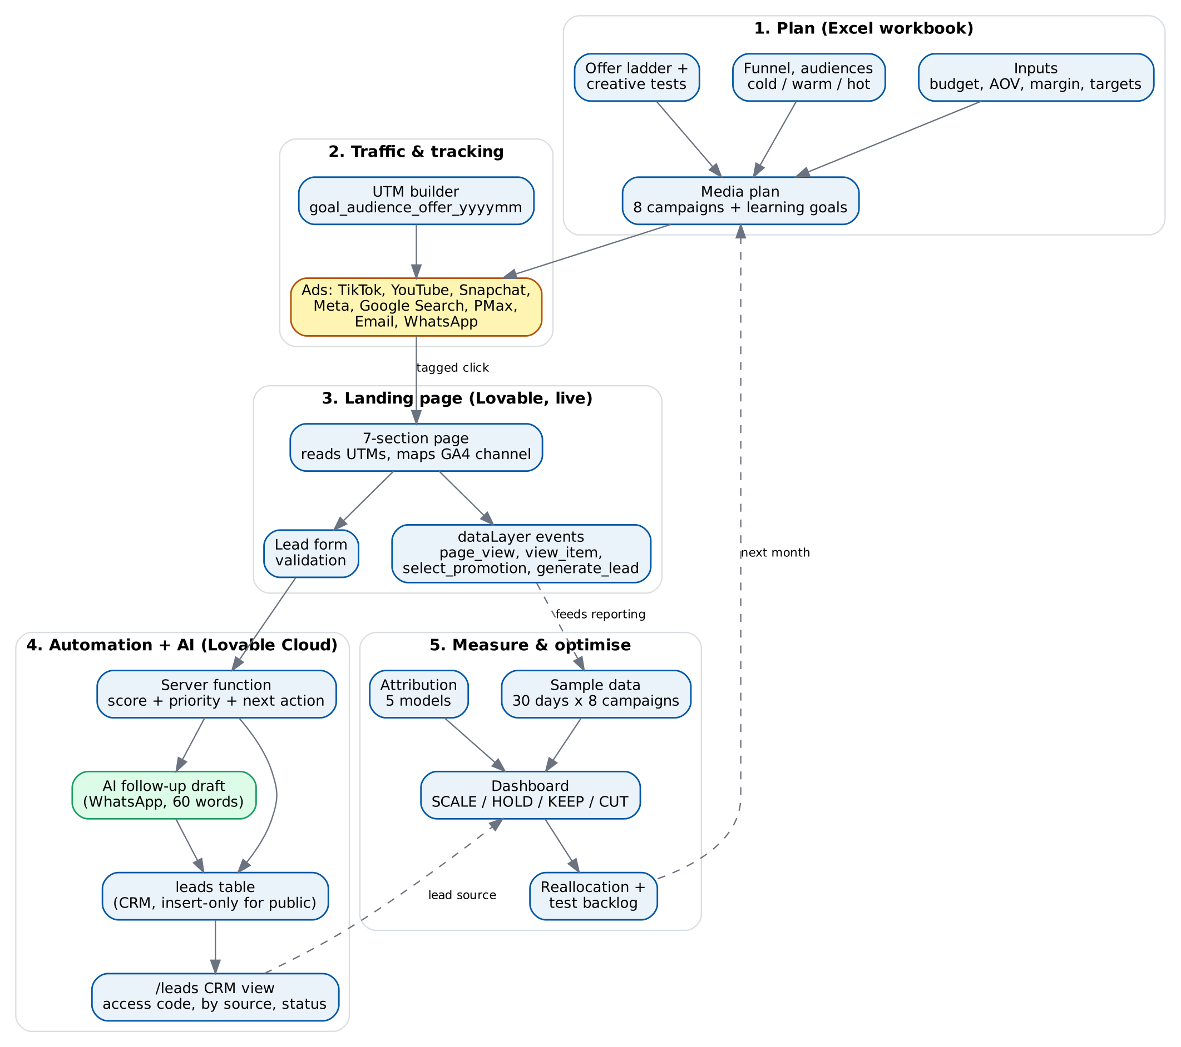
Figure 1. System architecture: plan → traffic & tracking → landing page → automation + AI → measure & optimise

4.2 Campaign objective map by funnel stage
Stage | Objective | Platforms | Primary KPI | Budget
TOFU · Awareness | Reach, video views, fill warm pools | TikTok, YouTube | CPM, 6s view rate | 20%
MOFU · Consideration | Traffic to planner and bundle | Meta, Snapchat | CTR, CPC, landing page views | 25%
BOFU · Conversion | Purchases | Google Search, PMax, Meta retargeting | CVR, CPA, ROAS | 50%
CARE · Retention | Room #2, repeat orders | Email, WhatsApp | Repeat rate, ROAS | 5%

4.3 Audience and retargeting structure
Tier | Definition | Window | Exclude | Frequency | Message job
Cold | Interests + 1% LAL of buyers, 24-34, compounds | - | Visitors 30d, buyers 180d | 2/week | Problem + aspiration
Warm | Video viewers 50%, engagers, planner starters | 30-60d | ATC 14d, buyers 30d | 3/week | Proof + delivery promise
Hot | View content 30d, ATC 14d, checkout 7d, searchers | 7-30d | Buyers 30d | 4-5/week | Risk reversal + COD
Customers | Buyers 7-180d, IKEA Family | 180d | Bought in 7d | 1-2/week | Room #2 (Full Apartment Plan)

4.4 Offer design and creative testing plan
Rung | Offer | Used in
Entry | Free Small Space Planning Session | Cold / warm: TikTok, YouTube, Meta
Core | New Home Starter Bundle from 4,500 EGP + delivery date guarantee | Hot: Search, PMax
Retargeting | Bundle + cash on delivery + assembly booked on delivery day | Hot: Meta DPA, checkout recovery
Retention | Full Apartment Plan: room #2 + IKEA Family perk | Customers: Email, WhatsApp

Nine copy-led ad concepts reuse existing IKEA assets (organic room tours as Spark Ads, catalog Reels and carousels, dynamic product ads, text templates), so no new photo or video production is needed. Six one-variable tests decide what scales:
Test | Variable | Variants | Decision rule
T1 TikTok hook | Opening hook | Aspiration vs problem vs social proof | +15% 6s view rate after 10,000 impressions per arm
T2 Meta angle | Message angle | Delivery vs price vs planning | 14 days or 1,000 clicks per arm; winner reused in Search copy
T3 Creative refresh | Rotation | 3 static vs 6 rotated every 10 days | Keeps CTR drop under 25% → becomes standard
T4 DPA overlay | Overlay text | COD vs delivery date vs none | 50 purchases per arm or 21 days
T5 RSA pinning | Headline 1 | Price-led vs delivery-led | Google Ads experiment at 95% significance
T6 WhatsApp copy | Opening line | Question vs checklist | 500 sends per arm

4.5 Budget split by source, stage and learning objective
ID | Platform | Stage | Tier | Share | Budget (EGP) | Learning objective
C01 | TikTok | TOFU | Growth (20) | 15% | 37,500 | Can TikTok build a warm pool cheaply enough to feed Search and retargeting?
C02 | YouTube | TOFU | Test (10) | 5% | 12,500 | Do YouTube Bumpers add reach TikTok misses at an acceptable CPM?
C03 | Snapchat | MOFU | Test (10) | 5% | 12,500 | Does Snapchat's 20-30 audience turn into planner visits?
C04 | Meta | MOFU | Proven (70) | 20% | 50,000 | Which angle wins on CTR and cost per landing page view?
C05 | Google Search | BOFU | Proven (70) | 22% | 55,000 | How much high-intent demand exists, and what CPA holds at scale?
C06 | Google PMax | BOFU | Proven (70) | 13% | 32,500 | Can feed-only PMax hit target ROAS without new creative?
C07 | Meta | BOFU | Proven (70) | 15% | 37,500 | Which window and frequency maximise retargeting ROAS?
C08 | Email + WhatsApp | CARE | Growth (20) | 5% | 12,500 | What share of buyers order a second room within 90 days?

4.6 Landing page structure and conversion actions
# | Section | Conversion action / tracking point
1 | Hero: first apartment, planned in one afternoon | Primary CTA → select_promotion
2 | Social proof (labelled illustrative) | -
3 | Problem: carpenter delays, hidden costs, five shops | -
4 | Solution: plan, pick, delivered and assembled | -
5 | Inside the bundle + guarantees | Section in view → view_item (value 4,500 EGP)
6 | FAQ: delivery areas, COD, returns, customisation | -
7 | Closing CTA + planning-session form | Submit → generate_lead + CRM row

4.7 UTM structure and tracking events
Tag | Rule | Allowed values / pattern
utm_source | Where from | meta, tiktok, google, youtube, snapchat, email, whatsapp
utm_medium | How | cpc (all paid), email, whatsapp, social (organic)
utm_campaign | Which initiative | goal_audience_offer_yyyymm (e.g. purchase_intent_nhsb_202611)
utm_content | Which creative | format_angle_version (e.g. rsa_bundle_price_v1)
utm_term | Which keyword | Search only (e.g. furniture_new_cairo)

Channel mapping applied on the page and in GA4: cpc + meta/tiktok/snapchat → Paid Social; cpc + youtube → Paid Video; cpc + google → Paid Search; email → Email; whatsapp → custom 'WhatsApp' channel group; no UTMs → Direct. Google Ads keeps auto-tagging on, with UTMs in the Final URL suffix.
Step | GA4 event | Meta | TikTok | Google Ads
Product interest | view_item | ViewContent | ViewContent | -
Planner intent | generate_lead | Lead | SubmitForm | Secondary
Cart | add_to_cart | AddToCart | AddToCart | -
Checkout | begin_checkout | InitiateCheckout | InitiateCheckout | -
Purchase | purchase | Purchase (event_id dedup with CAPI) | CompletePayment | Primary (value)

4.8 Automation workflow
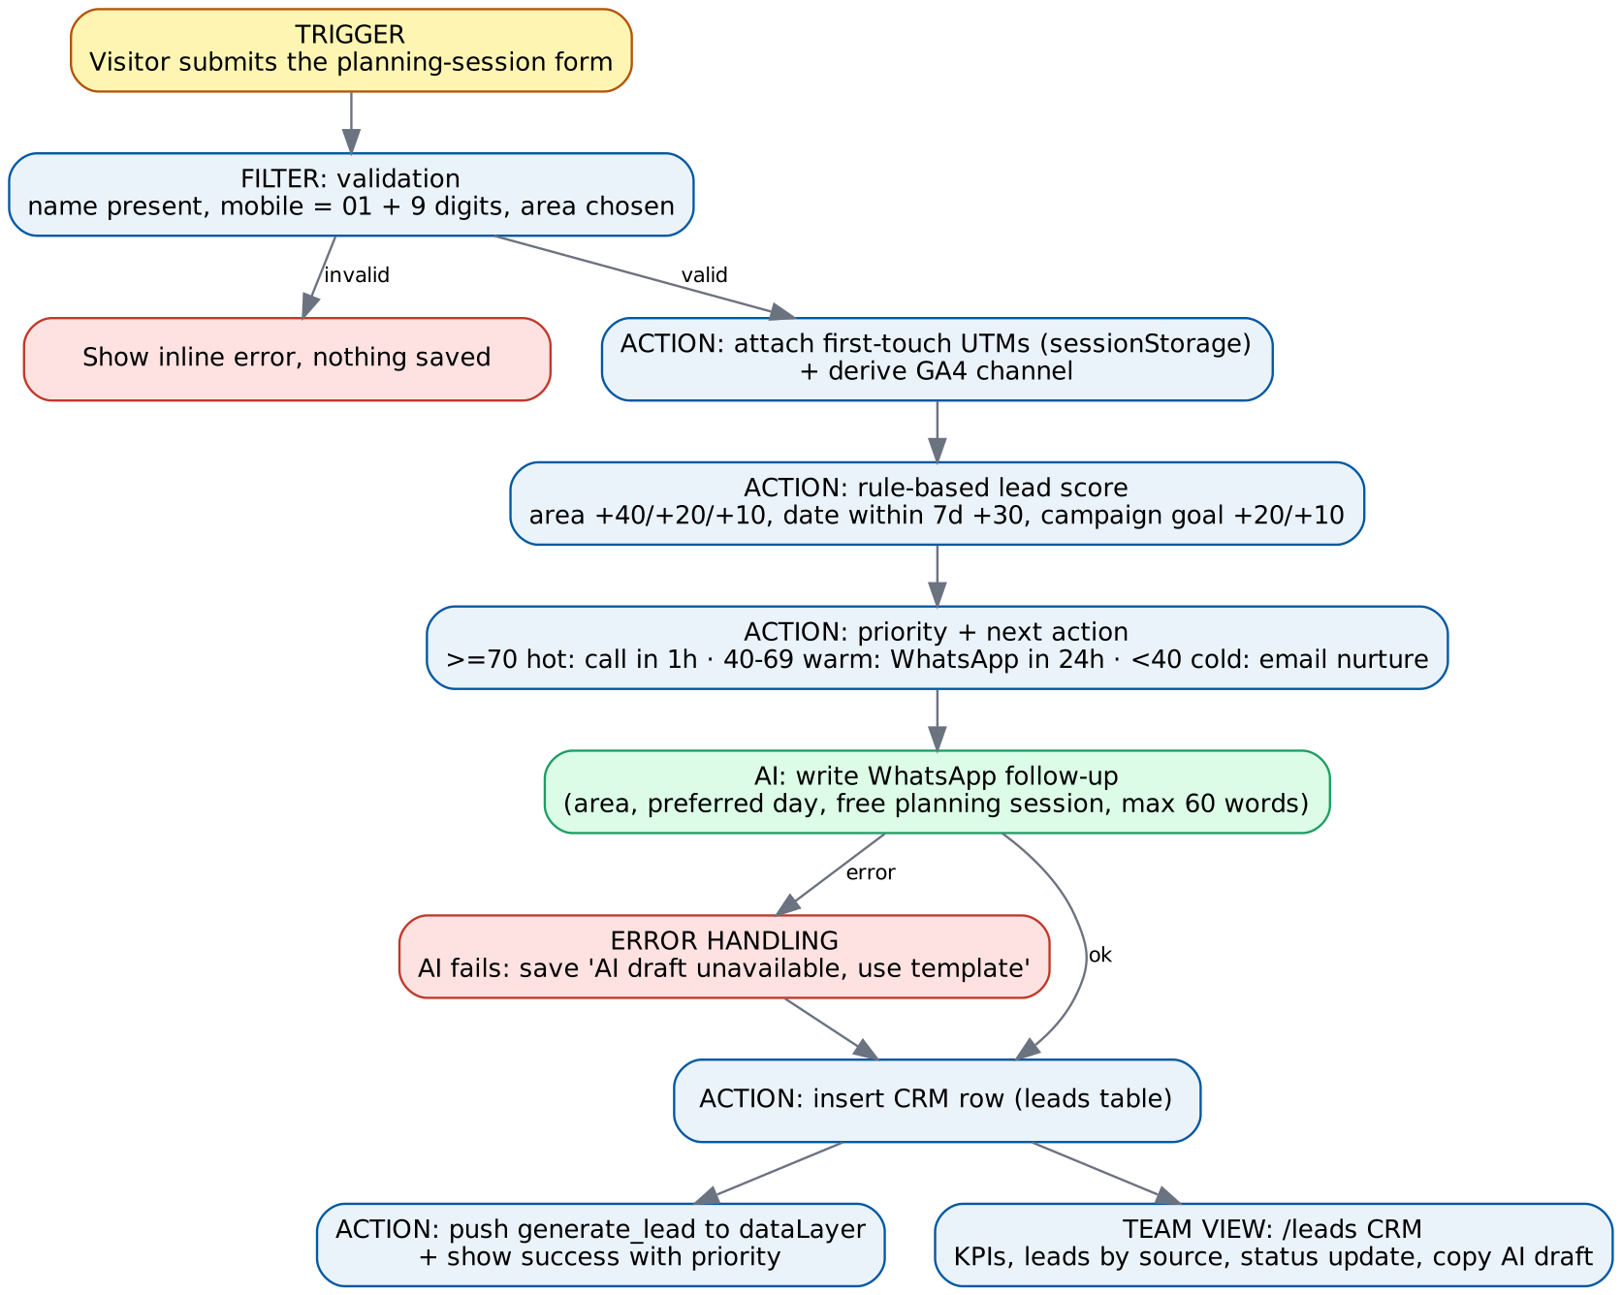
Figure 2. Lead workflow: trigger, filter, actions, AI step and error handling
Element | Design
Trigger | Visitor submits the planning-session form on the landing page
Filters | Name present; mobile matches 01 + 9 digits; area selected. Invalid → inline error, nothing saved
Data transfer | First-touch UTMs from sessionStorage + derived GA4 channel + landing URL travel with the form to a server function
Scoring | Area: New Cairo / 6th of October +40, Sheikh Zayed +20, Other +10 · Preferred day within 7 days +30 · Campaign goal: purchase +20, consideration +10
Routing | ≥70 hot → call within 1 hour · 40-69 warm → WhatsApp within 24 hours · <40 cold → email nurture
AI action | Lovable AI writes a WhatsApp follow-up draft saved on the lead
Error handling | If the AI call fails, the lead is still saved with 'AI draft unavailable, use template'
Output | CRM row in the leads table · generate_lead event (no personal data) · success message with priority

4.9 CRM / database structure and naming conventions
Field | Type | Rule
status | text | new → contacted → booked / lost (dropdown in CRM)
priority | text | hot / warm / cold from lead_score
lead_score | integer | 0-90, rule-based (section 4.8)
utm_* / ga4_channel | text | Copied from first touch; lowercase dictionary values
ai_followup | text | AI draft or fallback text
Security | RLS | Public: insert only. Read / update only through a server function that checks an access code

Naming conventions: campaigns and UTMs follow goal_audience_offer_yyyymm; campaign IDs C01-C08 are shared by the workbook, links and reports; test IDs follow TC (system) and TC-W (workbook).

4.10 AI component: prompt logic, intents and escalation
Item | Design
Input | Lead name, area, preferred day, campaign goal
Prompt logic | Write a friendly WhatsApp follow-up in English, max 60 words, mention area and preferred day, offer the free planning session, no prices or promises beyond the page, sign as 'The Home Starter team (DEPI concept)'
Intent handled | Book the planning session (single intent by design: the form only captures this intent)
Escalation | Hot leads → human call within 1 hour; the AI text is a draft the team copies and sends, never auto-sent
Guardrails | No personal data sent to analytics; fallback template on failure; team can edit before sending

5. Implementation

5.1 What was built
Deliverable | Content | Location
Planning workbook | 13 linked sheets: Cover, Inputs, Funnel & Audiences, Audience & Retargeting, Media Plan, Budget Split, Creative Testing, UTM Builder, Tracking Plan, Attribution, Sample Data, Dashboard, Optimization (3,000+ formulas, zero errors) | IKEA_Egypt_Paid_Media_UTM_Plan.xlsx
Landing page | 7-section mobile-first page, UTM reader, GA4 channel mapping, dataLayer events, concept notices | https://new-home-starter-bundle.lovable.app
Lead workflow + AI | Server-side validation, attribution, scoring, routing, AI follow-up, fallback, CRM insert | Lovable Cloud (same project)
CRM view | Code-protected /leads: KPIs, leads by source, status updates, AI drafts | https://new-home-starter-bundle.lovable.app/leads (code: depi2026)
Presentation deck | 19 slides on the DEPI template with speaker notes | IKEA_Egypt_Paid_Media_Graduation_Project.pptx

5.2 Sample data
The Sample Data sheet holds 240 simulated daily rows (30 days × 8 campaigns) generated from the plan's benchmarks with random noise and built-in patterns: a fatiguing Meta prospecting ad set (CTR falls from week 1 to week 4 while CPM rises), a budget-capped Search campaign, rising retargeting frequency, and two weak test channels. Twelve sample conversion paths drive the attribution comparison. The CRM holds 12 clearly fake seed leads across the campaigns.

5.3 Results from the sample data
Campaign | ROAS | Assist share | CTR W1 → W4 | Status
C01 TikTok | 0.36x | 19.6% | 0.59% → 0.59% | KEEP: ASSISTS
C02 YouTube | 0.88x | 3.7% | 0.29% → 0.26% | CUT
C03 Snapchat | 0.73x | 3.4% | 0.53% → 0.54% | CUT
C04 Meta | 3.14x | 9.8% | 1.35% → 0.89% | HOLD + REFRESH CREATIVE
C05 Google Search | 7.26x | 24.0% | 6.40% → 6.33% | SCALE
C06 Google PMax | 4.05x | 13.6% | 1.46% → 1.47% | HOLD
C07 Meta | 5.29x | 9.9% | 1.77% → 1.53% | SCALE
C08 Email + WhatsApp | 9.17x | 16.1% | 8.17% → 8.11% | SCALE

Model | TikTok | Google Search | Email/WhatsApp | YouTube
Last click | 0 | 23,400 | 15,300 | 0
First click | 25,900 | 3,900 | 4,600 | 4,100
Linear | 8,817 | 12,417 | 8,167 | 2,050
Time decay | 4,028 | 16,788 | 10,714 | 1,367
Position-based | 10,780 | 13,220 | 8,880 | 2,050

5.4 Evidence
Evidence | Link / location | What it shows
Live landing page | https://new-home-starter-bundle.lovable.app/?utm_source=google&utm_medium=cpc&utm_campaign=purchase_intent_nhsb_202611&utm_content=rsa_bundle_price_v1&utm_term=furniture_new_cairo | Open the 'Tracking debug' card: Channel Paid Search and all five UTMs (verified on the published site, 10 Oct 2026)
CRM (demo) | https://new-home-starter-bundle.lovable.app/leads · access code depi2026 | KPIs, leads by source, status updates, AI follow-up drafts on 13 test leads
Workbook | IKEA_Egypt_Paid_Media_UTM_Plan.xlsx | Dashboard statuses, UTM Builder check column, Attribution totals
Automated test run | Lovable project, browser test script run_qa.py | 17 live-system scenarios with expected vs actual (section 6.1)

Tip for the defence: open the UTM link live, submit a test lead, then show it in /leads with its source, score and AI draft.

6. Final Presentation, Testing & Reports

6.1 Testing report
25 scenarios were run across the workbook (TC-W) and the live system (TC). 25 passed after fixes.
ID | Scenario | Expected | Actual | Status
TC-W1 | Change monthly budget 250K → 300K | Every sheet rescales, no errors | Media Plan total 300,000; Search 66,000; BOFU 150,000; week 4 90,000; 0 errors | PASS
TC-W2 | UTM row with capitals and a space in the audience code ('Meta', 'test aud') | Values normalised to lowercase, no spaces in the final URL | First run: campaign became 'purchase_test aud_nhsb_202611' and the check said OK. After fix: 'purchase_test_aud_nhsb_202611', source 'meta', check OK | PASS
TC-W3 | UTM row without utm_content | Check column flags MISSING | MISSING | PASS
TC-W4 | Media Plan shares no longer total 100% | Visible warning | 'CHECK: shares must sum to 100%' | PASS
TC-W5 | Raise target ROAS 3.5x → 5x | Statuses recalculate from the rule | C07 Meta retargeting moves SCALE → HOLD; others follow the rule | PASS
TC-W6 | Recommended reallocation shares ≠ 100% | Visible warning | 'CHECK: recommended shares must sum to 100%' | PASS
TC-W7 | Attribution totals under all 5 models | Each equals path revenue (55,100 EGP) | 55,100 under last click, first click, linear, time decay, position-based | PASS
TC-W8 | Full recalculation of the workbook | Zero formula errors | 3,051 formulas, 0 errors | PASS
TC01 | TikTok UTM link on the live page | Debug card shows values, channel Paid Social | All values shown, Paid Social | PASS
TC02 | YouTube UTM link | Paid Video | Paid Video | PASS
TC03 | Google Search UTM link with utm_term | Paid Search, term shown | Paid Search, furniture_new_cairo shown | PASS
TC04 | Email UTM link | Email | Email | PASS
TC05 | WhatsApp UTM link | WhatsApp (custom group) | WhatsApp (custom group) | PASS
TC06 | Page with no UTMs, new session | All 'none', Direct | 5 x 'none', Direct | PASS
TC07 | TikTok link, then plain page in the same session | First-touch TikTok UTMs kept | TikTok values and Paid Social kept | PASS
TC08 | Load + hero CTA click + scroll to bundle | page_view, select_promotion, view_item (4,500 EGP) | All three fired, view_item 4,500 EGP | PASS
TC09 | Form with mobile '12345' | Inline error, no lead saved | Error shown, lead count unchanged (13) | PASS
TC10 | Google link, New Cairo, tomorrow | Score 90, hot, call within 1 hour, AI draft, no PII in event | 90, hot, call within 1 hour, draft written, no name/phone in event | PASS
TC11 | No UTMs, area Other, 20 days ahead | Score 10, cold, email nurture, Direct | 10, cold, email nurture, Direct | PASS
TC12 | Email link, Sheikh Zayed, 3 days ahead | Score 50, warm | 50, warm | PASS
TC13 | CRM with wrong code '1234' | Access denied, no data | 'That access code did not work.', no tables shown | PASS
TC14 | CRM with the correct code | KPI tiles and leads-by-source totals equal the list | 16 leads listed, every total = 16 | PASS
TC15 | Change a lead status to contacted, reload | Status persists | Contacted on the page and in the database | PASS
TC16 | Read the leads table with the public key | No rows (blocked by row-level security) | Empty list returned | PASS
TC17 | Force the AI step to fail (invalid model) | Lead still saved with fallback text | Saved with 'AI draft unavailable, use template' | PASS

Errors found and fixed
ID | Error | Fix
TC-W2 | Campaign formula did not replace spaces, and the check on spare builder rows only looked for missing tags | Campaign formula now TRIMs and SUBSTITUTEs spaces with '_'; spare rows use the same case/space check as the main rows

6.2 Optimisation plan and recommendations
Move | Why (evidence) | Change
Scale Google Search | ROAS 7.3x, budget-capped every day | 22% → 28%, tROAS once 30+ conversions/month
Double Email + WhatsApp | ROAS 9.2x, fixes the room #2 leak | 5% → 10%, add browse-abandon and room #2 flows
Raise PMax | ROAS 4.0x above target | 13% → 15%
Keep TikTok | 20% of position-based credit | Hold 15%, judge on CPM, view rate, assists
Refresh Meta prospecting | CTR 1.35% → 0.89% | Rotate assets every 10 days, 20% → 17%
Hold Meta retargeting | SCALE signal but pool-limited | Hold 15%, frequency cap 3/week
Pause YouTube + Snapchat | Below break-even and < 8% assist share | 0%, re-test Snapchat with a compound geo-fence

Projected blended ROAS moves from 4.14x to 4.79x (+163,514 EGP revenue) on the same 250,000 EGP, using an 85% efficiency haircut on added budget.

6.3 Weekly reporting rhythm
- What happened? Five headline numbers vs last week.
- Why did it happen? Campaign-level drivers from the Dashboard.
- What does it mean? Status changes and attribution shifts.
- What will we do? One to three actions with owner and deadline.
- What are we watching? Fatigue flags, pacing, open tests.

6.4 Limitations
- Performance data is simulated; benchmarks are planning ranges, not IKEA Egypt account data.
- Attribution uses 12 sample journeys and a rule-based model; data-driven attribution needs real GA4 volume.
- The reallocation projection is last-click based and ignores lost assist value from paused channels.
- The AI follow-up is a draft for a human to send; WhatsApp sending is simulated.
- Pixels and GTM are specified and QA-listed, not installed on a real IKEA property.

6.5 Next steps and improvement roadmap
Horizon | Step
Next 30 days | Run the 6 creative tests and the TikTok geo holdout; apply the reallocation; weekly report every Sunday
60 days | Connect real GA4 + platform exports to the Sample Data sheet (same columns) and a Looker Studio view; switch Search to tROAS
90 days | Send WhatsApp follow-ups through the WhatsApp Business API; add email nurture for cold leads; move to data-driven attribution once volume allows
Next quarter | Test a BNPL partner (ValU / Aman) to open the installment-driven segment; add a 6th of October pickup point to the plan

Appendix A · AI usage log and prompt library
Stage | AI tool | What AI did | Human decision
Project selection | Claude | Scored the 20 project options on effort, tools and fit | Chose Project 5 to match paid media expertise and avoid video production
Planning | Claude | Drafted the workbook structure, formulas and simulated data model | Set budget, targets, thresholds and channel roles
Tracking | Claude | Built the UTM dictionary and builder formulas; found and fixed a space-handling bug in testing | Approved the goal_audience_offer_yyyymm convention (Session 16)
Landing page | Lovable | Built the 7-section page, tracking, workflow, CRM from written prompts | Wrote the brief, honesty notices and scoring rules
Follow-up | Lovable AI | Writes a WhatsApp draft for each lead | Team reviews and sends
QA | Claude + Lovable agent | Ran workbook scenarios and browser tests | Accepted fixes

Prompt library
Lead follow-up (production): Write a short, friendly WhatsApp follow-up in English, max 60 words, for {name} in {area} who prefers {preferred_day}. Offer the free planning session. No prices or promises beyond the page. Sign as 'The Home Starter team (DEPI concept)'.
Attribution coach (Session 16): You are a performance marketing analyst for an Egyptian D2C brand. Funnel length 5 days, channels TikTok, Meta, Google Search, Email/WhatsApp, ~220 conversions a month, current model last click. Recommend a model and predict which two channels gain or lose credit. Answer as a 4-row table.
Budget split (Session 20): For IKEA Egypt's New Home Starter Bundle, 250,000 EGP/month, goal = sales, audience = first-apartment couples 24-34 in New Cairo and 6th of October. Split spend across sources by funnel stage and justify each % with one platform job and one learning objective. Table only.
Weekly report (Session 21): From this dashboard export, answer: what happened, why, what it means, what we will do (owner + deadline), what we are watching. One page, five numbers, one recommendation.

Appendix B · Submission checklist
Checklist item (DEPI framework) | Where
Final documentation file (Word or PDF) | This document
Presentation deck with system architecture | Deck (19 slides, DEPI template); architecture in Figure 1
Links / screenshots: landing page, dashboard, workflows | https://new-home-starter-bundle.lovable.app · /leads · Workbook Dashboard · Section 5.4
Strategy, research, personas, competitor analysis, funnel map | Sections 2-4; Workbook Funnel & Audiences
Content calendar, creative samples, ad concepts, scripts | Workbook Creative Testing (9 ad concepts, 6 tests); no video by project scope
Tracking map, UTM structure, campaign plan, KPIs, traffic plan, optimisation | Workbook UTM Builder, Tracking Plan, Media Plan, Dashboard, Optimization
Automation / AI workflow diagrams, screenshots, testing evidence, sample outputs | Section 4.8, Figure 2, Section 6.1, CRM
Recommendations, limitations, next steps, roadmap | Sections 6.2-6.5

Appendix C · Sources and verification
- Statista Market Forecast: Egypt furniture revenue 2025 and CAGR 2025-2030 (via Session 3).
- Deep Market Insights: Egypt home decor market 2024 (via Session 3).
- ikea.com/eg: store locations, IKEA Family, click-and-collect, delivery (via Sessions 3-4).
- DEPI 2026 session materials 13-21: KPIs, offer design, pixels and events, UTM and attribution (incl. ~600 conversions/month for data-driven), landing pages, funnels, retargeting, reporting.
- Illustrative and labelled: budget, AOV, margin, platform benchmarks, simulated test month, sample journeys, persona income, review counts from the Session 3 exercise.

