**About**

This RPA project will use excel with a list of products to search for their prices on 4 different websites. Script will save the prices to the excel file and email it the the given email address using outlook.

**Requirements**

1. Install RPA get basic understanding from the User Guide video tutorials
2. Install and setup outlook 2013 with your email

**Setup**

1. Unzip PriceSearch.zip
2. Move the unzipped folder to your C:\Users\<USERNAME>\workfusion-workspace. Username is your username for your computer.
3. Open RPA recorder and open file PriceSearch.rpae from Media Files tab

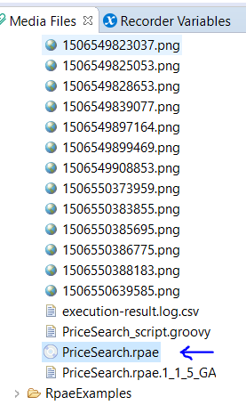

1. Update excel_file_path and excel_file variable values with your username. Verify the path is valid on your system

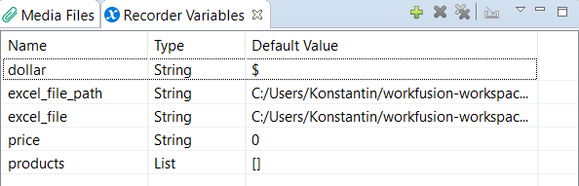

1. Update variable email_to to the email you want the excel to be sent
2. Play recording