**Initial Design Meeting**

**Creative director: Erin**

**Designer/developer: Zeyuan**

* Color ideas:
  + Black & white w/ yellow as an accent color
  + Black, white and red
* Menu and page setup
  + Home, background, Julius Neubronner/technology, and uses as main pages
    - World war I, World war ii, and Post-world war ii as subpages underneath uses pages
  + Menu: dropdown menu?
* Font:
  + Similar fonts to the posters in the creative brief
    - Serif
    - Letter pressed look?
* Aesthetics
  + Retro
  + Newspaper look could be interesting
    - Ex: New York Times
    - 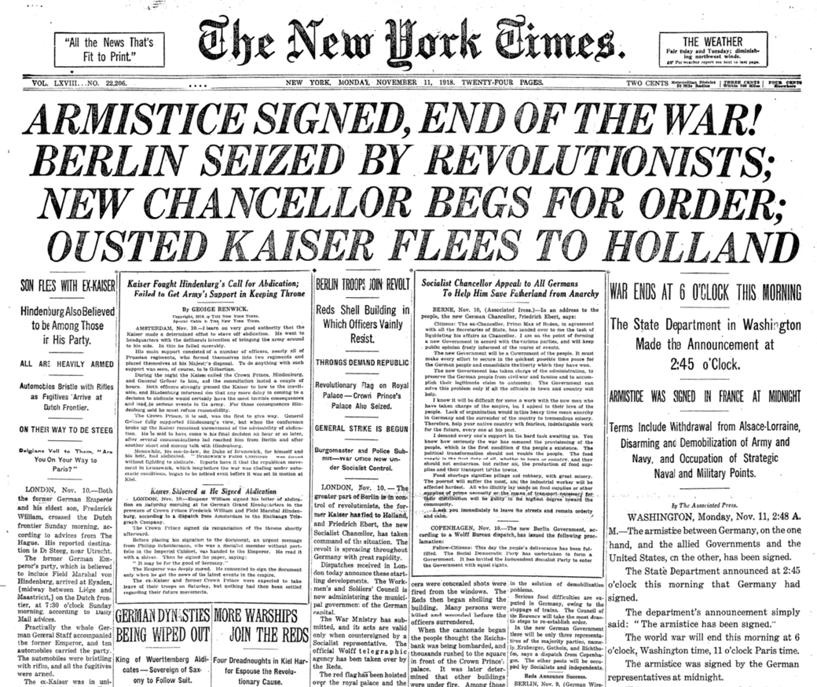
    - 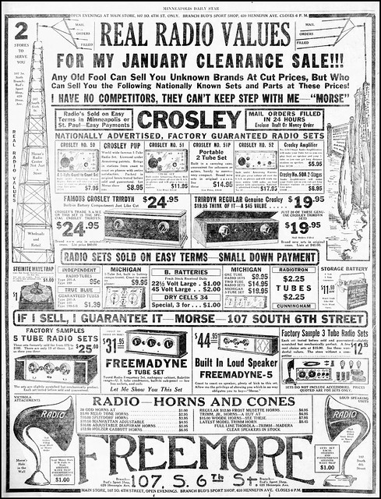
  + Lots of images