4/7/2015

Game Design Team

Michael Chimick

Sojourn

User Guide

Table of Contents

External 2

System Requirements 2

Game Requirements 2

Internal 3

Pre-Round 3

The Start Menu 3

The Lobby Menu 5

Peri-Round 6

Game Rules 6

Vessels 7

Deities 8

Gatekeepers 9

Ghosts 10

Post-Round 10

Encyclopedia 11

Game Map 11

Generation 11

Vessel Classes 12

Warrior 12

Shaman 12

Deity Abilities 13

Vitality 13

Demise 13

Gatekeepers 14

The Lost 14

Guardians 16

# External

This section describes anything the user needs to know in order to run the game; anything that occurs or needs to occur before the game is or can be running.

## System Requirements

In order for the game client or the game server to be run on a computer, the computer must be running a Linux-based operating system.

The computer must be connected to the internet, for both game servers and game clients.

## Game Requirements

In order to play a round of the game, there will need to be a game server running, and a minimum of four game clients. To run the game server: run the serv runnable in the Linux terminal, with an argument for a port number, for example; ./serv 7000

To run a client, simply run the app runnable in another Linux terminal. The client can be run on a separate computer from the server.

The port number given to the server as an argument should be recorded or otherwise stored by the user, as it will be later needed by any client wishing to connect to the server. Any connecting client will also require the server’s internet address. (See the Pre-Round section)

The game server and game clients do not need to be run in any particular order, however the game clients will require the game server to be running in order to proceed past the ‘Start Menu’. (See the Pre-Round section)

# Internal

This section describes anything a user can do or interact with while the game client is running.

## Pre-Round

This section describes all the steps needed to start a round of the game, from the view of a single game client user.

### The Start Menu

This section describes how a game client can utilize the Start Menu.

#### Game Client View

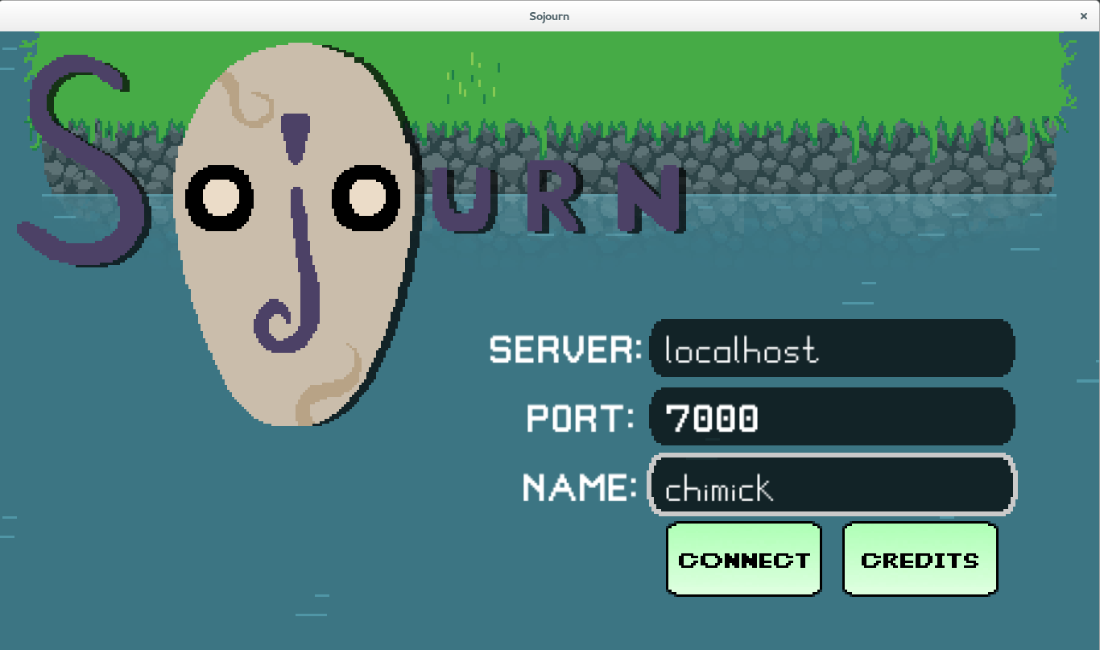

#### Description

Once the game client is run, the Start Menu will be displayed. On the Start Menu there are three text fields; IP, Port, and Username. The IP and Port fields are required to connect to the server, and should reference the appropriate computer (See the Game Requirements section). The Username field is used to identify yourself to other game clients on connected to the server, this field can be filled with whatever characters the user chooses.

#### Interaction

The first text field is selected by default, and pressing the ‘Enter’, or ‘Return’, key will rotate between them in a closed circle.

Clicking the Connect button will submit the contents of the text fields and attempt to connect to the specified server. If the text field information was correct, it will connect to the server lobby and display the Lobby Menu, otherwise a message will be displayed.

Clicking the Credits button will bring the user to the Credits menu, where the developers of the game will be displayed, from there you can navigate back to the Start Menu via another button.

### The Lobby Menu

This section describes how a game client can utilize the Lobby Menu.

#### Game Client

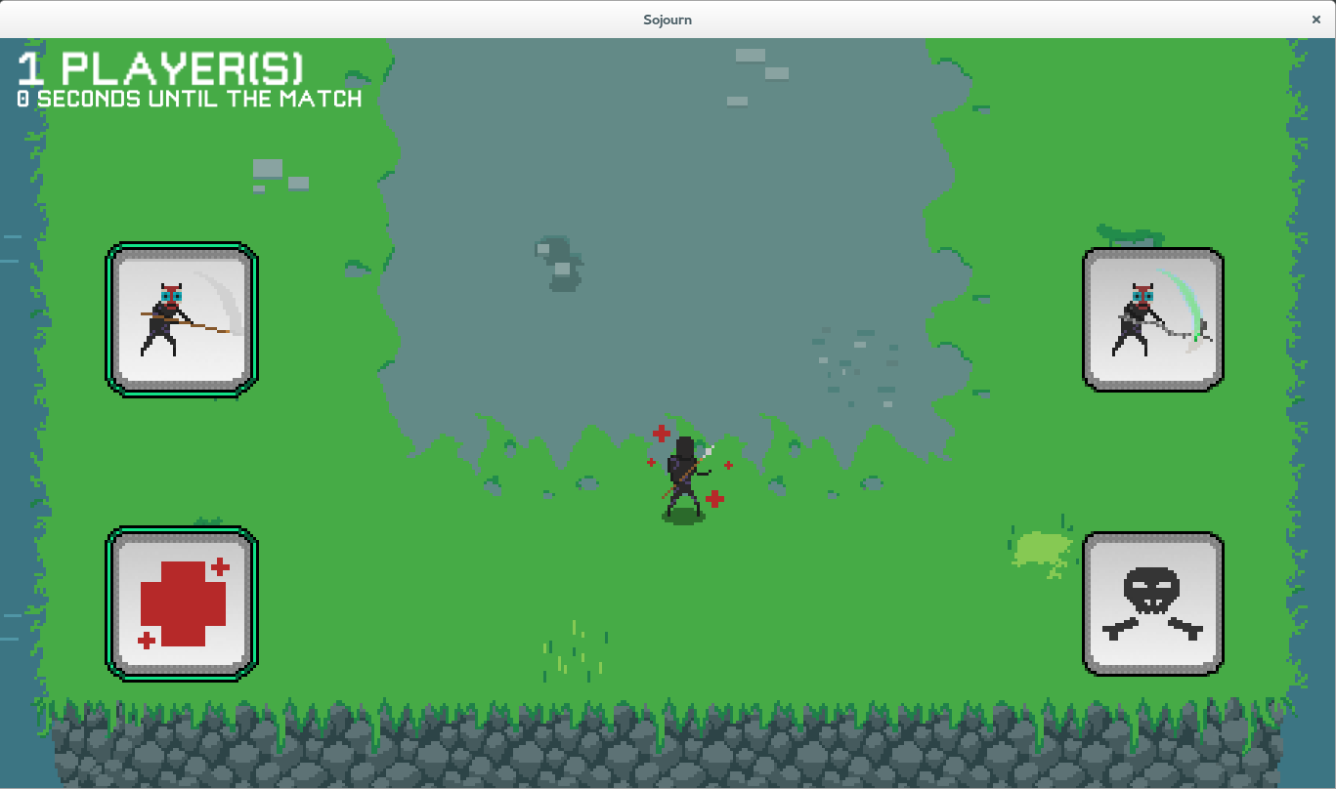

#### Description

The Lobby Menu is a hub where a player is kept while waiting for a game round to begin. There is a counter in the top left for the number of players in the lobby, and it allows the player to select which classes they wish to be for the next round. The can also leave the server and return to the start menu.

#### Interaction

There are two pairs of buttons in the center of the screen, the top two allow the user to select which Vessel Class they wish to be in the next round, and the bottom two allow the user to select which Deity Class they wish to be in the next round.

Once at least four players have joined the lobby, the timer will begin to countdown, and the game round will start. Players can join or leave during this time, but the game round will not start without at least four players. Four of the players in the lobby will be randomly chosen as vessels, with the remainder being deities. If there are only four players, there won’t be any deities that round.

The Leave button in the top right will disconnect the game client from the game server and display the Start Menu.

## Peri-Round

This section describes all the features of the game round that affect or are affected by a game client during a round.

### Game Rules

The goal of the game round is to have the most score at the end of the round; every player is competing against every other player, be they vessel or deity. (For information on the playing area, see the Game Map section)

#### Start State

At the start of the round, each of the four vessels is spawned in each of the four corners of the map, and the deities are looking at the center of the map. The deity abilities begin the round on cooldown.

Across the map, there are randomly spawned gatekeepers.

#### End Condition

The round ends when either only one vessel remains standing, or the timer reaches zero. If the case is the former, the vessel will get a score bonus for being the last vessel remaining. This causes all players to transition to the Scoreboard Menu. (See the Post-Round section)

### Vessels

A Vessel is a player controlled character that is present on the game map during a round, the vessel can be damaged and cause damage to the gatekeepers and vessels on the game map. Thus, the vessel has a health value, and will die when the value reaches zero. If this occurs during a game round, the vessel will become a Ghost (See the Ghost section). Likewise, vessels can kill gatekeepers, and in doing so gain Experience.

#### Game Client

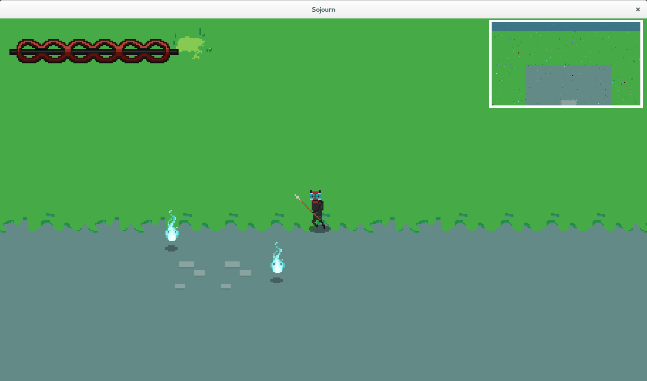

#### Interface

During play, there are elements of the screen that represent values of the vessel. In the center of the screen, there is the avatar that represents the vessel. In the top left there is a red bar that represents the vessel’s health. In the top right, there is a box that contains a view of the game map at a higher perspective, it shows everything on the map within the bounds of the higher view.

#### Movement

Through keyboard input, the player can move the vessel avatar, and thus the camera. This allows the vessel to traverse the game map. The keyboard controls are: W to move up, A to move left, D to move right, and S to move down.

#### Combat

Each vessel is equipped with a weapon, and can use their weapon by clicking on the screen. The weapon will fire a projectile from the vessel avatar towards the point of click.

#### Experience

By killing gatekeepers or other vessels, a vessel can gain experience. After enough experience is gained, the vessel will Level Up. Levelling up causes an increase to the vessels attack power, the vessel’s speed, and the value of the vessel’s health bar.

#### Scoring

Vessels can gain score by killing gatekeepers or vessels, levelling up, or being the last vessel standing at the end of the round. Score determines who won the round.

### Deities

Deities are player controlled entities that have no physical presence on the game map. Deities cannot be damaged or die. Deities can merely use their abilities and gain score in an attempt to win the round.

#### Game Client

//

#### Interface

//

#### Camera

The deity can move their camera much the same way the vessels can: W to move up, A to move left, D to move right, and S to move down.

#### Abilities

Deities are given abilities, the same abilities the user selected in the Lobby Menu, and can use their abilities to affect the round. Abilities are casted by clicking the ability icon, and is directed at the area inside the target reticle. Abilities require that there be a target within the reticle to affect, else the ability will miss with no effect.

#### Scoring

Deities can accumulate score through the effective use of their abilities; whenever an ability is used, the more effect it has, the more score the deity will be given.

### Gatekeepers

Gatekeepers are artificial intelligence controlled characters on the game map, which will attack any vessel that comes within their sight radius. They vary in size and power, but all attack in the same manner.

#### Example

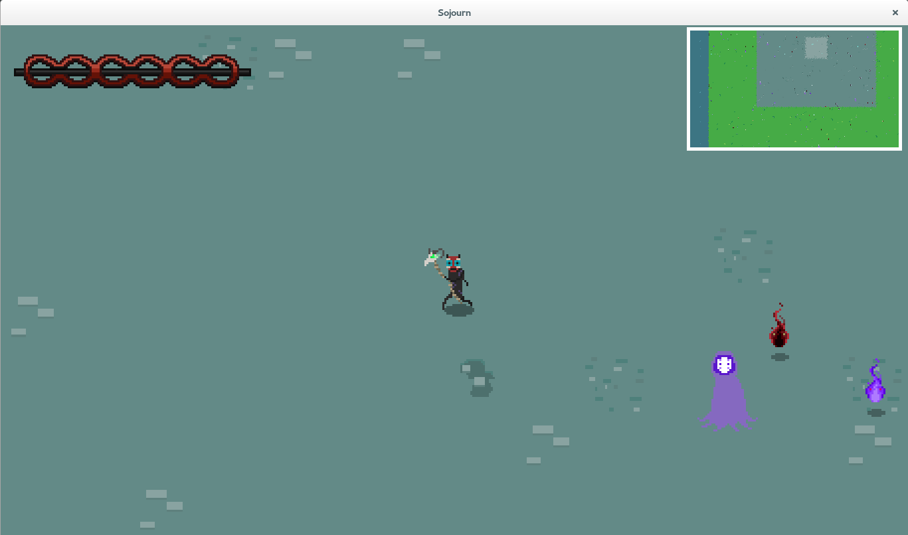

#### Lost Souls

Lost Souls are the weaker gatekeepers, the minions of the Guardians. Lost souls are fairly small and can do little damage to the vessel.

#### Guardians

Guardians are the stronger gatekeepers, are much larger than the lost souls, and can do much more damage to vessels

### Ghosts

Ghosts are player controlled characters that are not unlike deities, except for the lack of abilities. Ghosts can only move their camera and view the round occur, not affect its outcome. A user can only be assigned to be a ghost if they were a vessel and they died, or if their game client connected to a server that was currently hosting a game round.

Players remain a ghost until the end of the round.

## Post-Round

Once the end condition of a round occurs, the game clients are redirected to the Scoreboard Menu, which displays the scores for everyone in the round. After ten seconds on the scoreboard menu, the clients will be redirected to the Lobby Menu, where there will be a countdown of thirty seconds before the next game round starts, thus completing the loop.

# Encyclopedia

This section specifically describes all the content in the game, which can be seen in during a game round. (See the Peri-Round section)

## Game Map

This section describes all the aspects of the game map, or playing area during a game round.

### Generation

The game map is a procedurally generated set of tiles, which contain random numbers of gatekeepers. This is different every game round.

#### Example

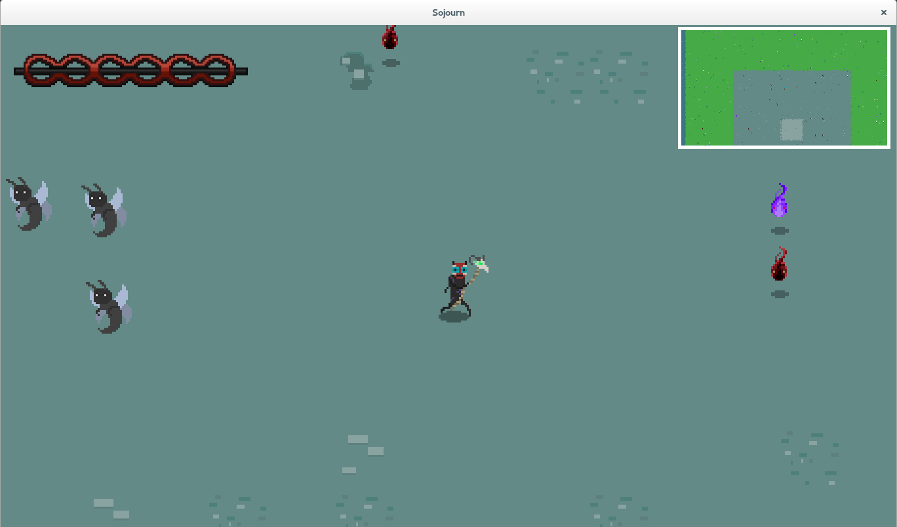

#### Tiles

There are types of tiles, there are stone tiles and grass tiles. There is always a large cluster of stone tiles in the center of the map, with an outer ring of grass tiles. Random numbers of gatekeepers spawn on these tiles.

#### Vessels Spawn

Vessels will spawn in the four corners of the map, and no gatekeepers can spawn in the same tile.

## Vessel Classes

This section describes the specific vessel classes that are in the game.

### Warrior

The warrior class is a vessel that starts with a high health value but has a very short range attack.

#### Example

### Shaman

The shaman class is a vessel that starts with a low health value but a high power long range attack.

#### Example

## Deity Abilities

This section describes the specific deity abilities that can be used in a game round. Deity abilities are clustered into groups of three, and are selected as a group, not individually.

### Vitality

The vitality group contains abilities that are centered on healing characters, which includes vessels or gatekeepers.

#### 1

//

#### 2

//

#### 3

//

### Demise

The demise group contains abilities that are centered on damaging characters, which includes vessels or gatekeepers.

#### 1

//

#### 2

//

#### 3

//

## Gatekeepers

This section specifically describes the gatekeepers that can be encountered in a game round.

### The Lost

The Lost are weaker guardians, and can spawn anywhere on the game map.

#### Bee

//

#### Example



#### Wisp

//

#### Examples



### Guardians

//

#### Queen Bee

//

#### Example



#### Wanderer

//

#### Example

