Лабораторная работа № 2.
Расчет коэффициентов разделяющей линии и вычисление отступа (margin) для объектов разных классов.

- Используя данные графиков (табл. 11), вычислите коэффициенты

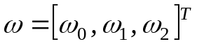

разделяющей линии, которая определяется выражением

.

2. Вычислите отступы для зеленых и синих точек. Зеленые точки относятся к классу +1, синие точки относятся к классу –1. Отступ вычисляется по формуле

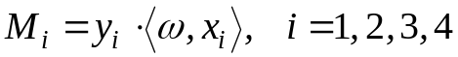

где 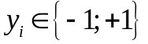– метка класса объекта 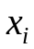; 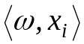– скалярное произведение векторов ω и x_{i}. Координаты вектора ω должны удовлетворять условию: отступ для точек, расположенных дальше от разделяющей линии, должен быть положительным, а для точек, расположенных близко к разделяющей линии, – отрицательным.

Вариант | Графики | Вариант | Графики
1 | 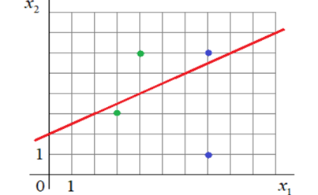 | 6 | 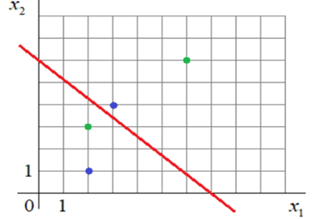
2 | 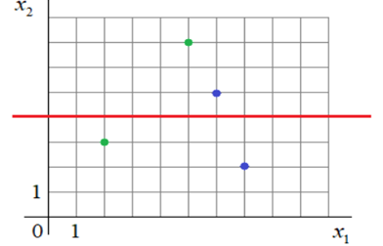 | 7 | 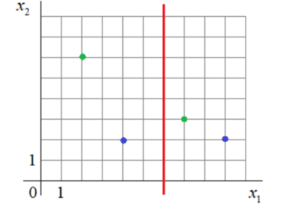
3 | 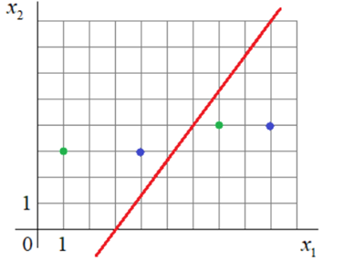 | 8 | 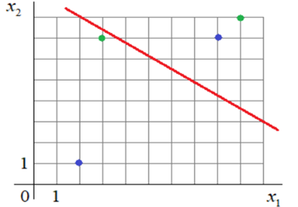
4 | 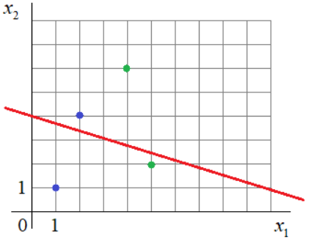 | 9 | 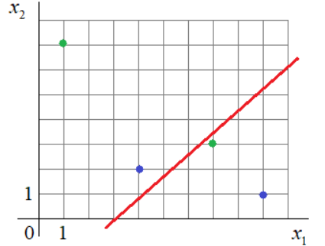
5 | 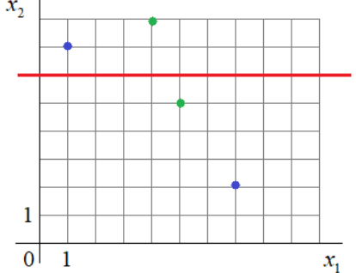 | 10 | 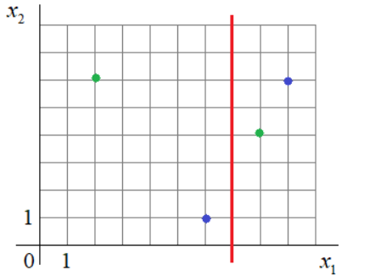

Табл. 11. Графики разделяющих линий

Содержание отчета
1. Титульный лист с названием лабораторной работы, номером своего варианта, фамилией студента и группы.
2. Расчеты для весов разделяющей линии.
3. Расчеты для отступов.
4. Выводы по полученным результатам.

Ниже приведены обучающие выборки, необходимые для выполнения заданий 3 – 6 (по вариантам).

Вариант 1

data_x = [(5.8, 2.7), (6.7, 3.1), (5.7, 2.9), (5.5, 2.4), (4.8, 3.4), (5.4, 3.4), (4.8, 3.0), (5.5, 2.5), (5.3, 3.7), (7.0, 3.2), (5.6, 2.9), (4.9, 3.1), (4.8,3.0), (5.0, 2.3), (5.2, 3.4), (5.1, 3.8), (5.0, 3.0), (5.0, 3.3), (4.6, 3.1), (5.5,2.6), (5.0, 3.5), (6.7, 3.0), (6.0, 2.2), (4.8, 3.1), (6.4, 2.9), (5.6, 3.0), (4.4,3.0), (4.9, 2.4), (5.6, 3.0), (5.0, 3.6), (5.1, 3.3), (5.8, 4.0), (5.5, 2.4), (5.2,2.7), (5.1, 3.8), (5.1, 3.5), (5.5, 4.2), (4.9, 3.1), (5.9, 3.2), (5.7, 2.6), (4.7,3.2), (5.4, 3.9), (5.8, 2.6), (5.1, 3.4), (6.4, 3.2), (5.8, 2.7), (5.6, 2.7), (5.7,2.8), (5.4, 3.0), (5.0, 3.2), (4.6, 3.4), (6.0, 2.7), (6.6, 3.0), (4.9, 3.0), (4.9,3.6), (4.4, 3.2), (5.4, 3.4), (6.0, 3.4), (5.9, 3.0), (6.1, 2.8), (5.1, 3.7), (5.5,3.5), (6.1, 3.0), (6.2, 2.2), (5.7, 3.0), (5.2, 3.5), (5.4, 3.7), (4.6, 3.2), (5.2,4.1), (5.0, 2.0), (6.8, 2.8), (5.0, 3.5), (6.7, 3.1), (6.3, 3.3), (6.0, 2.9), (4.7,3.2), (6.6, 2.9), (5.6, 2.5), (4.4, 2.9), (6.2, 2.9), (6.1, 2.9), (4.3, 3.0), (6.9,3.1), (5.7, 3.8), (5.4, 3.9), (6.1, 2.8), (4.6, 3.6), (5.5, 2.3), (4.8, 3.4), (6.5,2.8), (6.3, 2.5), (5.1, 3.8), (5.7, 4.4), (5.0, 3.4), (4.5, 2.3), (5.7, 2.8), (5.1,2.5), (5.1, 3.5), (6.3, 2.3), (5.0, 3.4)]

data_y = [1, 1, 1, 1, -1, -1, -1, 1, -1, 1, 1, -1, -1, 1, -1, -1, -1, -1, -1, 1,
-1, 1, 1, -1, 1, 1, -1, 1, 1, -1, -1, -1, 1, 1, -1, -1, -1, -1, 1, 1, -1, -1, 1,
-1, 1, 1, 1, 1, 1, -1, -1, 1, 1, -1, -1, -1, -1, 1, 1, 1, -1, -1, 1, 1, 1, -1, -1, -1, -1, 1, 1, -1, 1, 1, 1, -1, 1, 1, -1, 1, 1, -1, 1, -1, -1, 1, -1, 1, -1, 1, 1, -1, -1, -1, -1, 1, 1, -1, 1, -1]

Вариант 2

data_x = [(4.9, 3.3), (5.6, 4.5), (6.4, 4.3), (6.7, 5.7), (6.3, 5.0), (5.2, 3.9), (5.5, 3.7), (5.6, 3.6), (5.5, 3.8), (6.1, 4.7), (7.4, 6.1), (6.0, 5.1), (5.5,4.4), (5.9, 5.1), (6.5, 5.8), (6.5, 4.6), (6.7, 4.4), (6.3, 5.6), (5.9, 4.8), (6.0,4.5), (5.6, 4.1), (5.6, 4.9), (4.9, 4.5), (6.2, 4.5), (6.1, 4.7), (6.1, 4.9), (6.2,5.4), (5.7, 4.2), (6.1, 5.6), (5.8, 4.0), (6.6, 4.6), (5.6, 4.2), (7.2, 6.1), (7.7,6.7), (5.6, 3.9), (7.7, 6.9), (6.0, 4.0), (6.1, 4.0), (7.6, 6.6), (5.1, 3.0), (6.3,6.0), (6.7, 5.7), (6.8, 5.9), (6.4, 5.5), (7.0, 4.7), (5.8, 5.1), (5.8, 5.1), (6.4,5.3), (6.3, 4.9), (6.4, 5.3), (5.7, 3.5), (7.2, 5.8), (6.4, 5.6), (5.7, 4.5), (6.0,4.5), (7.7, 6.1), (6.2, 4.3), (7.1, 5.9), (7.3, 6.3), (5.0, 3.3), (6.3, 5.1), (5.8,3.9), (6.4, 4.5), (6.3, 5.6), (6.8, 5.5), (6.9, 5.4), (5.5, 4.0), (5.7, 4.1), (6.5,5.5), (6.3, 4.7), (5.0, 3.5), (6.7, 5.8), (6.9, 4.9), (7.7, 6.7), (5.8, 4.1), (6.4,5.6), (6.7, 5.2), (6.7, 4.7), (5.4, 4.5), (6.8, 4.8), (5.7, 4.2), (5.5, 4.0), (6.3,4.9), (6.5, 5.2), (5.8, 5.1), (6.0, 4.8), (6.2, 4.8), (6.5, 5.1), (7.9, 6.4), (6.7,5.0), (6.7, 5.6), (6.0, 5.0), (6.1, 4.6), (5.7, 5.0), (7.2, 6.0), (6.3, 4.4), (5.9,4.2), (6.9, 5.1), (6.6, 4.4), (6.9, 5.7)]

data_y = [-1, -1, -1, 1, 1, -1, -1, -1, -1, -1, 1, -1, -1, 1, 1, -1, -1, 1, -1,
-1, -1, 1, 1, -1, -1, 1, 1, -1, 1, -1, -1, -1, 1, 1, -1, 1, -1, -1, 1, -1, 1, 1, 1, 1, -1, 1, 1, 1, 1, 1, -1, 1, 1, -1, -1, 1, -1, 1, 1, -1, 1, -1, -1, 1, 1, 1,
-1, -1, 1, -1, -1, 1, -1, 1, -1, 1, 1, -1, -1, -1, -1, -1, -1, 1, 1, 1, 1, 1, 1,
-1, 1, 1, -1, 1, 1, -1, -1, 1, -1, 1]

Вариант 3

data_x = [(7.2, 2.5), (6.4, 2.2), (6.3, 1.5), (7.7, 2.2), (6.2, 1.8), (5.7, 1.3), (7.1, 2.1), (5.8, 2.4), (5.2, 1.4), (5.9, 1.5), (7.0, 1.4), (6.8, 2.1), (7.2, 1.6), (6.7, 2.4), (6.0, 1.5), (5.1, 1.1), (6.6, 1.3), (6.1, 1.4), (6.7, 2.1), (6.4, 1.8), (5.6, 1.3), (6.9, 2.3), (6.4, 1.9), (6.9, 2.3), (6.5, 2.2), (6.0,1.5), (5.6, 1.1), (5.6, 1.5), (6.0, 1.0), (6.0, 1.8), (6.7, 2.5), (7.7, 2.3), (5.5,1.1), (5.8, 1.0), (6.9, 2.1), (6.6, 1.4), (6.3, 1.6), (6.1, 1.4), (5.0, 1.0), (7.7,2.0), (4.9, 1.7), (7.2, 1.8), (6.8, 1.4), (6.1, 1.2), (5.8, 1.9), (6.3, 2.5), (5.7,2.0), (6.5, 1.8), (7.6, 2.1), (6.3, 1.5), (6.7, 1.4), (6.4, 2.3), (6.2, 2.3), (6.3,1.9), (5.5, 1.3), (7.9, 2.0), (6.7, 1.8), (6.4, 1.3), (6.5, 2.0), (6.5, 1.5), (6.9,1.5), (5.6, 1.3), (5.8, 1.2), (6.7, 2.3), (6.0, 1.6), (5.7, 1.2), (5.7, 1.0), (5.5,1.0), (6.1, 1.4), (6.3, 1.8), (5.7, 1.3), (6.1, 1.3), (5.5, 1.3), (6.3, 1.3), (5.9,1.8), (7.7, 2.3), (6.5, 2.0), (5.6, 2.0), (6.7, 1.7), (5.7, 1.3), (5.5, 1.2), (5.0,1.0), (5.8, 1.9), (6.2, 1.3), (6.2, 1.5), (6.3, 2.4), (6.4, 1.5), (7.4, 1.9), (6.8,2.3), (5.6, 1.3), (5.8, 1.2), (7.3, 1.8), (6.7, 1.5), (6.3, 1.8), (6.0, 1.6), (6.4,2.1), (6.1, 1.8), (5.9, 1.8), (5.4, 1.5), (4.9, 1.0)]

data_y = [1, 1, 1, 1, 1, -1, 1, 1, -1, -1, -1, 1, 1, 1, -1, -1, -1, 1, 1, 1, -1, 1, 1, 1, 1, 1, -1, -1, -1, 1, 1, 1, -1, -1, 1, -1, -1, -1, -1, 1, 1, 1, -1, -1, 1, 1, 1, 1, 1, -1, -1, 1, 1, 1, -1, 1, 1, -1, 1, -1, -1, -1, -1, 1, -1, -1, -1, -1, -1, 1, -1, -1, -1, -1, 1, 1, 1, 1, -1, -1, -1, -1, 1, -1, -1, 1, -1, 1, 1, -1, -1, 1, -1, 1, -1, 1, 1, -1, -1, -1]

Вариант 4

data_x = [(5.3, 2.3), (5.7, 2.5), (4.0, 1.0), (5.6, 2.4), (4.5, 1.5), (5.4, 2.3), (4.8, 1.8), (4.5, 1.5), (5.1, 1.5), (6.1, 2.3), (5.1, 1.9), (4.0, 1.2), (5.2,2.0), (3.9, 1.4), (4.2, 1.2), (4.7, 1.5), (4.8, 1.8), (3.6, 1.3), (4.6, 1.4), (4.5,1.7),(3.0, 1.1), (4.3, 1.3), (4.5, 1.3), (5.5, 2.1), (3.5, 1.0), (5.6, 2.2), (4.2, 1.5), (5.8, 1.8), (5.5, 1.8), (5.7, 2.3), (6.4, 2.0), (5.0, 1.7), (6.7,2.0), (4.0, 1.3), (4.4, 1.4), (4.5, 1.5), (5.6, 2.4), (5.8, 1.6), (4.6, 1.3), (4.1,1.3), (5.1, 2.3), (5.2, 2.3), (5.6, 1.4), (5.1, 1.8), (4.9, 1.5), (6.7, 2.2), (4.4,1.3), (3.9, 1.1), (6.3, 1.8), (6.0, 1.8), (4.5, 1.6), (6.6, 2.1), (4.1, 1.3), (4.5,1.5), (6.1, 2.5), (4.1, 1.0), (4.4, 1.2), (5.4, 2.1), (5.0, 1.5), (5.0, 2.0), (4.9,1.5), (5.9, 2.1), (4.3, 1.3), (4.0, 1.3), (4.9, 2.0), (4.9, 1.8), (4.0, 1.3), (5.5,1.8), (3.7, 1.0), (6.9, 2.3), (5.7, 2.1), (5.3, 1.9), (4.4, 1.4), (5.6, 1.8), (3.3,1.0), (4.8, 1.8), (6.0, 2.5), (5.9, 2.3), (4.9, 1.8), (3.3, 1.0), (3.9, 1.2), (5.6,2.1), (5.8, 2.2), (3.8, 1.1), (3.5, 1.0), (4.5, 1.5), (5.1, 1.9), (4.7, 1.4), (5.1,1.6), (5.1, 2.0), (4.8, 1.4), (5.0, 1.9), (5.1, 2.4), (4.6, 1.5), (6.1, 1.9), (4.7,1.6),(4.7, 1.4), (4.7, 1.2), (4.2, 1.3), (4.2, 1.3)]

data_y = [1, 1, -1, 1, -1, 1, 1, -1, 1, 1, 1, -1, 1, -1, -1, -1, -1, -1, -1, 1,
-1, -1, -1, 1, -1, 1, -1, 1, 1, 1, 1, -1, 1, -1, -1, -1, 1, 1, -1, -1, 1, 1, 1, 1, -1, 1, -1, -1, 1, 1, -1, 1, -1, -1, 1, -1, -1, 1, 1, 1, -1, 1, -1, -1, 1, 1, -1, 1, -1, 1, 1, 1, -1, 1, -1, 1, 1, 1, 1, -1, -1, 1, 1, -1, -1, -1, 1, -1, -1, 1, -1, 1, 1, -1, 1, -1, -1, -1, -1, -1]

Вариант 5

data_x = [(5.8, 1.2), (5.6, 1.5), (6.5, 1.5), (6.1, 1.3), (6.4, 1.3), (7.7, 2.0), (6.0, 1.8), (5.6, 1.3), (6.0, 1.6), (5.8, 1.9), (5.7, 2.0), (6.3, 1.5), (6.2,1.8), (7.7, 2.3), (5.8, 1.2), (6.3, 1.8), (6.0, 1.0), (6.2, 1.3), (5.7, 1.3), (6.3,1.9), (6.7, 2.5), (5.5, 1.2), (4.9, 1.0), (6.1, 1.4), (6.0, 1.6), (7.2, 2.5), (7.3,1.8), (6.6, 1.4), (5.6, 2.0), (5.5, 1.0), (6.4, 2.2), (5.6, 1.3), (6.6, 1.3), (6.9,2.1), (6.8, 2.1), (5.7, 1.3), (7.0, 1.4), (6.1, 1.4), (6.1, 1.8), (6.7, 1.7), (6.0,1.5), (6.5, 1.8), (6.4, 1.5), (6.9, 1.5), (5.6, 1.3), (6.7, 1.4), (5.8, 1.9), (6.3,1.3), (6.7, 2.1), (6.2, 2.3), (6.3, 2.4), (6.7, 1.8), (6.4, 2.3), (6.2, 1.5), (6.1,1.4), (7.1, 2.1), (5.7, 1.0), (6.8, 1.4), (6.8, 2.3), (5.1, 1.1), (4.9, 1.7), (5.9,1.8), (7.4, 1.9), (6.5, 2.0), (6.7, 1.5), (6.5, 2.0), (5.8, 1.0), (6.4, 2.1), (7.6,2.1), (5.8, 2.4), (7.7, 2.2), (6.3, 1.5), (5.0, 1.0), (6.3, 1.6), (7.7, 2.3), (6.4,1.9), (6.5, 2.2), (5.7, 1.2), (6.9, 2.3), (5.7, 1.3), (6.1, 1.2), (5.4, 1.5), (5.2,1.4), (6.7, 2.3), (7.9, 2.0), (5.6, 1.1), (7.2, 1.8), (5.5, 1.3), (7.2, 1.6), (6.3,2.5), (6.3, 1.8), (6.7, 2.4), (5.0, 1.0), (6.4, 1.8), (6.9, 2.3), (5.5, 1.3), (5.5,1.1), (5.9, 1.5), (6.0, 1.5), (5.9, 1.8)]

data_y = [-1, -1, -1, -1, -1, 1, 1, -1, -1, 1, 1, -1, 1, 1, -1, 1, -1, -1, -1, 1, 1, -1, -1, -1, -1, 1, 1, -1, 1, -1, 1, -1, -1, 1, 1, -1, -1, 1, 1, -1, 1, 1, -1, -1, -1, -1, 1, -1, 1, 1, 1, 1, 1, -1, -1, 1, -1, -1, 1, -1, 1, -1, 1, 1, -1, 1, -1, 1, 1, 1, 1, 1, -1, -1, 1, 1, 1, -1, 1, -1, -1, -1, -1, 1, 1, -1, 1, -1, 1, 1, 1, 1, -1, 1, 1, -1, -1, -1, -1, 1]

Вариант 6

data_x = [(2.6, 1.0), (3.0, 2.3), (3.4, 1.6), (3.0, 1.5), (2.7, 1.0), (3.8, 2.0), (3.0, 1.8), (2.8, 2.1), (2.9, 1.3), (3.0, 1.8), (3.2, 1.5), (2.7, 1.8), (3.0,1.4), (3.3, 2.5), (2.7, 1.9), (2.6, 1.2), (3.1, 1.4), (2.7, 1.9), (3.1, 2.4), (3.0,1.5), (2.8, 1.4), (3.1, 1.5), (2.5, 1.8), (2.8, 1.3), (2.8, 1.8), (2.2, 1.5), (3.3,2.5), (3.2, 1.8), (3.6, 2.5), (3.0, 1.7), (2.3, 1.3), (2.8, 1.3), (2.5, 1.5), (3.0,2.1), (2.0, 1.0), (2.8, 2.2), (3.0, 1.6), (3.1, 2.1), (3.2, 2.3), (2.5, 1.7), (2.5,1.1), (3.2, 2.3), (2.8, 1.2), (2.9, 1.5), (2.6, 1.4), (2.2, 1.0), (3.3, 2.1), (2.4,1.1), (3.4, 2.4), (3.0, 1.2), (2.8, 1.5), (3.2, 1.4), (3.8, 2.2), (2.8, 2.4), (3.0,1.8), (3.0, 1.5), (3.0, 1.4), (3.0, 2.1), (2.4, 1.0), (3.4, 2.3), (2.7, 1.4), (2.3,1.0), (2.9, 1.3), (3.3, 1.6), (2.7, 1.3), (2.6, 1.2), (2.4, 1.0), (3.2, 2.0), (3.1,1.5), (3.0, 1.8), (2.8, 1.9), (2.7, 1.9), (2.8, 1.5), (3.2, 1.8), (3.1, 1.8), (2.5,1.1), (2.2, 1.5), (2.9, 1.4), (3.0, 2.1), (2.9, 1.3), (2.8, 2.0), (2.5, 2.0), (3.0,2.2), (3.2, 2.3), (3.1, 2.3), (2.8, 1.3), (2.5, 1.9), (3.0, 2.3), (2.9, 1.3), (2.9,1.8), (3.0, 2.0), (2.9, 1.8), (2.7, 1.2), (2.5, 1.3), (3.0, 1.3), (2.6, 2.3), (2.8,2.0), (2.9, 1.3), (2.7, 1.6), (2.3, 1.3)]

data_y = [-1, 1, -1, -1, -1, 1, 1, 1, -1, 1, -1, 1, -1, 1, 1, -1, -1, 1, 1, -1,
-1, -1, 1, -1, 1, -1, 1, -1, 1, -1, -1, -1, -1, 1, -1, 1, 1, 1, 1, 1, -1, 1, -1,
-1, 1, -1, 1, -1, 1, -1, 1, -1, 1, 1, 1, -1, -1, 1, -1, 1, -1, -1, -1, -1, -1, -1, -1, 1, -1, 1, 1, 1, -1, 1, 1, -1, 1, -1, 1, -1, 1, 1, 1, 1, 1, -1, 1, 1, -1, 1, 1, 1, -1, -1, -1, 1, 1, -1, -1, -1]

Вариант 7

data_x = [(3.0, 1.3), (3.4, 1.6), (3.4, 0.4), (3.7, 0.2), (3.5, 0.2), (3.4, 0.2), (3.4, 0.4), (3.9, 0.4), (3.4, 0.3), (3.2, 0.2), (2.8, 1.3), (3.5, 0.3), (2.4,1.0), (3.0, 0.1), (3.6, 0.2), (3.2, 0.2), (2.9, 0.2), (2.9, 1.3), (2.3, 1.3), (3.8,0.2), (3.2, 1.5), (2.3, 1.0), (3.0, 1.7), (3.3, 0.2), (3.4, 0.2), (3.8, 0.3), (2.0,1.0), (3.1, 0.2), (2.5, 1.3), (2.4, 1.1), (3.2, 0.2), (2.2, 1.0), (3.1, 1.4), (3.0,0.2), (3.0, 0.2), (3.4, 0.2), (3.7, 0.2), (2.8, 1.2), (2.9, 1.4), (4.0, 0.2), (3.2,1.4), (3.2, 0.2), (2.9, 1.3), (2.9, 1.3), (3.5, 0.2), (3.3, 1.6), (2.9, 1.3), (2.7,1.0), (2.9, 1.3), (3.4, 0.2), (3.2, 0.2), (4.1, 0.1), (3.5, 0.6), (2.7, 1.4), (2.3,0.3), (2.9, 1.5), (3.1, 1.5), (3.5, 0.2), (2.7, 1.6), (3.3, 0.5), (3.0, 1.4), (3.6,0.2), (3.0, 1.2), (2.8, 1.3), (2.5, 1.1), (3.0, 1.5), (3.1, 0.2), (2.6, 1.0), (2.7,1.2), (2.2, 1.5), (3.7, 0.4), (3.4, 0.2), (3.5, 0.3), (3.6, 0.1), (2.5, 1.5), (2.6,1.2), (2.8, 1.3), (3.1, 0.1), (2.4, 1.0), (3.1, 1.5), (2.3, 1.3), (2.8, 1.5), (3.0,0.3), (3.0, 0.2), (2.5, 1.1), (3.0, 1.5), (3.2, 1.8), (3.9, 0.4), (2.8, 1.4), (4.2,0.2), (3.4, 0.2), (2.7, 1.3), (3.8, 0.3), (3.0, 1.4), (2.6, 1.2), (4.4, 0.4), (3.8,0.4), (3.1, 0.2), (3.0, 0.1), (3.0, 1.5)]

data_y = [1, 1, -1, -1, -1, -1, -1, -1, -1, -1, 1, -1, 1, -1, -1, -1, -1, 1, 1,
-1, 1, 1, 1, -1, -1, -1, 1, -1, 1, 1, -1, 1, 1, -1, -1, -1, -1, 1, 1, -1, 1, -1, 1, 1, -1, 1, 1, 1, 1, -1, -1, -1, -1, 1, -1, 1, 1, -1, 1, -1, 1, -1, 1, 1, 1, 1,
-1, 1, 1, 1, -1, -1, -1, -1, 1, 1, 1, -1, 1, 1, 1, 1, -1, -1, 1, 1, 1, -1, 1, -1, -1, 1, -1, 1, 1, -1, -1, -1, -1, 1]

Вариант 8

data_x = [(2.9, 6.0), (3.8, 5.1), (3.0, 4.9), (3.5, 5.0), (2.6, 5.5), (3.4, 4.6), (3.8, 5.1), (3.5, 5.5), (2.3, 5.0), (3.6, 4.9), (3.5, 5.1), (2.8, 5.7), (3.0,5.4), (2.9, 6.4), (3.0, 4.3), (3.0, 4.8), (3.5, 5.1), (3.2, 4.7), (2.8, 5.7), (4.2,5.5), (2.5, 6.3), (2.4, 4.9), (3.1, 4.8), (3.7, 5.4), (3.0, 5.6), (2.7, 5.6), (3.1,6.9), (2.7, 6.0), (3.4, 4.8), (2.4, 5.5), (3.3, 5.1), (2.5, 5.6), (2.9, 6.2), (3.0,5.9), (2.8, 6.1), (3.0, 4.4), (2.7, 5.2), (2.9, 5.7), (3.3, 5.0), (3.2, 6.4), (3.4,5.2), (3.4, 5.0), (3.1, 4.9), (4.4, 5.7), (2.8, 6.1), (3.4, 5.0), (3.1, 6.7), (3.7,5.1), (3.1, 4.9), (4.0, 5.8), (2.3, 4.5), (3.1, 6.7), (3.2, 5.0), (2.4, 5.5), (3.6,5.0), (3.9, 5.4), (3.5, 5.0), (2.6, 5.7), (2.8, 6.8), (3.9, 5.4), (2.2, 6.0), (3.2,4.4), (3.8, 5.7), (3.2, 4.7), (2.9, 6.6), (3.0, 4.8), (2.6, 5.8), (3.0, 5.0), (3.4,5.1), (3.8, 5.1), (2.3, 6.3), (3.6, 4.6), (2.7, 5.8), (2.9, 4.4), (3.2, 4.6), (3.5,5.2), (3.1, 4.6), (2.5, 5.5), (2.2, 6.2), (3.2, 7.0), (3.3, 6.3), (3.0, 6.1), (3.4,4.8), (3.4, 5.4), (2.3, 5.5), (2.5, 5.1), (3.4, 6.0), (2.0, 5.0), (2.9, 5.6), (2.7,5.8), (2.8, 6.5), (3.4, 5.4), (3.7, 5.3), (4.1, 5.2), (3.0, 5.6), (3.0, 6.6), (2.9,6.1), (3.0, 6.7), (3.0, 5.7), (3.2, 5.9)]

data_y = [1, -1, -1, -1, 1, -1, -1, -1, 1, -1, -1, 1, 1, 1, -1, -1, -1, -1, 1, -1, 1, 1, -1, -1, 1, 1, 1, 1, -1, 1, -1, 1, 1, 1, 1, -1, 1, 1, -1, 1, -1, -1, -1, -1, 1, -1, 1, -1, -1, -1, -1, 1, -1, 1, -1, -1, -1, 1, 1, -1, 1, -1, -1, -1, 1, -1, 1, -1, -1, -1, 1, -1, 1, -1, -1, -1, -1, 1, 1, 1, 1, 1, -1, -1, 1, 1, 1, 1, 1, 1, 1, -1, -1, -1, 1, 1, 1, 1, 1, 1]

Вариант 9

data_x = [(1.3, 5.5), (1.5, 4.9), (4.9, 6.3), (1.5, 5.2), (3.5, 5.7), (1.4, 4.6), (4.8, 5.9), (4.5, 5.7), (3.7, 5.5), (1.5, 5.3), (4.6, 6.1), (1.6, 4.8), (1.5,5.0), (4.0, 5.5), (1.3, 4.7), (1.4, 5.0), (1.7, 5.1), (1.5, 5.2), (3.9, 5.2), (1.5,4.6), (4.1, 5.8), (1.9, 5.1), (4.0, 5.5), (4.6, 6.6), (4.5, 6.4), (4.5, 6.0), (4.7,6.1), (1.3, 4.5), (5.1, 6.0), (4.4, 6.6), (4.0, 6.1), (4.5, 6.2), (3.8, 5.5), (1.5,5.4), (4.9, 6.9), (3.0, 5.1), (4.5, 5.6), (1.4, 4.9), (4.0, 5.8), (5.0, 6.7), (4.4,5.5), (3.9, 5.6), (1.4, 4.6), (3.3, 4.9), (3.9, 5.8), (4.2, 5.7), (4.4, 6.3), (1.4,5.1), (1.6, 5.0), (1.5, 5.1), (4.7, 6.3), (3.6, 5.6), (4.4, 6.7), (1.7, 5.4), (1.3,4.4), (4.1, 5.6), (1.0, 4.6), (4.3, 6.2), (1.4, 4.4), (4.5, 6.0), (4.7, 6.7), (3.3,5.0), (1.5, 4.9), (3.5, 5.0), (1.6, 4.7), (1.4, 4.9), (1.4, 4.8), (1.3, 5.0), (4.6,6.5), (4.0, 6.0), (4.7, 6.1), (1.6, 5.0), (1.4, 5.2), (4.7, 7.0), (1.1, 4.3), (1.6,5.1), (4.3, 6.4), (1.2, 5.8), (1.9, 4.8), (1.4, 4.8), (1.5, 5.1), (4.8, 6.8), (4.1,5.7), (1.7, 5.7), (1.6, 5.0), (4.2, 5.7), (1.6, 4.8), (1.2, 5.0), (1.3, 4.4), (1.7,5.4), (4.5, 5.4), (4.2, 5.6), (1.5, 5.4), (1.4, 5.5), (1.4, 5.1), (1.5, 5.1), (4.2,5.9), (1.5, 5.7), (1.4, 5.0), (1.3, 5.4)]

data_y = [-1, -1, 1, -1, 1, -1, 1, 1, 1, -1, 1, -1, -1, 1, -1, -1, -1, -1, 1, -1, 1, -1, 1, 1, 1, 1, 1, -1, 1, 1, 1, 1, 1, -1, 1, 1, 1, -1, 1, 1, 1, 1, -1, 1, 1, 1, 1, -1, -1, -1, 1, 1, 1, -1, -1, 1, -1, 1, -1, 1, 1, 1, -1, 1, -1, -1, -1, -1, 1, 1, 1, -1, -1, 1, -1, -1, 1, -1, -1, -1, -1, 1, 1, -1, -1, 1, -1, -1, -1, -1, 1, 1, -1, -1, -1, -1, 1, -1, -1, -1]

Вариант 10

data_x = [(3.0, 4.9), (2.7, 3.9), (3.0, 5.5), (2.6, 4.0), (2.9, 4.3), (3.1, 5.1), (2.2, 4.5), (2.3, 3.3), (2.7, 5.1), (3.3, 5.7), (2.8, 5.1), (2.8, 4.9), (2.5,4.5), (2.8, 4.7), (3.2, 4.7), (3.2, 5.7), (2.8, 6.1), (3.6, 6.1), (2.8, 4.8), (2.9,4.5), (3.1, 4.9), (2.3, 4.4), (3.3, 6.0), (2.6, 5.6), (3.0, 4.4), (2.9, 4.7), (2.8,4.0), (2.5, 5.8), (2.4, 3.3), (2.8, 6.7), (3.0, 5.1), (2.3, 4.0), (3.1, 5.5), (2.8,4.8), (2.7, 5.1), (2.5, 4.0), (3.1, 4.4), (3.8, 6.7), (3.1, 5.6), (3.1, 4.7), (3.0,5.8), (3.0, 5.2), (3.0, 4.5), (2.7, 4.9), (3.0, 6.6), (2.9, 4.6), (3.0, 4.6), (2.6,3.5), (2.7, 5.1), (2.5, 5.0), (2.0, 3.5), (3.2, 5.9), (2.5, 5.0), (3.4, 5.6), (3.4,4.5), (3.2, 5.3), (2.2, 4.0), (2.2, 5.0), (3.3, 4.7), (2.7, 4.1), (2.4, 3.7), (3.0,4.2), (3.2, 6.0), (3.0, 4.2), (3.0, 4.5), (2.7, 4.2), (2.5, 3.0), (2.8, 4.6), (2.9,4.2), (3.1, 5.4), (2.5, 4.9), (3.2, 5.1), (2.8, 4.5), (2.8, 5.6), (3.4, 5.4), (2.7,3.9), (3.0, 6.1), (3.0, 5.8), (3.0, 4.1), (2.5, 3.9), (2.4, 3.8), (2.6, 4.4), (2.9,3.6), (3.3, 5.7), (2.9, 5.6), (3.0, 5.2), (3.0, 4.8), (2.7, 5.3), (2.8, 4.1), (2.8,5.6), (3.2, 4.5), (3.0, 5.9), (2.9, 4.3), (2.6, 6.9), (2.8, 5.1), (2.9, 6.3), (3.2,4.8), (3.0, 5.5), (3.0, 5.0), (3.8, 6.4)]
data_y = [1, -1, 1, -1, -1, 1, -1, -1, -1, 1, 1, 1, 1, -1, -1, 1, 1, 1, -1, -1,
-1, -1, 1, 1, -1, -1, -1, 1, -1, 1, 1, -1, 1, 1, 1, -1, -1, 1, 1, -1, 1, 1, -1, 1, 1, -1, -1, -1, 1, 1, -1, 1, 1, 1, -1, 1, -1, 1, -1, -1, -1, -1, 1, -1, -1, -1, -1, -1, -1, 1, -1, 1, -1, 1, 1, -1, 1, 1, -1, -1, -1, -1, -1, 1, 1, 1, 1, 1, -1, 1, -1, 1, -1, 1, 11, 1, -1, 1, -1, 1]

