Contents

Getting Started 2

Source Ports 2

IWADs 3

The Main Screen 4

Column Sorting / Ordering 4

Search 4

Adding Files to your Library 5

Importing ZDL Files 5

Launching 6

Main Launch Screen 6

Adding Additional Files 7

Selecting Individual Files 8

Recording Demos 8

Adding and Playing Demos 8

The Main Menu 9

Context Menu 10

Utilities 11

Tags 13

Metadata 14

Generating Text Files 15

Settings 16

Configuration 16

Launch Settings 16

File Tracking and Statistics 17

Context Menu 17

Sharing Demos and Screenshots 18

Adding Demos and Screenshots 18

Save Games 18

Statistics 19

Downloading from idgames 20

Portability 21

Submitting Bugs and Feature Request 22

# Getting Started

## Source Ports

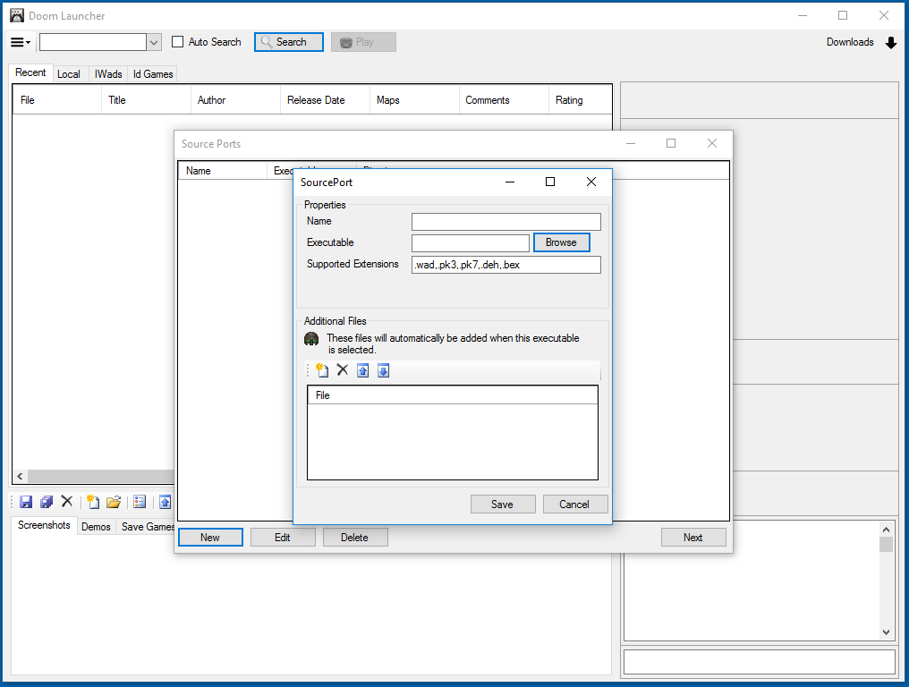

When opening Doom Launcher for the first time a prompt will display to add Source Ports. Click the New button in the bottom left and then click Browse to select the executable to your Source Port.

[Download ZDoom](Download%20ZDoom) - <https://www.zdoom.org/downloads>

* Name: The display name for the Source Port.
* Executable: The path to the executable.
* Supported Extensions: The file extensions that will automatically load with the Source Port. Doom Launcher by default will use .wad, .pk3, .pk7, .deh, and .bex.
* Additional Files: Adding Game Files here will automatically load with this Source Port. For example, adding Brutal Doom to GZDoom will automatically load Brutal Doom when launching GZDoom.

## IWADs

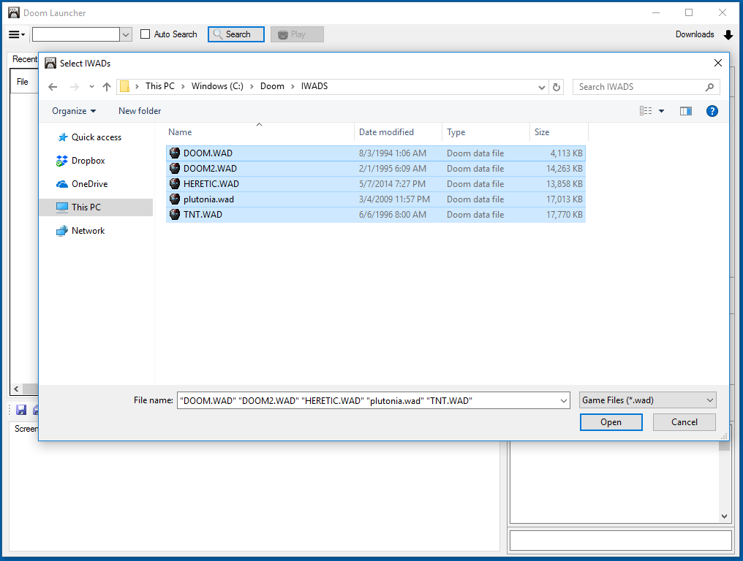

The next prompt will be for selecting IWADs. You can select one or more IWADs for Doom Launcher to use. If you do not have any IWADs you can download Freedoom.

[Freedoom](http://freedoom.github.io/download.html) - <http://freedoom.github.io/download.html>

# The Main Screen

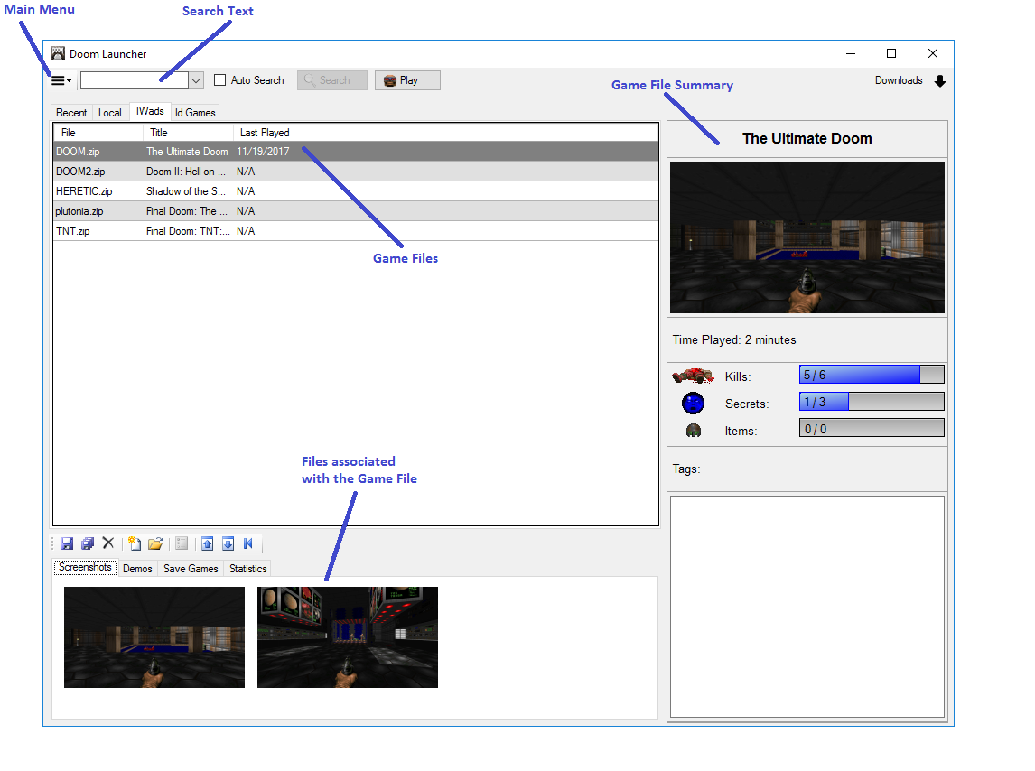

By default, Doom Launcher will have four tabs:

* **Recent**: Displays the most recently downloaded files in your library.
* **Local**: Displays all the files in your library.
* **IWads**: IWad files are in this tab. E.g. Doom II
* **Id Games**: Automatically connects to Id Games and displays the most recent files.

## Column Sorting / Ordering

Clicking a column will sort the column.

Holding click and dragging a column will change the position of a column. Doom Launcher will save all column order and sorting changes.

## Search

Entering text in the Search Text field and clicking search will filter the results in the current tab view. Selecting the down arrow next to the Search Text field will display the available fields to search. Checking the Auto Search text box will automatically display the results as text is entered.

# Adding Files to your Library

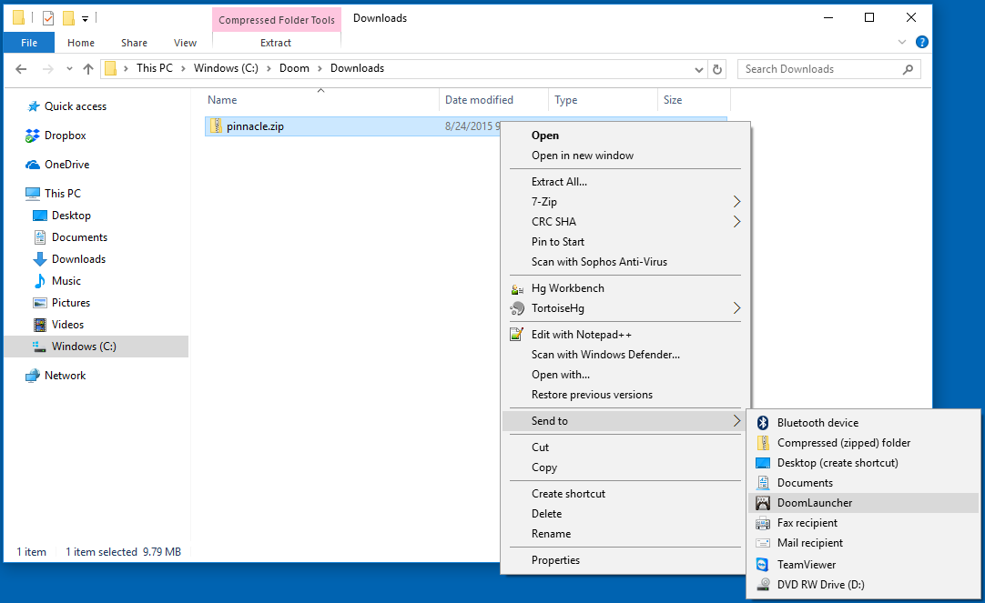

There are two ways to add files to Doom Launcher from your computer:

1. Right click the file, Send to, and select DoomLauncher
2. Drag and drop the file to either the Recent or Local tab

# Importing ZDL Files

Doom Launcher will automatically handle .zdl files. Simply drag and drop the .zdl file or right click and send to Doom Launcher.

# Launching

## Main Launch Screen

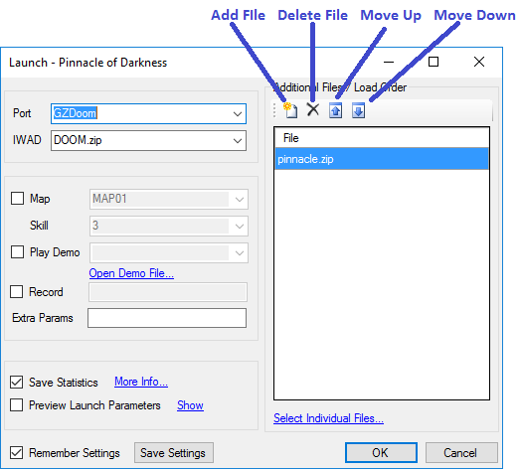

* **Port**: The Source Port to launch.
* **IWAD**: The IWAD to load.
* **Map**: Automatically warps to the selected map if the checkbox is checked.
* **Skill**: Desired skill when warping to a selected map.
* **Play** **Demo**: Automatically plays the selected demo if the check box is checked. Doom Launcher keeps track of demos by port. Changing the selected port in the drop down will display all demos associated with the port for this file.
* **Record**: Records a demo with the typed name.
* **Extra** **Params**: Custom parameters to add.
* **Save** **Statistics**: Automatically saves statistics for supported ports. For more info see File Tracking and Statistics
* **Preview** **Launch** **Parameters**: Will display the parameters generated by Doom Launcher in a window when launching. Additionally, click **Show** to display the launch parameters.
* **Additional** **Files / Load Order**: Maintains a list of files for launching.
* **Select** **Individual** **Files**: Displays all files available in the zip file for loading. The Supported Extensions option in the Source Port dialog automatically selects the files with a matching extension.
* **Remember** **Settings**: Automatically saves the settings in the dialog box when clicking OK.
* **Save** **Settings**: Saves all settings in the dialog box when launched.

## Adding Additional Files

To add an additional file to load click the Add File button.

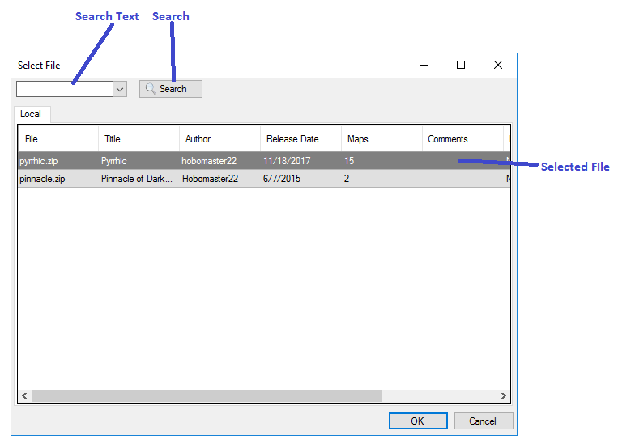

## Selecting Individual Files

To select individual files inside the archives to load click Select Individual Files.

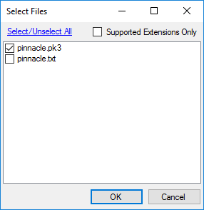

1. **Selected / Unselect All**: Selects/unselects all files.
2. **Supported Extensions Only**: Displays only extensions matching the Supported Extensions option in the Source Ports dialog.

## Recording Demos

To record a demo, check the Record check box and enter a name for the demo. When complete, Doom Launcher will add an entry in the Demos tab. To share the Demo file, right click to copy to your clipboard and paste anywhere you like. See File Tracking and Statistics for more details.

## Adding and Playing Demos

Clicking Open Demo File opens a file browse dialog to add a demo file. Adding a demo will automatically select it for playback. For supported demos, Doom Launcher will automatically add additional files from your library required by the demo. Doom Launcher will display a warning for required files that are missing from the library. Currently Zandronum is the only port supported for this automatic feature.

For full demo management, see Adding Demos and Screenshots for more details.

# The Main Menu

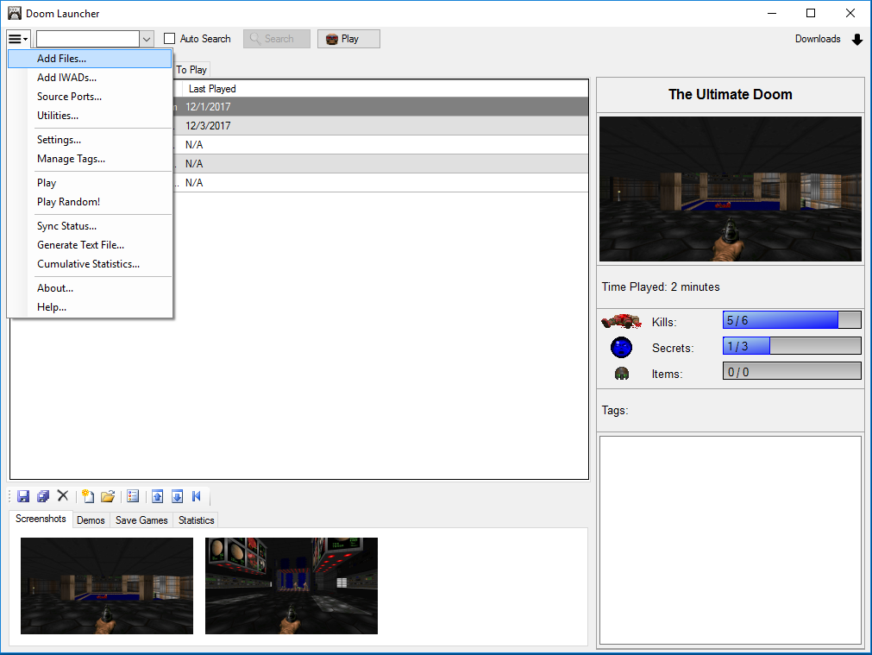

* **Add** **Files**: Opens a file browse dialog to select files to add to Doom Launcher.
* **Add** **IWADs**: Opens a file browse dialog to select files to add to Doom Launcher.
* **Source** **Ports**: Opens the Source Ports dialog.
* **Utilities**: Opens the Utilities dialog.
* **Settings**: Opens the Settings dialog.
* **Manage** **Tags**: Opens the Tags dialog.
* **Play**: Opens the Launch dialog.
* **Play** **Random**: Opens the Launch dialog with a random file selected from the library.
* **Sync** **Status**: Checks the files in the database against the files in the local file system for dealing with discrepancies.
* **Generate** **Text** **File**: Opens dialog for automatically generating a text file for the archive. See Generating Text Files for more info.
* **Cumulative** **Statistics**: Displays the cumulative statistics of all files in the current tab.
* **About**: Opens the About dialog.
* **Help**: Opens the Help document.

# Context Menu

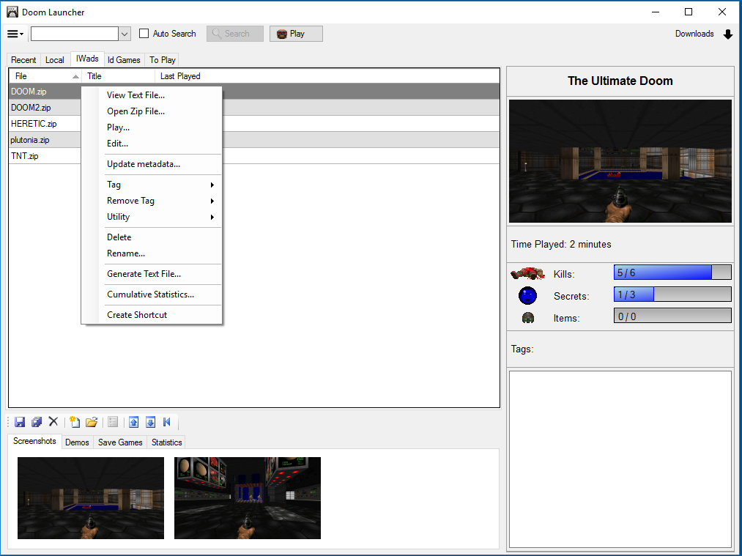

Right clicking a file will display the context menu.

* **View Text File**: Opens the text file in the archive. If more than one text file exists, a prompt will open with all text files in the archive.
* **Open Zip File**: Opens the zip archive.
* **Play**: Opens the launch dialog.
* **Edit**: Opens the edit dialog for editing the details of the archive.
* **Update Metadata**: Searches for the file on idgames and prompts with any metadata found. See Metadata for more info.
* **Tag**: Displays a list of user defined tags to associate with the archive.
* **Remove** **Tag**: Displays a list of user defined tags to remove from the archive.
* **Utility**: Displays a list of user defined utilities to open.
* **Delete**: Deletes the archive.
* **Rename**: Renames the physical archive on the computer.
* **Generate** **Text** **File**: Opens dialog for automatically generating a text file for the archive. See Generating Text Files for more info.
* **Cumulative** **Statistics**: Displays the cumulative statistics of all files in the current tab.
* **Create** **Shortcut**: Creates a shortcut to launch the file on the desktop.

# Utilities

Utilities are a quick way to open and inspect files in Doom Launcher. To open the utilities screen, select Utilities from the Main Menu, or right click a file and selecting Utility and Manage Utilites. The Utilities screen is very similar to the Source Ports screen with an additional File Option, which is an optional switch for the file parameter. Most utilities will not require a file option.

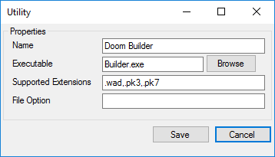

* **Name**: Display name for the utility.
* **Executable**: The executable to launch for the utility.
* **Supported** **Extensions:** Extensions that the utility will support. Doom Launcher will default to .wad, .pk3, and .pk7.
* **File** **Option**: Optional parameter to prefix the file parameter.

Right clicking a file and selecting a utility will open a dialog for selecting files in the archive to open.

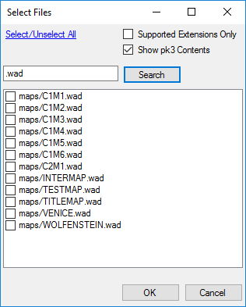

* **Support Extensions Only**: Will display only the supported extensions for the utility defined by the Supported Extensions option of the utility.
* **Show pk3 Contents**: Displays the contents of pk3 files.
* **Search**: Clicking search will filter the results to items that contain the search text.

# Tags

Tags are a way to organize files. Clicking the Main Menu and selecting Manage Tags or right clicking a file and selecting Tag and Manage Tags will open the screen managing tags.

Right click a file and select Tag and the tag name to tag the file.

Rich click a file and select Remove Tag and the tag name to remove.

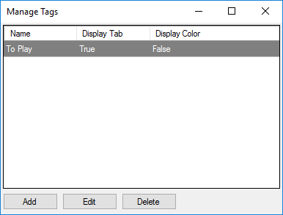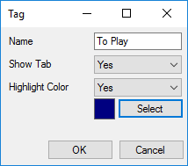

* **Name**: The name of the tag
* **Display** **Tab**: Creates a tab to the main screen with tag name to the Main Screen.
* **Display** **Color**: Highlights all tagged files with the selected color.

# Metadata

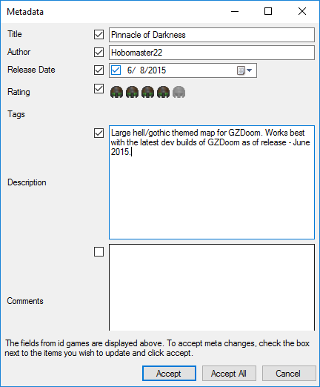

Right clicking a file, or multiple files and selecting Update Metadata will automatically search for the on idgames. On a successful search, a prompt for updateable fields will display. Each field will have a check box for accepting the updates.

# Generating Text Files

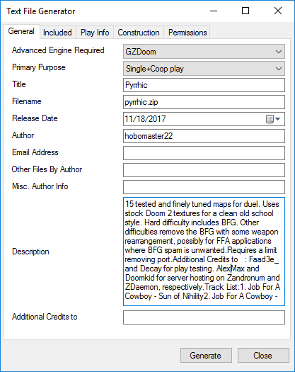

Doom Launcher can automatically generate an idgames style text file filling in all available information known to Doom Launcher. Clicking Generate will create the text file and automatically open in the default text editor. To generate a text file right click a file and select Generate Text File.

# Settings

## Configuration

* Id Games URL: The main URL for accessing idgames.
* API Page: The API page path for idgames.
* Mirror URL: The mirror to use for downloading from idgames.
* Screenshot Capture Directories: Additional directories to scan for screenshots. This field is to capture screenshots from source ports that do not use their local directory.
* Game File Directory: Where all game archives are stored for Doom Launcher.

## Launch Settings

* Port: Default port to select when launching a file.
* IWAD: Default IWAD to select when launching a file.
* Skill: Default skill to select when launching a file.

# File Tracking and Statistics

Doom Launcher associates files with archives such as screenshots, demos, save games, and statistics.



## Context Menu

Right click anywhere in the file list to bring up the context menu.

* **Copy**: Copies the selected file to the clipboard.
* **Copy** **All**: Copies all the files in the current view.
* **Delete**: Deletes the selected file.
* **Add** **File**: Opens a file browse dialog to select a new file to add from the computer.
* **Open** **File**: Opens the file.
* **Edit Details**: Edits the details of the file, description and source port.
* **Move** **Up**: Moves the file up in priority.
* **Move** **Down**: Moves the file down I priority.
* **Set** **First**: Sets the file to the top. In Screenshots this will be the larger image displayed on the right.

## Sharing Demos and Screenshots

To share files such as screenshots or recorded demos, right click the file and select Copy to copy to your clipboard. Then paste the files anywhere on your computer.

## Adding Demos and Screenshots

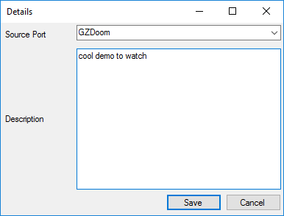

To add a file such as a demo to play, first select the file in the main screen that the demo will use (e.g. DOOM2 in the IWADs tab). Click the Add File button or right click in the view and select Add File. Add a description for the demo and select the port for the demo. When launching, selecting the appropriate Source Port will display the demo in the Play Demo drop down.

## Save Games

Doom Launcher automatically saves and save game files by source port. When a file is launched the save files are automatically copied to the source ports directory. Doom Launcher automatically recognizes save games by extension: .zds, .dsg, and .esg.

## Statistics

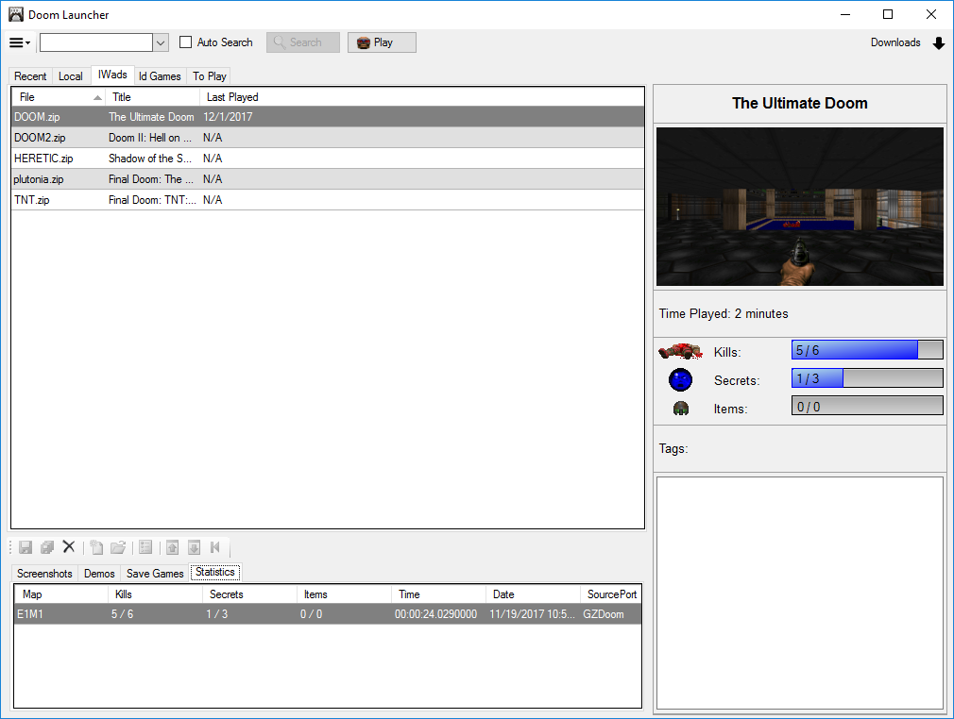

When launching, the 'Save Statistics' option will become available when a supported source port is selected.

Supported ports for statistics:

* **ZDoom**: For all ZDoom based ports. Uses save games to parse statistics. This means statistics cannot be read for the last level of an episode. Items are not available on ZDoom, Zandronum, and versions of GZDoom prior to 3.5.0. Statistics will be recorded when the game is saved or when an auto save is generated.
* **PrBoomPlus**: Uses the -levelstat parameter and parses the generated levelstat.txt. All statistics will be recorded when the game has exited.
* **CNDoom**: Uses the -printstats parameter and parses the generated stdout.txt. All statistics will be recorded when the game has exited.

The bottom statistics tab will display the statistics for each individual map. Right clicking and selecting Copy will copy the selected rows text to your clipboard. The right panel will display the cumulative statistics for the file.

# Downloading from idgames

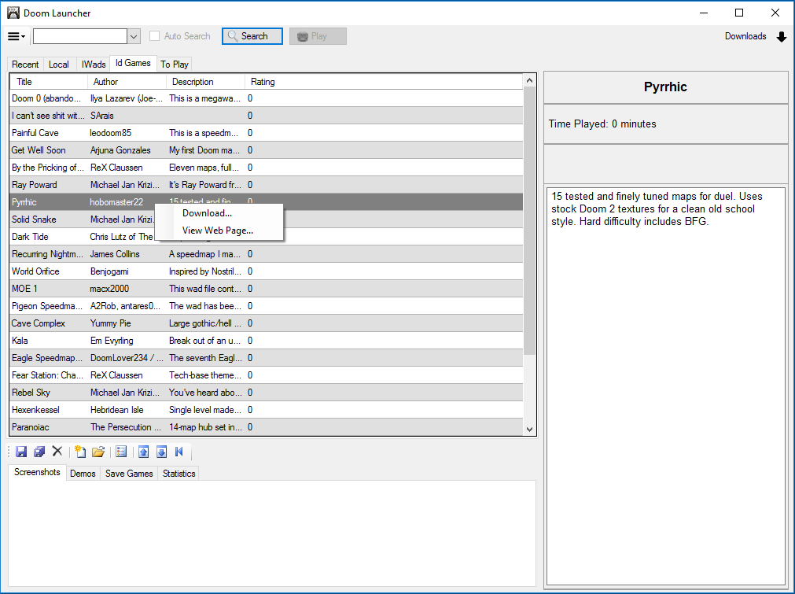

Doom Launcher directly integrates with idgames and will display the most recent files uploaded. Double click or right click and select Download to download the file directly to Doom Launcher. If Doom Launcher cannot access idgames try changing the mirror in the Settings.

* **Download**: Downloads the selected file.
* **View Web Page**: Opens the webpage for the selected file.

# Portability

Doom Launcher can work on a portable device such as a USB drive.

1. Add a SourcePorts folder to the Doom Launcher folder.
   1. e.g. DoomLauncher\SourcePorts\
2. Add all source ports to the new SourcePorts directory.
   1. e.g. DoomLauncher\SourcePorts\ZDoom\
3. Add the source ports in the Source Ports dialog. Doom Launcher will recognize they are local file paths.

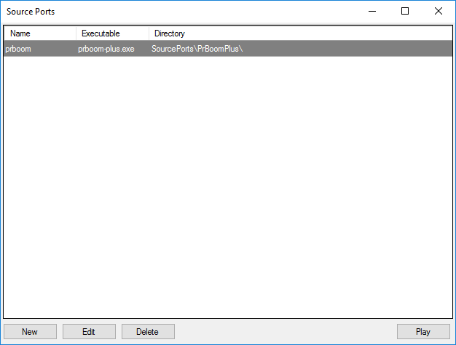

# Submitting Bugs and Feature Request

Doomworld:

<http://www.doomworld.com/vb/doom-general/69346-doom-launcher-doom-frontend-database/>

Realm667:

<http://realm667.com/index.php/en/kunena/doom-launcher>