 | 5 October 2026  CONSCIOUS INVESTMENTS  Initiating Coverage Report

Micron Technology, Inc. (MU)
Memory Lane, Now With a Toll Booth!
- Micron Technology, Inc. (MU) turned a $37.4 bn revenue year in FY'25 into $133.2 bn in FY'26, and 4Q'26 revenue of $54.2 bn carried a GAAP gross margin of 86.8% against 44.7% a year earlier. AI demand is outrunning memory supply, and management says so directly.  - Take-or-pay Strategic Customer Agreements, signed from 3Q'26, give MU fixed or banded prices and committed volumes, and customers had deposited $12.7 bn by year end. We think these floors make the next downturn shallower than FY'23, when revenue fell (49.5%) and gross margin reached (9.1%).  - The Street expects FY'27E revenue of $274.9 bn and FY'28E revenue of $314.2 bn, and our base case adopts both. We part company on margin: EBITDA margin fades from 83.0% in FY'27E to 65.0% in FY'31E, so our FY'28E EPS of $163.68 is 20.5% below the Street's $205.95.  - At 5.9x NTM EPS and after a 272.4% gain YTD, the shares price MU as a cyclical at its peak. Net cash of about $68.3 bn and adjusted free cash flow of $62.3 bn in FY'26 fund $27.4 bn of net CapEx without outside capital. We think the market is too sceptical about how long the revenue lasts.  - We rate MU Outperform with a base-case price target of $1,242.41, an implied 17.0% return against an S&P 500 expected return of 10.1% over 15 months. Our bull case is $1,535.90 and our bear case $306.91. The rating clears its 5.0-point band by 6.9 points, which is a narrow margin, and the bear case is a 71.1% loss, so position size matters.  COMPANY OVERVIEW  Micron Technology, Inc. (MU) designs and manufactures DRAM, NAND and NOR memory and storage, sold under the Micron and Crucial brands, and has been headquartered in Boise, Idaho since its founding in 1978. FY'26 revenue was $133.2 bn, of which the Cloud Memory, Core Data Center, Mobile and Client, and Automotive and Embedded business units contributed $16.3 bn, $18.0 bn, $13.1 bn and $6.8 bn in 4Q'26 alone. DRAM was 76.5% of FY'25 revenue and NAND 22.7%. Competitors named in the 10-K include Samsung, SK hynix, Kioxia, Sandisk, CXMT and YMTC. The Company employed about 53,000 people at Aug'25 and is led by Chairman and CEO Sanjay Mehrotra. Its market capitalisation is about $1.2 tn and the next earnings date is 2026-12-23. | RATING  OUTPERFORM  vs. S&P 500 expected 10.1% over 15 months  KEY STATISTICS  EPS (GAAP)  ANALYST  Ethan Stott  stott@consciousinvestments.org
  Bear | Current | Base PT | Bull
  $306.91 | $1,062.29 | $1,242.41 | $1,535.90
  (71.1%) |  | 17.0% | 44.6%
  Symbol | NASDAQ: MU
  52-Week Range | $181.60 – $1,213.56
  YTD Performance | 272.4%
  Market Cap | $1.2 tn
  Dividend Yield | 0.1%
  NTM P/E | 5.9x
  NTM EV/EBITDA | 4.9x
  ROE | 17.2%
  ROA | 11.2%
  ROIC | 15.4%
  FY (Sep) | 2026A | 2027E | 2028E
  Q1 | 4.60 | 35.56 | 36.42
  YoY |  | 673.1% | 2.4%
  Q2 | 12.07 | 29.00 | 29.70
  YoY |  | 140.3% | 2.4%
  Q3 | 24.67 | 35.48 | 36.34
  YoY |  | 43.8% | 2.4%
  Q4 | N/A | 59.78 | 61.22
  YoY |  | N/A | 2.4%
  Year | N/A | 159.83 | 163.68

TABLE OF CONTENTS
INVESTMENT SUMMARY 3
INDUSTRY OVERVIEW 4
Bit Rate Hikes 4
A Short History of Long Cycles 4
Contract Killed the Spot Star 4
The Supply Side Wakes Up 4
BUSINESS OVERVIEW 5
Cloud Memory Business Unit (36.2% of FY'25 Revenue) 5
Core Data Center Business Unit (19.3% of FY'25 Revenue) 5
Mobile and Client Business Unit (31.7% of FY'25 Revenue) 5
Automotive and Embedded Business Unit (12.7% of FY'25 Revenue) 6
UNDERVALUATION & THESIS 7
Past Peak Performance 7
The Street Is Right on Revenue, Wrong on Margin 7
CATALYSTS & DRIVERS 9
Guide Dogs 9
Contract Lines 9
New Fabs, New Questions 9
RISKS TO INVESTMENT THESIS 10
The Cycle Returns Early 10
Margin Fades Faster Than We Model 10
A Narrow Margin of Safety on the Rating 10
Customer and Credit Concentration 10
Trade Policy and Government Intervention 10
PEER GROUP ANALYSIS 11
VALUATION ANALYSIS 12
Model Assumptions 12
FINANCIAL ANALYSIS 14
APPENDIX 15
Exhibit I: Bulls vs Bears 15
Exhibit II: Exit Strategy 15

INVESTMENT SUMMARY
Bull Case Price Target: $1,535.90
12–18 Month Target Return: 44.6%
Supply stays short through calendar 2027, the Strategic Customer Agreements hold gross margin near 86.0%, and 1Q'27 revenue of $61.5 bn proves a floor and not a peak. Our bull case lifts FY'27E revenue to $300.0 bn, above the Street's $274.9 bn, and holds EBITDA margin at 84.0% in FY'27E before it settles at 70.0%. Revenue grows to $365.0 bn by FY'31E, EPS holds near $165.64 and the target multiples sit 15.0% above our base, at about 8.1x NTM P/E and 6.9x EV/EBITDA, against 5.9x NTM P/E today. The bull price target is $1,535.90, a 44.6% return, which lands just above the Street mean price target of $1,521.76. That is where the stock goes if the market stops pricing a cycle.
Base Case Price Target: $1,242.41
12–18 Month Target Return: 17.0%
Our base case accepts the Street's revenue and disputes its margin. FY'27E revenue of $274.9 bn is 11.8% above the 1Q'27 guide run-rate of $246.0 bn and matches consensus, and FY'28E revenue of $314.2 bn does the same, before growth slows to 3.0% a year as Boise and Singapore capacity arrives. EBITDA margin fades from 83.0% in FY'27E to 65.0% by FY'31E, which is still 10.3 points above the FY'22 peak of 54.7% because contract floors keep prices above past cycles. That fade is why FY'27E EPS of $159.83 is 9.4% below the Street's $176.42 and FY'28E EPS of $163.68 is 20.5% below $205.95. At a 15.3% WACC, a 6.0x exit multiple and a 50/25/25 blend of DCF, P/E and EV/EBITDA, the base price target is $1,242.41, a 17.0% return. That beats the S&P 500's expected 10.1% over the horizon by 6.9 points, just over the 5.0-point band for an Outperform.
Bear Case Price Target: $306.91
12–18 Month Target Return: (71.1%)
The cycle returns on schedule. Industry supply grows from 2027, contract prices reset toward the market, and revenue drops from $180.0 bn in FY'27E to $110.0 bn in FY'28E, a decline of (38.9%). EBITDA margin falls to 40.0% by FY'31E, which is still above the 36.2% of FY'24 and far above the 12.9% of FY'23. EPS drops to $44.04 in FY'28E, the target multiples compress 30.0% to about 4.9x NTM P/E and 4.2x EV/EBITDA, and the WACC rises 0.5 points to 15.8%. The bear price target is $306.91, a (71.1%) return, and the shares are still above their 52-week low of $181.60. A beta of 2.23 and a 466.1% one-year gain mean this path needs no external shock, only normal memory behaviour. The skew is the reason we size this idea carefully: the base case gains 17.0% and the bear case loses 71.1%.
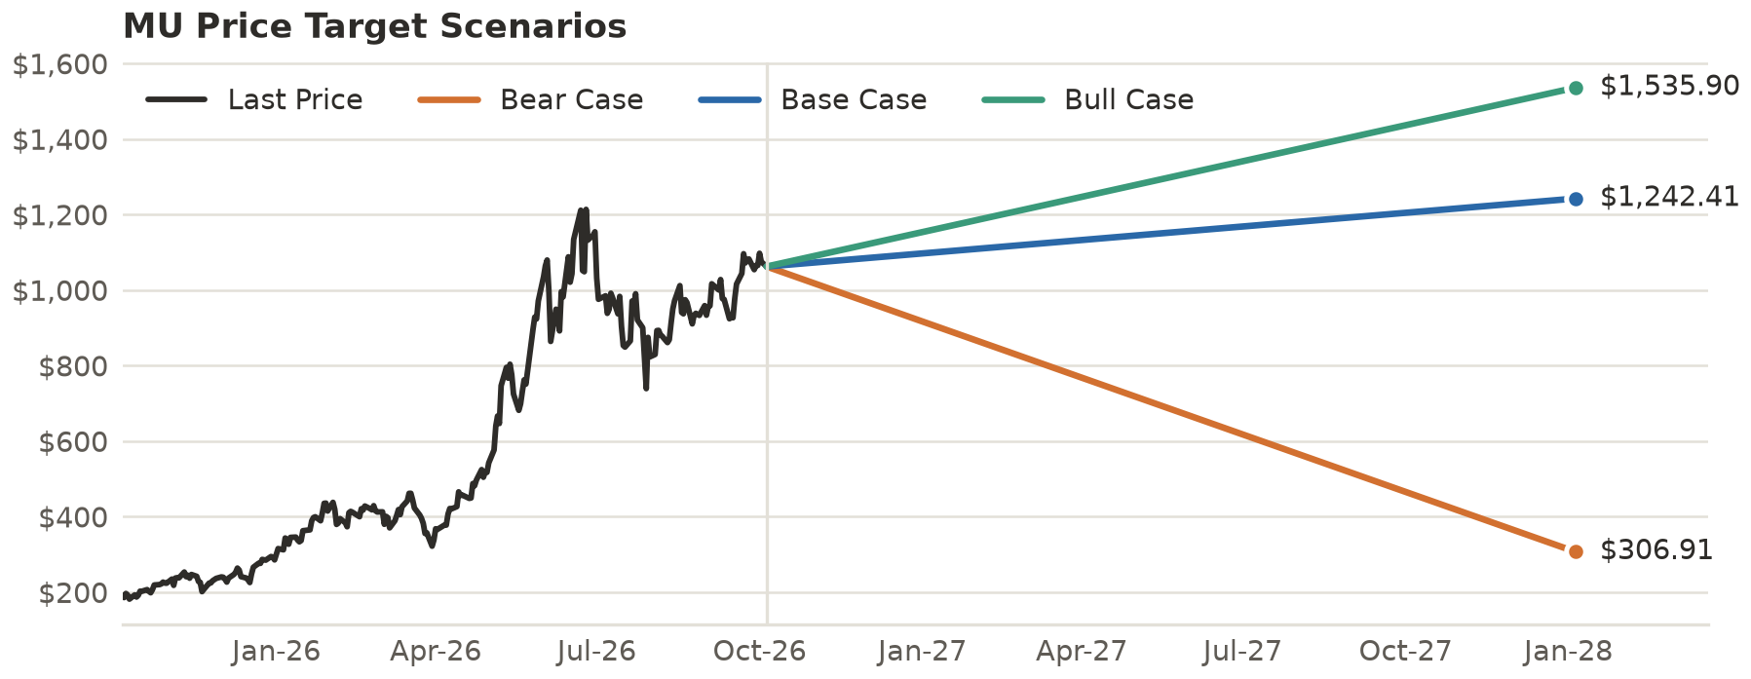
Source: Conscious Investments model, Yahoo Finance
Headquarters | Boise, Idaho | Chief Executive Officer | Sanjay Mehrotra
Number of Employees | ~53,000 (as of Aug'25) | GICS Sector | Technology
GICS Sub-Industry | Semiconductors | Fiscal Year End | 0903
Source: SEC filings, Yahoo Finance

INDUSTRY OVERVIEW

Bit Rate Hikes
Memory demand has outgrown memory supply. In 3Q'26 management wrote that AI-driven growth in the data center has accelerated demand for memory and storage at a rate greater than MU's ability, and the industry's ability, to add supply. The company has made supply allocation decisions that may affect certain customers and end markets because overall demand for memory and storage exceeds overall industry supply. Strong DRAM and NAND demand with constrained supply has lifted pricing and profitability across the portfolio. The financial result is visible in MU's own numbers: quarterly revenue rose from $11.3 bn in 4Q'25 to $54.2 bn in 4Q'26, with GAAP gross margin moving from 44.7% to 86.8%. Our team reads that as a pricing event first and a volume event second, which is why it can reverse.

A Short History of Long Cycles
Memory has always been a boom-and-bust business, and the 10-K says why. Competitors may raise CapEx and add worldwide supply, and MU and others have plans to build new capacity. Governments have assisted some competitors and may support new entrants, which adds to supply risk. The last full turn shows the amplitude: revenue fell (49.5%) in FY'23 to $15.5 bn, gross margin was (9.1%) and operating margin (37.0%), and then revenue recovered 61.6% in FY'24 and 48.9% in FY'25. Over FY'21 to FY'25, gross margin ranged from (9.1%) to 45.2%. FY'26's 80.7% GAAP gross margin is outside anything in that range.

Contract Killed the Spot Star
The structural change this cycle is contractual. In 3Q'26 and 4Q'26 MU signed Strategic Customer Agreements, structured as take-or-pay with binding volumes over multi-year terms. Pricing is fixed or banded for most agreements, the largest carry a ceiling near the calendar 2Q'26 market price and a floor for the term, and a minority have no price protection at all. Customers placed $12.7 bn of deposits in FY'26, and noncurrent customer contract liabilities stood at $12.9 bn at the Sep'26 year end, up from $0.1 bn a year earlier. If the floors hold, the downside of the next down-cycle is cut off at a margin well above past peaks, in management's words. We cannot see the floor levels, the term lengths or the share of revenue under contract, so we cannot price that protection precisely.

The Supply Side Wakes Up
Capacity is the variable that ends cycles. MU's Boise fab is projected to produce its first DRAM wafers in mid-calendar 2027, a second Boise fab was announced in Jun'25, and a first New York fab, broken ground in Jan'26, supplies 2030 and beyond. In Singapore, an HBM advanced packaging site adds capacity from the first half of calendar 2027 and a further wafer fab is being built in the NAND complex, while MU bought a wafer fab in Tongluo, Taiwan, from Powerchip for $1.8 bn in Mar'26. Government support helps pay for it: up to $6.1 bn of CHIPS Act direct funding, a 35.0% investment tax credit, and a non-binding term sheet for up to $5.5 bn from New York State. MU's own CapEx guide was about $27.0 bn net for FY'26. Competitors Samsung, SK hynix, Kioxia, Sandisk, CXMT and YMTC face the same demand and are free to respond.

BUSINESS OVERVIEW
Micron Technology, Inc. (MU) makes memory and storage in three technologies: DRAM, NAND and NOR. DRAM is fast, volatile memory used in data center, PC, graphics, mobile and automotive systems and includes high-bandwidth memory (HBM), a 3D stacked architecture built for AI. NAND is non-volatile storage used in solid-state drives and in managed form in phones and cars. MU sells through four business units, makes its products in its own fabs and uses subcontractors for some steps, and invests in process technology to raise bit density per wafer and cut cost per bit. DRAM generated $28.6 bn (76.5%) of FY'25 revenue and NAND $8.5 bn (22.7%), with the United States accounting for 64.5% by customer location. In 4Q'26 the four business units earned operating margins of 76.0%, 85.0%, 88.0% and 79.0%, on gross margins of 83.0%, 90.0%, 90.0% and 84.0%.
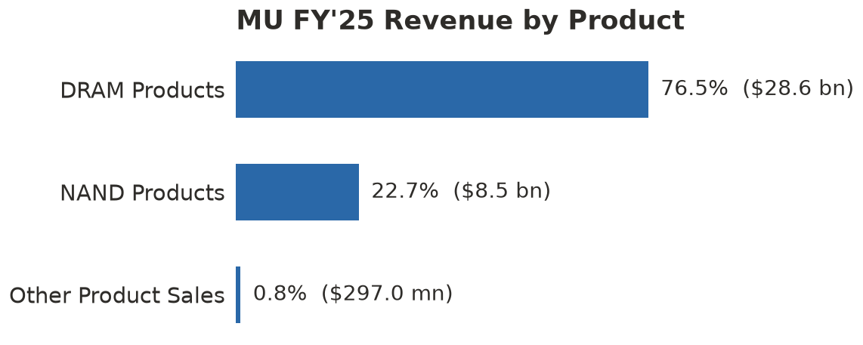
Source: SEC filings
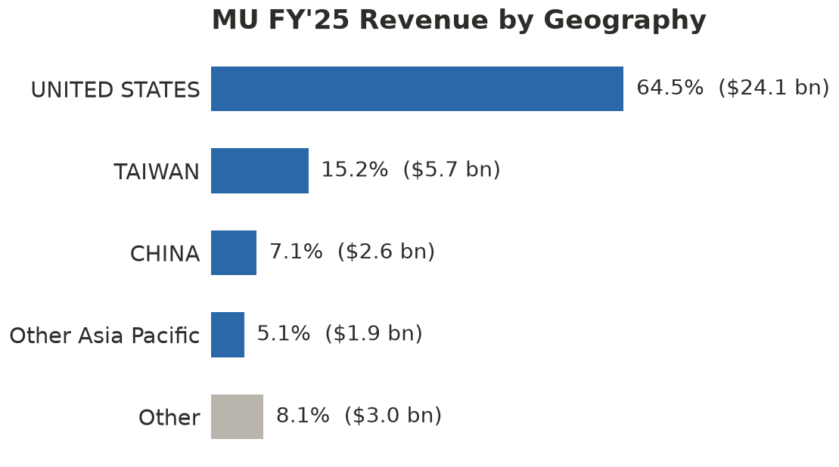
Source: SEC filings

Cloud Memory Business Unit (36.2% of FY'25 Revenue)
The Cloud Memory Business Unit (CMBU) sells memory to large hyperscale cloud customers and HBM to all data center customers. CMBU revenue was $13.5 bn in FY'25, up from $3.8 bn in FY'24 and $1.9 bn in FY'23, and $16.3 bn in 4Q'26 alone. MU began volume production of 24GB 8-high HBM3E in 2024, and 12-high HBM3E was the majority of HBM shipments in 4Q'25. Management reports that its server LPDDR SOCAMM revenue more than doubled sequentially in 4Q'26 and that 1-gamma 8,800 MT/s server modules have cleared multiple customer qualifications. Gross margin in the unit was 83.0% in 4Q'26 against 59.0% a year earlier. Our team sees CMBU as the unit most exposed to a single customer type, the hyperscaler, and the one where contracts matter most.

Core Data Center Business Unit (19.3% of FY'25 Revenue)
The Core Data Center Business Unit (CDBU) serves mid-tier cloud, enterprise and OEM data center customers and sells storage to all data center customers. Revenue was $7.2 bn in FY'25 and reached $18.0 bn in 4Q'26, up from $1.6 bn a year earlier, which makes it the largest unit by revenue in the latest quarter. Gross margin rose from 41.0% to 90.0% and operating margin from 25.0% to 85.0% over the same period. The PCIe Gen 5 7600 and Gen 6 9650 SSDs are now shipping to leading customers for KV-cache applications, and the 6600 ION SSD had a strong volume ramp in 4Q'26. Revenue grew 11.4 times in a year while margin more than doubled, which is a pricing and demand signal and not a mix shift alone.

Mobile and Client Business Unit (31.7% of FY'25 Revenue)
The Mobile and Client Business Unit (MCBU) sells memory and storage into phones, PCs and consumer devices, mainly LPDDR5 and LPDDR4 DRAM, managed NAND and client SSDs. Revenue was $11.9 bn in FY'25, flat against $11.7 bn in FY'24, and $13.1 bn in 4Q'26. Gross margin was 90.0% in 4Q'26 against 36.0% a year earlier. MU is shipping 6-channel 1-gamma LPDDR5X for flagship mobile devices and has secured design wins with every Tier 1 OEM for AI workstation products. The Company has said that supply allocation decisions may affect certain customers and end markets, and this unit is where we would expect any rationing to show up first.

Automotive and Embedded Business Unit (12.7% of FY'25 Revenue)
The Automotive and Embedded Business Unit (AEBU) sells to automotive, industrial and consumer embedded customers, mainly LPDDR5 and LPDDR4, managed NAND, DDR4 and DDR3 and GDDR6. Revenue was $4.8 bn in FY'25 and $6.8 bn in 4Q'26, up from $1.4 bn a year earlier. Gross margin moved from 31.0% to 84.0% and operating margin from 20.0% to 79.0%. At 12.6% of 4Q'26 revenue it is the smallest driver of the thesis, and we include it for completeness.

UNDERVALUATION & THESIS
MU trades at an NTM P/E of 5.9x on consensus EPS of $179.01, against a point-in-time LTM P/E of 24.0x that compares with medians of 27.0x over one year, 26.2x over two years and 26.4x over three years. On EV/EBITDA the picture is the same: the current LTM multiple is 17.5x against medians of 16.1x, 13.0x and 16.1x. The two measures disagree because they read different earnings. The LTM figures still contain the weak quarters of FY'25 and early FY'26, while the NTM figure reflects a run-rate of $54.2 bn of quarterly revenue and a 1Q'27 guide of $61.5 bn. Our team reads that gap as the market declining to capitalise peak earnings, and we agree with the instinct. The question is not whether MU is cheap on NTM EPS, which it is, but whether NTM EPS is a number the Company can repeat.

Past Peak Performance
The last peak-earnings year was FY'22, and the multiples then are the right comparison. In the year to Sep'22 the LTM EV/EBITDA had a median of 4.9x and ranged from 2.9x to 8.4x, and the LTM P/E had a median of 9.4x. Our 6.0x exit EV/EBITDA sits inside that peak-year range, and today's NTM P/E of 5.9x is below the peak-year LTM median of 9.4x. The 3-year median multiples of 26.4x P/E and 16.1x EV/EBITDA were set mostly on trough or recovery earnings from FY'23 to FY'25, so they overstate what the market will pay for peak profits. Investors who anchor on them see a stock at a 77.7% discount to its 3-year P/E median, and we think that discount is mostly the normal cost of owning peak margins in a cyclical industry. The share price has risen from a 52-week low of $181.60 to $1,062.29, and the 272.4% gain since the start of the year has already re-rated part of the stock, which is why our upside is 17.0% and not the Street's 43.3%.

The Street Is Right on Revenue, Wrong on Margin
Consensus expects FY'27 revenue of $274.9 bn, up 106.4%, and FY'28 revenue of $314.2 bn, up a further 14.3%, with EPS of $176.42 and $205.95. The range around FY'27 EPS runs from $72.29 to $214.70 across 36 analysts, a spread of nearly three times, which shows that the Street itself does not agree on the margin. Our base case takes the Street's revenue as given and tests the margin: EBITDA margin of 83.0% in FY'27E fading to 65.0% in FY'31E gives FY'27E EPS of $159.83 and FY'28E EPS of $163.68, which are 9.4% and 20.5% below consensus. We are therefore more cautious than the Street on profit and no less confident on sales. MU has beaten EPS consensus in each of the last four quarters, by 5.0% on 30Sep'26, 21.4% on 24Jun'26, 33.2% on 18Mar'26 and 20.6% on 17Dec'25, and we expect the guide to be beaten again. We think the market is right to doubt the margin and wrong to price the whole business as a trough. Our price target of $1,242.41 is 17.0% above the current price, while the Street mean of $1,521.76 is 43.3% above it, so even after trimming the Street's margin we sit between today's price and its view.
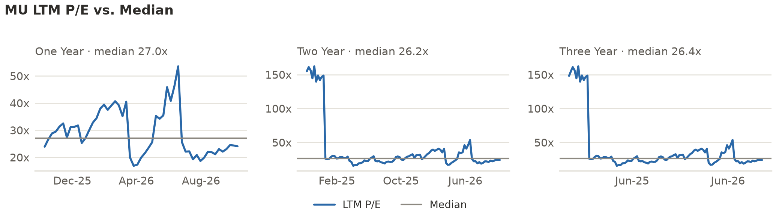
Source: SEC filings, Yahoo Finance; LTM P/E is point-in-time (as filed)
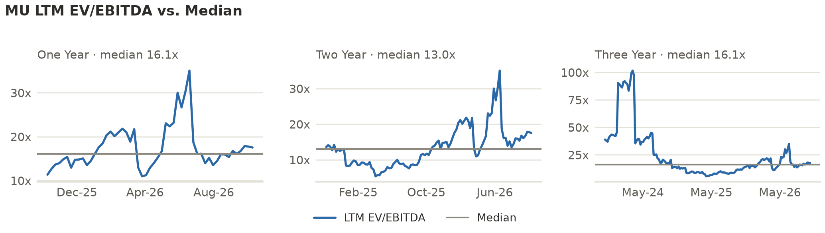
Source: SEC filings, Yahoo Finance; LTM EV/EBITDA is point-in-time

CATALYSTS & DRIVERS
Three events in the next 15 months decide whether MU's revenue and margin are a floor or a peak. Each one is dated, and each moves our base-case numbers by a quantifiable amount. The first reveals demand, the second reveals contract protection, and the third reveals supply.

Guide Dogs
MU reports 1Q'27 results on 2026-12-23 against guidance of revenue of $61.5 bn plus or minus $1.5 bn, a GAAP gross margin of about 85.95% and GAAP EPS of $37.84 plus or minus $1.00. Our base case assumes FY'27E revenue of $274.9 bn, which requires an average of $68.7 bn a quarter, so MU must keep growing after 1Q'27 for the Street and for us to be right. Each $1.0 bn of quarterly revenue above that path is worth about $4.0 bn of annual revenue and, at our 83.0% EBITDA margin, about $3.3 bn of EBITDA. MU has beaten consensus EPS in each of the last four quarters by between 5.0% and 33.2%. A fifth beat with a 2Q'27 guide above $68.0 bn would keep us on the base path and move us toward our bull-case revenue of $300.0 bn.

Contract Lines
The FY'26 10-K is due soon, since last year's was filed on 3Oct'25. The filing should disclose more about the Strategic Customer Agreements: the share of FY'27 revenue under contract, the length of the terms and the level of the floor price. Customers had deposited $12.7 bn by year end, and noncurrent customer contract liabilities were $12.9 bn. If the disclosed floor implies a gross margin above 75.0% for most of FY'28, our base-case 76.0% EBITDA margin in FY'28E is about right and the fade to 65.0% by FY'31E is conservative, and if the minority of unprotected contracts turns out to be 40.0% or more of volume, our margin is too high. Either answer moves our $1,242.41 target toward the bull case of $1,535.90 or toward the bear case of $306.91.

New Fabs, New Questions
The supply side has a calendar. The Boise fab projects first DRAM wafers in mid-calendar 2027, the Singapore HBM packaging site adds capacity from the first half of calendar 2027, and the Tongluo, Taiwan fab, bought for $1.8 bn in Mar'26, is expected to support meaningful shipments. Our base case adds CapEx of $37.7 bn in FY'27E and $52.5 bn in FY'28E, and slows revenue growth to 3.0% a year from FY'29E as supply grows. The tell is the trajectory of competitor and customer commentary through the 3Q'27 reporting season: faster industry bit growth would argue for our bear path, while delayed ramps would support the bull case. Government funding also matters, because CHIPS Act support of up to $6.1 bn and a 35.0% investment tax credit lower the net cost of this CapEx.

RISKS TO INVESTMENT THESIS
Our Outperform rating rests on the Street's revenue arriving and on margins staying well above past cycles. These are the risks to that view, and the first one is the cycle itself.

The Cycle Returns Early
Memory prices fell fast in FY'23, when revenue dropped (49.5%) and gross margin reached (9.1%). If supply additions from Boise, Singapore and Taiwan from calendar 2027, or from competitors, arrive faster than we model, revenue could look like our bear case: $180.0 bn in FY'27E and $110.0 bn in FY'28E, with a price target of $306.91, a (71.1%) return. The bear case is not a tail we can ignore, because MU's beta is 2.23 and the shares are up 466.1% in a year.
- Mitigant: the Strategic Customer Agreements are take-or-pay with binding multi-year volumes and, for most, fixed or banded prices. Net cash of about $68.3 bn against $5.2 bn of debt means MU can fund the downturn from its own balance sheet. We also size the idea for the bear case, not the base case.

Margin Fades Faster Than We Model
Our base case already fades EBITDA margin from 83.0% in FY'27E to 65.0% in FY'31E, but a faster slide would cut EPS and the multiples at once. A margin of 55.0% in FY'28E instead of 76.0% would reduce that year's EBITDA by about $66.0 bn on $314.2 bn of revenue (our arithmetic).
- Mitigant: a minority of agreements have no price protection, but most carry a floor, and management says floor pricing yields gross margins well above any past cycle peak. The FY'22 peak EBITDA margin was 54.7%, so even our bear case ends above the FY'23 trough.

A Narrow Margin of Safety on the Rating
The rating is relative to the S&P 500's expected 10.1% over 15 months, and our base case clears the 5.0-point band by only 6.9 points. A share price above about $1,080 would put the base-case return under the 15.1% threshold, and above about $1,183 would put the same target two ratings lower (our arithmetic). The shares are only 1.7% below the first level today.
- Mitigant: the 17.0% base return is measured from $1,062.29, and the bull case of $1,535.90 is 44.6% above it. We would revisit the rating on any move through those levels rather than defend it.

Customer and Credit Concentration
Receivables reached $36.2 bn at year end, up from $9.3 bn, equal to about 65 days of 4Q'26 revenue. A single large customer group, the hyperscalers, anchors the demand. If buyers delay payment or cancel orders, working capital absorbs cash.
- Mitigant: MU held $73.5 bn of cash and investments at year end against $5.2 bn of debt, so it can absorb a working capital swing without outside funding.

Trade Policy and Government Intervention
MU's 10-K flags tariffs, export controls and restrictions on selling to certain customers as risks, and it competes with firms that receive government assistance. 7.1% of FY'25 revenue came from China and 3.0% from Hong Kong.
- Mitigant: 64.5% of FY'25 revenue came from the United States, and CHIPS Act funding of up to $6.1 bn offsets part of the domestic build.

PEER GROUP ANALYSIS
The 10-K names six companies as MU's main competitors in memory and storage: Samsung Electronics Co., Ltd., SK hynix Inc., Kioxia Holdings Corporation, Sandisk Corporation, ChangXin Memory Technologies, Inc. (CXMT) and Yangtze Memory Technologies Co., Ltd. (YMTC). For this report we describe the group and leave out trading comparables, because a peer table means live market-data requests and because current memory multiples at peak earnings are not a reliable guide to value.
Samsung Electronics Co., Ltd. and SK hynix Inc. head the 10-K's list of competitors in memory and storage. They matter to the thesis because the supply response to today's pricing will come from their capital spending as much as from MU's own, and MU states that competitors may raise CapEx and add supply.
Kioxia Holdings Corporation and Sandisk Corporation are also named competitors, and NAND was 22.7% of MU's FY'25 revenue. MU sells SSDs and managed NAND mainly through its Core Data Center and Mobile and Client units, which together reached $31.1 bn of revenue in 4Q'26.
ChangXin Memory Technologies, Inc. (CXMT) and Yangtze Memory Technologies Co., Ltd. (YMTC) are the last two names on the list, and the 10-K separately warns that governments have provided and may provide significant assistance to competitors or new entrants. Government-backed capacity is the least predictable input to our supply view, which is why we keep the bear case open.

VALUATION ANALYSIS

Model Assumptions
Our model starts from FY'26 revenue of $133.2 bn and projects five fiscal years, FY'27E to FY'31E. Base revenue follows the Street for two years, $274.9 bn in FY'27E and $314.2 bn in FY'28E, and then grows 3.0% a year to $323.6 bn, $333.3 bn and $343.3 bn as new industry capacity arrives. The 1Q'27 guide run-rate is $246.0 bn, so FY'27E needs sequential growth from here, which is the point of the 3.0% fade afterwards. EBITDA margin is 83.0% in FY'27E and fades to 65.0% by FY'31E, against 81.7% in FY'26 and a prior peak of 54.7% in FY'22. CapEx follows $37.7 bn in FY'27E and $52.5 bn in FY'28E before easing to about $43.0 bn, in line with the build-out in Idaho, New York, Singapore, Taiwan and Japan. The tax rate is 15.0%, based on 14.8% in FY'26, and net cash is $68.3 bn on 1,147 mn diluted shares.
The discount rate is 15.3%, built from a 5.3% risk-free rate, a 2.23 beta and a 4.5% equity risk premium, with debt at under 1.0% of capital. The beta is high because it spans the FY'23 drawdown, and we keep it because the rating is a statement about a volatile stock. The terminal value uses a 6.0x exit EV/EBITDA on FY'31E, which implies perpetual growth of 3.7% and 56.6% of enterprise value in the base case. In FY'22, the last peak-earnings year, LTM EV/EBITDA had a median of 4.9x, so 6.0x sits above the typical peak multiple and well below the 3-year median of 16.1x, which was set on depressed earnings. The price target blends 50.0% DCF at $1,295.38, 25.0% forward P/E at 7.0x for $1,103.42, and 25.0% EV/EBITDA at 6.0x for $1,275.44, on NTM metrics at the Jan'28 target date.
The model raises two warnings and both are deliberate. First-year revenue growth of 106.4% is the Street's own FY'27 figure, applied to a base year that ended on 3Sep'26. FY'28E EPS of $163.68 is 20.5% below consensus of $205.95, because our EBITDA margin of 76.0% is below the Street's and because depreciation catches up with $52.5 bn of CapEx. The bull case moves revenue to $300.0 bn in FY'27E, adds 5.0 points of margin, raises target multiples 15.0% and lowers WACC by 0.5 points. The bear case cuts FY'27E revenue to $180.0 bn, drops FY'28E revenue to $110.0 bn, reduces margins by 25.0 points by FY'31E, lowers target multiples 30.0% and raises WACC 0.5 points.
MU Base Case Model Assumptions
 | FY'27E | FY'28E | FY'29E | FY'30E | FY'31E
Revenue growth | 106.4% | 14.3% | 3.0% | 3.0% | 3.0%
EBITDA margin | 83.0% | 76.0% | 68.0% | 66.0% | 65.0%
D&A % of revenue | 4.6% | 5.6% | 7.1% | 8.0% | 8.5%
CapEx % of revenue | 13.7% | 16.7% | 15.6% | 13.0% | 12.5%
Tax rate | 15.0% | 15.0% | 15.0% | 15.0% | 15.0%

Input | Value | Input | Value
Risk-free rate | 5.3% | Beta | 2.23
Equity risk premium | 4.5% | Pre-tax cost of debt | 8.3%
Target forward P/E | 7.0x | Target EV/EBITDA | 6.0x
Exit EV/EBITDA | 6.0x | Horizon | 15 months
Source: Conscious Investments model; risk-free rate from 10Y UST; beta from Yahoo Finance
MU Valuation Summary
 | Bear Case | Base Case | Bull Case
WACC | 15.8% | 15.3% | 14.8%
Cost of equity | 15.8% | 15.3% | 14.8%
Terminal method | Exit 4.2x EV/EBITDA | Exit 6.0x EV/EBITDA | Exit 6.9x EV/EBITDA
PV of cash flows | $177.2 bn | $510.3 bn | $575.4 bn
PV of terminal value | $106.2 bn | $665.1 bn | $894.7 bn
Enterprise value | $283.4 bn | $1.2 tn | $1.5 tn
Less: net debt (negative = net cash) | ($68.3 bn) | ($68.3 bn) | ($68.3 bn)
Equity value | $351.7 bn | $1.2 tn | $1.5 tn
Implied perpetual growth | 2.5% | 3.7% | 4.5%
DCF price target | $367.73 | $1,295.38 | $1,593.82
Forward P/E price target | $191.03 | $1,103.42 | $1,380.52
EV/EBITDA price target | $301.15 | $1,275.44 | $1,575.45
Blended price target (DCF 50%, PE 25%, EV/EBITDA 25%) | $306.91 | $1,242.41 | $1,535.90
Implied return | (71.1%) | 17.0% | 44.6%
Source: Conscious Investments model
MU DCF Price Target Sensitivity: WACC vs. Exit EV/EBITDA
WACC \ Exit EV/EBITDA | 4.0x | 5.0x | 6.0x | 7.0x | 8.0x
14.3% | $1,094.87 | $1,215.44 | $1,336.02 | $1,456.60 | $1,577.18
14.8% | $1,079.42 | $1,197.44 | $1,315.46 | $1,433.48 | $1,551.50
15.3% | $1,064.33 | $1,179.86 | $1,295.38 | $1,410.91 | $1,526.44
15.8% | $1,049.58 | $1,162.68 | $1,275.77 | $1,388.87 | $1,501.97
16.3% | $1,035.16 | $1,145.89 | $1,256.62 | $1,367.35 | $1,478.08
Source: Conscious Investments model
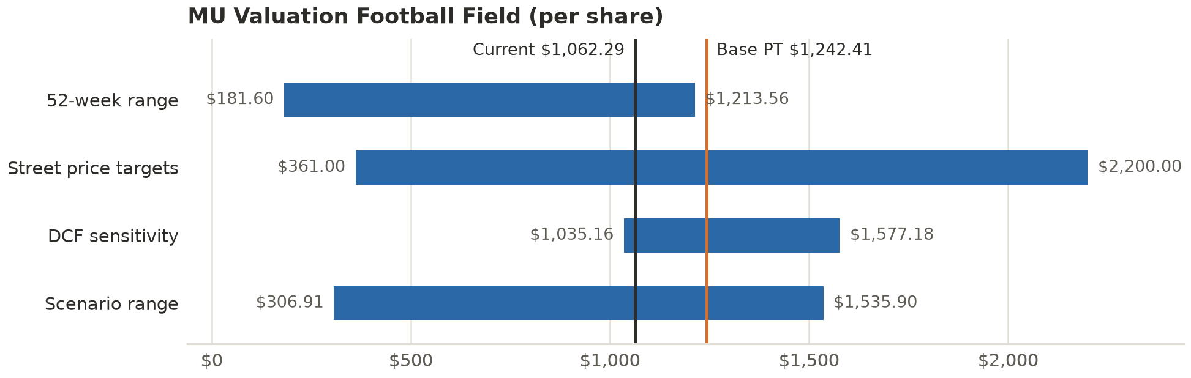
Source: Conscious Investments model, Yahoo Finance

FINANCIAL ANALYSIS
MU Financial Summary (USD)
Summary | 2023 | 2024 | 2025 | 2027e | 2028e | 2029e | 2030e | 2031e
Total revenue | $15.5 bn | $25.1 bn | $37.4 bn | $274.9 bn | $314.2 bn | $323.6 bn | $333.3 bn | $343.3 bn
% growth YoY | N/A | 61.6% | 48.9% | 635.5% | 14.3% | 3.0% | 3.0% | 3.0%
EBITDA | $2.0 bn | $9.1 bn | $18.1 bn | $228.2 bn | $238.8 bn | $220.0 bn | $220.0 bn | $223.1 bn
EBITDA margin | 12.9% | 36.2% | 48.5% | 83.0% | 76.0% | 68.0% | 66.0% | 65.0%
Net income | ($5.8 bn) | $778.0 mn | $8.5 bn | $183.7 bn | $188.5 bn | $168.2 bn | $165.0 bn | $165.5 bn
Diluted EPS | $-5.34 | $0.70 | $7.59 | $159.83 | $163.68 | $145.74 | $142.70 | $142.88
% growth YoY | N/A | N/A | 984.3% | 2,005.7% | 2.4% | (11.0%) | (2.1%) | 0.1%
Free cash flow* | ($6.1 bn) | $121.0 mn | $1.7 bn | $141.2 bn | $148.4 bn | $138.8 bn | $146.5 bn | $149.9 bn
Source: SEC filings (actuals), Conscious Investments model (estimates). *Actual FCF = CFO less CapEx; estimates are unlevered FCF. Estimates are base case.
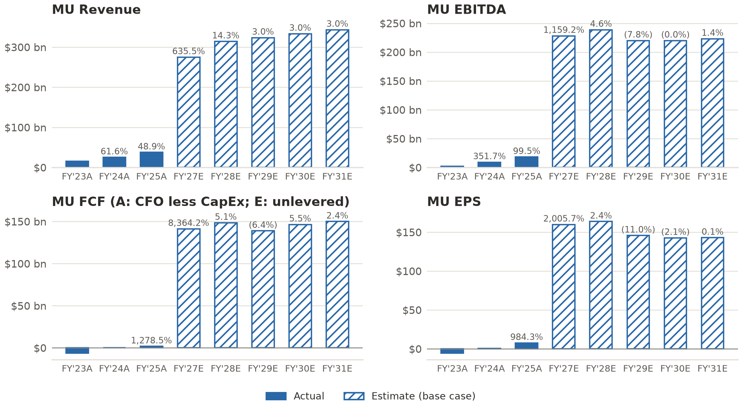
Source: SEC filings, Conscious Investments model
The history is a single cycle with three turning points. In FY'23 revenue fell (49.5%) to $15.5 bn, operating margin was (37.0%) and the net loss was $5.8 bn. FY'24 and FY'25 brought recovery to $25.1 bn and $37.4 bn of revenue, with operating margin of 5.2% and 26.1%. The third turn is FY'26: revenue of $133.2 bn, GAAP gross margin of 80.7%, GAAP operating income of $99.3 bn and operating cash flow of $89.7 bn against $17.5 bn a year earlier. The exhibits above run to the latest XBRL filing, 3Q'26, because the FY'26 10-K is not yet filed, and the FY'26 totals here come from the 2026-09-30 earnings release.
Cash generation has changed shape. Adjusted free cash flow was $62.3 bn in FY'26 and $33.2 bn in 4Q'26 alone, after net CapEx of $27.4 bn for the year. The balance sheet shows $73.5 bn of cash, marketable investments and restricted cash against $5.2 bn of debt, and MU repaid $10.0 bn of debt during the year. Receivables of $36.2 bn and noncurrent customer contract liabilities of $12.9 bn are the two working capital lines to watch, one a use of cash and the other a source. The Board declared a quarterly dividend of $0.15 per share on 30Sep'26, a yield of 0.1% on the current price, and MU paid $0.6 bn of dividends in FY'26.

APPENDIX

Exhibit I: Bulls vs Bears
Bulls:
- FY'26 revenue of $133.2 bn and a 4Q'26 gross margin of 86.8% show the earning power of a supply-constrained market, and 1Q'27 guidance of $61.5 bn points higher.
- Take-or-pay Strategic Customer Agreements bring fixed or banded pricing and committed volumes, backed by $12.7 bn of customer deposits in FY'26.
- Net cash of about $68.3 bn and adjusted free cash flow of $62.3 bn let MU fund its build-out without raising capital.
- The stock trades at 5.9x NTM EPS with a Street mean price target of $1,521.76, 43.3% above the price, and our own base case is 17.0% above it.
Bears:
- Memory has a record of sharp reversals: revenue fell (49.5%) in FY'23 and gross margin reached (9.1%).
- New capacity from Boise, Singapore and Taiwan from calendar 2027 arrives into a market where rivals and state-backed entrants may also add supply.
- A minority of the Strategic Customer Agreements carry no price protection, and the terms of the rest are not fully disclosed.
- The shares are up 272.4% YTD with a beta of 2.23, and our bear case is a (71.1%) return, so a miss has little cushion.

Exhibit II: Exit Strategy
The Fund's intended horizon is 15 months, to Jan'28. We would revisit the Outperform rating on three signals. First, a disclosed floor price that implies a gross margin below 70.0% through FY'28, which would put our 76.0% EBITDA margin for that year at risk. Second, two consecutive quarterly revenue prints below $60.0 bn, which would put the run-rate below the $246.0 bn guide and our $274.9 bn FY'27E path out of reach. Third, a share price above about $1,080, where the base-case return on our $1,242.41 target falls to the 15.1% hurdle for the top rating (our arithmetic), or a price at or above the bull-case target of $1,535.90, which would mean the market has paid for the bull path. Above about $1,183 the same target would trail the S&P 500's expected 10.1% by more than 5.0 points (our arithmetic).

ABOUT CONSCIOUS INVESTMENTS
Conscious Investments is an independent equity research imprint authored by Ethan Stott. Its initiating coverage reports aim to combine primary-source financial analysis with a clear, falsifiable investment thesis. Conscious Investments does not manage client assets, is not a registered investment adviser or broker-dealer, and receives no compensation from the companies it covers.
DISCLAIMER
This report is provided for educational and informational purposes only and does not constitute investment advice, an offer to sell, or a solicitation of an offer to buy any security. It does not take into account the investment objectives, financial situation or needs of any reader. Readers should conduct their own research and consult a licensed financial professional before making any investment decision.
The information herein has been obtained from public sources believed to be reliable, including company filings with the U.S. Securities and Exchange Commission, but Conscious Investments makes no representation as to its accuracy or completeness. Forward-looking statements, estimates, price targets and ratings reflect the author's judgment as of the date of this report, are subject to change without notice, and may not be realized. Past performance is not indicative of future results. References to third-party publications are provided for reader convenience only, and Conscious Investments does not endorse their content.
Ratings are relative to the author's expected return for the S&P 500 over a 12–18 month horizon. Outperform: expected total return exceeds the S&P 500 by more than 5 percentage points. Neutral: within 5 percentage points. Underperform: trails by more than 5 percentage points.
Portions of this report were drafted with the assistance of AI tools and were reviewed by the author.
Holdings disclosure: The author holds no position in the securities discussed. The Fund's portfolio is a paper portfolio.

