IT Lab: Firewall, Domain Controller, Ticketing & Client Build
A home-lab environment built in VirtualBox: an OPNsense firewall/router, a Windows Server 2022 domain controller (AD DS, DNS, DHCP), a Linux ticketing server (osTicket), and a domain-joined Windows client.
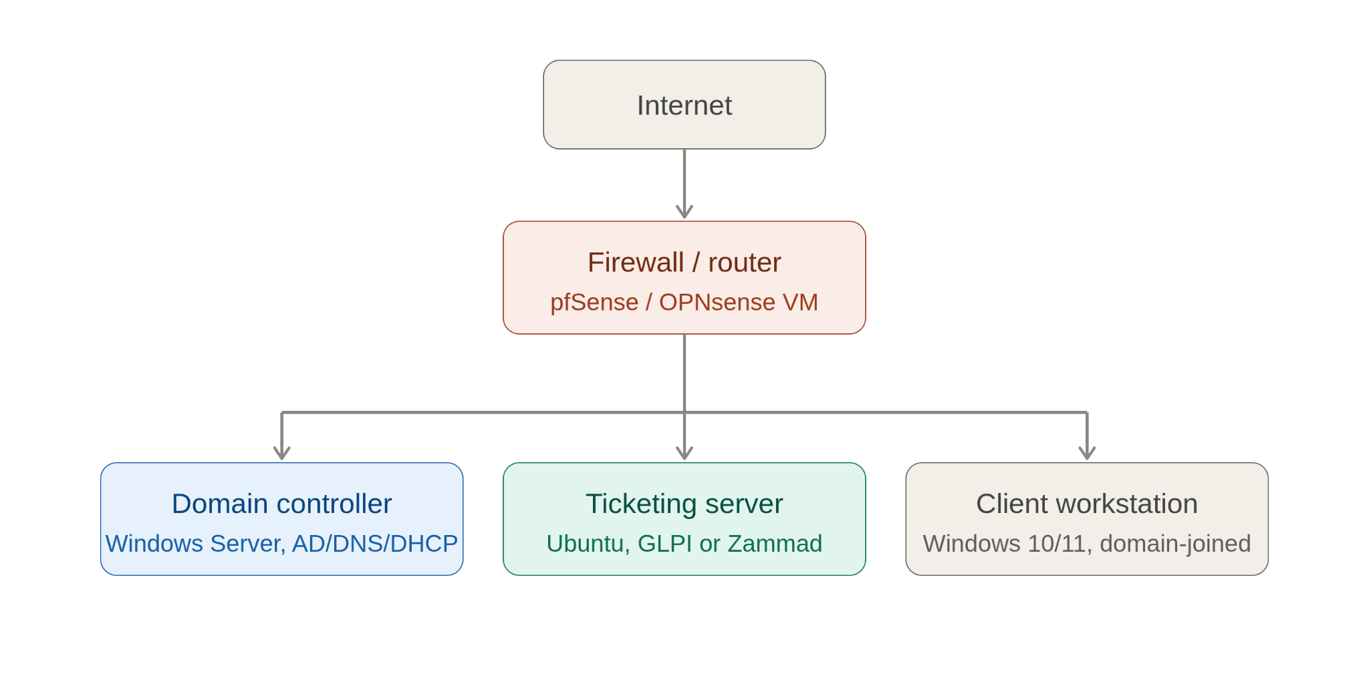
Lab network diagram

Lab Topology
Role | OS | Key Config
Firewall / Router | OPNsense | WAN: NAT (VirtualBox), LAN: 192.168.50.1/24
Domain Controller | Windows Server 2022 (Desktop Experience) | Domain: lab.local, static IP on the LAN subnet, DNS points to itself, runs AD DS + DNS + DHCP
Ticketing Server | Ubuntu Server (osTicket) | DHCP lease from the DC, internal network
Client | Windows 10/11 Pro | Domain-joined to lab.local
All VMs (other than the firewall’s WAN side) sit on the same VirtualBox Internal Network — the name must match exactly, character-for-character, on every adapter, or the VMs won’t be able to reach each other.

Prerequisites
- VirtualBox
- qemu-img (for converting the OPNsense raw image to VMDK)
- ISOs/images:
  - OPNsense (raw .img.bz2)
  - Windows Server 2022
  - Ubuntu Server
  - Windows 10

1. Firewall (OPNsense)
- Download the OPNsense image.
- 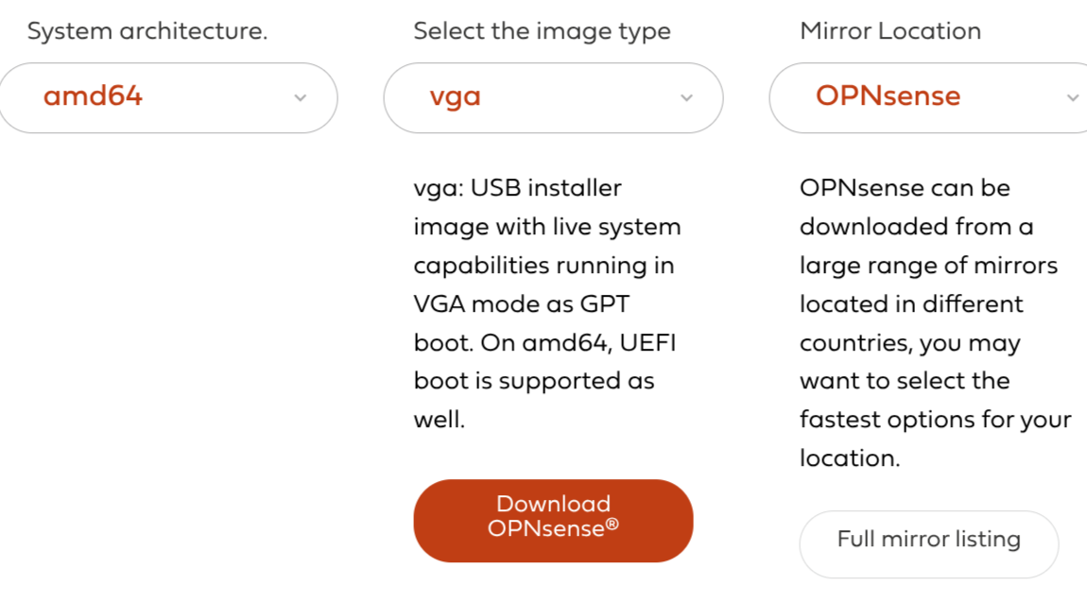
- OPNsense download page
- Decompress the .bz2 archive.
- 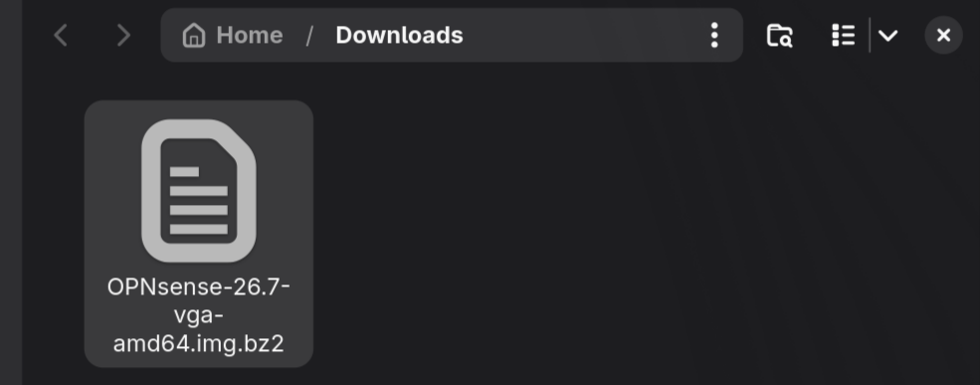
- Uncompressing the image
- Open a terminal and rename the extracted file for convenience.
- 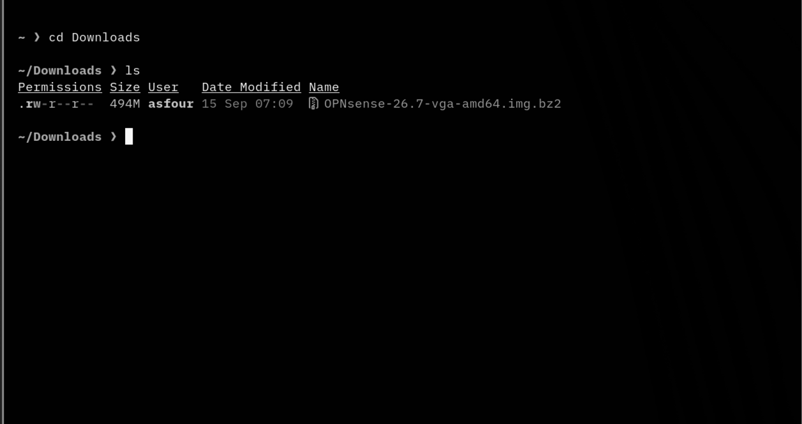
- Terminal, renaming the file
- Use bunzip2 to extract the .bz2 file — you should end up with this:
- 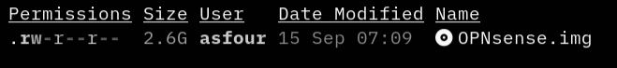
- Extracted file result
- Make sure qemu-img is installed, then convert the raw image to VMDK (VirtualBox can’t boot a raw image directly — it needs a container format like VMDK).
- 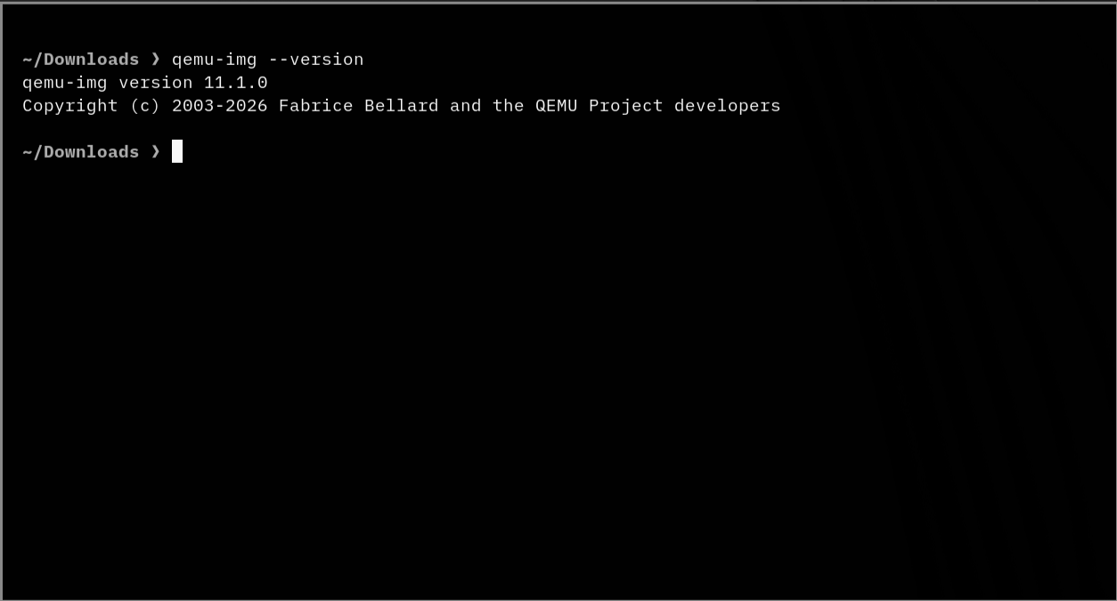
- qemu-img installed
- 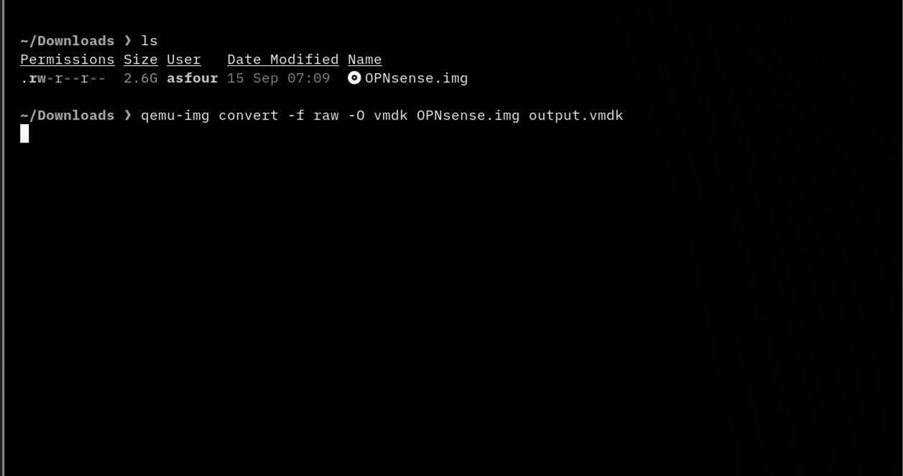
- Conversion command
- Delete the raw .img file and move the .vmdk out of the Downloads folder.
- 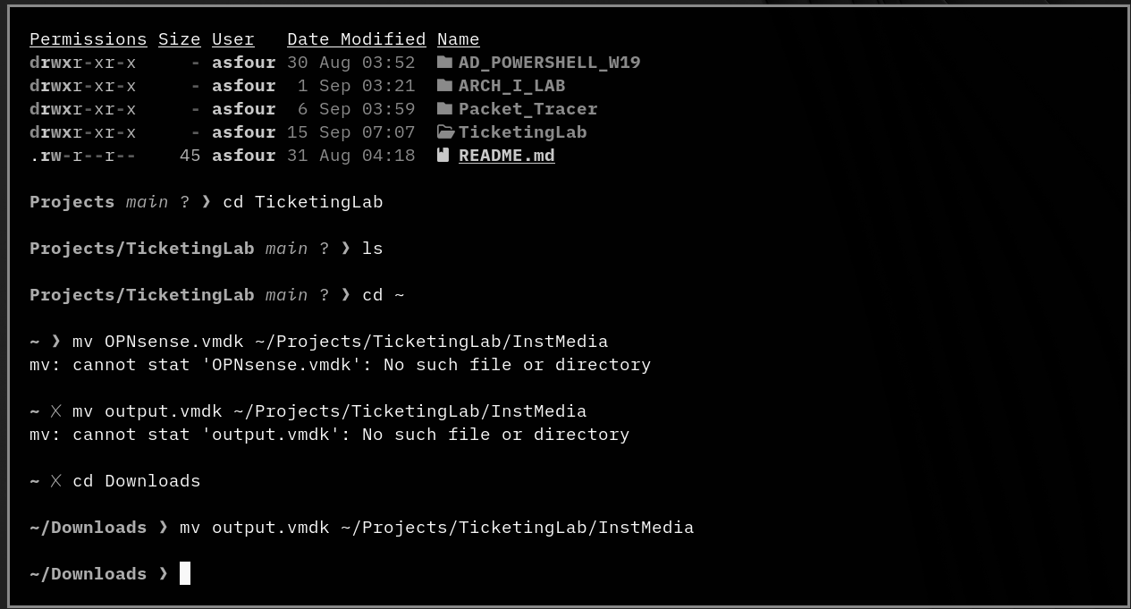
- Moving the vmdk file
- Rename output.vmdk to OPNsense.vmdk.
- 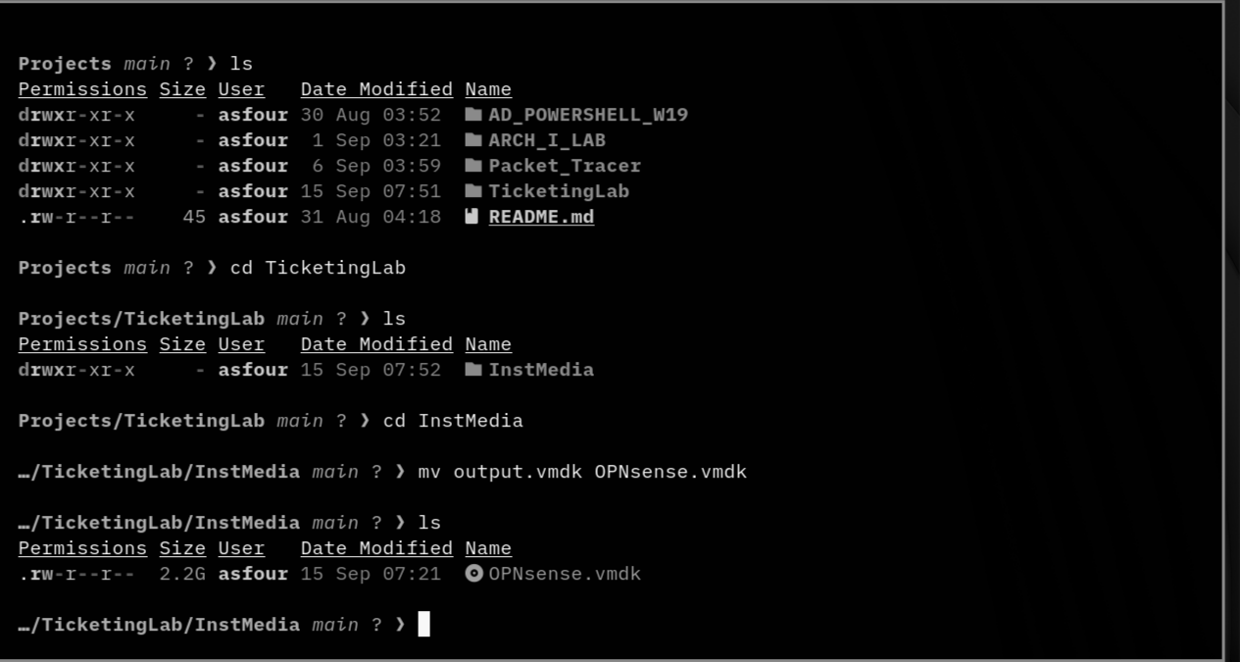
- Renamed vmdk
- In VirtualBox, create a new VM:
  - Leave the ISO field blank (booting from the VMDK instead).
  - OS type: BSD (OPNsense is FreeBSD-based, not Linux).
- 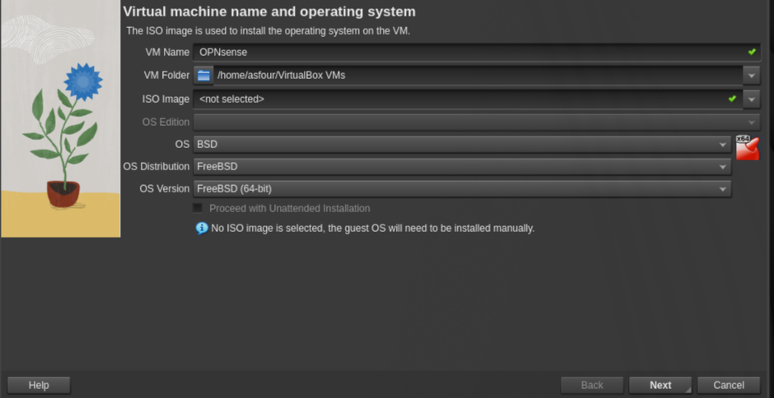
- New VM, ISO blank, BSD type
- Size the virtual hardware to taste — the lab used modest specs to save resources.
- 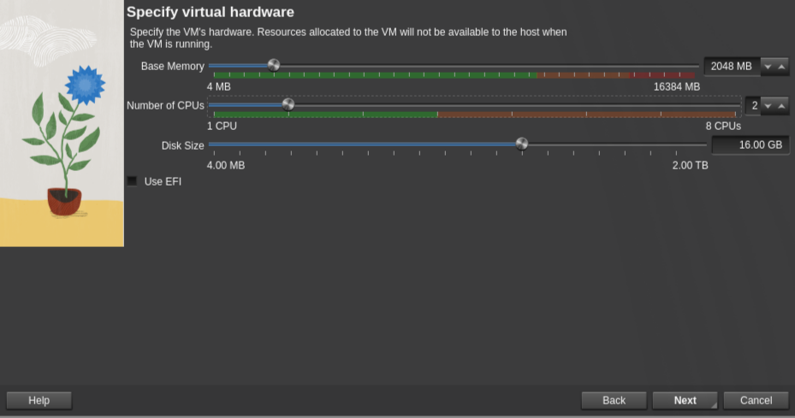
- Virtual hardware settings
- Right-click the new VM in the list and enable Expert Mode while configuring networking.
- 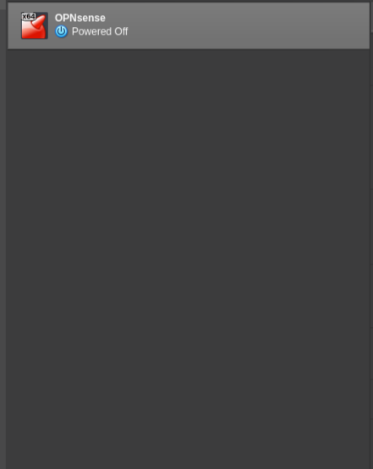
- VM list, expert mode
- Configure two network adapters:
  - Adapter 1 (LAN):
  - 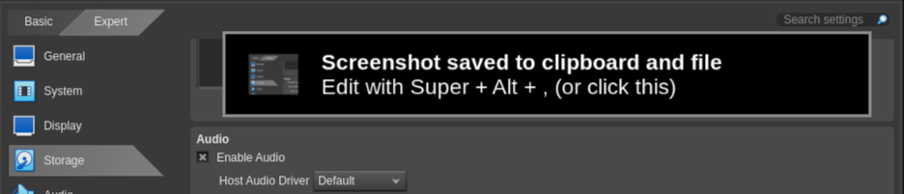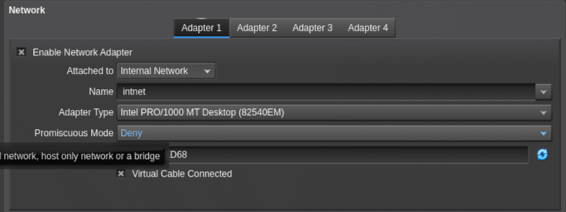
  - Adapter 2 (WAN):
  - 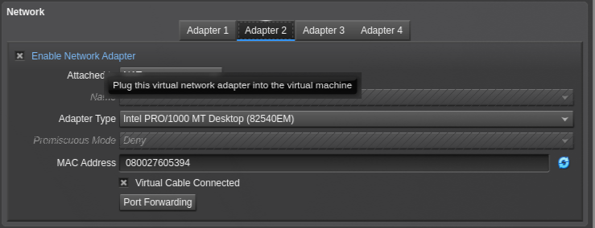
  - WAN adapter
- Under Storage, remove the default VDI, click the attachment icon, and add the OPNsense.vmdk.
- 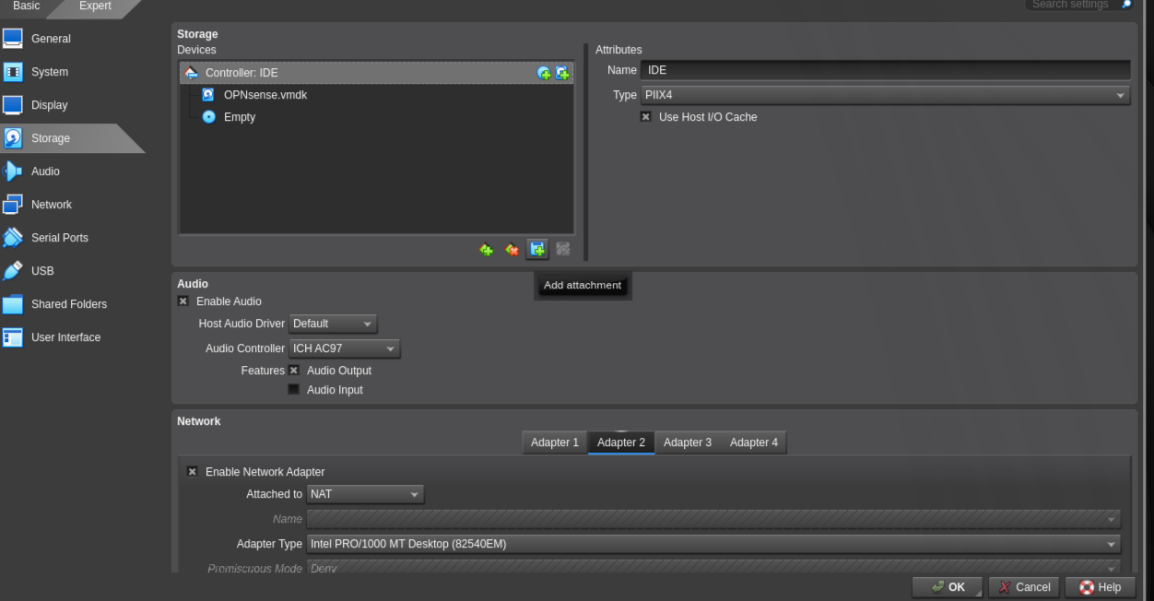
- Attaching the vmdk under storage
- Start the VM.
- 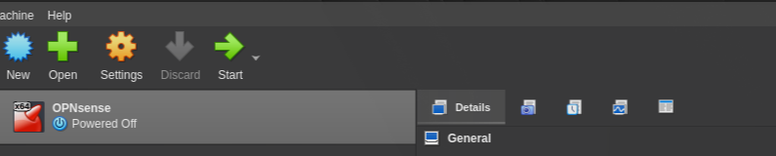
- Starting OPNsense
- 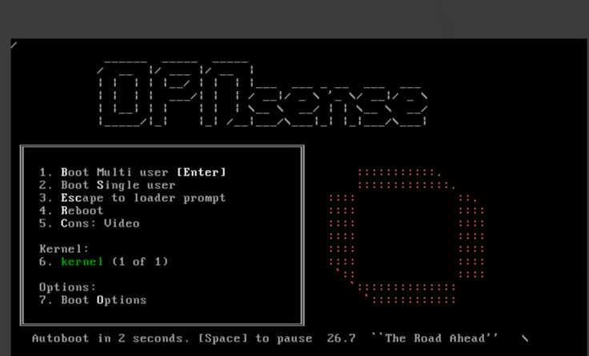
- Booting
- At the console, answer No to LAGGs (single NIC per side — nothing to bond) and No to VLANs (one flat subnet — nothing to tag).
- 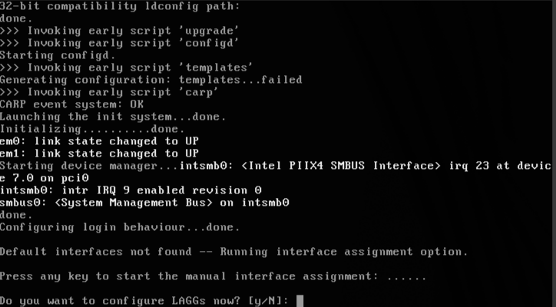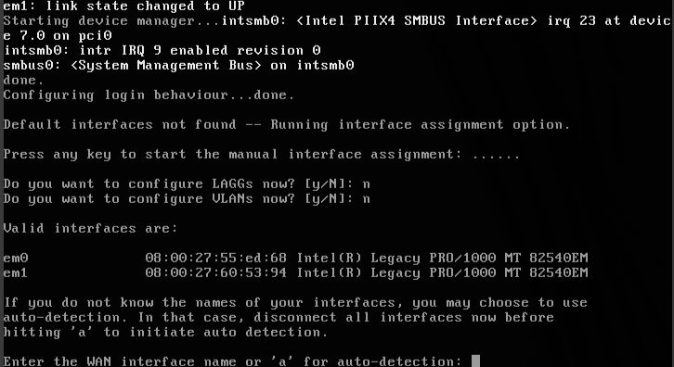
- Note the MAC addresses shown, then match them back to the adapters configured in VirtualBox to identify which is WAN and which is LAN.
- 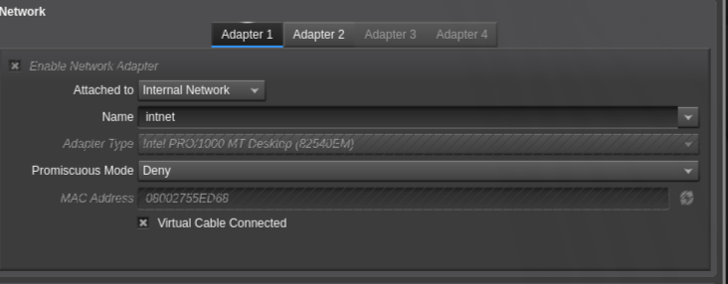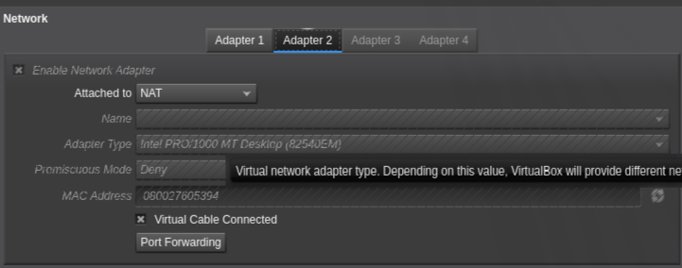
- Assign the WAN interface (attached to NAT) — e.g. em1 if its MAC ends in 394.
- 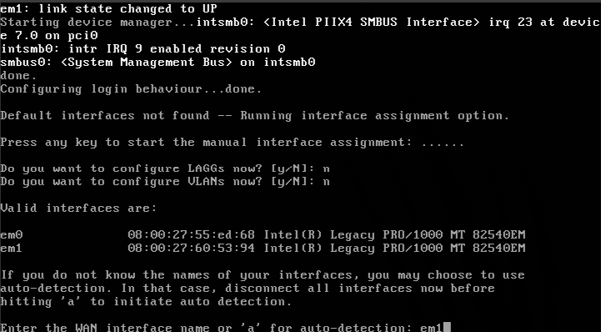
- Assigning WAN interface
- Add the LAN interface and skip the rest.
- 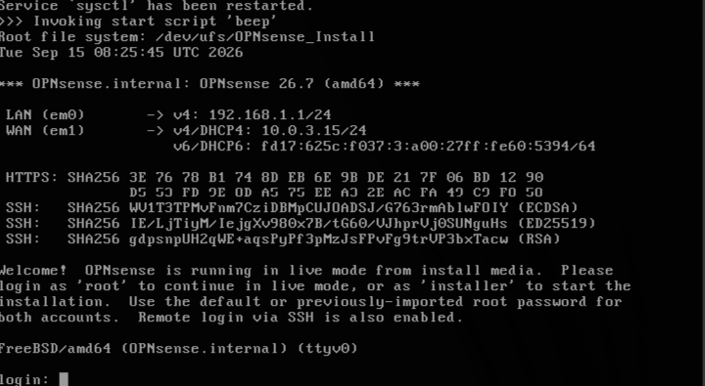
- Adding LAN interface
- Log in at the console with the default credentials:
- Username: root Password: opnsense
- 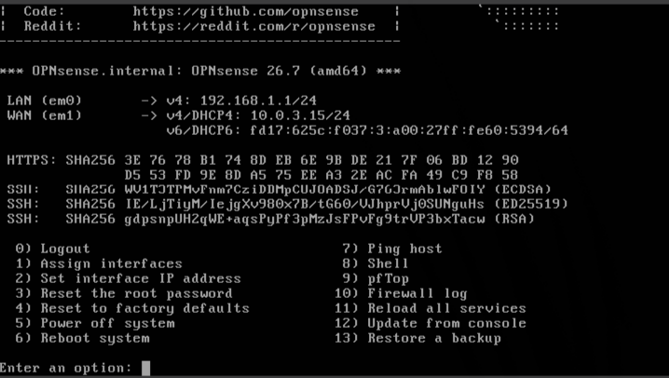
- Default login screen
- From the main menu: 2 → Set interface IP addresses → 1 for LAN. Decline DHCP on the LAN interface (the Windows DC will be the DHCP server — two DHCP servers on one subnet causes lease conflicts). Set the LAN IP to 192.168.50.1 / 24, decline the remaining prompts back to the main menu.
- 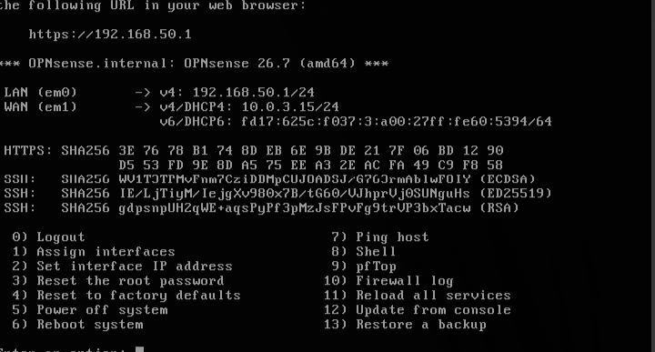
- Setting the LAN IP
- Leave OPNsense running (or headless, to save resources) — the DC needs it as the default gateway for internet access.

2. Domain Controller (Windows Server 2022)
- Download the Server 2022 ISO, move and rename it into your images folder.
- 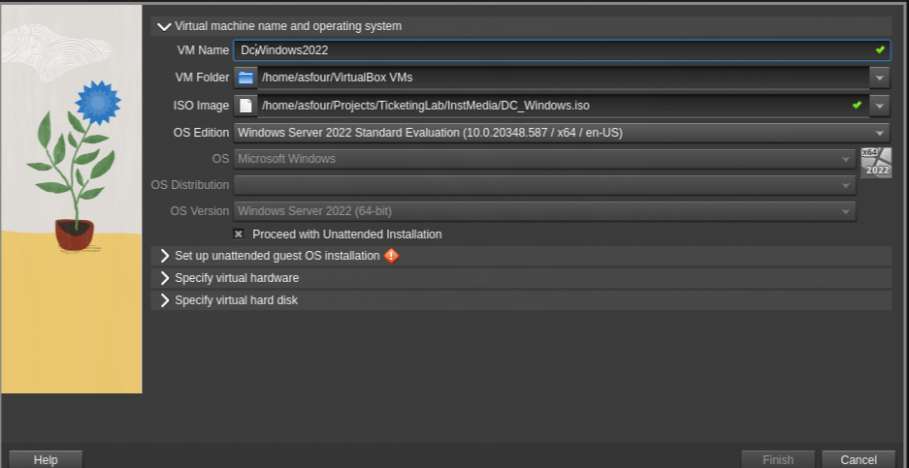
- Moving/renaming the ISO
- Create a new VM named DC_Windows and attach the ISO.
- 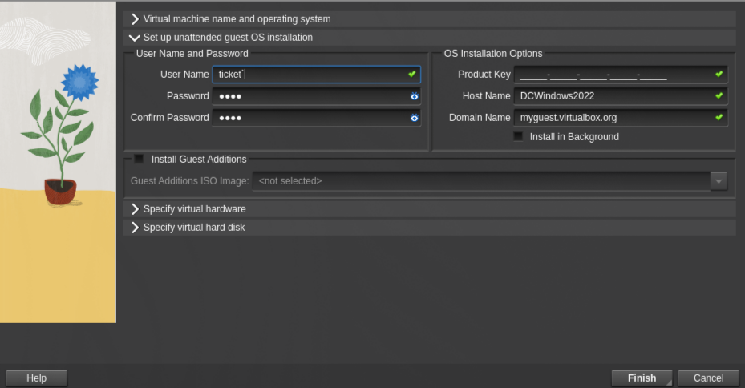
- New VM, DC_Windows
- Set credentials for the VM.
- 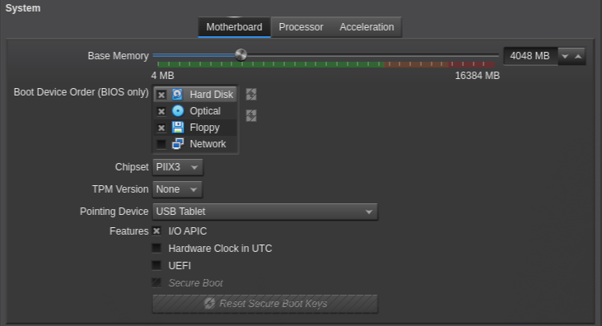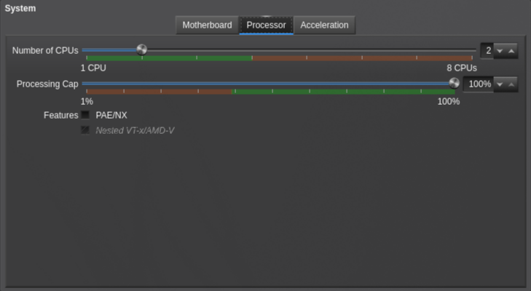
- Allocate 4 GB RAM / 2 vCPUs.
- 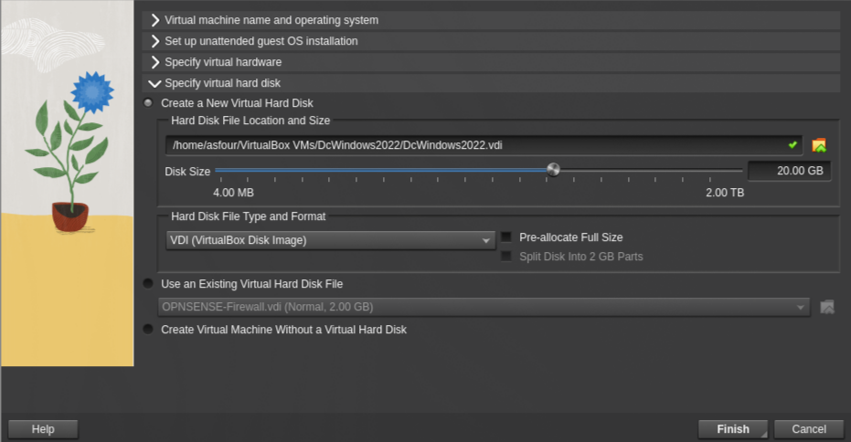
- 4GB RAM, 2 processors
- Allocate 20 GB of disk space.
- 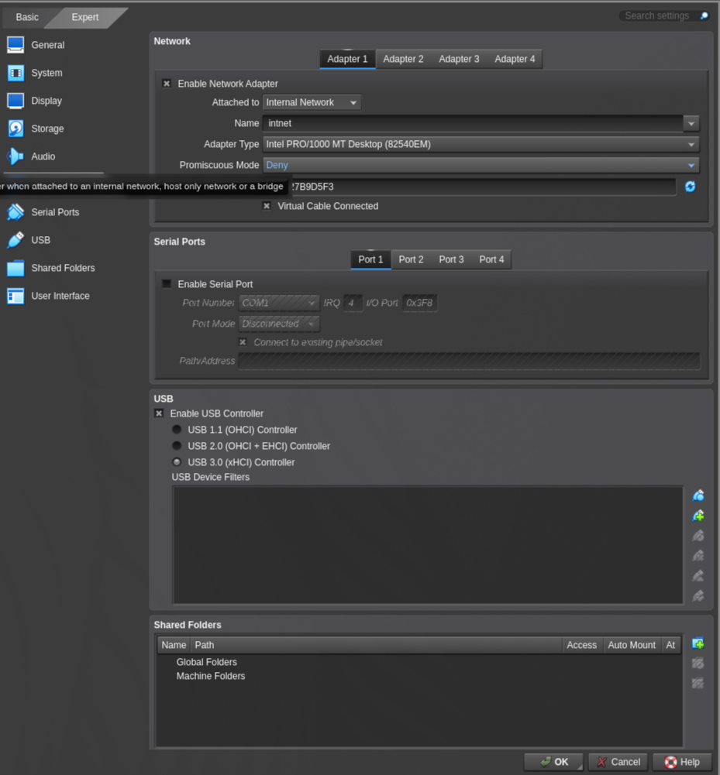
- Disk space allocation
- Make sure the network adapter is connected to the shared Internal Network — same name as the firewall’s LAN adapter (a mismatch isolates the DC from the firewall).
- 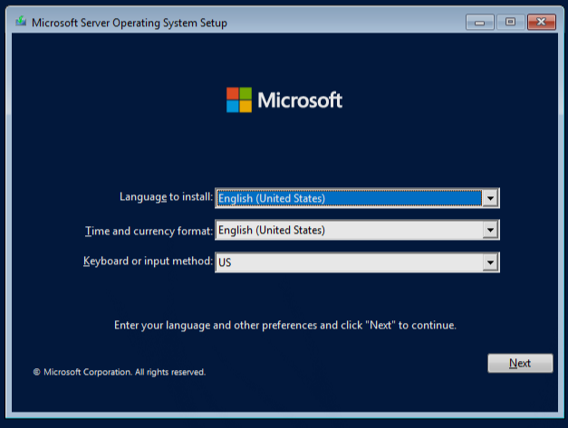
- Network adapter, internal network
- Start the VM and proceed through the Windows installation.
- 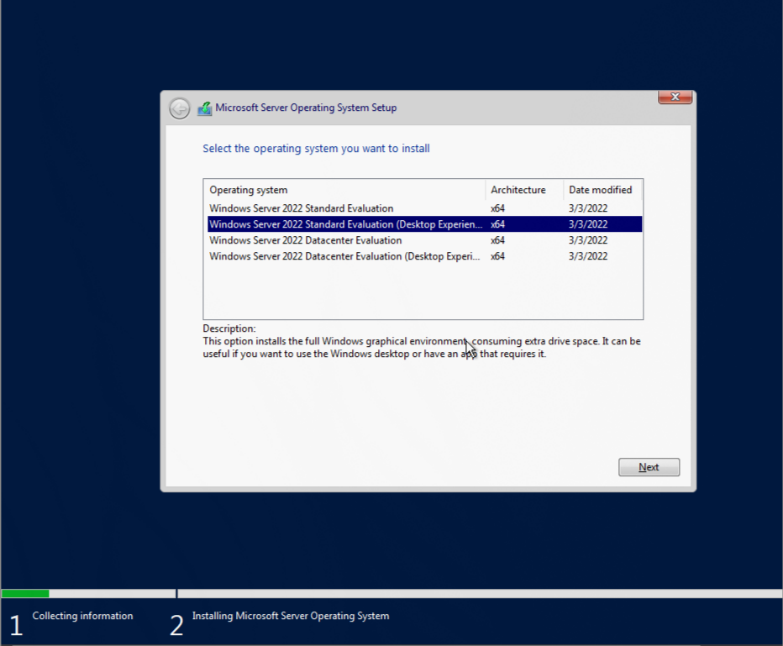
- Starting the VM
- Choose the Desktop Experience edition.
- 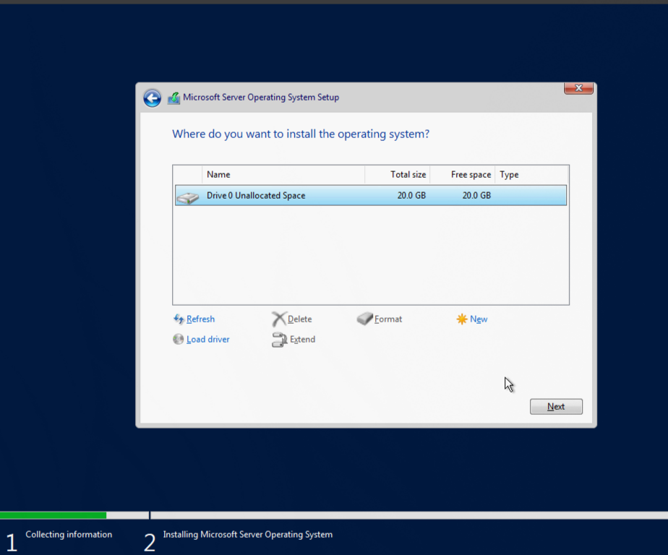
- Desktop Experience option
- Use custom install and select the unallocated space.
- 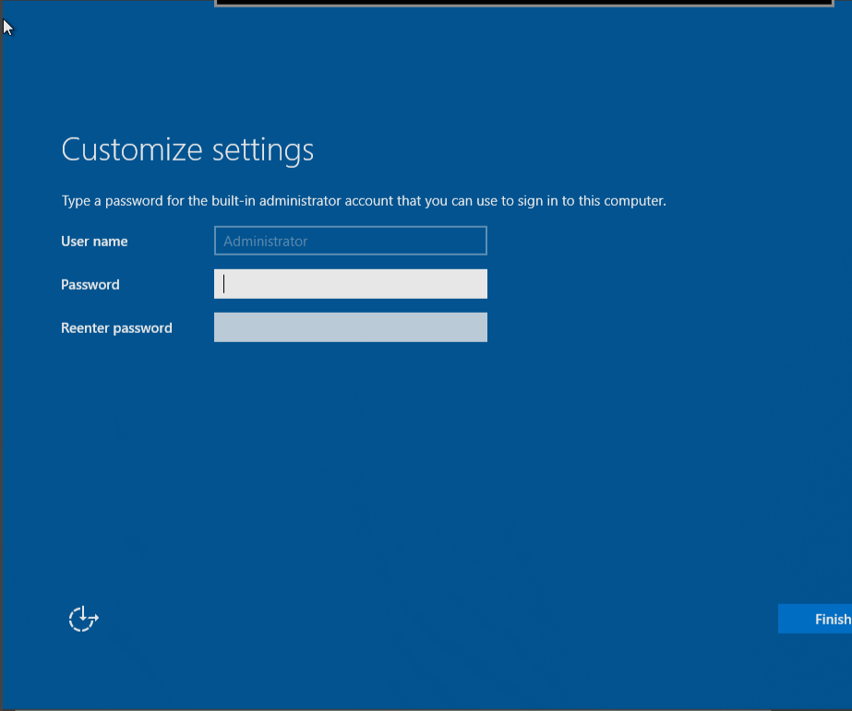
- Custom install, unallocated space
- Set the local administrator password.
- 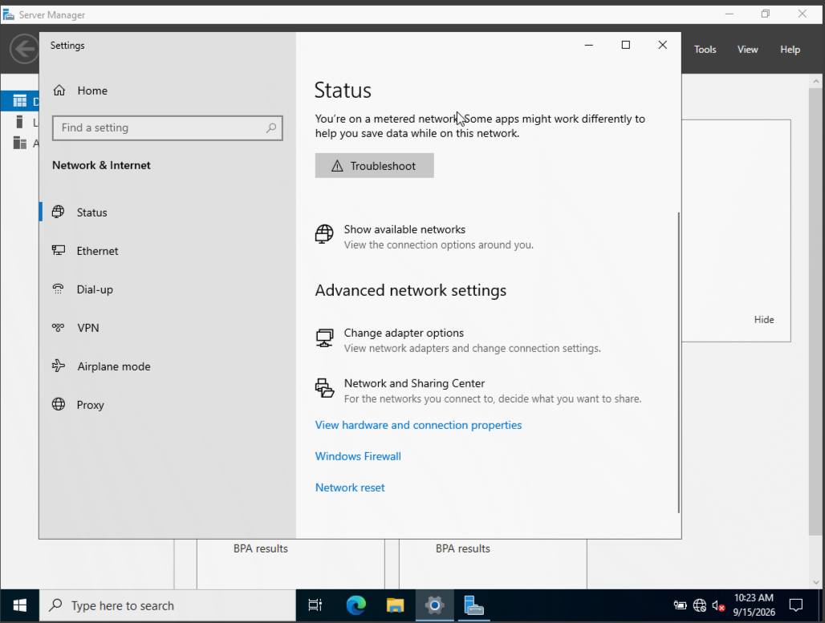
- Setting the admin password
- Check the network settings (globe icon → Network settings → Change adapter options → Ethernet → Details). You’ll see an APIPA address (169.254.x.x) — expected, since no DHCP server exists yet.
- 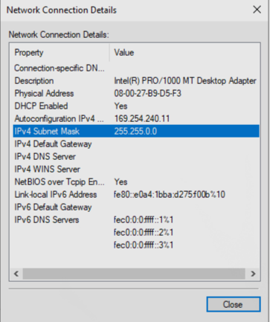
- APIPA address shown
- Set a static IP manually (Ethernet adapter → Properties → TCP/IPv4 → Properties):
  - IP address per your subnet plan
  - Default gateway: the OPNsense LAN IP (192.168.50.1)
  - DNS: loopback (127.0.0.1) — once AD DS is installed, this server hosts its own AD-integrated DNS zone.
- 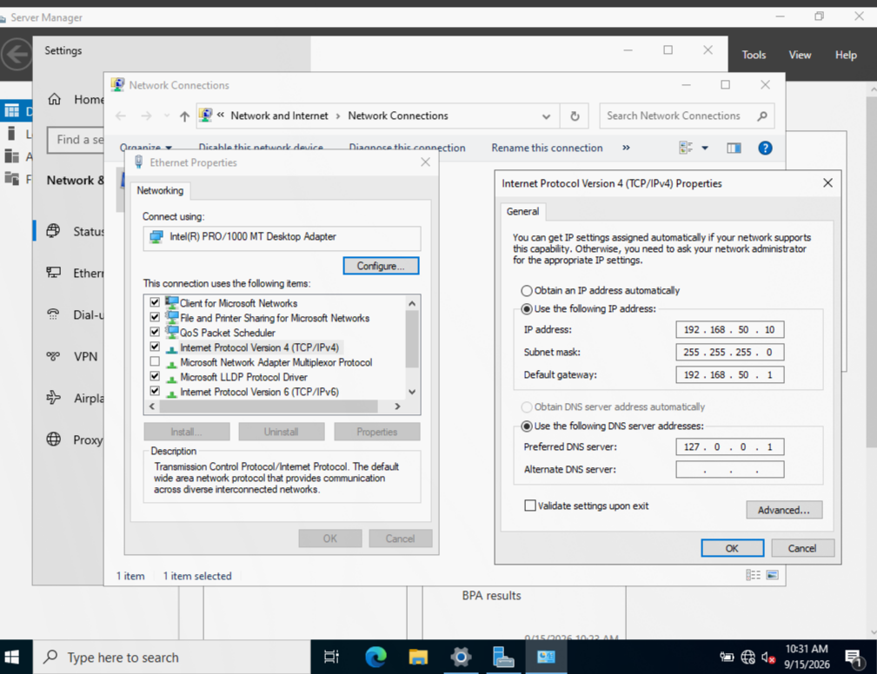
- TCP/IPv4 settings
- Server Manager → Add Roles: install DHCP, DNS, and AD DS together (DHCP will later be authorized against AD DS, and AD DS needs DNS to integrate with).
- 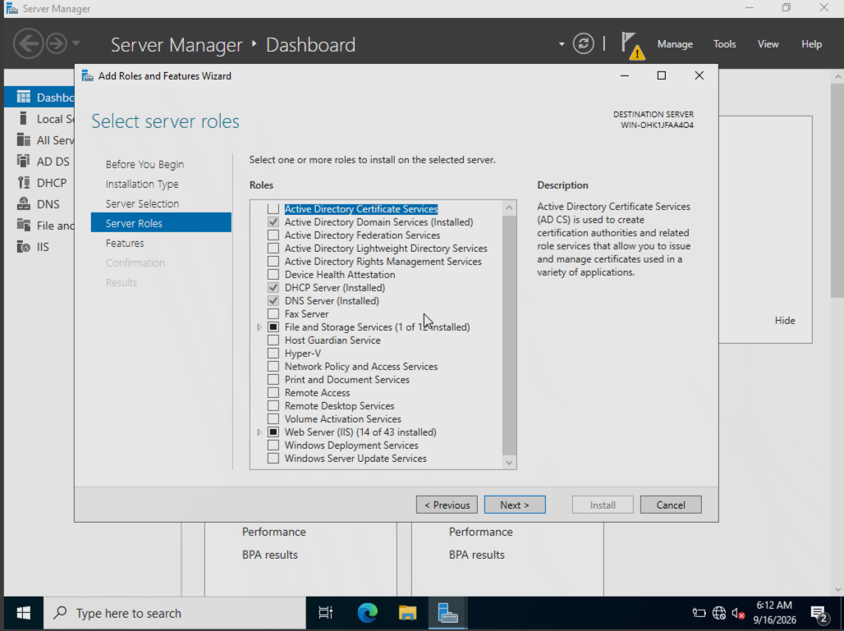
- Adding roles
- Click through to install, then restart the server.
- 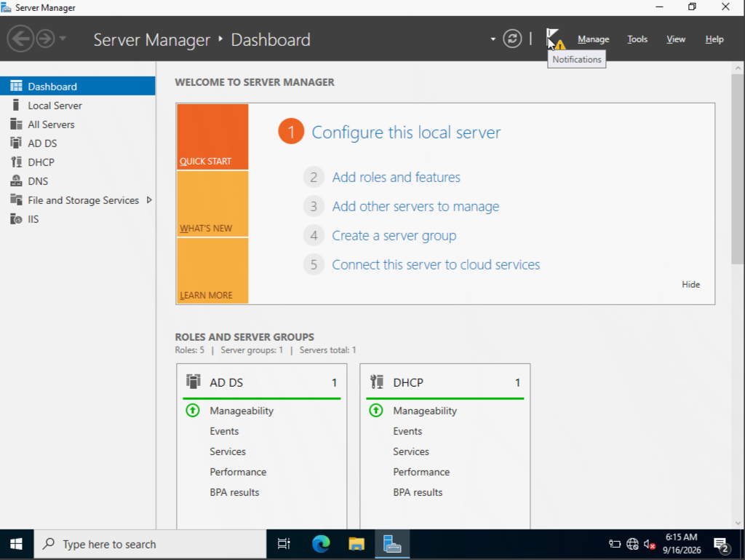
- Install and restart
- Click the notification flag and choose Promote this server to a domain controller.
- 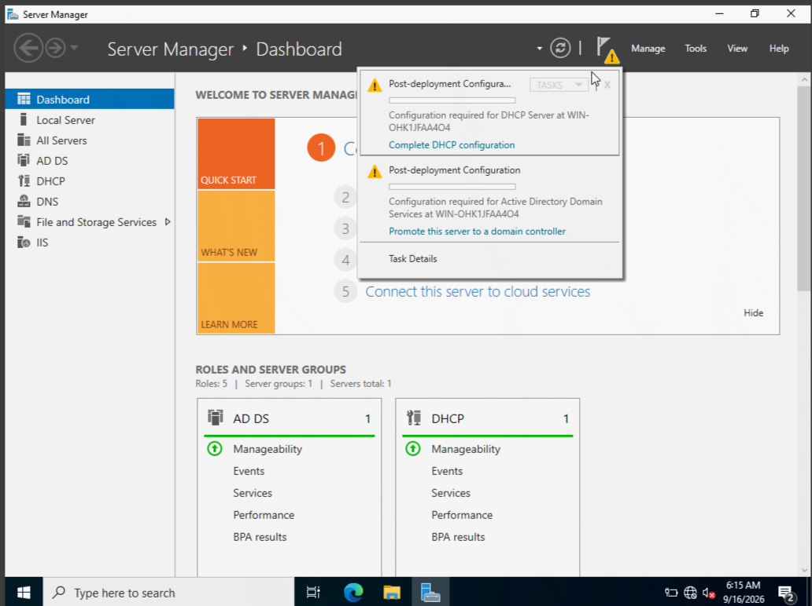
- Promote to domain controller
- Create a new forest, set the domain name to lab.local, and click through to install.
- 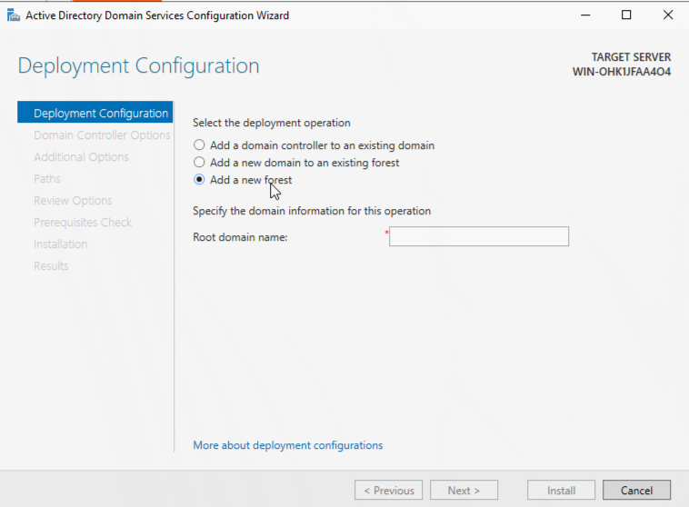
- Setting the domain to lab.local
- Set a DSRM password and click through to install — the server restarts automatically.
- 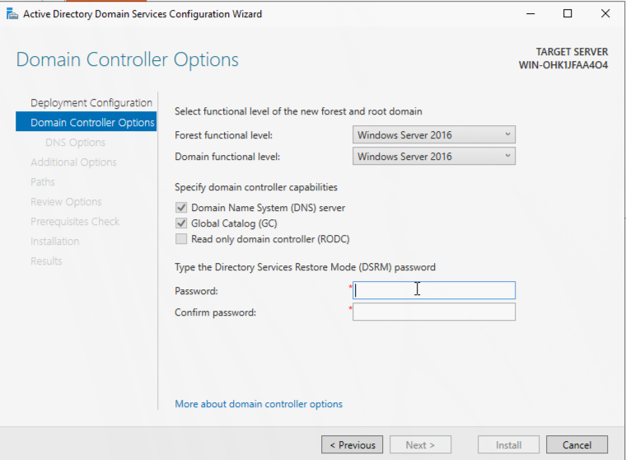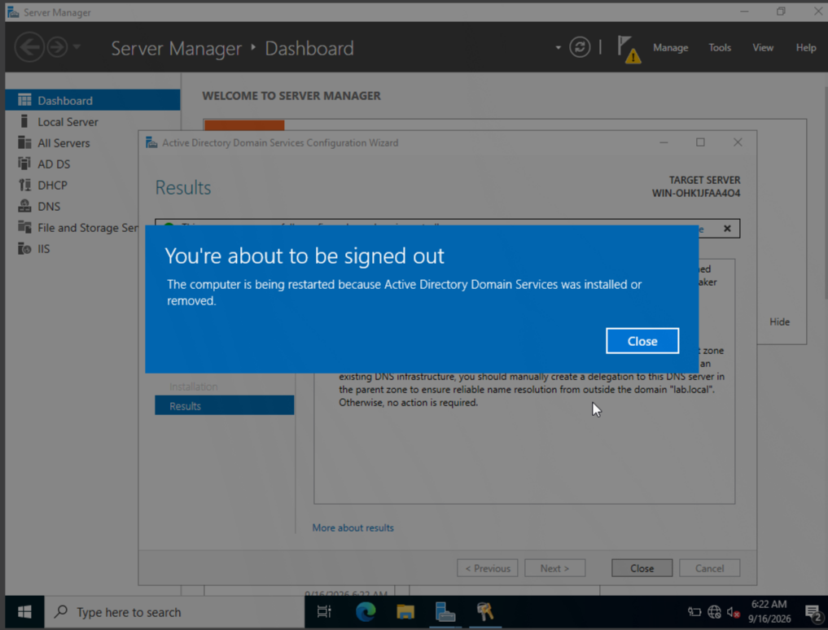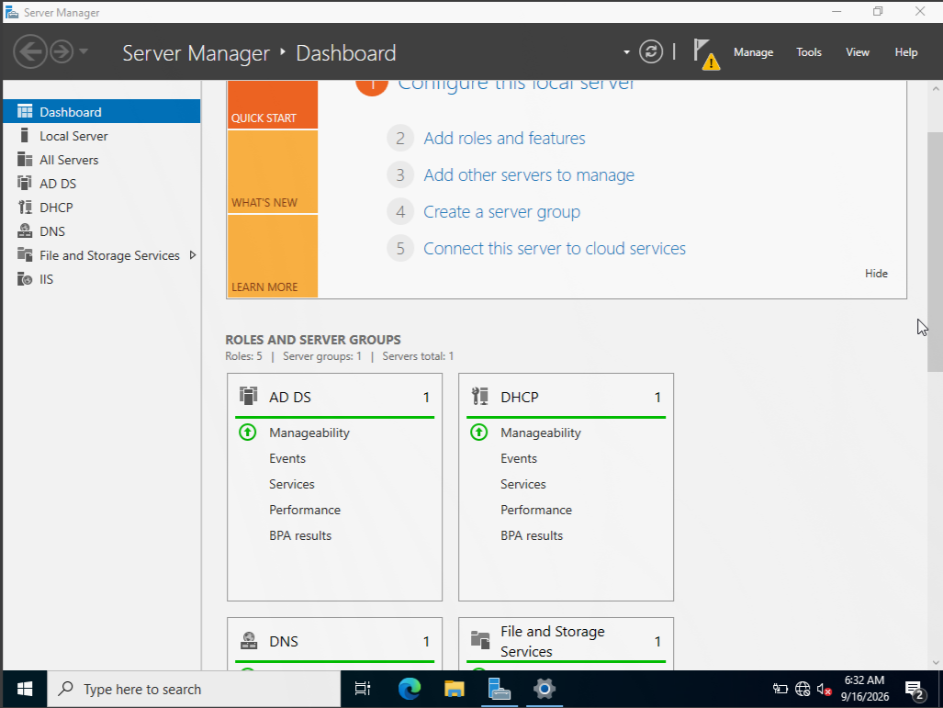
- Back in Server Manager, go to Tools.
- 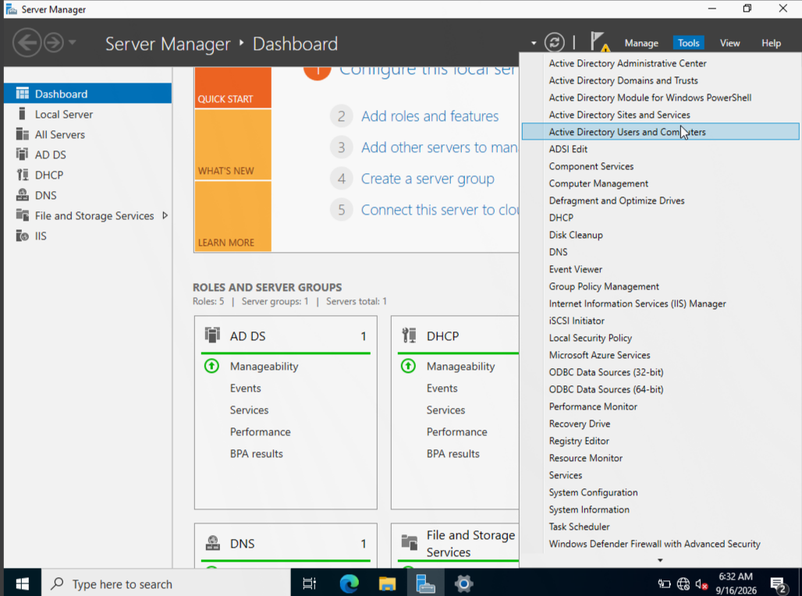
- Server Manager Tools menu
- Click DHCP.
- 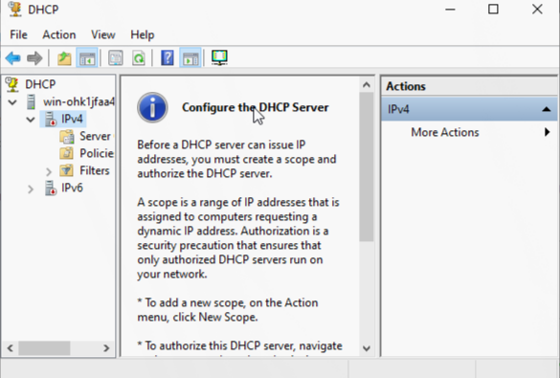
- DHCP console
- Right-click the DHCP node under IPv4 and create a New Scope.
- 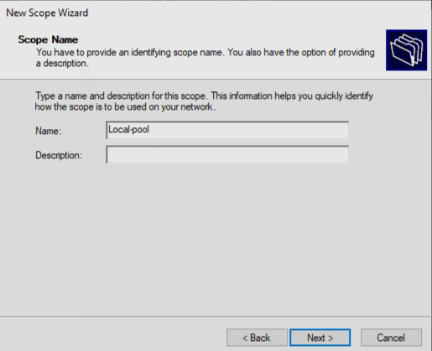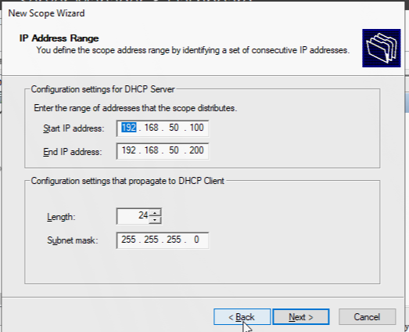
- Set the scope to match your subnet.
- 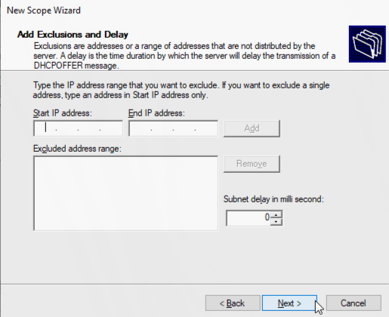
- Scope matching subnet
- No exclusions needed.
- 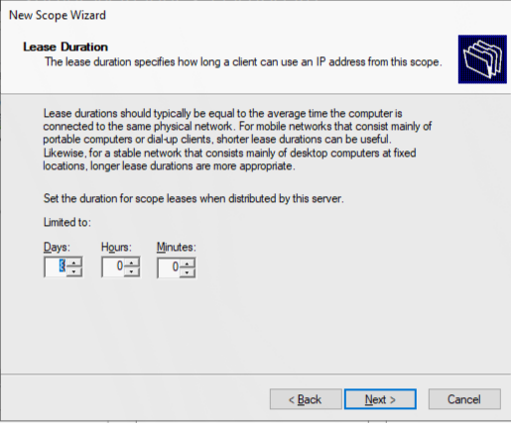
- No exclusions
- It’s a lab, so lease duration doesn’t matter much.
- 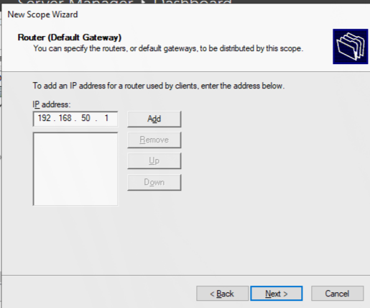
- Lease duration
- Set the router/default gateway option to the OPNsense LAN IP.
- 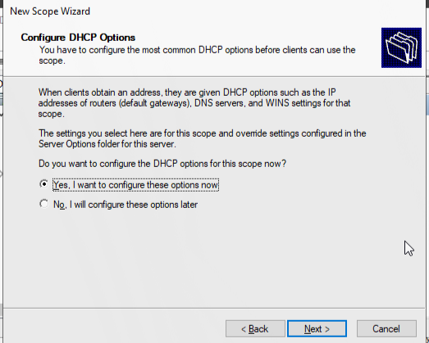
- Default gateway option
- Click through to finish, and confirm the scope is activated.
- 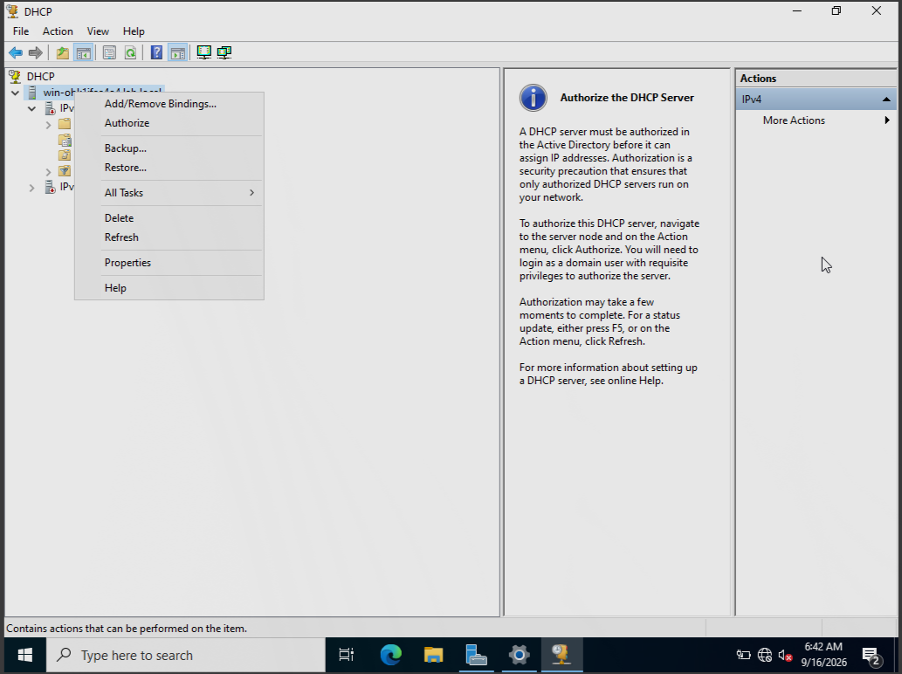
- Back to DHCP screen
- Right-click the DHCP server node and choose Authorize — this is what actually turns leasing on; an unauthorized DHCP server silently refuses to hand out leases on an AD network, even with the service running and scope active.
- 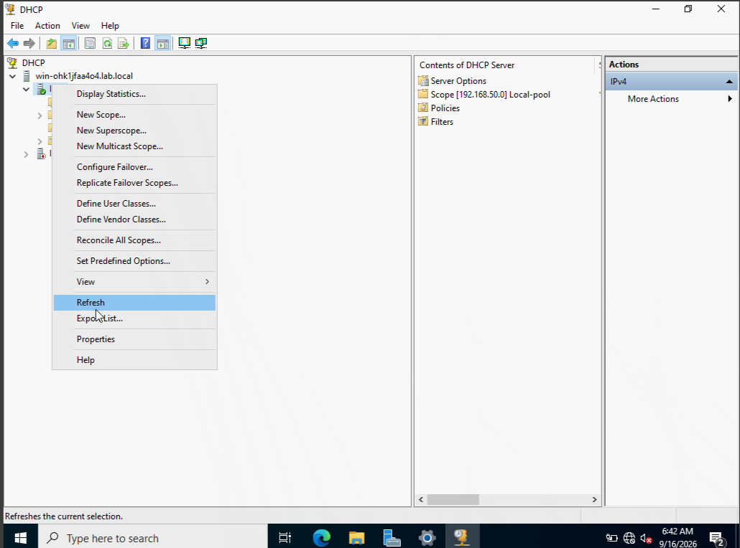
- Authorizing the DHCP server
- Refresh — the DHCP server node should turn green.
- 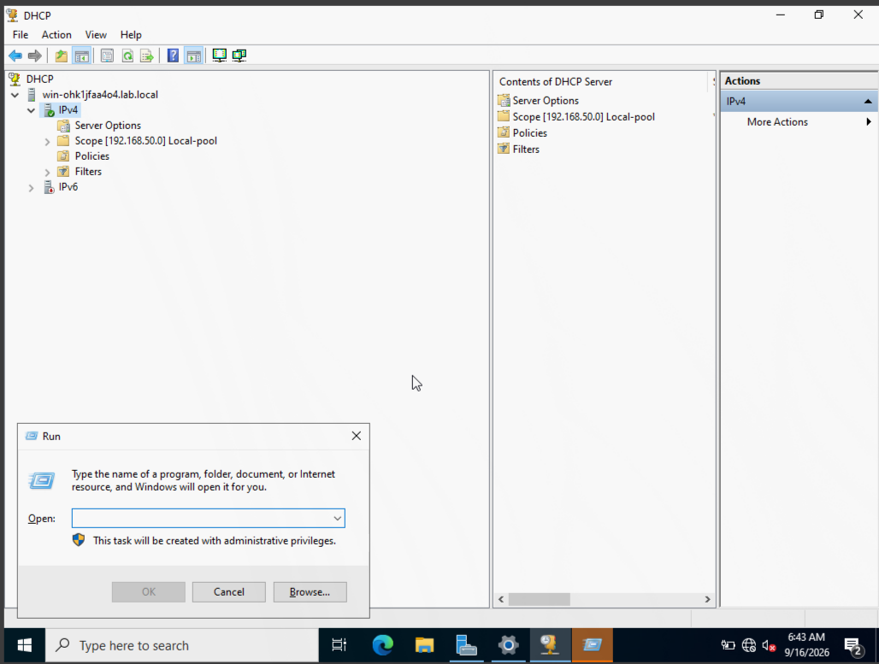
- DHCP server authorized, green
- Open services.msc (Win+R).
- 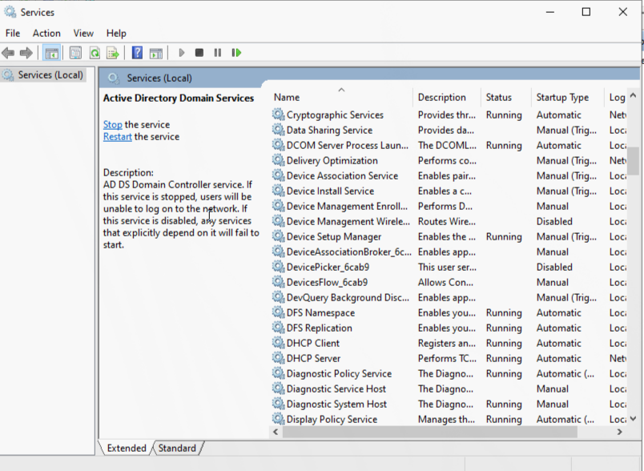
- services.msc
- Find the DHCP Server service and confirm it’s set to Automatic startup, so it survives reboots without manual intervention.
- 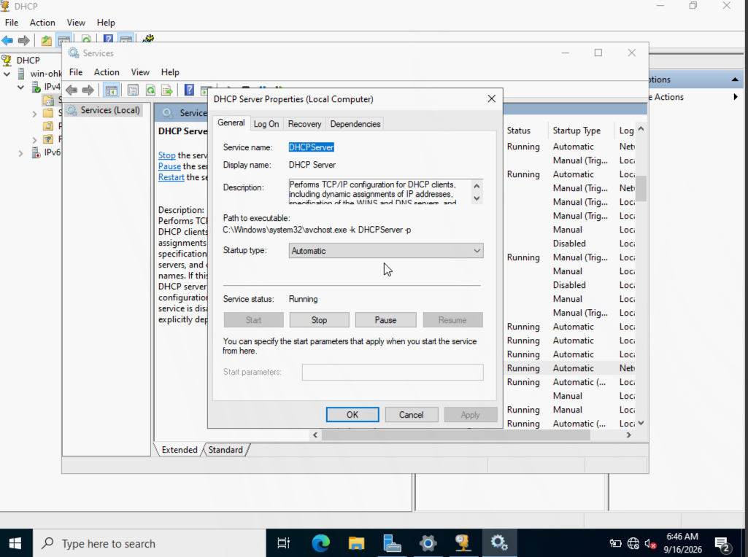
- DHCP Server service, automatic startup
- Create a domain user account to use on the client machine later.
- 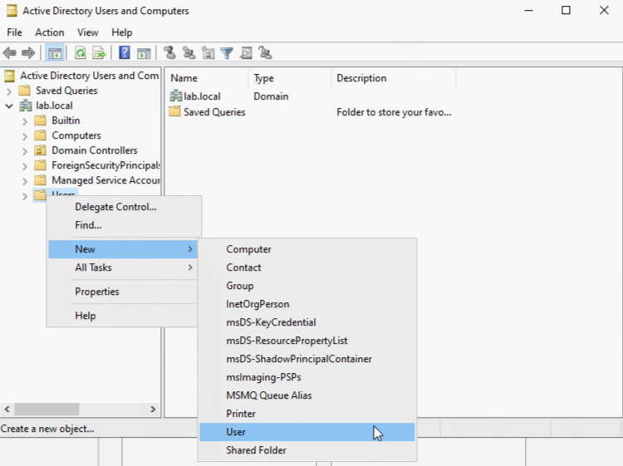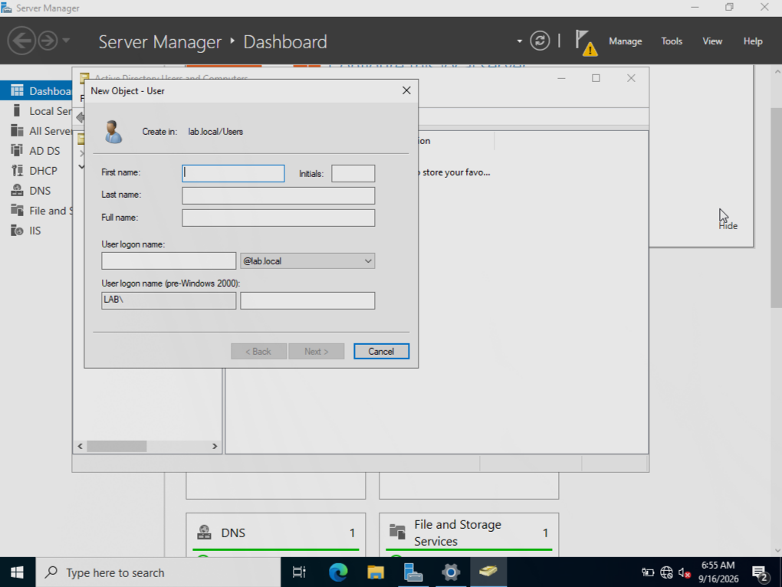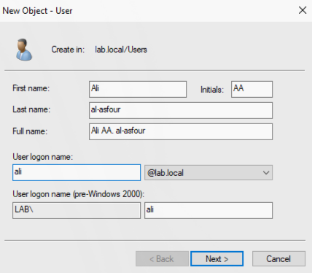

3. Ticketing Server (osTicket on Ubuntu)
- Download Ubuntu Server.
- 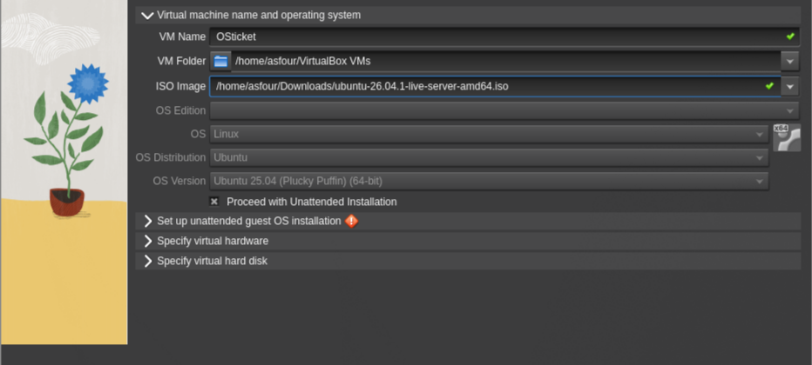
- Ubuntu Server download page
- Create a VM, attach the ISO, give it a name.
- 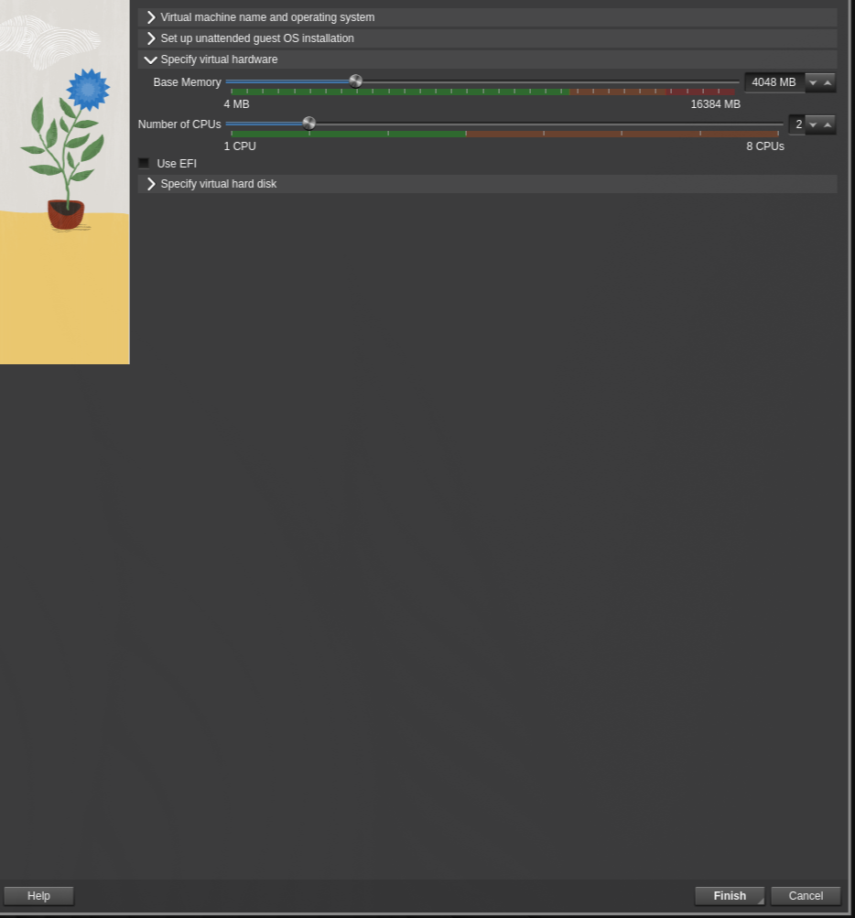
- New VM with ISO attached
- Allocate 4 GB RAM (recommended to avoid lag).
- 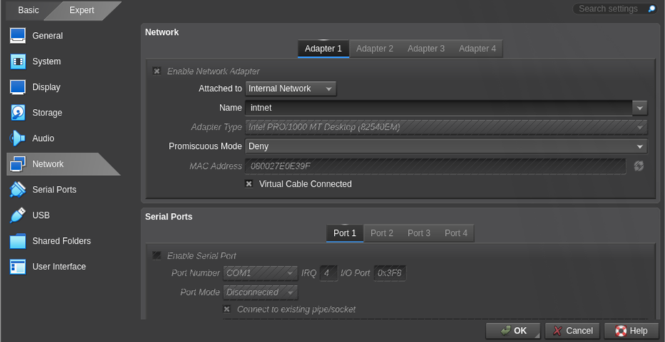
- 4GB RAM allocation
- Make sure the network adapter is connected to the same Internal Network so it can pull a DHCP lease from the DC.
- 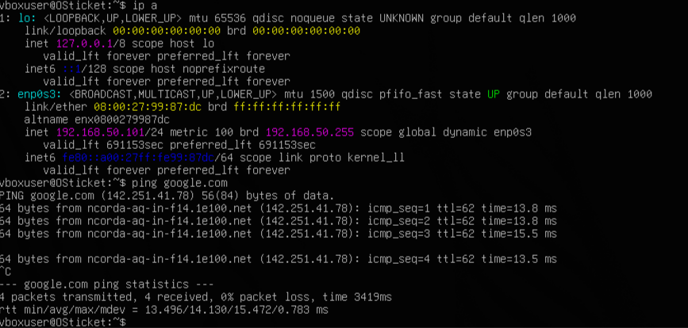
- Network adapter, internal
- After install, confirm it has a DHCP lease and internet connectivity, then update the system:
- sudo apt update && sudo apt upgrade -y
- Install your ticketing platform of choice (e.g. osTicket).

4. Windows Client
- Download the Windows 10 ISO and keep it with the rest of your images/ISOs.
- 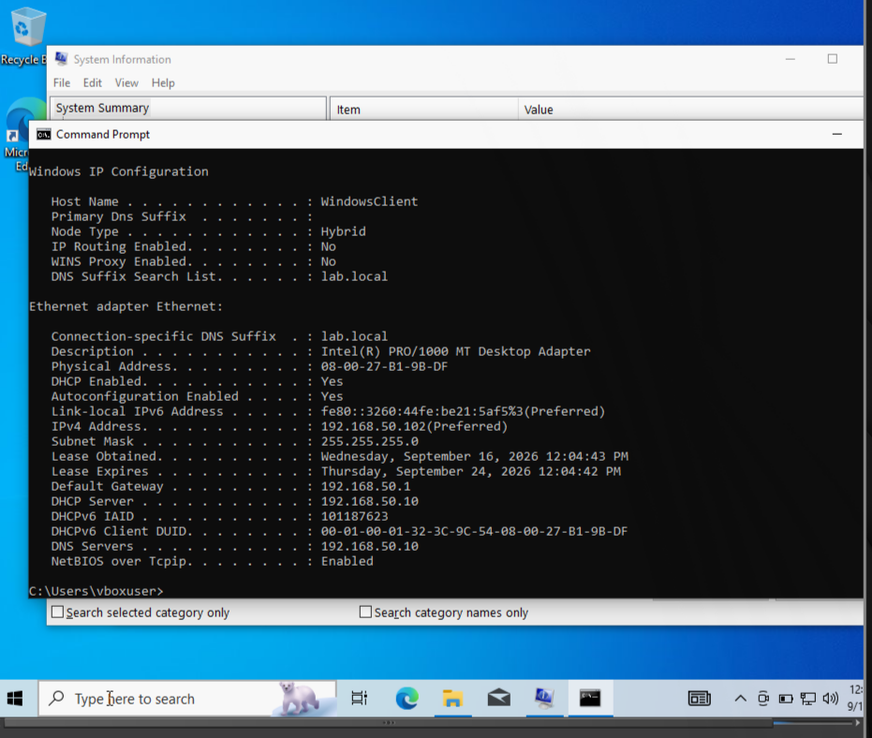
- Windows 10 download
- Create the VM, attach the ISO, confirm it picks up a DHCP lease.
- 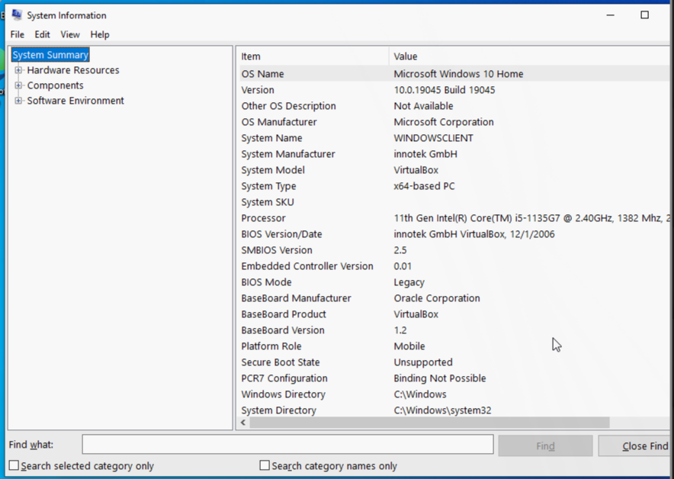
- Checking DHCP lease
- If you end up with a Home edition, upgrade to Pro (Home can’t join an Active Directory domain — only Pro/Enterprise/Education can).
- 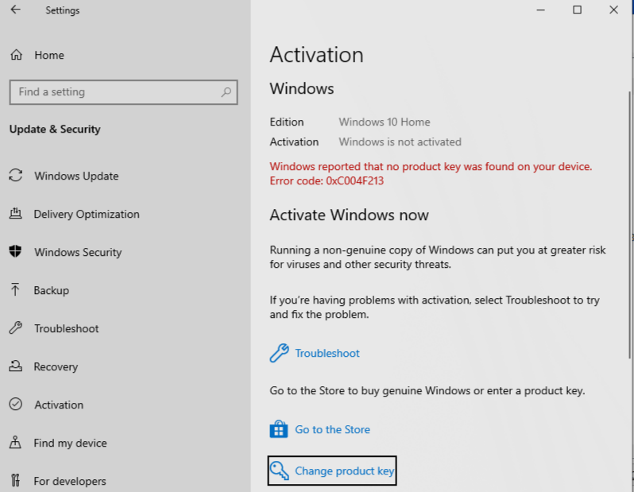
- Home edition, needs upgrade to Pro
- Settings → Update & Security → Activation → Change product key, enter Microsoft’s generic Pro KMS client key and let it reboot:
- VK7JG-NPHTM-C97JM-9MPGT-3V66T
- 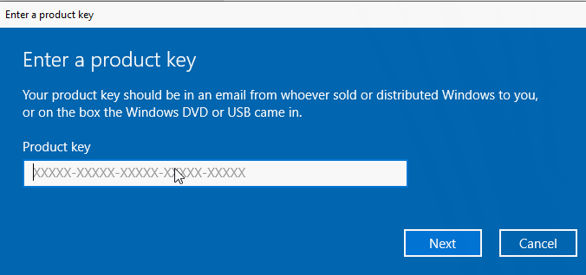
- Changing the product key
- Start the upgrade. This switches the edition to Pro; it still needs a genuine license to fully activate. If it won’t let you upgrade, temporarily disable the network adapter and try again.
- 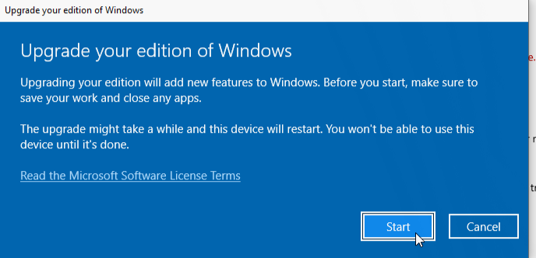
- Starting the upgrade
- 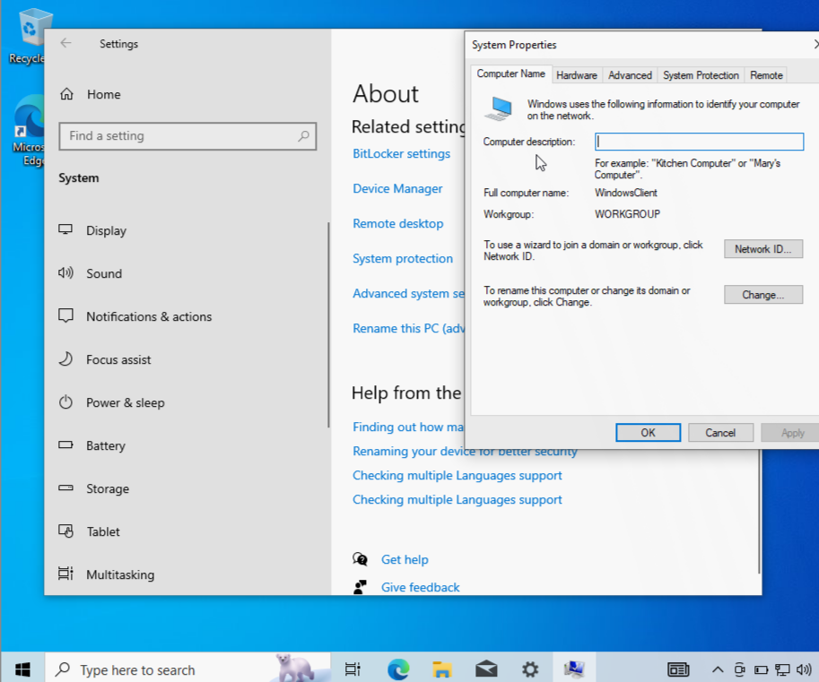
- Retry with network adapter disabled
- Go to Settings → About → Advanced system settings → Computer Name.
- 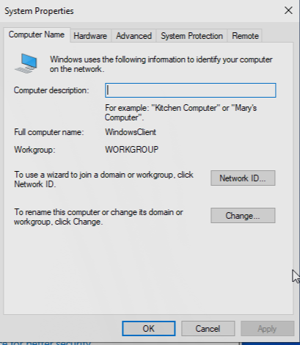
- Advanced system settings
- Click Change.
- 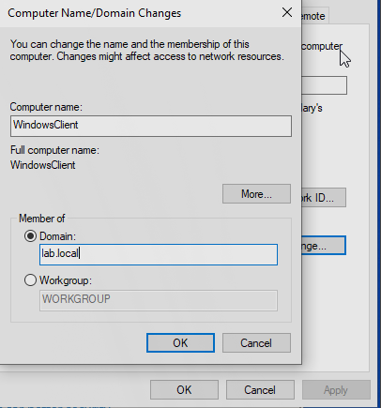
- Change computer name/domain
- Type the domain exactly as configured on the DC: lab.local, then authenticate with the domain user created earlier (e.g. ali@lab.local).
- 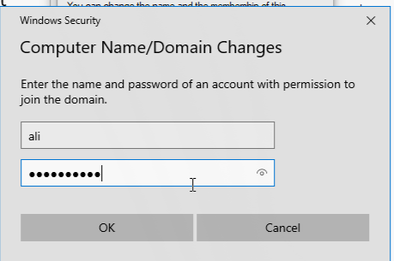
- Joining lab.local

Troubleshooting Notes
- VMs can’t see each other: almost always an Internal Network name mismatch — it’s case- and character-sensitive across every adapter.
- DC shows an APIPA (169.254.x.x) address: normal before DHCP is configured; not an error.
- DHCP scope active but no clients getting leases: the DHCP server is probably unauthorized in AD — right-click it in the DHCP console and choose Authorize.
- Client won’t join the domain: confirm the edition is Pro/Enterprise/Education and that the domain name was typed exactly as lab.local.

