Explainable Artificial Intelligence for Heart Disease Prediction: A Comparative Analysis of SHAP and LIME Using Random Forest Models
Author: Trisha Dasari
Master of Arts in Information Technology Management
Webster University – St Louis, MO, USA
td8m28@gmail.com

ABSTRACT

Heart disease remains one of the leading causes of mortality worldwide, making early diagnosis and accurate risk prediction critical for improving patient outcomes and supporting clinical decision-making. While machine learning (ML) models have demonstrated strong predictive capabilities in healthcare applications, many high-performing models operate as "black boxes," limiting transparency and reducing clinician trust in automated predictions. Explainable Artificial Intelligence (XAI) has emerged as an effective approach for addressing this challenge by providing interpretable explanations of model decisions. This study presents an Explainable AI framework for heart disease prediction using a Random Forest classifier integrated with SHAP (SHapley Additive exPlanations) and LIME (Local Interpretable Model-Agnostic Explanations).

The proposed framework was evaluated using the Heart Disease UCI dataset containing 920 patient records and 16 clinical attributes. Data preprocessing included missing value imputation, categorical feature encoding, and feature engineering, resulting in 21 predictive features for model training. The Random Forest classifier achieved an accuracy of 84.24% and a ROC-AUC score of 0.8363, demonstrating reliable predictive performance. Global model interpretability was achieved using SHAP, which identified exercise-induced angina, ST depression (oldpeak), cholesterol level, maximum heart rate, and age as the most influential predictors of heart disease. Local prediction explanations were generated using LIME to illustrate the contribution of individual clinical features for specific patient predictions.

A comparative analysis of SHAP and LIME highlights their complementary strengths in providing both global and local model explanations, thereby improving transparency and supporting trustworthy AI-assisted clinical decision-making. The findings demonstrate that integrating Explainable AI techniques with machine learning models enhances interpretability without compromising predictive performance, making the proposed framework suitable for healthcare decision support systems and future AI-driven clinical applications.

Keywords – Explainable Artificial Intelligence (XAI), Machine Learning, Random Forest, SHAP, LIME, Heart Disease Prediction, Healthcare Analytics, Clinical Decision Support Systems, Model Interpretability, Medical Decision Support.

I. INTRODUCTION
Artificial Intelligence (AI) has emerged as one of the most transformative technologies in modern healthcare, enabling data-driven clinical decision-making, disease diagnosis, personalized treatment planning, and predictive analytics. The rapid growth of electronic health records (EHRs), wearable health devices, and medical imaging systems has resulted in the generation of vast amounts of healthcare data. Extracting meaningful insights from these data requires advanced analytical techniques capable of identifying complex patterns that may not be apparent through traditional statistical methods. Consequently, AI and Machine Learning (ML) have become essential components of intelligent healthcare systems, supporting clinicians in improving diagnostic accuracy, operational efficiency, and patient outcomes.
Among various healthcare applications, heart disease prediction has received significant research attention due to cardiovascular diseases remaining one of the leading causes of mortality worldwide. According to the World Health Organization (WHO), cardiovascular diseases account for approximately 17.9 million deaths annually, representing nearly one-third of all global deaths. Early identification of patients at risk enables timely intervention, preventive treatment, and improved long-term survival. Machine learning algorithms have demonstrated considerable success in analyzing clinical data to predict heart disease by learning relationships between patient characteristics and disease outcomes. Popular algorithms including Logistic Regression, Decision Trees, Support Vector Machines, Random Forests, Gradient Boosting, and Neural Networks have been widely applied to improve predictive performance in cardiovascular diagnosis.
Among these techniques, the Random Forest classifier has gained widespread acceptance because of its robustness, resistance to overfitting, ability to model nonlinear relationships, and strong performance on structured healthcare datasets. By combining multiple decision trees through ensemble learning, Random Forest improves prediction accuracy while effectively handling noisy and heterogeneous medical data. However, despite achieving high predictive performance, ensemble machine learning models are often criticized for their limited interpretability. Healthcare professionals must understand why a model predicts that a patient is at high risk before incorporating AI recommendations into clinical practice.
This challenge has led to the emergence of Explainable Artificial Intelligence (XAI), a research area dedicated to improving the transparency and interpretability of machine learning models. Unlike conventional "black-box" models that provide predictions without justification, XAI techniques explain how individual features contribute to model decisions, enabling clinicians to understand, validate, and trust AI-generated recommendations. Explainability has become particularly important in healthcare because diagnostic decisions directly affect patient safety, treatment planning, and ethical responsibility. Regulatory frameworks and responsible AI initiatives increasingly emphasize transparency, fairness, accountability, and human oversight when deploying AI systems in clinical environments.
Among the most widely adopted XAI techniques are SHapley Additive exPlanations (SHAP) and Local Interpretable Model-Agnostic Explanations (LIME). SHAP, based on cooperative game theory, quantifies the contribution of each feature to a model's prediction and provides both global and local explanations of model behavior. LIME, in contrast, explains individual predictions by constructing an interpretable local surrogate model around a specific instance. These complementary techniques enable researchers and healthcare professionals to analyze overall feature importance while also understanding the reasoning behind predictions for individual patients. Their combined use has significantly advanced transparency and trustworthiness in AI-assisted healthcare systems.
Explainable AI also plays a critical role in Clinical Decision Support Systems (CDSS). Modern CDSS integrate patient information, predictive models, and evidence-based medical knowledge to assist clinicians in diagnosis, risk assessment, and treatment recommendations. Incorporating explainable machine learning models into CDSS enhances physician confidence by providing interpretable evidence alongside predictive outcomes. Rather than replacing clinicians, these systems function as decision-support tools that improve diagnostic consistency, reduce cognitive workload, and facilitate informed medical decisions.
Despite significant progress in AI-assisted healthcare, several challenges remain. Many existing studies primarily focus on maximizing prediction accuracy while giving limited attention to model transparency and explainability. Black-box models often produce highly accurate predictions without providing sufficient justification, limiting their practical adoption in safety-critical environments such as healthcare. Furthermore, many studies evaluate only a single explainability technique, making it difficult to understand the relative strengths and limitations of different XAI approaches in clinical prediction tasks.
Motivated by these challenges, this study proposes an Explainable Artificial Intelligence framework for heart disease prediction using the Heart Disease UCI dataset. A Random Forest classifier is employed to predict the presence of heart disease, while SHAP and LIME are integrated to provide comprehensive global and local explanations of model predictions. The proposed framework emphasizes both predictive performance and interpretability, supporting transparent and trustworthy AI-assisted clinical decision-making.
The primary objectives of this research are as follows:
- To develop a machine learning model for heart disease prediction using the Random Forest algorithm.
- To preprocess and analyze the Heart Disease UCI dataset through exploration data analysis and feature engineering.
- To evaluate model performance using Accuracy, Precision, Recall, F1-score, ROC-AUC, and Confusion Matrix.
- To apply SHAP for identifying globally important clinical features influencing heart disease prediction.
- To apply LIME for explaining individual patient-level predictions.
- Comparing SHAP and LIME based on interpretability, explainability, computational characteristics, and clinical usefulness.
- To demonstrate how Explainable Artificial Intelligence enhances transparency, trust, and decision support in healthcare applications.
The remainder of this paper is organized as follows. Section II reviews the existing literature on machine learning, Explainable AI, and healthcare decision support systems. Section III presents the proposed Explainable AI framework. Section IV describes the research methodology, including data preprocessing, model development, and evaluation procedures. Section V discusses the experimental results and comparative analysis of SHAP and LIME. Finally, Sections VI and VII present the conclusions, future research directions, and potential applications of Explainable AI in intelligent healthcare systems.

II. LITERATURE REVIEW

Artificial Intelligence (AI) has significantly transformed the healthcare sector by enabling intelligent data analysis, predictive modeling, medical image interpretation, disease diagnosis, and clinical decision support. The rapid digitization of healthcare through Electronic Health Records (EHRs), wearable sensors, and hospital information systems has generated large volumes of structured and unstructured medical data. Machine learning algorithms have become essential tools for extracting meaningful knowledge from these datasets, allowing healthcare professionals to identify disease patterns, predict patient outcomes, and improve treatment planning. Recent advances in AI have demonstrated substantial improvements in diagnostic accuracy, operational efficiency, and personalized medicine, making AI one of the most influential technologies in modern healthcare systems [1], [2].

Among various healthcare applications, heart disease prediction remains one of the most extensively studied areas because cardiovascular diseases continue to be the leading cause of mortality worldwide. According to the World Health Organization (WHO), approximately 17.9 million people die annually from cardiovascular diseases, emphasizing the need for early diagnosis and preventive healthcare strategies [3]. Numerous researchers have applied supervised machine learning algorithms—including Logistic Regression, Support Vector Machines (SVM), Decision Trees, Naïve Bayes, Artificial Neural Networks, and ensemble learning methods—to predict heart disease using clinical and demographic attributes [4], [5]. Comparative studies consistently report that ensemble learning algorithms often outperform individual classifiers due to their ability to reduce variance and improve predictive robustness.

Among ensemble techniques, the Random Forest algorithm, introduced by Breiman [6], has become one of the most widely adopted classifiers in healthcare analytics. Random Forest constructs multiple decision trees using bootstrap aggregation (bagging) and random feature selection, combining their outputs to improve classification accuracy and reduce overfitting. Its ability to handle nonlinear relationships, mixed data types, missing values, and high-dimensional datasets make it particularly suitable for medical prediction tasks. Several studies have demonstrated the effectiveness of Random Forest in predicting cardiovascular disease, diabetes, cancer prognosis, and other chronic diseases while maintaining competitive performance compared with deep learning models on structured clinical datasets [5], [7].

Despite achieving high predictive accuracy, many advanced machine learning algorithms including Random Forests, Gradient Boosting Machines, and Deep Neural Networks are often considered black-box models because their internal decision-making processes are difficult for humans to interpret. This lack of transparency presents a major challenge in healthcare, where clinicians must understand the rationale behind AI-generated predictions before integrating them into medical decision-making. Regulatory initiatives and ethical AI frameworks increasingly emphasize the need for transparency, fairness, accountability, and explainability when deploying AI systems in high-risk domains such as medicine [8], [9].

To address these challenges, the field of Explainable Artificial Intelligence (XAI) has emerged as an active area of research. Explainable AI aims to make machine learning models more transparent by providing understandable explanations for model predictions without significantly compromising predictive performance. Unlike traditional black-box approaches, XAI enables clinicians to identify which features most strongly influence predictions, thereby increasing confidence in AI-assisted diagnosis and supporting responsible clinical decision-making [10], [11]. Explainability has become a key requirement for trustworthy AI systems, particularly in healthcare, finance, and autonomous systems where decisions have significant societal consequences.

Among the most influential XAI techniques is SHapley Additive exPlanations (SHAP), proposed by Lundberg and Lee [12]. SHAP is based on cooperative game theory and calculates Shapley values to quantify the contribution of each feature to a prediction. One of SHAP's primary advantages is its ability to provide both global explanations, describing overall model behavior, and local explanations, explaining individual predictions. SHAP also satisfies desirable theoretical properties such as consistency and local accuracy, making it one of the most reliable methods for interpreting complex machine learning models. Consequently, SHAP has been widely adopted in healthcare applications to identify clinically significant predictors and validate machine learning decisions [12], [13].

Another widely used XAI technique is Local Interpretable Model-Agnostic Explanations (LIME), introduced by Ribeiro et al. [14]. Unlike SHAP, which provides both global and local interpretability, LIME focuses on explaining a single prediction by constructing an interpretable surrogate model around a specific instance. This local approximation enables users to understand why a model produces a particular prediction for an individual patient. Because LIME is model agnostic, it can explain predictions generated by virtually any machine learning algorithm. Its intuitive visualization and ease of interpretation have made it particularly valuable in clinical applications where physicians require patient-specific explanations to support diagnosis and treatment decisions [14], [15].

The growing adoption of AI in healthcare has also increased attention toward Trustworthy AI and Responsible AI. Trustworthy AI encompasses principles including transparency, explainability, robustness, fairness, accountability, privacy, and human oversight [8], [9]. The European Commission's Ethics Guidelines for Trustworthy AI emphasize that AI systems deployed in healthcare must remain technically robust while ensuring that medical professionals retain ultimate responsibility for clinical decisions [8]. Similarly, the National Institute of Standards and Technology (NIST) AI Risk Management Framework promotes governance practices that improve the reliability, safety, and transparency of AI applications across critical domains [16]. These frameworks have reinforced the importance of integrating explainability techniques such as SHAP and LIME into machine learning workflows to increase user confidence and regulatory compliance.

Explainable AI has become increasingly important within Clinical Decision Support Systems (CDSS). Modern CDSS combine patient information, predictive analytics, evidence-based medical knowledge, and machine learning algorithms to assist clinicians in diagnosis, risk assessment, and treatment planning. Traditional decision support systems primarily relied on rule-based reasoning, whereas contemporary AI-driven CDSS employ predictive models capable of identifying complex relationships within clinical data. However, the successful adoption of these systems depends not only on predictive performance but also on their ability to justify recommendations in a transparent and understandable manner [17], [18]. Integrating SHAP and LIME into clinical decision support enables healthcare professionals to interpret AI recommendations, validate predictions against clinical expertise, and improve physician trust in intelligent diagnostic systems.

Although previous studies have demonstrated the effectiveness of machine learning and explainable AI independently, comparatively fewer studies have evaluated the complementary use of SHAP and LIME for interpreting Random Forest models in heart disease prediction while systematically analyzing their respective strengths and limitations. This research addresses that gap by developing an Explainable AI framework that combines Random Forest classification with SHAP-based global explanations and LIME-based local explanations. Furthermore, the proposed framework evaluates interpretability, predictive performance, and practical applicability within healthcare decision support, contributing toward the development of transparent and trustworthy AI systems for clinical practice.

III. PROPOSED WORK

This study proposes an Explainable Artificial Intelligence (XAI) framework for heart disease prediction by integrating a Random Forest classifier with two complementary explainability techniques: SHapley Additive exPlanations (SHAP) and Local Interpretable Model-Agnostic Explanations (LIME). The framework is designed to provide not only accurate predictions but also transparent and interpretable explanations that support trustworthy clinical decision-making. The overall workflow of the proposed framework is illustrated in Figure 1.

Figure 1. Proposed Explainable AI Framework for Heart Disease Prediction
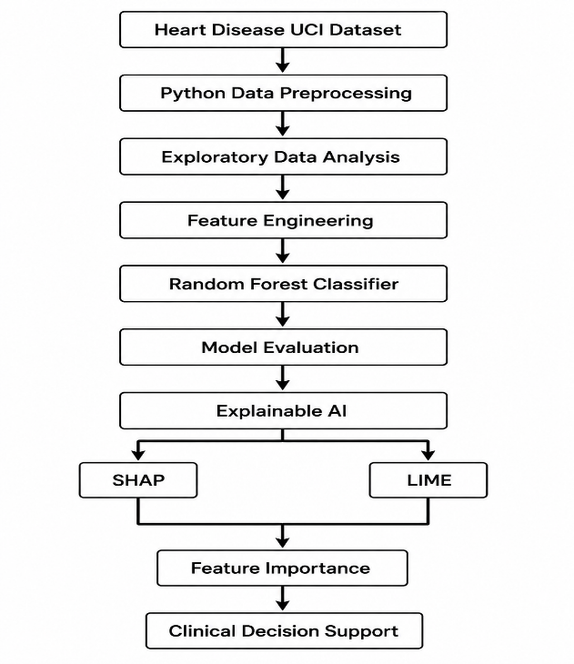

The proposed framework consists of seven sequential stages, beginning with data acquisition and ending with explainable clinical decision support. Each stage contributes to improving the predictive performance and interpretability of the developed machine learning model.

A. Heart Disease UCI Dataset
The framework utilizes the Heart Disease UCI dataset, obtained from the UCI Machine Learning Repository. The dataset contains 920 patient records collected from multiple clinical centers and includes 16 clinical attributes describing patient demographics, physiological measurements, diagnostic indicators, and heart disease status. These attributes include age, sex, resting blood pressure, cholesterol level, chest pain type, fasting blood sugar, electrocardiographic results, maximum heart rate achieved, exercise-induced angina, ST depression, thalassemia, and other clinically relevant variables. The target variable indicates the presence or absence of heart disease and forms the basis for supervised classification.

B. Data Preprocessing and Exploratory Data Analysis
Healthcare datasets often contain missing values, inconsistent formats, and categorical variables that require preprocessing before model development. In this study, missing numerical values were replaced using appropriate statistical imputation techniques, while categorical attributes were imputed using the most frequent category. One-hot encoding was subsequently applied to transform categorical variables into numerical representations suitable for machine learning algorithms.
Exploratory Data Analysis (EDA) was performed to understand the statistical characteristics of the dataset, examine feature distributions, identify missing values, and summarize important clinical variables. Descriptive statistics and data visualization techniques were employed to ensure data quality before model training.

C. Feature Engineering
Following preprocessing, categorical variables were converted into numerical features using one-hot encoding, increasing the total number of predictive variables from 16 original attributes to 21 encoded features. Feature engineering enabled the Random Forest classifier to effectively process categorical clinical information while preserving relevant diagnostic characteristics.

D. Random Forest Classification
The processed dataset was divided into 80% training data and 20% testing data using stratified sampling to preserve class distribution. A Random Forest classifier was then trained using processed clinical features to predict the presence of heart disease.
Random Forest was selected because of its ability to:
- Handle nonlinear relationships among clinical variables.
- Reduce overfitting through ensemble learning.
- Manage heterogeneous healthcare data effectively.
- Provide robust predictive performance with relatively low computational complexity.
- Generate feature importance scores for model interpretation.
The trained classifier produces binary predictions indicating whether a patient is likely to have heart disease.

E. Model Evaluation
The predictive performance of the Random Forest model was evaluated using several widely accepted classification metrics:
- Accuracy
- Precision
- Recall
- F1-score
- Receiver Operating Characteristic – Area Under Curve (ROC-AUC)
- Confusion Matrix
These evaluation metrics provide complementary perspectives on classification performance and allow comprehensive assessment of the model's diagnostic capability.

F. Explainable Artificial Intelligence
To improve transparency and interpretability, the proposed framework incorporates two complementary Explainable AI techniques.
- SHAP (SHapley Additive exPlanations)
SHAP was employed to generate global and local explanations of the Random Forest model. Based on cooperative game theory, SHAP assigns each feature a Shapley value representing its contribution to the final prediction. Global explanations identify the most influential clinical features across the entire dataset, while local explanations reveal how individual features affect predictions for specific patients.
- LIME (Local Interpretable Model-Agnostic Explanations)
LIME was utilized to explain individual predictions by approximating the Random Forest classifier with a locally interpretable linear model. For each selected patient, LIME identifies the clinical features that most strongly influence the predicted outcome, enabling physicians to understand the reasoning behind the model's decision.
The combined use of SHAP and LIME provides comprehensive model interpretability by supporting both dataset-level understanding and patient-specific explanations.

G. Clinical Decision Support
The final stage of the proposed framework integrates predictive modeling with Explainable AI to support clinical decision-making. Rather than functioning as a replacement for medical professionals, the framework acts as a Clinical Decision Support System (CDSS) by providing both prediction results and transparent explanations of the factors influencing those predictions. This enhances physician confidence, facilitates evidence-based diagnosis, and promotes responsible adoption of AI technologies in healthcare environments.
The proposed Explainable AI framework therefore combines robust predictive performance with transparent model interpretation, demonstrating how machine learning and explainability techniques can be integrated to develop trustworthy AI-assisted healthcare systems. By incorporating SHAP and LIME into the diagnostic workflow, the framework improves model transparency while maintaining strong classification performance, making it suitable for future intelligent clinical decision support applications.

IV. METHODOLOGY

This research adopts systematic machine learning and Explainable Artificial Intelligence (XAI) methodology for predicting heart disease while providing transparent explanations of model predictions. The methodology consists of six major stages: dataset acquisition, data preprocessing, feature engineering, machine learning model development, explainability analysis, and performance evaluation. The overall methodology is designed to ensure both predictive accuracy and interpretability, enabling the proposed framework to function as a trustworthy clinical decision support system.

- Dataset
The study utilizes the Heart Disease UCI dataset, one of the most widely used benchmark datasets for cardiovascular disease prediction research. The dataset was obtained from the UCI Machine Learning Repository and contains clinical information collected from multiple healthcare institutions. It consists of 920 patient records with 16 clinical attributes, representing demographic information, physiological measurements, diagnostic test results, and heart disease outcomes.
The dataset includes important clinical variables such as patient age, sex, chest pain type, resting blood pressure, cholesterol level, fasting blood sugar, resting electrocardiographic results, maximum heart rate achieved, exercise-induced angina, ST depression (oldpeak), slope of the ST segment, number of major vessels, thalassemia status, and the target variable indicating the presence or absence of heart disease.
The original target variable contained multiple severity levels ranging from 0 to 4. For this study, the problem was reformulated as a binary classification task, where:
- 0: No Heart Disease
- 1: Presence of Heart Disease
This binary representation is widely adopted in medical prediction studies and simplifies clinical interpretation.
Dataset Characteristics
Attribute | Description
Dataset | Heart Disease UCI
Number of Patients | 920
Original Features | 16
Encoded Features | 21
Prediction Task | Binary Classification
Target Variable | Heart Disease

B. Data Preprocessing
High-quality data preprocessing is essential for developing reliable machine learning models, particularly in healthcare where missing values and categorical variables are common. Several preprocessing steps were performed before model training.
- Missing Value Imputation
The original dataset contained missing values across multiple attributes, including resting blood pressure, cholesterol, fasting blood sugar, maximum heart rate, ST depression, slope, number of major vessels, and thalassemia.
Missing numerical values were replaced using the mean value of the corresponding feature, while missing categorical variables were imputed using the mode (most frequent category). This approach preserves the overall distribution of the data while preventing information loss caused by removing incomplete records.
Following preprocessing, all missing values were successfully eliminated, resulting in a complete dataset suitable for machine learning analysis.
- One-Hot Encoding
Several variables in the dataset, including sex, chest pain type, resting ECG results, slope, thalassemia, and dataset source, were categorical. These variables were transformed into numerical representations using one-hot encoding.
One-hot encoding creates binary indicator variables for each category while preventing the model from assuming ordinal relationships among categorical values. After encoding, the number of predictive features increased from 16 original attributes to 21 machine learning features.
- Feature Engineering
Feature engineering involved selecting relevant variables, removing the identifier column from model training, and generating encoded features through one-hot encoding. The resulting feature matrix preserved clinically significant information while ensuring compatibility with the Random Forest algorithm.
The processed dataset was then divided into independent predictor variables (X) and the target variable (y) for supervised learning.

C. Machine Learning Model
A Random Forest classifier was selected as the predictive model due to its robustness, high predictive performance, and suitability for structured healthcare datasets.
Random Forest is an ensemble learning algorithm that constructs multiple decision trees using bootstrap sampling and random feature selection. The final prediction is determined through majority voting across all decision trees, reducing variance and improving generalization performance.
The processed dataset was partitioned into:
- Training Set: 80% (736 samples)
- Testing Set: 20% (184 samples)
A fixed random state of 42 was used to ensure reproducibility of experimental results.
The Random Forest classifier was configured with 100 decision trees (n_estimators = 100), providing a balance between predictive accuracy and computational efficiency.

D. Explainable Artificial Intelligence
Although Random Forest provides strong predictive performance, it remains difficult to interpret directly because predictions result from the collective decisions of numerous decision trees. To improve model transparency, two complementary Explainable AI techniques were integrated into the framework.
- SHAP (SHapley Additive exPlanations)
SHAP was employed to explain both global model behavior and individual predictions. Based on Shapley values from cooperative game theory, SHAP assigns each feature an importance value that quantifies its contribution to the final prediction.
Two SHAP visualizations were generated:
- SHAP Summary Plot, illustrating feature influence across the entire dataset.
- SHAP Feature Importance Plot, ranking variables according to their average absolute SHAP values.
These visualizations identify the most influential clinical factors contributing to heart disease prediction while providing transparent explanations suitable for healthcare professionals.
- LIME (Local Interpretable Model-Agnostic Explanations)
LIME was applied to explain individual patient predictions generated by the Random Forest classifier. Rather than explaining the complete model, LIME constructs a locally interpretable linear approximation around a selected instance.
For each patient prediction, LIME identifies the clinical variables that positively or negatively influence the prediction outcome. This patient-specific explanation improves physician understanding and facilitates evidence-based clinical decision-making.
The combined use of SHAP and LIME enables both global model interpretability and local prediction explainability, offering complementary perspectives on model behavior.

E. Performance Evaluation
The predictive performance of the proposed framework was evaluated using widely accepted classification metrics for healthcare applications.
Accuracy
Accuracy measures the proportion of correctly classified instances among all predictions and provides an overall assessment of classification performance.
[
Accuracy = \frac{TP + TN}{TP + TN + FP + FN}
]
where:
- TP = True Positives
- TN = True Negatives
- FP = False Positives
- FN = False Negatives
The Random Forest classifier achieved an accuracy of 84.24%.
Precision
Precision evaluates the proportion of positive predictions that are positive.
[
Precision = \frac{TP}{TP + FP}
]
High precision indicates a low false-positive rate.
Recall
Recall, also known as sensitivity, measures the proportion of actual positive cases correctly identified by the classifier.
[
Recall = \frac{TP}{TP + FN}
]
High recall is particularly important in medical diagnosis because missed disease cases may have serious clinical consequences.
F1-Score
The F1-score represents the harmonic mean of precision and recall.
[
F1 = 2 \times \frac{Precision \times Recall}{Precision + Recall}
]
This metric provides a balanced assessment when class distributions are uneven.
Receiver Operating Characteristic – Area Under Curve (ROC-AUC)
ROC-AUC measures the classifier's ability to distinguish between patients with and without heart disease across different classification thresholds.
The proposed Random Forest model achieved a ROC-AUC score of 0.8363, demonstrating strong discrimination capability.
Confusion Matrix
A confusion matrix was also generated to visualize the classification performance by reporting:
- True Positives (TP)
- True Negatives (TN)
- False Positives (FP)
- False Negatives (FN)
The confusion matrix provides a comprehensive understanding of the classifier's prediction behavior and diagnostic reliability.

V. EXPERIMENTAL RESULTS

This section presents the experimental evaluation of the proposed Explainable Artificial Intelligence (XAI) framework for heart disease prediction. The framework combines a Random Forest classifier with SHAP and LIME explainability techniques to achieve both high predictive performance and model transparency. The experiments were conducted using the Heart Disease UCI dataset following the methodology described in Section IV. Performance was assessed through quantitative evaluation metrics and explainability analyses to demonstrate the effectiveness of the proposed framework.

A. Dataset Statistics
The Heart Disease UCI dataset consists of 920 patient records with 16 original clinical attributes. During preprocessing, missing values were successfully handled using statistical imputation techniques, and categorical variables were transformed using one-hot encoding, resulting in 21 predictive features for model training.
The dataset was divided into 80% training data (736 instances) and 20% testing data (184 instances) using stratified sampling to preserve the original class distribution. The binary target variable contains 411 patients without heart disease and 509 patients diagnosed with heart disease, providing a relatively balanced dataset suitable for supervised classification.
Figure 2. Dataset Statistics
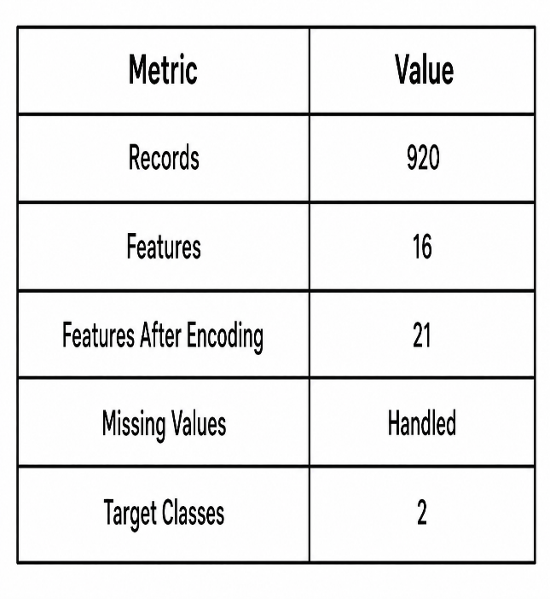
The preprocessing pipeline successfully eliminated all missing values, producing a clean dataset suitable for machine learning analysis. Feature encoding preserved all clinically significant information while enabling compatibility with the Random Forest classifier.

B. Random Forest Feature Importance
Following model training, feature importance scores were extracted from the Random Forest classifier to identify the clinical variables contributing most significantly to heart disease prediction.
The analysis revealed that cholesterol level (chol) was the most influential predictor with an importance score of 0.1339, followed by maximum heart rate achieved (thalach) with 0.1266, age with 0.1145, ST depression (oldpeak) with 0.1033, and exercise-induced angina (exang) with 0.0845. Additional important predictors included resting blood pressure, atypical angina, patient sex, thalassemia status, and non-anginal chest pain.
These findings are clinically meaningful because the identified features are widely recognized cardiovascular risk indicators frequently used by physicians during diagnostic evaluation.

Figure 3. Random Forest Feature Importance
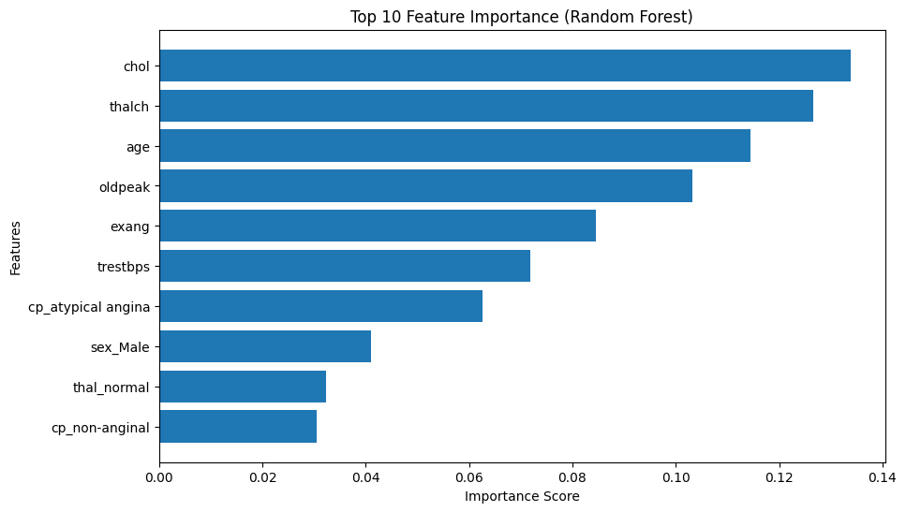
The feature importance visualization demonstrates that the Random Forest classifier primarily relies on established cardiovascular indicators rather than irrelevant variables, supporting the clinical validity of the developed prediction model.

C. SHAP Summary Analysis
To improve model transparency, SHAP (SHapley Additive exPlanations) was employed to analyze the contribution of individual features across the entire dataset.
The SHAP Summary Plot ranks features according to their overall influence on model predictions while simultaneously illustrating how different feature values affect prediction outcomes. Each point represents an individual patient record, where color indicates feature magnitude (red representing higher values and blue representing lower values), and horizontal position represents the corresponding SHAP value.
The analysis identified exercise-induced angina (exang), ST depression (oldpeak), atypical angina, cholesterol, maximum heart rate, and age as the most influential variables affecting model predictions. Higher values of several clinical variables consistently shifted predictions toward heart disease, while lower values generally contributed to non-disease classifications.
Figure 4. SHAP Summary Plot
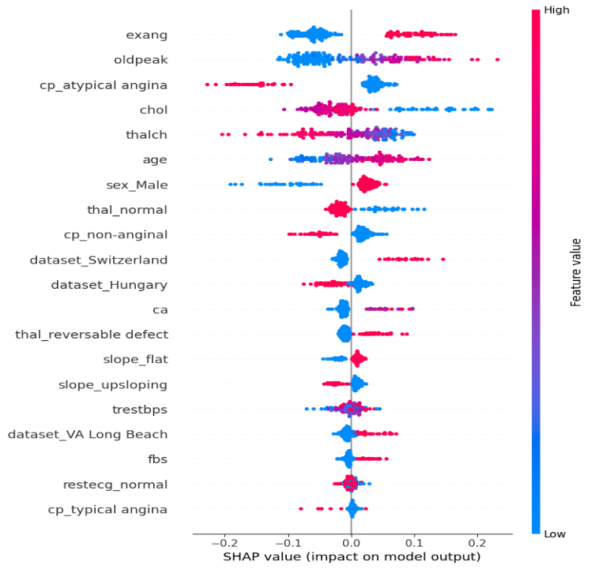
Unlike traditional feature importance methods, SHAP provides both feature ranking and directional influence, enabling clinicians to understand not only which variables are important but also how those variables contribute to disease prediction.

D. SHAP Feature Importance
To complement the SHAP Summary Plot, the mean absolute SHAP values were calculated to generate a global feature importance ranking.
The SHAP Feature Importance Plot confirms that exercise-induced angina, oldpeak, atypical angina, cholesterol, maximum heart rate, and age are consistently the strongest predictors across the dataset. Unlike impurity-based feature importance generated by Random Forest, SHAP quantifies each feature's actual contribution to prediction outcomes, making it more suitable for interpreting complex machine learning models.
Figure 5. SHAP Feature Importance
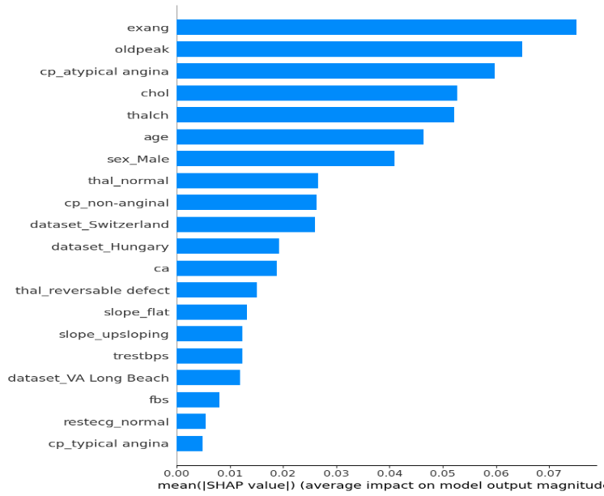
The consistency between Random Forest feature importance and SHAP rankings demonstrates that the developed model captures clinically meaningful relationships while maintaining interpretability.

E. LIME Explanation
Although SHAP provides comprehensive global explanations, physicians frequently require explanations for individual patient predictions. To address this need, Local Interpretable Model-Agnostic Explanations (LIME) was applied.
LIME generates patient-specific explanations by constructing a locally interpretable surrogate model around an individual prediction. The resulting visualization identifies the clinical variables that positively or negatively influenced the predicted outcome for a selected patient.
For the evaluated patient, LIME clearly highlighted the most influential clinical features contributing to the prediction, allowing physicians to verify whether the model's reasoning aligns with established medical knowledge. Such patient-level explanations improve clinician confidence by providing transparent evidence supporting individual diagnostic recommendations.
Figure 6. LIME Explanation for an Individual Prediction
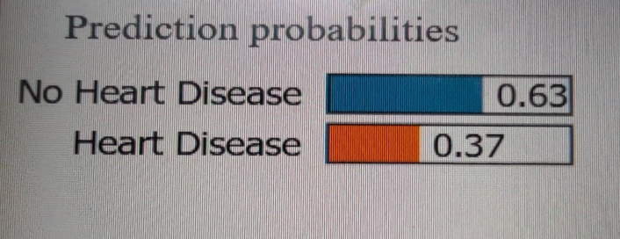
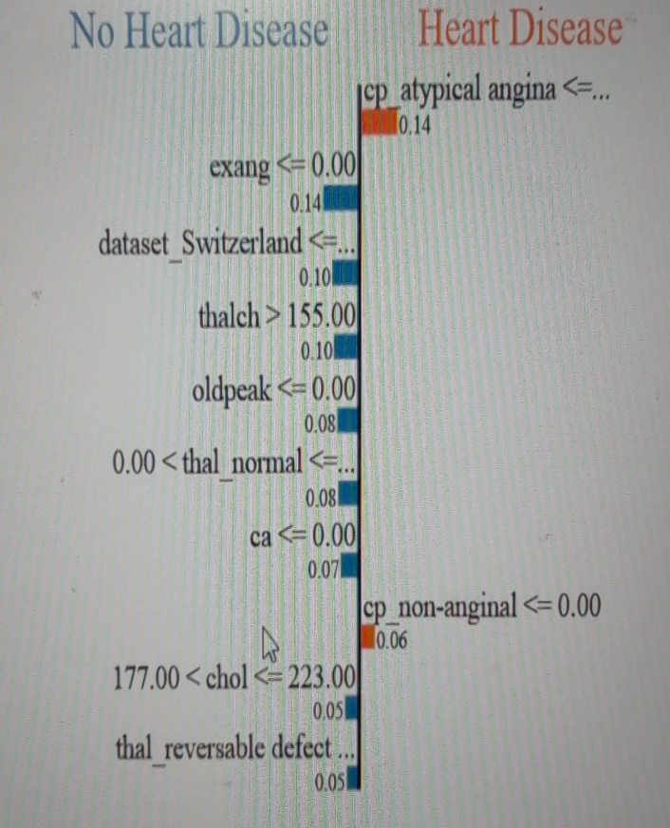
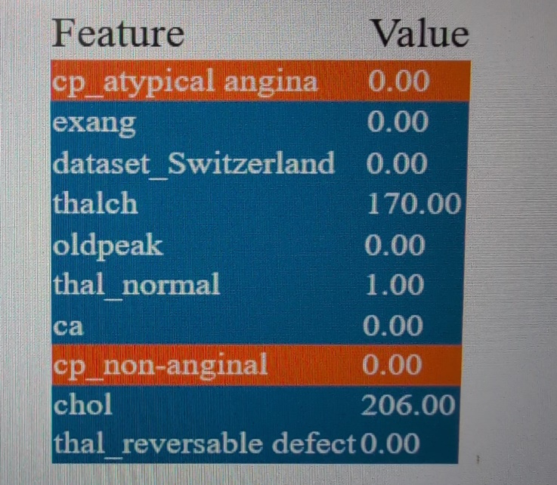

The LIME visualization demonstrates how local explainability complements global interpretability by focusing on patient-specific decision factors rather than overall model behavior.

F. Model Performance Evaluation
The predictive performance of the Random Forest classifier was evaluated using multiple classification metrics.
The developed model achieved an overall classification accuracy of 84.24%, indicating strong predictive capability for heart disease diagnosis. Precision, Recall, and F1-score were all approximately 0.84, demonstrating balanced classification performance across both disease and non-disease classes. Furthermore, the classifier achieved a ROC-AUC score of 0.8363, confirming good discrimination between positive and negative patient cases.
Figure 7. Random Forest Performance Metrics
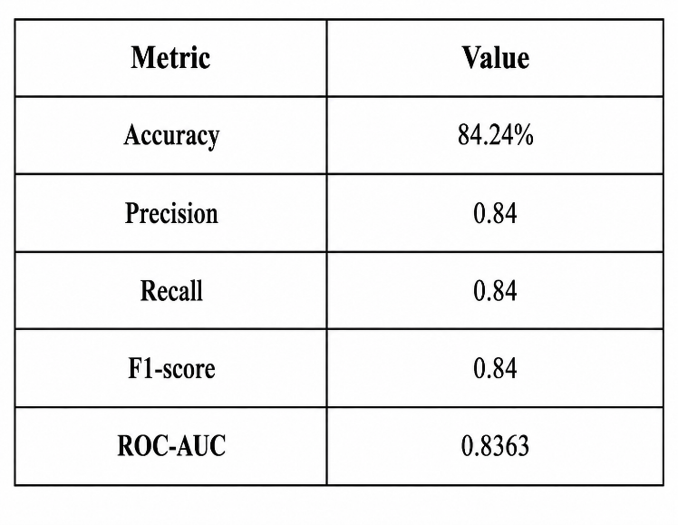
These performance results demonstrate that the Random Forest classifier effectively captures complex relationships among clinical variables while maintaining robust generalization performance.

G. Confusion Matrix
The confusion matrix provides a detailed assessment of classification outcomes.
The model correctly classified:
- 64 patients without heart disease (True Negatives)
- 91 patients with heart disease (True Positives)
Misclassifications included:
- 18 False Positives
- 11 False Negatives
Figure 8. Confusion Matrix
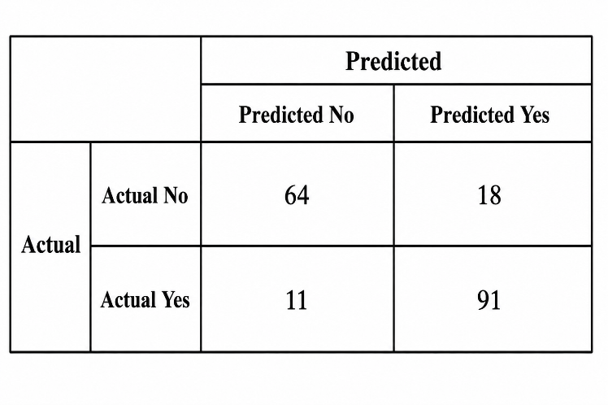
The relatively small number of false negatives is particularly important in healthcare because failing to identify patients with heart disease may delay diagnosis and treatment. The confusion matrix therefore indicates that the proposed model demonstrates satisfactory clinical reliability while maintaining balanced predictive performance.

H. Discussion
The experimental results demonstrate that the proposed Explainable Artificial Intelligence framework effectively combines predictive accuracy with model interpretability. The Random Forest classifier achieved an accuracy of 84.24% and a ROC-AUC score of 0.8363, confirming its suitability for heart disease prediction using structured clinical data. Ensemble learning enabled the model to capture complex nonlinear relationships among patient characteristics while reducing overfitting and maintaining robust performance on unseen data.
The SHAP analyses provided valuable global insights into model behavior by identifying exercise-induced angina, ST depression (oldpeak), cholesterol level, maximum heart rate, and age as the most influential predictors. These findings are consistent with established cardiovascular risk factors reported in clinical literature, demonstrating that the model's predictions are medically plausible rather than relying on spurious correlations.
LIME complemented SHAP by generating patient-specific explanations. Unlike SHAP's global perspective, LIME illustrated how individual clinical variables contributed to a single patient's prediction. Such local explanations enhance physician confidence by providing transparent reasoning that can be compared directly with clinical observations and diagnostic expertise.
From a clinical perspective, integrating SHAP and LIME into the prediction pipeline substantially improves the practical usability of machine learning models. Rather than presenting clinicians with unexplained predictions, the proposed framework provides interpretable evidence supporting each recommendation. This transparency promotes greater trust in AI-assisted diagnosis and aligns with current principles of Responsible AI and Explainable AI in healthcare.

VI. COMPARATIVE ANALYSIS

Explainable Artificial Intelligence (XAI) techniques play a crucial role in increasing the transparency and trustworthiness of machine learning models, particularly in healthcare applications where diagnostic decisions directly impact patient outcomes. In this study, two widely adopted explainability methods: SHapley Additive exPlanations (SHAP) and Local Interpretable Model-Agnostic Explanations (LIME) were applied to interpret the predictions of the Random Forest classifier. Although both techniques improve model interpretability, they differ significantly in their underlying methodology, computational requirements, and practical applications.
Table 3 summarizes the comparative characteristics of SHAP and LIME.

Table 3. Comparison of SHAP and LIME
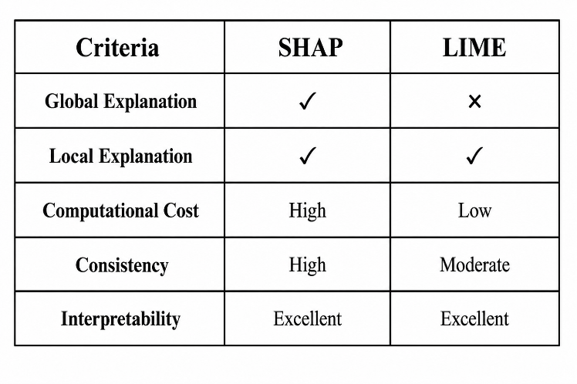A. Global Explanations
One of the major strengths of SHAP is its ability to provide global explanations of machine learning models. By computing Shapley values across the entire dataset, SHAP identifies the overall importance of each feature and quantifies its average contribution to model predictions. This enables researchers and healthcare professionals to understand the general behavior of the predictive model and identify the most influential clinical variables affecting heart disease diagnosis.
In contrast, LIME is designed primarily for local interpretation and does not provide a comprehensive global view of model behavior. While feature importance can be approximated by aggregating multiple LIME explanations, it is not inherently intended for global analysis. Therefore, SHAP is more appropriate for understanding dataset-wide feature influence and validating model behavior at the population level.

B. Local Explanations
Both SHAP and LIME can explain individual predictions; however, they achieve this objective using different approaches.
SHAP calculates exact or approximate Shapley values derived from cooperative game theory, ensuring mathematically consistent feature contributions for individual predictions. These explanations remain stable across similar observations and satisfy important theoretical properties such as local accuracy and consistency.
LIME generates local explanations by constructing an interpretable surrogate model around a selected prediction. It identifies the features that most strongly influence the prediction for a specific patient without attempting to explain the overall model. This makes LIME particularly valuable for clinicians who require patient-specific reasoning during diagnosis.
Consequently, SHAP offers both global and local interpretability, whereas LIME specializes in explaining individual predictions.

C. Interpretability
Interpretability is essential for increasing clinician confidence in AI-assisted healthcare systems. Both SHAP and LIME improve transparency by identifying the clinical variables responsible for model predictions.
SHAP provides richer interpretability by quantifying the magnitude and direction of each feature's contribution. The SHAP Summary Plot and SHAP Feature Importance Plot enable physicians to understand how high or low feature values influence disease prediction across the entire patient population.
LIME focuses on simplicity and ease of interpretation. Its intuitive visualizations highlight positive and negative contributions for individual patients, making explanations easier for clinicians without advanced machine learning expertise.
Although both techniques are highly interpretable, SHAP provides more comprehensive explanations, while LIME offers straightforward patient-level insights.

D. Computational Cost
Computational efficiency represents another important distinction between the two explainability techniques.
SHAP requires computation of Shapley values, which can be computationally expensive, particularly for large datasets or complex machine learning models. Although optimized implementations such as TreeSHAP significantly reduce computational complexity for tree-based models, SHAP generally requires greater computational resources than LIME.
LIME generates explanations by fitting a local surrogate model around a selected prediction, making it computationally less demanding for individual instances. Because explanations are generated independently for each prediction, LIME is generally faster for explaining single patient cases.
Therefore, SHAP offers more comprehensive explanations at the expense of higher computational cost, whereas LIME provides faster local explanations suitable for interactive clinical applications.

E. Practical Use in Healthcare
Healthcare applications require machine learning models that are both accurate and transparent. Explainability is essential because physicians must understand the rationale behind AI-generated recommendations before incorporating them into clinical decision-making.
SHAP is particularly valuable for model validation, feature importance analysis, and population-level clinical research. It enables healthcare organizations to verify that predictive models rely on medically meaningful variables rather than spurious correlations. Consequently, SHAP supports regulatory compliance, model auditing, and clinical research studies.
LIME is more suitable for patient-specific clinical decision support. By explaining individual predictions, LIME enables physicians to review the clinical factors influencing a particular diagnosis and compare AI recommendations with their own medical expertise. This capability enhances physician confidence and facilitates informed patient consultations.
The complementary strengths of SHAP and LIME suggest that both techniques should be used together in Explainable AI frameworks. SHAP provides a comprehensive understanding of overall model behavior, while LIME offers detailed explanations for individual patient predictions. Their combined use improves transparency, supports trustworthy AI, and enhances the practical applicability of machine learning models in healthcare environments.

Overall, the comparative analysis demonstrates that SHAP is the preferred technique for global model interpretation and feature importance analysis, whereas LIME excels in providing intuitive explanations for individual predictions. Integrating both approaches within the proposed framework results in a more transparent, interpretable, and clinically useful Explainable AI system for heart disease prediction.

VII. CONCLUSION

This study presented an Explainable Artificial Intelligence (XAI) framework for heart disease prediction by integrating a Random Forest classifier with two state-of-the-art explainability techniques, SHapley Additive exPlanations (SHAP) and Local Interpretable Model-Agnostic Explanations (LIME). The primary objective of the proposed framework was to develop a predictive model that not only achieves strong classification performance but also provides transparent and interpretable explanations to support trustworthy healthcare decision-making.

The proposed methodology was evaluated using the Heart Disease UCI dataset, comprising 920 patient records with 16 clinical attributes. Following data preprocessing, missing value imputation, and one-hot encoding, the dataset was transformed into 21 predictive features suitable for machine learning analysis. A Random Forest classifier was trained using an 80:20 train-test split and achieved an accuracy of 84.24%, with balanced Precision, Recall, and F1-score values of approximately 0.84, as well as a ROC-AUC score of 0.8363. These results demonstrate that the proposed model provides reliable predictive performance for binary heart disease classification while maintaining strong generalization capability.

Beyond predictive accuracy, this research emphasized the importance of model interpretability in healthcare. The SHAP analysis successfully identified the most influential clinical variables affecting heart disease prediction, including exercise-induced angina, ST depression (oldpeak), cholesterol level, maximum heart rate achieved, and age. The SHAP Summary Plot and SHAP Feature Importance Plot provided comprehensive global explanations of model behavior, allowing clinicians and researchers to understand how these variables influence prediction outcomes across the entire patient population.

To complement the global insights provided by SHAP, LIME was employed to explain individual patient predictions. The generated local explanations clearly illustrate how specific clinical features contributed positively or negatively to the predicted diagnosis for each patient. These patient-level explanations improve clinician confidence by providing transparent reasoning that can be directly compared with clinical observations and medical expertise.
The comparative analysis of SHAP and LIME demonstrated that the two explainability techniques provide complementary strengths. SHAP offers consistent global and local explanations supported by strong theoretical foundations, making it well suited for feature importance analysis, model validation, and clinical research. In contrast, LIME provides intuitive local explanations that are particularly valuable for explaining individual patient predictions during clinical consultations. Their combined use significantly enhances the transparency and interpretability of machine learning models without compromising predictive performance.

From a healthcare perspective, the proposed Explainable AI framework contributes toward the development of trustworthy Clinical Decision Support Systems (CDSS). Rather than replacing clinicians, the framework serves as an intelligent decision-support tool by combining accurate predictions with understandable explanations. This transparency enables physicians to validate AI recommendations, identify influential clinical factors, and make more informed diagnostic decisions. Such capabilities align closely with current principles of Responsible AI, Explainable AI, and trustworthy healthcare systems, which emphasize transparency, accountability, fairness, and human oversight.

Overall, the findings demonstrate that integrating Explainable Artificial Intelligence with machine learning models significantly improves the practical applicability of predictive analytics in healthcare. The combination of Random Forest, SHAP, and LIME provides a robust, interpretable, and clinically meaningful framework for heart disease prediction. As AI continues to transform modern healthcare, the adoption of transparent and explainable models will play an increasingly important role in supporting evidence-based clinical practice, strengthening physician trust, and promoting the responsible deployment of intelligent healthcare technologies.

VIII. FUTURE SCOPE

The rapid advancement of Artificial Intelligence (AI) and Explainable Artificial Intelligence (XAI) presents numerous opportunities for enhancing intelligent healthcare systems. While the proposed framework demonstrated strong predictive performance and improved interpretability using a Random Forest classifier integrated with SHAP and LIME, several promising research directions remain for further improving both prediction accuracy and clinical applicability.
One important direction is the evaluation of advanced ensemble learning algorithms such as Extreme Gradient Boosting (XGBoost), CatBoost, and LightGBM. These gradient boosting techniques have consistently demonstrated superior performance across various structured healthcare datasets by effectively handling nonlinear feature interactions, missing values, and class imbalance. Future studies should compare these algorithms with Random Forest to determine whether they can further improve heart prediction while maintaining interpretability through Explainable AI techniques.

Another promising research direction involves the application of Deep Learning models for cardiovascular disease prediction. Architectures such as Artificial Neural Networks (ANNs), Deep Neural Networks (DNNs), Convolutional Neural Networks (CNNs), and Transformer-based models have shown remarkable performance in complex medical prediction tasks. Combining deep learning with explainability techniques such as SHAP, Integrated Gradients, and attention visualization may enable the development of highly accurate yet interpretable diagnostic systems capable of processing large-scale multimodal healthcare data.

The emergence of Large Language Models (LLMs) also creates significant opportunities for intelligent healthcare applications. Future research may investigate GPT-based Clinical Assistants capable of summarizing patient records, interpreting explainability results, assisting physicians during diagnosis, answering clinical questions, and generating evidence-based recommendations. Integrating predictive machine learning models with conversational AI could significantly enhance clinician productivity and improve healthcare decision support.

Another important area is the integration of Retrieval-Augmented Generation (RAG) techniques into clinical decision support systems. RAG combines LLMs with external medical knowledge bases, allowing AI systems to retrieve current clinical guidelines, research publications, and evidence-based recommendations before generating responses. Such systems can provide more reliable and context-aware clinical explanations while reducing hallucination and improving factual accuracy.

Future intelligent healthcare systems may also benefit from Multi-Agent AI Systems, where multiple specialized AI agents collaborate to perform different clinical tasks. For example, one agent may perform disease prediction, another may generate SHAP-based explanations, another may retrieve relevant medical literature, while a separate agent assists clinicians through natural language interaction. Coordinated multi-agent architectures have the potential to improve scalability, robustness, and decision quality in complex healthcare environments.

Privacy-preserving machine learning represents another critical direction for future research. Federated Learning enables machine learning models to be trained collaboratively across multiple hospitals and healthcare institutions without requiring the exchange of sensitive patient data. By allowing institutions to share model updates rather than raw clinical records, federated learning supports regulatory compliance while improving model generalization across diverse patient populations. Combining Federated Learning with Explainable AI could facilitate trustworthy and privacy-preserving healthcare analytics.

As Large Language Models become increasingly integrated into healthcare, future research should also investigate Explainable Large Language Models (XLLMs) capable of providing transparent reasoning behind generated clinical recommendations. Current LLMs often produce highly capable outputs but offer limited insight into their internal reasoning processes. Developing explainability techniques specifically for LLM-based clinical assistants will be essential for increasing physician trust, regulatory acceptance, and safe deployment within healthcare environments.

Additional research may explore multimodal healthcare datasets that combine structured clinical records with medical imaging, genomic information, laboratory reports, wearable sensor data, and physician notes. Such multimodal Explainable AI frameworks could provide more comprehensive patient assessments while improving diagnostic accuracy and personalized treatment recommendations.

Finally, future studies should validate the proposed framework using larger and more diverse clinical datasets collected from multiple healthcare institutions. External validation, prospective clinical studies, and physician-centered usability evaluations will be necessary to assess the real-world effectiveness of Explainable AI systems in routine clinical practice. Incorporating human-centered evaluation metrics, fairness analysis, and Responsible AI principles will further strengthen the reliability and ethical deployment of AI-assisted Clinical Decision Support Systems.

IX. REFERENCES

[1] E. J. Topol, Deep Medicine: How Artificial Intelligence Can Make Healthcare Human Again. New York, NY, USA: Basic Books, 2019.
[2] A. Esteva et al., “A guide to deep learning in healthcare,” Nature Medicine, vol. 25, no. 1, pp. 24–29, 2019.
[3] World Health Organization, “Cardiovascular diseases (CVDs),” 2023. Available: https://www.who.int/news-room/fact-sheets/detail/cardiovascular-diseases-(cvds)
[4] D. Dua and C. Graff, “UCI Machine Learning Repository,” University of California, Irvine, School of Information and Computer Sciences, 2019. Available: https://archive.ics.uci.edu/
[5] S. Mohan, C. Thirumalai, and G. Srivastava, “Effective heart disease prediction using hybrid machine learning techniques,” IEEE Access, vol. 7, pp. 81542–81554, 2019.
[6] L. Breiman, “Random forests,” Machine Learning, vol. 45, no. 1, pp. 5–32, 2001.
[7] T. Chen and C. Guestrin, “XGBoost: A scalable tree boosting system,” in Proc. ACM SIGKDD, 2016, pp. 785–794.
[8] European Commission, Ethics Guidelines for Trustworthy AI, Brussels, Belgium, 2019.
[9] OECD, “OECD Principles on Artificial Intelligence,” Paris, France, 2019.
[10] D. Gunning and D. Aha, “DARPA's Explainable Artificial Intelligence (XAI) Program,” AI Magazine, vol. 40, no. 2, pp. 44–58, 2019.
[11] A. Adadi and M. Berrada, “Peeking inside the black-box: A survey on Explainable Artificial Intelligence (XAI),” IEEE Access, vol. 6, pp. 52138–52160, 2018.
[12] S. M. Lundberg and S.-I. Lee, “A unified approach to interpreting model predictions,” in Advances in Neural Information Processing Systems (NeurIPS), 2017.
[13] S. M. Lundberg et al., “Explainable machine-learning predictions for the prevention of hypoxaemia during surgery,” Nature Biomedical Engineering, vol. 2, pp. 749–760, 2018.
[14] M. T. Ribeiro, S. Singh, and C. Guestrin, “Why should I trust you? Explaining the predictions of any classifier,” in Proc. ACM SIGKDD, 2016, pp. 1135–1144.
[15] C. Molnar, Interpretable Machine Learning, 2nd ed., 2022. Available: https://christophm.github.io/interpretable-ml-book/
[16] National Institute of Standards and Technology (NIST), Artificial Intelligence Risk Management Framework (AI RMF 1.0), Gaithersburg, MD, USA, 2023.
[17] E. H. Shortliffe and J. J. Cimino, Biomedical Informatics: Computer Applications in Health Care and Biomedicine, 4th ed. Springer, 2014.
[18] R. S. Sutton et al., “An overview of clinical decision support systems: Benefits, risks, and strategies for success,” NPJ Digital Medicine, vol. 3, no. 17, 2020.
[19] D. Silver et al., “Mastering the game of Go with deep neural networks and tree search,” Nature, vol. 529, pp. 484–489, 2016.
[20] C. Rudin, “Stop explaining black box machine learning models for high stakes decisions and use interpretable models instead,” Nature Machine Intelligence, vol. 1, no. 5, pp. 206–215, 2019.

