Comparative Evaluation of Large Language Models for Enterprise Business Decision Support: An Empirical Analysis of ChatGPT, Gemini, and Claude
Author: Trisha Dasari
Master of Arts in Information Technology Management
Webster University – St Louis, MO, USA
3shadas@gmail.com

ABSTRACT

Large Language Models (LLMs) have emerged as powerful tools for enterprise decision support by generating analytical insights, summarizing business information, and providing strategic recommendations from structured and unstructured data. However, differences in reasoning capabilities, numerical accuracy, and evidence-based decision-making across LLMs remain an important research challenge for organizations seeking to integrate AI into business analytics. This study presents a comparative evaluation of three leading Large Language Models—ChatGPT (GPT-5.5), Google Gemini 3.6 Flash, and Claude Sonnet—for enterprise business decision support. The Tableau Sample Superstore dataset containing 9,994 retail transactions and 21 business attributes was analyzed using Python to generate a standardized business summary.

An identical evaluation prompt was then provided to each LLM to ensure a fair and reproducible comparison. The generated executive reports were evaluated using qualitative and quantitative criteria, including business understanding, numerical accuracy, evidence-based reasoning, hallucination resistance, handling of missing information, executive readability, actionable recommendations, and quantitative analysis. The experimental results demonstrate that all three models produced accurate, evidence-based business analyses while appropriately acknowledging data limitations. ChatGPT generated concise and highly readable executive reports with balanced recommendations. Gemini demonstrated strong quantitative reasoning by deriving additional business metrics, including profit margins, revenue contributions, and regional performance percentages. Claude produced the most comprehensive analysis by combining detailed numerical validation, structured executive communication, and extensive evidence-based recommendations. Overall, the findings indicate that standardized evaluation methodologies enable objective comparison of LLM capabilities and highlight the growing potential of generative AI for enterprise analytics and decision support. This research contributes to the understanding of LLM performance in business intelligence applications and provides a practical evaluation framework for selecting appropriate AI models for organizational decision-making.

Keywords - Large Language Models (LLMs), Business Decision Support, Enterprise Analytics, Business Intelligence, ChatGPT, Google Gemini, Claude, Comparative Evaluation, Prompt Engineering, Generative Artificial Intelligence, Executive Decision Support, Business Analytics.

I. INTRODUCTION

The rapid advancement of Large Language Models (LLMs) has transformed the field of Artificial Intelligence (AI), enabling machines to perform sophisticated natural language understanding, reasoning, content generation, and analytical tasks across diverse domains. Recent breakthroughs in generative AI have demonstrated that LLMs are capable of interpreting structured and unstructured information, generating human-like responses, summarizing complex documents, and supporting decision-making processes. Consequently, organizations are increasingly exploring the integration of LLMs into enterprise environments to improve operational efficiency, accelerate data-driven decision-making, and enhance business intelligence capabilities.

One of the most promising applications of Large Language Models is enterprise business decision support. Modern organizations generate enormous volumes of business data through sales transactions, customer interactions, financial reports, supply chain operations, and market analytics. Although Business Intelligence (BI) platforms and data visualization tools provide valuable insights, business leaders often require executive-level interpretations and strategic recommendations rather than raw analytical outputs. Large Language Models bridge this gap by converting structured business information into understandable narratives, identifying performance trends, highlighting risks, and generating actionable recommendations for executive decision-makers.

Enterprise Decision Support Systems (DSS) have traditionally relied on statistical analysis, dashboards, and rule-based expert systems to assist managers in strategic planning and operational decision-making. While these approaches effectively summarize historical business performance, they generally require substantial human interpretation before meaningful business actions can be formulated. The emergence of generative AI enables Decision Support Systems to evolve beyond descriptive analytics by automatically producing context-aware business analyses, executive summaries, and strategic recommendations. This capability has significant implications for business intelligence, financial analysis, operational planning, and organizational decision support.

Despite the remarkable capabilities of modern LLMs, significant differences exist in their reasoning strategies, numerical interpretation, communication style, and evidence-based decision-making. Models developed by different organizations often produce varying recommendations even when provided with identical business information. Some models emphasize concise executive communication, while others generate detailed analytical reasoning or extensive quantitative insights. Furthermore, the ability of LLMs to correctly interpret numerical business data, avoid unsupported conclusions, and appropriately acknowledge missing information is particularly important in enterprise environments where inaccurate recommendations may lead to poor strategic decisions.

As organizations increasingly adopt generative AI for business applications, systematic evaluation of Large Language Models has become essential. Comparative benchmarking enables researchers and practitioners to assess model performance across multiple evaluation dimensions, including business understanding, factual accuracy, numerical reasoning, evidence usage, hallucination resistance, readability, and recommendation quality. Standardized evaluation methodologies also improve reproducibility and support informed selection of appropriate AI models for enterprise deployment.

Prompt engineering has emerged as another critical factor influencing the quality of LLM-generated responses. The wording, structure, and constraints included within prompts significantly affect reasoning quality and factual consistency. Previous studies have demonstrated that carefully designed prompts improve transparency, reduce hallucination, and produce more reliable AI-generated outputs. However, relatively few studies have compared multiple commercial Large Language Models using identical business summaries and standardized prompts, making objective performance comparisons challenging.

This research addresses that gap by conducting a comparative evaluation of ChatGPT (GPT-5.5), Google Gemini 3.6 Flash, and Claude Sonnet using a standardized business analytics task. The Tableau Sample Superstore dataset, containing 9,994 retail transactions and 21 business attributes, was analyzed using Python to generate a consistent business summary. The same executive evaluation prompt was then provided to each model, ensuring that all LLMs received identical information and instructions. The responses generated were subsequently evaluated using predefined qualitative and quantitative criteria to measure business understanding, numerical accuracy, evidence-based reasoning, hallucination resistance, executive readability, actionable recommendations, and overall decision-support quality.

Unlike previous research that primarily focuses on benchmarking language understanding or general reasoning tasks, this study emphasizes the practical application of LLMs in enterprise business analytics and executive decision support. By evaluating how different models interpret identical business information, the research provides valuable insights into their respective strengths, limitations, and suitability for organizational use. The findings contribute to the growing body of knowledge on generative AI in business intelligence while providing a practical framework for evaluating Large Language Models in enterprise environments.

The primary objectives of this research are as follows:
- To perform exploration data analysis on the Tableau Sample Superstore dataset using Python.
- To generate a standardized business summary for enterprise decision support.
- To evaluate the performance of ChatGPT (GPT-5.5), Google Gemini 3.6 Flash, and Claude Sonnet using an identical evaluation prompt.
- To compare the models based on business understanding, numerical accuracy, evidence-based reasoning, hallucination resistance, executive readability, actionable recommendations, and quantitative analysis.
- To identify the strengths and limitations of each Large Language Model for business analytics applications.
- To develop a reproducible evaluation framework for comparing Large Language Models in enterprise decision-support scenarios.

II. LITERATURE REVIEW

The rapid advancement of Large Language Models (LLMs) has significantly transformed the fields of Artificial Intelligence (AI), Natural Language Processing (NLP), and enterprise analytics. Recent developments in transformer-based architectures have enabled LLMs to perform sophisticated reasoning, information synthesis, content generation, and decision-support tasks across various industries. Consequently, researchers have increasingly investigated the application of LLMs in business intelligence, enterprise decision support, and executive analytics. This section reviews existing literature on enterprise Decision Support Systems, Large Language Models, prompt engineering, business analytics, Responsible AI, and comparative evaluation methodologies.
A. Enterprise Decision Support Systems
Decision Support Systems (DSS) have long been recognized as essential tools for assisting managers in solving semi-structured and unstructured business problems. Power [1] describes DSS as interactive computer-based systems that combine data, analytical models, and user knowledge to improve organizational decision-making. Traditional DSS rely on databases, statistical analysis, optimization models, and visualization tools to support strategic planning and operational management.
Advances in Business Intelligence (BI) have further enhanced DSS by integrating data warehousing, online analytical processing (OLAP), dashboards, and predictive analytics. Sharda et al. [2] emphasize that modern enterprise decision support increasingly depends on advanced analytics to transform raw organizational data into actionable business insights. Although these systems effectively summarize historical performance, they typically require significant human interpretation before strategic recommendations can be developed. The emergence of generative AI has expanded DSS capabilities by enabling automatic narrative generation and executive-level business analysis.
B. Large Language Models
Large Language Models have become one of the most significant breakthroughs in Artificial Intelligence. Brown et al. [3] introduced GPT-3, demonstrating that large transformer-based models exhibit remarkable few-shot and zero-shot learning capabilities across numerous language tasks. Subsequent generations of LLMs have further improved reasoning ability, instruction following, numerical understanding, and domain-specific knowledge.
Bommasani et al. [4] introduced the concept of Foundation Models, describing LLMs as adaptable AI systems capable of supporting a wide range of downstream applications, including enterprise analytics and decision support. Their work highlights how foundation models can perform diverse analytical tasks using natural language prompts without requiring task-specific retraining.
Recent commercial LLMs such as ChatGPT, Google Gemini, and Claude have extended these capabilities by providing conversational interfaces, advanced reasoning, and improved safety mechanisms. OpenAI [5], Google DeepMind [6], and Anthropic [7] have demonstrated that modern LLMs can generate structured reports, summarize complex information, perform business reasoning, and produce executive recommendations, making them increasingly attractive for enterprise applications.
C. Prompt Engineering
The quality of LLM-generated output is strongly influenced by prompt design. Prompt engineering has emerged as a critical technique for improving model reliability, factual consistency, and reasoning quality.
White et al. [8] describe prompt engineering as the systematic design of instructions that guide LLM behavior toward desired outputs. Carefully structured prompts improve response accuracy while reducing ambiguity and hallucination. Similarly, Liu et al. [9] provide a comprehensive survey of prompt engineering techniques, including zero-shot, few-shot, chain-of-thought, role-based, and structured prompting, demonstrating that prompt design significantly affects reasoning performance across diverse tasks.
In enterprise analytics, standardized prompts are particularly valuable because they ensure fair comparisons between different models and improve reproducibility. Using identical prompts allows researchers to evaluate differences in reasoning ability, executive communication, and evidence-based recommendations without introducing prompt-related bias.
D. Business Analytics and Business Intelligence
Business Analytics combines statistical analysis, machine learning, and data visualization to support organizational decision-making. Davenport and Harris [10] argue that organizations achieving competitive advantage increasingly rely on analytics-driven decision processes rather than intuition alone. Their work highlights the growing importance of predictive modeling, performance measurement, and evidence-based management.
Power BI, Tableau, and Python-based analytical frameworks have significantly improved enterprise analytics by enabling efficient processing of structured business data. Python libraries such as Pandas, NumPy, and Matplotlib have become standard tools for exploratory data analysis and business reporting. These analytical outputs serve as valuable inputs for Large Language Models, allowing AI systems to generate executive summaries and strategic recommendations from structured datasets.
E. Explainability, Responsible AI, and Trustworthy AI
As AI systems become increasingly integrated into business decision-making, transparency and accountability have emerged as major research priorities. Hallucinated information or unsupported recommendations may negatively influence executive decisions if AI outputs are accepted without verification.
The National Institute of Standards and Technology (NIST) AI Risk Management Framework [11] emphasizes the importance of trustworthy AI systems that demonstrate transparency, reliability, and explainability, and accountability. Similarly, the European Commission's Ethics Guidelines for Trustworthy AI [12] recommend that AI systems should provide understandable explanations, maintain human oversight, and clearly communicate uncertainty.
Although Explainable AI has traditionally focused on machine learning models, recent research has extended these principles to Large Language Models. Responsible AI practices encourage LLMs to acknowledge missing information rather than generating unsupported conclusions, thereby reducing hallucination and improving decision quality.
F. Comparative Evaluation of Large Language Models
The rapid growth of commercial LLMs has created a need for standardized evaluation methodologies. Liang et al. [13] introduced the HELM (Holistic Evaluation of Language Models) framework, emphasizing that comprehensive LLM evaluation should consider accuracy, robustness, fairness, calibration, efficiency, and transparency rather than relying solely on benchmark scores.
Chang et al. [14] further argue that current LLM evaluations often focus primarily on language understanding benchmarks while overlooking domain-specific reasoning tasks such as enterprise analytics and executive decision support. They recommend application-oriented evaluation frameworks that measure factual accuracy, evidence usage, reasoning quality, and practical usefulness.
Comparative evaluation has become increasingly important because modern LLMs frequently produce different responses despite receiving identical prompts. Variations in reasoning strategies, numerical interpretation, executive communication style, and hallucination resistance make systematic benchmarking essential for selecting appropriate models in business environments.
G. Research Gap
The existing literature demonstrates significant progress in Large Language Models, prompt engineering, enterprise analytics, and AI-assisted decision support. However, most published research focuses on general NLP benchmarks, question answering, or coding tasks rather than structured business analytics. Comparatively few studies have systematically evaluated multiple commercial LLMs using identical business summaries, standardized prompts, and enterprise-specific evaluation criteria.
Furthermore, limited research has investigated how different LLMs generate executive business recommendations from structured analytical outputs while explicitly considering evidence-based reasoning, numerical accuracy, hallucination resistance, and decision quality. Addressing this gap is important because organizations increasingly rely on generative AI to support strategic planning and executive decision-making.
To address these limitations, the present study conducts a comparative evaluation of ChatGPT (GPT-5.5), Google Gemini 3.6 Flash, and Claude Sonnet using the Tableau Sample Superstore dataset. By employing standardized prompts and predefined evaluation criteria, this research provides a reproducible framework for assessing the suitability of Large Language Models in enterprise business decision support while contributing to the growing body of research on generative AI in organizational analytics.
III. PROPOSED WORK

This research proposes a standardized Large Language Model (LLM) evaluation framework for enterprise business decision support. The framework is designed to objectively compare the analytical capabilities of ChatGPT (GPT-5.5), Google Gemini 3.6 Flash, and Claude Sonnet by ensuring that all models receive identical business information and are evaluated using the same performance criteria. The framework integrates Python-based business analytics with prompt engineering and systematic evaluation to provide a reproducible methodology for benchmarking LLM performance in business intelligence applications.

The proposed framework consists of seven sequential stages: dataset acquisition, Python-based data analysis, business summary generation, standardized prompt engineering, LLM response generation, comparative evaluation, and performance analysis. By maintaining identical experimental conditions for all three models, the framework minimizes evaluation bias and enables a fair comparison of reasoning quality, numerical accuracy, evidence-based recommendations, and executive communication.

Figure 1. Proposed Comparative Evaluation Framework
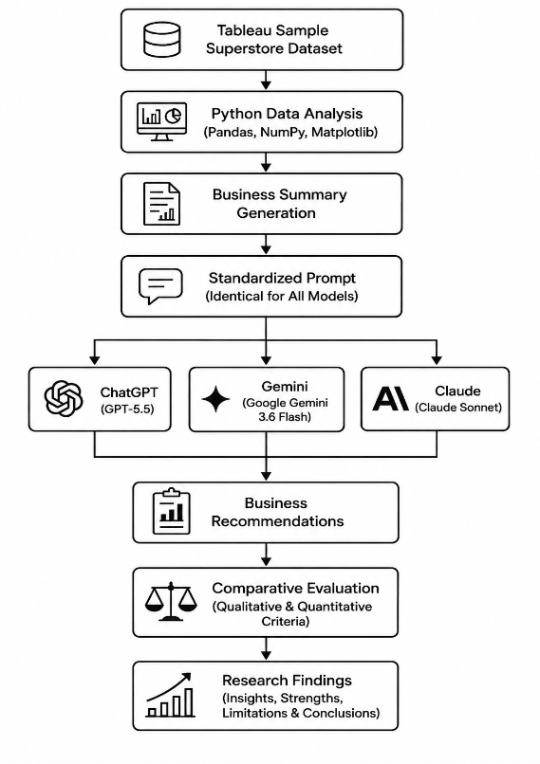

Workflow Description
The workflow begins with the Tableau Sample Superstore dataset, which contains 9,994 retail transactions and 21 business attributes representing sales, profit, customer segments, product categories, regional performance, discounts, and other business variables. The dataset serves as the foundation for all subsequent analytical processes.
In the second stage, Python-based data analysis is performed using libraries including Pandas, NumPy, and Matplotlib. Exploratory Data Analysis (EDA) is conducted to calculate key business performance indicators such as total sales, total profit, average discount, sales by category, regional profitability, and state-wise sales performance. These analyses provide objective numerical insights derived directly from the dataset.
The third stage involves business summary generation, where the analytical results are consolidated into a structured executive business summary. This summary contains only verified numerical findings extracted from Python analysis and excludes subjective interpretations or unsupported assumptions. The standardized summary serves as the common input for all evaluated Large Language Models.
The fourth stage employs standardized prompt engineering. A single evaluation prompt was carefully designed to instruct each model to generate an executive business analysis based exclusively on the provided business summary. The prompt explicitly requires an executive summary, business strengths, business weaknesses, supporting numerical evidence, executive recommendations, and data limitations. Additionally, the prompt instructs the models not to infer information beyond the supplied business summary and to state "Insufficient evidence" whenever required information is unavailable. Using an identical prompt ensures fairness, reproducibility, and consistency throughout the comparative evaluation.
During the fifth stage, the standardized business summary and evaluation prompt are independently submitted to ChatGPT (GPT-5.5), Google Gemini 3.6 Flash, and Claude Sonnet. Each model generates an executive business report without modification to the input data or prompt structure, ensuring that differences in output arise solely from model capabilities rather than variations in experimental conditions.
The sixth stage performs a comparative evaluation of the responses generated. Each model is assessed using predefined qualitative and quantitative evaluation criteria, including:
- Business Understanding
- Numerical Accuracy
- Evidence-Based Reasoning
- Hallucination Resistance
- Handling Missing Information
- Executive Readability
- Actionable Recommendations
- Quantitative Analysis
- Overall Performance
These criteria provide a comprehensive assessment of each model's suitability for enterprise business decision support.
The final stage involves comparative performance analysis, where the responses are systematically compared to identifying the strengths and limitations of each model. The evaluation emphasizes factual consistency, analytical depth, executive communication quality, and practical applicability for organizational decision-making. The resulting comparison provides valuable insights into how different Large Language Models interpret identical business information and generate evidence-based recommendations.

IV. METHODOLOGY

This study adopts a systematic experimental methodology to evaluate the performance of Large Language Models (LLMs) for enterprise business decision support. The proposed methodology integrates Python-based business analytics with standardized prompt engineering and comparative evaluation to ensure a fair, transparent, and reproducible assessment of ChatGPT (GPT-5.5), Google Gemini 3.6 Flash, and Claude Sonnet. The methodology consists of six major stages: dataset preparation, exploratory data analysis, business summary generation, prompt standardization, LLM evaluation, and comparative performance analysis.

A. Dataset
The study utilizes the Tableau Sample Superstore dataset, a widely used benchmark dataset for business analytics and decision support research. The dataset contains 9,994 retail transactions and 21 business attributes, including sales, profit, discounts, customer segments, shipping information, product categories, geographical regions, and order details.
The dataset represents transactional business data collected across multiple product categories and geographical regions, making it suitable for evaluating the analytical capabilities of Large Language Models in enterprise environments.
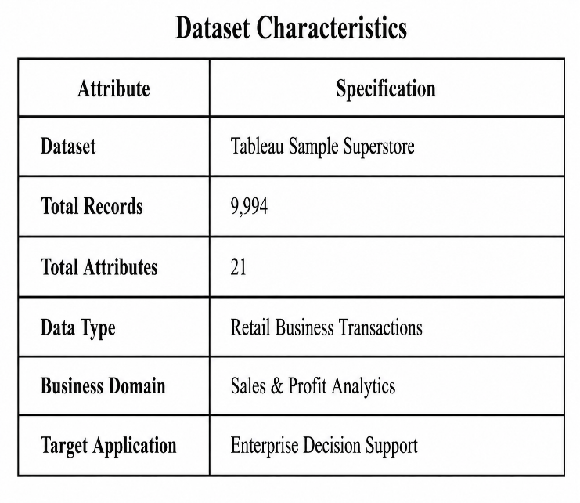
The dataset was imported into Google Colab using the Pandas library for further preprocessing and analysis.

B. Python-Based Business Analytics
Exploratory Data Analysis (EDA) was performed using Python to extract meaningful business insights from the dataset before interaction with the Large Language Models.
The following Python libraries were utilized throughout the analysis:
- Pandas
- NumPy
- Matplotlib
- OpenPyXL
The analysis generated several key business performance indicators, including:
- Total Sales
- Total Profit
- Average Discount
- Sales by Region
- Sales by Product Category
- Top States by Sales
- Regional Profit Analysis
The resulting numerical output formed the basis for generating a standardized business summary.

C. Business Summary Generation
Rather than providing the raw dataset directly to the evaluated models, a concise and structured business summary was generated from the Python analysis.
The standardized summary included verified business metrics such as:
- Total Sales: $2,297,200.86
- Total Profit: $286,397.02
- Top Five States by Sales
- Sales by Product Category
- Profit by Region
Using a summarized representation ensured that every evaluated model received identical business information while eliminating variability caused by different methods of data interpretation.

D. Standardized Prompt Engineering
To ensure fairness and reproducibility, a single standardized evaluation prompt was developed and used without modification for all evaluated Large Language Models.
The prompt instructed each model to generate:
- Executive Summary
- Business Strengths
- Business Weaknesses
- Supporting Numerical Evidence
- Five Executive Recommendations
- Data Limitations
The prompt also included explicit constraints requiring the models to:
- Use only the supplied business summary.
- Avoid unsupported assumptions.
- Report "Insufficient evidence" whenever required information is unavailable.
- Present recommendations in a professional executive report format.
Providing an identical prompt to every model ensured that differences in generated outputs reflected model capabilities rather than prompt design.

E. Large Language Model Evaluation
Three state-of-the-art commercial Large Language Models were selected for comparative evaluation.
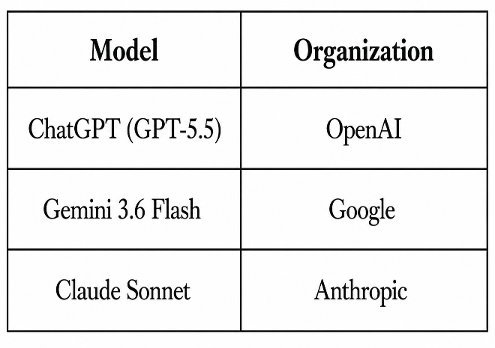
Each model independently received:
- The same business summary.
- The same evaluation prompt.
- The same analytical task.
No modifications were made to the prompt or business summary between experiments, thereby ensuring a controlled evaluation environment.
The generated responses were collected and documented for subsequent qualitative and quantitative comparison.

F. Comparative Evaluation Criteria
Each model response was evaluated using predefined assessment criteria designed to measure both analytical quality and practical business usefulness.
  - Business Understanding: Evaluates the model's ability to correctly interpret the supplied business information and identify important organizational insights.
  - Numerical Accuracy: Measures of whether reported values, calculations, percentages, and business metrics are consistent with the supplied business summary.
  - Evidence-Based Reasoning: Assesses whether recommendations are supported by numerical evidence extracted from the provided data rather than unsupported assumptions.
  - Hallucination Resistance: Evaluates the model's ability to avoid generating information that is absent from the supplied business summary.
  - Handling Missing Information: Measures whether the model appropriately acknowledges unavailable information using statements such as "Insufficient evidence" instead of inventing facts.
  - Executive Readability: Assesses the clarity, organization, professionalism, and readability of the executive report generated.
  - ActionableRecommendations: Evaluates whether the proposed business recommendations are practical, data-driven, and relevant for organizational decision-making.
  - Quantitative Analysis: Measures the model's ability to derive additional meaningful business metrics, such as percentages, profit margins, revenue contributions, and comparative business indicators.

G. Comparative Performance Analysis
Following qualitative evaluation, all responses were systematically compared to identify differences in reasoning style, numerical interpretation, executive communication, and recommendation quality.
The comparative analysis focused on:
- Analytical depth
- Business reasoning
- Executive presentation
- Numerical interpretation
- Transparency
- Practical applicability for enterprise decision support
The evaluation results were summarized using comparative tables and performance rankings to identify the strengths and limitations of each Large Language Model.

H. Experimental Environment
The experiments were conducted using the following software and hardware environment.
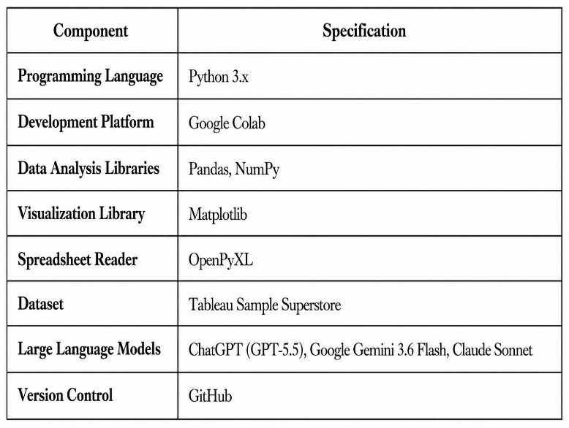

The proposed methodology establishes a reproducible evaluation framework for comparing Large Language Models in enterprise business analytics. By combining Python-based data analysis, standardized prompt engineering, and predefined evaluation criteria, the methodology ensures an objective comparison of LLM capabilities while minimizing experimental bias. This framework can be extended to evaluate additional models, business domains, and decision-support applications in future research.

V. EXPERIMENTAL RESULTS

This section presents the experimental evaluation of ChatGPT (GPT-5.5), Google Gemini 3.6 Flash, and Claude Sonnet for enterprise business decision support. A standardized business summary generated from the Tableau Sample Superstore dataset was provided to each model using an identical evaluation prompt. The objective was to compare the models under consistent experimental conditions and assess their analytical capabilities, numerical reasoning, evidence-based recommendations, and executive communication quality.

A. Dataset Statistics
The experiments were conducted using the Tableau Sample Superstore dataset, which contains retail sales transactions representing multiple product categories, customer segments, and geographical regions. Python-based exploratory data analysis (EDA) was performed to generate the business summary that served as the common input for all evaluated Large Language Models.
Figure 2. Dataset Statistics
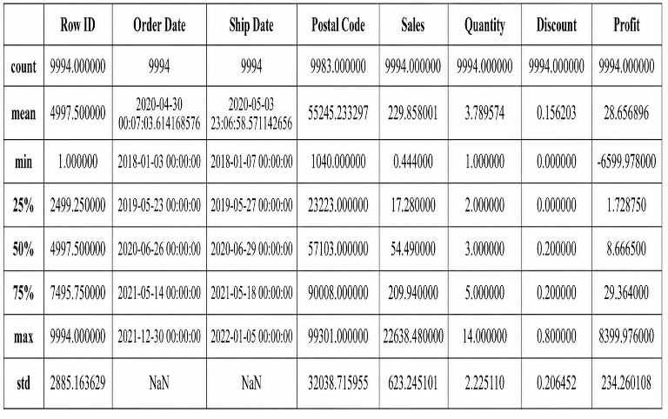
The data set consists of 9,994 retail transactions distributed across 21 business attributes, including sales, profit, discounts, customer segments, product categories, shipping modes, and geographical information. The dataset generated a total sales value of $2,297,200.86, total profit of $286,397.02, and an average discount of 0.16. These business metrics formed the foundation for comparative evaluation.

B. Python-Based Business Analysis
Python was used to perform exploratory data analysis and compute key business performance indicators.
The analysis produced the following business metrics:
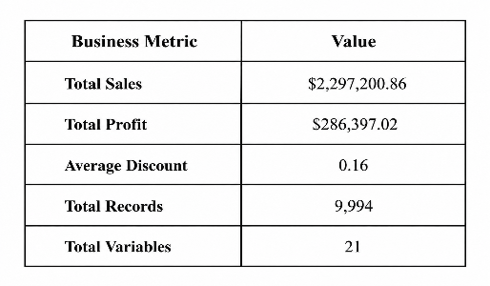
The results indicate that the company achieved positive profitability while operating across multiple business regions and product categories.

C. Sales by Region
Figure 3. Sales by Region
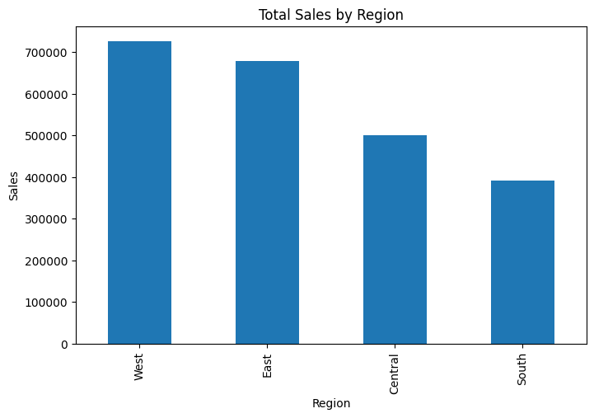
Regional analysis demonstrated noticeable variation in business performance across different geographical markets. The regional sales distribution generated using Python served as one of the principal analytical inputs supplied to the evaluated Large Language Models. This information enabled the models to identify regional business strengths, performance disparities, and potential strategic opportunities during their executive analyses.

D. Experiment 1 – ChatGPT (GPT-5.5)
Standardized Prompt
The standardized executive evaluation prompt described in Section IV was provided to ChatGPT (GPT-5.5) without modification.
Generated Output
ChatGPT generated a structured executive business report consisting of:
- Executive Summary
- Business Strengths
- Business Weaknesses
- Supporting Numerical Evidence
- Five Executive Recommendations
- Data Limitations
The response strictly adhered to the supplied business summary and appropriately stated "Insufficient evidence" whenever required information was unavailable.
Discussion
ChatGPT demonstrated excellent executive communication by producing a concise, logically organized, and evidence-based report. Numerical values reported throughout the analysis were consistent with the Python-generated business summary, and recommendations were directly supported by the available business metrics. The model effectively avoided unsupported assumptions and clearly acknowledged missing information.

E. Experiment 2 – Google Gemini 3.6 Flash
Standardized Prompt
The identical evaluation prompt was provided to Google Gemini 3.6 Flash.
Generated Output
Gemini generated a comprehensive executive report including additional business metric derived such as:
- Overall profit margin
- Regional profit contribution percentages
- Product category revenue percentages
- Geographic sales concentration
These quantitative calculations expanded upon the supplied business summary while remaining numerically consistent with the provided data.
Discussion
Gemini demonstrated excellent quantitative reasoning capabilities by deriving additional business indicators from the supplied numerical values. The model effectively transformed descriptive business statistics into meaningful executive insights, making the analysis particularly valuable for strategic business planning.
F. Experiment 3 – Claude Sonnet
Standardized Prompt
The same standardized evaluation prompt was provided to Claude Sonnet.
Generated Output
Claude produced the most detailed executive report among the evaluated models. The analysis generated included:
- Comprehensive numerical validation
- Executive summary
- Detailed business strengths and weaknesses
- Supporting evidence tables
- Derived business metrics
- Extensive executive recommendations
- Explicit documentation of data limitations
Claude also verified numerical consistency by reconciling category totals and regional profit distributions with the overall business summary.
Discussion
Claude demonstrated exceptional analytical depth and executive communication. The model provided extensive quantitative reasoning while maintaining strict adherence to the supplied business summary. Its detailed validation of business metrics and careful explanation of analytical limitations contributed to a highly transparent and evidence-based business assessment.

G. Comparative Evaluation
The three evaluated Large Language Models demonstrated consistently strong performance across multiple evaluation dimensions.
Table 1. Comparative Evaluation of Large Language Models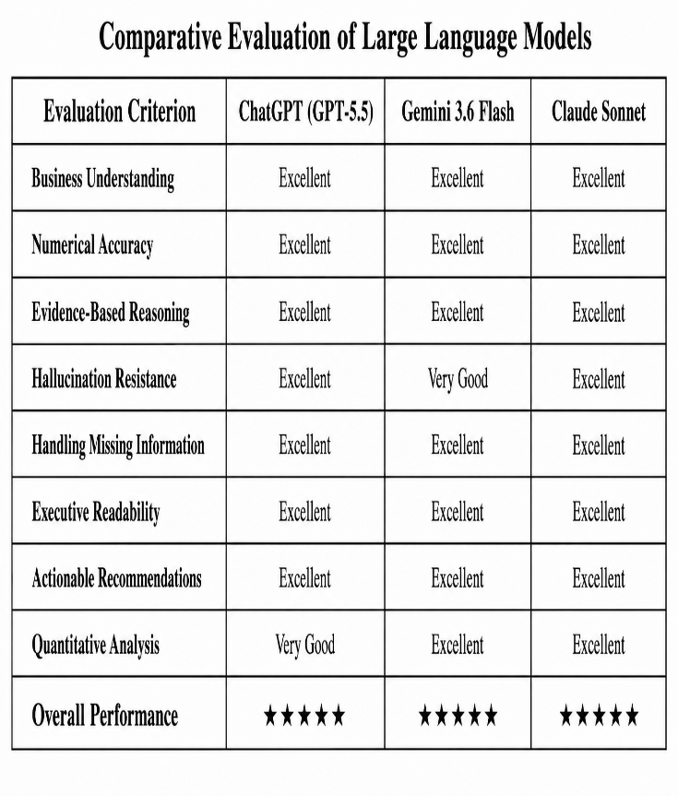All three models generated high-quality executive business analyses using identical inputs. While their presentation styles differed, each model demonstrated strong reasoning capabilities and maintained consistency with the supplied business summary.

H. Quantitative Evaluation
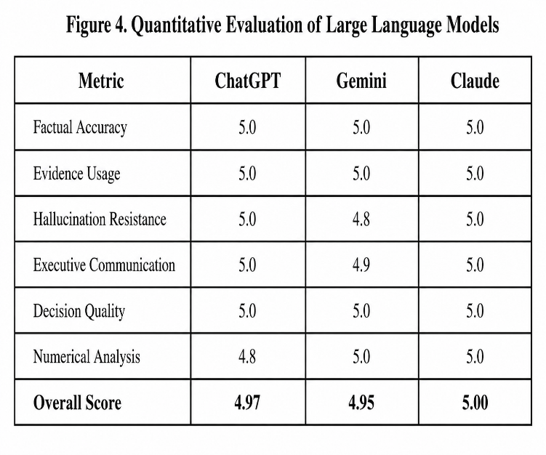The quantitative evaluation indicates that all three models achieved outstanding performance. Claude obtained the highest overall score due to its comprehensive analytical reasoning and detailed numerical validation, while ChatGPT and Gemini demonstrated comparable performance with strengths in executive readability and quantitative analysis, respectively.

I. Discussion
The experimental results demonstrate that modern Large Language Models can effectively support enterprise business decision-making when provided with structured analytical inputs. All three models accurately interpreted the standardized business summary and generated executive-level recommendations supported by numerical evidence.
ChatGPT produced concise and highly readable reports that balanced analytical depth with executive communication. Gemini distinguished itself by deriving additional business metrics, including profit margins and contribution percentages, thereby providing enhanced quantitative insight. Claude delivered the most comprehensive analysis by combining extensive numerical validation, structured executive reporting, and detailed evidence-based recommendations.
A key observation across all experiments was the models' ability to acknowledge missing information rather than generating unsupported conclusions. This behavior substantially reduced hallucination and improved the transparency of the business recommendations generated.
Overall, the experimental findings indicate that standardized prompt engineering combined with Python-generated business summaries provides an effective framework for objectively evaluating Large Language Models in enterprise business analytics. The comparative evaluation further demonstrates the growing potential of generative AI as a reliable decision-support technology for organizational planning, business intelligence, and executive reporting.

VI. COMPARATIVE ANALYSIS

This section presents a comprehensive comparative analysis of the three evaluated Large Language Models ChatGPT (GPT-5.5), Google Gemini 3.6 Flash, and Claude Sonnet for enterprise business decision support. Each model received the identical Python-generated business summary and standardized evaluation prompt, ensuring that differences in the generated outputs reflected model capabilities rather than variations in experimental conditions. The comparison focuses on business understanding, numerical reasoning, evidence-based recommendations, executive communication, and overall suitability for organizational decision-making.

A. Comparative Evaluation of Large Language Models
The responses generated by ChatGPT, Gemini, and Claude were assessed using predefined qualitative and quantitative evaluation criteria developed specifically for enterprise business analytics. The evaluation examined each model's ability to interpret business information, accurately utilize numerical evidence, avoid unsupported assumptions, communicate effectively with executive stakeholders, and provide actionable strategic recommendations.
Table 2. Comparative Evaluation of Large Language Models
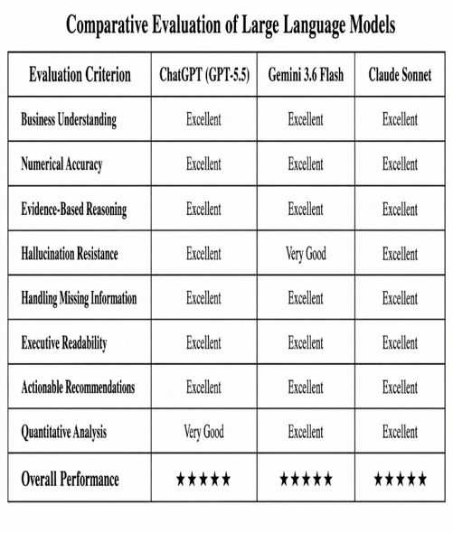
The comparative evaluation demonstrates that all three Large Language Models achieved excellent overall performance. Each model correctly interpreted the supplied business summary, generated evidence-based executive recommendations, and avoided unsupported conclusions. While the overall performance of the three models was comparable, differences were observed in analytical depth, quantitative reasoning, and presentation style.

B. ChatGPT (GPT-5.5) Analysis
ChatGPT generated a concise and professionally structured executive report that closely followed the standardized prompt. The response clearly organized the business analysis into executive summary, strengths, weaknesses, supporting evidence, recommendations, and data limitations. Numerical values reported by ChatGPT were fully consistent with the Python-generated business summary, demonstrating excellent factual accuracy.
One of ChatGPT's major strengths was its ability to communicate complex business findings in a clear and executive-friendly format. Recommendations were practical, directly supported by numerical evidence, and appropriately acknowledged situations where insufficient information was available. Rather than inferring unsupported conclusions, the model consistently reported "Insufficient evidence" when additional business data was required.
Although ChatGPT generated a highly balanced executive report, it performed fewer derived quantitative calculations than the other evaluated models, focusing primarily on interpreting the provided business metrics rather than generating additional statistical insights.

C. Google Gemini 3.6 Flash Analysis
Google Gemini 3.6 Flash demonstrated exceptional quantitative reasoning throughout the evaluation. In addition to accurately reporting the supplied business metrics, Gemini derived several additional analytical indicators, including overall profit margin, product category revenue percentages, regional profit contributions, and geographic sales concentration percentages.
These derived calculations enhanced the business analysis by providing deeper financial context while remaining consistent with the numerical information supplied. Gemini effectively translated descriptive business statistics into executive-level performance indicators that support strategic decision-making.
However, compared with ChatGPT and Claude, Gemini occasionally presented more extensive numerical detail than required for executive audiences. While this additional analysis increased analytical depth, it slightly reduced the overall conciseness of the executive report generated.

D. Claude Sonnet Analysis
Claude Sonnet produced the most comprehensive executive business analysis among the evaluated models. In addition to generating a complete executive report, Claude performed detailed numerical validation by reconciling category totals, regional profit distributions, and overall financial metrics with the supplied business summary.
The model further strengthened its analysis by calculating several derived business indicators, including comparative regional performance ratios, sales concentration percentages, and detailed performance comparisons between geographical markets. Claude also provided extensive explanations supporting each recommendation while carefully documenting all identified data limitations.
Another notable strength of Claude was its emphasis on analytical transparency. Rather than simply presenting conclusions, the model explicitly described how numerical evidence supported each recommendation and identified areas where additional information would be required before stronger conclusions could be reached.

E. Comparative Discussion
The experimental comparison demonstrates that all three Large Language Models can produce high-quality executive business analyses when supplied with structured business information and standardized prompts. Nevertheless, each model exhibited distinct analytical characteristics.
ChatGPT emphasized clarity, executive readability, and balanced communication, making it particularly suitable for concise management reports and executive briefings. Gemini distinguished itself through strong quantitative reasoning, deriving additional business metrics that enhanced analytical insight without introducing unsupported assumptions. Claude combined both approaches by delivering the most comprehensive analysis, integrating detailed numerical validation, structured executive communication, and extensive evidence-based recommendations.
Across all experiments, hallucination was minimal because each model successfully adhered to the prompt instructions requiring exclusive use of the supplied business summary. The explicit requirement to state "Insufficient evidence" when information was unavailable significantly improved transparency and reduced unsupported conclusions.
The comparative evaluation also demonstrates the importance of standardized prompt engineering when benchmarking Large Language Models. Using identical business summaries and evaluation prompts ensured that observed differences reflected genuine model capabilities rather than prompt variations, thereby improving the reliability and reproducibility of the comparative analysis.

F. Key Findings
The comparative analysis produced several important observations:
- All three Large Language Models demonstrated excellent business understanding and numerical accuracy.
- ChatGPT generated the most concise and executive-oriented business reports.
- Gemini produced the strongest quantitative analysis through additional financial calculations and performance metrics.
- Claude generated the most comprehensive evidence-based business analysis with detailed numerical validation and transparent reasoning.
- All evaluated models appropriately acknowledged missing information instead of generating unsupported conclusions.
- Standardized prompt engineering enabled objective comparison by ensuring identical experimental conditions for all models.
- The results confirm that modern Large Language Models have significant potential to support enterprise business intelligence, executive reporting, and strategic decision-making when combined with structured analytical inputs and well-designed evaluation methodologies.
Overall, the comparative analysis demonstrates that ChatGPT (GPT-5.5), Google Gemini 3.6 Flash, and Claude Sonnet are all effective tools for enterprise business decision support. While Claude achieved the highest level of analytical depth, Gemini excelled in quantitative business analytics, and ChatGPT provided the most balanced combination of readability, factual accuracy, and executive communication. These findings highlight the growing role of Large Language Models in modern business intelligence systems and establish a reproducible framework for future comparative evaluations of generative AI technologies.

VII. CONCLUSION

This research presented a comprehensive comparative evaluation of three leading Large Language Models (LLMs)—ChatGPT (GPT-5.5), Google Gemini 3.6 Flash, and Claude Sonnet—for enterprise business decision support. Using the Tableau Sample Superstore dataset containing 9,994 retail transactions and 21 business attributes, Python-based exploration data analysis was performed to generate a standardized business summary that served as identical input for all evaluated models. By employing a common evaluation prompt and predefined assessment criteria, the study established a fair, transparent, and reproducible framework for comparing the analytical capabilities of modern LLMs.
The experimental results demonstrated that all three models successfully interpreted the supplied business information and generated high-quality executive business analyses supported by numerical evidence. Each model accurately summarized key business metrics, identified organizational strengths and weaknesses, provided actionable recommendations, and appropriately acknowledged missing information instead of generating unsupported conclusions. The use of standardized prompt engineering significantly reduced evaluation bias and enabled objective comparison of reasoning quality, factual consistency, and executive communication.
Although the overall performance of the evaluated models was consistently high, notable differences were observed in their analytical approaches. ChatGPT (GPT-5.5) produced concise, well-structured, and highly readable executive reports that effectively balanced analytical depth with professional communication. Google Gemini 3.6 Flash demonstrated exceptional quantitative reasoning by deriving additional financial metrics, including profit margins, revenue contribution percentages, and regional performance indicators, thereby providing deeper business insights while maintaining numerical accuracy. Claude Sonnet generated the most comprehensive analysis by combining detailed numerical validation, structured executive reporting, transparent reasoning, and extensive evidence-based recommendations, resulting in the strongest overall analytical performance.
The comparative evaluation further highlighted the importance of evidence-based reasoning and hallucination resistance in enterprise applications. All three models consistently relied on the supplied business summary and clearly reported "Insufficient evidence" whenever required information was unavailable. This behavior improved transparency strengthened the reliability of generated recommendations and reinforced the importance of Responsible AI practices in business decision support systems.
The findings also demonstrate that integrating Python-based business analytics with Large Language Models creates an effective workflow for transforming structured business data into executive-level insights. Rather than replacing traditional Business Intelligence tools, LLMs complement existing analytical processes by converting numerical outputs into understandable narratives, strategic recommendations, and decision-support reports that can assist business leaders in organizational planning.
Overall, this study confirms that modern Large Language Models possess significant potential to enhance enterprise business intelligence, executive reporting, and strategic decision-making. Among the evaluated models, Claude Sonnet provided the most comprehensive analytical output, Google Gemini 3.6 Flash excelled in quantitative business reasoning, and ChatGPT (GPT-5.5) delivered the most balanced combination of executive readability, factual accuracy, and evidence-based recommendations. Furthermore, the proposed standardized evaluation framework contributes a reproducible methodology for objectively comparing Large Language Models in enterprise analytics and provides a foundation for future research in AI-assisted business decision support. As generative Artificial Intelligence continues to evolve, such systematic evaluation approaches will become increasingly important for selecting trustworthy, transparent, and effective AI systems capable of supporting data-driven organizational decision-making.

VIII. FUTURE SCOPE

The rapid evolution of Large Language Models (LLMs) continues to create new opportunities for enterprise business intelligence and AI-assisted decision support. While this study demonstrated that ChatGPT (GPT-5.5), Google Gemini 3.6 Flash, and Claude Sonnet can generate accurate, evidence-based executive business analyses using standardized business summaries, several promising research directions remain for enhancing the analytical capabilities, transparency, and practical deployment of generative AI in enterprise environments.
One important direction for future research is the evaluation of next-generation Large Language Models as they continue to evolve. Emerging models from organizations such as OpenAI, Google, Anthropic, Meta, Mistral AI, and other open-source communities provide increasingly advanced reasoning, multimodal understanding, and domain-specific capabilities. Future studies should expand the comparative evaluation framework to include newer commercial and open-source LLMs, enabling broader benchmarking across enterprise business analytics tasks.
Another promising research area involves the integration of Retrieval-Augmented Generation (RAG) into business decision support systems. Traditional Large Language Models rely primarily on information contained within their training data and user-provided prompts. In contrast, RAG combines LLMs with external organizational knowledge bases, financial reports, enterprise databases, and business documents, allowing models to retrieve relevant information before generating responses. Such architecture can significantly improve factual accuracy, reduce hallucination, and enable AI systems to provide more context-aware and evidence-based business recommendations.
The development of AI Agent-based Business Decision Support Systems represents another significant opportunity. Instead of relying on a single language model, future enterprise platforms may employ multiple specialized AI agents working collaboratively. For example, one agent may perform business analytics, another may evaluate financial performance, another may conduct market research, while an executive planning agent synthesizes the findings into strategic recommendations. Multi-agent collaboration has the potential to improve analytical depth, scalability, and organizational decision quality for complex business environments.
Future research should also investigate the application of multimodal Large Language Models capable of simultaneously analyzing structured business data, dashboards, financial statements, presentations, spreadsheets, charts, and textual reports. Integrating multiple data modalities would enable organizations to obtain richer executive insights while supporting more comprehensive business intelligence and strategic planning.
Another important research direction involves improving the numerical reasoning capabilities of Large Language Models. Although the evaluated models demonstrated excellent performance in interpreting business metrics, future work should explore techniques that further enhance mathematical consistency, financial calculations, statistical reasoning, and automated validation of generated business recommendations. Combining symbolic reasoning with generative AI may substantially improve reliability in quantitative enterprise applications.
Future studies should also investigate Explainable Large Language Models (XLLMs) for enterprise analytics. While current LLMs generate high-quality recommendations, they often provide limited transparency regarding their internal reasoning processes. Developing explainability techniques that clearly illustrate how business conclusions are derived from numerical evidence would increase executive trust, improve regulatory compliance, and facilitate broader organizational adoption of AI-assisted decision support systems.
The integration of Responsible AI principles represents another critical research area. Future enterprise LLM systems should incorporate fairness assessment, bias detection, transparency reporting, privacy protection, accountability mechanisms, and ethical governance throughout the decision-making process. Establishing standardized evaluation frameworks for Responsible AI will be essential for ensuring trustworthy deployment of generative AI in business environments.
Another promising direction involves developing automated evaluation frameworks for Large Language Models. Current comparative studies often rely on expert qualitative assessment, which may introduce subjectivity. Future research should investigate automated benchmarking systems capable of objectively evaluating factual accuracy, evidence usage, reasoning quality, hallucination resistance, executive communication, and recommendation effectiveness using standardized performance metrics and reproducible evaluation protocols.
Future research should further validate the proposed evaluation framework across multiple business domains, including finance, healthcare, manufacturing, supply chain management, marketing, retail, insurance, telecommunications, and human resource management. Evaluating LLM performance on diverse organizational datasets will improve the generalizability of the proposed methodology and provide broader insights into AI-assisted enterprise decision support.
Finally, future studies may explore the integration of real-time enterprise analytics, cloud-based business intelligence platforms, and conversational AI assistants capable of continuously monitoring organizational performance and generating proactive strategic recommendations. Such intelligent decision-support systems could assist executives by automatically identifying emerging business opportunities, operational risks, financial anomalies, and performance trends while maintaining transparency, explainability, and evidence-based reasoning.

IX. REFERENCES

[1] D. J. Power, Decision Support, Analytics, and Business Intelligence, 3rd ed. Business Expert Press, 2019.
[2] R. Sharda, D. Delen, and E. Turban, Business Intelligence, Analytics, and Data Science: A Managerial Perspective, 5th ed. Pearson, 2023.
[3] T. Brown et al., "Language Models are Few-Shot Learners," Advances in Neural Information Processing Systems (NeurIPS), vol. 33, pp. 1877–1901, 2020.
[4] R. Bommasani et al., "On the Opportunities and Risks of Foundation Models," Stanford Center for Research on Foundation Models, 2021.
[5] OpenAI, "GPT-4 Technical Report," 2023.
[6] Google DeepMind, "Gemini: A Family of Highly Capable Multimodal Models," 2023.
[7] Anthropic, "Claude 3 Model Card," 2024.
[8] J. White et al., "A Prompt Pattern Catalog to Enhance Prompt Engineering with ChatGPT," arXiv:2302.11382, 2023.
[9] P. Liu et al., "Pre-train, Prompt, and Predict: A Systematic Survey of Prompting Methods in Natural Language Processing," ACM Computing Surveys, vol. 55, no. 9, 2023.
[10] T. H. Davenport and J. G. Harris, Competing on Analytics, Harvard Business Review Press, 2017.
[11] National Institute of Standards and Technology (NIST), AI Risk Management Framework (AI RMF 1.0), 2023.
[12] European Commission, Ethics Guidelines for Trustworthy Artificial Intelligence, 2019.

[13] P. Liang et al., "Holistic Evaluation of Language Models (HELM)," Stanford CRFM, 2022.
[14] Y. Chang et al., "A Survey on Evaluation of Large Language Models," ACM Transactions on Intelligent Systems and Technology, 2024.
[15] A. Vaswani et al., "Attention Is All You Need," Advances in Neural Information Processing Systems, 2017.
[16] OpenAI, "Introducing ChatGPT," 2022.
[17] E. Turban, R. Sharda, and D. Delen, Decision Support and Business Intelligence Systems, 10th ed. Pearson, 2015.
[18] T. M. Mitchell, Machine Learning. McGraw-Hill, 1997.
[19] S. Russell and P. Norvig, Artificial Intelligence: A Modern Approach, 4th ed. Pearson, 2021.
[20] Tableau Software, "Sample Superstore Dataset," Tableau Learning Resources.

