Installation
- Copy the module to the Python Path of Open ERP.
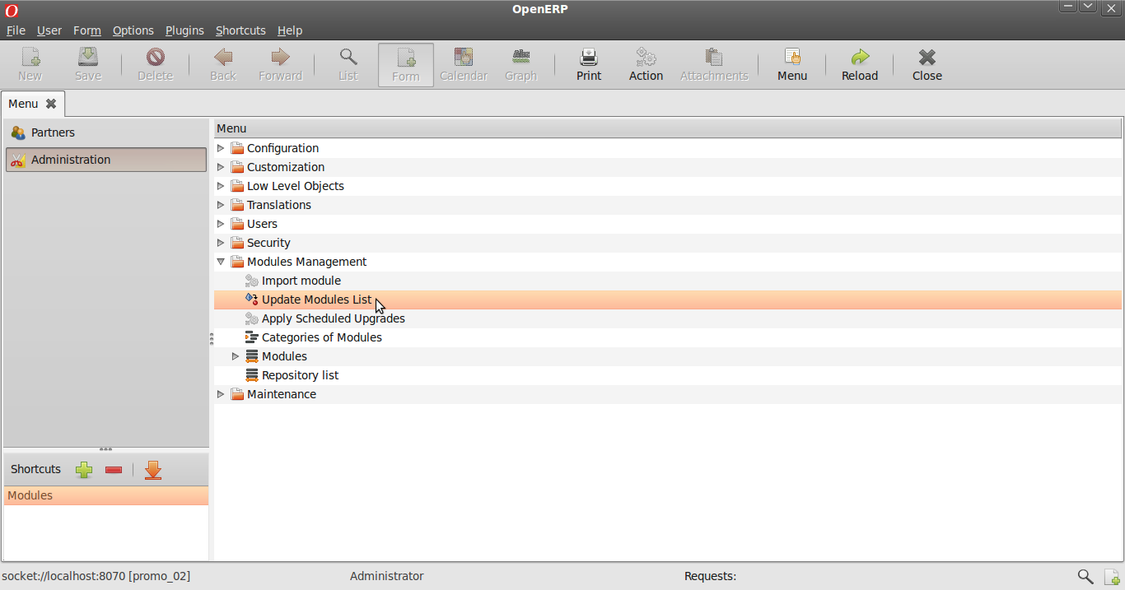Illustration 1: Menu to Module Installation
- Goto Administration >> Modules and Search for the module as shown.
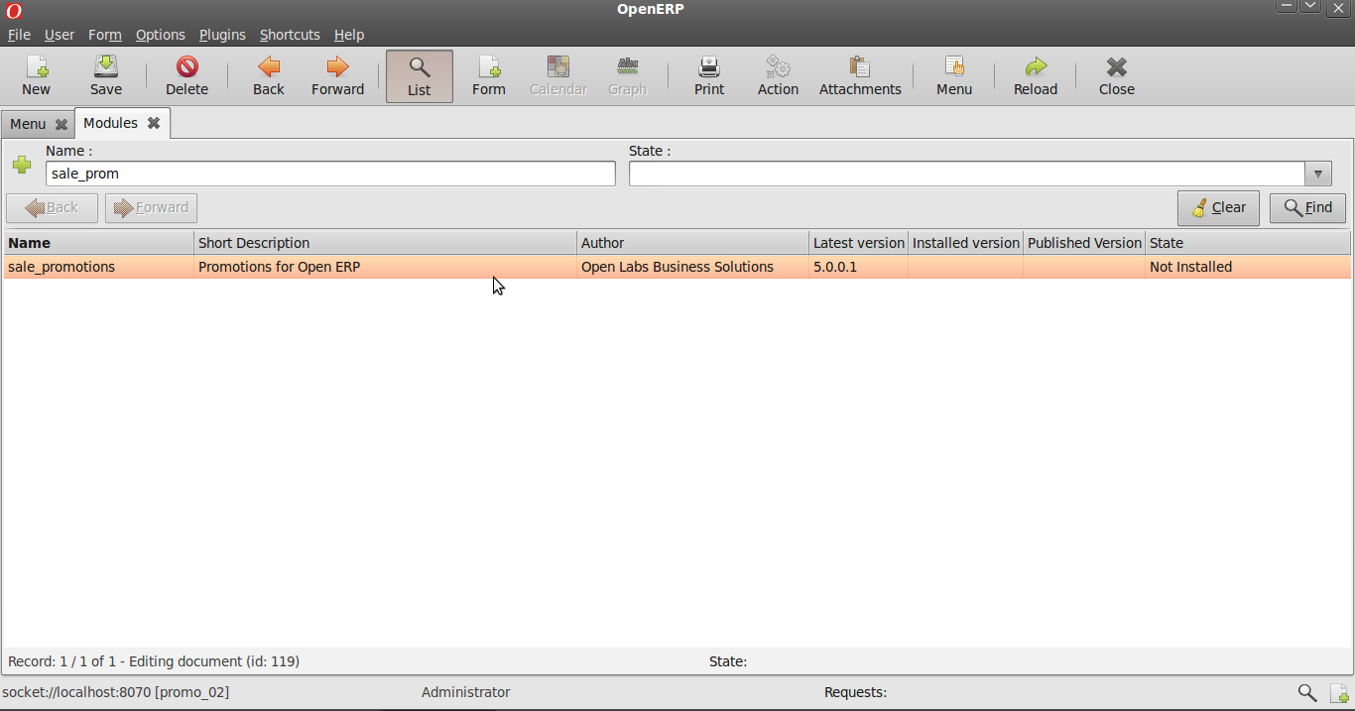Illustration 2: Module selection
Install the module by clicking 'Schedule for Installation'
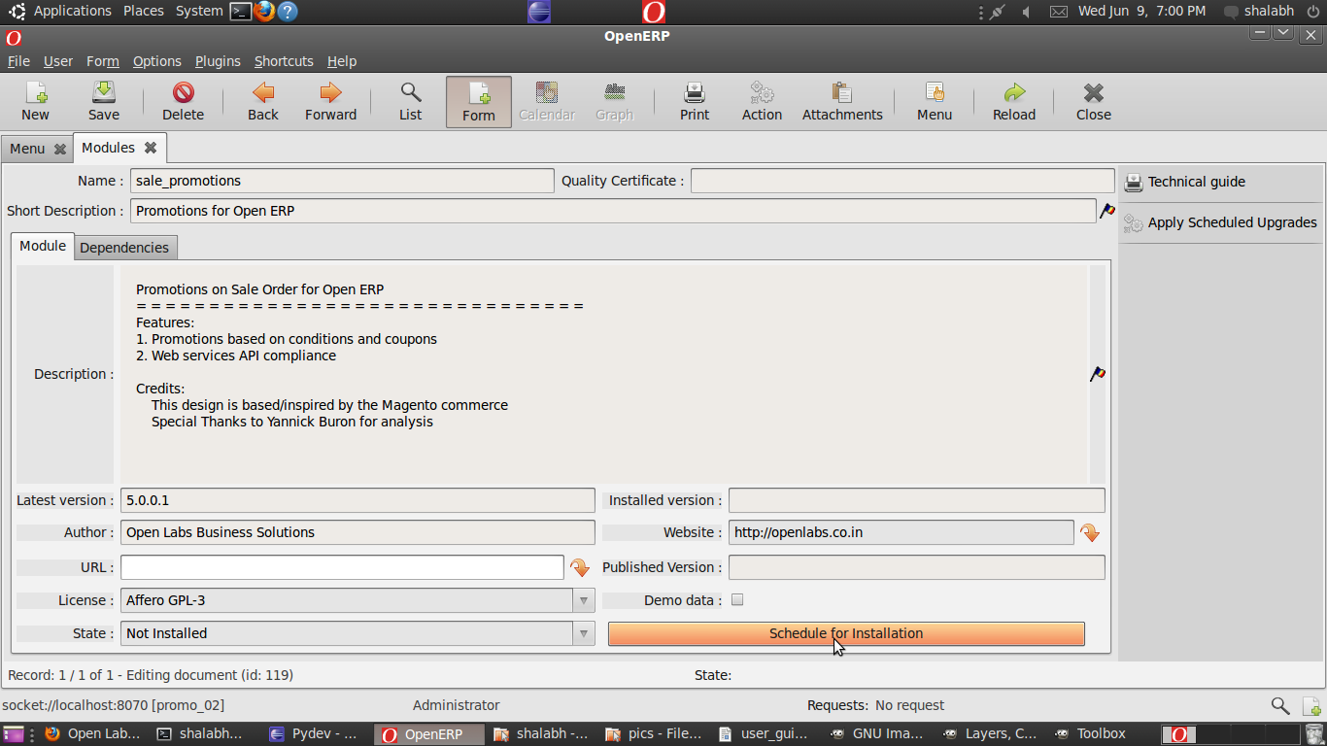Illustration 3: Installing the module
Click on 'Apply Scheduled Upgrades' to perform actual Installation.
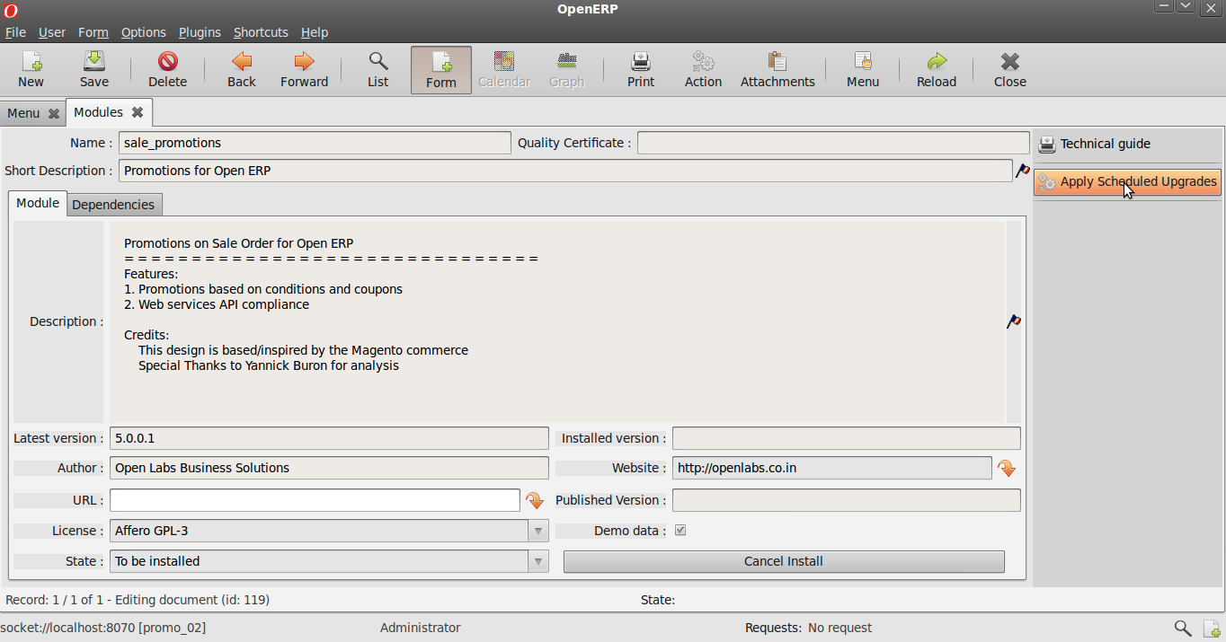Illustration 4: Applying the new module
The module with the dependency module (sale) will be installed. If this module is already installed, only this module will be installed.

Dealing with Promotions
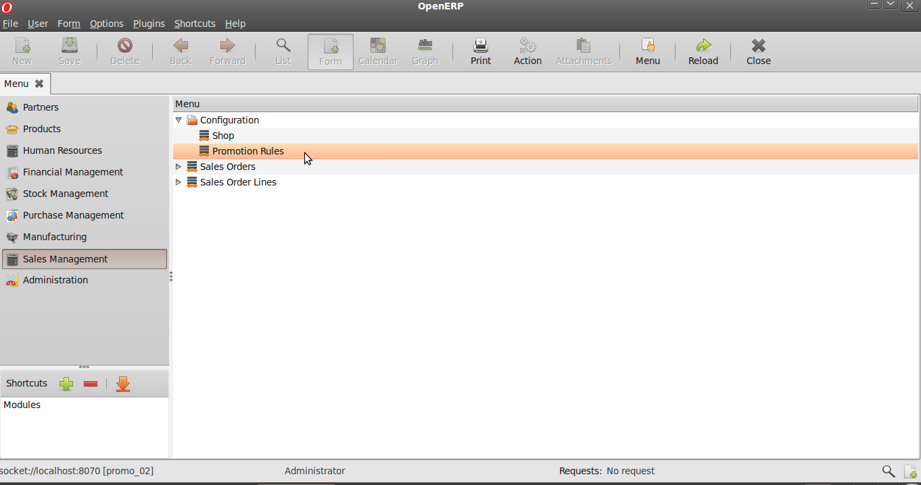Illustration 5: Reaching Promotions

Goto Sales Management >> Configuration >> Promotion Rules
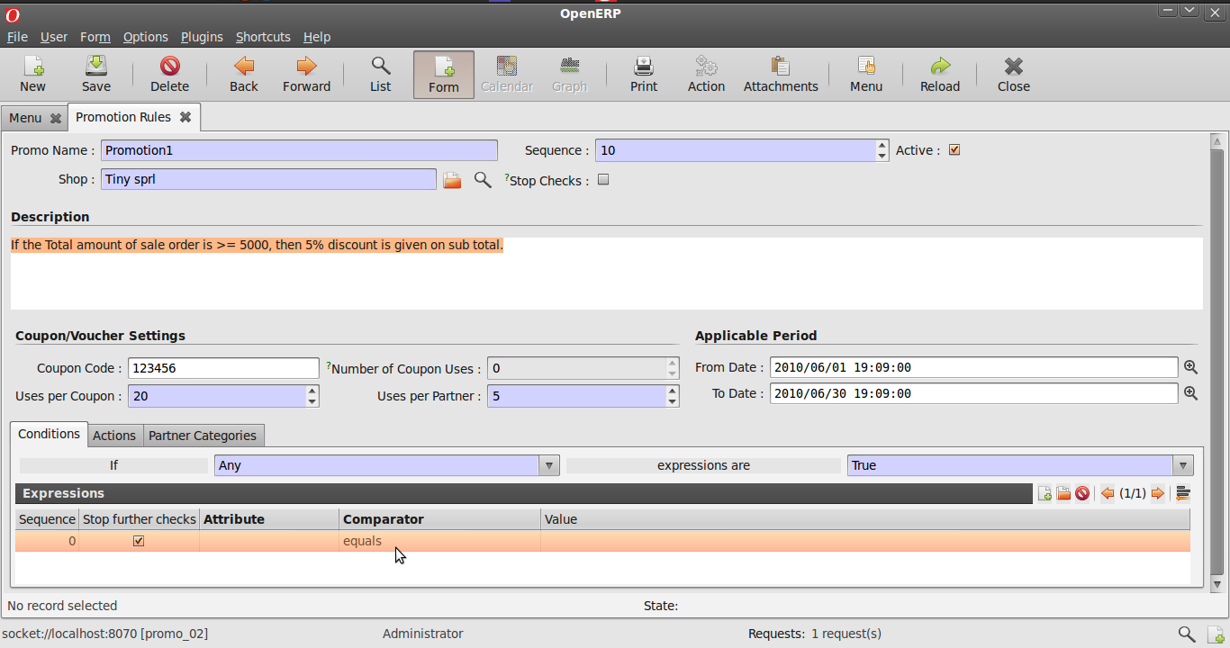Illustration 6: Creating a New Promotion

Description of fields :
Sequence : This field ensures the order in which the promotions will act upon a sale order if more than one promotion acts on a sale order.
Active : Only active promotions can act on a sale order.
Stop Checks : If more than one promotion act on a sale order, then the promotion with this field ticked will cause further promotions from being acted upon.
From Date and End Date : Any promotion will act upon a sale order if its applicable period is valid.
Coupon Code : This is a unique code of the promotion coupon which can be used to directly apply a promotion to a sale order.
Uses per Coupon : This field restricts the maximum number of times a coupon can be used .
Uses per Partner : This field restricts the maximum number of times a coupon can be used by a partner.
Number of Coupon Uses : This field indicates the number of times the coupon has been used till now.
Now we will try to create a promotion with the aim as described in Description.
Creating Expressions
Enter all the details here as per the requirements.
Here a demonstration of how expressions and actions are designed will be given.

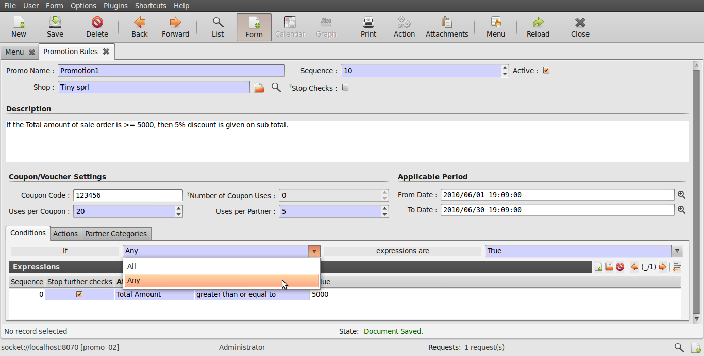Illustration 7: Choosing expression validity.

Above illustration shows how the list of expressions below can be used. Here either all the the expressions can be applied or either any of them. User can also choose between making the expressions True or False for actions to act on them.
Description of fields :
Sequence : This field ensures the order in which the expressions will act execute.
Stop Further Checks : If more than one expression is present, then the expression with this field ticked will stop the execution of any expression after it in sequence.
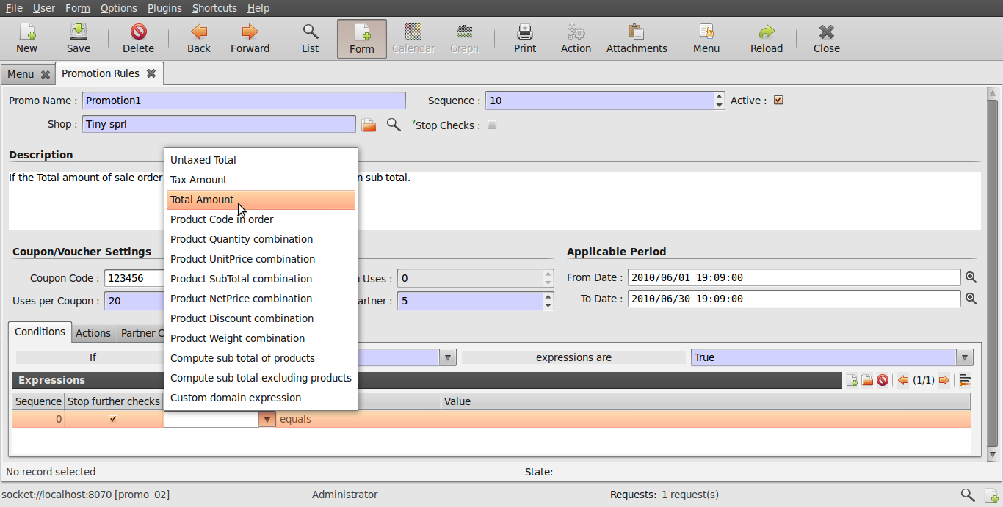Illustration 8: Choosing an attribute.

An attribute is chosen above which will be the criteria for comparison be based.
User has the flexibility of choosing between various options available which can be as simple as Total Amount or Tax Amount and can be a combination of various attributes like Product Quantity Combination etc. Experienced User can also have their own Custom Domain Expression.
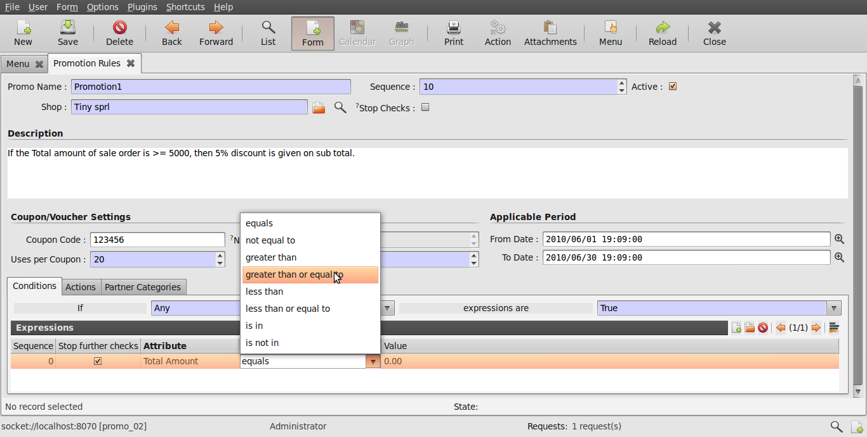Illustration 9: Choosing an comparator.
The figure above shows how a comparator is chosen. These are normal mathematical and list operators and work as their name indicates. This will compare the value of attribute from sale order with the value defined here as shown in the next illustration.
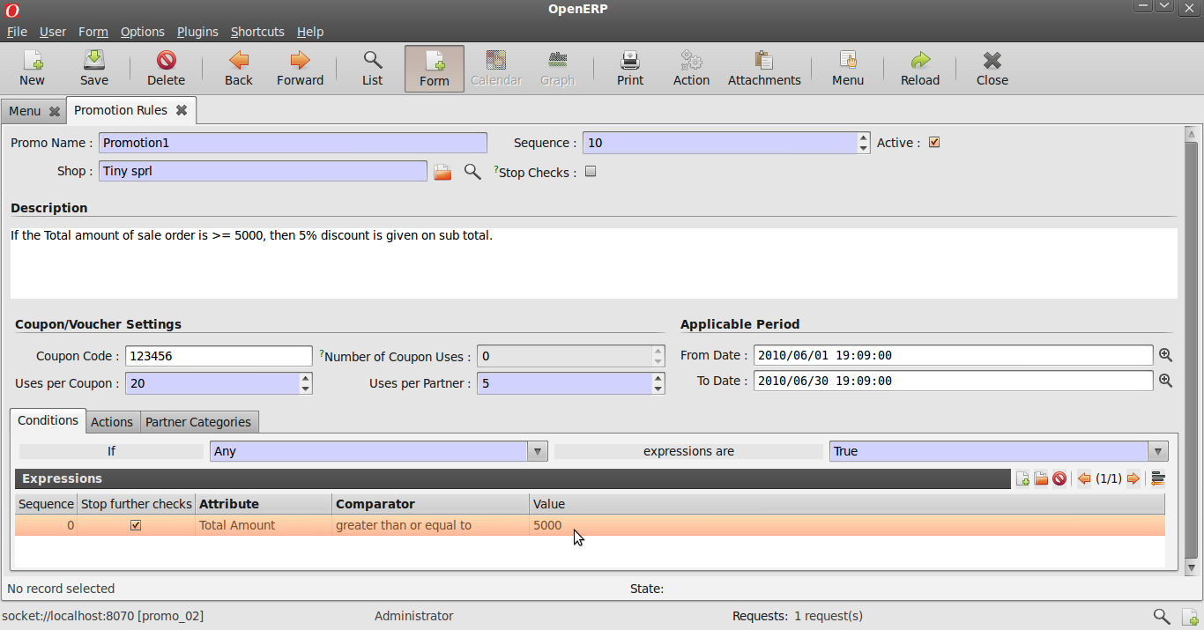Illustration 10: Choosing a value for comparison.
In the Value field, user must enter the value that he/she wishes to be used for comparison. Sometime the this field might contain a value 'product_code'. In this case, the product_code has to be replaced by the actual product of a product eg. 'product_code' >> 'PC1'.
Defining Actions
Actions can be chosen from the list that have to be performed when sale order attributes meet an expression.
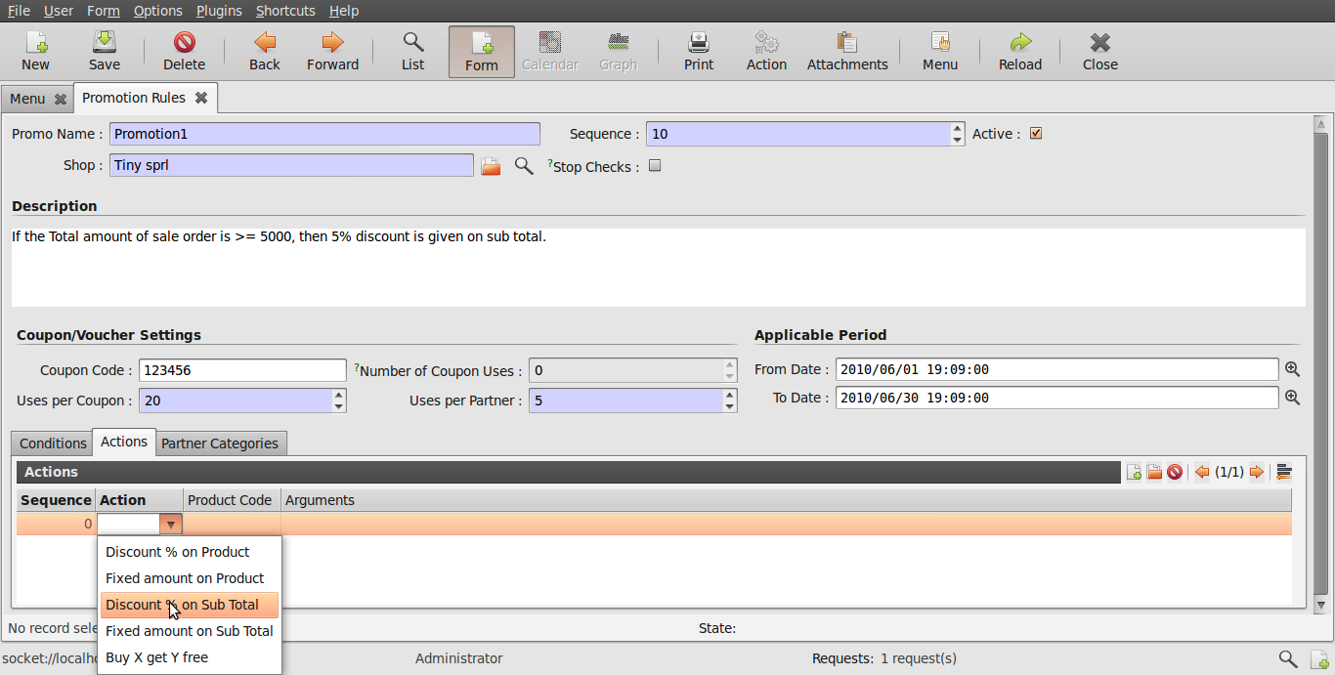Illustration 11: Choosing an action.
Actions can be compared to various promotional offers that are provided to customers. These are simple like giving some discount or giving a fixed amount off on a product or sub total or simply giving away some product free with another product.
Arguments can be set as required. Actions will be performed according to these arguments.
Above the product code field is useful when some action is chosen to be acted on a product specifically. Here product needs to be entered as explained on page 8. An example is shown below.
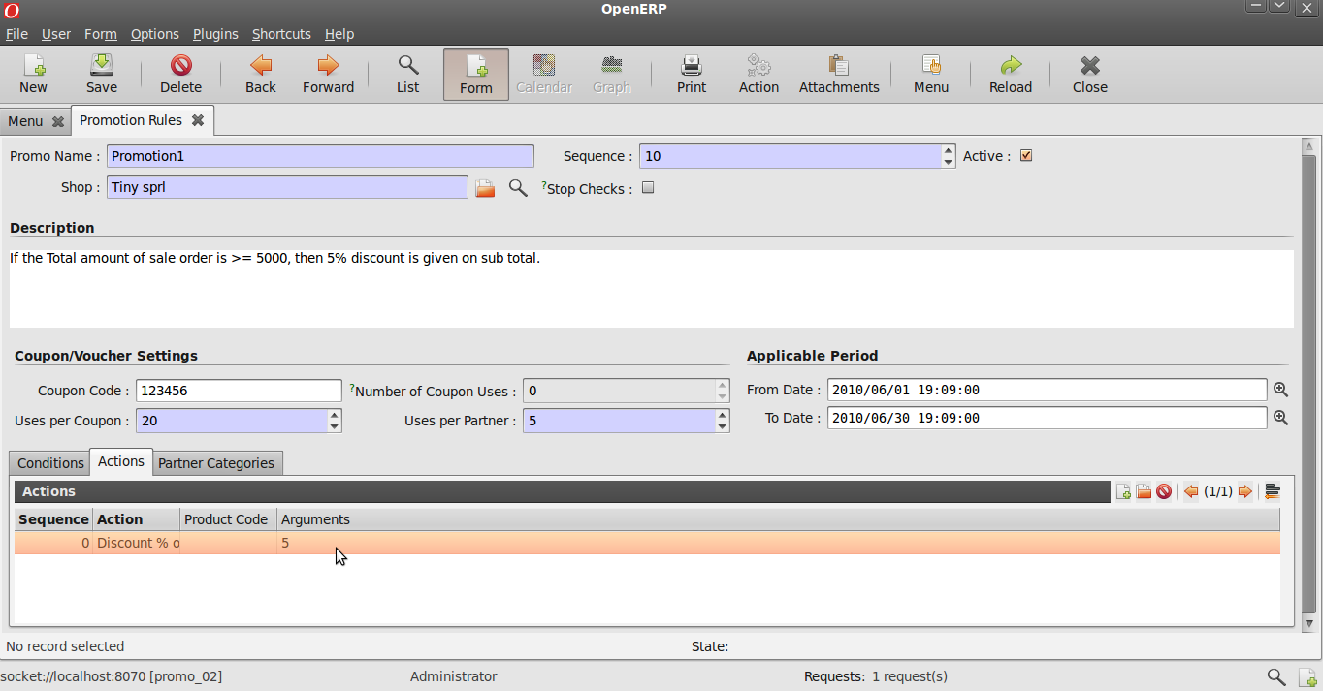Illustration 12: Setting arguments.
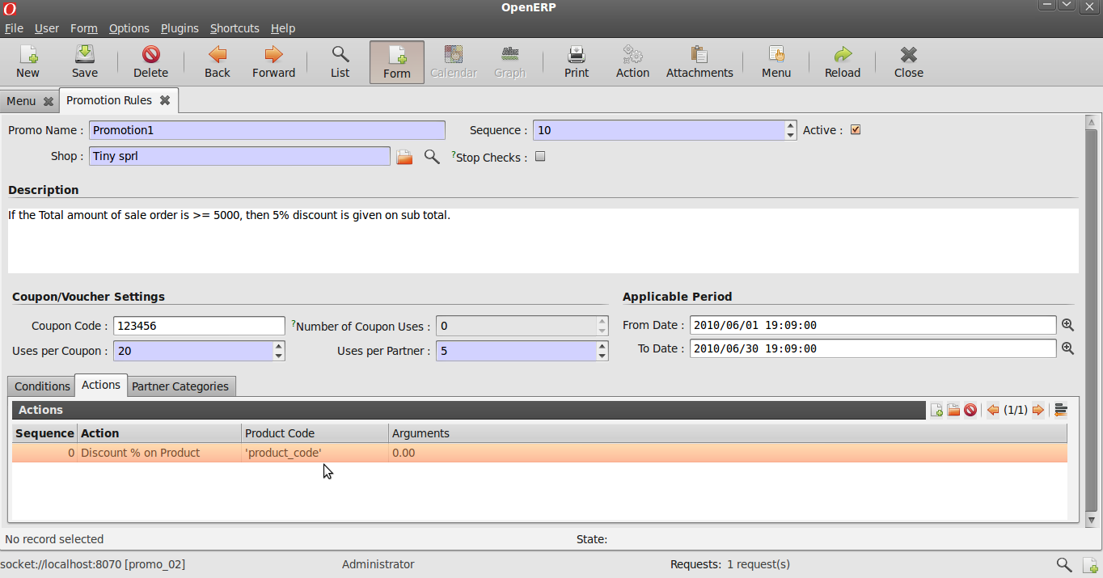Illustration 13: Example of an action related to product. Here product_code needs to be replaced with required code of a product.
Any promotion will be applicable to any sales order if the partner's category there matches the Partner Category/Categories chosen here.
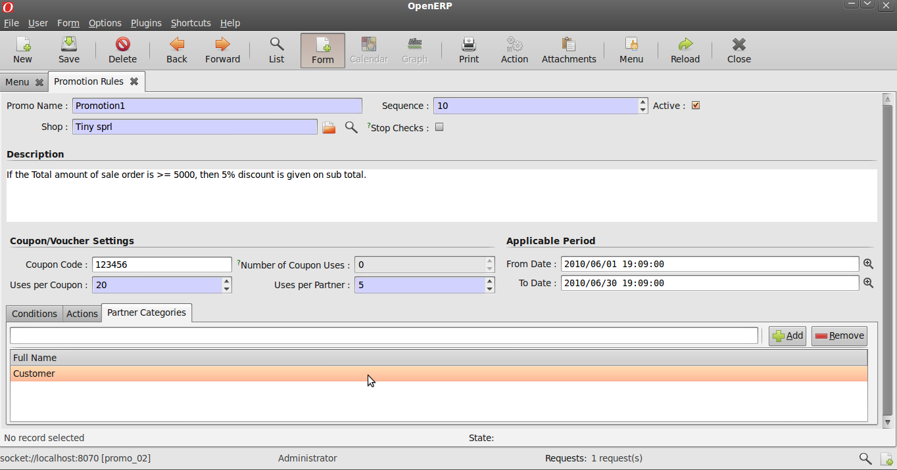Illustration 14: Setting Partner Categories.
Promotions work on sales orders
A coupon code can be added to a sale order in the Other Data Tab as shown above.
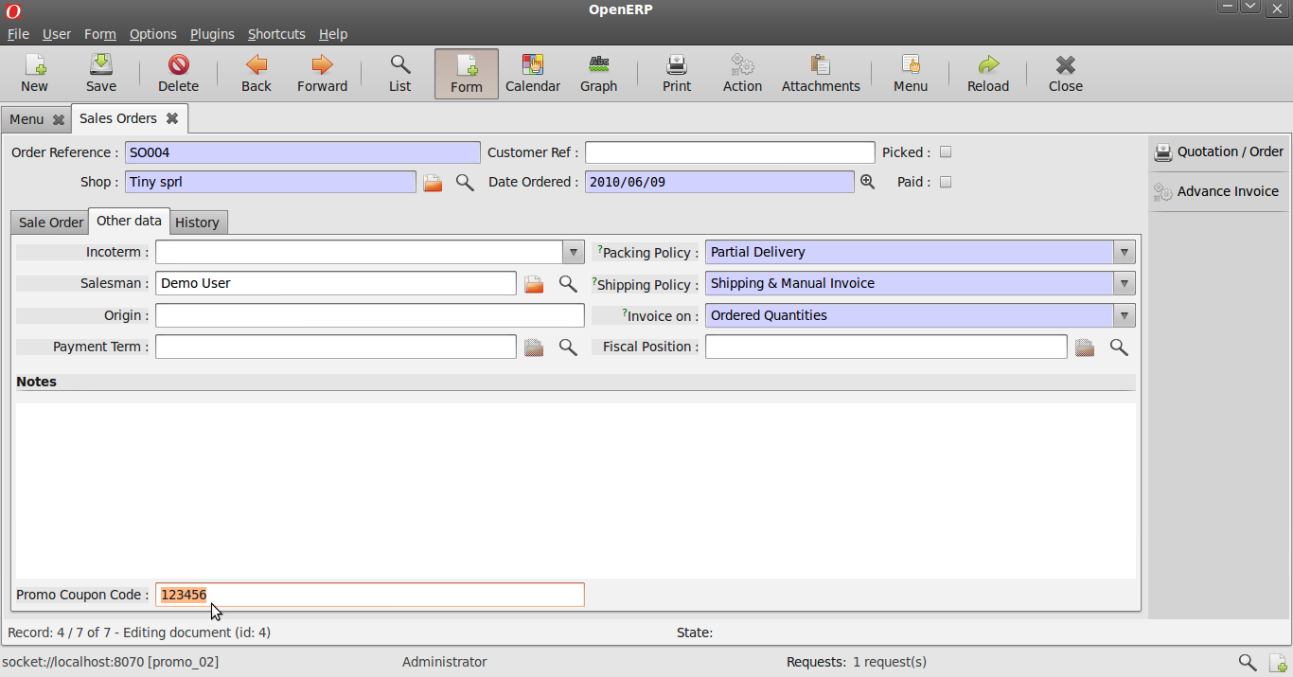Illustration 15: Setting coupon code to be applied on sales order.
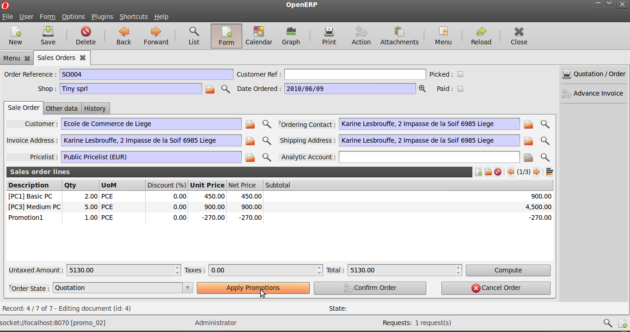Illustration 16: Applying Promotions.
Promotions can be applied to a sale order by clicking on the Apply promotion Button.
Note that a new line has been added showing the discount done as per the promotion defined in illustrations above.

