**Refference** :- https://www.tutorialspoint.com/kubernetes/index.htm

**K8S Architecture**

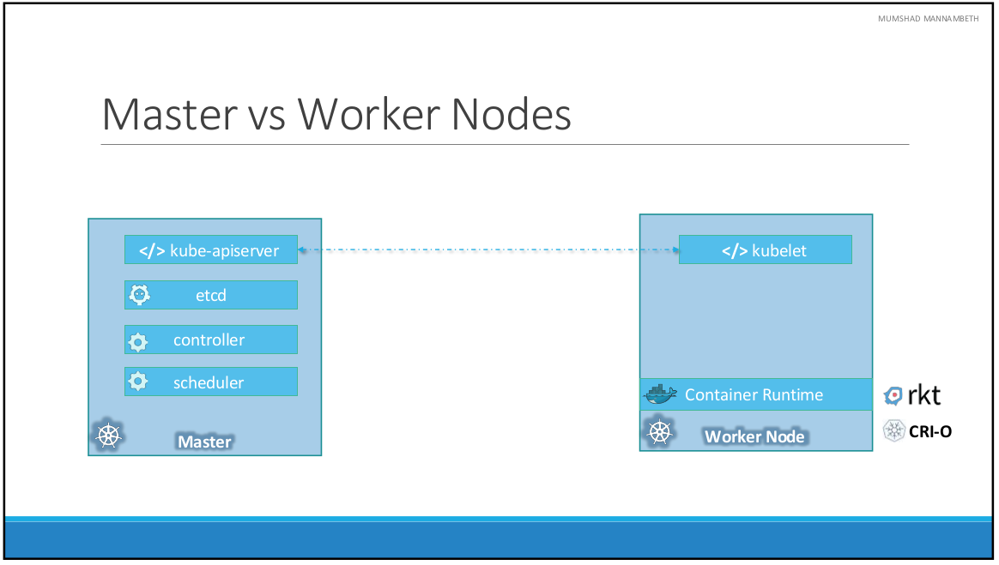

**etcd :-** is an open source distributed key-value store used to hold and manage the critical information that distributed systems need to keep running. Most notably, it manages the configuration data, state data, and metadata for Kubernetes, the popular container orchestration platform.

**Kubernates Installation**

1) Docker required.

2) install etcd 2.0 (etcd required to build k8s.)

> ETCD_VER=v3.5.10

> GOOGLE_URL=https://storage.googleapis.com/etcd

> curl -L ${GOOGLE_URL}/${ETCD_VER}/etcd-${ETCD_VER}-linux-amd64.tar.gz -o /tmp/etcd-${ETCD_VER}-linux-amd64.tar.gz

# extract to softwares location

> tar xzvf /tmp/etcd-${ETCD_VER}-linux-amd64.tar.gz

> sudo cp -R /tmp/etcd-v3.5.10-linux-amd64 ~/workload/softwares/

> rm -f /tmp/etcd-${ETCD_VER}-linux-amd64.tar.gz

> add entry of etcd server to .bashrc.

> run etcd command and check if etcd works fine.

3) build k8s

> clone k8s to softwares path.

>git clone https://github.com/GoogleCloudPlatform/kubernetes.git

> cd kubernates

> make (takes long time. K8s of 1 gb approx. Also requires **sudo apt install**

**golang-go**)

>make creates **_output** folder. We can copy that to /usr/bin or *‘/usr/local/bin’ or ‘/opt/bin/’*

>

4) add entries to “/etc/hosts/” file.

> vi /e*tc/*hosts/

>

# in case of different machines.

10.11.50.12 kube-master

10.11.50.11 kube-minion

# in case of same machine.

127.0.0.1 kube-master

127.0.0.1 kube-minion

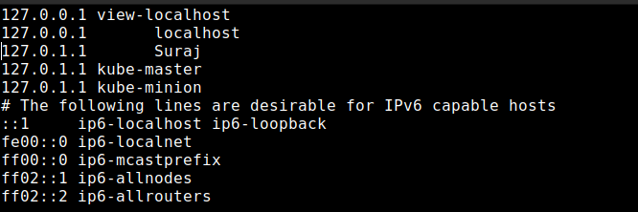

pfb ss for reference.

