This Document we will discuss about mapping a static web app with GoDaddy domain.

*When you add a custom domain to an App Service, you need to validate the domain*

*to verify domain ownership. To verify domain ownership for contoso.com you will*

*create a txt record that contains the Custom Domain Verification ID. The CNAME*

*record is used to map www.contoso.com to webapp.azurewebsites.ne*

BELOW ARE FEW TYPES OF DNS RECORDS

A:-

SRV:-

CNAME :-

TXT :-

PTR :-

We will create a static web page under sspatil static web app and map with domain **sspatil.in**

References

-----------------

https://learn.microsoft.com/en-us/azure/static-web-apps/custom-domain-external

https://learn.microsoft.com/en-us/azure/static-web-apps/custom-domain-azure-dns

<https://youtu.be/yzsJIqsGYi4>

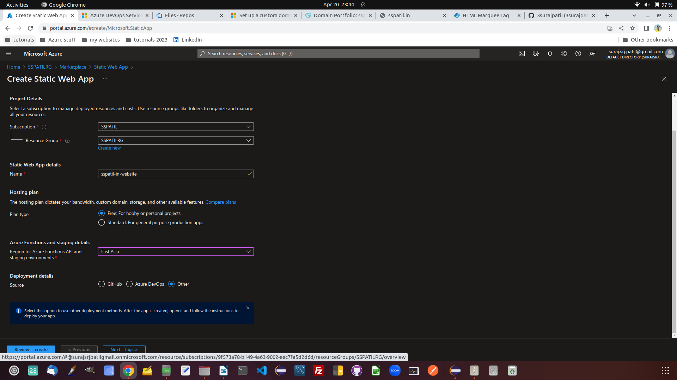

Create a static web app on azure providing github repo as a source.

Test the static web app with provided url on azure after deployment.

### Create DNS records in Azure DNS

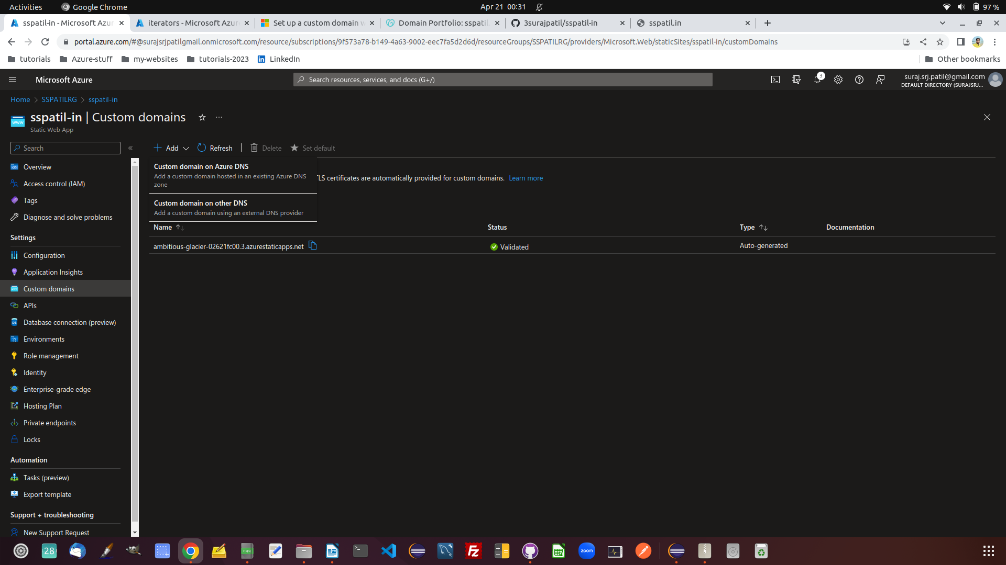

Generate some txt in add custom domain.

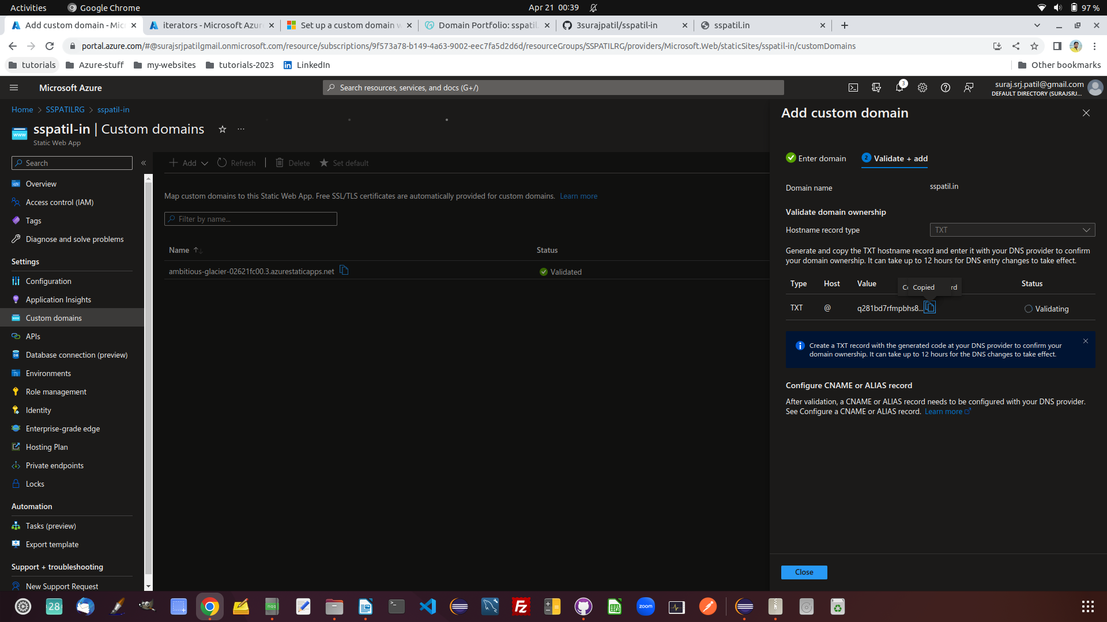

Also you need to add existing azure dns CNAME in godaddy

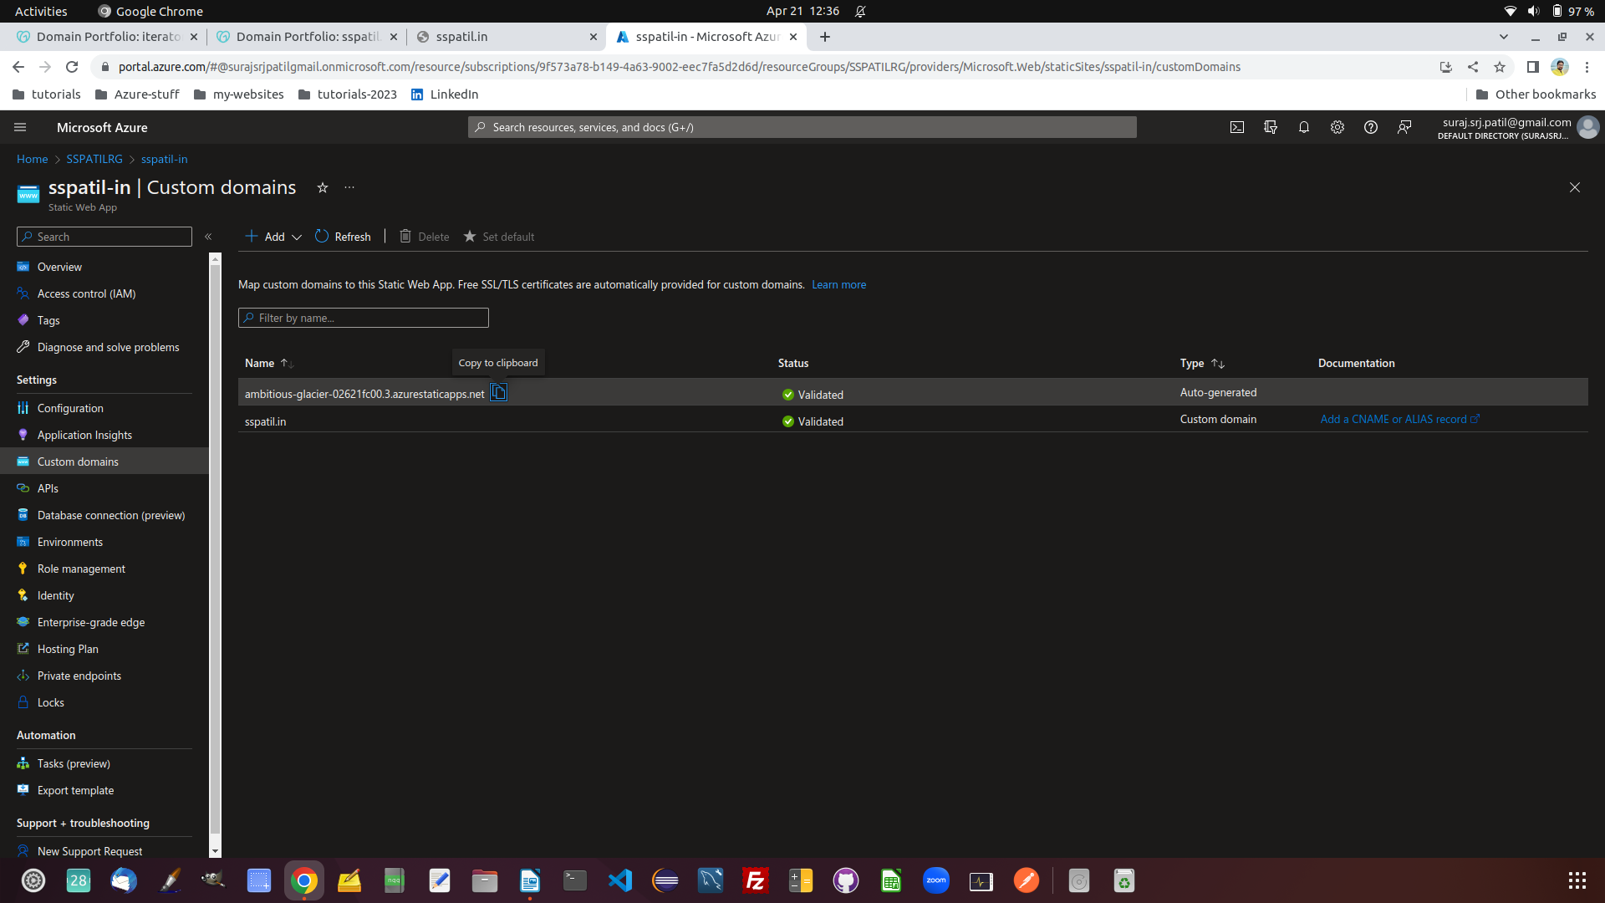

look for cname record.

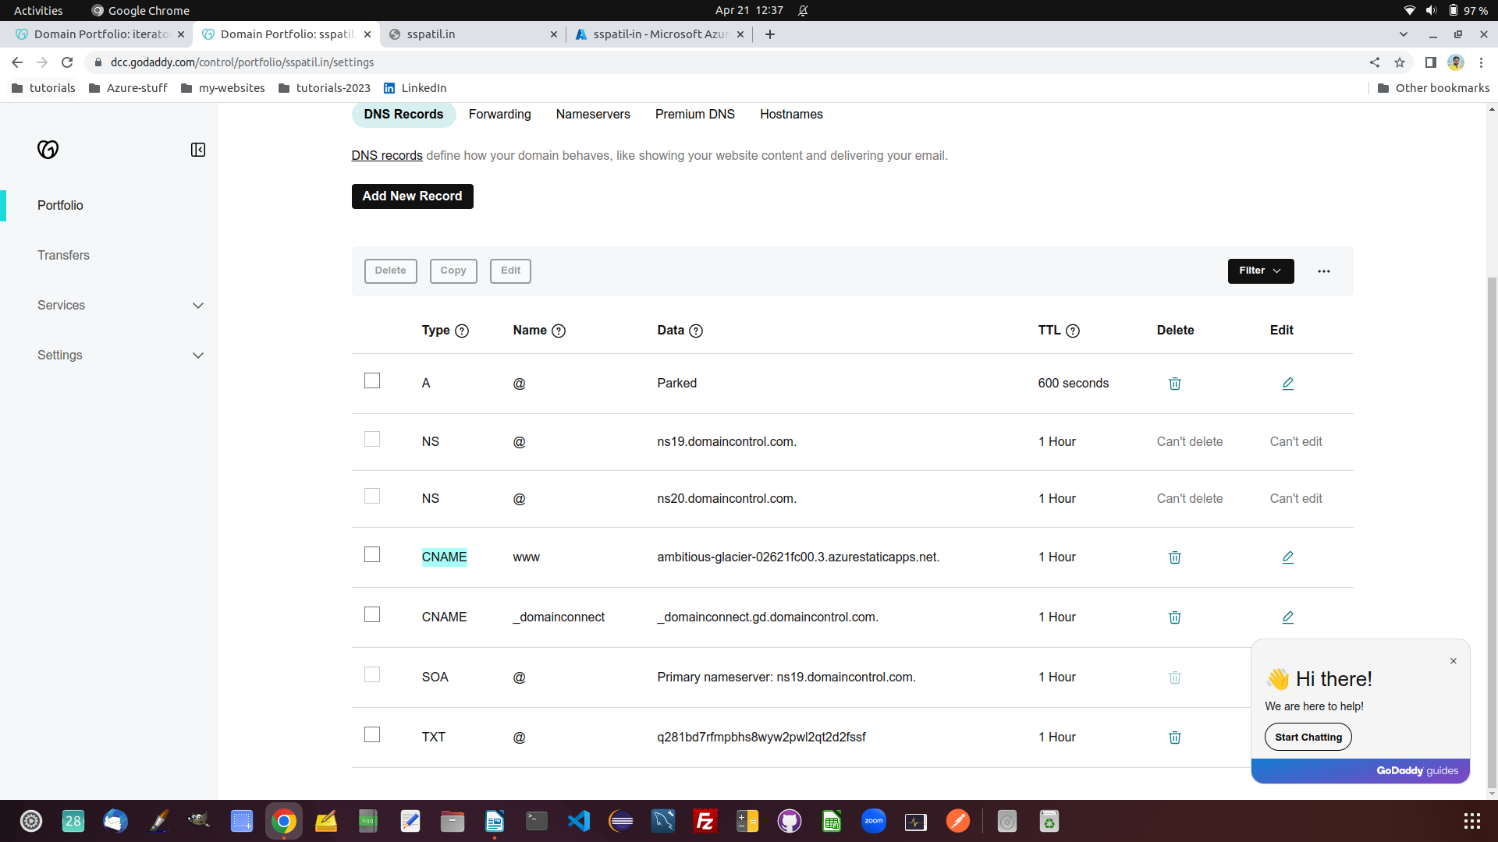

Also do nslookup ambitious-glacier-02621fc00.3.azurestaticapps.net.

And whatever ip you receive , you need to add/edit that in A records on godaddy.

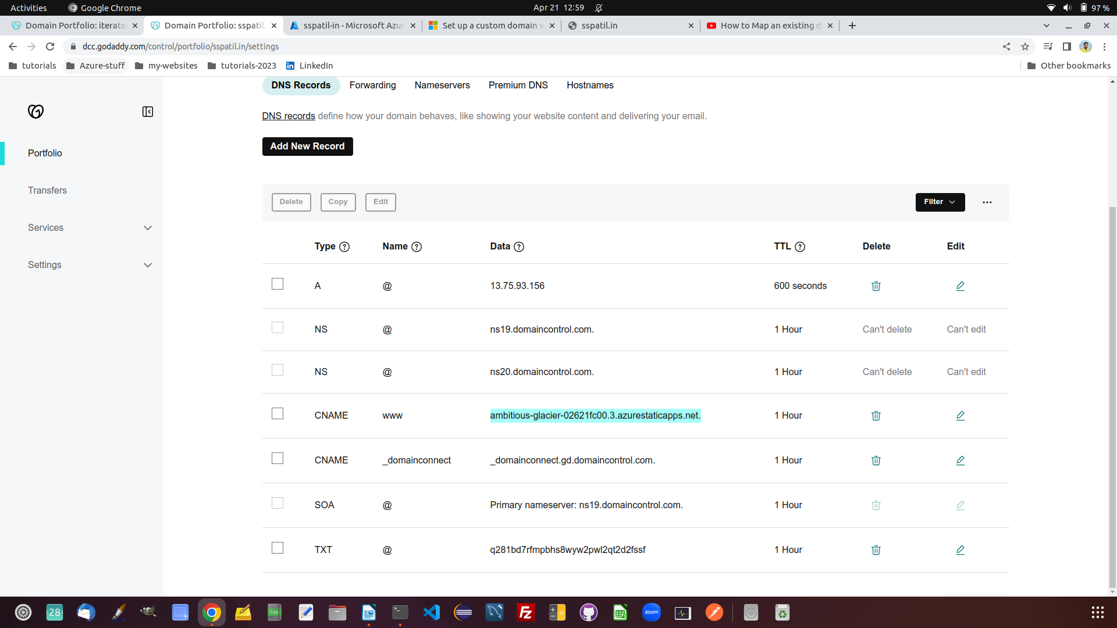

go to manage domain on godaddy , inside your purchased domain somewhere.

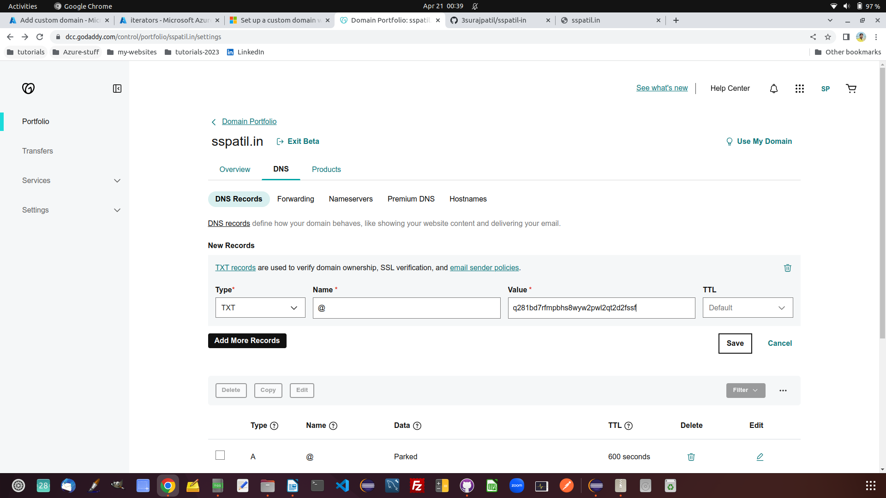

Basically process is to create a static web app on azure portal and then just add a custom domain to your static web app . While adding custom domain , create a TXT @ XXXXXX something in add record on azure and use generated text at godaddy website under manage domain.