Ethan Christopher Powell

474086542

Website integration

Assessment Task 2

Contents

Conversation Log 2

Part 1 – Documenting Project Requirements 3

1.1 Documentation of Web Application Requirements 3

1.2 Requirements Checklist 5

Part 2 – Design Specifications and Architectural Requirements 7

The Mobile Hour Site Map: 7

## Conversation Log

|  |  |  |  |
| --- | --- | --- | --- |
| DATE | TOPIC | DISCUSSION | STAKEHOLDER |
| 25/04/2024 | Feedback Request  (via email) | Requesting review + feedback for web application requirements table. | Cameron Hughes  (Project Manager) |
| 29/04/2024 | Approval received | - | Cameron Hughes (Project Manager) |
| 03/04/2024 | Feedback Request (via email) | Requesting review + feedback for web architecture design. | Cameron Hughes (Project Manager) |
|  |  |  |  |
|  | *Add rows as necessary* |  |  |

# Part 1 – Documenting Project Requirements

## 1.1 Documentation of Web Application Requirements

|  |  |
| --- | --- |
| Project Mobile Hour | |
| 1.2 PROJECT DETAILS | |
| Client details: | The Mobile Hour |
| Developer details: | Uptown IT - Web Development Department  42 Technology Avenue, Brisbane 4000  Contact Person: Alan Turing, M. 0102 123 123 [alan.turing@data.com](mailto:alan.turing@data.com) |
| Purpose/Goal: | Redesign and develop a new website for The Mobile Hour to replace the existing outdated website. |
| Objectives: | * Develop responsive website with modern design and functionality. * Integration of a secure admin area for managing product information, user data, and change logs. * Ensure compliance with legislative standards. |
| Client expectations: | The client expects a visually appealing website with enhanced functionality, security features, and a user-friendly admin interface for managing products and users. |
| Legislative standards: | Compliance with relevant data protection and privacy laws:   * [The Privacy Act 1988](https://www.oaic.gov.au/privacy/privacy-legislation/the-privacy-act) * [Disability Discrimination Act](https://humanrights.gov.au/our-work/disability-rights/brief-guide-disability-discrimination-act) * [The Spam Act 2003](https://www.legislation.gov.au/C2004A01214/latest/text) * [Austalian Consumer Law (ACL)](https://consumer.gov.au/) |
| Project duration: | 9 Weeks |
| Other: Please list | - |
| 1.3 REQUIREMENTS | |
| **Hardware** |  |
| Hardware platform: | Any modern computer or server capable of running a web server and database server. |
| **Software** |  |
| OS: | Windows |
| Web server: | Apache |
| Frameworks (front/back end): | Frontend – Bootstrap |
| Languages:  APIs: | HTML, CSS, JavaScript, PHP |
| Database server: | MySQL |
| DBMS: | MySQL (MySQL Workbench) |
| Other: Please list | - |
| 1.4 Functionality | |
| Website functionality: | * Responsive design for seamless browsing experience across devices. * Product listing and browsing for all website visitors. * Secure admin area with login functionality. * CRUD operations for managing products and users. * Stock management functionality. * Change log tracking for product and user modifications. |
| 1.5 Database Integration | |
| Connection to database server requirements: | Secure connection using appropriate protocols |
| Database functionality: | * Store product information, user data, and change logs. * Implement CRUD operations for managing data. |
| User data input requirements: | Input forms for adding/modifying products and user accounts |
| Data storage requirements: | Store product details, user information, and change logs in the database. |
| Other: Please list | * Adding a table for images. |
| 1.6 User interface | |
| User characteristics: | * Website visitors: Potential customers interested in purchasing a mobile phone. * Admin Users: Managers responsible for managing products and users. |
| User needs: | * Website visitor: Easy navigation, product browsing, and purchasing options. * Admin users: Access to secure admin area, intuitive interface for managing products and users. |
| Design principles: | * Modern and visually appealing design * Intuitive user interface with clear navigation paths |
| Navigation: | Clear and structured navigation menus for easy browsing. |
| Accessibility features: | * Ensure accessibility compliance. |
| Devices supported: | Support for desktop, laptop, tablet, and mobile devices. |
| Other: Please list | - |
| 1.7 Security procedures | |
| Authentication: | * Implementing secure authentication, password hashing using PHP. * Using session tokens to manages user authentication and authorization. |
| Injection: | * Use of prepared statements. * Sanitising user input. |
| Protocols: | * HTTPS * TLS |
| Other: Please list | * Updating software dependencies and libraries to patch vulnerabilities. |

## Requirements Checklist

|  |  |  |
| --- | --- | --- |
| Acceptance Requirements Checklist | | |
| REQUIREMENTS | Test Results | COMMENTS |
| Required hardware. | *PASS* |  |
| Required software. | *PASS* |  |
| **Functionality:** | Choose an item. |  |
| Responsive design across devices |  |  |
| Product listing and browsing for all users |  |  |
| Secure admin area |  |  |
| Secure login and signup functionality |  |  |
| Implementation of CRUD operations |  |  |
| Change log tracking |  |  |
| **Database Integration:** |  |  |
| Secure connection to database |  |  |
| Storage of user information |  |  |
| Implementation of CRUD operations |  |  |
| Integrity constraints enforced |  |  |
| Forms input correct data |  |  |
| **User Interface:** |  |  |
| Users - Easy navigation |  |  |
| Users - Product browsing |  |  |
| Admins – Access to secure admin area |  |  |
| Admins – Intuitive interface for product management |  |  |
| Modern and visually appealing design |  |  |
| Intuitive user interface with menus for easy browsing |  |  |
| Accessibility compliance |  |  |
| **Security Procedures:** |  |  |
| Implementation of secure authentication |  |  |
| Password hashing |  |  |
| Session tokens |  |  |
| Use of prepared statements |  |  |
| Sanitizing user inputs |  |  |

# Part 2 – Design Specifications and Architectural Requirements

### The Mobile Hour Site Map:

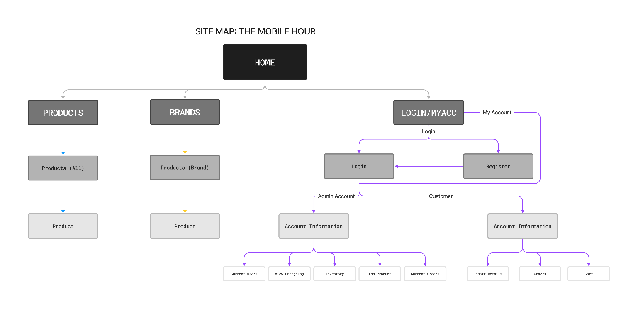

Figure 1: The Mobile Hour site map.

### The Mobile Hour UML Use Case Diagram:

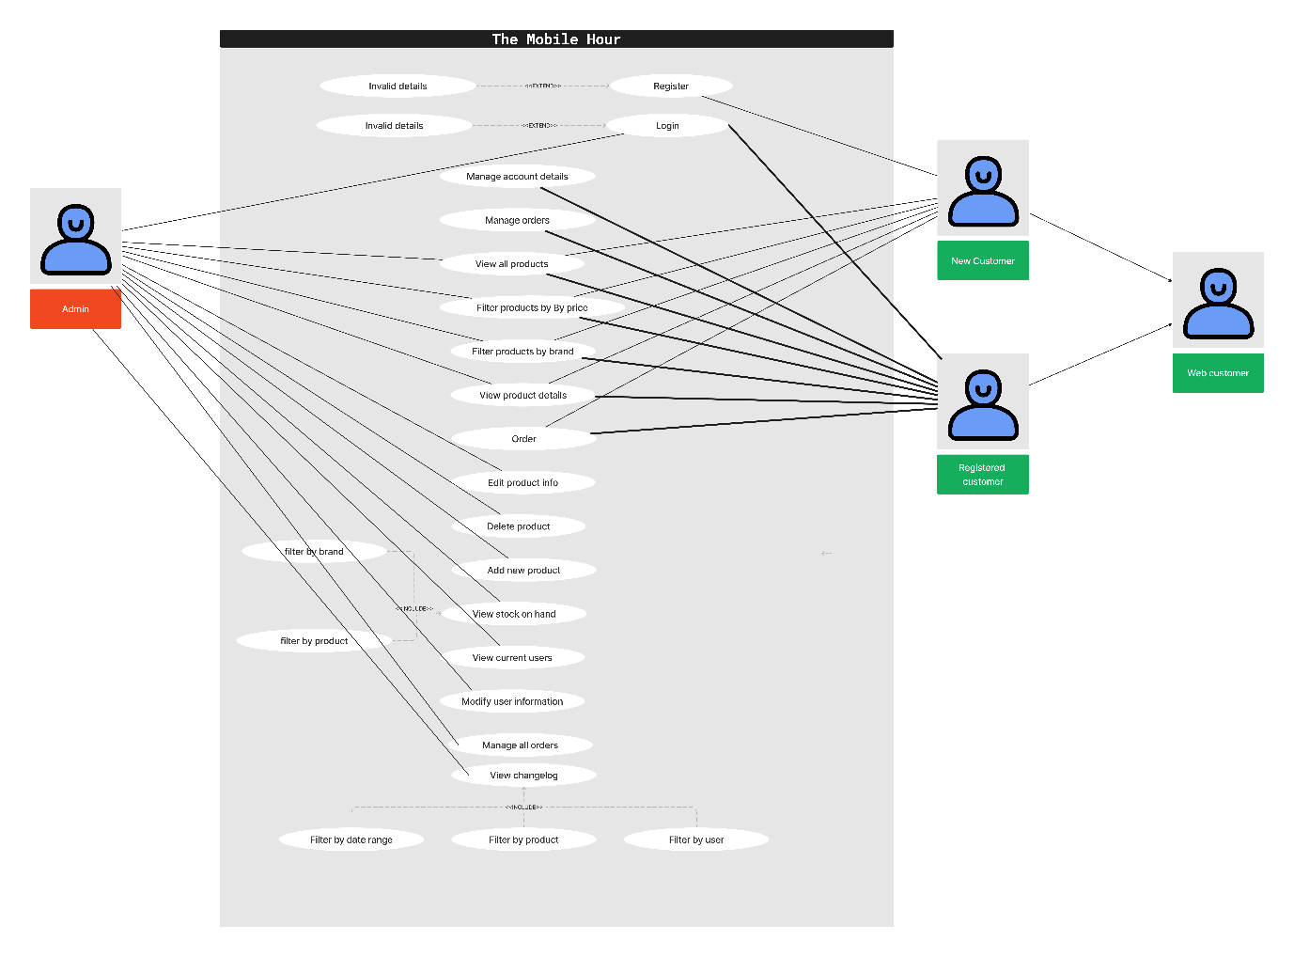

Figure 2: The Mobile Hour use case diagram.

### The Mobile Hour Wireframes

Wireframes attached below:



### The Mobile Hour Prototype

Prototype can be viewed [here.](https://www.figma.com/proto/x9EwlLbqn5IsAUZWyMM9xy/Prototype?page-id=0%3A1&type=design&node-id=1-2&viewport=573%2C652%2C0.54&t=aNewWqghnedr9VjJ-1&scaling=min-zoom&mode=design)

### Database Integration Plan

#### Database Connection Setup

* Install and configure XAMPP and Apache.
* Install and configure MySQL Workbench.
* Define database connection params in PHP (host, username, password etc).
* Establish a database connection using PDO in PHP.

#### Database Structure Setup

* Review the database structure provided by The Mobile Hour.
* Work out data types and create the database using MySQL Workbench.
* Create tables and columns based on the ERD.
* Implement tables for product and brand images.
* Implement integrity constraints.
* Populate tables with test data.

#### User Authentication Setup

* Using MySQL Workbench, create a manager account with low level permissions to the database.
* Admins and Users will be authenticated via PHP.

#### Data Transfer and Querying

* Utilizing PHP to handle data transfer between the website and the database.
* Implement basic CRUD (Create, Read, Update, Delete) operations to manage users and products.
* SQL queries will be utilized along with the PHP scripts to query the database based on requirements.

#### Testing Database Functionality

* Database tables will be populated with test data.
* Data retrieval will be tested based on criteria (e.g brand, price).
* Testing each CRUD operation to ensure it works as expected.

### Technical Upgrades

* PHP to be at latest version ensuring it is compatible with PDO and XAMPP.
* XAMPP to be at latest version.
* MariaDB at latest version.
* Ensure MySQL Workbench is updated.

### Database Administrator Account

Database admin for The Mobile Hour:  
  
**username: admin**  
**password: themobilehour  
  
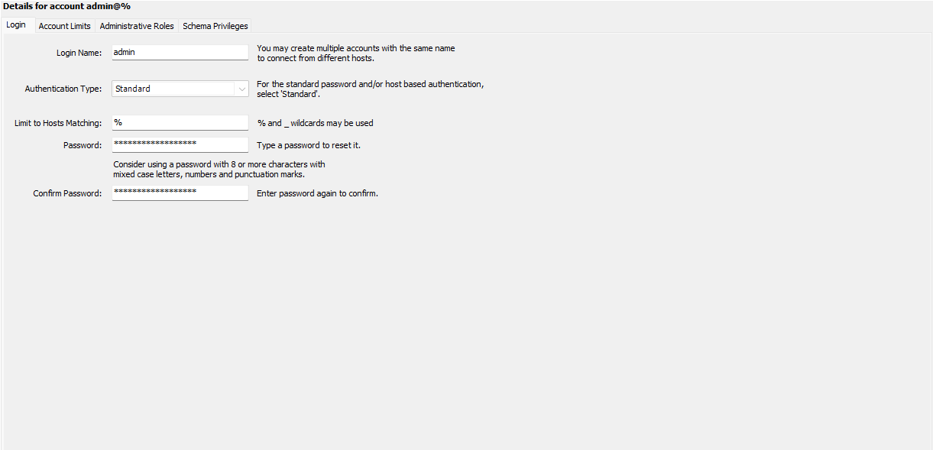**

Figure 3 Admin profile.

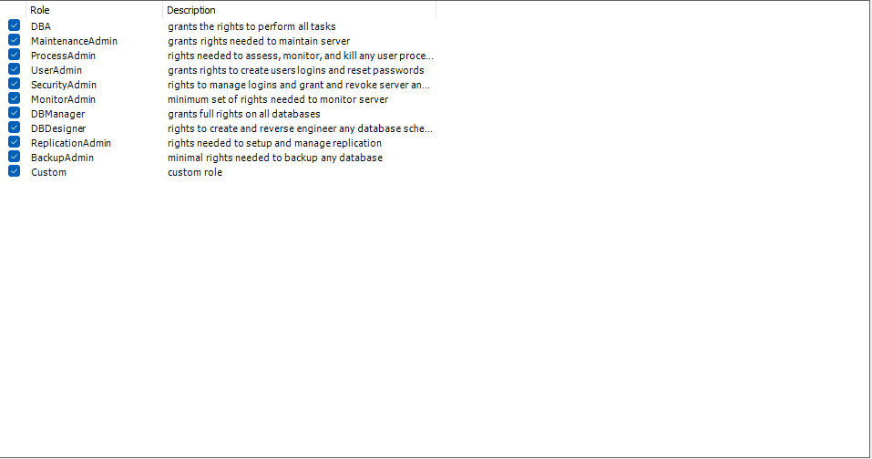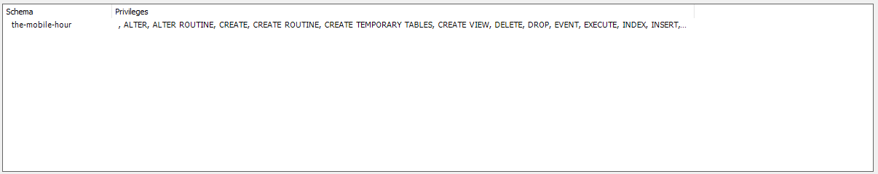

Figure 4 Admin privileges granted.

### Integration of Database and Website

**db.php** – establishes connection with the database   
  
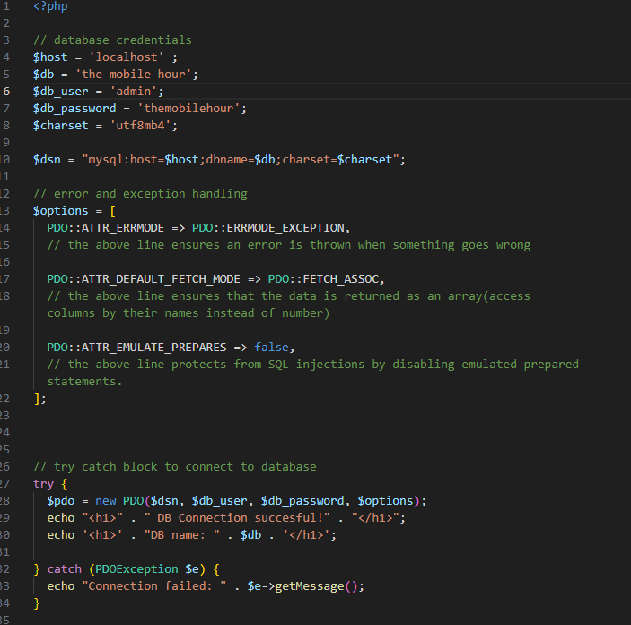

Figure 5 db.php

“DB Connection successful!” on landing page to indicate successful connection with database  
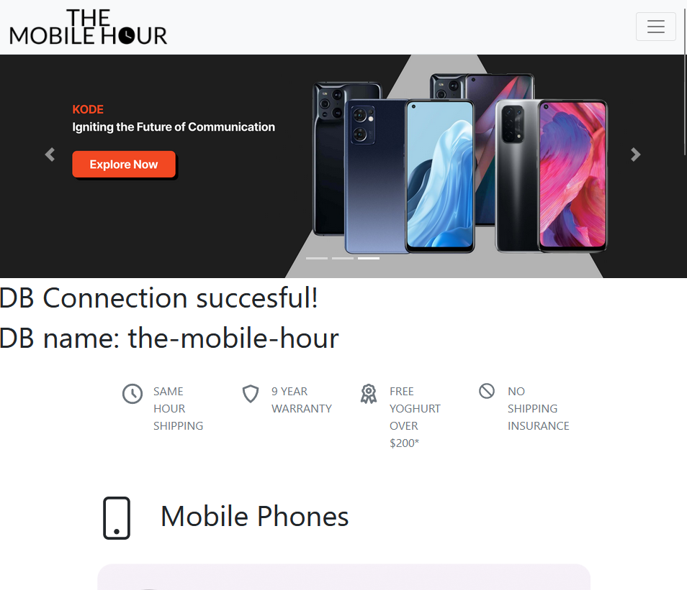

Figure 6 Connection successful