Вариант 17

y = 0.00084(ln x 5/ 4 + b) /(x2 + 3.82), x0 = -2.35;

x k = -2;dx = 0.05;

x0 = -0.05;xk = 0.15;dx = 0.01;

a = 74.2;

Листинг

using System;

using System.Windows.Forms;

namespace LR_5_6

{

public partial class Form1 : Form

{

public Form1()

{

InitializeComponent();

}

private void button_result_Click(object sender, EventArgs e)

{

double x0 = Convert.ToDouble(input_x0.Text);

double xk = Convert.ToDouble(input_xk.Text);

double dx = Convert.ToDouble(input_dx.Text);

double a = Convert.ToDouble(input_a.Text);

result.Text = "Работу выполнил ст. Саломатин С.В." + Environment.NewLine;

double x = x0;

while (x <= (xk + dx / 2))

{

double y = 0.00084 * ((Math.Pow(Math.Log(Math.Abs(x)), 5 / 4) + a) / (Math.Pow(x, 2) + 3.82));

result.Text += "x=" + Convert.ToString(x) +

"; y=" + Convert.ToString(y) +

Environment.NewLine;

x = x + dx;

}

}

}

}

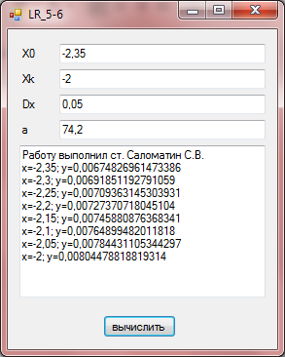

Вариант 5

y = x4 + cos(2 + x3 - d),

x 0 = 4.6;x k = 5.8;dx = 0.2;

d = 1.3;

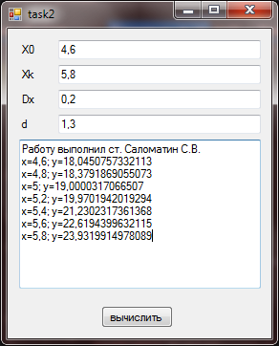

Вариант 7

y = 9(x +15 x3 + b3 ),

x 0 = -2.4;xk = 1;dx = 0.2;

b = 2.5;

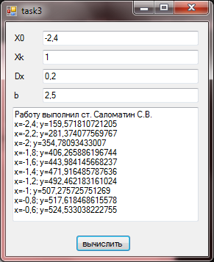

Вариант 10

y = x × sin( x + b - 0.0084),

x0 = -2.05;xk = -3.05;dx = -0.2; b = 3.4;

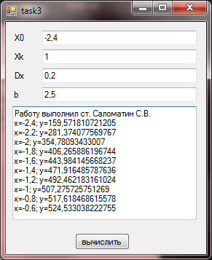

Вариант 12

y = 9(x3 + b3 )tgx,

x 0 = 1;xk = 2.2;dx = 0.2;

b = 3.2;

