Project Summary Paper: Work with YourTTS

Vilnius University
Faculty of Mathematics and Information Sciences
Data Science Master’s Program

By
Edgar Dževeckij

October 2026
Vilnius

Introduction

Context
This paper examines how the pretrained YourTTS model handles Lithuanian, a language it does not support. Lithuanian speech is first synthesised zero-shot and compared with English, then synthesised again after fine-tuning the model on Lithuanian recordings.

Methodology
The reference material that is used for the model is recorded and provided by the author. The replicated Lithuanian speech will be compared with a recorded English saying, serving as a benchmark of a language which is supported by the YourTTS model and its accompanying library.

Used Tools
The YourTTS model from the Coqui TTS library is run in Python 3.10.11 on a laptop with 32 GB of RAM and an 8 GB GPU. Following the principle of proportionality, the fine-tuning is scaled to these resources.

Applied Methods
Recordings in Lithuanian and English will be provided to the model to be synthesised and compared. The pretrained model synthesises both sentences, imitating the voice of the matching reference recording. The model is then fine-tuned on the Lithuanian training set and synthesises the Lithuanian sentence again.

Text to Speech Model Setup

The Pretrained TTS Model
As a brief description of the model in use covered by this paper, the YourTTS model is a speech synthesis model especially suited for zero-shot (ZS) multi-speaker text-to-speech. It is built upon the VITS model, with modifications that add multilingual and multi-speaker capabilities. Being considered a zero-shot model, it is suitable for use even with minimal training. For personal experiments, this model can be accessed via the dedicated python library.

Supported Languages
In this experiment, English and Lithuanian are the base languages used as reference data for the YourTTS model. The model supports English as a usable language, being one of the most wide-spoken languages on the planet. Lithuanian is a much smaller language in comparison. When reading the documentation and checking the available language selection via the given python library, it was established that Lithuanian was not a supported language, making high-quality zero-shot synthesis less comparable to natural speech. Additionally, the model takes the pronunciation rules and accent of a supported language when synthesising a language that is not supported, even going as far as dropping letters which are not found in its internal dictionary. Other supported languages for the model include French, and Portuguese (Brazilian dialect).

Zero-Shot Speech Synthesis (English)

Reference Recording Summary
For this experiment, the English phrase “This is a test of the speech synthesis system.” is recorded by the author and given to the pre-built YourTTS model as a reference observation. The recording used has the following characteristics:
Table 1.
Features of the English Clean Speech Audio
Feature | Value
Duration (s) | 4.693
Sampling rate (kHz) | 48 (converted to 16 kHz for comparison)
Format | WAV
Note. Compiled by author.

Author’s opinion on Model Performance
The single phrase is given to the model as an example and the model gives back the synthesised speech of the same phrase. The speech returned to the author in comparison is shorter in recording time. When it comes to the tone and voice characteristics of the recording, it can be heard that the voice used does not fully mimic the voice features recorded but are in turn a mixture of voices used in the training data. This can usually be attributed to larger models, as they have inputs from multiple speakers, so the synthesised result averages all input characteristics when outputting while still adding certain characteristics of the original input in the output returned.

Reference and Results Comparison
To compare the results of the original recording and the synthesised speech more objectively, visualisations like waveforms, magnitude spectra, and fundamental frequency contours can be compared. The scale of both speech samples shown are scaled to compare the amplitude frequency, and tone differences. Duration is only scaled for the F0 contour comparison to see how tone during word pronunciation differs. The synthesised speech possesses lower amounts of silent audio at the beginning of the recording, while the magnitude spectrum closely follows the natural speech audio. The magnitude dropoff in the natural recording just before the Nyquist frequency reflects the low-pass filter automatically applied when downsampling the recording, which avoids introducing aliasing artefacts. Another stark difference can be observed in the F0 contour plot, as the natural speech shows more dynamic movements in pitch, whereas the synthesised speech shows lower variability. This can be at least partly attributed to differences in how strongly different words and syllables are emphasised in the natural speech example.
Figure 1.
Waveform Comparison of Natural and Synthesised Speech (English)
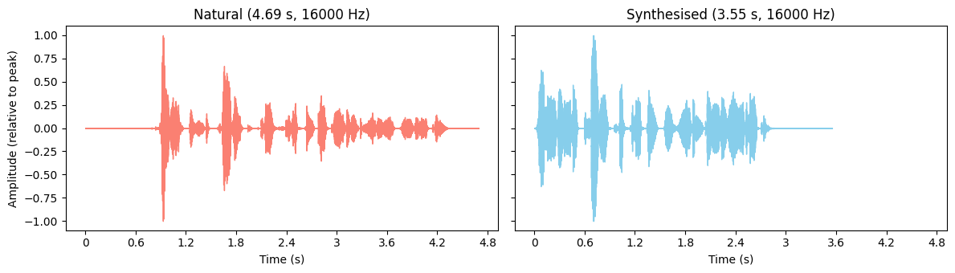
Note. The original recording of the author’s voice rescaled to fit the full amplitude scale. Compiled by author.
Figure 2.
Magnitude Spectrum Comparison of Natural and Synthesised Speech (English)
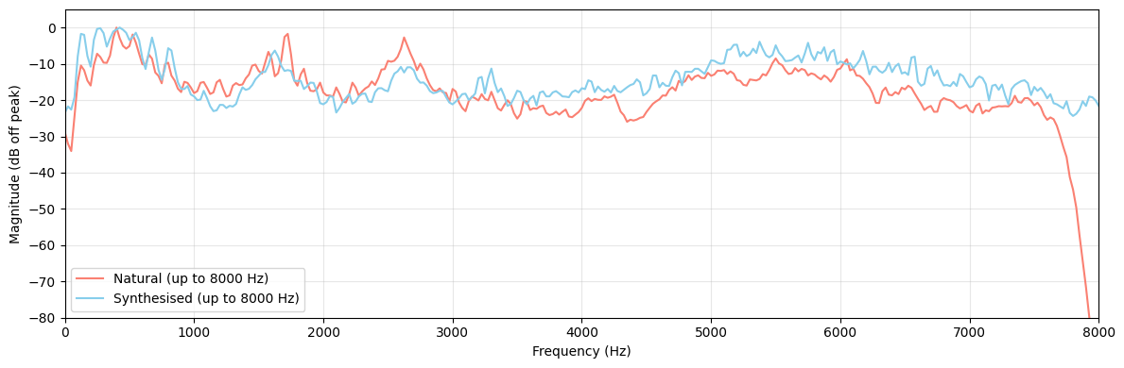
Note. The original recording of the author’s voice has been rescaled to possess the same sample rate as the original audio (16 kHz). Compiled by author.
Figure 3.
Spectrogram Comparison of Natural and Synthesised Speech (English)
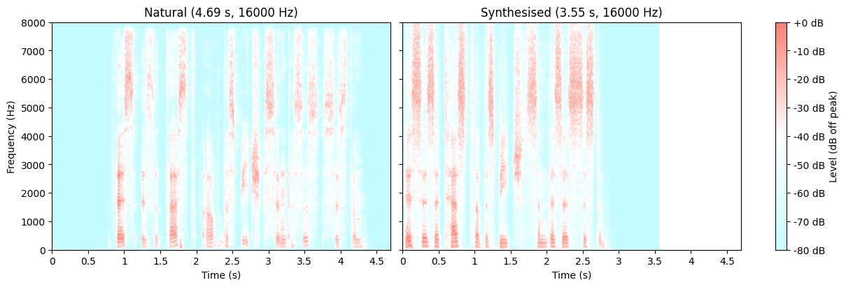
Note. The original recording of the author’s voice has been rescaled to possess the same sample rate as the original audio (16 kHz). Compiled by author.
Figure 4.
Normalised F0 Contour Comparison of Natural and Synthesised Speech (English)
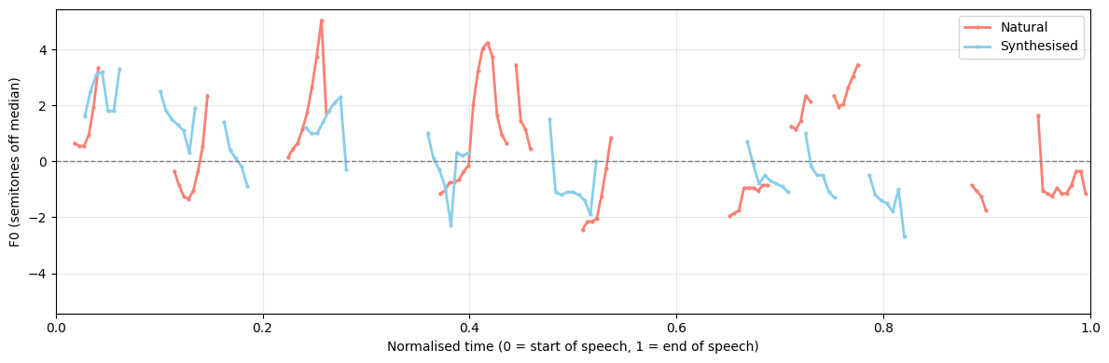
Note. Durations are normalised to account for recording duration differences between natural and synthesised speech, allowing for same-word comparison. Compiled by author.
Additionally, to visual differences, quantifiable differences of both audio files can be observed. Duration of both recordings varies from 3.553 for the synthesised speech to 4.693 for the real recording. Spectral characteristics also differ: the synthesised recording possesses a higher spectral, indicating a brighter timbre, and a higher RMS level, indicating greater signal energy, than the real recording. Regarding fundamental frequencies, the real recording possesses a higher F0 mean and lower variability than the synthesised recording.
Table 2.
Quantifiable Metric Comparison of Natural and Synthesised Speech Recordings (English)
Feature | Clean Speech | Synthesised Speech
Duration (s) | 4.693 | 3.553
Speech duration (s) | 3.435 | 2.848
Sampling rate (kHz) | 16 | 16
RMS level (dBFS) | - 40.311 | - 21.510
Spectral centroid (kHz) | 3.160 | 3.400
F0 mean (Hz) | 131.12 | 128.776
F0 std (Hz) | 13.912 | 10.704
Format | WAV | WAV
Note. Compiled by author.

Zero-Shot Speech Synthesis (Lithuanian)

Reference Recording Summary
To experiment with how the model perceives audio in a different language, an additional Lithuanian phrase “Tai yra šnekos sintezės sistemos testas.”, recorded by the author, is given to the same model as a reference. The single recording has the following characteristics:
Table 3.
Features of the Lithuanian Clean Speech Audio
Feature | Value
Duration (s) | 5.163
Sampling rate (kHz) | 48 (converted to 16 kHz for comparison)
Channels | 2
Format | WAV file
Note. Compiled by author.

Author’s opinion on Model Performance
Given that Lithuanian is not a supported language for the YourTTS model, the model returns the synthesised Lithuanian recording with a hearable English accent. The model was deemed to not sound that similar to the author, again, carrying the aggregated voice characteristics of the speakers that trained the model, plus trying to mimic the author.

Reference and Results Comparison
Just like with the English language comparison, the performance of the synthesised speech compared to the original recording is plotted using waveforms, magnitude spectrum plots, spectrograms, normalised F0 contour maps, and compared via quantifiable metrics. The following plots and table can be found in Appendix A, with the same format and order as seen in the previous paper segment.
When comparing visual plots, the synthesised speech is shorter than the natural recording, possessing less of the initial silence period observed at the beginning of the natural speech recording, as well as shorter and more uniform gaps between words. Regarding tone, the model’s F0 contour shows less overall pitch range than natural speech, though with more frequent local pitch fluctuations within each individual word. Opposed to the natural recording, individual words show a declining pitch pattern throughout the sentence, whereas the natural speech either only increases or decreases within a single word.
When examining the quantifiable characteristics such as spectral differences, the synthesised speech shows a higher RMS level, though this may reflect microphone distance and recording conditions of the natural speech recording rather than the synthesis itself. For fundamental frequency, the synthesised speech shows a slightly lower mean and significantly lower variability, indicating more monotonal speech with less emphasis on individual syllables: likely a consequence of the model’s limited support for Lithuanian phonology without additional training.

Experimenting With a Lithuanian Dataset

Lithuanian Emotional Speech Corpus (EMO)
To try to improve the performance of Lithuanian speech synthesis, the Lithuanian Emotional Speech Corpus can be used as additional training material for the YourTTS model. The corpus itself carries high quality audio of varying speakers and emotions, making it a linguistically rich dataset. Given the concept of the proportionality and the goal of the project, only a part of a single archive of the corpus (archive_009) will be utilised as training data.

Selected Speaker and Emotion
To further segment the scope of the training data, shortening training times, only one combination of speaker and emotion is chosen. The speaker chosen for the experiment is the one that possesses the longest total duration of recordings present in the archive_009 folder. With a total duration of 16.4 minutes across 192 recordings, speaker 29, possessing the “Surprise” emotion, is the chosen speaker. The main audio parameters of the chosen speaker’s audio recordings can be observed in the table below:
Table 4.
Main Audio Parameters for the Selected Speaker and Emotion
Feature | Value
Total duration (min) | 16.39
Average duration (s) | 5.12
Minimum duration (s) | 0.96
Maximum duration (s) | 7.98
Sampling rate (kHz) | 96
Bit depth | 24
Channels | 1
Format | WAVEX file
Recordings (#) | 192
Note. Compiled by author.
When exploring the durations of the recordings chosen, durations wary from 0.96 seconds for the shortest recording to 7.98 seconds for the longest. Average recording duration stands at 5.12 seconds. When analysing all recording durations, the following histogram can be drawn, with recording duration on the x-axis and recording quantity on the y-axis:
Figure 5.
Recording Duration Distribution for Speaker 29 With the "Surprise" Emotion
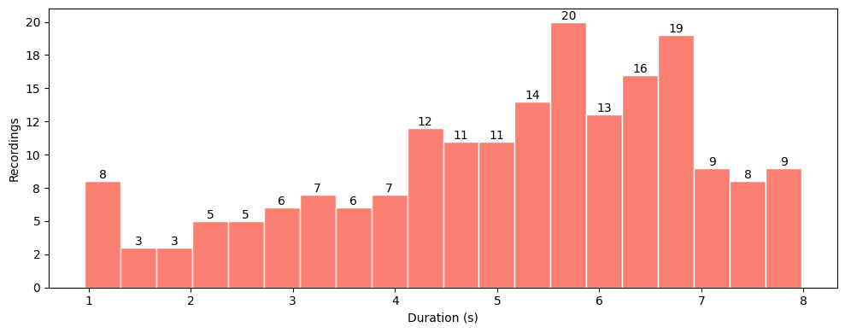
Note. Compiled by author.

Training/Testing Sets
The selected number of recordings are split into training (90%) and test (10%) sets. The training sample contains 172 recordings, while the validation sample contains 20 recordings. Recording duration within each sample also lies within the 90% range for the test set and 10% for the validation set. A visual representation of the recording quantity and duration distribution per subsample can be observed below with a table of main numeric characteristics:
Figure 6.
a) Recording Quantity per Sample Type. b) Recording Duration Distribution by Sample Type
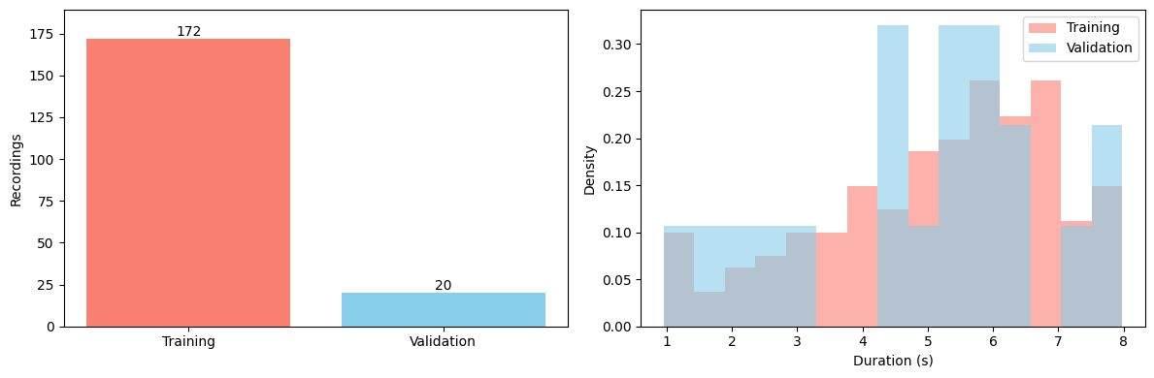
Note. Compiled by author.
Table 5.
Recording Quantity and Duration Characteristics by Sample Type
Split | Recordings | Total Duration (min) | Average Duration (s)
Training | 172 | 14.762 | 5.150
Validation | 20 | 1.624 | 4.872
Note. Compiled by author.

Additional Task Fine-Tuning YourTTS

Additional Training Data
In the zero-shot experiment, the pretrained model synthesised Lithuanian speech with English pronunciation rules, producing an accent and omitting letters it could not interpret. Fine-tuning addresses this by training the initiated model on Lithuanian speech data. The training set prepared from the Lithuanian Emotional Speech Corpus is used for this experiment, which was prepared in the previous chapter.
Before starting the tuning process, the data is additionally adapted to the trained model:
- The recordings are converted from 96 kHz to 16 kHz, the sampling frequency YourTTS works with;
- A speaker embedding is computed for every recording with the model's own speaker encoder;
- Six Lithuanian letters missing from the model's vocabulary (č, ė, į, š, ų, ž) are added, together with a new language label, lt. These start untrained, while all other weights come from the pretrained model.

Model Fine-Tuning
The model is trained with the trainer of the Coqui TTS library, using the settings YourTTS was originally trained with. In line with the principle of proportionality, two settings are reduced to suit the hardware available. The batch size is lowered given constraints on the amount of GPU memory being used, and the number of epochs is lowered to 100 (1000 is referenced within the Coqui TTS model training recipe) to keep the training time reasonable.
Table 6.
Main Model Training Parameters
Parameter | Value
Training / validation samples | 172 / 20
Epochs | 100
Batch size | 16
Optimiser | AdamW
Loss Function | Mel spectrogram loss
Learning rate | 0.0002
Note. Compiled by author.
After every epoch, the model is evaluated on the validation recordings using the mel spectrogram loss: the difference between the mel-spectrograms of the real and the generated speech. The weights from the epoch with the lowest validation loss are kept as the final model, so training for longer than needed does not make the kept model worse. No hyperparameter search is performed. With more time and computing power, tuning settings such as the learning rates and loss weights could improve the results further. To observe the progress of how well the model was adjusted after every epoch, the change in mel spectrogram loss and total generator loss are plotted. Key epoch loss numbers are also displayed. Epoch 67 presented the lowest amount of loss and is considered the best model parameter configuration. This configuration is saved and will be used for further speech synthesis on the same Lithuanian phrase as used before when zero-shooting. Total training time equated to 168.8 minutes.
Figure 7.
Model Loss Curves After Each Training Epoch
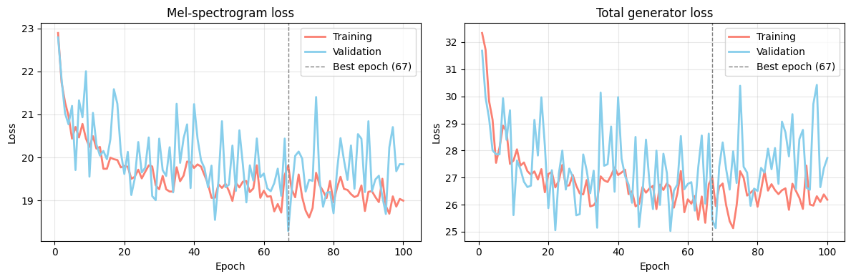
Note. Compiled by author.
Figure 8.
Loss Comparison Between Epochs
Epoch | Training Loss (Mel) | Validation Loss (Mel) | Training Loss (Total) | Validation Loss (Total)
First | 22.895 | 22.794 | 32.337 | 31.682
Best (67th) | 19.811 | 18.288 | 27.012 | 25.438
Last | 18.994 | 19.841 | 26.184 | 22.721
Note. Compiled by author.

Author’s opinion on Model Performance
Regarding the newly synthesised Lithuanian phrase, the fine-tuned model shows a noticeable improvement in output quality and sounds more natural. Since training was conducted on a corpus of recordings not voiced by the author, the model appears to have absorbed fragments of the training speakers’ vocal characteristics. As a result, traces of the underlying training data remain perceptible in the output . Compared to the pre-fine-tuning synthesised speech, this difference is noticeable, though the output still lacks certain pronunciation features, which could likely be improved with additional training data and further training time.

Reference and Results Comparison
The additionally trained and fine-tuned model is prompted to regenerate the test phrase “Tai yra šnekos sintezės sistemos testas.” The following graphs present a visual comparison against the natural speech recording created by the author, covering waveform, magnitude spectrum, spectrogram, and F0 contour comparisons. An additional quantifiable metric comparison, covering duration, sampling rate, tonal, and loudness measures, aggregates results across three conditions: the natural recording, the benchmark synthesised speech prior to being trained, and the tuned model following fine-tuning on the chosen part of the Lithuanian EMO dataset. Plots and quantifiable characteristics are presented in Appendix B.

Conclusions
From the completed experiments, the following conclusions can be reached:
- The YourTTS model provides functional zero-shot speech synthesis capabilities for all languages, even if they are not supported. In that case, the model adapts the pronunciation rules and characters used in a supported language and returns legible speech. The quality of said speech can be varied. In the case of Lithuanian speech synthesis, the generated speech possessed a strong foreign accent and the voice used was perceived to not be similar to the given reference, rather an aggregation of training voices used in a supported model language.
- The fine-tuning process, in the author’s opinion, improved the results of Lithuanian speech synthesis significantly, even when training on limited training data. The improvement could also be seen in quantifiable terms: compared to the zero-shot synthesised speech, the fine-tuned output showed gaps between words that more closely resembled the natural recording, alongside more emphasised and varied pronunciation, and greater similarity between the natural and fine-tuned mel spectrograms, the optimised loss function during the fine tuning.
If the further goal of this experiment is to improve the quality of Lithuanian speech synthesis, additional training data can be provided to the model to learn additional pronunciation rules and add missing characters (ą, ę, ū) that were not used in the provided training data. Additionally, the YourTTS model can further be tuned to different hyperparameters, which can result in improved synthesis performance and higher perception of natural speech.

Appendix A: Comparison of Natural and Synthesised Speech (Lithuanian)
Figure 9.
Waveform Comparison of Natural and Synthesised Speech (Lithuanian)
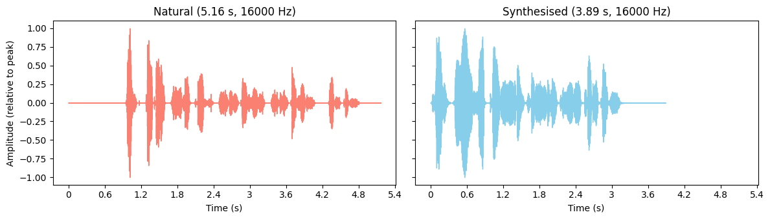
Note. Compiled by author.
Figure 10.
Magnitude Spectrum Comparison of Natural and Synthesised Speech (Lithuanian)
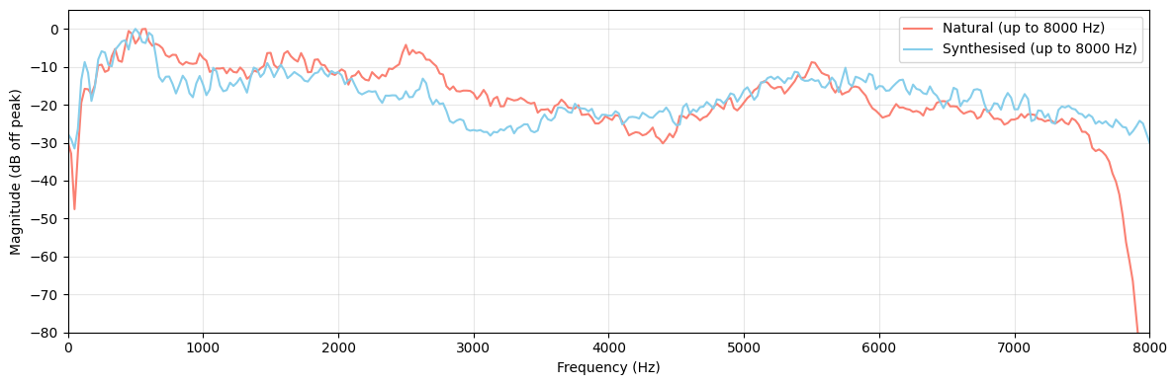
Note. Line plots plotted together to show differences in frequency and magnitude. Compiled by author.
Figure 11.
Spectrogram Comparison of Natural and Synthesised Speech (Lithuanian)
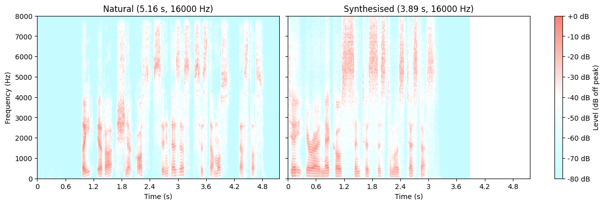
Note. Scale of spectrogram is uniform to show differences in duration and frequency. Compiled by author.
Figure 12.
Normalised F0 Contour Comparison of Natural and Synthesised Speech (Lithuanian)
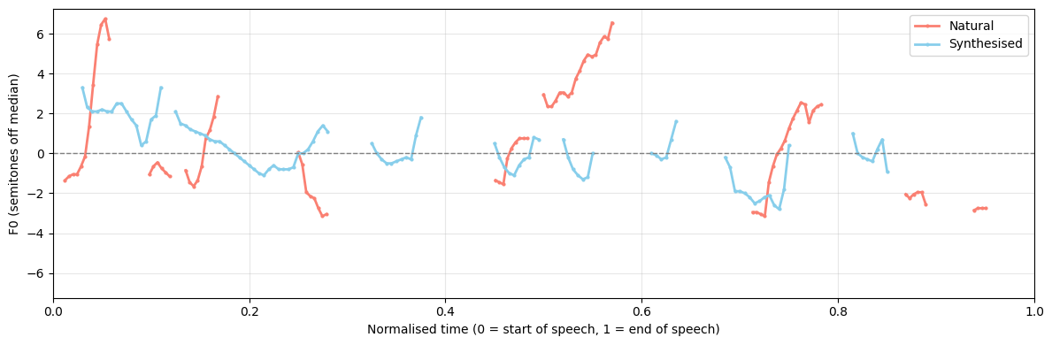
Note. Durations are normalised to account for length differences between natural and synthesised speech. Compiled by author.
Table 7.
Quantifiable Metric Comparison of Natural and Synthesised Speech Recordings (Lithuanian)
Feature | Clean Speech | Synthesised Speech
Duration (s) | 5.163 | 3.889
Speech duration (s) | 3.904 | 3.200
Sampling rate (kHz) | 16 | 16
RMS level (dBFS) | - 42.598 | - 20.037
Spectral centroid (kHz) | 3.011 | 3.183
F0 mean (Hz) | 126.893 | 124.521
F0 std (Hz) | 20.932 | 9.451
Note. Compiled by author.

Appendix B: Comparison of Natural, Synthesised, and Fine-Tuned Speech (Lithuanian)
Figure 13.
Waveform Comparison of Natural and Fine-Tuned Speech (Lithuanian)
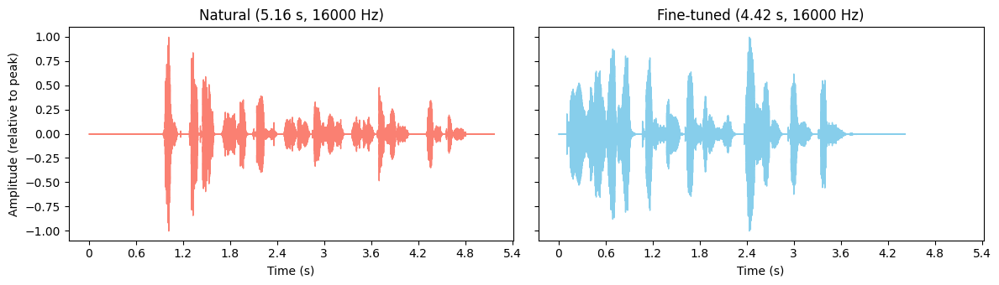
Note. Compiled by author.
Figure 14.
Magnitude Spectrum Comparison of Natural and Fine-Tuned Speech (Lithuanian)
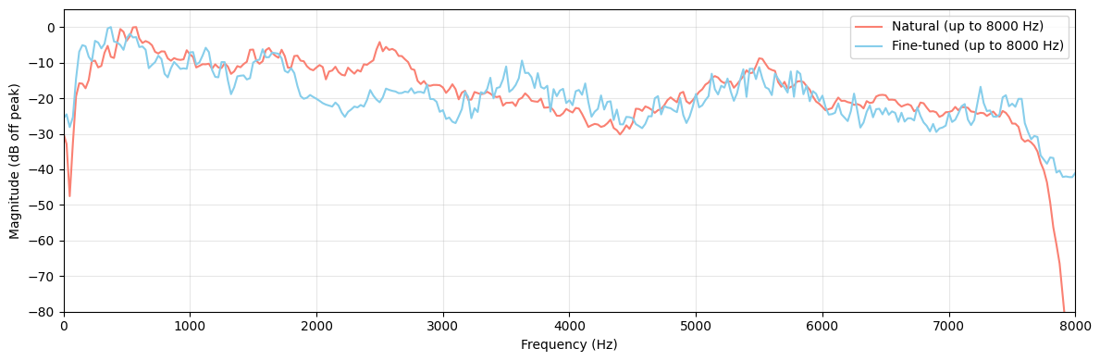
Note. Line plots plotted together to show differences in frequency and magnitude. Compiled by author.
Figure 15.
Spectrogram Comparison of Natural and Fine-Tuned Speech (Lithuanian)
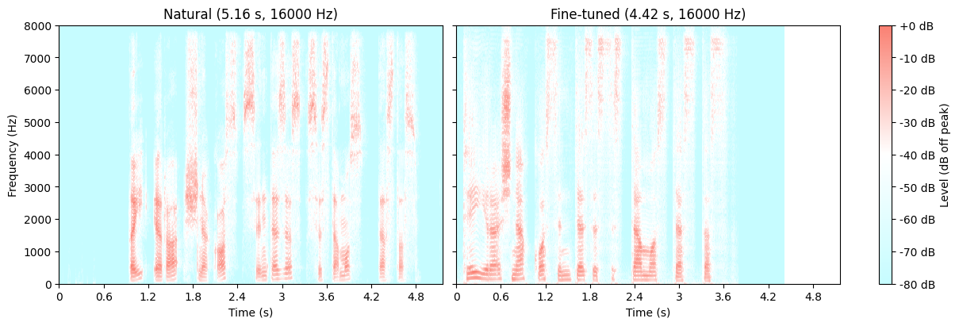
Note. Scale of spectrogram is uniform to show differences in duration and frequency. Compiled by author.
Figure 16.
Normalised F0 Contour Comparison of Natural and Fine-Tuned Speech (Lithuanian)
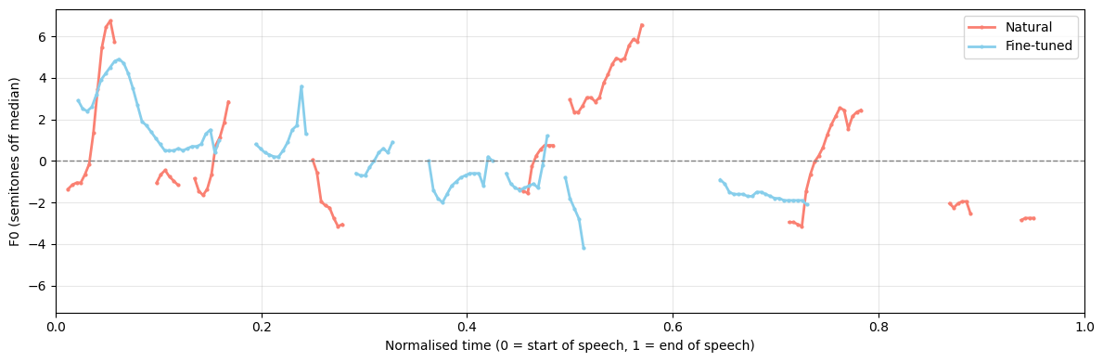
Note. Durations are normalised to account for length differences between natural and synthesised speech. Compiled by author.
Table 8.
Comparison of Natural, Synthesised and Fine-Tuned Speech Instances (Lithuanian)
Feature | Natural Speech | Synthesised Speech | Fine-Tuned Speech
Duration (s) | 5.163 | 3.889 | 4.417
Speech duration (s) | 3.904 | 3.200 | 3.616
Sampling rate (kHz) | 16 | 16 | 16
RMS level (dBFS) | - 42.598 | - 20.037 | -18.749
Spectral centroid (kHz) | 3.011 | 3.183 | 2.963
F0 mean (Hz) | 126.893 | 124.521 | 141.00
F0 std (Hz) | 20.932 | 9.451 | 15.888
Note. Compiled by author.

Appendix X: Source Code Used to Complete Analyses, Draw Plots and Tables

