Project Summary Paper: 10-Word Speech Recognition

Vilnius University
Faculty of Mathematics and Information Sciences
Data Science Master’s Program

By
Edgar Dževeckij

October 2026
Vilnius

Introduction

Context
This paper describes the process of building a machine learning model that classifies individual spoken words from the Google Speech Commands dataset, covering data preparation, model architecture and training. It then summarises the model's performance when tested under different speech conditions.

Used Tools
A Convolutional Neural Network (CNN) is selected for its ability to extract discriminative features from 2D spectrogram representations while providing an appropriate balance between classification performance and computational efficiency. The CNN architecture is based on the python’s programming language library “Torch”, which is one of the most versatile and widely used libraries for creating various types of neural networks.

Applied Methods
The total dataset will be split into a training and test sample. Each of the samples created will contain at all unique words, but no speaker overlap is allowed between training and test sets. The training sample will be used to train the machine learning methods chosen for analysis and the testing dataset recognition results will be compared at the end. The grouping of samples into distinct datasets will not include replacement to not allow the possibility for duplicate observations. This will make the predictions of the algorithm bias. On the contrary, this will limit the amount of training and testing data available is limited, which might lead to overfitting on an extremely small number of examples. As for comparing results of how well the model is able to classify the words spoken in different noise conditions, accuracy, precision and recall are used as the main performance benchmarks. These metrics are supported by average prediction probability to see how certain the CNN at the time of making its predictions.

Dataset Preparation

Data Description
The data analysed contains audio sample observations of 10 unique spoken words from 5 distinct speakers. The audio files are extracted from the Google Speech Commands Dataset. Each speaker recorded every word exactly 5 times, so each word has 25 recordings, 250 recordings in total. Audio file metadata variables were used to deduct the word and speaker of each audio file. These variables will be encoded as labels to be able to correctly split the training and testing datasets and to train the model properly.
Words chosen for the experiment represent numbers being spoken, with the number range being from 0-9(e.g. 0 is spoken as “zero”, 1 as “one”, and so on). Sampling frequency used is 16 kHz for all recordings.
A single speaker is chosen at random as the dedicated test speaker while all other speakers will be used as the training data for the model.

Data Collection and Quality Control
A side script written in Python was executed to identify speakers who had at least five distinct recordings for a given word. Unique combinations of these speakers were then searched to identify groups with sufficient recordings across shared words. As some of the most complete words in the dataset were number being spoken, this process identified speakers who had recorded all ten numbers, resulting in the final analysis sample. This resulted in a total sample of 5 distinct speakers with all ten words being recorded (no missing observations). Additionally, each speaker recorded the same word fives times. Regarding recording uniformity, all recordings have the same length and sample ratio.

Feature Extraction

Feature Extraction Pipeline
Given that CNNs need a 2D representation of the data, observations will be converted into log-mel spectrograms before training and testing the outlined model. Mel spectrograms are derived from regular spectrograms by applying triangular mel filters, warping the image differently at low and high frequencies. They are suitable for the CNN because its small convolution filters slide over the spectrogram and respond to local time–frequency patterns.
It also takes care of dimension reduction, minimising computation complexity. A logarithmic transformation is applied on the base mel spectrogram. At this step, the “speaker” and “word” labels are carried over until the train-test split step. The following data processing and feature extraction pipeline:
- Recordings are loaded at their native sampling frequency and are the same length (1 s).
- Signals are split into overlapping 25 ms frames taken every 10 ms, ensuring speech stationarity. Each frame is multiplied by a Hann window, reducing spectral leakage.
- Frames are zero-padded and transformed with the FFT into a power spectrum (257 bins, 31.25 Hz apart).
- The power spectrum is passed through 64 triangular mel filters spanning from 0 Hz to the Nyquist frequency (8 kHz). 64 bands is chosen as a multiple of 16 (representing 16 kHz speech), which is detailed enough to show the vowel formants and consonant noise.
- The mel powers are converted to decibels relative to the loudest time-frequency bin of the same recording. This removes differences in overall loudness while applying the log transformation.
- The log-mel values are standardised with the mean and standard deviation of the training set.
From the log-mel spectrogram below it can be observed that some consonants carry especially high frequency cues, showing up as sudden tall peaks on the log-mel spectrogram. Another obvious part of the word is the gap in frequencies when a silent letter is meant to be spoken.
Figure 1.
Sample Mel Spectrogram Obtained from Audio File Feature Extraction
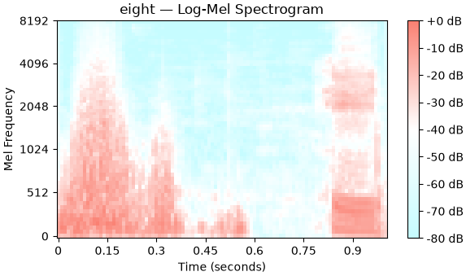
Note. X-axis: recording length, Y-axis: frequency, colour: signal strength in decibels (dB). Compiled by author. Source: Google Speech Commands dataset.

Model selection

Convolutional Neural Networks
A convolutional neural network (CNN) is a neural network designed for grid-like data such as images. Each recording is converted into a log-mel spectrogram of 64 mel bands × 101 time frames. The CNN treats it as a single-channel image.
The network learns its weights through backpropagation. The prediction error (cross-entropy loss) is passed backwards from the output layer to the first layer to find how much each weight contributed to it. The Adam optimiser, with a learning rate of 0.001, then updates the weights. Training runs for 10 epochs with batches of 16 recordings.
The network has five convolutional blocks, each made of the same four layers:
- Convolutional layer: slides 3 × 3 filters over the input to detect local patterns in time and frequency. Padding of 1 keeps the map size unchanged. The number of filters doubles in each block, so deeper blocks can capture more complex patterns.
- Batch normalisation: normalises each filter's output over the batch, which makes training more stable and faster.
- ReLU: sets negative values to zero (max(0, x)) while keeping positive numbers unchanged. This adds the non-linearity the network needs to learn more than linear combinations of its input.
- Max pooling: keeps only the highest value in each 2 × 2 area, which halves the height and width of the feature maps. This reduces computation and makes the features less sensitive to small shifts.
Together, the five blocks reduce the input from 64 × 101 to a 128 × 2 × 3 feature map. This map is flattened into 768 values and passed through dropout (p = 0.3) to reduce overfitting. A fully connected layer then maps these values to 10 outputs, one per word, and a softmax function turns them into class probabilities.

Model Implementation

Model Training
The model is trained across 10 epochs to see the improvement of accuracy and cross-entropy (loss function) between different epochs. The Adam optimiser is chosen with a learning rate of 0.001. Accuracy peaks and is maintained starting in epoch 8, and at epoch 10 loss of the estimates has reached an almost indistinguishable improvement compared to the last training run.
Figure 2.
Model Training Loss and Accuracy Dynamics Across Training Epochs
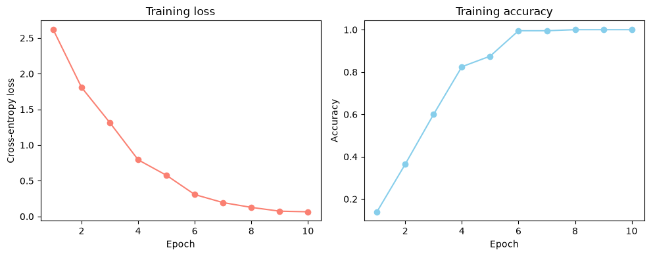
Note. Model initiated and result charts compiled by author.
Although testing is expected to take place not only on clean speech, but also noisy speech, training does not include the addition of noise with the goal of observing how a model tested on high quality speech is able to distinguish it in noisy environments.

Model Testing and Evaluation
The unused recordings are tested to observe the ability to distinguish speech of the same words spoken by a different speaker. An example confusion matrix for one noise condition is provided below.
Figure 3.
Confusion Matrix for Clean Speech Testing Predictions
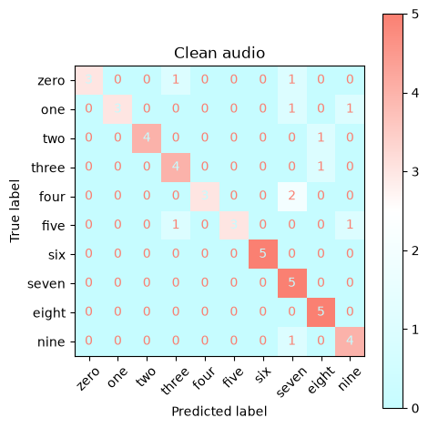
Note. Other produced confusion matrices with supplementary prediction probability distributions for all different conditions can be found in the appendices and project code. Model initiated and result charts compiled by author.

Applying Noise
Various types and intensities of noise are applied to the clean speech recordings to observe how the classification power of the model changes. Types of noise introduced include Gaussian white noise, pink noise, and real world rain noise on top of the clean speech recording. SNR intensities applied include 30dB, 20dB, 10dB, and 0dB.
When looking at how different noise conditions visually obstruct the clean speech, it can be observed that there are additional fluctuations in the waveform and more static in the spectrogram, which makes the differences between low and high frequency regions. Results for all combinations of noise type and intensity can be found within the project code or the appendices.
Figure 4.
Waveform Comparison Between Clean and Noisy Speech
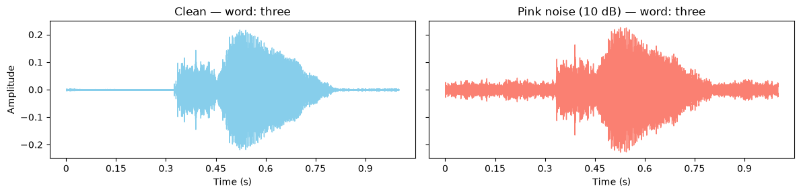
Note. Other examples of comparison between clean speech and speech under different noise conditions can be found in the appendices and project code. Model initiated and result charts compiled by author.
Figure 5
Mel Spectrogram Comparison Between Clean and Noisy Speech
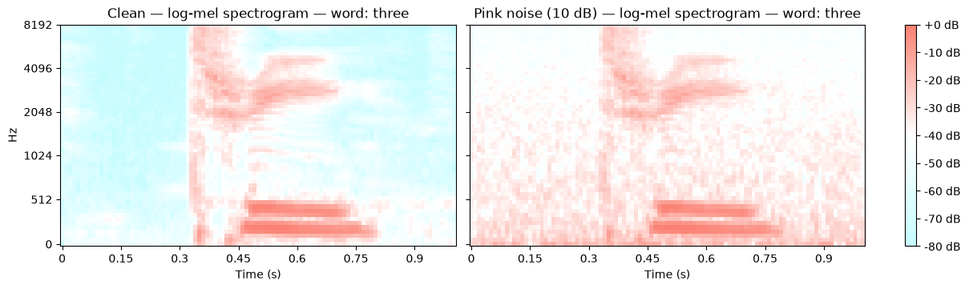
Note. Other examples of comparison between clean speech and speech under different noise conditions can be found in the appendices and project code. Model initiated and result charts compiled by author.

Results Comparison
Given the model was trained on original recordings with no additional noise or disturbances, the highest accuracy was reached when testing on clean recordings (78%). It also possessed the lowest share of false positives and the highest share of true positives (precision and recall). Given the significant difference in accuracy compared to model training, it indicates a possible overfitting problem, even though dropout was employed. Prediction accuracy slightly increases when strong noise is applied, but the model just defaults to guessing one single class (“zero”) every time. Results for the top performing noise conditions are given in the table below. Full results table can be found in the appendices.
Table 1.
Results Comparison Under Different Noise Conditions
Speech Type | Accuracy | Precision | Recall | Average Prediction Probability
Clean Speech | 0.78 | 0.85 | 0.78 | 0.62
Pink Noise (30 dB) | 0.62 | 0.65 | 0.62 | 0.59
Rain Noise (30 dB) | 0.46 | 0.51 | 0.46 | 0.59
Rain Noise (20 dB) | 0.42 | 0.23 | 0.42 | 0.54
Note. Results are sorted by overall prediction accuracy first and precision second. Compiled by author.
When looking at how different noise types impacted the evaluation metrics, applying pink noise had the least downward effect when small amounts of noise were added, white was generally the most hindering, and the real life noise addition had the lowest change in hinderance when switching between different amounts of noise.
When exploring how difficult it was to guess one word or the other, models that did not guess one singular word had a better time at guessing numbers “three”, “six”, “seven”, “eight”, “nine” and guessed worse on “zero”, “one”, “four”, “five”. Some of this guess might be attributed to existence of stops and sibilants for the more often guessed words and approximants and fricatives for the lesser guessed words, impacting the general noise level or bursts of noise produced by different words. Additionally, collection of audio on a large scale cannot be completed only on state of the art audio conditions, so the general recording conditions of each speaker can also be a factor.
Table 2.
Prediction Accuracy for Each Number Under Different Noise Conditions
Speech Type | zero | one | two | three | four | five | six | seven | eight | nine
Clean Speech | 0.6 | 0.6 | 0.8 | 0.8 | 0.6 | 0.6 | 1.0 | 1.0 | 1.0 | 0.8
Pink Noise (30 dB) | 1.0 | 0.0 | 0.6 | 0.8 | 0.6 | 0.6 | 1.0 | 0.6 | 0.2 | 0.8
Rain Noise (30 dB) | 0.8 | 0.0 | 0.0 | 0.6 | 0.2 | 0.6 | 1.0 | 0.4 | 0.2 | 0.8
Rain Noise (20 dB) | 1.0 | 0.0 | 0.0 | 0.8 | 0.0 | 0.8 | 1.0 | 0.0 | 0.0 | 0.6
Note. Results are sorted by overall prediction accuracy first and precision second. Compiled by author.
When looking at most confused words, excluding single-guess model tests, less noise translated generally into less confusion. Under small amounts of noise, recordings with real world noise are confused less often, with the most severe case being that “eight“ is guessed as “three“, “one“ guessed as “five“, and “two“ guessed as “six“. Under heavy noise, multiple words for each noise type confuse all instances of a single word. The detailed table of confusions, containing total number of confusions and most confused word pairs, is provided within the appendices.
Table 3.
Most Confused Words Under Different Noise Conditions
Speech Type | Errors | Most Confused | 2nd Most Confused | 3rd Most Confused
Clean Speech | 11 | “four” as “seven” | “five” as “nine” | “five” as “three”
Pink Noise (30 dB) | 19 | “eight” as “three” | “one” as “five” | “one” as “nine”
Rain Noise (30 dB) | 27 | “eight” as “three” | “one” as “five” | “two” as “six”
Rain Noise (20 dB) | 29 | “eight” as “three” | “seven” as “zero” | “four” as “zero”
Note. Results are sorted by overall prediction accuracy first and precision second. Compiled by author.

Conclusions
From the completed experiments, the following conclusions can be reached:
- Given a small number of observations in the overall dataset, overfitting is most likely causing training to appear greater than the practical results that can be achieved in the testing phase.
- The shift in model results when different noise conditions are applied scales with the intensity of the noise overlayed. The best results are observed when real world noise is applied, which may be connected to the existence of natural noise in the clear speech recording which the model is trained on.
- When exploring which numbers are guessed more often, it appears that numbers containing stops and sibilants are recognised better in different noise conditions, showing more distinctive features even observed with visual mel spectrograms.
If the further goal of this experiment is to increase the performance of classification under different noise conditions, an addition of observations is crucial to reduce bias and improve accuracy. Additionally, adding additional convolution layers and increasing model complexity is possible, allowing to uncover more features within the data.

Appendix A: Evaluation Metric Summary by Noise Conditions
Table 4.
Full Results Comparison Under Different Noise Conditions
Speech Type | Accuracy | Precision | Recall | Average Prediction Probability
Clean Speech | 0.78 | 0.855 | 0.78 | 0.617
Pink Noise (30 dB) | 0.62 | 0.648 | 0.62 | 0.588
Rain Noise (30 dB) | 0.46 | 0.509 | 0.46 | 0.588
Rain Noise (20 dB) | 0.42 | 0.231 | 0.42 | 0.541
White Noise (30 dB) | 0.40 | 0.404 | 0.40 | 0.595
Pink Noise (20 dB) | 0.38 | 0.211 | 0.38 | 0.571
White Noise (20 dB) | 0.34 | 0.242 | 0.34 | 0.553
Rain Noise (10 dB) | 0.22 | 0.212 | 0.22 | 0.625
Pink Noise (10 dB) | 0.20 | 0.111 | 0.20 | 0.733
White Noise (10 dB) | 0.20 | 0.095 | 0.20 | 0.693
White Noise (0 dB) | 0.10 | 0.010 | 0.10 | 0.854
Pink Noise (0 dB) | 0.10 | 0.010 | 0.10 | 0.925
Rain Noise (0 dB) | 0.10 | 0.010 | 0.10 | 0.735

Appendix B: Per-Word Prediction Probability by Noise Condition
Table 5.
Full Prediction Accuracy for Each Number Under Different Noise Conditions
Speech Type | zero | one | two | three | four | five | six | seven | eight | nine
Clean Speech | 0.6 | 0.6 | 0.8 | 0.8 | 0.6 | 0.6 | 1.0 | 1.0 | 1.0 | 0.8
Pink Noise (30 dB) | 1.0 | 0.0 | 0.6 | 0.8 | 0.6 | 0.6 | 1.0 | 0.6 | 0.2 | 0.8
Rain Noise (30 dB) | 0.8 | 0.0 | 0.0 | 0.6 | 0.2 | 0.6 | 1.0 | 0.4 | 0.2 | 0.8
Rain Noise (20 dB) | 1.0 | 0.0 | 0.0 | 0.8 | 0.0 | 0.8 | 1.0 | 0.0 | 0.0 | 0.6
White Noise (30 dB) | 0.6 | 0.0 | 0.0 | 0.4 | 0.2 | 0.6 | 1.0 | 0.4 | 0.0 | 0.8
Pink Noise (20 dB) | 1.0 | 0.0 | 0.0 | 0.4 | 0.0 | 0.6 | 1.0 | 0.0 | 0.0 | .8
White Noise (20 dB) | .8 | 0.0 | 0.0 | 0.4 | 0.0 | 0.8 | 1.0 | 0.0 | 0.0 | .4
Rain Noise (10 dB) | 1.0 | 0.0 | 0.0 | 0.0 | 0.0 | 0.6 | 0.6 | 0.0 | 0.0 | 0.0
Pink Noise (10 dB) | 1.0 | 0.0 | 0.0 | 0.0 | 0.0 | 0.0 | 1.0 | 0.0 | 0.0 | 0.0
White Noise (10 dB) | 1.0 | 0.0 | 0.0 | 0.0 | 0.0 | 0.0 | 1.0 | 0.0 | 0.0 | 0.0
White Noise (0 dB) | 1.0 | 0.0 | 0.0 | 0.0 | 0.0 | 0.0 | 0.0 | 0.0 | 0.0 | 0.0
Pink Noise (0 dB) | 1.0 | 0.0 | 0.0 | 0.0 | 0.0 | 0.0 | 0.0 | 0.0 | 0.0 | 0.0
Rain Noise (0 dB) | 1.0 | 0.0 | 0.0 | 0.0 | 0.0 | 0.0 | 0.0 | 0.0 | 0.0 | 0.0

Appendix C: Most Confused Words by Noise Conditions
Table 6.
Full Most Confused Words Under Different Noise Conditions
Speech Type | Errors | Most Confused | 2nd Most Confused | 3rd Most Confused
Clean Speech | 11 | “four” as “seven” | “five” as “nine” | “five” as “three”
Pink Noise (30 dB) | 19 | “eight” as “three” | “one” as “five” | “one” as “nine”
Rain Noise (30 dB) | 27 | “eight” as “three” | “one” as “five” | “two” as “six”
Rain Noise (20 dB) | 29 | “eight” as “three” | “seven” as “zero” | “four” as “zero”
White Noise (30 dB) | 30 | “two” as “six” | “one” as “five” | “eight” as “three”
Pink Noise (20 dB) | 31 | “seven” as “zero” | “four” as “zero” | “three” as “six”
White Noise (20 dB) | 33 | “two” as “six” | “eight” as “six” | “nine” as “zero”
Rain Noise (10 dB) | 39 | “eight” as “zero” | “four” as “zero” | “nine” as “zero”
Pink Noise (10 dB) | 40 | “eight” as “zero” | “five” as “zero” | “four” as “zero”
White Noise (10 dB) | 40 | “eight” as “zero” | “four” as “zero” | “nine” as “zero”
White Noise (0 dB) | 45 | “eight” as “zero” | “five” as “zero” | “four” as “zero”
Pink Noise (0 dB) | 45 | “eight” as “zero” | “five” as “zero” | “four” as “zero”
Rain Noise (0 dB) | 45 | “eight” as “zero” | “five” as “zero” | “four” as “zero”

Appendix D: Waveform Representations of Different Words
Figure 6
Waveform Representations of Different Words Used for Word Recognition
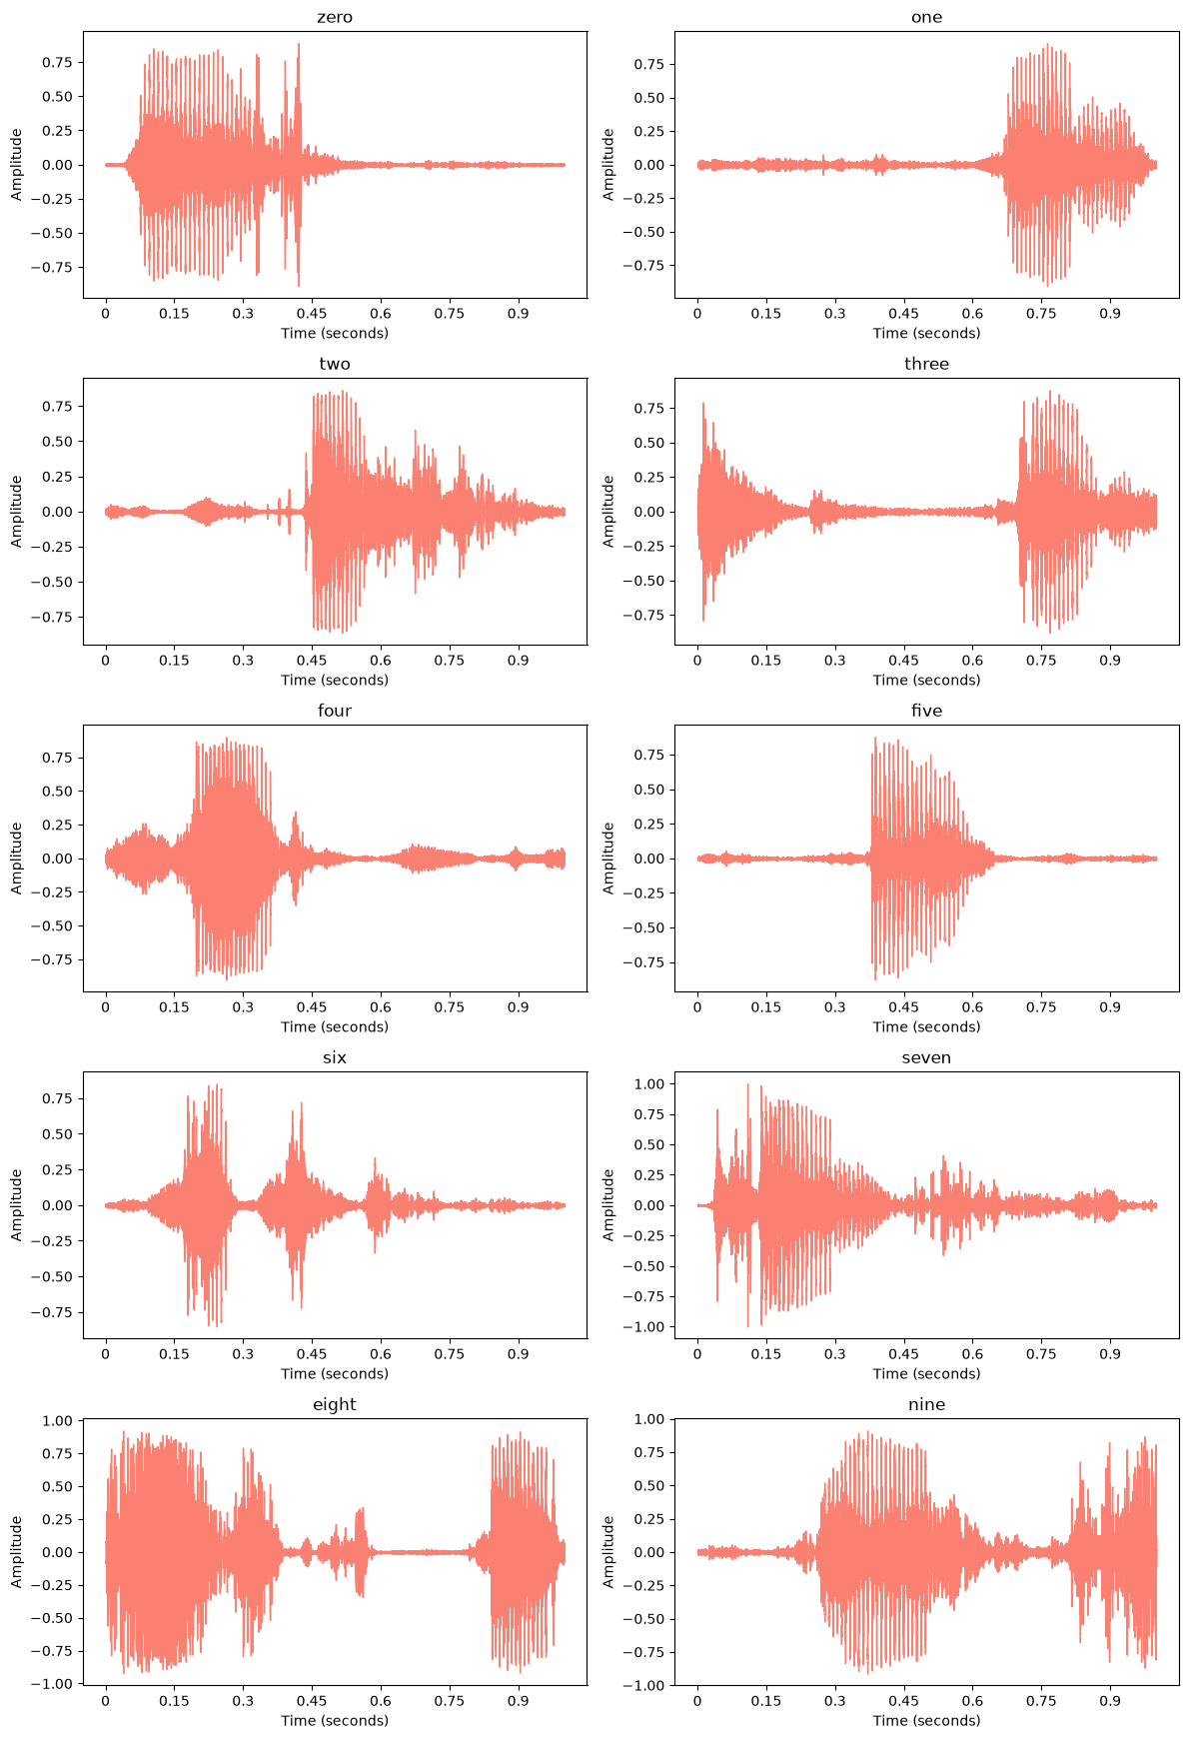

Appendix E: Frequency Domain Representations of Different Words
Figure 7.
Frequency Domain Representations of Different Words Used for Word Recognition
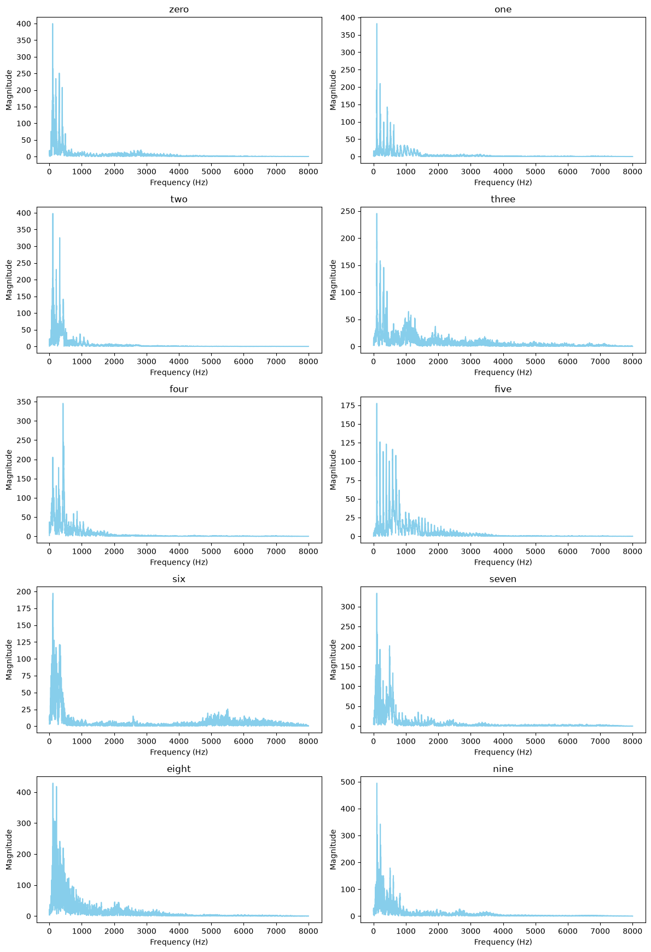

Appendix F: Mel Spectrograms of Different Words (Clean Speech)
Figure 8.
Mel Spectrogram Representations of Different Words Used for Word Recognition
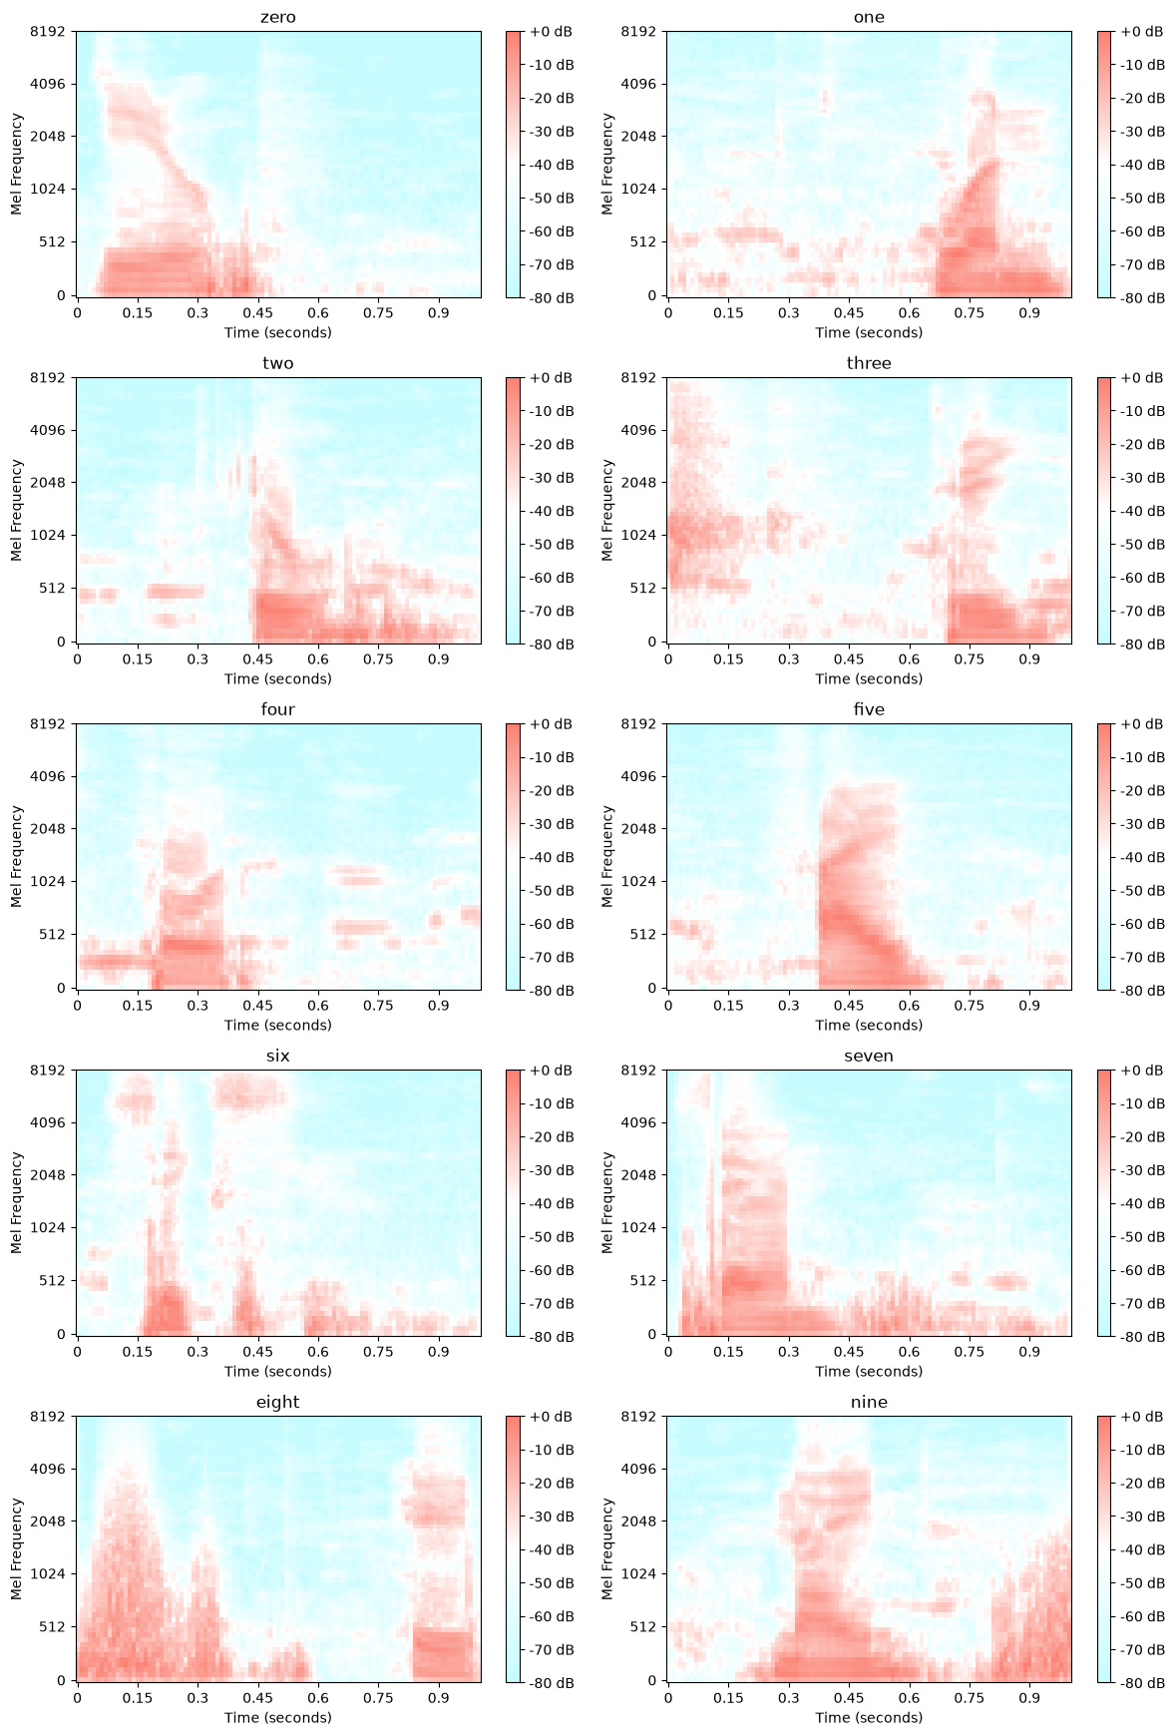

Appendix G: Waveform Comparison of Clean Speech and Speech Under Different Noise Conditions
Figure 9.
Waveform Representations of Different Words Under Different Noise Conditions
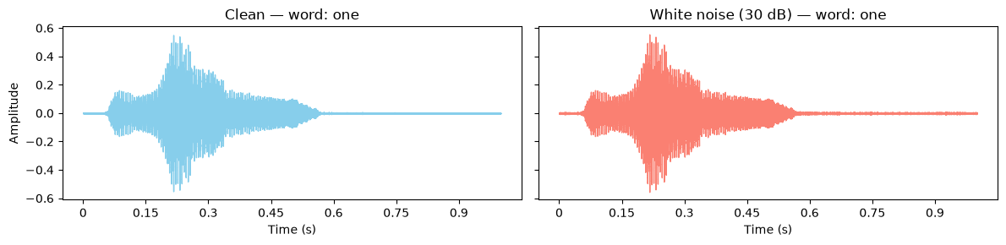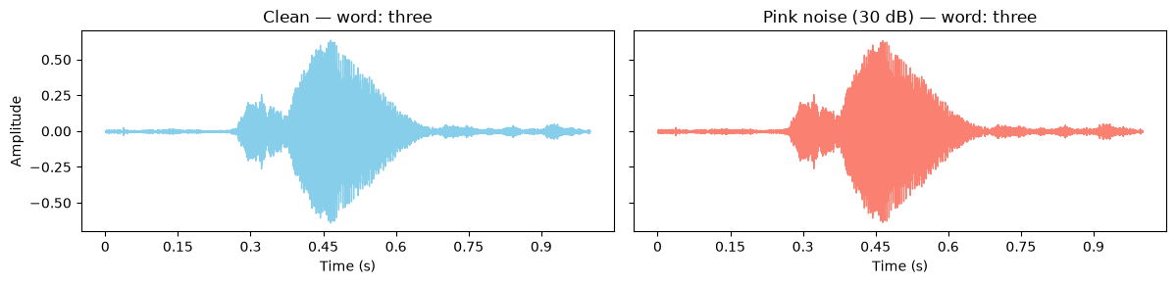
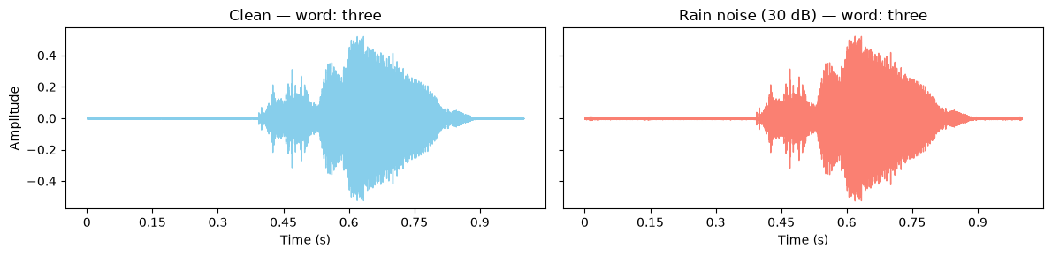
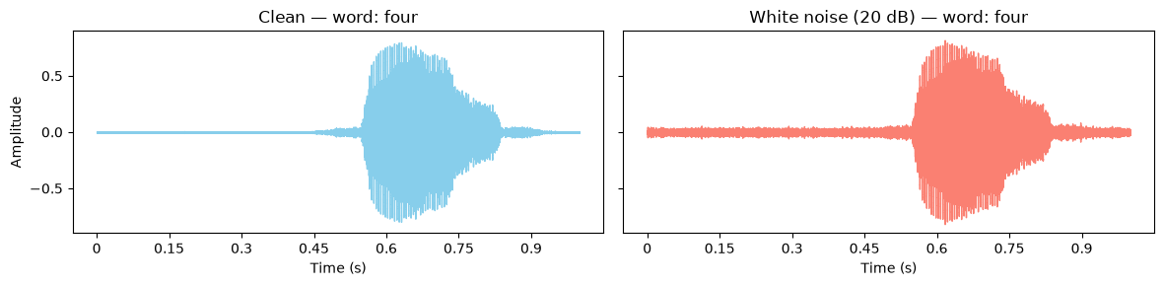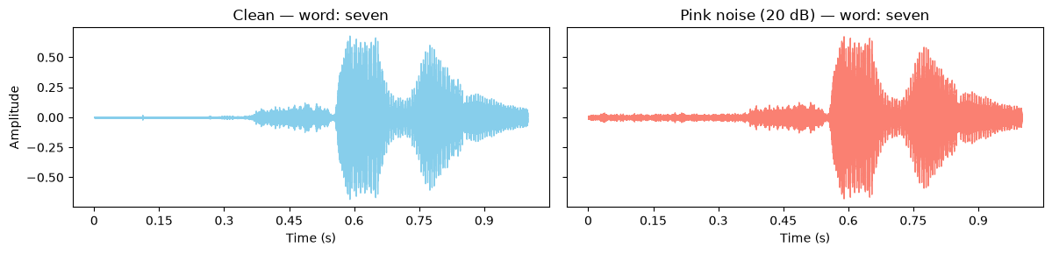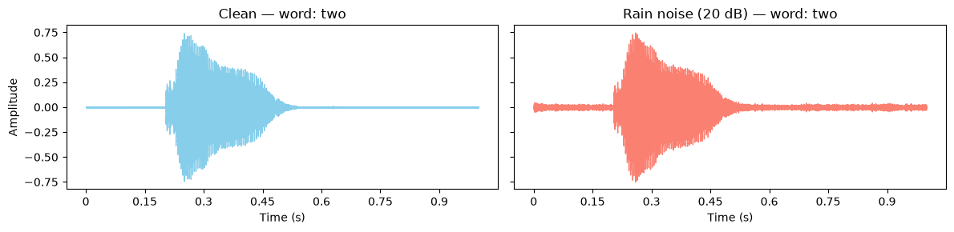
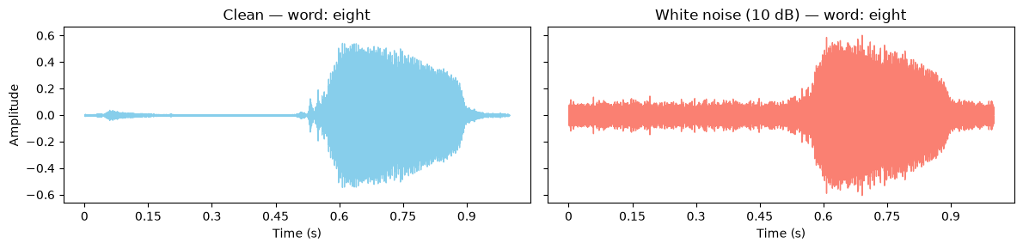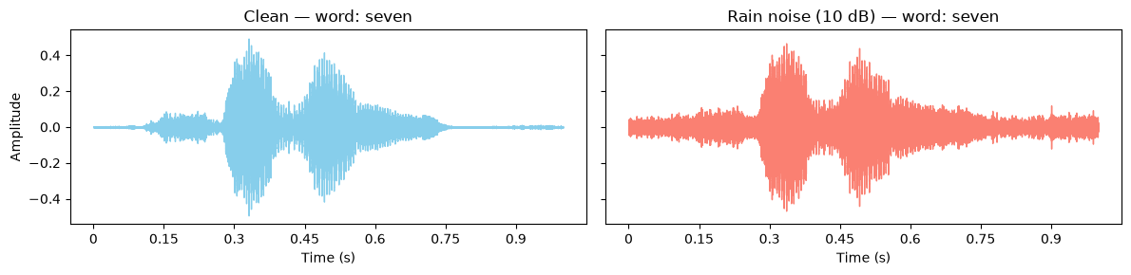
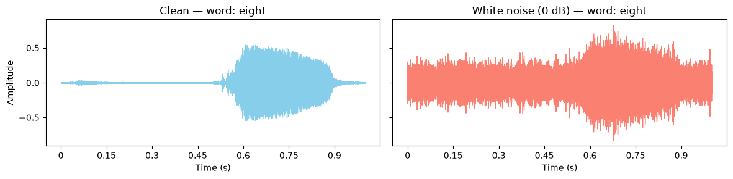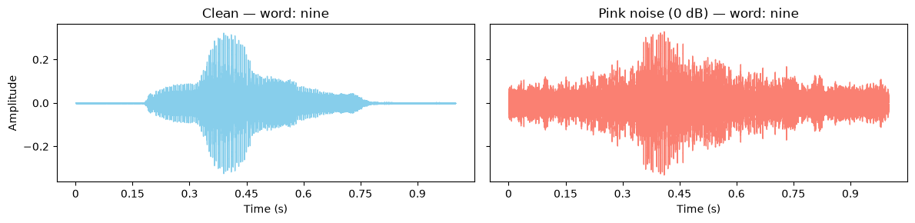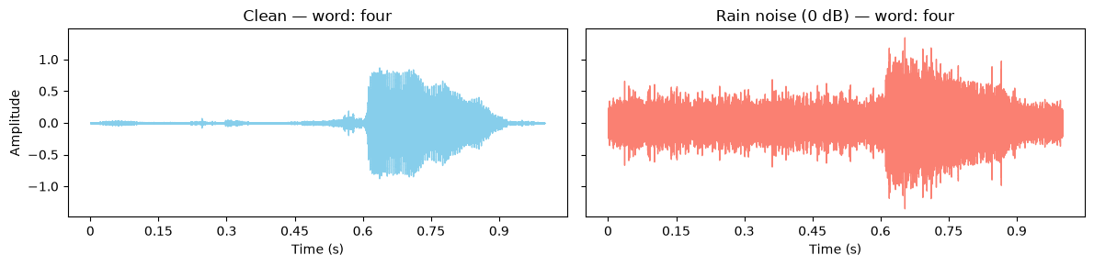

Appendix H: Mel Spectrogram Comparison of Clean Speech and Speech Under Different Noise Conditions
Figure 10.
Mel Spectrogram Representations of Different Words Under Different Noise Conditions
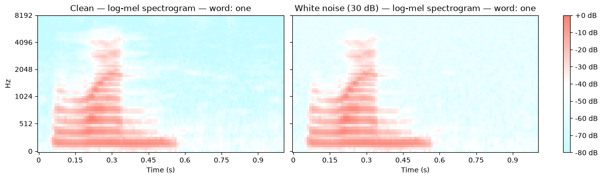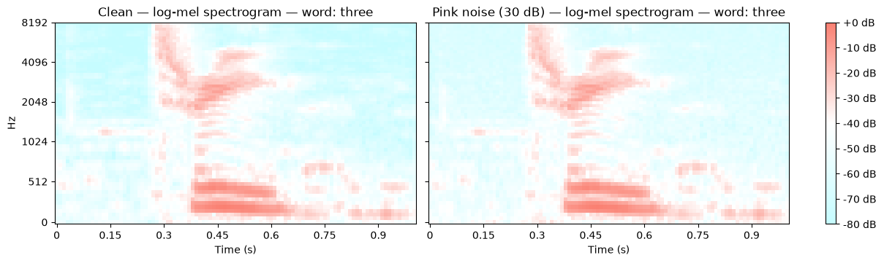
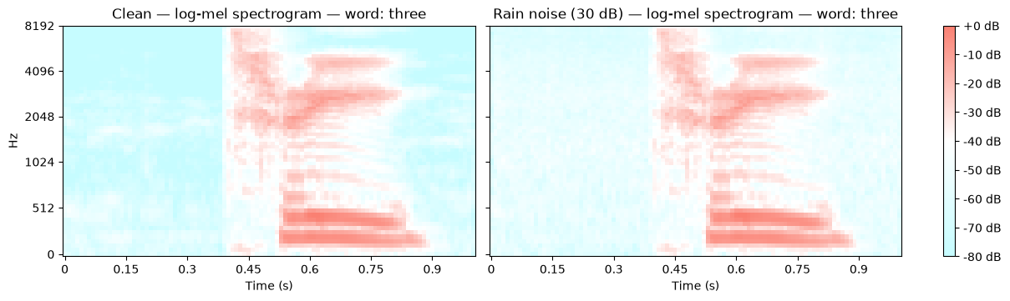
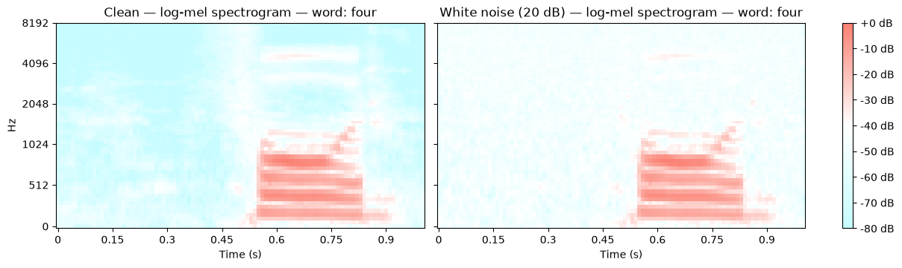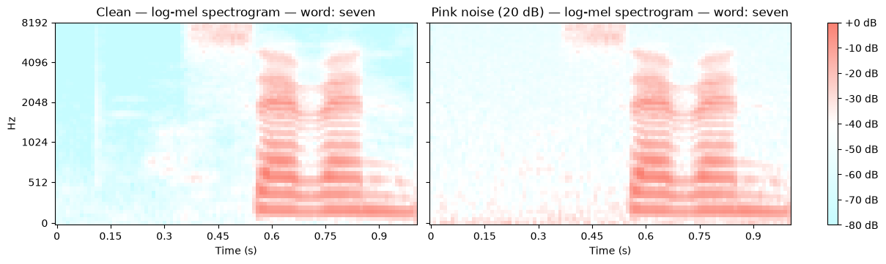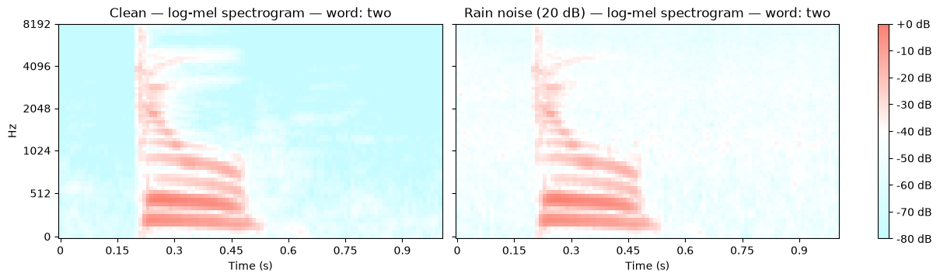
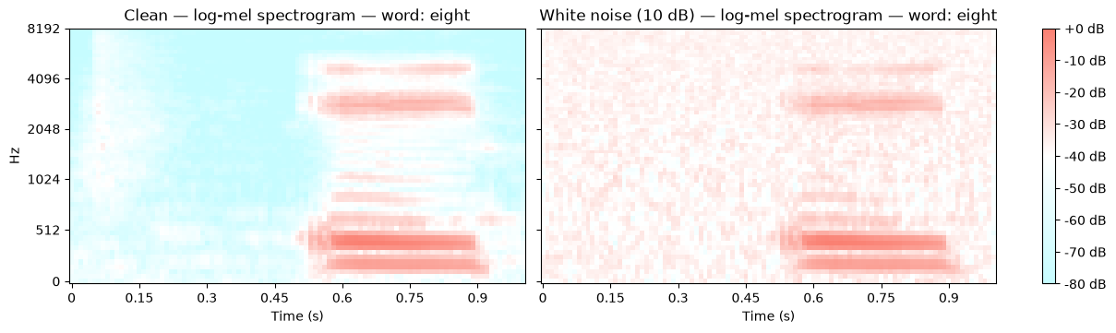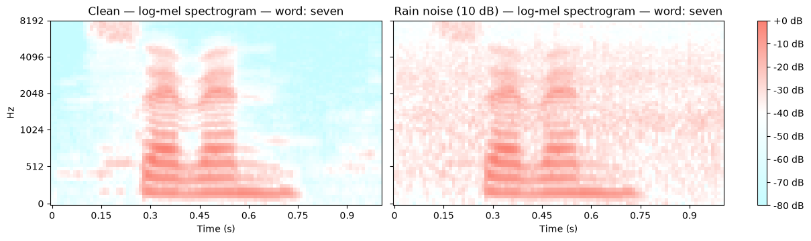
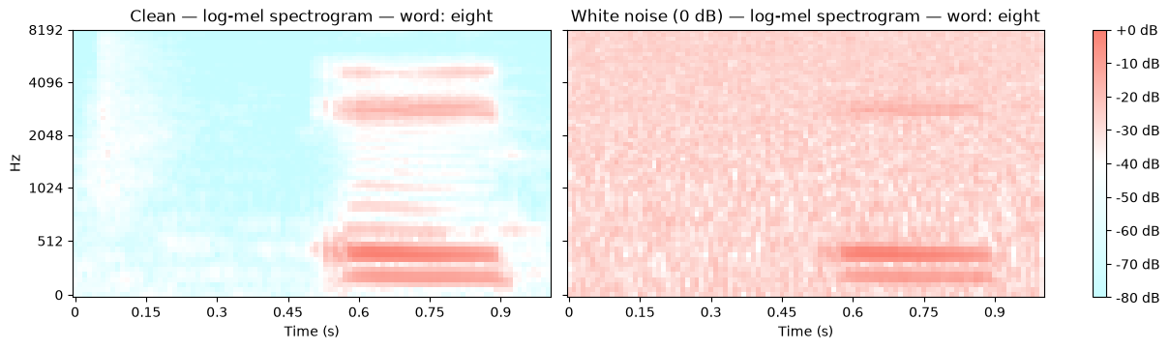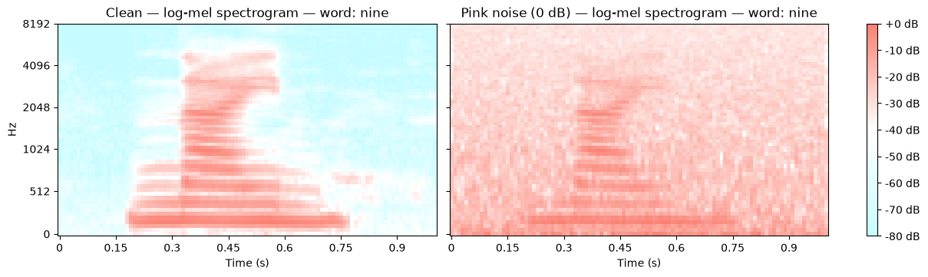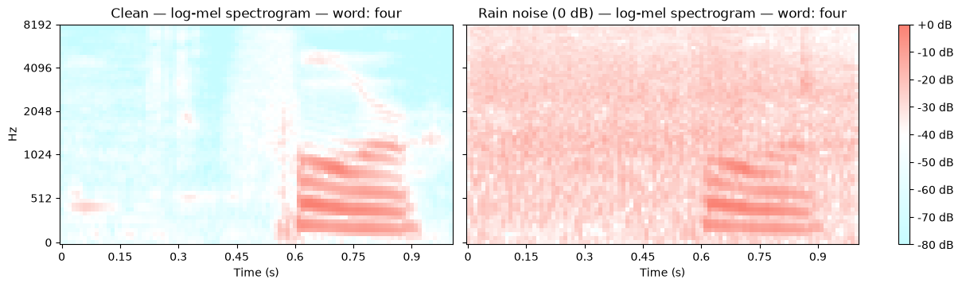

Appendix I: Confusion Matrices Under Different Noise Conditions
Figure 11.
Model Performance (Accuracy) Under Different Noise Conditions
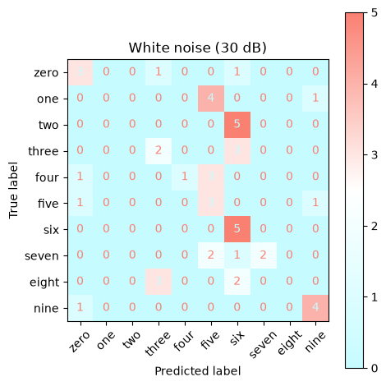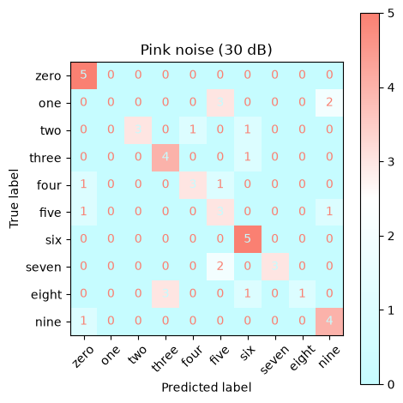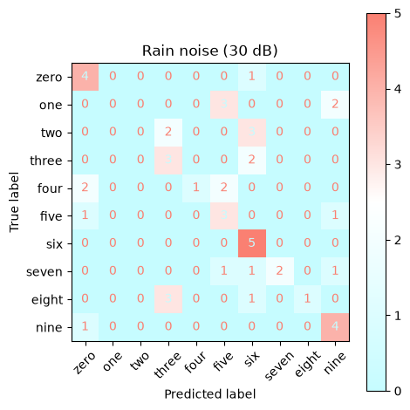
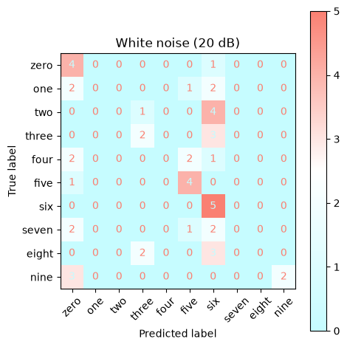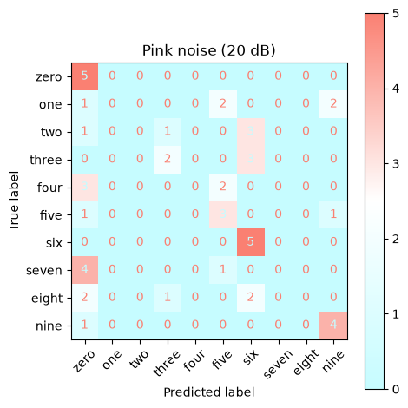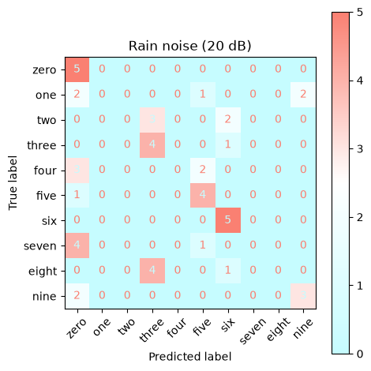
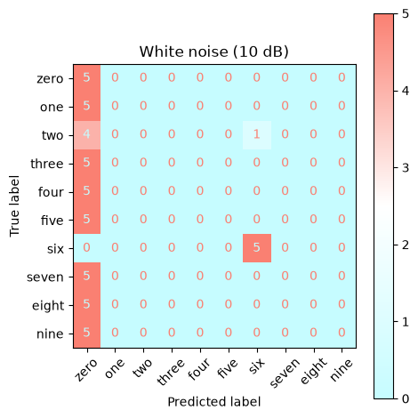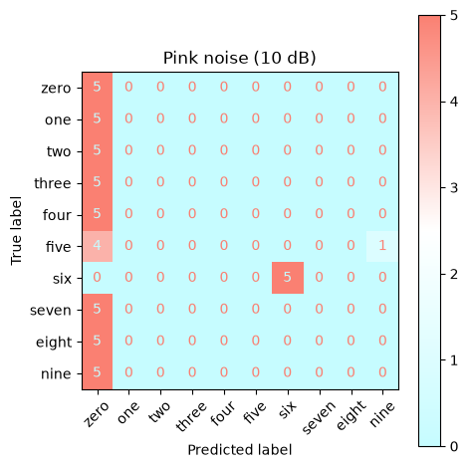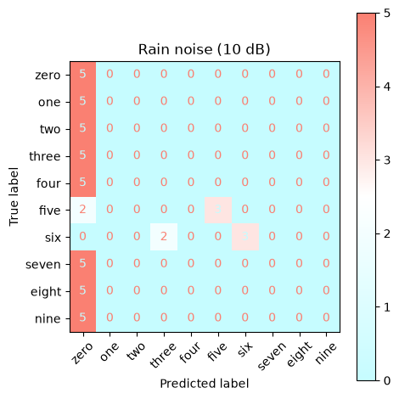
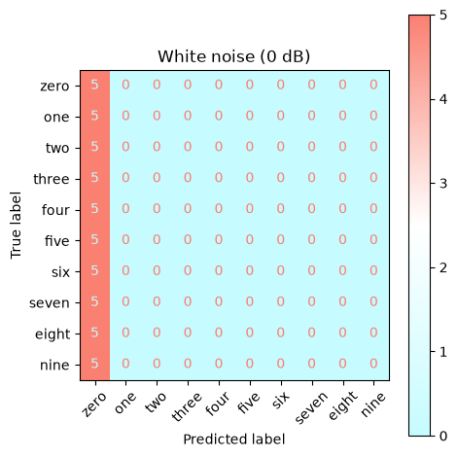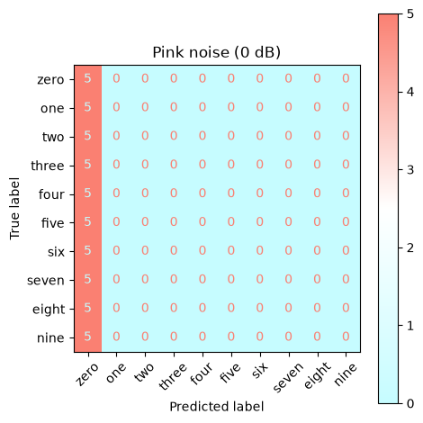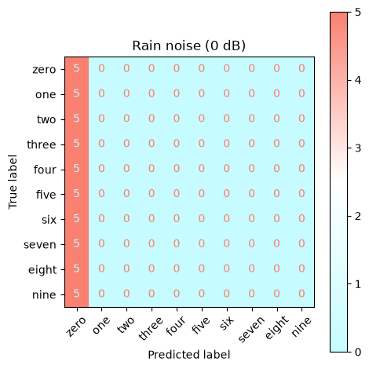

Appendix J: Prediction Probability Distributions for Different Numbers Under Different Noise Conditions
Figure 12.
Model Confidence (Prediction Probability) Under Different Noise Conditions
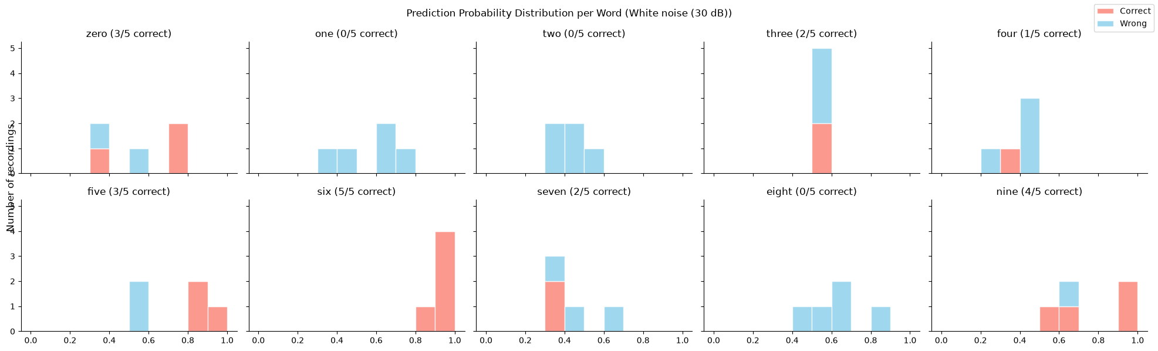
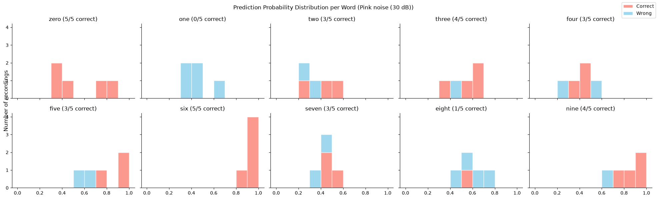
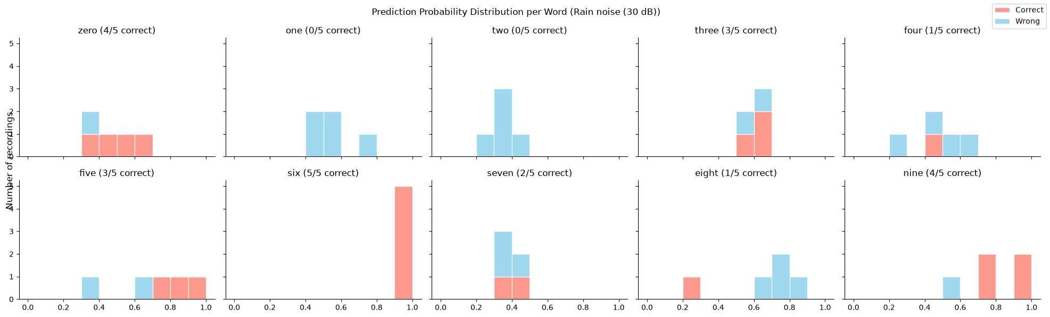
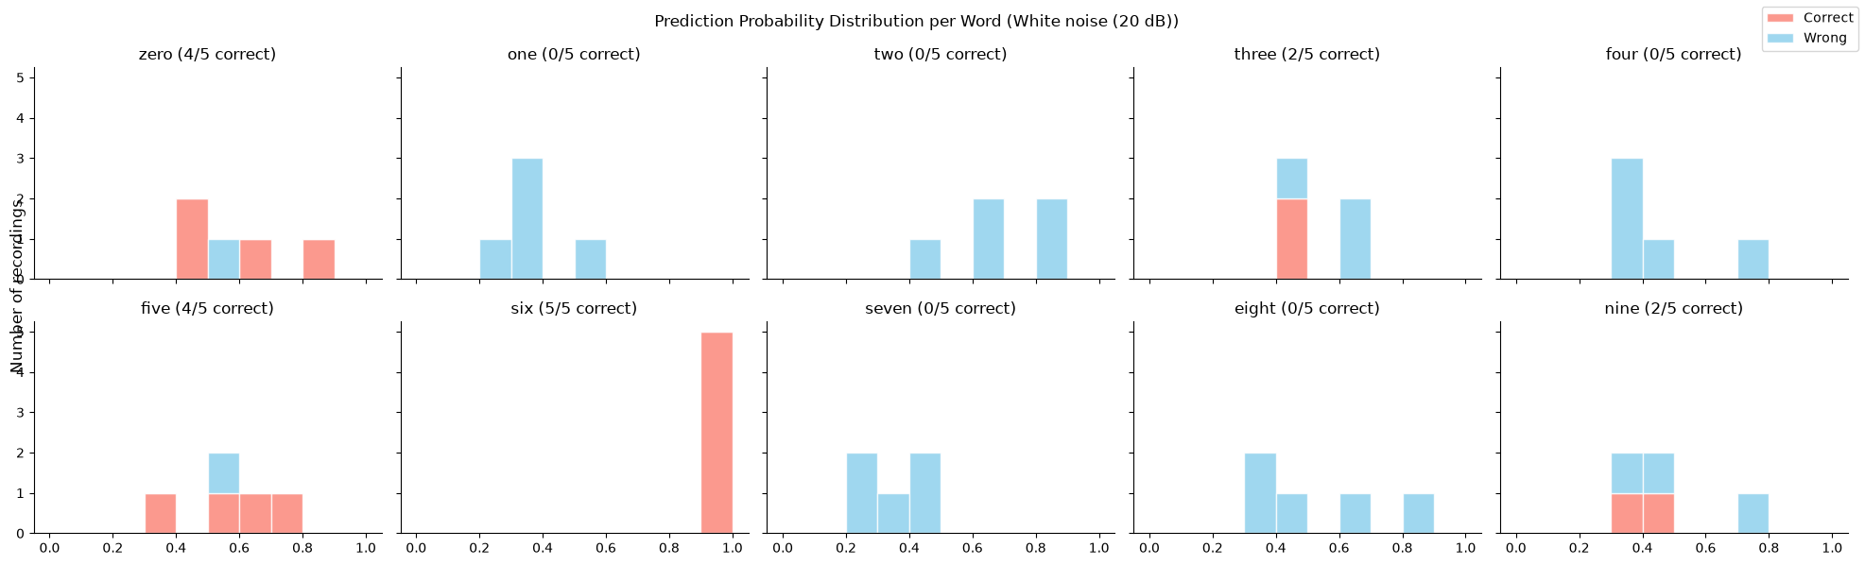
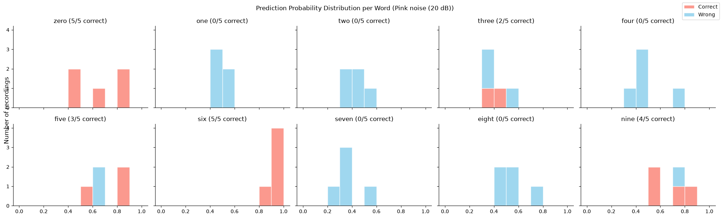
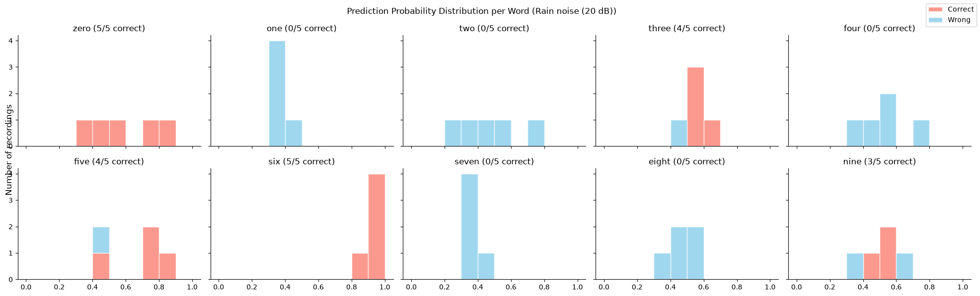
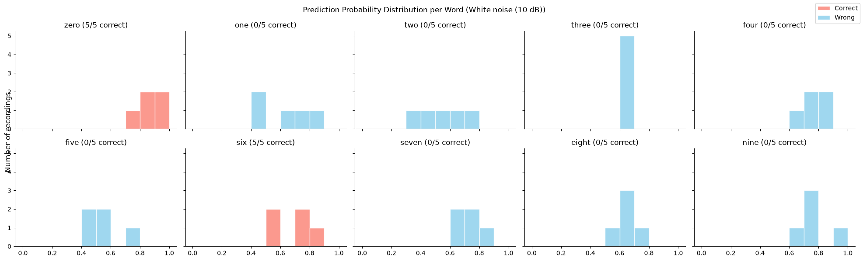
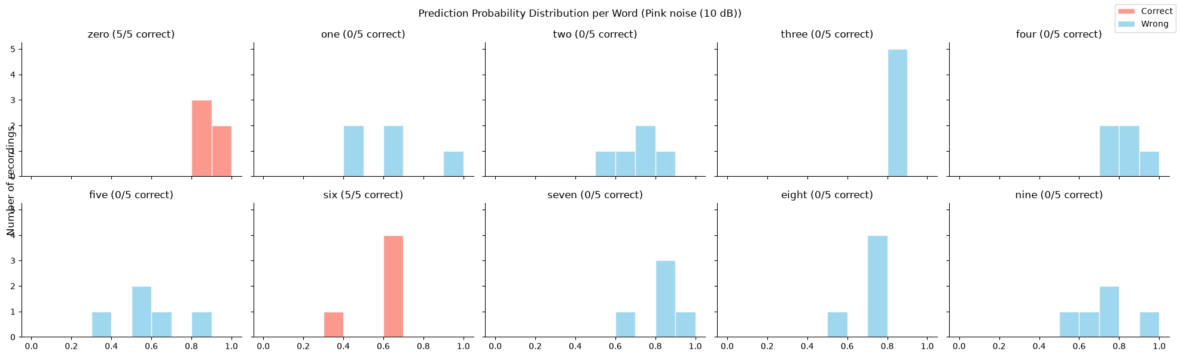
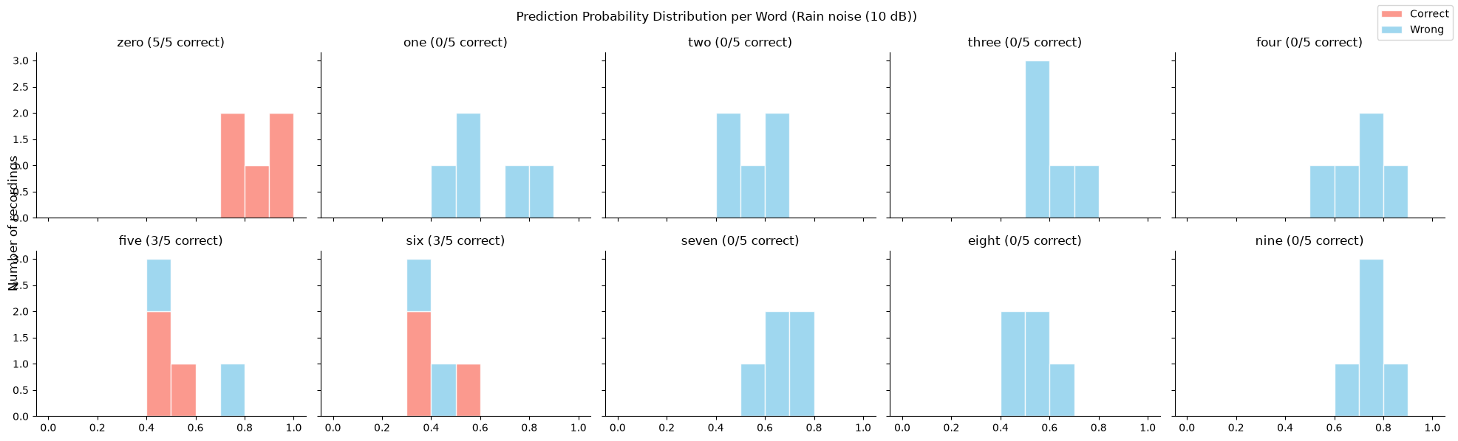
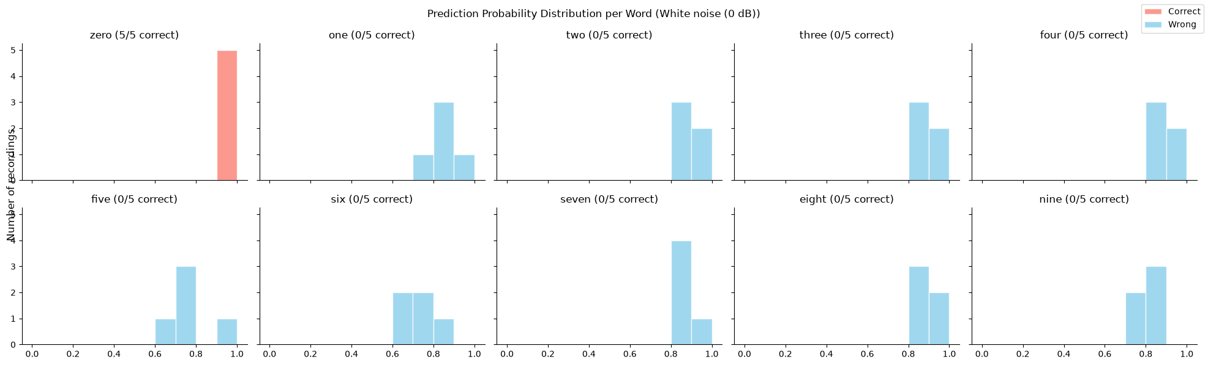
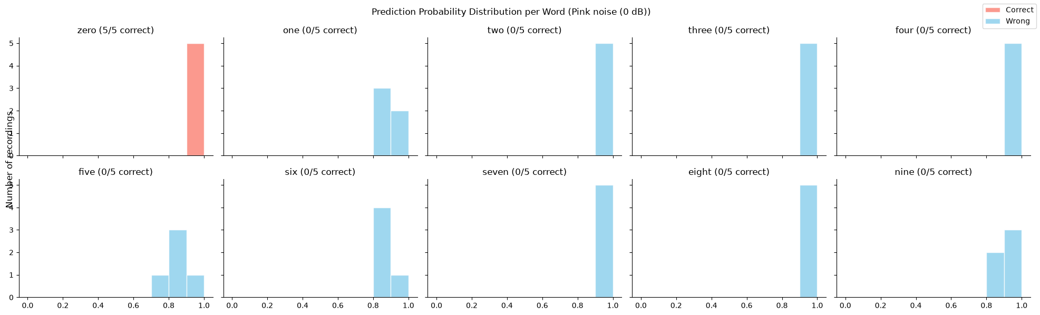
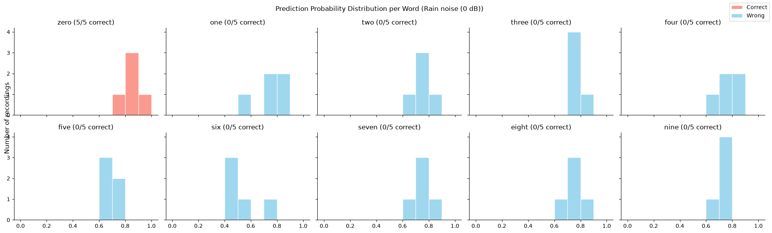

Appendix X: Source Code Used to Complete Analyses, Draw Plots and Tables

