
Ver. 2.5.0

USER MANUAL ADDONS

Andrea Stagi

Table of Contents
Web interface 3
Collapse instruments 3
Collapse project informations 3
Making a Pdf 4
Gantt (reprise) 5
Task Box 6
Task Networks 7
WBS 8

Web interface

Collapse instruments
This interface has been projected for optimizing the space on the page. In fact you can collapse graphic instruments by using the pen button.
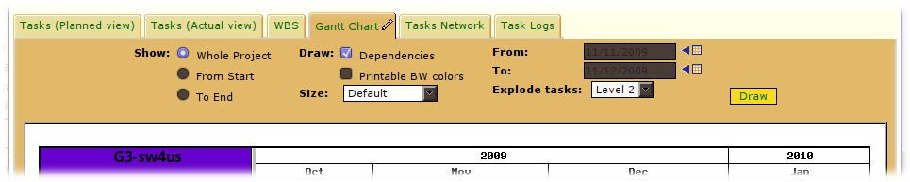
Fig. 4.0: not collapsed Gantt chart

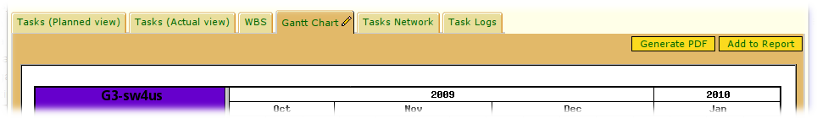
Fig. 4.1: collapsed Gantt chart, instruments are invisible

Collapse project informations
You can collapse project informations with a classic (+) button.

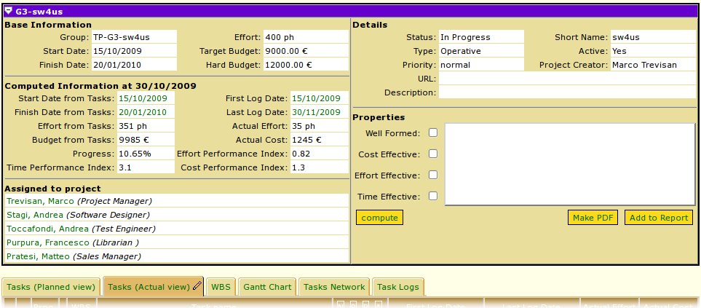
Fig. 4.2: a not collapsed project view

And collapsed:

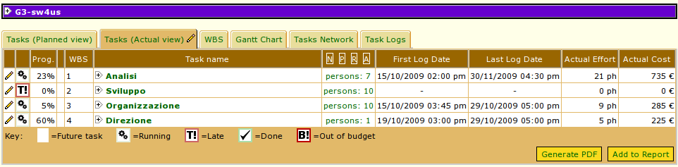
Fig. 4.3: a collapsed project view

Making a Pdf
For tasks ( both planned and actual ), Gantt, task network and WBS you can find on top right a button for creating a copy of that in pdf format.

Fig. 5.0: button for making a Pdf

Gantt (reprise)
There are tree time modalities for showing a Gantt graphic: you can choose to view graphic from start to current date, from current date to project end or whole project as default. You can do this using the combo box on the right. If you want to know how Gantt evolves between particular dates, you can choose this interval from the menu under the combo box. For project tasks you can choose also to show your names, efforts and resources, specifying also the maximum level to explode tasks by using the combo box below.

There are also some drawing options. You can select to view dependencies, task progress status, draw Gantt in BW colors and specify the graphic size (hours, day as default, weeks, months).

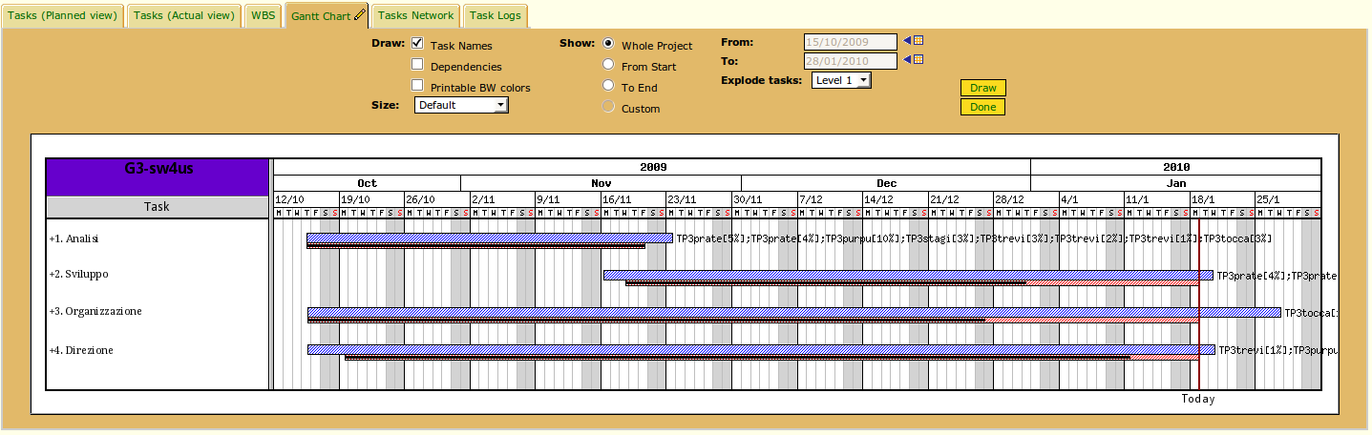
Fig. 1.0: a Gantt graphic

Here is a BW version of Gantt graphic.

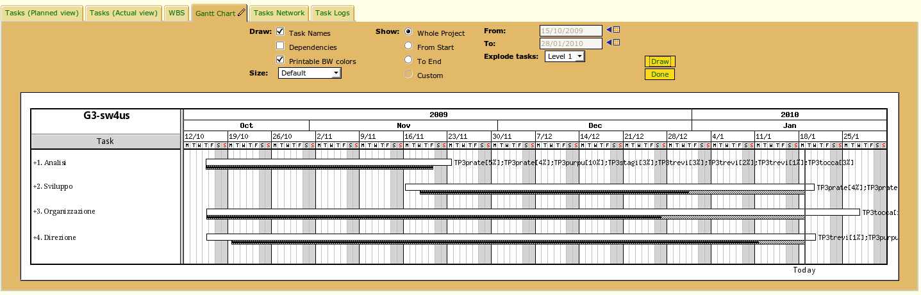
Fig. 1.1: a Gantt graphic in BW colors

Task Box
A Task Box is a particular table used to describe a task, showing all its useful informations. Here is a description of a task box used in Pmango.

Task title
∆ not serious compliances
∆! serious compliances
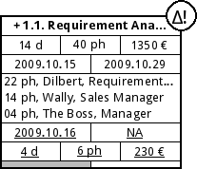
Task can be expanded

Task duration, effort and budget
Planned timeframe
Resources

Actual task duration, effort and budget
Actual timeframe

Progress status

- The header shows,besides the title, a (+) symbol when you want to view the childs of a task and a (∆!) or (∆) symbol to show the severity level of compliances.

- After that you can find all planned task data, its duration ( in days ), its effort ( in person hour ), its budget and its planned timeframe.

- In the middle, you can find all human resources used in the task, with a description and the planned effort for everyone. You can also find ( underlined ) the actual effort for every resource.

- After that you can find the actual task data, its duration ( in days ), its effort ( in person hour ), its budget and its planned timeframe.

- On the bottom you can find a little progess bar, showing the actual level of completion of the task.

We have described a complete task box, but it can be more compressed than previous version. We reports most useful types of compressed task boxes.

Fig. 2.0: a task box with only its identifier code.

Fig. 2.1: a task box with its identifier code and name.

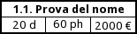

Fig. 2.2: a task box with its planned data.

Task Networks
A task network starts with a (●) symbol, indicating the start project milestone and ends with a () symbol, indicating the end project milestone. At the start project milestone are linked tasks without any dependencies from other tasks (having the end project milestone as depending task).

For every task you can show its name, if has an allert, its progress, planned data, actual data, planned resources, actual resources, planned timeframe, actual timeframe and critical path. You can also explode tasks level and specify size of tasks (hours, day as default, weeks, months) by using the combo box. There are tree time modalities for showing a Task Networks chart: you can choose to show it from start to current date, from current date to project end or whole project as default. You can do this using the combo box on the right. If you want to know how Task Networks evolves between particular dates, you can choose this interval from the menu under the combo box.

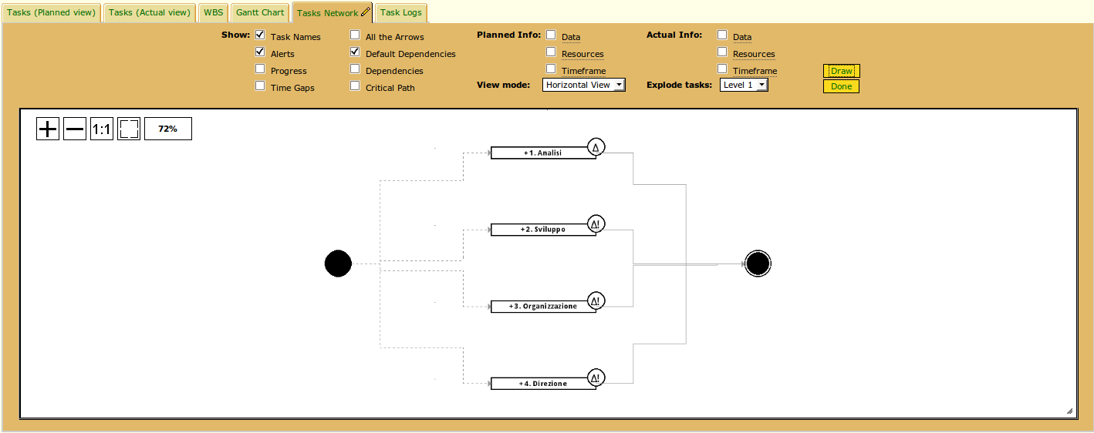
Fig. 3.0: example of Task Network

Here is explained all WBS buttons to modify the graphic:

- (+) button: increments size of the graphic.
- ( - ) button: decrement size of the graphic.
- (1:1) button: makes graphic zoom at 100%.
- () button: makes the best fit of the graphic.

WBS
WBS is a particular tree to represent tasks: the root is represented by task0 and its sons will be first level activities that will have second level activities as sons....
There are some options for representing WBS, as default WBS will be represented with only task box identifier code.

For every task you can show its name, if has an allert, its progress, planned data, actual data, planned resources, actual resources, planned timeframe and actual timeframe. You can also explode tasks level and specify size of tasks (hours, day as default, weeks, months) by using the combo box. There are tree time modalities for showing a WBS chart: you can choose to show it from start to current date, from current date to project end or whole project as default. You can do this using the combo box on the right. If you want to know how WBS evolves between particular dates, you can choose this interval from the menu under the combo box.

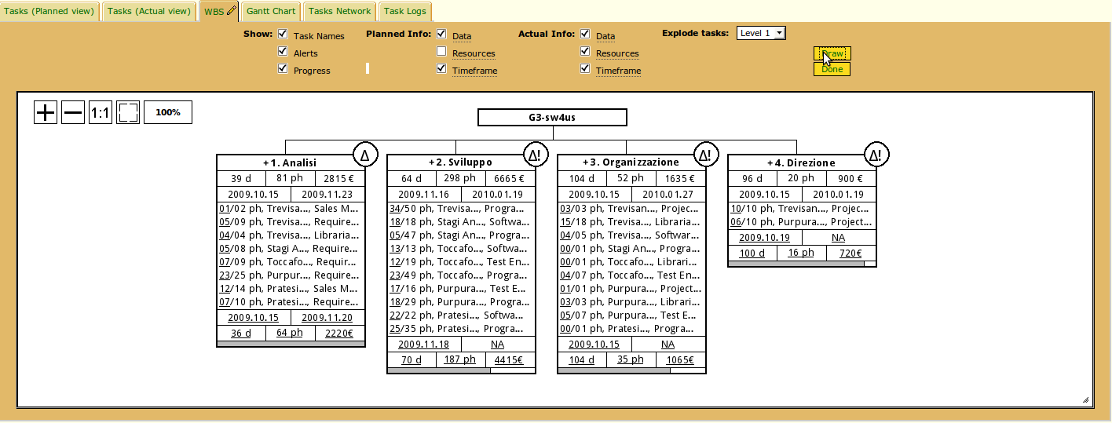
Fig. 6.0: an example of WBS

Here is explained all WBS buttons to modify the graphic:

- (+) button: increments size of the graphic.
- ( - ) button: decrement size of the graphic.
- (1:1) button: makes graphic zoom at 100%.
- () button: makes the best fit of the graphic.

