****3volutions AG  
Weissensteinstrasse 87  
CH-3007 Bern

**Synchronisation Exchange**

**Inhaltsverzeichnis**

1 Introduction 2

2 Overview 3

3 Processes 4

3.1 (A)- Register for push subscription 4

3.2 (B) - New Booking via the Web Application 4

3.3 (C) - New Booking via an MS Outlook client with Add-in 4

3.4 (D) Adjustment via the Web Application 4

3.5 (E) - Adjustment via an MS Outlook Client with Add-In 5

3.6 (F) – Adjustment via an MS Outlook Client without Add-In 5

4 Installation and Configuration 6

4.1 ROOMS Environment 7

4.1.1 Globale configuration 7

4.1.2 User configuration 8

4.2 Exchange 2013 (2016) 9

4.3 Exchange Online (O365) 10

4.3.1 Configuring Rooms to use OAuth Authentication 10

4.3.2 Push notifications from Exchange Online 11

4.4 Exchange 2010 12

4.5 Outlook Addin 14

4.5.1 Allgemeines 14

4.5.2 Prerequisites 14

4.5.3 Installation 14

4.5.4 Uninstallation 15

5 Troubleshooting 17

5.1 Exchange 2010 17

5.1.1 Outlook Addin 17

5.1.2 Exchange Server 17

5.1.3 ROOMS WebService 17

5.1.4 ROOMS Windows Service 18

5.1.5 ROOMS Benutzerprofil 19

5.1.6 ROOMS Konfiguration 19

5.2 Outlook Addin 20

# [Introduction](https://wiki.garaio.com/pages/viewpage.action?pageId=81461353)

For the sake of simplicity, we will only use the masculine form in this document although we are of course referring to both men and women.

The term Exchange 20xx is substitutable, therefore we will only use Exchange which covers every version.

This document contains all the necessary information for synchronizing booking made in a ROOMS 4 environment with calendar entries in an MS Exchange environment. This synchronization incorporates the following functions:

1. Bookings from the ROOMS 4 environment can be exported into an MS Exchange environment as calendar entries. *(This function is part of the basic installation but needs to be configured).*
2. When creating or editing calendar entries, you can create new ROOMS 4 bookings directly in an MS Outlook client. *(This function requires the additional installation of the ROOMS 4 Outlook add-in on all relevant clients; this is an optional enhancement, and is not absolutely necessary in order to run the synchronization).*
3. In both cases, all changes are implemented on both elements at the same time. *(This function is part of the basic installation but needs to be configured).*

First you must decide which MS Exchange versions you want to synchronize; different installation and configuration steps are required depending on the required functionality and version. Please note that the information in this document will therefore either refer to one or several specific versions (versions will be indicated) or will be generally applicable (no specific indication). Currently MS Exchange 2007, 2010 and 2013 are supported.

A ROOMS 4 environment can be synchronized with different MS Exchange versions and environments at the same time because the synchronization can be configured per user. However, only one MS Exchange version and environment can be synchronized per user.

A booking can only be synchronized with the calendar of the booking organizer (meeting participants receive a booking request from the organizer). If the user registered in the ROOMS 4 web application does not correspond to the organizer of a booking (if a booking has been made on behalf of another person), a calendar entry will be created in a different calendar during synchronization. If the organizer changes a booking that has already been synchronized, the calendar entry is deleted in the calendar of the previous organizer and a new entry is created in the calendar of the new organizer.

The MS Outlook version is not linked to a specific user, and different versions can be run at the same time. Currently, MS Outlook versions 2007, 2010 and 2013 are supported.

# [Overview](https://wiki.garaio.com/pages/viewpage.action?pageId=81461366)

The following chapters will provide an overview of the different system components and how they interact with each other.

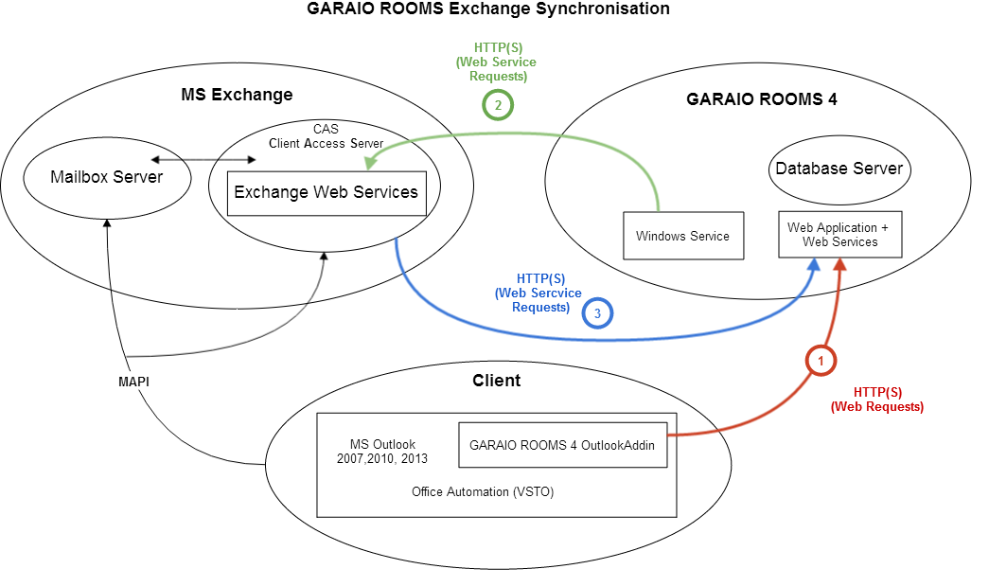

The selected scaling or number of servers (machines) and breakdown of components is not included in the overview. For more information on this subject, please refer to the [operating manual](https://wiki.garaio.com/display/ROOMSKBALL/Installationsanleitung).

**ROOMS Environment**

This includes the database, the web application with the web services, and the Windows service.

**MS Exchange Environment**

This includes a Client Access server, a Mailbox server, and normally other MS Exchange server components that are not relevant to the synchronization.

**Client Environment**

This includes the MS Outlook client and other components that are not relevant to the synchronization.

**MAPI Environment**

This includes communication between an MS Outlook client and an MS Exchange environment.

**Http(s)** **Connection 1**

This includes web requests (REST) from the ROOMS 4 Outlook add-in to the ROOMS 4 web application. These requests check the availability of resources and carry out bookings.

**Http(s)** **Connection 2**

This includes web service requests (SOAP) from the ROOMS 4 Windows services to the Exchange web services of an MS Exchange Mailbox server. These requests are used to synchronize calendar entries with bookings, request FreeBusy information, and manage subscriptions of push notifications.

**Http(s)** **Connection 3**

This includes web service requests (SOAP) in the form of push notifications that are sent from the MS Exchange environment to the ROOMS 4 web services. These requests are used to synchronize the bookings with the calendar entries.

# Processes

## (A)- [Register for push subscription](https://wiki.garaio.com/display/ROOMSKBALL/Step+A+-+Register+for+push+subscription)

The Windows service creates a Push Notification Subscription via **Connection 2** for the calendar folder of the relevant user's mailbox.

## (B) - [New Booking via the Web Application](https://wiki.garaio.com/display/ROOMSKBALL/Step+B+-+New+Booking+via+the+Web+Application)

B1. The user creates a new booking via the ROOMS 4 web application (browser).

B2. The Windows service creates a new calendar entry via **Connection 2**. The ItemId of the calendar entry is stored on the booking and the AppointmentOid of the booking is stored in the calendar entry.

B3. The MS Exchange environment sends a push notification (create) via **Connection 3**. The booking is found via the ItemId but with no changes detected (because the calendar entry was only created with the values of the booking: B2).

## (C) - [New Booking via an MS Outlook client with Add-in](https://wiki.garaio.com/display/ROOMSKBALL/Step+C+-+New+Booking+via+an+MS+Outlook+client+with+Add-in)

C1. The user creates a new calendar entry in an MS Outlook client, and opens the booking tab of ROOMS 4 Outlook add-in.

C2. The ROOMS 4 Outlook add-in searches for available resources via **Connection 1**.

C3. The user selects a resource and saves the calendar entry.

C4. The ROOMS 4 Outlook add-in creates a new booking via **Connection 1**. The AppointmentOid of the reservation is stored in the calendar entry.  
Note: The changes may first need to be sent to the MS Exchange environment in an MS Outlook client (F9)!

C5. The MS Exchange environment sends a push notification (create) via **Connection 3**. No booking is found with the corresponding ItemId.

C6. The Windows service searches for a calendar entry with the corresponding AppointmentOid, and stores its ItemId on the booking.

## (D) [Adjustment via the Web Application](https://wiki.garaio.com/display/ROOMSKBALL/Step+D+-+Adjustment+via+the+Web+Application)

D1. The user changes/cancels a booking via the ROOMS 4 web application (browser).

D2. The Windows service updates/deletes the calendar entry with the corresponding ItemId via **Connection 2**.

D3. The MS Exchange environment sends a push notification (update/delete) via **Connection 3**. The booking is found via the ItemId but with no changes detected (because the calendar entry was only updated with the values of the booking: D2).

## (E) - [Adjustment via an MS Outlook Client with Add-In](https://wiki.garaio.com/display/ROOMSKBALL/Step+E+-+Adjustment+via+an+MS+Outlook+Client+with+Add-In)

E1. The user changes/deletes a calendar entry in an MS Outlook client with the ROOMS 4 Outlook add-in. The stored AppointmentOid indicates that the calendar entry is linked to a booking.

E2. The ROOMS 4 Outlook add-in updates/cancels the booking via **Connection 1**.  
Note: The changes may first need to be sent to the MS Exchange environment in an MS Outlook client (F9)!

E3. The MS Exchange environment sends a push notification (update/delete) via **Connection 3**. The booking is found via the ItemId but with no changes detected (because the booking was already updated with the values of the calendar entry: F2).  
Note: If the Delete function is called for a calendar entry in MS Outlook, it is not deleted but moved to the recycle bin. The entry is only properly deleted once the recycle bin has been emptied (or if the Shift key is held down when the Delete function is called). The booking is then canceled in ROOMS 4.

## (F) – [Adjustment via an MS Outlook Client without Add-In](https://wiki.garaio.com/display/ROOMSKBALL/Step+F+-+Adjustment+via+an+MS+Outlook+Client+without+Add-In)

F1. The user changes/deletes a calendar entry in an MS Outlook client without the ROOMS 4 Outlook add-in (or MS Outlook Web Access, POP3, IMAP, etc.).  
Note: The changes may first need to be sent to the MS Exchange environment in an MS Outlook client (F9)!

F2. The MS Exchange environment sends a push notification (update/delete) via **Connection 3**. The booking is found via the ItemId and a change is detected; the booking is updated/canceled accordingly.

***Note:*** *If the Delete function is called for a calendar entry in MS Outlook, it is not deleted but moved to the recycle bin. The entry is only properly deleted once the recycle bin has been emptied (or if the Shift key is held down when the Delete function is called). The booking is then canceled in ROOMS 4.*

# [Installation and Configuration](https://wiki.garaio.com/pages/viewpage.action?pageId=81461669)

This guide is intended for people which are used to configure an exchange environment.

A synchronization with an MS Exchange environment implies that the MS Exchange Server and mailboxes are accessible from the ROOMS 4 environment. Since the mailboxes contain private and sometimes confidential or business-relevant information, this is a sensitive issue. ROOMS 4 is therefore based on the available standards for each MS Exchange version, and optimizes synchronization with regard to security and performance. Even with careful considerations of these points, it remains unavoidable that fundamental concessions will have to be made in these areas.

One of these concessions is the authorization for a service account on the relevant MS Exchange server. Theoretically, it is possible to carry out synchronization when a user is registered on the web application. This would avoid the need for a general authorization of a service account. Unfortunately, this concept creates a large number of difficulties:

* The configuration becomes far more complex (impersonation, service principal names, delegation, MS Outlook releases).
* Some functions become invalid (booking changes that are not relevant to a specific user — including all actions of the ROOMS 4 Windows services — cannot be synchronized).
* Performance suffers considerably (users have to wait until the synchronization is completed because it cannot be implemented asynchronously).

Our experiences in the Enterprise environment have shown that this concept is not practical because of the difficulties outlined above and that authorization for a service account is the only feasible solution. The associated security risks must be (and can be) solved within the organization.

Another concession is the higher load on the corresponding MS Exchange server. The requests sent via **Connection 2** and in particular via **Connection 3** and the time needed to prepare these requests can significantly increase the load on the MS Exchange server and the ROOMS 4 server and may require additional hardware. The necessary calculations and tests must be run before the solution is implemented. These tests must and can prevent the risk of performance problems at an early stage.

## ROOMS Environment

### Globale configuration

In order to enable the windows service to handle any sync related actions you need to enable these jobs for the service. This can be achieved by adding these three entries to the structuremap configuration on the configuration system section within the web application.



Additionally to the settings above, the value of the Application root-URL entry must be checked for correctness. This URL is used to create the required endpoint for the push notifications (see **Connection 3**).

### User configuration

In order to create a synchronized booking, the synchronization must be configured for the given user.

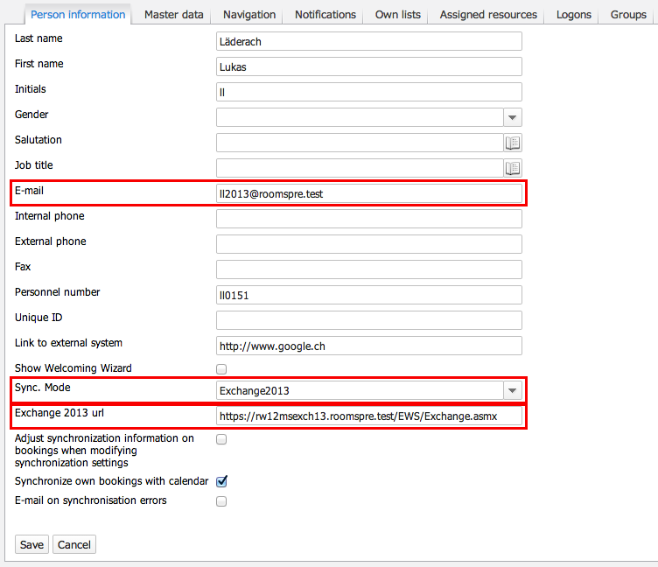

**E-mail**: The primary STMP address for the respective user **Sync. Mode**: Select your target Exchange version  
**Exchange20XX URL**: The URL where the EWS (**E**xchange **W**eb **S**ervices) are located

## Exchange 2013 (2016)

To enable synchronization with an MS Exchange 2013 environment, the account on which the ROOMS 4 Windows service is running must have the necessary access rights. Instead of normal full access rights the "impersonation" right can be assigned for this. The advantage of this is that it can only be used in the context of the MS Exchange web services. The authorized account can then run actions on behalf of another user in which the ROOMS 4 environment accesses a specific user's own mailbox.

To assign this right, the following command must be executed in the Exchange Management console: The first command assigns the "function right" so that the Client Access Server can be accessed and the second command assigns the "data rights" so that the relevant mailbox servers can be accessed (and therefore their mailboxes). Examples of the two commands are shown below:

Optional: If required, you can grant the permission to a dedicated group of mailbox users. To achieve this you have to create such a scope, execute the command mentioned above, but this time include the scope you just created. Of course, you can use an already existing scope if you have an appropriate one.



The value of the RecipientRestrictionFilter parameter can be adjusted very precisely. Consider the following example, which filters for a specific domain-group and recipientType.



Depending on your exact Exchange version it might be possible that the execution of the cmdlet New-ManagementRoleAssignement is disabled per default. If this is the case, you need to enable it with the following command:



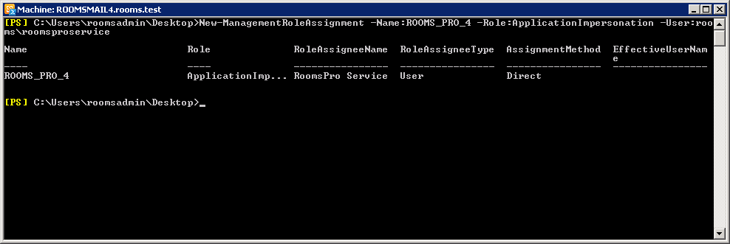

According to our research, the above "data right" impersonation can only be assigned at mailbox server or mailbox level but not to the individual folders or elements. This is because the MS Exchange server runs the impersonation early on (when the connection is established) and no longer subsequently differentiates between real or impersonated users when accessing folders and elements (it is not even possible to determine whether this is an impersonated user or not in the log files).



The used account must **not** be an MS Exchange administrator!

Additionally, the Client Throttling Policies need to be considered. These policies are supposed to protect the web services against any malicious attacks (e.g. ddos) and are used to distribute the load correctly.

To gain unrestricted access to ROOMS, the execution of the following commands is necessary:



Please consider the following Microsoft articles for any additional information on these topics:

[Configure Exchange Impersonation](http://msdn.microsoft.com/en-us/library/bb204095.aspx):  
http://msdn.microsoft.com/en-us/library/bb204095.aspx  
Create a ManagementScope (Technet):  
http://technet.microsoft.com/en-us/library/dd335137%28EXCHG.140%29.aspx  
[Throttling Policies](http://technet.microsoft.com/en-us/library/dd298094.aspx):  
<http://technet.microsoft.com/en-us/library/dd298094.aspx>

## Exchange Online (O365)

Rooms Release 4.7.2010 enables support for OAuth Authentication for Exchange Online:

Exchange provides the following authentication options for you to choose from:

1. OAuth 2.0 (Exchange Online only)
2. NTLM (Exchange on-premises only)
3. Basic (no longer recommended)

<https://docs.microsoft.com/en-us/exchange/client-developer/exchange-web-services/how-to-authenticate-an-ews-application-by-using-oauth>

### Configuring Rooms to use OAuth Authentication

In Setting 🡪 User 🡪 Person set the Sync. Mode

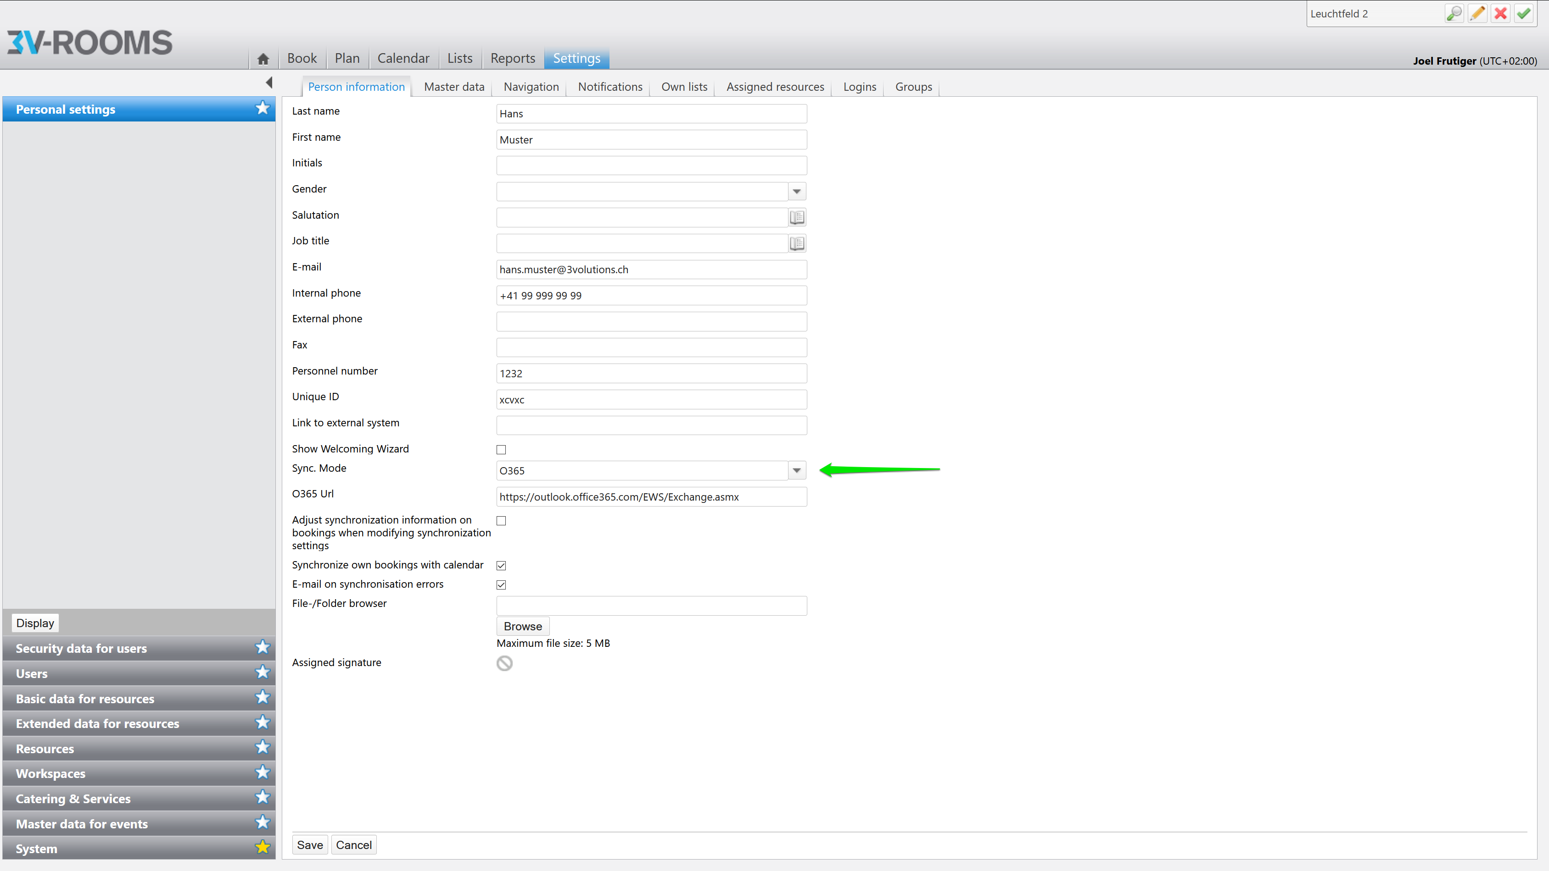

The correct URL should already be applied: <https://outlook.office365.com/EWS/Exchange.asmx>

On the application server the credentials need to be added to RoomsAppSettings.config. To get the Credentials follow these steps:

1. Open a browser and navigate to the Azure Active Directory admin center and login using a personal account (aka: Microsoft Account) or Work or School Account.
2. Select Azure Active Directory in the left-hand navigation, then select App registrations under Manage.
3. Select New registration. On the Register an application page, set the values as follows
   1. Set Name to a friendly name for your app.
   2. Set Supported account types to the choice that makes sense for your scenario.
   3. For Redirect URI, change the dropdown to Public client (mobile & desktop) and set the value to urn:ietf:wg:oauth:2.0:oob.
4. Choose Register. On the next page, copy the value of the Application (client) ID and save it, you will need it later.
5. Select API permissions in the left-hand navigation under Manage.
6. Select Add a permission. On the Request API permissions page, select Exchange under Supported legacy APIs.
7. Select Application permissions and then select full_access_as_app. Click on Add permissions.
8. Select Grant admin consent for org and accept the consent dialog.
9. Select Certificates & Secrets in the left-hand navigation under Manage.
10. Select New client secret, enter a short description and select Add.
11. Copy the Value of the newly added client secret and save it, you will need it later.

Now add the following lines to your RoomsAppSettings.conifg and restart the rooms service, replace xxx with the information gathered in the previous steps.



### Push notifications from Exchange Online

Successful synchronization requires Push Notifications to be sent to the webservice, see 5.1.3

Exchange Online is in the Cloud so public access to the Webservice is required. With Rooms Version 4.7.2010 you can define a separate URL for the Service:



## Exchange 2010

To enable synchronization with an MS Exchange 2010 environment, the account on which the ROOMS 4 Windows service is running must have the necessary access rights. Instead of normal full access rights, the "impersonation" right can be assigned for this. The advantage of this is that it can only be used in the context of the MS Exchange web services. The authorized account can then run actions on behalf of another user in which the ROOMS 4 environment accesses a specific user's own mailbox.

To assign this right, the following command must be executed in the Exchange Management console: The first command assigns the "function right" so that the Client Access Server can be accessed and the second command assigns the "data rights" so that the relevant mailbox servers can be accessed (and therefore their mailboxes). Examples of the two commands are shown below:



Optional: If required, you can grant the permission to a dedicated group of mailbox users. To achieve this, you have to create such a scope, execute the command mentioned above, but this time include the scope you just created. Of course, you can use an already existing scope if you have an appropriate one:



The value of the RecipientRestrictionFilter parameter can be adjusted very precisely. Consider the following example, which filters for a specific domain-group and recipientType:



Depending on your exact Exchange version it might be possible that the execution of the cmdlet New-ManagementRoleAssignement is disabled per default. If this is the case, you need to enable it with the following command:





According to our research, the above "data right" impersonation can only be assigned at mailbox server or mailbox level but not to the individual folders or elements. This is because the MS Exchange Server runs the impersonation early on (when the connection is established), and no longer subsequently differentiates between real or impersonated users when accessing folders and elements (it is not even possible to determine whether this is an impersonated user or not in the log files).

The used account must **not** be an MS Exchange administrator!

Additionally, the Client Throttling Policies need to be considered. These policies are supposed to protect the web services against any malicious attacks (e.g. ddos) and are used to distribute the load correctly.

To gain unrestricted access to ROOMS, the execution of the following commands is necessary:



The above throttling commands are valid for Exchange 2010 SP1 and above. If your SP-Level is below (we recommend to upgrade asap) you need to use the following commands:



Please consider the following Microsoft articles for additional information on these topics:

[Configure Exchange Impersonation](http://msdn.microsoft.com/en-us/library/bb204095.aspx):  
http://msdn.microsoft.com/en-us/library/bb204095.aspx  
[Create a ManagementScope erstellen (Technet)](http://technet.microsoft.com/en-us/library/dd335137%28EXCHG.140%29.aspx):  
http://technet.microsoft.com/en-us/library/dd335137%28EXCHG.140%29.aspx  
[Throttling Policies](http://technet.microsoft.com/en-us/library/dd298094.aspx):  
http://technet.microsoft.com/en-us/library/dd298094.aspx

## Outlook Addin

Only the 32Bit version of MS Outlook 2010 is supported.

### Allgemeines

In order to make bookings directly in an MS Outlook client, the ROOMS Outlook add-in needs to be installed on all desired clients. The installation needs to be done with the setup package that is optimized for your Outlook version. An assistant asks for the configuration settings step by step (installation path and root-URL of the ROOMS web application) and executes the necessary installation processes. The add-in is available to all users of the relevant clients after the installation.

### Prerequisites

* Microsoft .NET Framework 4.0 Extended (oder höher)
* Visual Studio Tools for Office 4.0

### Installation

The installation file Rooms_OutlookAddin_Office20XX_X.msi is available in our Download area.

Outlook should be closed prior to the installation.

The installation file can be used for initial installations as well as for updates. A deinstallation of already installed versions is not necessary as the setup assumes this task. The values specified for the previous installation are adopted during an update.

The installation assistant is only available in German.

|  |  |
| --- | --- |
| Step | Description |
| /download/attachments/56235135/1.png?version=1&modificationDate=1347287401974&api=v2 | Welcome step – no interaction needed. |
| /download/attachments/56235135/2.png?version=1&modificationDate=1347287405921&api=v2 | Accept the license terms (Lizenzvereinbarung). |
| /download/attachments/56235135/3.png?version=1&modificationDate=1347287408777&api=v2 | Specify the installation path. It is recommended to use the default path. |
| /download/attachments/56235135/4.png?version=1&modificationDate=1347287411333&api=v2 | Specify the URL of the ROOMS web application in the format "http(s)://server/tenant". |
| /download/attachments/56235135/5.png?version=1&modificationDate=1347287413792&api=v2 | Confirmation step - no interaction. Click on install (Installieren). |

In order to automatically execute the installation for a larger number of clients, the following command can be used for a so-called "unattended installation":

msiexec /i Rooms_OutlookAddin_Office2010_X.msi /quiet AGREETOLICENSE=yes ADDINURI=http(s)://server/tenant

The name of the installation file and the URL are to be adjusted accordingly.

### Uninstallation

Either re-execute the installation file and choose the option "Remove" after accepting the license terms, OR open programs and features in the control panel, select the entry "ROOMS OutlookAddin Office2010" and click on "Remove".

In order to automatically execute the deinstallation for a larger number of clients, the following command can be used for a so-called "unattended installation":

msiexec /x Rooms_OutlookAddin_Office2010_X.msi /quiet AGREETOLICENSE=yes ADDINURI=http(s)://server/tenant

The name of the installation file and the URL are to be adjusted accordingly.

# Troubleshooting

This chapter discusses the most important points that are helpful for error analysis.

**The user profile features a tool to the check the synchronization settings, which automatically runs through the whole synchronization process and issues configuration problems.**

Please consult the wiki entry Test environment for the correct specifications concerning the Exchange configuration for our development and testing environment, especially the chapters Server and User accounts. Every developer should have an account on the mail servers according to the following example:

* Sync Exchange URL or OWA: see Server
* User name: rooms[abbr][2003|2007|2010]@rooms.test (e.g. rooms\ll2010@rooms.test, see also User accounts)
* Password: to be found under Person Exchange Test Accounts in ROOMS PRO Password Repository
* Should the developer not have an user account on the relevant mail server yet, he needs the AD admin of the domain rooms.test to create one for him.

## Exchange 2010

All server, client and user names need to be adjusted to the particular environment.

### Outlook Addin

* Open add-in installation path
* Open AppSettings.config
* Check root-URL entry:



* Root-URL needs to callable by the client without entering credentials

### Exchange Server

* Ensure that the client to be synchronized is accessible through the following URL:  
  <https://anon.roomsweb2.rooms.test/webservices/syncnotification.svc?3v>

### ROOMS WebService

Check in ROOMS if the web service is running correctly. This can be checked easily by calling the following URL:

<https://anon.roomsweb2.rooms.test/webservices/syncnotification.svc>

If everything is configured correctly, the following page should be displayed:

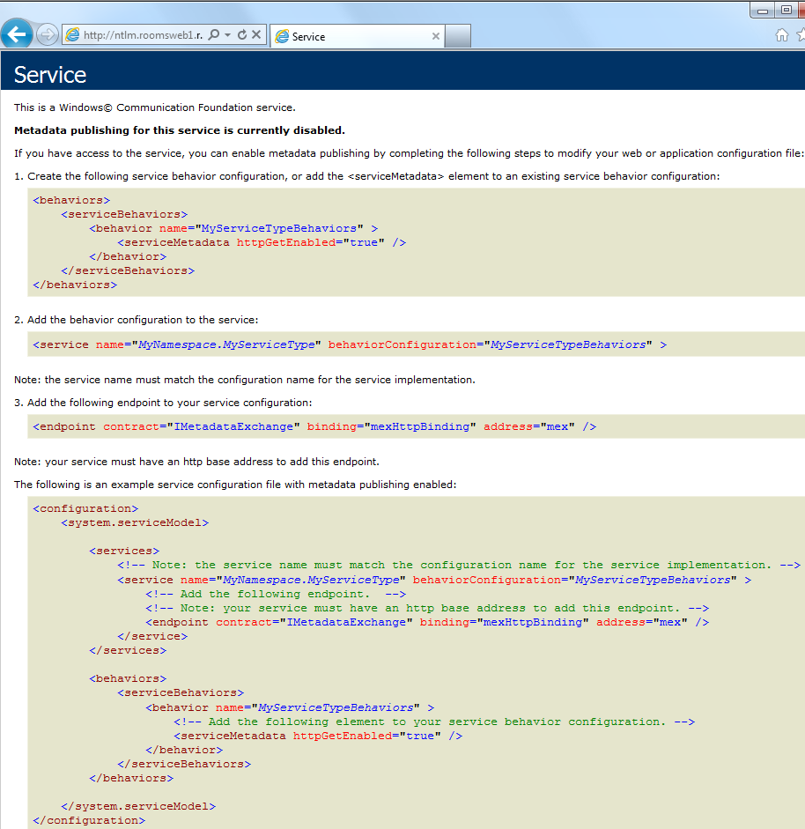

### ROOMS Windows Service

Ensure that Windows service was started and that the correct connection string was stored.



***Note to developers***: authentication can be circumvented by storing the necessary credentials in AppSettings.config:

### ROOMS Benutzerprofil

Check the sync settings in the user profile:

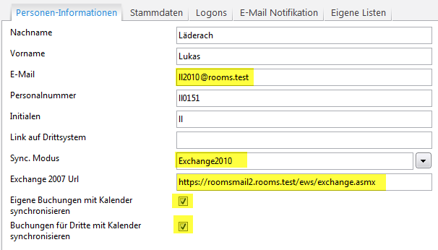

### ROOMS Konfiguration

The following values must be adjusted to the particular environment:

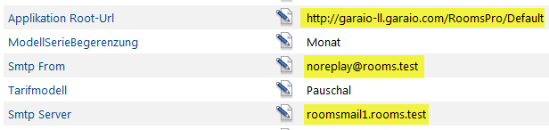

**Booking for others (Clerk function)**

Note that the e-mail address of the person in whose calendar the booking should be made corresponds to a valid and active person.

## Outlook Addin

1. Open Programs and Features in the Control Panel: Is the add-in installed? Does the add-in version match the Office version (example: 2010/2010)?

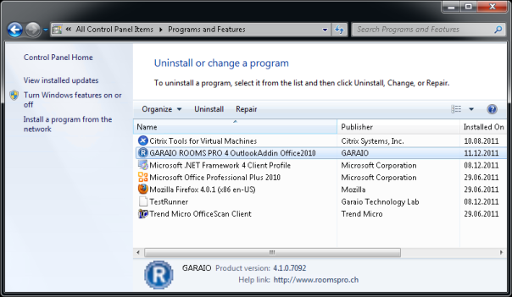

* The add-in is not installed: execute installation
* The versions do not match: uninstall add-in and install the matching version

Launch MS Outlook, then...

* select Outlook 2010: File, Options, Add-ins, COM Add-ins, Go to
* select Outlook 2007: Extras, Trust Center, Add-ins, COM Add-Ins, Go to
* select Outlook 2003: Extras, Options, Further, Advanced settings, COM Add-ins

Is the add-in listed? Is the check box in front of it activated?

* The add-in is not listed: open regedit, export HKLM\Software and HKCU\Software. Send exported file to 3Volutions together with the version of the operating system (x64?), the MS Office and add-in version number (see screenshot or "Properties" of the file Garaio.Products.RoomsPro.OutlookAddin.Core.dll, details tab).
* The add-in is listed but the check box in front of it is not activated: activate check box and close dialogue. Is the sidebar now displayed? Is the check box still activated when opening the dialogue again?  
  -> No: open event log, search for recent error entries. Copy content and contact Garaio..