1.CHAUHAN PREET 2. MISTRY KAVYA 3. KOTKAR SHREYANSH 4. MAHALE SOHAM

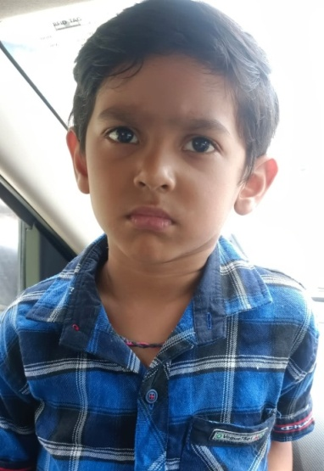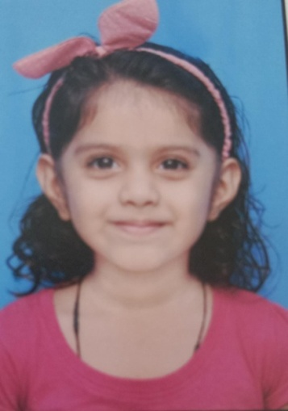 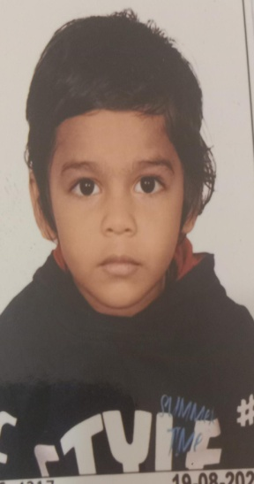 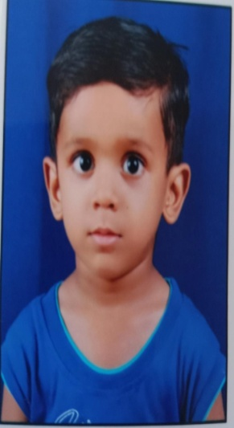

5. pandye himani 6. SAHU AMAHIRA 7. KHAMBHAYATA DITYA 8. MAHAJAN ANVITA 9. PANCHAL SHALIN

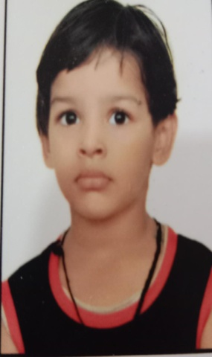 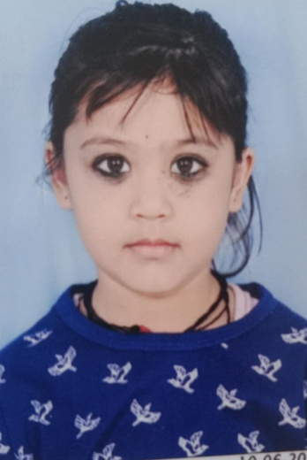 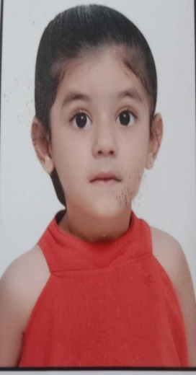 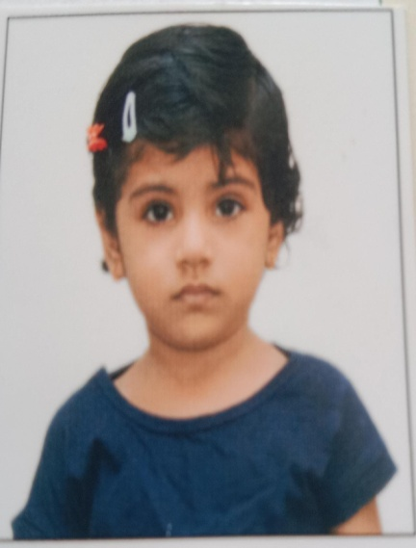

9. PANCHAL SHALIN 10. RANE DHARIKA 11. YADAV ISHANI 12. KORADIYA ABHISHEK

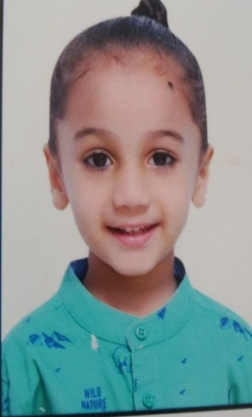 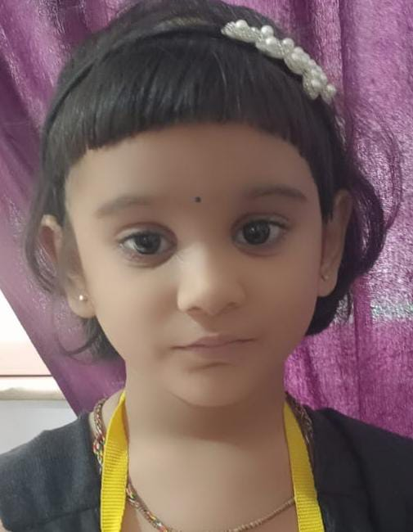 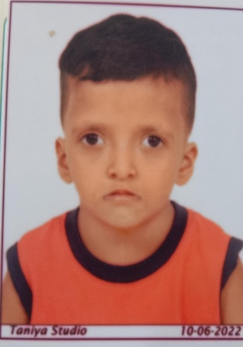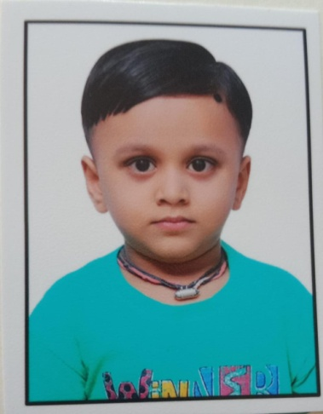

13.. RAJPUT HINA 14. PANCHAL VANSH 15. KUSHWAHA RUDRAA

