Snap Crackle Pop POS System

Initial Requirements

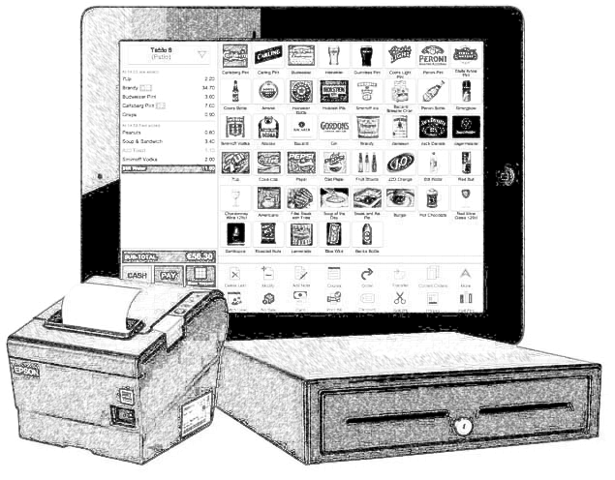

Sasha Iliyn, Ryan Williams, Jacob Asmuth, Skyler Swenson, Phillip Smith

Sunday, October 25, 2015

Table of Contents

Introduction 3

Functional Requirements 3-4

Register 3-4

Administrative Program 4

Networking 4

Database 4

Non Functional 4-5

Platform 4-5

Performance 5

Communication 5

# Introduction

This document contains a summary of system requirements for the Crackle Pop POS System. The requirements section is broken into two main parts, functional and nonfunctional requirements. Functional requirements are meant to capture all operations the system must be able to perform while non-functional requirements are important aspects of the system but are not visible to the operator.

# Functional Requirements

The area of functional requirements describes operations the system is intended to perform. These operations are captured as short statements; each statement intended to describe a single behavior. These statements are grouped based on similarity. The groups are called functional areas and encompass functional modules to be treated as individual efforts in development, testing and deployment.

Functional Requirements are prioritized as follows:

* H-A : High Priority, Architecture – These requirements are mandatory for architectural integrity of the system technical operation.
* H : High Priority – These requirements are part of system basic operation. Without these requirements, the system cannot be considered operational.
* M : Mid-Level Priority – These requirements are necessary for a final delivered system. The system will function without these operations; however, it may not be useful from and end user perspective.
* L : Low Level Priority – These requirements are items that would be nice to have implemented but do not add to necessary functions for end system implementation.

## Register

The Crackle Pop POS Register contains those requirements involved with the register front-end that cashiers will use as part of the system.

1. The System shall verify logins to employees
   1. The system shall allow employees to logout to the login window. -H-A
      1. The system shall not allow employees to exit the program except by logout -H
   2. The system shall allow managers to give temporary permissions boosts to cashiers -L
   3. The system shall have each program authorize users via a standardized login window –H-A
      1. The system shall allow authorized users to exit the login window -H
         1. The system shall have a button to exit the register program -H
         2. The system shall have a button to shut down the workstation -L
         3. The system shall have a button to restart the workstation -L
      2. The system shall highlight the text in the username or password fields as focus is gained-M
      3. The system shall cycle between username and password fields when the tab key is pressed-M
      4. The system shall intercept all exit key presses so that only managers can exit the program via manager shut down programs. -H
2. The system shall display inventory of items as retrieved from the server. H-A
3. The system shall verify and charge digital payments. M
   1. The system shall verify and charge credit cards. M
   2. The system shall verify and charge PayPal. L
   3. The system shall verify and charge NFC-based payments such as Apple Pay & Android Pay. L
4. The system shall display information about the sale. H
   1. The system shall show the price of each item. H
   2. The system shall show the total price of all items. H
   3. The system shall show any coupons’ savings. M
   4. The system shall show total coupon savings. M
   5. The system shall be able to display item weights when a digital scale is connected. M
   6. The system shall show price per unit of items that are sold based on weight. M
5. The system shall produce a receipt of each transaction. H
   1. The system shall be able to print the receipt - H
   2. The system shall be able to e-mail an electronic version of the receipt - L
   3. The system shall store a copy of all receipts in the internal database – H
6. The system shall identify barcodes.
   1. The system shall obtain a unique item ID from a scanned barcode. - H
   2. The system shall retrieve product information from the item ID. - H
   3. The system shall obtain coupon information from a scanned barcode if it is not an item -H
7. The system shall allow the user to enter information manually. – L
   1. The system shall allow the user to enter a phone number. - L
   2. The system shall allow the user to enter an address. – L
   3. The system shall allow the user to enter a name. – L
   4. The system shall allow the user to enter a check number. – M
   5. The system shall allow the user to enter a credit card number manually. – M
8. The system shall allow editing of the sale. -H
   1. The system shall allow the user to remove an item. -H
   2. The system shall allow the user to change the price of an item. -M
   3. The system shall allow the user to remove a coupon. -H
   4. The system shall allow the user to change a coupon’s amount. -M

## Admin program

1. The System shall verify logins to employees
   1. The system shall allow employees to logout. -H-A
      1. The system shall not allow admin to exit the program except by logout
2. The system shall allow the user to enter product types. – H
   1. The system shall allow the user to enter a product type name. - H
   2. The system shall allow the user to enter a product type barcode. – L
   3. The system shall allow the user to enter a product type quantity. - H
   4. The system shall allow the user to enter a product type cost. - H
   5. The system shall allow the user to enter a product weight. – L
3. The system shall allow the entering of individual products.
   1. The system shall allow the user to update the stock. – H
   2. The system shall allow the user to set an expiration date. – M
   3. The system shall allow the user to flag an item. – L
4. The system shall allow the entering of employees.
   1. The system shall allow the user to add an employee. – H
   2. The system shall allow the user to remove an employee. - H
   3. The system shall allow the user to search an employee. - H
5. The system shall allow the entering of customers.
   1. The system shall allow the user to add a customer. - H
   2. The system shall allow the user to delete a customer. - H
   3. The system shall allow the user to search a customer. - H
6. The system shall generate an XML of company’s earnings. - L
   1. The system shall display yearly earnings. - L
   2. The system shall display quarterly earnings. - L
   3. The system shall display the difference between years. - L
   4. The system shall display the difference between quarters. - L
7. The system shall allow the permission of users to be changed. – H-A
   1. The system shall allow the user to update another user’s permissions. - H
   2. The system shall restrict changes based on original user’s permissions. - H
8. The system shall apply storewide coupons or sales. - M
   1. The system shall allow a sale to be applied to all products. - M
   2. The system shall allow a coupon to be applied to all products. - M
   3. The system shall allow a sale to be applied to all items of brand X. - M
   4. The system shall allow a coupon to be applied to all items of brand X. - M
   5. The system shall allow a sale to be applied to all items of category X. - M
   6. The system shall allow a coupon to be applied to all items of category X. - M
9. The system shall display product statistics. - L
   1. The system shall display products that are expiring before selling. - L
   2. The system shall display products the frequently go out of stock. - L
   3. The system shall display products that have little movement. - L
   4. The system shall display products with a large amount of movement. – L
10. The system shall log user actions.
    1. The system shall store a log of all register activity. – L
    2. The system shall store a log of all admin activity. -L
    3. The system shall display a log of all register activity – L
    4. The system shall display a log of all admin activity - L

## Database

The Crackle Pop POS System Database contains requirements for the structure of the database as well as what it contains and what its functions are.

1. The system shall store employee data. H-A
   1. The system shall store employee ID. H-A
   2. The system shall store encrypted employee passwords. H-A
   3. The system shall store employee privileges. H-A
2. Must contain the item data. H-A
   1. The system shall store item names. H-A
   2. The system shall store item prices. H-A
   3. The system shall store item ID codes. H-A
   4. The system shall store item quantities. H-A
3. The system shall store customer data. L
   1. The system shall store customer names. L
   2. The system shall store customer rewards points. L
   3. The system shall store customer receipts. L
4. The system will have procedures to handle common tasks
   1. Fetching data about items, users, and customers
      1. The system will return retrieved data in XML format
   2. Adding data about items, users, and customers
   3. Modifying data about items, users, and customers
   4. Removing data about items, users, and customers

# Non Functional

The area of Non-Functional requirements contains statements driving system implementation areas not considered to be directly related to operational behavior. These will be items that drive construction and platform details.

## Platform

These requirements are related to underlying computer technology for supporting of the end system.

1. Server Side Platform.
   1. All systems, (register, admin, and data base) will run on a windows platform.
   2. The register and admin system will be written in C#.
   3. Network between the server and clients will be handled in C++.
   4. The database will be implemented on a freely distributable SQL platform.

## Performance

These statements are related to minimum and maximum criteria for system speed and metrics related to system efficiency and operation.

1. Register system will need to show the correct name and price when an item number is entered or scanned.
2. Inventory will need to be updated when a sale is completed.
3. Administrative changes will take effect on restart.

## Communication

These requirements detail implementation and underlying support for digital communications for interlinking the system to other digital systems.

1. System will be mostly a local network for the register to admin.
2. Registers will communicate to the admin after every sale.
3. System will use either a local or secured internet connection for admin to server connection.
4. Admin program will communicate to the database after every sale.