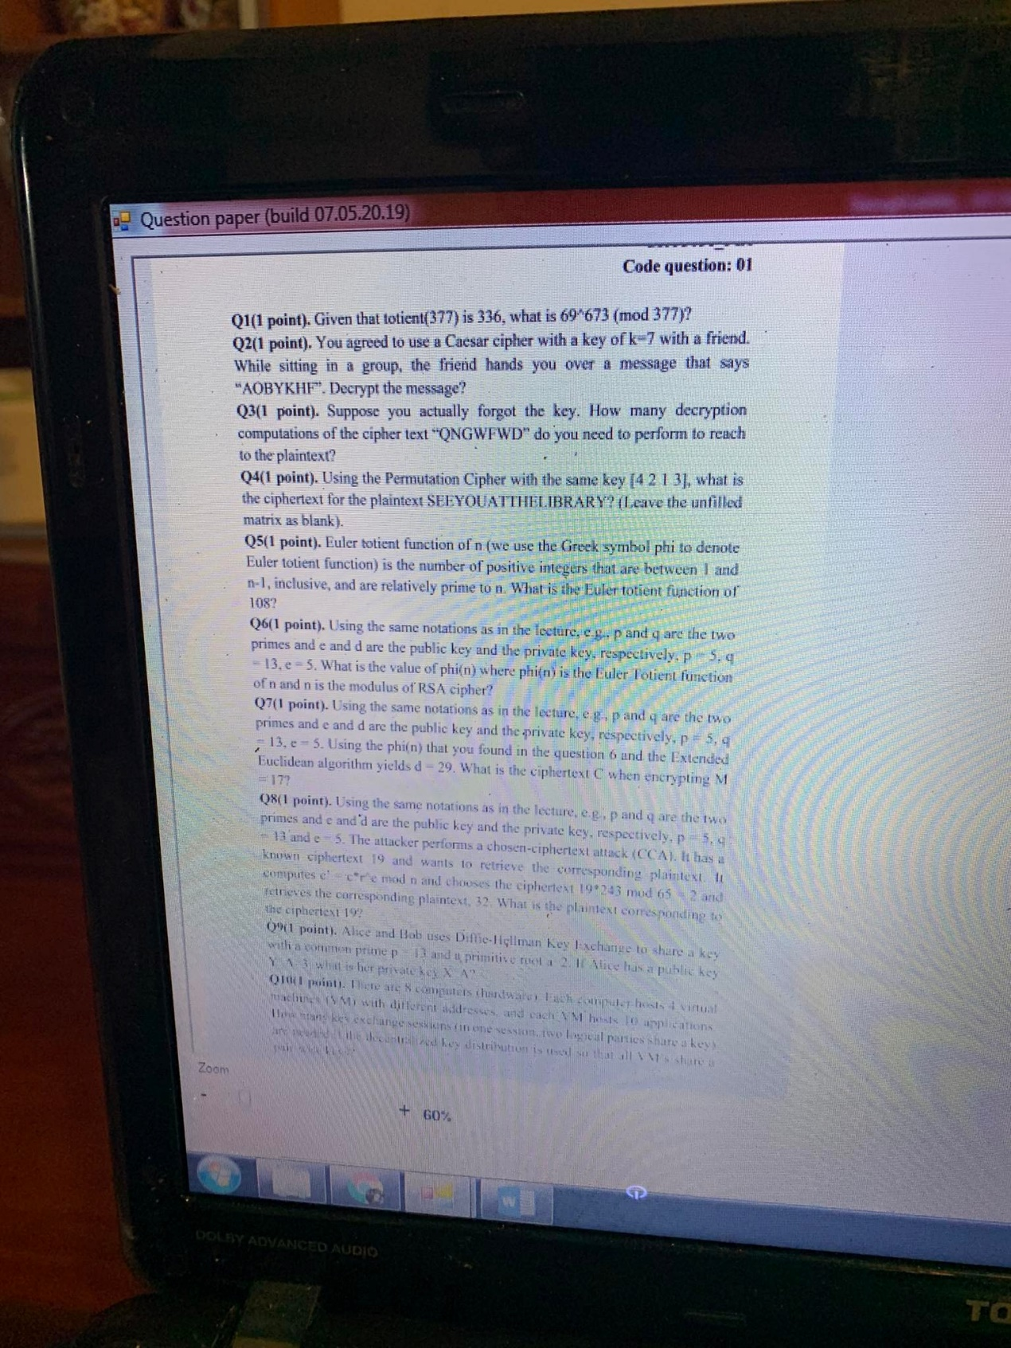

Q1)
Euler’s Theorem: If n $≥$ 1 and GCD(a,n) = 1 then a^totient(n) $≡$ 1(mod n)
totient(377) =336
69^673 mod 377 = ((69^336)^2 * 69) mod 377
= (( (69^336)^2 mod 377 )*( 69 mod 377 )) mod 377
= (1*69) mod 377 = 69

Q2)
- The English alphabet:
A | B | C | D | E | F | G | H | I | J | K | L | M | N | O | P | Q | R | S | T | U | V | W | X | Y | Z
0 | 1 | 2 | 3 | 4 | 5 | 6 | 7 | 8 | 9 | 10 | 11 | 12 | 13 | 14 | 15 | 16 | 17 | 18 | 19 | 20 | 21 | 22 | 23 | 24 | 25

- Caesar cipher decrypt with a key k = 7:
Formula: c = ( x-k ) mod 26

A = (0-7) mod 26 = 19 ---> T
O = (14 - 7) mod 26 = 7 ----> H
B = (1 - 7) mod 26 = 20 ---> U
Y = (24-7) mod 26 = 17 ---> R
K = (10 - 7) mod 26 = 3 ---> D
H = (7-7 ) mod 26 = 0 ---> A
F = (5-7) mod 26 = 24 ---> Y
----> The plain text of AOBYKHF is THURDAY

Q3)
- Because the formula of decryption Caesar cipher is:
c = (x -k) mod 26
---> If forgot the key, after 26 times rotated the text will come right back to the original.

Q4)
- Permutation Cipher with a key:
4 | 2 | 1 | 3
S | E | E | Y
O | U | A | T
T | H | E | L
I | B | R | A
R | Y
---> Write cipher text of SEEYOUATTHELIBRARY by write letters each column following the order of key 1 -> 2 -> 3 -> 4: EAEREUHBYYTLASOTIR

Q5)
108 = 2^2 * 3^3
totient(108) = 108*(1-1/2)*(1-1/3) = 36

Q6)
p = 5 , q=13 , e=5
n=p*q=5*13 = 65
---> totient(65) = (p-1)*(q-1) = 4*12 = 48

Q7)
p=5 , q=13 , e=5 , d=29 , M=17
---> n = 5*13 = 65
---> totient(65) = (p-1)*(q-1) = 4*12 = 48
- Formula of Extended Euclidean algorithm:
Encryption: C = M^e mod n
---> C = 17^5 mod 65
= (17^2 * 17^2 * 17) mod 65
= ((17^2 mod 65) * (17^2 mod 65) * (17 mod 65)) mod 65
= (29*29*17) mod 65
= 62

Q8)
p=5 , q=13 , e=5 , C=19 , m’ = 32
n = p*q = 13*5 = 65
c’ = c*r^e mod n choose the ciphertext 19*243 mod 65 = 2
---> r =$\sqrt[5]{243}$ = 3
m’ = m*r mod n ---> 32 = m*3 mod 65 --->m =54

Q9)
Y_A=3 , a=2 , p=13
- Use formula Diffie-Hellman Key Exchange:
Y_A = a^X_A mod p
3 = 2^X_A mod 13
---> X_A = 4

Q10)
- Suppose n is called as the number of all VM’s.
- Because there are 8 computers (hardware), each computer hosts 4 virtual machines (VM) with different addresses:
---> n = 8*4 = 32 (VM’s)
---> We need (n*(n-1))/2 keys for n VM’s = (32*31)/2 = 496 key exchange sessions

