一道ctf训练营的web题witeup

0x01 uri
http://ctf.idf.cn/index.php?g=game&m=article&a=index&id=28
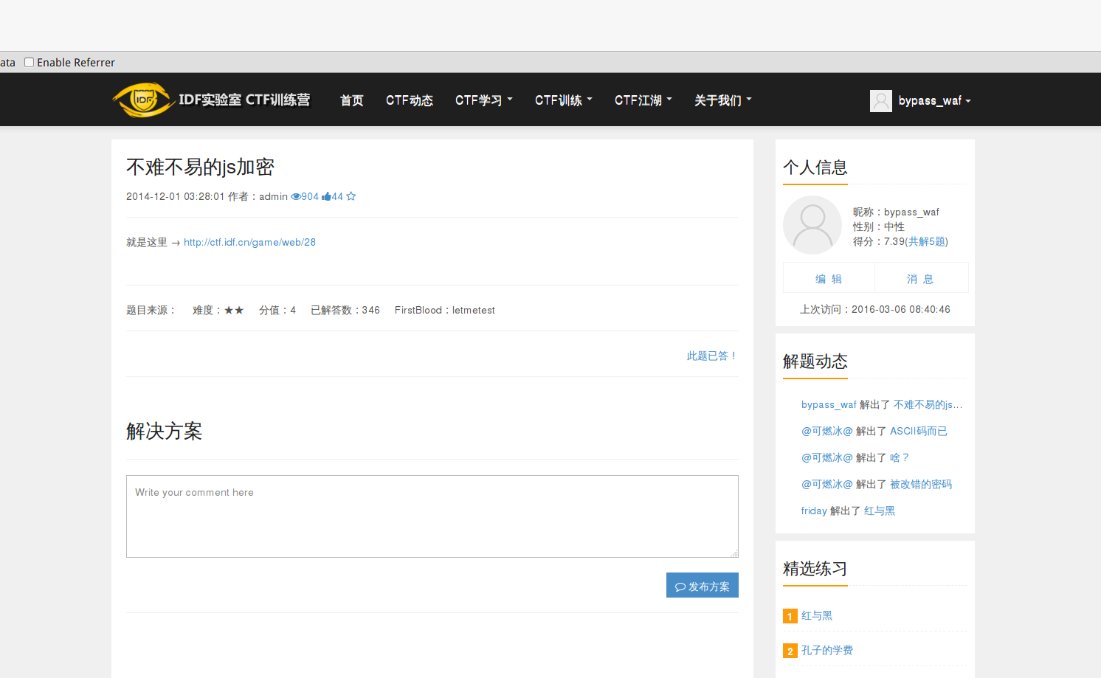

0x02 求flag过程
１>>打开firebug中script:
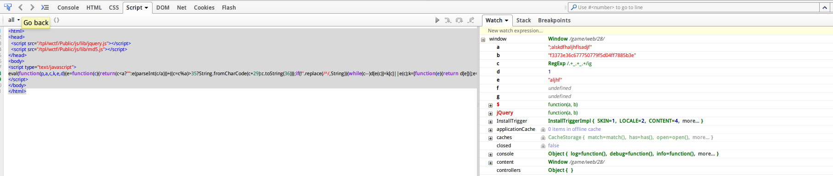
2>>具体内容：
<html>
<head>
<script src="/tpl/wctf/Public/js/lib/jquery.js"></script>
<script src="/tpl/wctf/Public/js/lib/md5.js"></script>
</head>
<body>
<script type="text/javascript">
eval(function(p,a,c,k,e,d){e=function(c){return(c<a?"":e(parseInt(c/a)))+((c=c%a)>35?String.fromCharCode(c+29):c.toString(36))};if(!''.replace(/^/,String)){while(c--)d[e(c)]=k[c]||e(c);k=[function(e){return d[e]}];e=function(){return'\\w+'};c=1;};while(c--)if(k[c])p=p.replace(new RegExp('\\b'+e(c)+'\\b','g'),k[c]);return p;}('4 a=1d("\\T\\Q\\Z\\10\\5\\Y\\n\\S\\X\\L\\W\\V\\x","");4 b="\\5\\j\\j\\0\\j\\h\\j\\k\\11\\k\\0\\0\\0\\3\\2\\0\\0\\C\\5\\3\\p\\2\\i\\5\\5\\0\\q\\q\\3\\u\\j\\h";4 c=/.+w.+w.+/P;4 d=t;4 e=a.1(O,y);9($.A(e)==b.B(/7/D,++d).B(/8/D,d*z)){4 f=a.1(t/d,R);9(f.1(y,z)=="\\1b\\M"&&$.A(f.1(t/d,d+E))=="\\p\\2\\6\\3\\i\\p\\3\\2\\i\\q\\u\\3\\n\\3\\h\\u\\6\\2\\h\\5\\6\\k\\i\\k\\i\\2\\2\\0\\6\\C\\5\\6"){r=a.1(15);9(r.m(d)-o==r.m(++d)-o&&r.m(--d)-o==r.m(--d)){4 g=l.H(1e);g=g.v()+g.v();9(r.1((++d)*E,1c)==g.19("\\h\\n\\M\\18")&&c.16(a)){d=l(s)+l(a.17)}}}};9(a.1(F,s)!=l.H(d)||a.1(F,s)=="\\12"){K("\\13\\L\\14\\1a\\N\\N\\J\\J")}U{K("\\I\\G\\I\\G\\x")}',62,77,'x37|substr|x30|x35|var|x66|x31|||if||||||||x65|x34|x33|x36|String|charCodeAt|x61|0x19|x64|x38||0x1|0x0|x62|toLowerCase|_|uff01|0x5|0x2|md5|replace|x39|ig|0x3|0x4|u559c|fromCharCode|u606d|u3002|alert|uff0c|x73|u60f3|0x8|gi|u5165|0x7|x67|u8f93|else|u5e74|u5c11|u5427|x6c|u4f60|u7684|x63|x7a|u989d|u518d|0xd|test|length|x79|concat|u53bb|x6a|0x6|prompt|0x4f'.split('|'),0,{}))
</script>
</body>
</html>
3>>本地新建一个html页面，内容为上述内容，其中由于存在：
<script src="/tpl/wctf/Public/js/lib/jquery.js"></script>
<script src="/tpl/wctf/Public/js/lib/md5.js"></script>
需要本地建立相应文件夹并将两个js文件下载到目录：
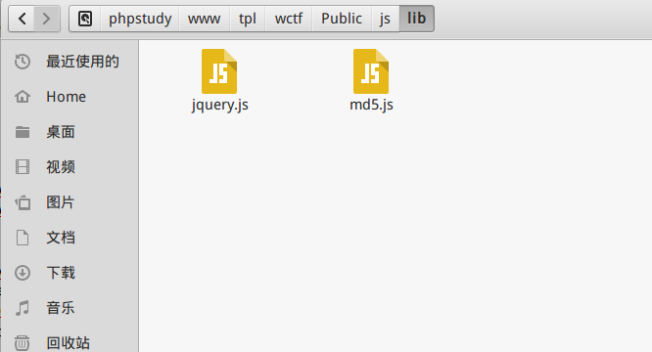
4>>２中js代码转换成易看代码：
用sublime text打开，安装JsFormat插件，可通过快捷键ctrl+alt+f
实现javascript代码自动对齐，js代码转换后变成：

var a = prompt("\\u8f93\\u5165\\u4f60\\u7684\\x66\\x6c\\x61\\x67\\u5427\\uff0c\\u5c11\\u5e74\\uff01", "");
var b = "\\x66\\x33\\x33\\x37\\x33\\x65\\x33\\x36\\x63\\x36\\x37\\x37\\x37\\x35\\x30\\x37\\x37\\x39\\x66\\x35\\x64\\x30\\x34\\x66\\x66\\x37\\x38\\x38\\x35\\x62\\x33\\x65";
var c = /.+_.+_.+/gi;
var d = 0x0;
var e = a.substr(0x8, 0x5);
if ($.md5(e) == b.replace(/7/ig, ++d).replace(/8/ig, d * 0x2)) {
var f = a.substr(0x0 / d, 0x7);
if (f.substr(0x5, 0x2) == "\\x6a\\x73" && $.md5(f.substr(0x0 / d, d + 0x3)) == "\\x64\\x30\\x31\\x35\\x34\\x64\\x35\\x30\\x34\\x38\\x62\\x35\\x61\\x35\\x65\\x62\\x31\\x30\\x65\\x66\\x31\\x36\\x34\\x36\\x34\\x30\\x30\\x37\\x31\\x39\\x66\\x31") {
r = a.substr(0xd);
if (r.charCodeAt(d) - 0x19 == r.charCodeAt(++d) - 0x19 && r.charCodeAt(--d) - 0x19 == r.charCodeAt(--d)) {
var g = String.fromCharCode(0x4f);
g = g.toLowerCase() + g.toLowerCase();
if (r.substr((++d) * 0x3, 0x6) == g.concat("\\x65\\x61\\x73\\x79") && c.test(a)) {
d = String(0x1) + String(a.length)
}
}
}
};
if (a.substr(0x4, 0x1) != String.fromCharCode(d) || a.substr(0x4, 0x1) == "\\x7a") {
alert("\\u989d\\uff0c\\u518d\\u53bb\\u60f3\\u60f3\\u3002\\u3002")
} else {
alert("\\u606d\\u559c\\u606d\\u559c\\uff01")
后将该js放进本地新建的html中，其中html内嵌js格式为：
<html>
<head>
<script src="/tpl/wctf/Public/js/lib/jquery.js"></script>
<script src="/tpl/wctf/Public/js/lib/md5.js"></script>
</head>
<body>
<Script Language="JavaScript">
Put your script code here ...
</script>
</body>
</html>
加入转换后js效果：
<html>
<body>
<Script Language="JavaScript">
var a = prompt("\u8f93\u5165\u4f60\u7684\x66\x6c\x61\x67\u5427\uff0c\u5c11\u5e74\uff01", "");
var b = "\x66\x33\x33\x37\x33\x65\x33\x36\x63\x36\x37\x37\x37\x35\x30\x37\x37\x39\x66\x35\x64\x30\x34\x66\x66\x37\x38\x38\x35\x62\x33\x65";
var c = /.+_.+_.+/gi;
var d = 0x0;
var e = a.substr(0x8, 0x5);
if ($.md5(e) == b.replace(/7/ig, ++d).replace(/8/ig, d * 0x2)) {
var f = a.substr(0x0 / d, 0x7);
if (f.substr(0x5, 0x2) == "\x6a\x73" && $.md5(f.substr(0x0 / d, d + 0x3)) == "\x64\x30\x31\x35\x34\x64\x35\x30\x34\x38\x62\x35\x61\x35\x65\x62\x31\x30\x65\x66\x31\x36\x34\x36\x34\x30\x30\x37\x31\x39\x66\x31") {
r = a.substr(0xd);
if (r.charCodeAt(d) - 0x19 == r.charCodeAt(++d) - 0x19 && r.charCodeAt(--d) - 0x19 == r.charCodeAt(--d)) {
var g = String.fromCharCode(0x4f);
g = g.toLowerCase() + g.toLowerCase();
if (r.substr((++d) * 0x3, 0x6) == g.concat("\x65\x61\x73\x79") && c.test(a)) {
d = String(0x1) + String(a.length)
}
}
}
};
if (a.substr(0x4, 0x1) != String.fromCharCode(d) || a.substr(0x4, 0x1) == "\x7a") {
alert("\u989d\uff0c\u518d\u53bb\u60f3\u60f3\u3002\u3002")
} else {
alert("\u606d\u559c\u606d\u559c\uff01")
}
</script>
</body>
</html>
5>>chrome访问本地html,并用开发者工具调试js:
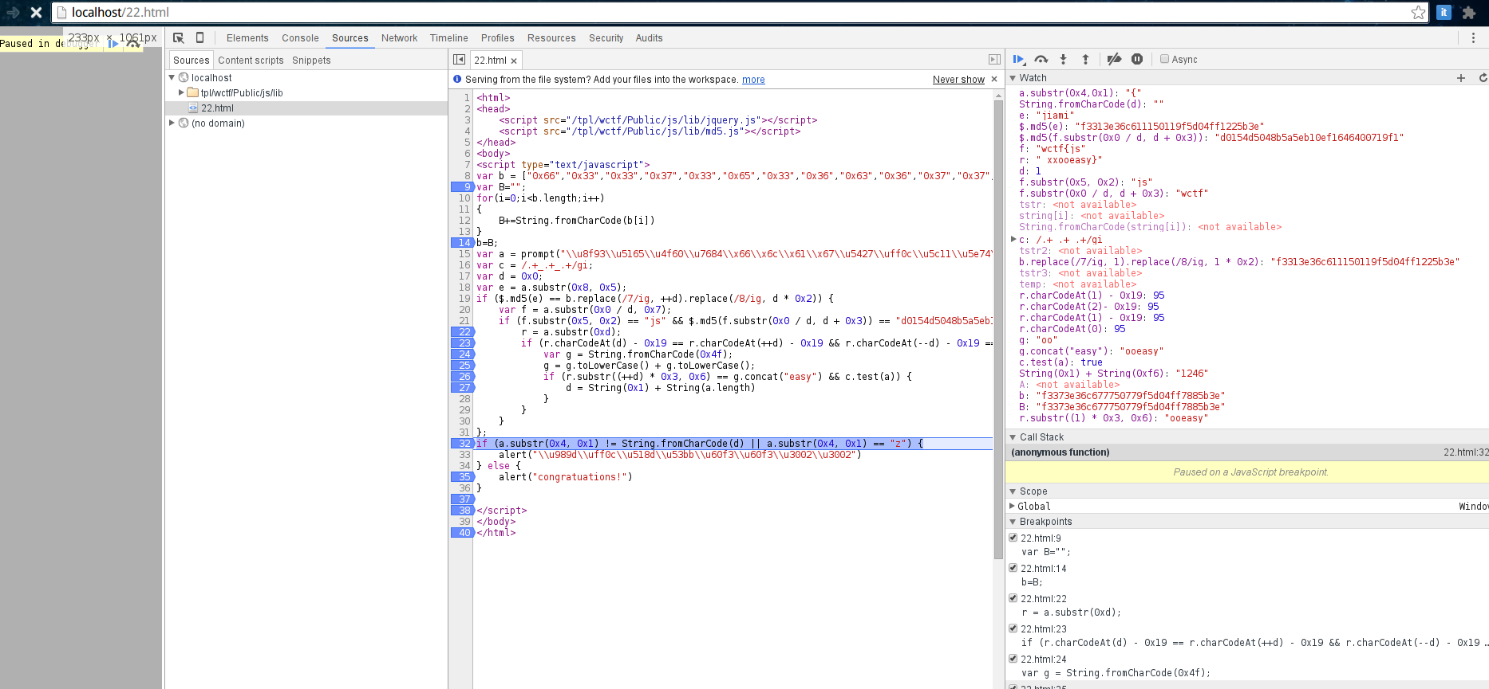
调试过程中发现，４中被转换后的js中的字符表示形式：
var b = "\x66\x33\x33\x37\x33\x65\x33\x36\x63\x36\x37\x37\x37\x35\x30\x37\x37\x39\x66\x35\x64\x30\x34\x66\x66\x37\x38\x38\x35\x62\x33\x65";

if (f.substr(0x5, 0x2) == "\x6a\x73" && $.md5(f.substr(0x0 / d, d + 0x3)) == "\x64\x30\x31\x35\x34\x64\x35\x30\x34\x38\x62\x35\x61\x35\x65\x62\x31\x30\x65\x66\x31\x36\x34\x36\x34\x30\x30\x37\x31\x39\x66\x31")

if (r.substr((++d) * 0x3, 0x6) == g.concat("\x65\x61\x73\x79") && c.test(a))

if (a.substr(0x4, 0x1) != String.fromCharCode(d) || a.substr(0x4, 0x1) == "\x7a")
以上４处无法满足调试成立关系，这有可能是js转换插件JsFormat引起的，将上面的十六进制形式转换成正常字符形式，用js代码实现：
var b = ["0x66","0x33","0x33","0x37","0x33","0x65","0x33","0x36","0x63","0x36","0x37","0x37","0x37","0x35","0x30","0x37","0x37","0x39","0x66","0x35","0x64","0x30","0x34","0x66","0x66","0x37","0x38","0x38","0x35","0x62","0x33","0x65"];
var B="";
for(i=0;i<b.length;i++)
{
B+=String.fromCharCode(b[i])
}
b=B;

if (f.substr(0x5, 0x2) == "js" && $.md5(f.substr(0x0 / d, d + 0x3)) == "d0154d5048b5a5eb10ef1646400719f1")

if (r.substr((++d) * 0x3, 0x6) == g.concat("easy") && c.test(a))

if (a.substr(0x4, 0x1) != String.fromCharCode(d) || a.substr(0x4, 0x1) == "z")
6>>最后html内嵌js的完整可调试代码为：
<html>
<head>
<script src="/tpl/wctf/Public/js/lib/jquery.js"></script>
<script src="/tpl/wctf/Public/js/lib/md5.js"></script>
</head>
<body>
<script type="text/javascript">
var b = ["0x66","0x33","0x33","0x37","0x33","0x65","0x33","0x36","0x63","0x36","0x37","0x37","0x37","0x35","0x30","0x37","0x37","0x39","0x66","0x35","0x64","0x30","0x34","0x66","0x66","0x37","0x38","0x38","0x35","0x62","0x33","0x65"];
var B="";
for(i=0;i<b.length;i++)
{
B+=String.fromCharCode(b[i])
}
b=B;
var a = prompt("\\u8f93\\u5165\\u4f60\\u7684\\x66\\x6c\\x61\\x67\\u5427\\uff0c\\u5c11\\u5e74\\uff01", "");
var c = /.+_.+_.+/gi;
var d = 0x0;
var e = a.substr(0x8, 0x5);
if ($.md5(e) == b.replace(/7/ig, ++d).replace(/8/ig, d * 0x2)) {
var f = a.substr(0x0 / d, 0x7);
if (f.substr(0x5, 0x2) == "js" && $.md5(f.substr(0x0 / d, d + 0x3)) == "d0154d5048b5a5eb10ef1646400719f1") {
r = a.substr(0xd);
if (r.charCodeAt(d) - 0x19 == r.charCodeAt(++d) - 0x19 && r.charCodeAt(--d) - 0x19 == r.charCodeAt(--d)) {
var g = String.fromCharCode(0x4f);
g = g.toLowerCase() + g.toLowerCase();
if (r.substr((++d) * 0x3, 0x6) == g.concat("easy") && c.test(a)) {
d = String(0x1) + String(a.length)
}
}
}
};
if (a.substr(0x4, 0x1) != String.fromCharCode(d) || a.substr(0x4, 0x1) == "z") {
alert("\\u989d\\uff0c\\u518d\\u53bb\\u60f3\\u60f3\\u3002\\u3002")
} else {
alert("congratuations!")
}

</script>
</body>
</html>
7>>本地调试
在watch这里可以加各种表达式用来实时查看变量的值：
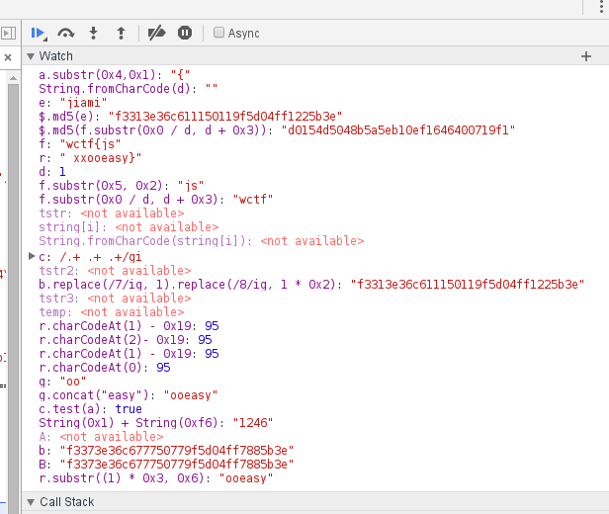

其中要注意的是，由于开始的时候一直监控了:
b.replace(/7/ig, ++d).replace(/8/ig, d * 0x2)

r.charCodeAt(++d) - 0x19 && r.charCodeAt(--d) - 0x19 == r.charCodeAt(--d)
两个表达式的值，导致一直算不出正确的答案，后来发现监控中加了++d,--d等的值会随着调试过程动态改变d的值，而这将改变d在调试代码中的本来应有的值，从而无法正确调试到答案，解决方法，去掉这两个表达式的监控，在调试过程中计算d的值，可将这两个监控表达式改成：
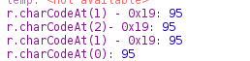
然后动态调试，其中有两个md5解密分别为：
wctf
jiami
算出最后的答案应该是：
wctf{js_jiami_xxooeasy
但是提交显示不正确，尝试在最后加了个}符号，答案正确。

