Sensors are used everywhere around us, it has a wide variety of applications starting from what you are using your mobile to complex machineries

Some Image (Yet to decide)

What is a sensor?

Sensors basically detects the physical quantity like force, Pressure, Light and converts it into electrical signal to measure the applied physical quantity

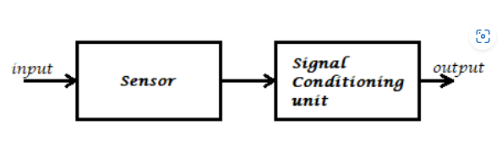



Signal Conditioning:

Takes some input signal, modifies(Amplify, Filter, Sample ) it and gives output

Classification of Sensors

➢ Active Sensor:Active sensor emits energy, transmits energy or drives a signal and detects and measures the reflected signal. As a result, external power source is needed for active sensors in order to detect and measure.

Active Sensors are those which require an external excitation signal or a power signal. E.g.: LiDAR (Light Detection and Ranging), Photoconductive Cell,Accelerometers

➢ Passive Sensor: Does not require any additional energy source to produce output signal. They respond to changes around them.

**The power is necessary only for the reading of the measured property.**

E.g.: Radiometers, film photography, anemometer (Wind Speed Sensor), seismic sensors

➢ Based on Detection: Some of the means of detection are Electric, Biological, Chemical, Radioactive etc.

➢ Analogue Sensors: Produce an analogue output (Continuous Signal)

➢ Digital Sensors: Work with discrete or digital data(Zeroes and ones)

➢ Some of the conversion phenomena are Photoelectric, Thermoelectric, Electrochemical, Electromagnetic, Thermo-optic, etc.

Types of sensors?

1. **Light Sensors :**

Light sensors are photoelectric sensors that converts light energy (photons) into electrical energy

1. **Photodiodes**: The diode is connected in reverse bias giving rise to negligible current. When light source is illuminated, the reverse current increases and the diode resistance drops

The measured current is nearly equal to the intensity of the light

Application: Used as IR receiver

1. **Photoresistor :** A photoresistor (or light-dependent resistor, LDR, or photoconductive cell) is a light-controlled variable resistor. The resistance of a photoresistor decreases with increasing incident light intensity (photoconductivity).

It won’t respond if the light is not exactly focused on its surface.

Applications: Agriculture, Weather monitoring, Temp. Control

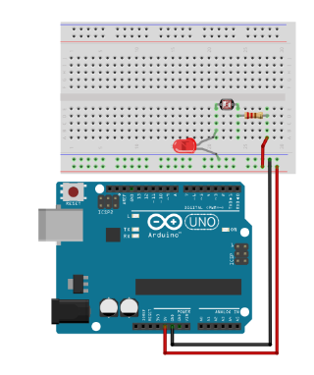

1. **Infrared Sensor**

There are two parts: Transmitter and Receiver

It sends an infrared red signal using **IR Led** and senses the reflected signal using **Photodiode.**

Photodiode resistance changes according to the amount of IR radiation falling on it, hence the voltage drop across it also changes and by using we can sense the voltage change and generate the output accordingly.

**Note that object shouldn’t be black as it will absorb all the IR light, instead of reflecting.**

**Two Methods :**

**Direct**

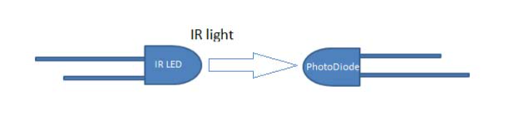

Indirect

Applications: Obstacle avoidance, Line Follower, TV remote …

1. **Temperature Sensors**

Detect the variation in temperature

1. **Thermistor**

They are made up of pure semiconductors, whose conductivity is due to holes and electrons. When Temp. increases more no. of electrons participate in conduction, induces current.

This change in current flow can be used to determine the amount of change in temperature.

1. **Thermocouple**

Uses two different types of metals, when temp. increases potential difference is developed between them, which can be measured which is a measure of the Temp. Change

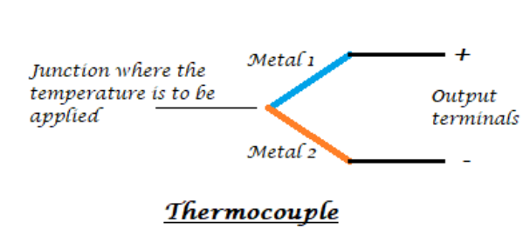

**Applications :** Temp of engine, Industrial temperature measurement, Exhaust Gas Temperature sensors, battery Temp. Monitoring

1. Potentiometer:

Used to detect the position. Its resistance is proportional to the length of the wire

Uses: Volume control in audio equipment, Position sensing (Joystick) Tuning Circuits

1. Encoder:

Converts information from one format to another, like light rays to electrical signals(Optical Sensing)

The encoder sends a feedback signal that can be used to determine position, count, speed, or direction.

Applications: CNC, Robotic arms, Position sensing

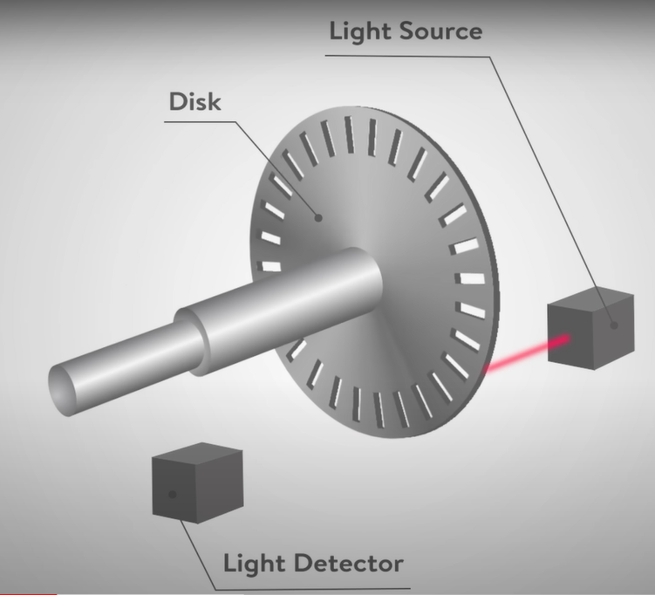

1. Hall Effect Sensors:

Converts magnetic field variations into electric signals

Works on the principle of Hall Effect

Hall effect : When current carrying conductor is placed in a magnetic field the electrons flowing through the conductor displaces towards the edges, thus giving rise to voltage difference, called hall voltage.

Applications :

Security systems, Anti-Lock braking system

