**0.4A_1500rpm 20480 channel_3**

**传感器安装至第二轴**

**传动比 i = 90/36 = 2.5 当二轴齿轮转动一圈，输入轴(电机)转动 2.5圈，转动一圈耗时1500/60 * 2.5 = 0.1s**

**采样长度为0.1s * 20480Hz = 2048**

**Time domain**

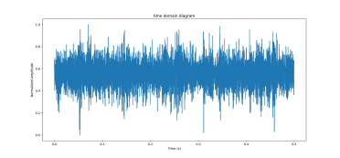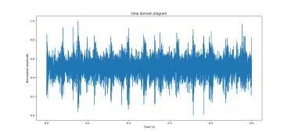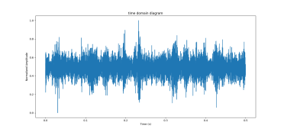

broken_half_tooth broken_tooth eccentric_gear

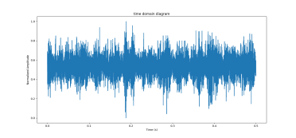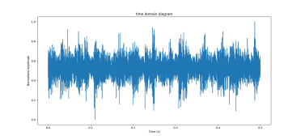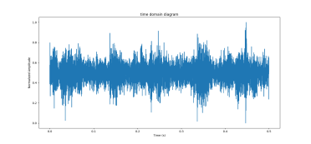

crack_gear normal surface_wear

**Frequency domain (FFT)**

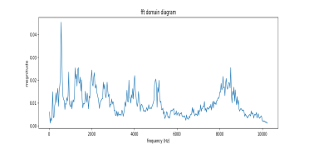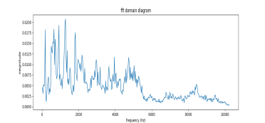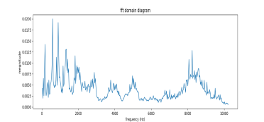

broken_half_tooth broken_tooth eccentric_gear

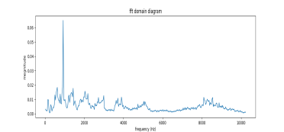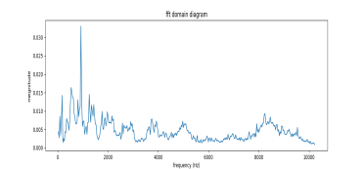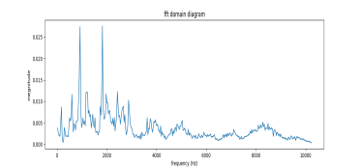

crack_gear normal surface_wear

**STFT 2D**

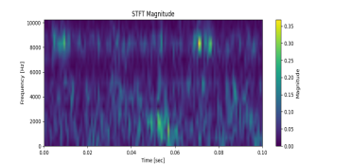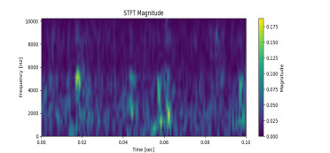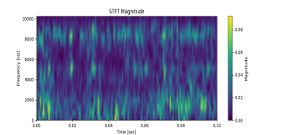

broken_half_tooth broken_tooth eccentric_gear

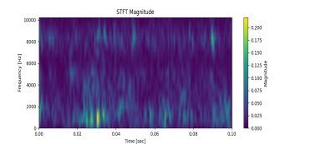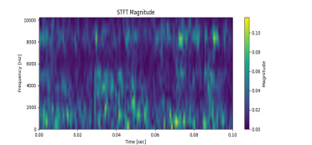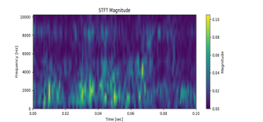

crack_gear normal surface_wear

**STFT 3D**

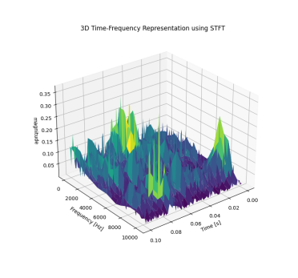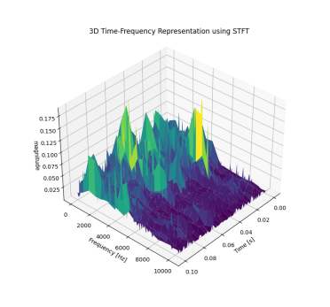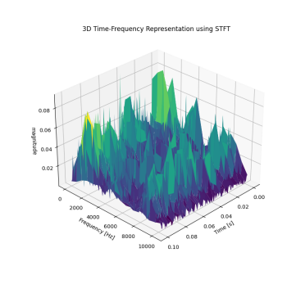

broken_half_tooth broken_tooth eccentric_gear

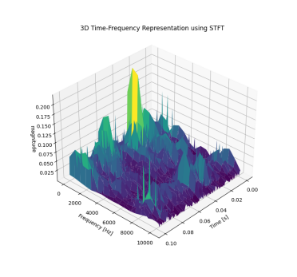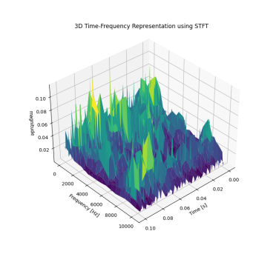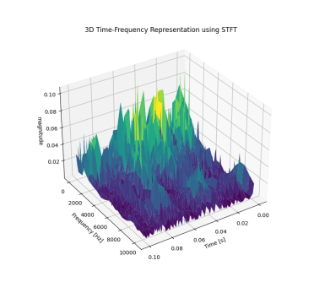

crack_gear normal surface_wear

原始，未归一化 6min

