Example manuscript demonstrating the use of the papaja template

Frederik Aust

# What is papaja?

As you may have heard, recently, there has been a growing interest in reproducible research. Reproducible data analysis is an easy to implement and important aspect of the strive towards reproducibility. For *R* users, RMarkdown has been suggested as one possible framework for reproducible analyses. Markdown is a simple formatting syntax for authoring HTML, PDF, and MS Word documents. This example document assumes you have hoped onto the band wagon and know how to use RMarkdown to conduct and comment your analyses. If you're new to [RMarkdown](http://rmarkdown.rstudio.com/), I recommend you get to grips with it first.

I use [RStudio](http://www.rstudio.com/) (which makes use of [pandoc](http://johnmacfarlane.net/pandoc/)) to create my documents, but the general process should work when using pandoc directly from the command line.

# How do I use papaja?

With the papaja-template, when you click RStudio's *Knit* button an APA conform manuscript will be generated that includes both your text and the output of any embedded R code chunks within the manuscript.

## Printing R output

Any output from R is included as you usually would using RMarkdown.

summary(cars)

## speed dist   
## Min. : 4.0 Min. : 2   
## 1st Qu.:12.0 1st Qu.: 26   
## Median :15.0 Median : 36   
## Mean :15.4 Mean : 43   
## 3rd Qu.:19.0 3rd Qu.: 56   
## Max. :25.0 Max. :120

### Print tables

For prettier tables, I suggest you have a look at my helper function apa.table() in the [papaja repository](https://github.com/crsh/papaja). Of course, e.g, the popular xtable or tables packages can also be used to create tables when knitting PDF. Unfortunately, xtable() captions are [set to the left page margin](http://tex.stackexchange.com/questions/42209/centering-tables-in-document-class-apa6). Also, these packages cannot be used when you want to create Microsoft Word documents. apa.table() creates tables that conform to APA guidelines and are correctly rendered in PDF and Word documents. However, as of now the formatting of tables is somewhat limited due to missing functionality in pandoc (e.g. it is not possible to have cells span across multiple columns).

As required by the APA guidelines, tables are on the final pages of the manuscript when creating PDF documents. This is not the case in Word documents, however.

source("../helper/apatable.r")  
apa.table(  
 apply(cars, 2, function(x) round(  
 c(Mean = mean(x), SD = sd(x), Min = min(x), Max = max(x)), 2)  
 )  
 , align = c("l", "r", "r")  
 , caption = "A summary table of the cars dataset."  
 , note = "This table was created using apa.table()"  
 , var.names = "Descriptives"  
)

Table. *A summary table of the cars dataset.*

|  |  |  |
| --- | --- | --- |
| Descriptives | speed | dist |
| Mean | 15.4 | 42.98 |
| SD | 5.29 | 25.77 |
| Min | 4 | 2 |
| Max | 25 | 120 |

*Note.* This table was created using apa.table()

Please note that Word documents will be less polished than PDF because of the limitly limited functionality of pandoc when it comes to creating Word templates. The resulting documents should be pretty enough to enable collaboration with Wordy colleagues.

### Plots

You can also embed plots, for example:

plot(cars)

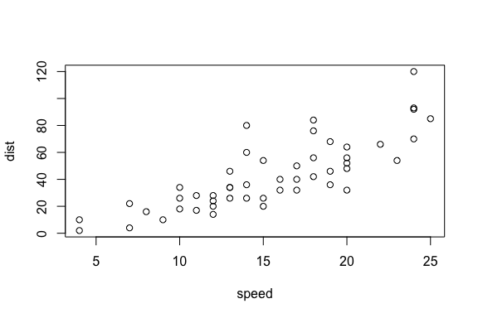

Exmple figure created by in-document R code.

As required by the APA guidelines, figures, too, are printed to the final pages of the document.

## Citations

You can insert citations like this:

[e.g., @bauer_2014; @bem_2011] → (e.g., Baumer, Cetinkaya-Rundel, Bray, Loi, & Horton, 2014; Bem, 2011).

Citing without parentheses is, of course, also possible:

@bauer_2014 → Baumer et al. (2014).

The citation style is set in the header of this document with the csl parameter. The relevant references will, of course, be added to the documents references automatically. In order for citations to work, you need to supply a .bib-file to the bibliography parameter in the document header. See the [RMarkdown documentation](http://rmarkdown.rstudio.com/authoring_bibliographies_and_citations.html) and [Citation Style Language](http://citationstyles.org/) for further details.

## Document options

This text is set as manuscript. If you want a thesis-like document you can change the classoption in the document header from man to doc. You can also preview a polished journal typesetting by changing the classoption to jou.

When creating PDF documents, line numbering can be activated by setting the lineno argument in the header of this document to true. This option has no effect on Word documents.

## Last words

That's all I have. Enjoy writing your manuscript. If you have any trouble or ideas for improvements, open an [issue](https://github.com/crsh/papaja/issues) on GitHub or make a pull request with the fix. ;)

# References

Baumer, B., Cetinkaya-Rundel, M., Bray, A., Loi, L., & Horton, N. J. (2014). R Markdown: Integrating A Reproducible Analysis Tool into Introductory Statistics. *ArXiv E-Prints*. Retrieved from <http://adsabs.harvard.edu/abs/2014arXiv1402.1894B>

Bem, D. J. (2011). Feeling the future: experimental evidence for anomalous retroactive influences on cognition and affect. *Journal of Personality and Social Psychology*, *100*(3), 407—425. doi:[10.1037/a0021524](http://dx.doi.org/10.1037/a0021524)