local IP range

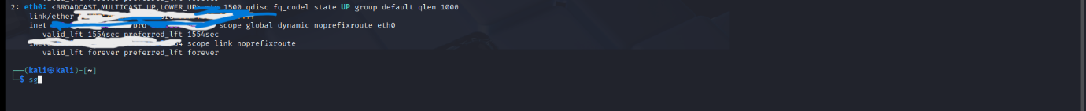

NMAP Scan

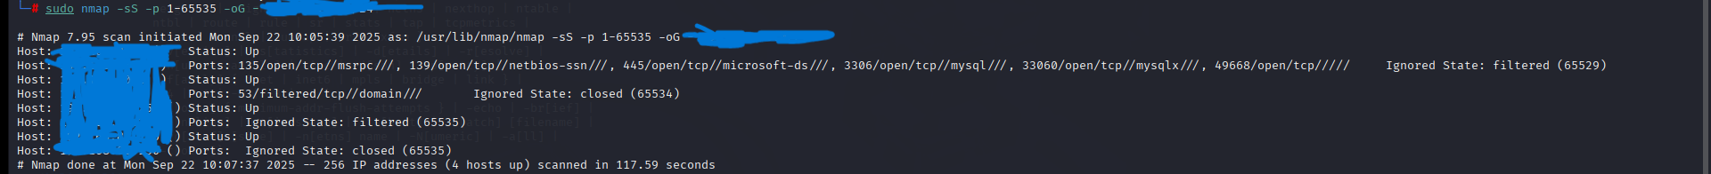

open ports found in total are 6 in total cant don’t want to share

Identified potential security risks from open ports.

Wireshark Captures