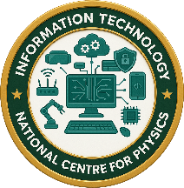
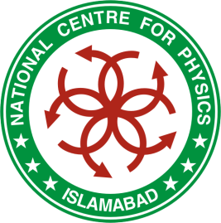
International Symposium on Data Technologies
I S D T – 2 0 2 6
April 15-17, 2026

National Centre for Physics (NCP), Islamabad, Pakistan

Project Detail

- Project

Project Title:
Click or tap here to enter text.

Project Category: (Web Application, Mobile App, AI/ML, Data Science, Cyber Security, IoT, Game, Other)

Click or tap here to enter text.

- Project Overview
Click or tap here to enter text.

- Technology Stack

Programming Languages, Frameworks/Libraries, Database (if any), Tools/Platforms Used:
Click or tap here to enter text.

- Key Features

List the main features of your project (bullet points preferred):
Click or tap here to enter text.

- Target Users

Who will use this system/application:
Click or tap here to enter text.

- Project Status

Idea Stage / Prototype / Partially Completed / Fully Functional:
Click or tap here to enter text.

- Expected Impact

What impact will this project have if implemented or scaled?
Click or tap here to enter text.

- Additional Information (Optional)

Demo Link / GitHub Repository / Video (if available):
Click or tap here to enter text.

Any other relevant details:
Click or tap here to enter text.

