./

Report – Automatic Bus Booking System

Course Code: <CODE>



Version Number:

Team Members :

Team No:

Module: Model Based System Engineering

|  |  |  |  |  |  |
| --- | --- | --- | --- | --- | --- |
| **Ver. Rel. No.** | **Release Date** | **Prepared. By** | **Reviewed By** | **Approved By** | **Remarks/Revision Details** |
|  |  |  |  |  |  |
|  |  |  |  |  |  |
|  |  |  |  |  |  |
|  |  |  |  |  |  |
|  |  |  |  |  |  |

**Document History**

# 

Contents

pROJECT 3

Introduction 4

Requirements 5

SWOT Analysis 6

Design 7

Testing 8

References 10

**TOPIC =Automatic Bus Booking System**

**Introduction:**

This is the project on the online ticketing system of express bus company, which in most cases; the company has problems with their ticketing and scheduling process. This project intends to computerize its semi computerized ticketing system to provide better customer service. Because of that, the company can provide the easier way of travelling to the customer or passenger. Electronic tickets, or e-tickets, give evidence that their holders have permission to enter a place of entertainment, use a means of transportation, or have access to some Internet services. Bus Ticket Reservation System enables the bus company's customer to buy bus ticket online. E-ticket is the easier and quickest way to take bus. The online system is a new system because it havens exists in bus company and even in Malaysia. Currently, staff at the bus ticket counter is using an internal system to sell ticket at the counter. Customer is unable to buy bus ticket online at this moment and must go to the counter to buy bus ticket. Sometimes, customer needs to queue up a long queue to buy bus ticket and ask for information. Besides that, customer also not allows buying bus ticket through telephone and Transnational’s telephone line is always busy.

**Requirements:**

|  |  |  |
| --- | --- | --- |
| Users | Type | Description |
| Admin | Admin-level-1 | Admin totally control the proposed system they can action view and every work including checking ticket are displayed to the passengers, and every counter transaction status. |
| Operator | Operator(level-2) | Operator can view the seats distribution. If a visitor or user request for a new ticket with fully follow their instruction and the operator confirm his ticket and send the confirmation by phone. |
| Visitor/Registered user | Basic level-3 | The user can request only new ticket from to destination place. |

**SWOT Analysis:**

**STRENGTH:**

The main strength of this project is it is user friendly and can easily handle by the android mobile user. The accuracy level is higher.

**WEAKNESS:**

Tickets become a barer bond commodity type of asset the second they are printed, resulting in potential theft, loss and counterfeit to the patron, and lost income, information and theft for the event sponsor.

**OPPORTUNITY:**

This product helps us to provide great opportunity in reducing the burden of the human.

**THREATS:**

To control illegal ticket trading activities by ticket brokers and all the ticket scalpers, law enforcement agencies are being challenged.

**Design:**

**Behavioral UML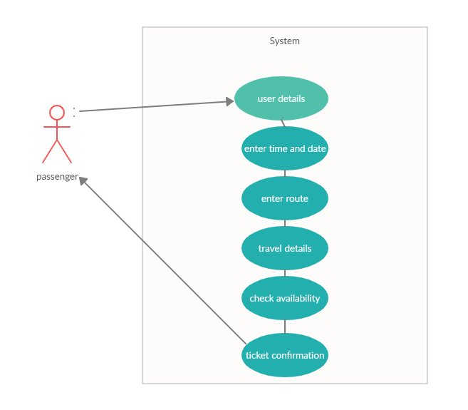:**

**Structural UML**:

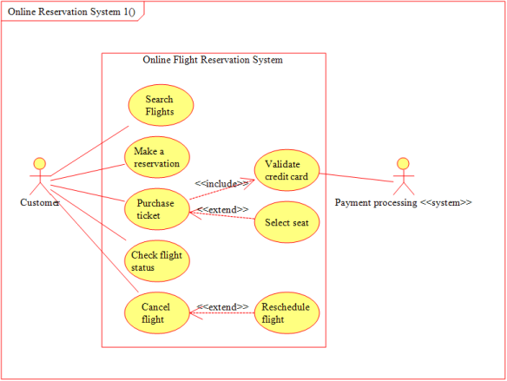

**Test Cases:**

|  |  |  |  |  |  |
| --- | --- | --- | --- | --- | --- |
| **ID** | **Description** | **Pre-condition** | **Expected-input** | **Expected-output** | **Actual output** |
| 1 | Problem arises in booking | When 2 peoples booking same seat | The two peoples need same seat. | The person who fills first can hold on the same seat and the other person should occupy the other seat | The system operates |
| 2 | Problem arises due to the size of the bus | While entering through the booking site the number of seats available should be shown | The person needs more seats than available | The reminder or an alert should be given to help the customer. | The system operates successfully. |

**Conclusion:**

It can be observed that computer applications are very important in every field of human endeavor. Here all the information about customer that made reservation can be gotten just by clicking a button with this new system, some of the difficulties encountered with the manual system are overcome. It will also reduce the workload of the staff, reduce the time used for making reservation at the bus terminal and increase efficiency. The application also can update records in various files automatically thereby relieving the company’s staff the stress of working from file security of data.

**References:**

[1] 4 october 2017. [Online]. Available: <http://www.securionpay.com>.

[2] RACHNA and P. SINGH, "Issues and Challenges of Electronic Payment Systems," International Journal for Research in Management and Pharmacy, 9, December 2013.

[3] Princewill Aigbe and Jackson Akpojaro, "Analysis of Security Issues in Electronic Payment Systems," International Journal of Computer Applications (0975 – 8887), 10, December 2014.

[4] S. Sumanjeet, "Emergence of Payment Systems in the age of Electronic Commerce: The State of Art," Asia Pacific Journal of Finance and Banking Research.

[5] D. U. P. S. B. V. Goyal, "Mobile Banking in India: Practices, Challenges and Security Issues," International Journal of Advanced Trends in Computer Science and Engineering, 2012.

[6] A. Y. A. M. S. Uddin, "E-Wallet System for Bangladesh an Electronic Payment System".