

**Document History**

|  |  |  |  |  |  |
| --- | --- | --- | --- | --- | --- |
| **Ver. Rel. No.** | **Release Date** | **Prepared. By** | **Reviewed By** | **To be Approved By** | **Remarks/Revision Details** |
|  |  | Divyesh M |  |  |  |
|  |  |  |  |  |  |
|  |  |  |  |  |  |
|  |  |  |  |  |  |
|  |  |  |  |  |  |
|  |  |  |  |  |  |

# 

**Contents**

**Activity 2:- Statistical Analysis of Crop Production** **3**

Introduction 4

**Requirements:** **4**

High Level Requirements: 5

Low Level Requirements: 5

**Design** **6**

Behavioral Diagrams 6

USE Case Diagram 6

Activity Diagram 6

Structural Diagrams 8

Class Diagram 8

Components Diagram 9

**Test Plan** **9**

Requirement based testing 9

Boundary condition testing 10

Scenario Based testing 10

**Activity 3:- GITHUB** **11**

GITHUB repository 11

GITHUB Actions 11

GITHUB issue 12

Raising Issue 12

Issue resolved and closed 13

# 

# 

# 

# 

# 

# 

# Activity 2:- Statistical Analysis of Crop Production

### Introduction

Today, India ranks second worldwide in the farm output. Agriculture is demographically the broadest economic sector and plays a significant role in the overall socio-economic fabric of India. Agriculture is a unique business crop production which is dependent on many climate and economy factors. Some of the factors on which agriculture is dependent are soil, climate, cultivation, irrigation, fertilizers, temperature, rainfall, harvesting, pesticide weeds and other factors.The .csv file includes crop cultivation in different districts which also highlights the cultivation in different seasons ,year wise data on crop covered area (Hectare) and production (Tonnes). The data is used to study and analyse crop production, production contribution to district/State/country.The system is also a vital source for formulating crop related schemes and assessing their impacts. Implementation of the project using all the C++ concepts with extended LINUX concepts. In this project find out some key values using given data. Some point are given below:

1. Find State using Production
2. States with kharif crops
3. Remove Production using production number
4. How to find Production using ID
5. Count all crop production
6. Count of states with potato plants
7. Find out States with minimum area
8. FInd out the Maximum production District

Implemented this all cases in the project to find the value/place immediately using key values. Which helps to analyze the data easily as well as saves the time .

## **Requirements:**

### High Level Requirements:

|  |  |
| --- | --- |
| **ID** | **Description** |
| HL_01 | When user gives input as a production ID then find State using production |
| HL_02 | Find out states with kharif season |
| HL_03 | Using area code should remove the respective production from database |
| HL_04 | If user gives the productionID then code should able to find the type of production |
| HL_05 | Should able to find count of database |
| HL_06 | Find the number of States whose grows the potatoes crops |
| HL_07 | Which States have a minimum area. |
| HL_08 | Gives the district which grows the maximum production. |

### Low Level Requirements:

|  |  |
| --- | --- |
| **ID** | **Description** |
| LL_01_HH_01 | Read Production appropriately |
| LL_02_HH_02 | Get Season function should work |
| LL_03_HH_03 | If user enter area code then code should get it properly |
| LL_04_HL_04 | define Itrator should increment for every database entry |
| LL_05_HL_05 | Production should not vary continuously |
| LL_06_HL_06 | Getting the value of crops |
| LL_07_HL_07 | Comparison function need to work properly |
| LL_08_HL_08 | Getting value of district for each iteration |

## **Design**

### Behavioral Diagrams

### USE Case Diagram

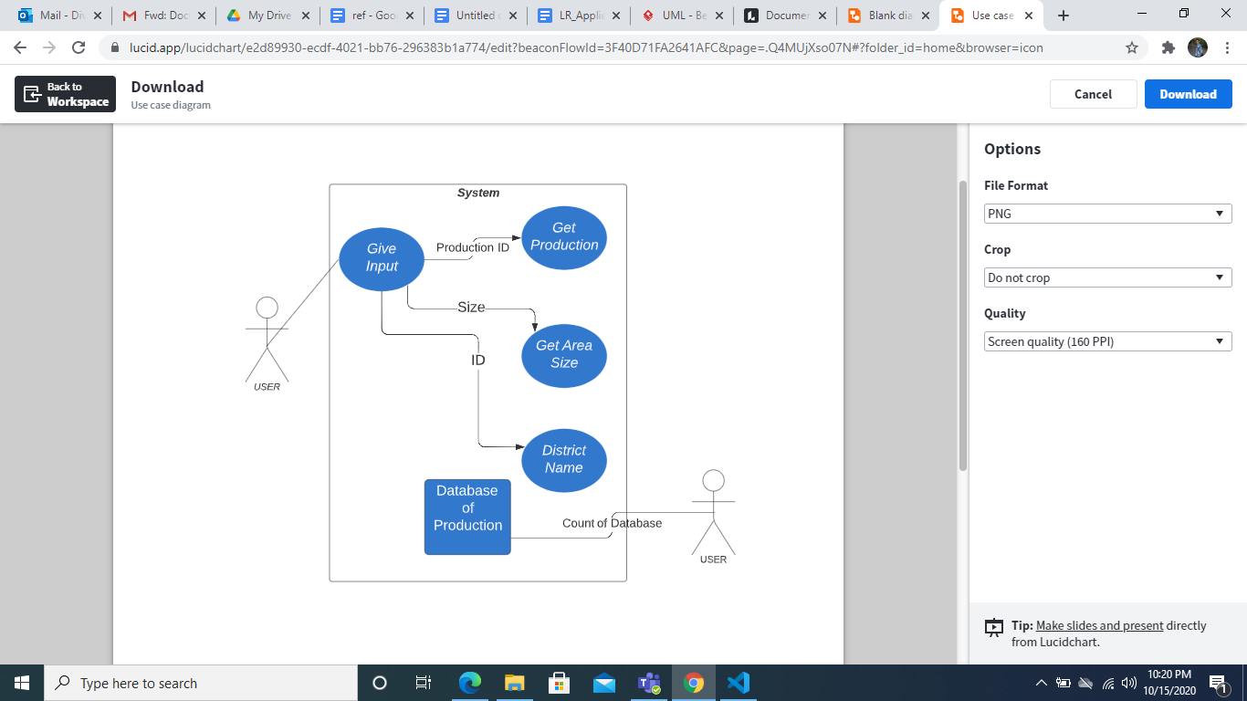

### Activity Diagram

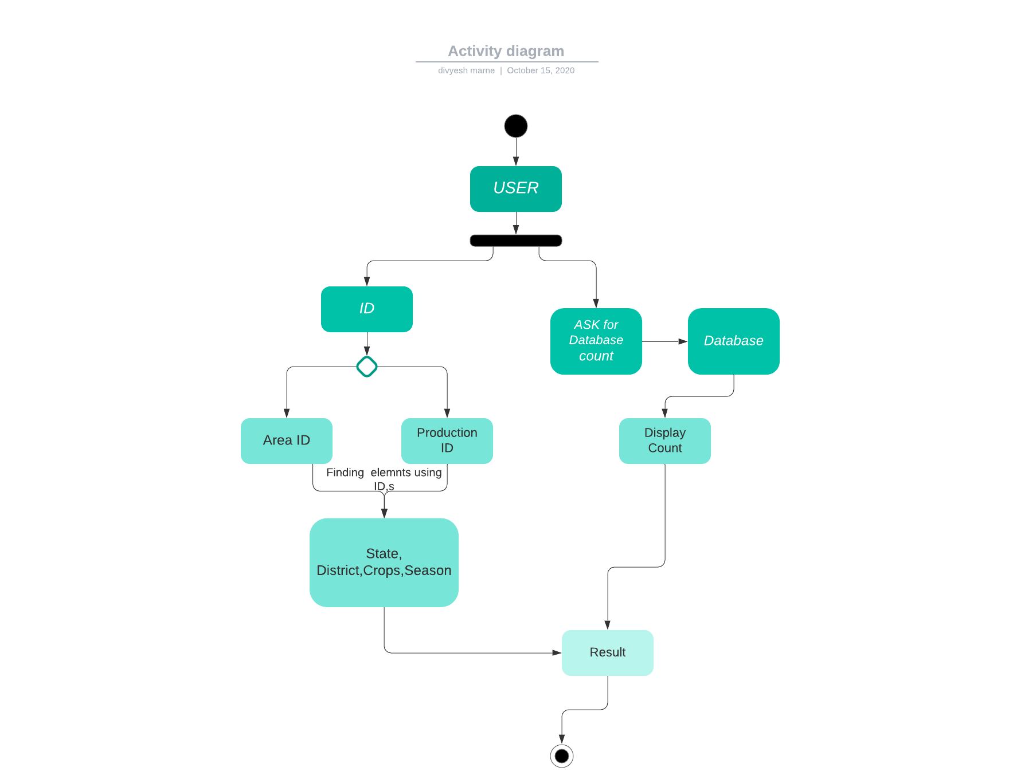

# 

# 

# 

### Structural Diagrams

### Class Diagram

# 

### Components Diagram

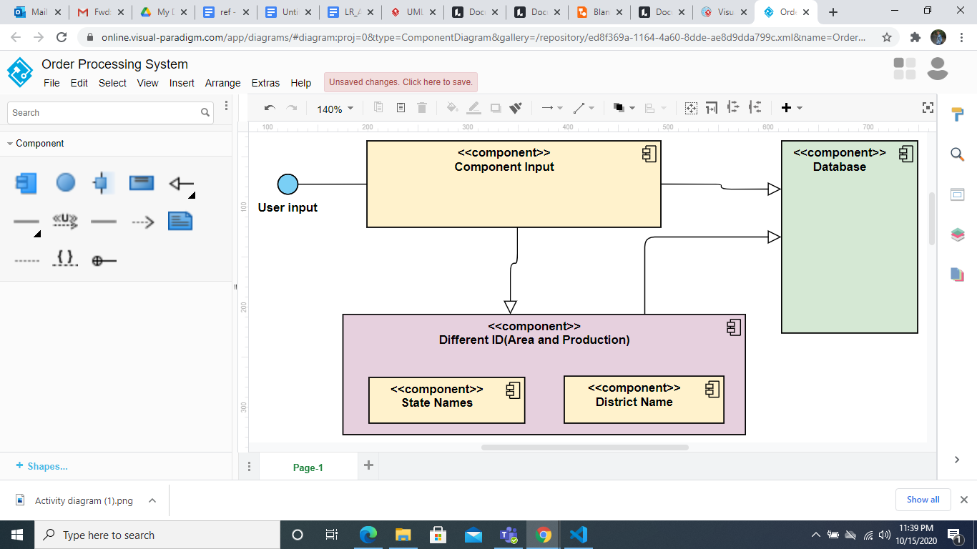

# 

## **Test Plan**

### Requirement based testing

|  |  |  |  |  |
| --- | --- | --- | --- | --- |
| **TEST_ID** | **Description** | **Expected Input** | **Expected Output** | **Actual Output** |
| 1_HL_01 | When user gives input as a production ID then find State using production | Input Should be Production ID to find state | The state name with respect to PRoduction ID | TEST Case passed |
| 2_HL_02 | Find out states with kharif season | Pass Kharif to Season column in database using iterator | List of the States whose grows up Kharif | Complete list of states |
| 3_HL_03 | Using area code should remove the respective production from database | Area ID | Delete Complete data related to Area ID | Data related to this is removed |
| 4_HL_04 | If user gives the productionID then code should able to find the type of production | Production ID | Type of the Production | TEST case passed |
| 5_HL_05 | Should able to find count of database | Pass the database to Iterator | Count of the database | Displayed Count |
| 6_HL_06 | Find the number of States whose grows the potatoes crops | Pass state column to iterator | List of States Whose grows potato crops | Complete list of states |
| 7_HL_07 | Which States have a minimum area. | Area itself to iterator | The State name Which has minimum area | State name(whose has less area) |
| 8_HL_08 | Give the districtName which grows the maximum production. | Production | The Name of district will display which has maximum production | District Name displayed |

### Boundary condition testing

1) When user wants to find District or State which is not there in database

2) Limited Database

### Scenario Based testing

1) When user give String instead of integer value

2) When the user enters an operand which is undefined

# Activity 3:- GITHUB

### GITHUB repository

GITHUB Link: <https://github.com/99002456/MINI_PROJECT.git>

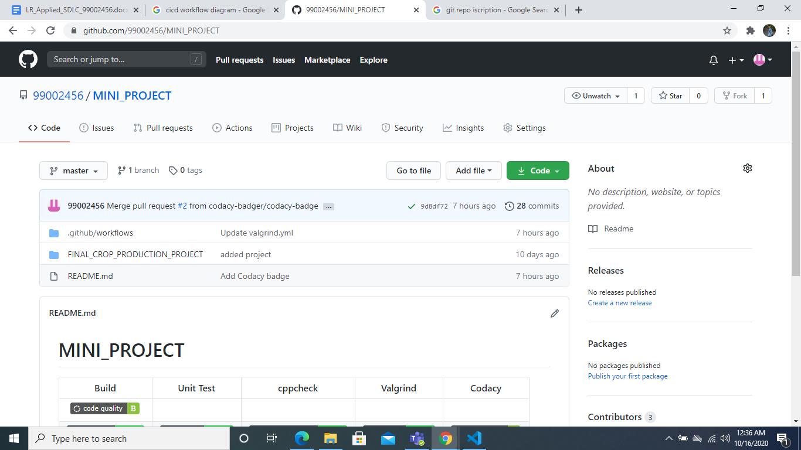

### GITHUB Actions

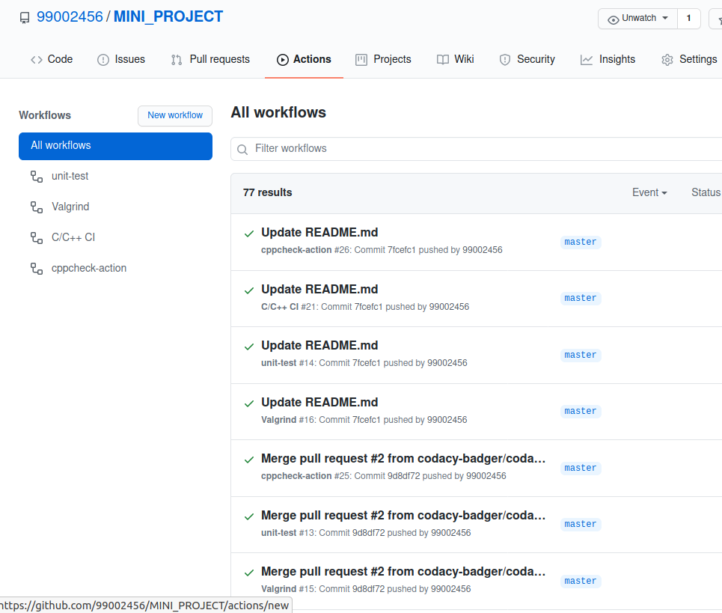

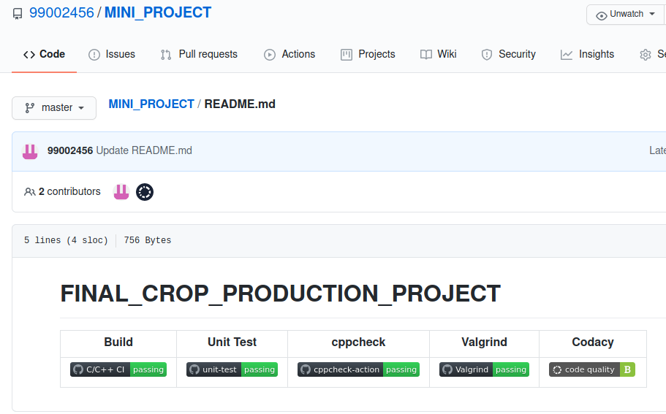

### GITHUB issue

#### **Raising Issue**

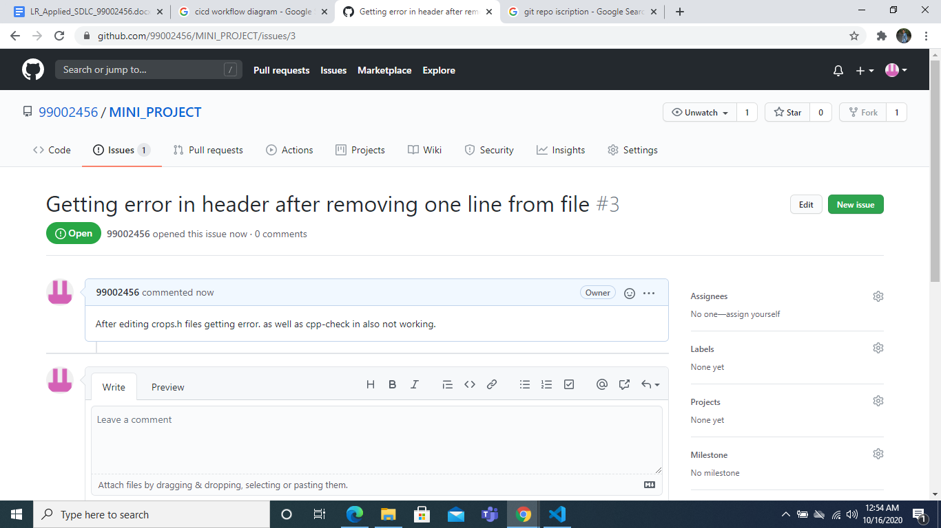

#### **Issue resolved and closed**



 

 