Instruction for run the project

1. This project need Eclipse or IDEA (preferable)to open it
2. I will use IDEA to show how to check and run our application

<1> Click main src folder to check source code

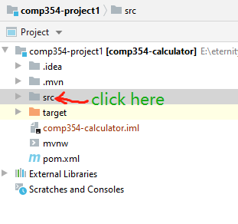

<2>click main for source code

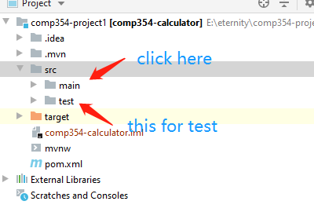

<3>folders for front-end part and back-end part

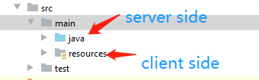

<4>find the main application

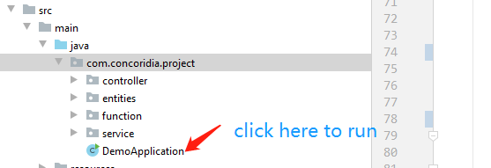

<5> run the application

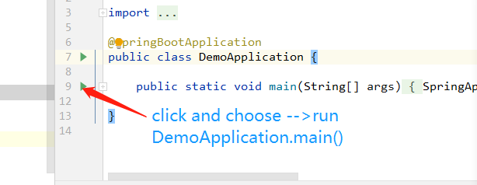

<6>application started successfully

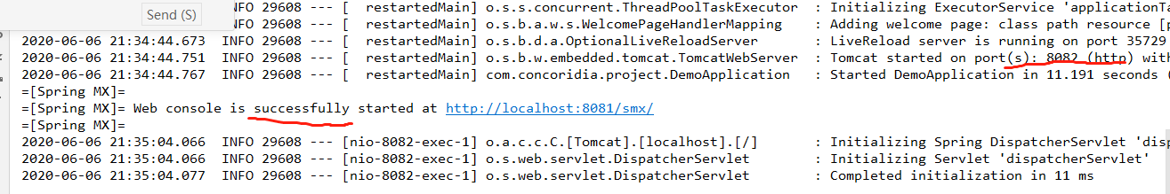

<7>test on webpage

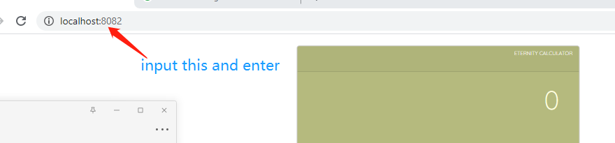

<8>

How to use:

<1> how to input a negative number:

Input a number first, then input (-)

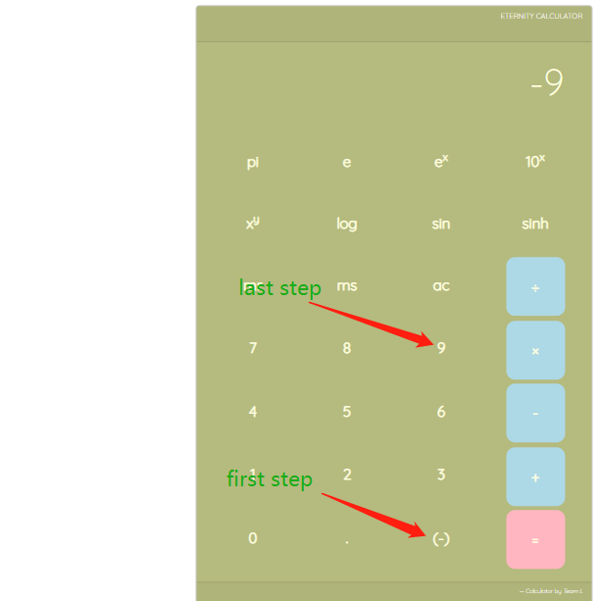

<2> one parameter operation like: sin, sinh,10^x,log.

Input number first, then input operator.For example :sin8

Click 8 and then click sin, you will get the result

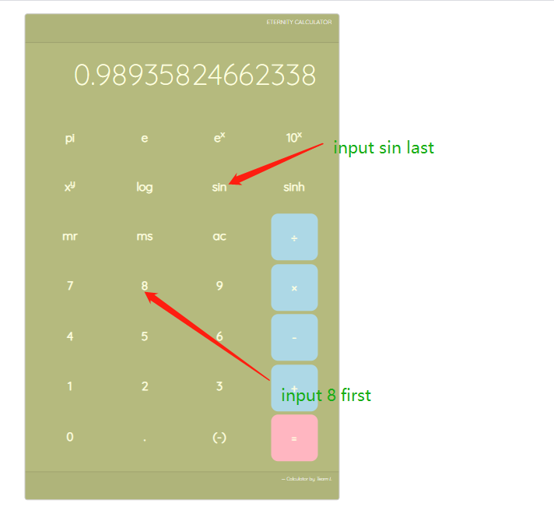

<3> one parameters operation like: x^y,+,-,\*,/

Input number first, then input operator.For example :9^2

Click 9 and click xy and 2,finally input = you will get the result

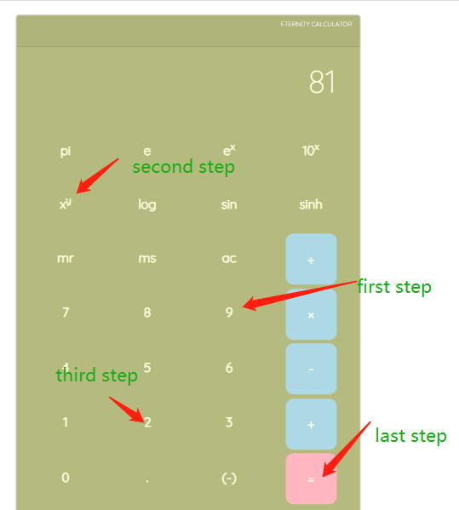

<4> e and pi just press the corresponding button

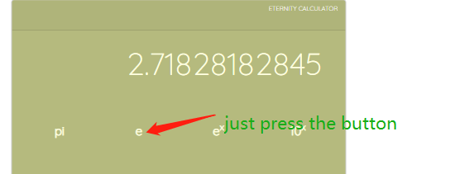

1. Show the source codes structure

<1> server side

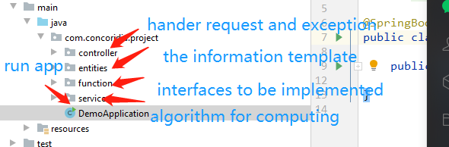

<2> Client side

