SET10112 2017-8 TR2 001 Practical coursework
James Wright¹
¹ Edinburgh Napier University, Edinburgh, Scotland
40091207@live.napier.ac.uk
Abstract. This report details the design of a control system for a submarine. This machine specification was created using the B-Method and Atelier B. Contained in this report is the machine definitions and descriptions.
Keywords: B-Method, Machine Specification, Proof Obligation.
- Introduction
The system designed is intended to control the various subsystems of a nuclear submarine that are required to perform the tasks the submarine must be able to accomplish. These tasks include controlling the depth of the submarine, firing of the submarines torpedoes, controlling the hatches of the submarine and detecting any issues with the subsystems that require a response.
- Machine Structure
The Submarine control system contains nine component machines, five of these machine components consist of the subsystems of the Submarine, these are the “Rudders” which controls the steering of the ship, “Doors” which controls the hatches of the Submarine, “Torpedoes” which control the launching of the Submarines torpedoes, “Engines” which controls the throttle for the Submarines engine and “Ballasts” which is used to control the Submarines depth through the changing of the Submarine ballast levels. These machine components that represent the Submarine subsystems are all included within the “Controller” machine component of the system. The interaction between the user and the Submarines subsystems are controlled using the operations of this machine component.

The Controller machine component is then included within the Sensor machine component, this inclusion allows the Sensor machine the ability to control the Submarine subsystems through the Controller machine component which are controlled through the subsystem machine components highlighted previously. Also included in the Sensor system along with the Controller component is the SensorResults machine component and the Alerts machine component. The SensorResults contains the information that the sensor produces that may be required by other components within the Controller component when performing operations. The Alerts component is used to display alerts to the user, these alerts are controlled by the sensor machine component based on the information that the sensors detect.
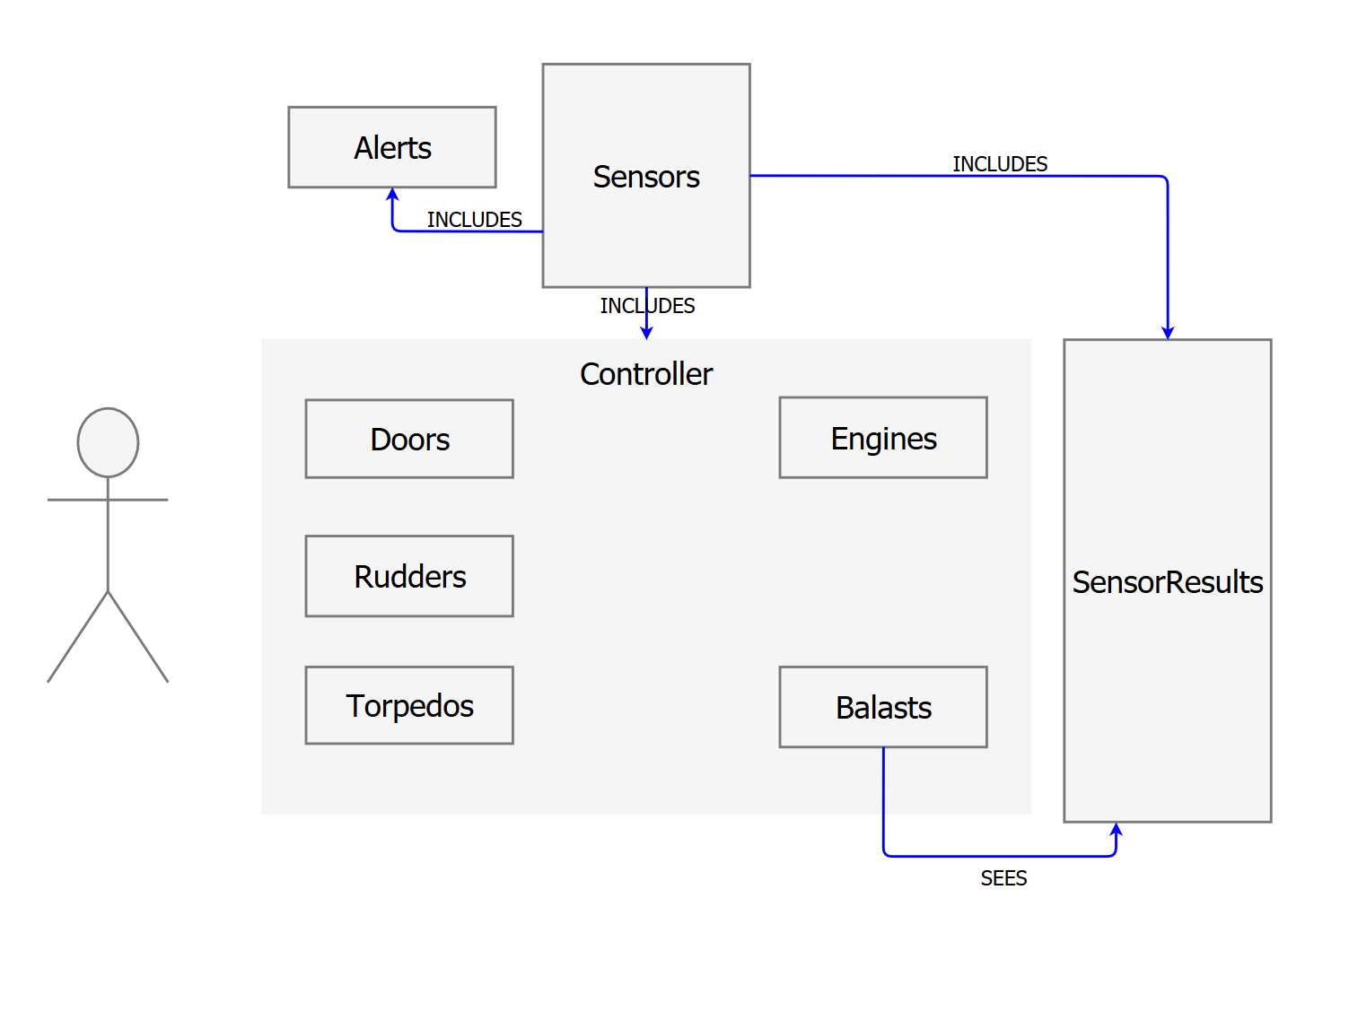
Figure 1: UML Diagram representing the Submarine Control system design
Figure 1 above describes the Submarine Control system and the machine components that is consists of along with the interaction between them. The “Ballasts” machine component SEES the SensorResults which are supplied by the Sensor machine component it is included in.
- Description of Submachines
The Doors machine is used to control the hatch doors on the Submarine. The machine uses two SETS, a set of DOORS which represent each of the doors and a set of DOOR_STATE which represents the state of each door on the Submarine. The state of a door can be either of the DOOR_STATE’s which are; {open, closed}. The Doors machine uses a variable door_state to represent the current doors DOOR_STATE which is controls through the invariant door_state : DOORS DOOR_STATE which ensures that the door_state represents a door and that it has a value that is within the DOOR_STATE set, either open or closed. When initialized this variable representing the state of a door of DOORS set is set to being closed initially; door_state := DOOR*{closed}.
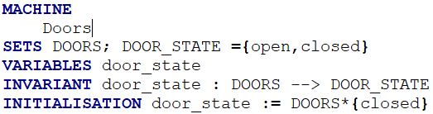
Figure 2: Doors machine SETS, VARIABLES, INVARIANT and INITLIZATION
The Doors machine has two operations that are used to control the door_state of each DOORS. These are open_door and close_door, both of these operations require an input of type DOORS which is the door that is being interacted with. open_door requires as a precondition that the door being interacted with is first closed through door_state = DOORS*{closed}, the operation then sets the door_state of the door inputted to open. close_door is similar to open_door except it is used to set a door that is closed to open by setting the door_state of the inputted door of type DOORS to open or door_state = DOOR*{open}. These can be seen below in Figure 3
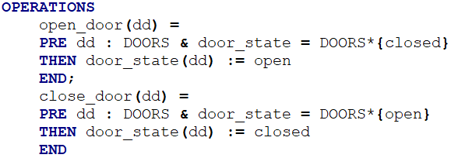
Figure 3: Doors OPERATIONS
The Ballast machine is used by the Submarine control system to adjust the depth of the Submarine. To achieve this the Ballast machine component SEES the machine SendsorResults which contains the data recorded by the Submarines sensors. The Ballast machine uses a single variable ballast_level to represent the level of the submarines ballast tanks, this variable is required by the INVARIANT to be a natural number between 0 and 100. When initialized the ballast_level is set to 0 which meets the condition of the INVARIANT. This section is show below in Figure 4.

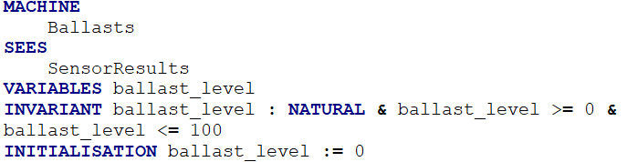
Figure 4: Ballasts SEES, VARIABLES, INVARIANT and INITIALISATION
The Ballast machine then also has the OPERATIONS, surface, dive and ascend which control the level of ballast within the submarines tanks. By changing this the depth of the Submarine is then changed. “surface” requires no inputs and only sets the ballast_level to 0. This causes the Submarine to surface. dive and ascend are then used to control the specific depth of the Submarine, ascend is used to reduce the level of ballast in the ballast tanks, this causes the submarine depth to decrease. The pre-condition of this operation is that the operation does not cause the level of ballast in the ballast_tank to be outside of the 0 to 100 range set by the invariant. ascend is then used to perform the reverse of this and increase the level of ballast in the tanks causing the Submarine to increase its depth. The precondition of this operation is that the depth provided by the SensorResults SEES described above is not at 100 which represents that the Submarine is at 100% of the maximum depth it can reach. If this is the case the operation does not increase the ballast and remains at the depth it is currently at. These operations are shown below in Figure 5.
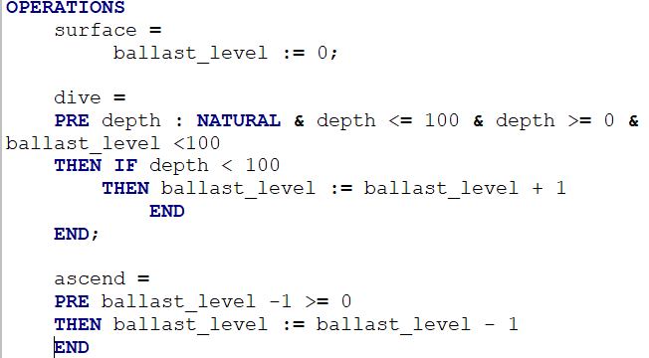
Figure 5: Ballasts OPERATIONS
The Engines machine component is used to control the level of power the engines are currently under. To perform this a variable representing the power is used; engine_power. This variable is required to be a NATURAL number between 0 and 100, the variable is then initialized as 0. This is described in Figure 6.
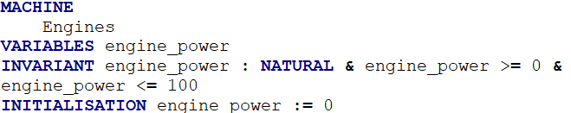
Figure 6: Engines VARIABLES, INVARIANT and INITLISATION
The Engines Component contains only one OPERATION which is used to set the power level of the engine. To achieve this the operation set_power is used with an input of the change in power level desired, this input must be a natural number between 0 and 100. The operation then uses an IF statement to check if the addition of the change to the current power level would break the invariant. If the power level would be greater than 100 it is set to 100 and if the level would be below 0 it is set to 0, if the operation would not cause the variable to reach a state outside the INVARIANT the input is added to the current power level. This operation is described below in Figure 7.
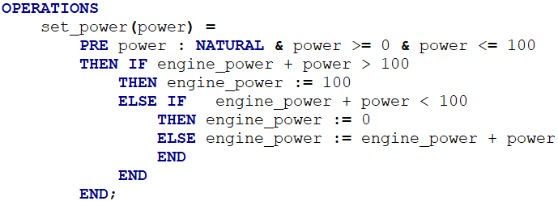
Figure 7: Engine OPERATIONS
The machine component “rudders” is used by the Submarine control system to set the rudder position which controls the direction that the submarine is headed in. To achieve this a variant column_angle is used that is required to be an integer between -45 and +45 this is to represent a 90° range that the rudder can exhibit with 0 being straight forward. The rudder_angle variable is then set to 0 to represent this during initialization. This section of the machine is show in Figure 8
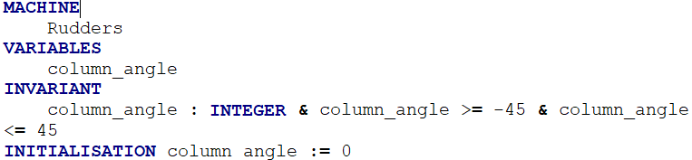
Figure 8: Rudders VARIABLES, INVARIANT and INITIALISATION
Similar to the engine machine component the angle of the column is set based on an input provided to the OPERATION set_angle, this represents the change in angle the operation will perform, this input must be of type integer and be within -45 and +45. An IF is then used to check if the addition of the input to the current angle would cause the variable to reach a point outside of the column_angles invariant requirement. If the addition of the input to the current value would be greater than +45 it is set to 45 if the value would be below -45 it is set to -45. This ensures the pre-condition is maintained. This operation is shown below in Figure 9
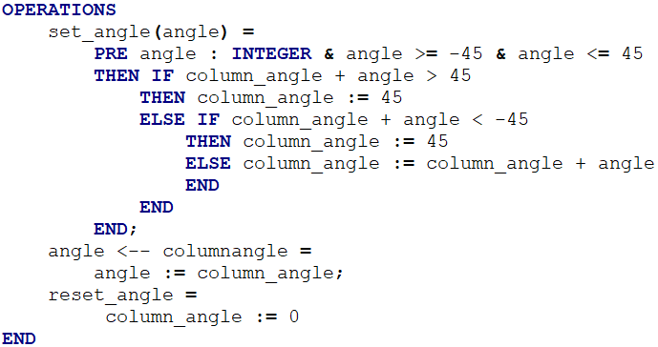
Figure 9: Rudders OPERATIONS
The Torpedos machine is used to control the torpedoes/torpedo tubes that the Submarine carries. These torpedoes are represented by a SET; TORPEDOS with each torpedo being in a state of either loaded or unloaded represented by the SET TORPEDO_STATE. The Torpedo machine then uses a variable torpedo_state to represent the current torpedo’s TORPEDO_STATE which is controlled through the INVARIANT torpedo_state : TORPEDOS TORPEDO_STATE. The state of a Torpedo tube is initialized as being loaded. This section of the machine is described by Figure 10
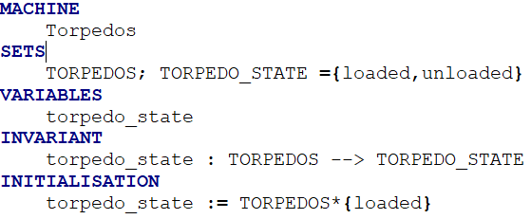
Figure 10: Torpedos SETS, VARIABLES, INVARIANT and INITIALISATION
The OPERATIONS that the torpedo machine can perform are launch_torpedo and reload_torpedo. Each of these operations require an input of tt that is of type TORPEDOS. In launch_torpedo this torpedo/torpedo tube must be loaded for it to be fired. The operation then sets the torpedo/tube state to unloaded. The reverse of this is true of the reload_torpedo option where the system requies the torpedo/tube being selected be unloaded so that is can then be reloaded. These operations are show below in Figure 11.
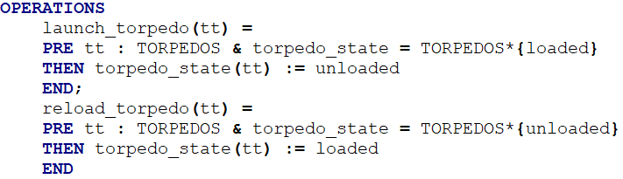
Figure 11: Torpedos OPERATIONS
The controller machine controls the interaction between the user and the subsystems and also the Sensor and the subsystems. The Controller machine INCLUDES the Doors, Engines, Ballasts and Torpedos machines that represent the subsystems. The Controller promotes close_door from the Doors machine and reload_torpedo from the Torpedos machines. The Controller uses the SET; LOCK_STATUS to represent the variable lock_status for each of the hatch doors in the Doors machine. Each lock_status is of DOORS set and must meet the SET; LOCK_STATUS requirements. The Invariant also requires that any open door also be unlocked. The other variable of the machine is the key_valid which is required to be BOOL by the invariant, this represents the captains key being inserted. The lock_status and key_valid are set to locked and FALSE respectively, this requirement meets the INVARIANT pre-condition. This can be seen below in Figure 12.
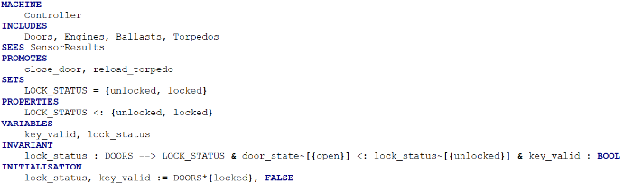
Figure 12: Controller INCLUDES, SEES, PROMOTES, SETS, VARIABLES, INVARIANT and INITALISATION
The OPERATIONS of Controller are used to interact with the subsystems of the Submarine which are included within the Controller machine, these are opendoor, unlock_door, lock_door launchtorpedo, submarine surface, descend submarine and ascend_submarine. launchtorpedo requires that the key_valid = true which which is used to prevent a torpedo being fired when the captains key is not inserted. The opendoor operation requires that at least one door be open by requiring the cardinality of closed doors be greater than 0, if there are no other doors closed then a closed door cannot be opened. Opening a door also requires that the door_state = closed. unlock_door requires an input that is of type DOORS and requires that the door was locked lock_status(dd) = locked. ascend_submarine and descend submarine are used to control the depth of the submarine using the Ballast machine that is included within the Controller machine.
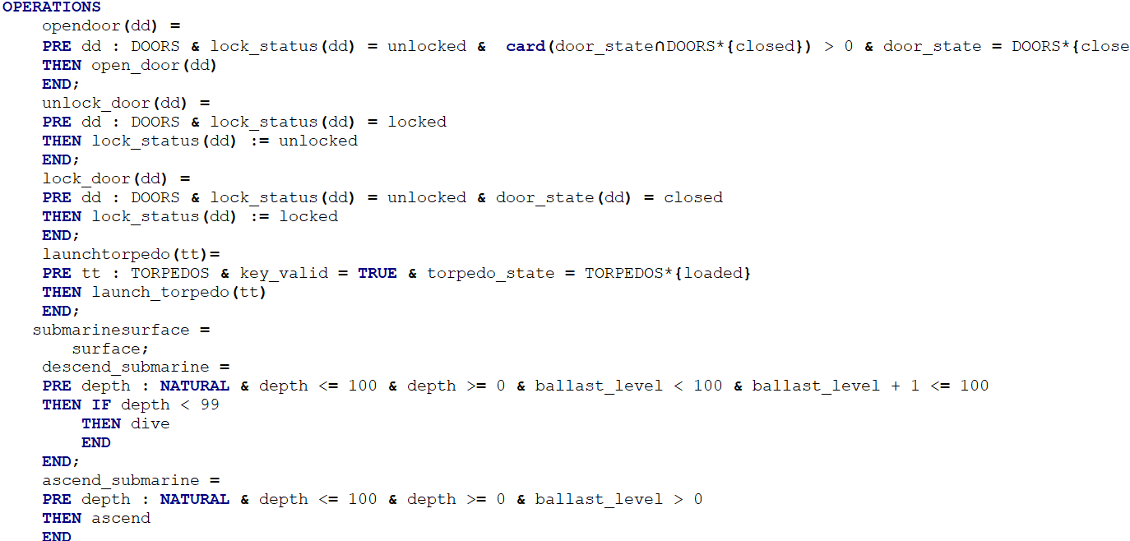
Figure 13: Controller OPERATIONS
The sensor machine controls the Submarine sensors and the information they produce/receive. The Sensor machine INCLUDES Controller, Alerts and SensorResults within it. The variables used to represent the current readings from the Sensor system are sensor_temp, sensor_oxygen and sensor_depth, each of these variables must be natural numbers between 0 and 100 representing a percentage. These variables are all initialized as 0 meeting the INVARIANT requirement. This is described below in Figure 14.
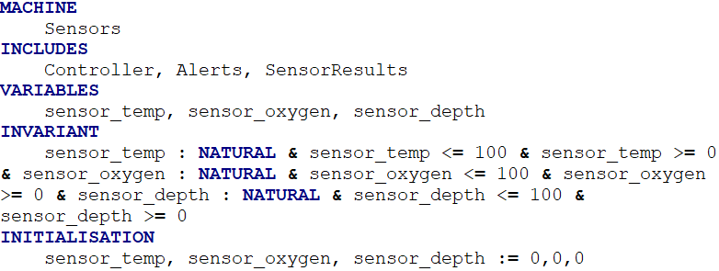.
Figure 14: Sensors INCLUDES, VARIABLES, INVARIANT and INITLIALISATION
The Sensors machine component contains 3 operations, update_sensor_data, oxygen_level_low and engine_overheating. update_sensor_data ensures the variables received by the sensors is a natural number and between 0 and 100 and then it supplies this information to the SensorResults machine. oxygen_level_low is used in the event that the oxygen level reaches 5% or below, if it is the submarine is surfaced using submarinesurface which is contained in the included Controller machine and also sets an oxygen alert within the Alerts Machine. engine_overheating provides a similar functionality when the temp of the reactor reaches 95% or above the allowed limit the submarine is also forced to surface to prevent a meltdown. These operations are show below in Figure 15
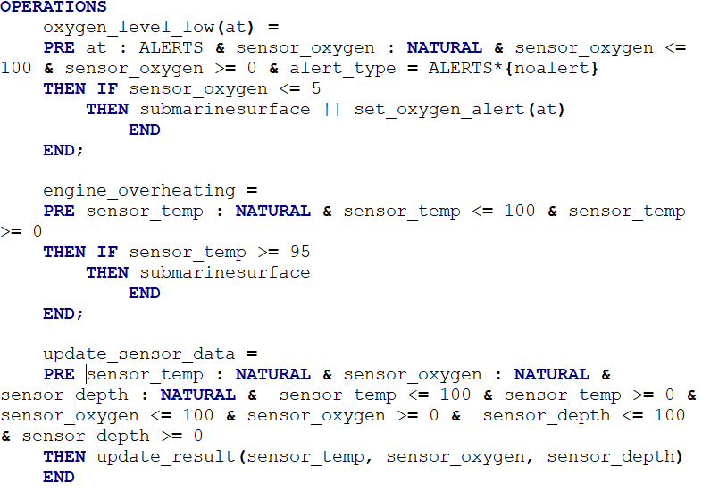
Figure 15: Sensors OPERATIONS
The SensorResults machine is used to control the Sensor readings provided by the Sensor machine. These readings are stored in the VARIABLES temperature, oxygen_level and depth, this allows other machines to SEE the information and use it. As with sensor each of these variables must be a natural number and between 0 and 100. Each variable is also initialized as 0 meeting the pre-condition of the INVARIANT. This section of the machine is show below in Figure 16

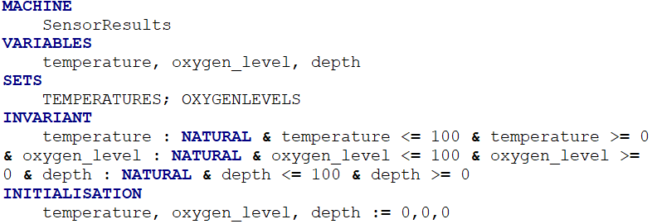
Figure 16: SensorResults VARIABLES, SETS, INVARIANT and INITIALISATION
The SensorResults machine contains only one OPERATION update_results which takes the information provided by the Sensor (reactor temperature, oxygen level and depth) and ensures they are natural numbers between 0 and 100 and sets the machines variables to the data provided.
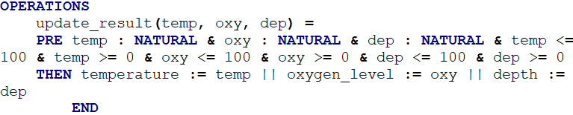
Figure 17: SensorResults OPERATIONS
Alerts: The Alerts Machine is used to display any errors to the user of the system such as the captain. The system currently provides the ability to display an oxygen critical alert to the captain. The system uses the variable alert_type to represent the alert which can be either noalert or oxygencritical. The alert type is set to noalert on initialization, to change this the OPERATION set_oxygen_alert is used which sets the alert type of the ALERT to oxygencritical. This machine is shown below in Figure 18
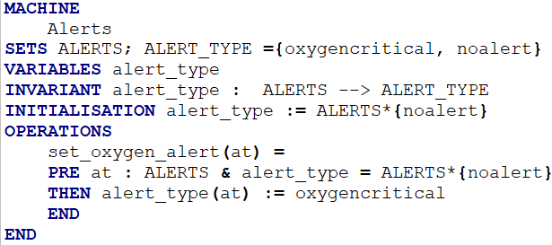
Figure 18: Alerts Machine
- Proof of Consistency
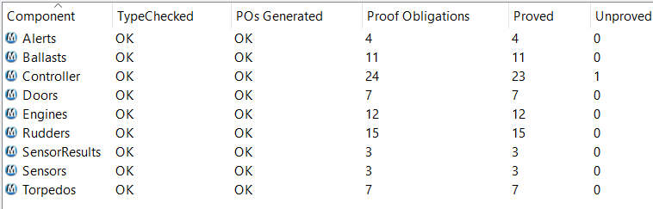
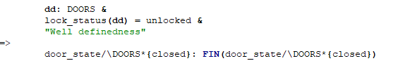
- Conclusion
A typical Submarine does not contain only a single example of each component in a subsystem, for example a Submarine would typically have more than one engine and Oxygen tank. The system could be improved by adding the ability for the Submarine to have multiple of each subsystem. This is not provided by the Submarine control system designed. The system designed does not meet full Consistency and has one unproved proof Obligation which is required to be successful.

