**Remote, Underground Powervault Inspection Robot**

ECE 4011 Senior Design Project

Team P.V.I.R.

Project Advisor: Lukas Graber

Stephanie Chan, stephchan40@gatech.edu

Elizabeth Fuller, efuller3@gatech.edu

Adrian Muñoz, am262601@gatech.edu

Nelson Raphael, nraphael7@gatech.edu

Lemek Robinson, lrobinson61@gatech.edu

Version 1 Submitted:

11/28/2018

Version 2 Submitted:

1/18/2019

**Table of Contents**

**Executive Summary (5 pts)**......................................................................................................... iii

1. **Introduction (5 pts)**........................................................................................................... 1

1.1 Objective........................................................................................................... 1

1.2 Motivation......................................................................................................... 1

1.3 Background....................................................................................................... 2

**2. Project Description and Goals (15 pts)**............................................................................ 3

**3. Technical Specification (20 pts)**........................................................................................ 4

**4. Design Approach and Details (20 pts)** ………………………………………………...5

4.1 Design Approach................................................................................................. 5

4.2 Codes and Standards............................................................................................ 11

4.3 Constraints, Alternatives, and Tradeoffs.............................................................. 12

**5. Schedule, Tasks, and Milestones (10 pts)**......................................................................... 15

**6. Project Demonstration (5 pts)**........................................................................................... 15

**7. Marketing and Cost Analysis (5 pts)**................................................................................ 16

7.1 Marketing Analysis.............................................................................................. 16

7.2 Cost Analysis....................................................................................................... 17

**8. Current Status (10 pts)**...................................................................................................... 19

**9. References (5 pts)**............................................................................................................... 20

**Appendix A - Gantt Chart** ........................................................................................................ 22

**Appendix B - Pert Chart** ........................................................................................................... 25

**Appendix C - Task List** .............................................................................................................. 26

**Executive Summary**

P.V.I.R is a remotely operated, recon robot that uses non-destructive testing methods (NDT) to retrieve information from powervaults. P.V.I.R will consist of a water-tight aluminum body for movement, a mechanical arm for positioning the camera and other sensors, a sensor package to retrieve information in the powervault, and a user interface for interacting with the robot. The robot must be able to read gauges in a poorly lit environment, and relay information to a remote server. The base of the robot has been built by a previous mechanical team. This project will focus on designing and implementing the sensor package, the control system, and the data collection and display system of the robot. A mechanical arm will support the camera and other sensors.

P.V.I.R is designed to be used to gather information in situations where powervaults are not safe for humans to enter. The pilot of the P.V.I.R can inspect the powervault without putting themselves in a dangerous situation. The P.V.I.R has visual sensing capability for reading gauges in the powervault, audio sensing to record high voltage, electrical discharge, gas sensors to test air quality, and an RGB-D sensor to map the terrain of the powervault. The P.V.I.R will be controlled remotely by a user interface program that runs on a computer or tablet. The program will also organize and record the information received.

The total price of all the components used in design are approximated to be around $755. Some of the sensors and microcontrollers used in this project are legacy parts and are do not contribute to the actual cost of development. The cost of parts for the robot is around $420 with room left over for shipping cost and tax. P.V.I.R will be sold for $1750.

**Powervault Inspection Robot**

**1. Introduction**

Team P.V.I.R is designing a power vault inspection robot. The team is requesting $500 from Georgia Institute of Technology - College of Electrical and Computer Engineering. The $500 will be used to develop a sensor package, a control GUI, a mechanical arm, and a robot testing environment.

**1.1 Objective**

The objective of P.V.I.R is to evaluate the environment of a transformer vault. This will reduce the risk that workers have to take while doing routine inspections. P.V.I.R is a durable and easy to control, mobile, recon robot that gathers information specific to power vaults. It will retrieve and display visual data, infrared data, data concerning air quality and a live feed from the robot’s camera. The main body of the powervault inspection robot was designed by a previous team. This project will focus on designing and building the sensor package, the software package and the mechanical arm that supports the sensor package.

**1.2 Motivation**

The motivation behind P.V.I.R consists of a need to speed up the downtime of the power grid due to repairs and to minimize the likelihood of injuries for utility workers in a dangerous environment. An inspection robot will cut down the number of workers hurt while on the job. In 2016, the number of fatalities on the job was 5,190 people [1]. This is an average of about 14 people a day. Inspection robots will help utility workers understand and troubleshoot problems in a safer and more efficient manner. Previous senior design teams and the EPRI have designed and tested robot vehicles that navigate in underground vaults [2]. Underground inspection robot designers are aware that the end users are utility workers with prior experience performing vault inspections and scheduled maintenance routines. Both of these procedures require different types of information that will be expected from the robot. The improvements offered by our design include a more efficient and convenient means of communication from the user to the robot, as well as, a more enjoyable user interface by including a game controller and a mobile recording system.

**1.3 Background**

Previous groups have completed a few tasks related to our project. More than one form of mobile robot can survey a powervault, ranging from watertight treaded vehicles to aerial drones. Each of these iterations were tested and some were equipped with control systems and sensor packages. This provided the group with the option of either building a robot from scratch or starting with a pre-existing robot as a base, which is an essential building block. The pre-existing robot bodies were intended to be waterproof, dust resistant, and durable on uneven terrains. The current tasks of the group are based on a continued design problem to create a suitable, teleoperated, mobile robot to survey power vaults of varying sizes and conditions. These conditions include but are not limited to varying vault dimensions, gas content, standing water levels, and varying locations of instrument gauges in the vault. A starting point already exists regarding the project, but the team will be focused on developing the sensor package, setting up an efficient control system, and developing a servo arm. The servo arm can adjust the height for the camera to read the gauges accurately. A novel concept unique to our design is incorporating a virtual reality headset to enable a real-time viewing mode for the user. The final design solution is imagined to be a two person system with one operator and one observer, since most power vault inspections are typically two person endeavors due to safety regulations.

**2. Project Description and Goals**

The team will be prototyping a sensor package, software package, and a mechanical arm. A testing environment will also be designed and built. The sensor package will contain an IR camera, gas, temperature, humidity, and air quality sensors. A camera will be anchored on a mechanical arm which will be able to move vertically and rotate 360°. A microphone will be used to pick up possible corona in the transformer vault. All of the sensor data will be displayed on a control GUI that the team is also developing. This GUI will be displayable on a tablet or laptop. The GUI will display all important information desired by the utility workers operating P.V.I.R to optimize the power vault procedure efficiency by providing quick access to data for educated decisions and improvised actions.

The goals for the project are as follows:

* Create an efficient sensor setup to take necessary readings in the power vault.
* Build a motor powered arm that is attached to the top of the robot, which allows the sensor setup to be raised and lowered to the required height.
* Program a control system that manages the motor speed and maneuverability in an easily understood and secure manner that functions through a user interface an operator can interact with on a PC.
* Provide real time video feed for the observer from the robot’s point of view.
* Build a testing environment comprised of 6ft tall boards with installed dummy gauges to simulate a power vault setup. This will be used to demonstrate the robot at the Design Expo.

The total estimated cost for this project is around $264,000. This accounts for the cost of labor of five engineers working on average of eight hours a week each for 16 weeks, the costs of the hardware purchased, and the cost of the website creation. This is interpreted as if these are research and development engineers since the solution would implemented many times over by the company. The main audience for this design solution would be utility companies such as Georgia Power.

**3. Technical Specifications**

Table 1. Mechanical Arm Specifications

|  |  |
| --- | --- |
| **Mechanical Arm Specs** | |
| Feature | Specification |
| Height | Variable height from 1 - 6 feet |
| Degrees of Freedom | 2 degrees of rotation |
| Size | Fits in a 760mm Diameter Manhole |

Table 2. Sensor Package Specifications

|  |  |
| --- | --- |
| **Sensor Package Specs** | |
| Feature | Specification |
| Video | Can Stream Video to GUI |
| Gas Sensor | Check Air Quality |
| IR Thermal Camera | Record Thermal Images |

Table 3. GUI Specifications.

|  |  |
| --- | --- |
| **GUI Specs** | |
| Feature | Specification |
| Mobile | Useable on tablet or laptop |
| Control Capabilities | Uses a remote control |
| Logging | Log Information |
| Data Streaming | Real-Time Data Streaming |

**4. Design Approach and Details**

**4.1 Design Approach**

The GUI design has a number of avenues that can be pursued. The GUI will have a video display window surrounded by cards that display the sensor information. Data can be logged over time and saved for future viewing. The main programming scripts considered are Python, C# or Matlab’s App Designer. Each option has pros and cons that are worth exploring. C# and App Designer have an easy to use, drag and drop builder that will make organizing the GUI easier. Kivy is a Python library that naturally runs multiple functions in parallel and compartmentalizes each section of the GUI. Kivy also can be exported as an android or IOS app, making this option compatible with mobile phones and tablets. This is very important to the desired use of the GUI because tablets and phones are more user friendly for field application due to their portability. Python also has a large volume of libraries that can be used alongside kivy to make the overall program more versatile and dynamic. Matlab’s App Designer has better capacity for graphing charts in 2D and 3D.

The critical path of the GUI design is the communication design. Each of the programing scripts mentioned above are built to make the graphical portion of design easier. The difficulty comes from the organization and prioritization of data being sent to the main program. The program will utilize TCP/IP to send and receive information securely. The GUI design described above allows for the information to be processed and organized by the Raspberry Pi before sending to the GUI. In order to reduce the difficulty of this task, smaller, less complicated, tasks are prototyped to prove a method. These methods will be used to code the final program. This will reduce the amount of time spent on debugging the full program All options have similar capabilities when it comes to the layout of the program.

Figures 1, 2, 3, and 4 below shows the current layout concepts of the GUI. Figures 1, and 2 are implemented in the Python language. Figure 1 shows a login page. This will be used to add a layer of security to the controls of the robot.

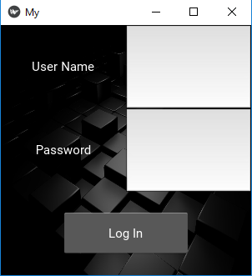

Figure 1. Login page of GUI.

Figure 2 shows the main page which will be the displayed following the login page. The main page will mostly consist of the video feed from the robot. On the peripherals of the main page are live values from P.V.I.R’s sensors. Each page will have access to a side menu that will be used to navigate between pages. Figure 3 shows how the navigation tab will look over the current page. This has not yet been built in the prototype.

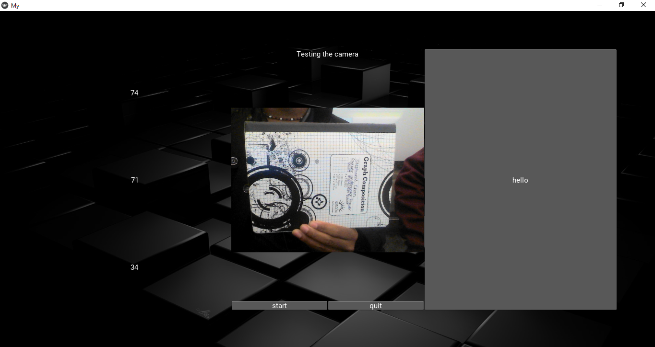

Figure 2. Main Page of GUI.

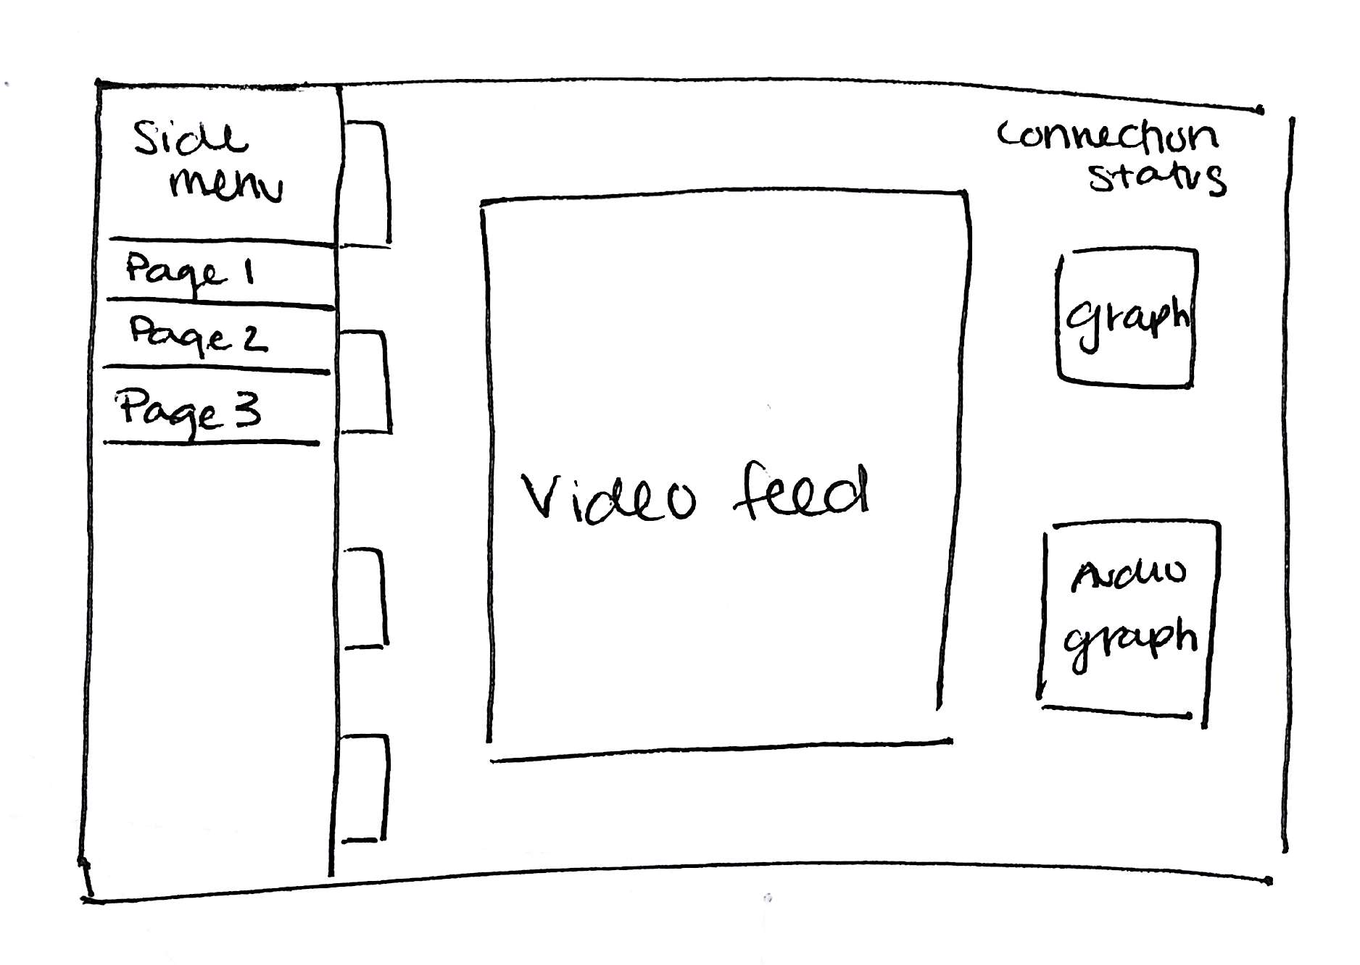

Figure 3. Main page of GUI with side menu displayed.

Lastly, Figure 4 shows an additional page that will allow the user to view time plots of sensor data in more detail. This has not been prototyped in Python yet.

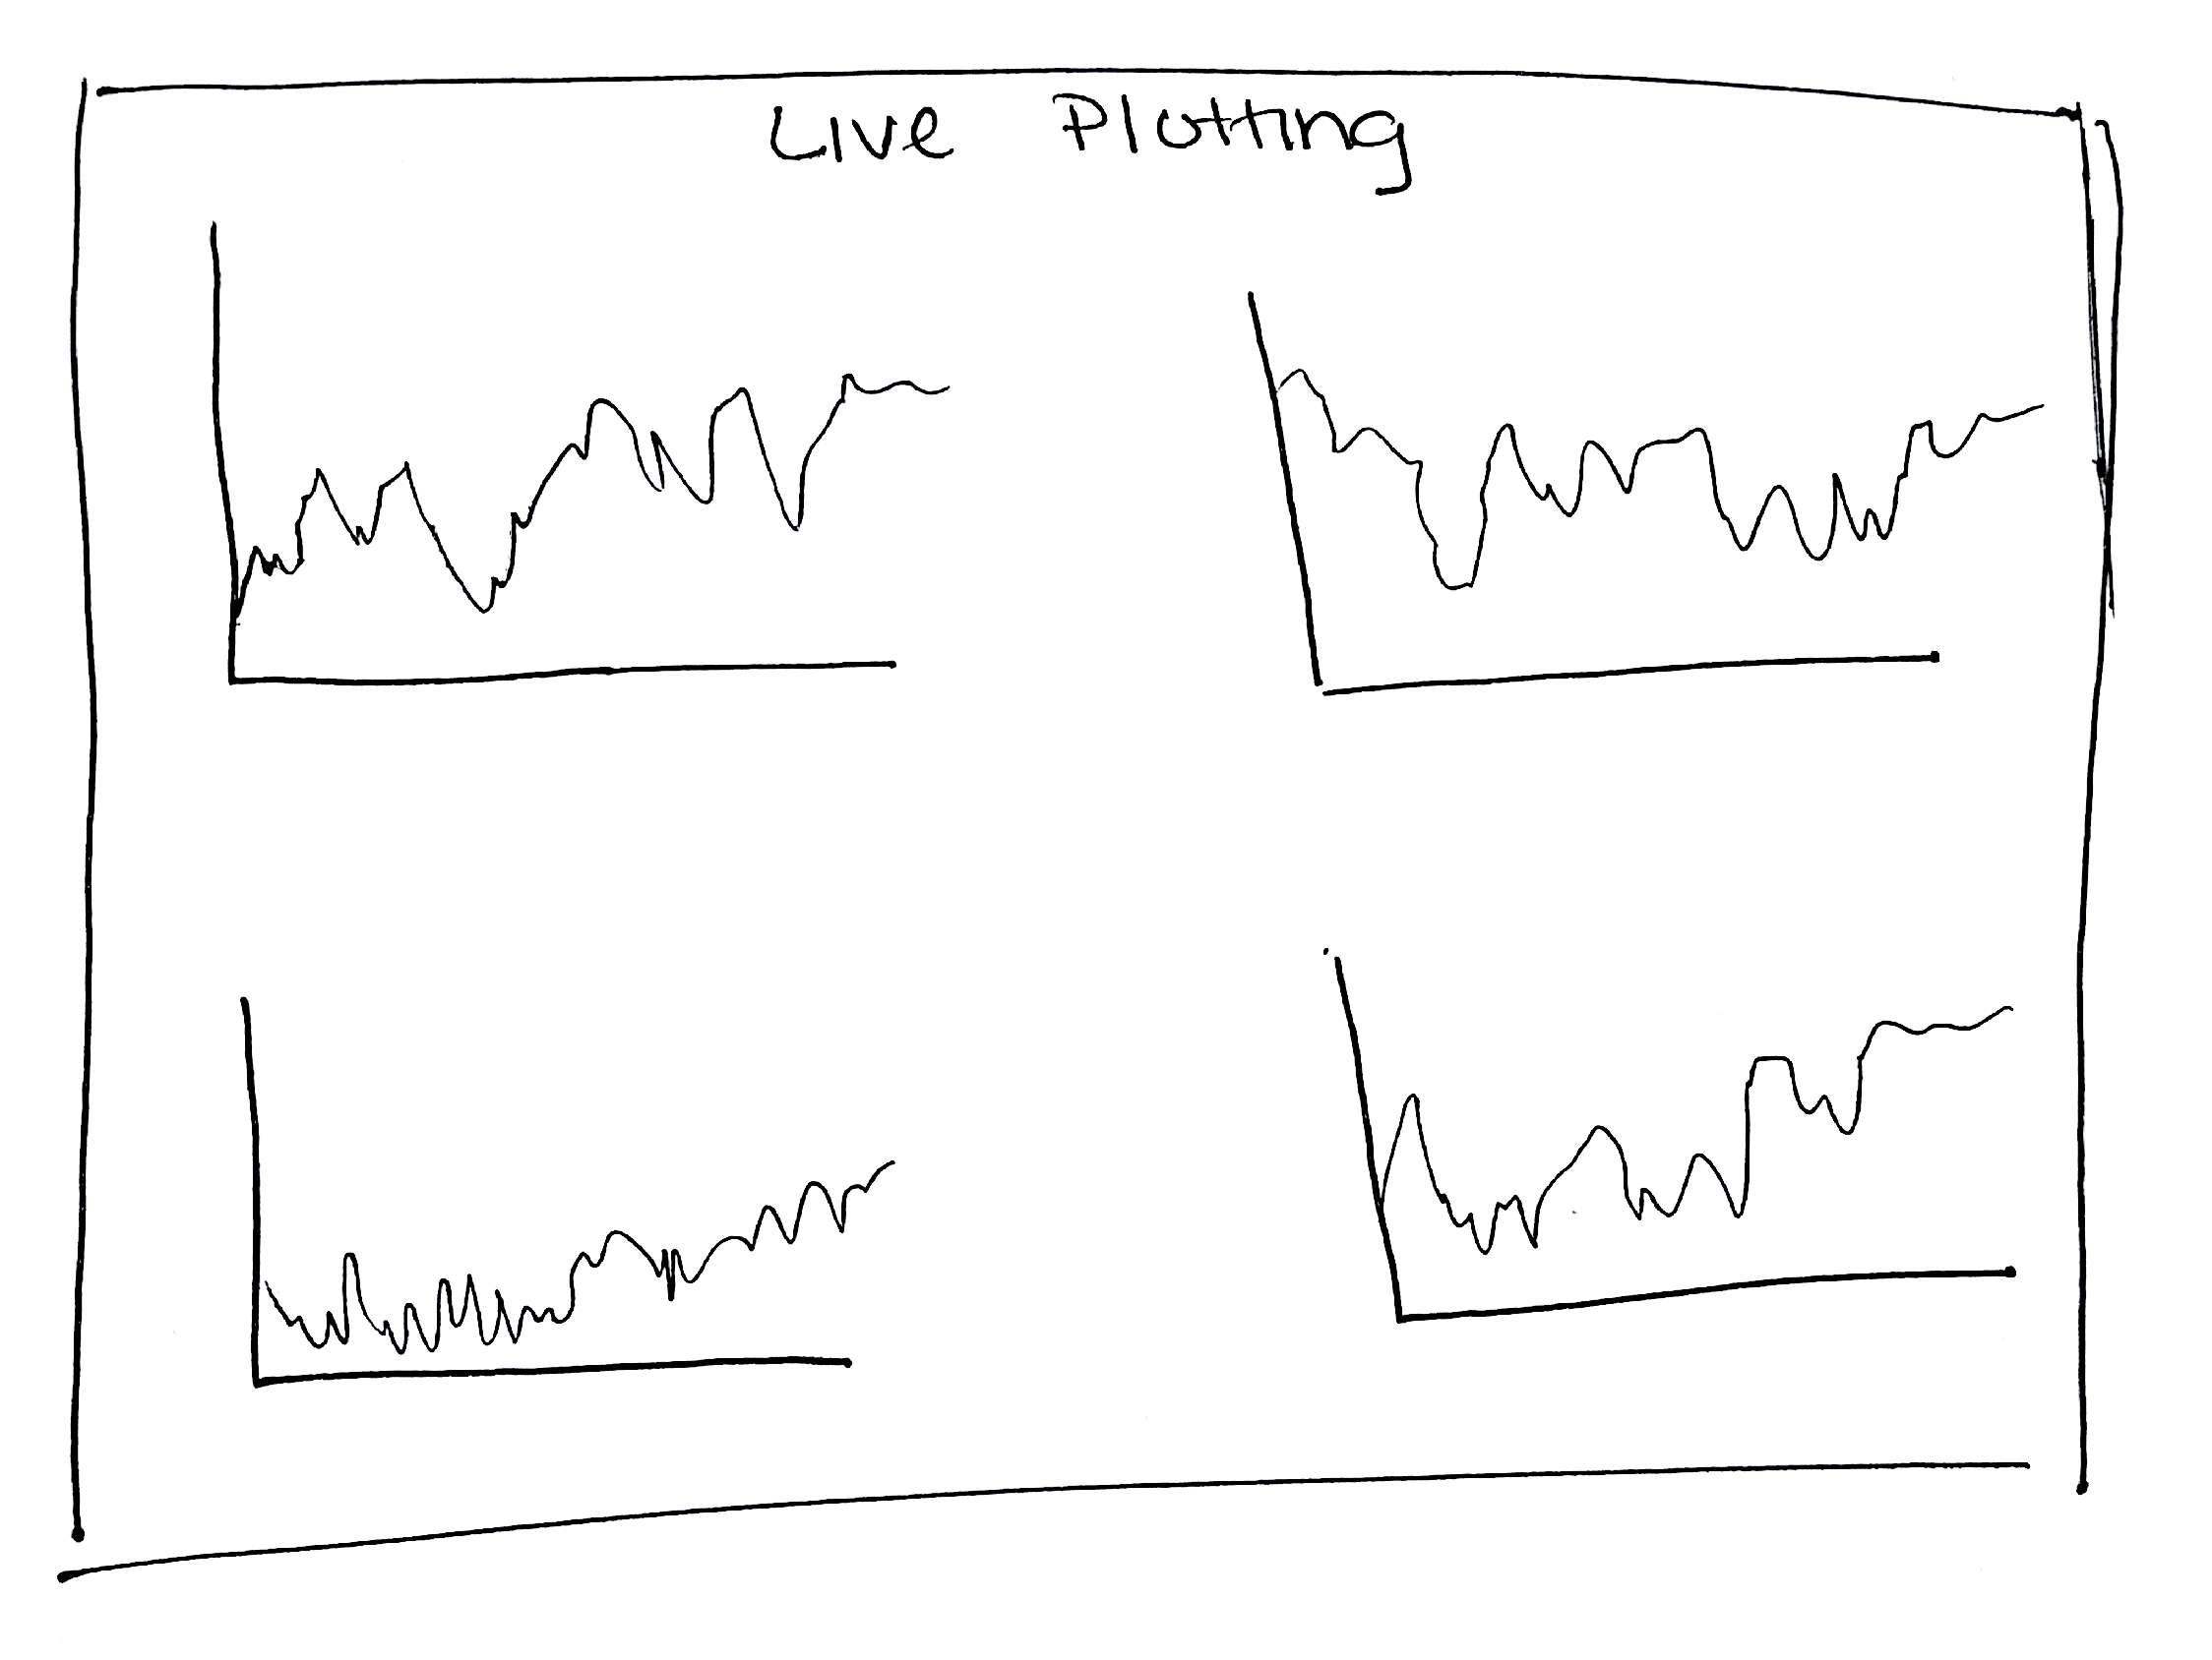

Figure 4. Additional live plotting page of GUI.

The team is considering the use of T-slots for the mechanical arm on which the camera and sensor package will be mounted. A rough design sketch of this setup is shown in Figure 5. A CAD drawing for this has been started. The mechanical arm will consist of two t-slot bars mounted on a platform that will rotate the arm 360°. The camera and sensor package will be attached on a platform between the two bars. Servos will be attached on the sides of the platform so the user has the ability to tilt the camera up and down. This same design can also be accomplished using lead screws instead of t-slot bars. A scissor lift design also is being taken into consideration because a condensed lift will be more stable while the robot is in motion. To rotate the base 360°, there are two methods that are being explored. The first method is using a servo attached at the base to rotate the arm. The other method is using a lazy susan with a timing belt between the arm base and the top of the robot.

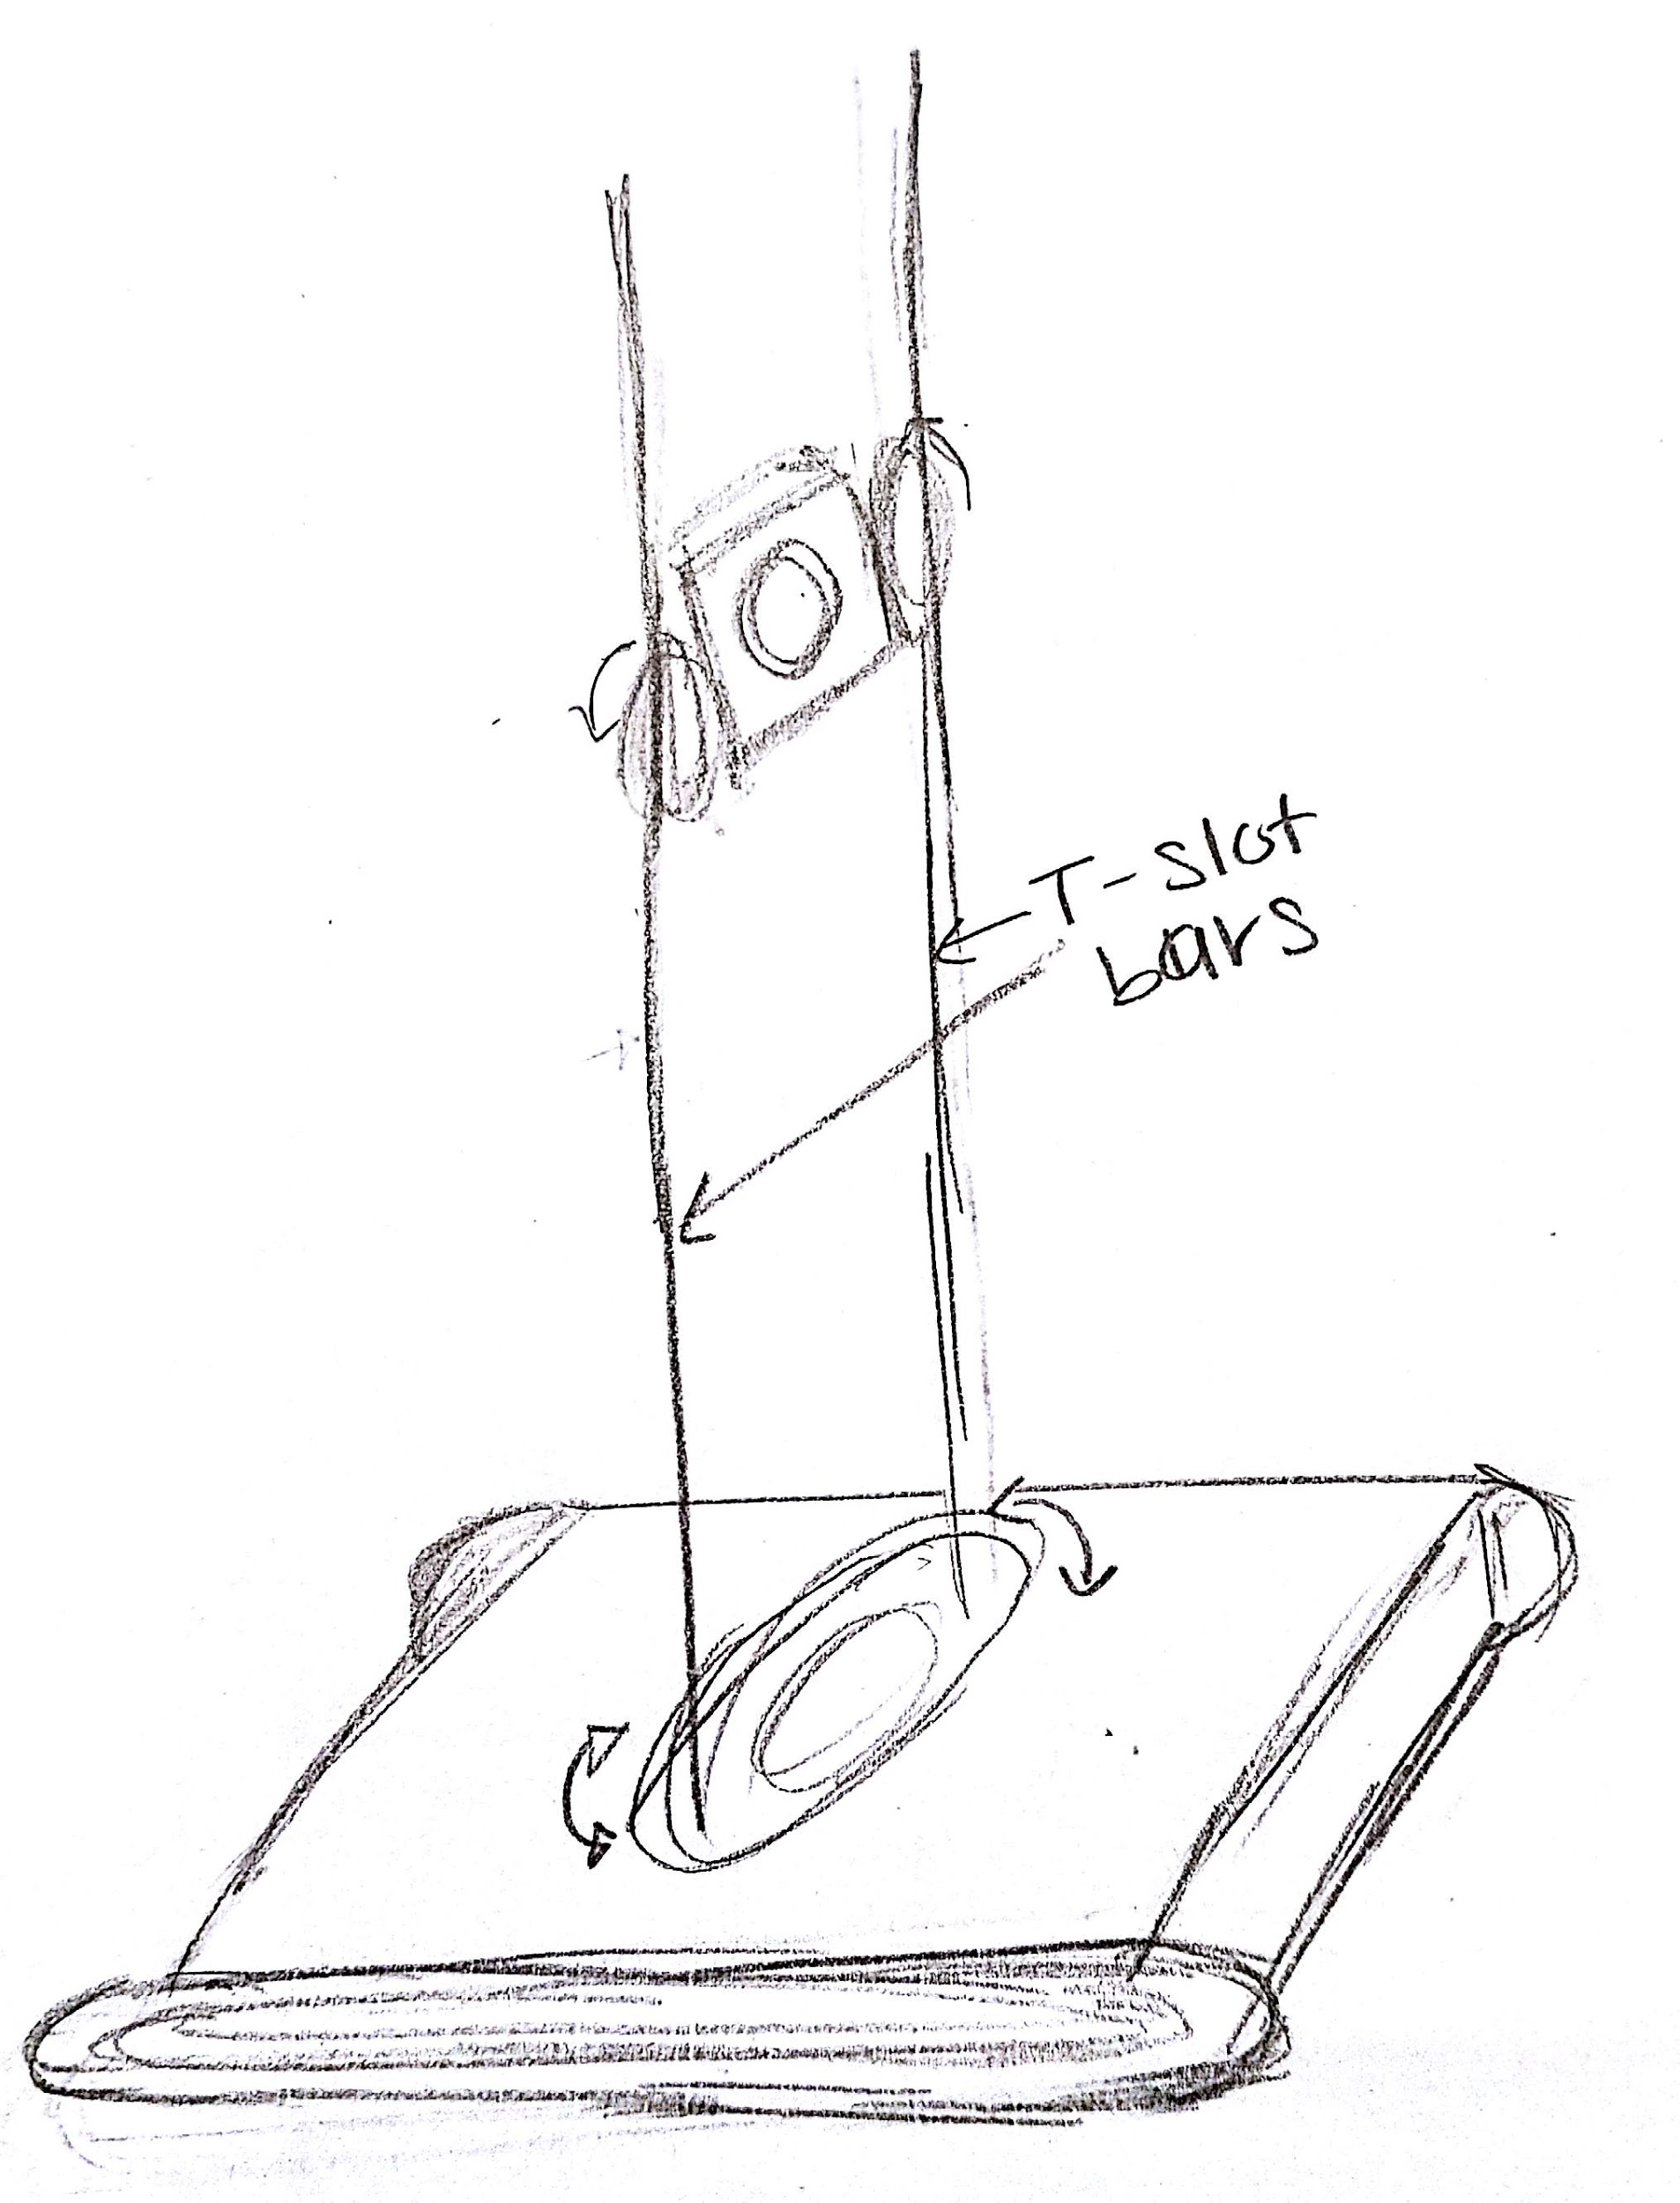

Figure 5. Design sketch showing mechanical arm connection and servos using t-slots.

When designing the hardware set up of the robot, the team created 6 iterations of a connection diagram. The team will be taking the approach that utilizes both the Arduino and the Raspberry Pi along with the sensor package mentioned prior as shown in Figure 6. The iterations that are not used are shown and discussed in section 4.3 of this project proposal. A few things are being tested to verify the feasibility of our design: OpenCV use on a Raspberry Pi, camera type selection for the use of OpenCV with Raspberry Pi, and interfacing a microcontroller that uses C++ to operate with the Raspberry Pi. These have yielded the following outcomes. Using OpenCV on a Raspberry Pi is possible, but requires a large amount of space on the microSD that serves as the boot disk for the microcontroller, thus requiring the user to adjust the partition and remove many large libraries that will be unnecessary in the project. Webcam integration with a Raspberry Pi via USB hub is possible, but the stream rate has an extreme amount of latency and would cause the system to be slightly behind for the observer versus the remote operator. A Pi camera functions better, but when dealing with the conditions in the vault the Pi camera does not have a very large chance of surviving without a protective casing, thus a GoPro has been considered. This may cause the original problem to reoccur due to the GoPro not being designed for a Raspberry Pi. Interfacing the Raspberry Pi with a microcontroller that runs C++ is definitely possible already via a serial connection using a master slave connection. There are a lot of pre-existing examples. The aspects of the project left to verify are the controller to Kivy app communication, and threading all of these processes together so the design parts can operate in parallel.

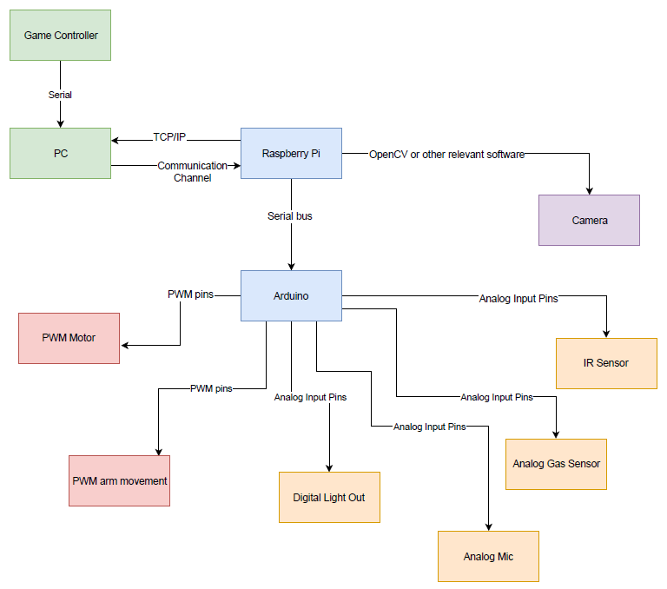

Figure 6. Hardware setup for the proposed design solution.

Other design considerations for the control system include speed controls, object detection, and movement restrictions. The robot has little need to move at high speeds so implementing a slower max speed will help make the robot easier to control. Because the robot is remote controlled, it will be easy for the user to accidentally bump into surrounding objects. The use of detection sensors will allow the robot to have a safe buffer around itself to help minimize damage to the vault and to the robot. The robot will need to be restricted in movement while the arm is extended. Weight distribution is important to test while the robot is in motion such that the robot will not topple over while inspecting a vault.

Ultimately, this design was chosen to minimize unnecessary extra features while still achieving the overall goal.

**4.2 Codes and Standards**

1. Ethernet: IEEE 802.3
   1. This standard ensures that the ethernet ports for the robot’s microprocessor and the machine the application is running on are compatible [3]. This includes TCP/IP protocols.
   2. It also standardizes the speed of communication between the devices [3].
2. Wireless: IEEE 802.11
   1. This standard ensures wireless local area network (WLAN) communication between separate systems are compatible [4].
3. Serial Bus Communication: RS-232, RS-422 and RS-485
   1. RS-232 is the oldest and most widely used serial communication protocol and is used in most laptop serial interfaces. RS-232 was developed in 1962 [5].
   2. RS-422 and RS-485 are newer and faster communication protocols [5].
4. I2C Protocol
   1. This standard ensures a specific serial bus master slave protocols works between devices [6].
      1. This makes it easier to send complex information between multiple processors by putting one in charge of the others while only using 2 wires [6].
5. USB 1.1 2.0, 3.0/3.1
   1. USB 1.1 was the first edition of the USB standard, developed in 1988. Since then, the standard has been upgraded to 2.0 and 3.0/3.1 which have faster speeds [7].
   2. This allows for universal ports that enable communication.

**4.3 Constraints, Alternatives, and Tradeoffs**

Some alternative designs that had varying interactions between microcontrollers, sensors, and the user interaction (VR, Tango Tablet, or Kinect Camera) were considered. The iterations were compared using by looking at the pros and cons. One of the designs ruled out uses both a Raspberry Pi and Arduino. This is shown in figure 8. Using OpenCV on a Raspberry Pi is possible, but requires a large amount of space on the microSD that serves as the boot disk for the microcontroller, thus requiring the user to adjust the partition and remove many large libraries that will be unnecessary in the project. Webcam integration with a Raspberry Pi via USB hub is possible, but the stream rate has an extreme amount of latency and would cause the system to be slightly behind for the observer versus the remote operator. A Pi camera functions better, but when dealing with the conditions in the vault the Pi camera does not have a very large chance of surviving without a protective casing, thus a GoPro has been considered. This may cause the original problem to reoccur due to the GoPro not being designed for a Raspberry Pi. Interfacing the Raspberry Pi with a microcontroller that runs C++ is definitely possible already via a serial connection using a master slave connection. There are a lot of pre-existing examples. The aspects of the project left to verify are the interfacing the Tango Tablet with the Raspberry Pi, integrating the VR apparatus with the Raspberry Pi and threading all of these processes together so the design parts can operate in parallel. This iteration was not used due to the large number of components that will have to work and communicate with each other as well as draw power.

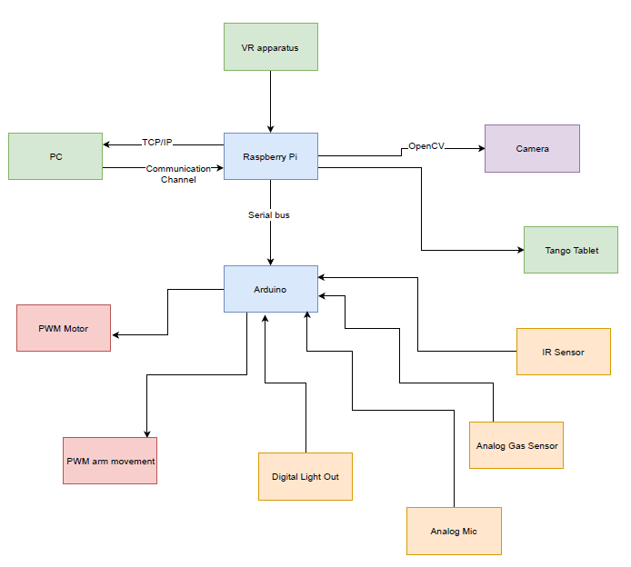

Figure 7. First iteration showing all connections using a Pi and Arduino with VR

Another iteration that was taken into consideration has every device and every I/O of the system had to go through a single Raspberry Pi as shown in Figure 8. While the exclusion of the Arduino microcontroller implied one less communication platform to worry about, there were a few trade-offs. Major trade-offs with this approach were that Python was the main programming language, which not many of us are familiar with. Only one device controlling all aspects of the robot increases the concern for scheduling parallel work. Furthermore, an ADC would have been necessary to receive input from the analog sensors.

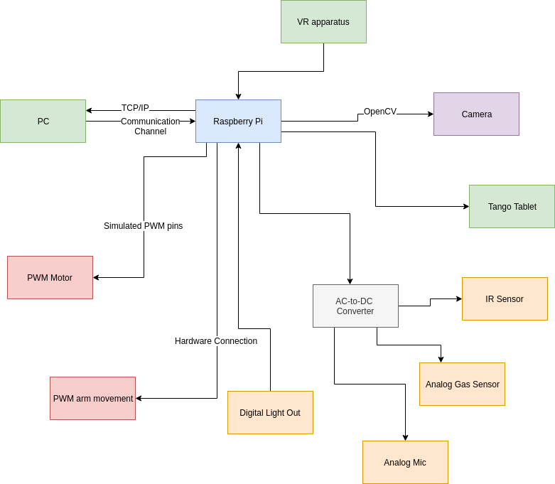

Figure 8. Second iteration showing all connections going through a single Pi.

Another design iteration not selected utilizes both the Raspberry Pi and the Arduino. In this iteration, the VR headset was not included. This iteration is shown in Figure 9. It should be noted that the VR headset will require more labor as another device and user interface will need to be designed and coded. This will result in a higher overall cost. The trade-off from the exclusion of the VR headset was the novelty brought by the virtual experience from the VR headset.

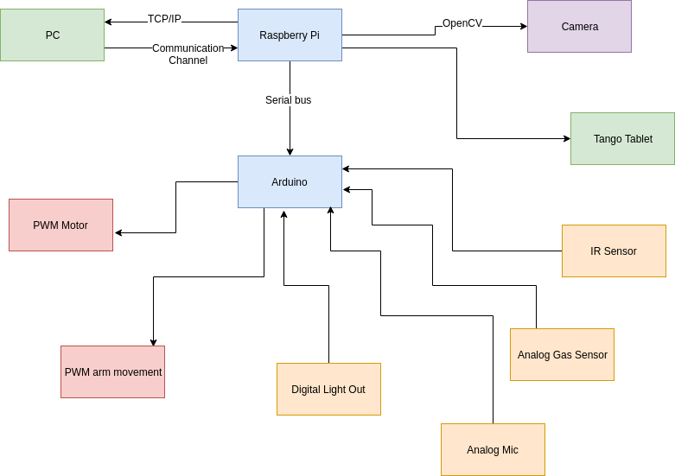

Figure 9. Third iteration showing all connections using a Pi and Arduino without VR.

The next design iteration not selected has a single Raspberry Pi controlling every aspect of the project much like the iteration shown above in Figure 8. The difference is that the VR headset is not included in this design shown in Figure 10. Once again, the major trade-off from this approach is a high dependability on the Raspberry Pi.

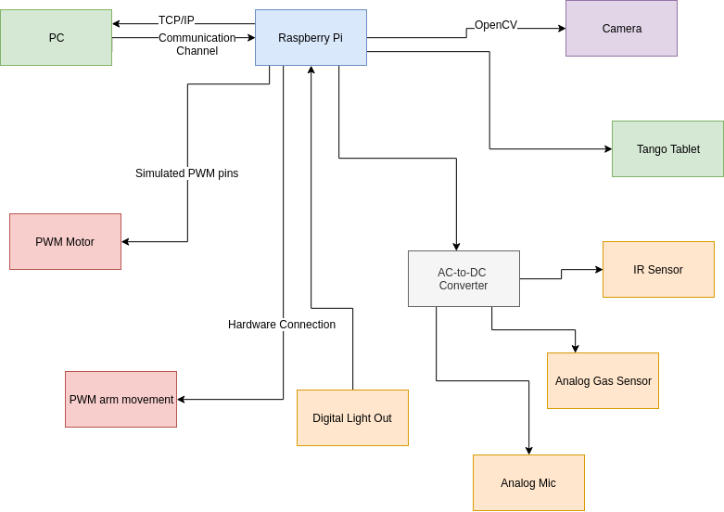

Figure 10. Second iteration showing all connections going through a single Pi without VR.

The last design iteration utilizes the Microsoft Kinect sensor instead of the Tango tablet as shown in figure 11. The Microsoft Kinect sensor is the same RGB-D camera that the Tango tablet uses. In order to access the information on the Tango tablet, one would have to design a C# program using the Unity 3D engine. This is a large effort considering the 3D mapping capability of the robot is peripheral. The Kinect sensor can be accessed by the Raspberry Pi directly and processes the image information itself. This makes it easier to export the information obtained from the depth camera to the GUI running on the remote computer. The Python program can utilize Libfreenect or OpenKinect to process the 3D information. Using the Kinect sensor, however, increases the computational load of the Raspberry Pi and also makes prioritization of information an issue.

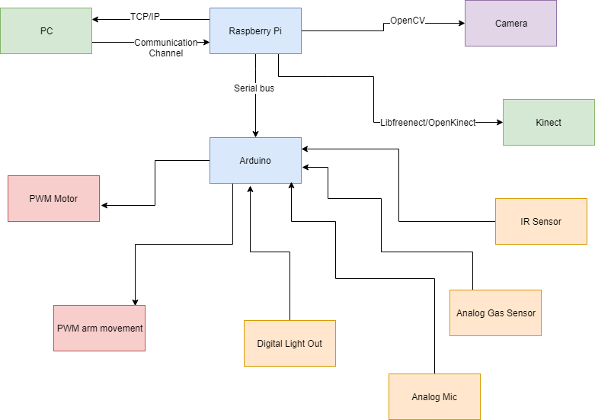

Figure 11. Last iteration showing Kinect.

Constraints limiting the design options and the overall robot performance were the robot size cannot exceed the size of the manhole. The limited budget to purchase parts limiting our freedom to buy higher quality parts with perhaps better performance, which also limits our ability to buy extra accessories for the robot. The robot needs to be flexible and intuitive for the user which implies that the user interface needs to be accessible without a steep learning curve for non-technical utility workers. Robustness, waterproof capabilities, and wireless communication through walls were other major constraints taken into consideration primarily due to obstacles on the ground and the hazardous environment P.V.I.R. will be exposed to. These constraints were driving motives to lower the robot at the manhole and use an antenna as a means of wireless communication between the robot and the manhole location.

**5. Schedule, Tasks, and Milestones**

We’ve began the CAD design of the robot mechanical arm and the different software components. Appendix A contains the Gantt chart with an estimated timeline of project milestones. The Gantt chart lists break down of the milestones including the designing, planning, building and testing of the mechanical arm, sensor package, and user interface. The Gantt chart shows the start time, end time, and duration of all of the tasks. Next to each task is the name of the student that will take lead on that task. Table 4 below also list the team members, their title if applicable and the task they will take lead on.

Table 4: List of task that each member of the team will take lead on

|  |  |
| --- | --- |
| **Task Lead** | **Tasks** |
| Stephanie Chan - Team Leader | * Team Leader tasks * Order motors/controllers for control system * PERF Board design for sensor package * Order materials for mechanical arm * Order sensors |
| Elizabeth Fuller | * Sensor package schematic * Control system design * Testing sensor parts |
| Adrian Muñoz | * Mechanical arm CAD design * 3D prototype of mechanical arm |
| Nelson Raphael - Web Master | * Project website * Mechanical arm CAD design * Integrating control system into robot shell * Test Environment CAD design |
| Lemek Robinson | * GUI Design * Testing communications with GUI |
| All | * Scrapping robot and testing parts for usability * Assemble mechanical arm onto robot * Soldering PERF Board * Mounting PERF Board to robot * Test Environment Build |

Team leader tasks not listed in the table include: sending weekly reports, updating gantt chart for the weekly meetings, keeping track of tasks and when they need to be started or finished to progress the project, keep track of in class due dates, and being the point of contact for the Design Expo. Deliverables include Oral Presentation, Final Design Proposal, Final Project Demo, and Design Expo. All members of the team will also be responsible for contributing to the deliverables and the final testing of the robot.

Appendix B includes a PERT chart that identifies the critical path. The tasks included in the critical path are associated with the development and testing of the software needed for the amplifier. The tasks that include software are more at risk because the team’s skill set is more competent in hardware compared to software and will require more time.

**6. Project Demonstration**

The demonstration at the Senior Design Expo will ideally be a two-part approach. The first part will be pre-recorded test runs of the P.V.I.R. at the Bunger-Henry Transformer Vault. Given that the on campus vault is an open air vault and not truly a confined space, all of the field conditions can not be simulated. Therefore the P.V.I.R. can be tested for efficacy of the humidity, air quality, and temperature sensors, as well as the responsiveness of the control system, robotic arm manipulation, and operation through the guided user interface (GUI). Other conditions such as detecting dangerous gases and arc flashes are not viable for that environment or our project schedule. Each of the videos for the sensor tests will contain three test cases and in order to establish a control variable the conditions will also be measured by the counterpart handheld sensor for accuracy. This will allow for the errors in the readings to be calculated and graphed accordingly. Testing in the Bunger-Henry vault will be difficult because supervision will be required to get in and out of the vault.

The manipulator can be demonstrated with a series of gauge readings within a certain height, while the GUI can show its operability with a screen capture walkthrough video of it being used. Lastly the speed control system can be tested during assembly to show the analog inputs being turned into a digital control system that controls the motor. This signal can be plotted over time and shown real time with the motor movement. As an end result six videos will be produced containing the test cases for each of the relevant sensor packages as well as the control system, robotic arm manipulation, and GUI operation.

Secondly, some of the demonstrations can be repeated for the Capstone expo using foam boards and gauges. Primarily gauge reading in dark environments with a flashlight and robot maneuverability and arm manipulation using the controller.

**7. Marketing and Cost Analysis**

**7.1 Marketing Analysis**

Robots and drones are becoming a more popular option for industrial inspection [8]. Regular inspection is important to maintain equipment and worker safety. Many robots today can inspect pipeline, buildings, equipment, and more. Because of modern day technology inspection robots are faster and more efficient than the average utility worker. They are safer because the utility worker will no longer have to go into a power vault or other potentially dangerous environments. AETOS, GE Inspection Robotics, and Honeybee Robotics are in the top companies in the inspection robot market [9]. Currently AETOS has a wide range of unmanned land inspection robots. Their robots are equipped with different types of sensors and imaging technology that can inspect for corrosion, cracks, defects and other damages [10]. The AETOS robot uses nondestructive testing (NDT) methods and can be configured to conduct different types of land based inspections, specifically for oil and gas, petrochemical, and infrastructure. Like the AETOS robot, P.V.I.R also utilizes many different sensors and imaging systems for inspection. The AETOS website does not list the different sensor capabilities but P.V.I.R uses gas sensors, infrared array sensors, sounds sensors, a camera and a RGB-D camera for inspection. P.V.I.R also uses NDT methods to inspect the power vault. Unlike the AETOS land robot, P.V.I.R is not unmanned and is instead controlled using a gaming system controller. This allows the utility worker to have full control over what they want to see in the power vault and where they want to drive it. Additionally, while the AETOS land robot can be configured for different types of inspections, the P.V.I.R is designed specifically for the utility workers to inspect the power vaults that they are working in and to ensure that they are in a safe work environment.

**7.2 Cost Analysis**

The P.V.I.R is made up of three parts, a robot base, a mechanical arm, and a sensor package. For the purposes of this project, the cost of the robot base development is not accounted for because the base was developed by a previous team. The needed components for the development of the mechanical arm and sensor package is shown in Table 5. The prices for the microcontrollers, webcam, tango tablet, and microphone are estimated prices as these part will be procured from Dr. Mick West Robotics Laboratory. The total cost column in Table 5 show the cost to the P.V.I.R team without having to purchase the obtained items.

Table 5. Individual Component Cost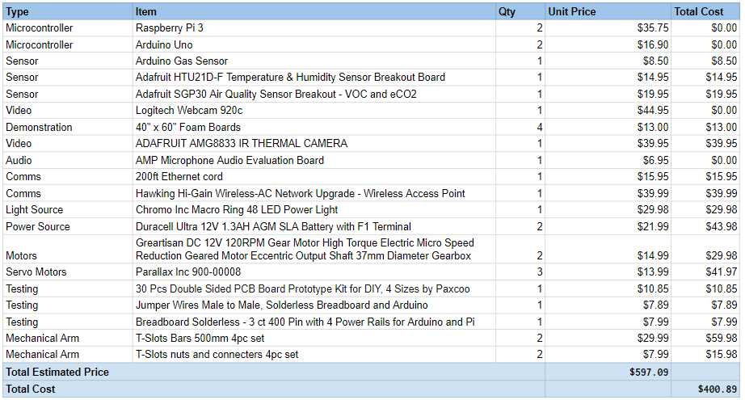

The total cost of labor shown in Table 6 was determined with an assumed salary of $60,000 per engineer. This gives an average of $28.85 per hour. Assuming an engineer is working the typical 40 hour work week for 12 weeks, the total number of hours worked will be 480 hours. This gives a total cost of labor to be $13,848.00.

Table 6. Total Labor Hours and Cost Per Engineer

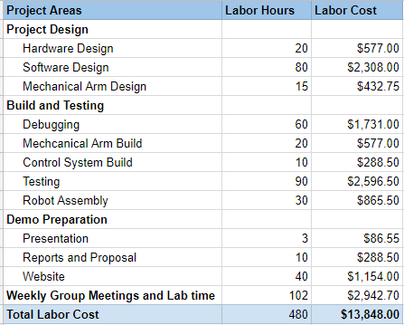

The development cost shown in Table 7 is calculated using 30% of the total labor cost as the fringe benefit and 120% of materials and labor as the overhead. The total development cost comes out to be $264,449.73.

Table 7. Development Cost

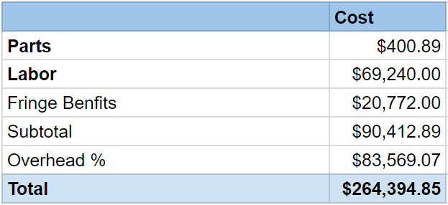

Over a 5-year period, there will be 4,950 units produced and sold. This number is chosen because there are about 3,300 power utility companies in the United States [11] and it is assumed that the average number robots per company is 1.5. The components that make up the sensor package and mechanical arm can be bought in bulk for a discounted price of $400 per unit. The manufacturing employees will be paid $15 an hour to assemble the robot. The engineers responsible for testing the robot will be paid $28 an hour. The sales expense will make up 10% of the final selling price of $1,750. This selling price is competitive with other inspection robots on market currently. SuperDroid Robots have an inspection robot with the cost of $1,836 [12]. As shown in Table 8, the estimated profit per unit is $295.56. This is calculated with fringe benefits being 30% of labor and overhead being 120% of labor, materials, and fringe benefits. The estimated amortized development cost is $25. Over a 5-year period, the total profit will be $1,463,022.00.

Table 8. Selling Price and Profit per unit with 5-year profit for 4950 units

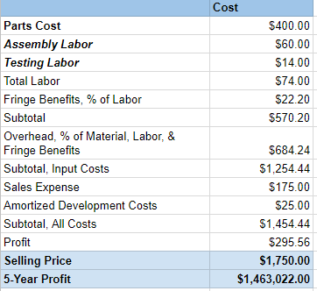

**8. Current Status**

The various parts and components for the project have been determined and listed in a bill of materials. We have decided on a set-up for the two microcontrollers and the peripheral connections. Task A, as listed in Appendix C, the design and development of the GUI, has begun. Currently, the GUI shows a working login page and can access the camera and display a live camera feed. Task B, scrapping previous robots, is 100% complete. Additionally, the mechanical arm CAD design and the testing environment design have been started. Potential functions and the mapping of the functions to the game controller have also been identified. The remaining tasks from Appendix C has not been started at this time.

**9. References**

[1] “UNITED STATES DEPARTMENT OF LABOR,” *Occupational Safety and Health*

*Administration*. [Online]. Available: https://www.osha.gov/oshstats/commonstats.html.

[Accessed: 26-Nov-2018].

[2] T.Zhao, A.J Phillips, and S. W. Eckroad, “Underground Utility Vault Inspection System

and Method,” U.S. Patent 8,706,340, 22 Apr., 2014.

[3] “802.3-2018 - IEEE Standard for Ethernet,” *IEEE-SA - The IEEE Standards Association -*

*Home*. [Online]. Available: https://standards.ieee.org/standard/802_3-2018.html#.

[Accessed: 26-Nov-2018].

[4] “802.11-2016 - IEEE Standard for Information technology--Telecommunications and

information exchange between systems Local and metropolitan area networks--Specific

requirements - Part 11: Wireless LAN Medium Access Control (MAC) and Physical

Layer (PHY) Specifications,” *IEEE-SA - The IEEE Standards Association - Home*.

[Online]. Available: https://standards.ieee.org/standard/802_11-2016.html. [Accessed:

28-Nov-2018].

[5] electronics radio, “Serial data transmission standards,” *Electronics Notes*. [Online].

Available: https://www.electronics-notes.com/articles/connectivity/serial-data-

communications/transmission-standards.php. [Accessed: 25-Nov-2018].

[6] “I2C Info – I2C Bus, Interface and Protocol,” *I2C Info – I2C Bus, Interface and Protocol*.

[Online]. Available: http://i2c.info/. [Accessed: 25-Nov-2018].

[7] electronics radio, “USB Universal Serial Bus Standards,” *Electronics Notes*. [Online].

Available: https://www.electronics-notes.com/articles/connectivity/usb-universal-

serial-bus/standards.php. [Accessed: 28-Nov-2018].

[8] “Guide to Industrial Inspection Robots,” *Global Electronic Services*, 11-Jun-2018.

[Online]. Available: https://blog.gesrepair.com/guide-inspection-robots-used-industrial

-sectors/. [Accessed: 27-Nov-2018].

[9] Morton, “Global Inspection Robots Market Analysis 2018 – AETOS, GE Inspection

Robotics, Honeybee Robotics, Inuktun Services,” *Technology 24*. [Online]. Available:

https://ittechnology24.com/global-inspection-robots-market-analysis-2018-aetos-ge-

inspection-robotics-honeybee-robotics-inuktun-services/. [Accessed: 26-Nov-2018].

[10] AETOS, “Robotic Inspection Solutions,” *Mistrasgroup.* [Online]. Available:

https://www.mistrasgroup.com/services/company/publications/AETOS_Robotic_

Inspection_Solutions.pdf. [Accessed: 26-Nov-2018].

[11] “U.S.: largest utility companies 2018,” *Statista*. [Online]. Available:

https://www.statista.com/statistics/237773/the-largest-electric-utilities-in-the-us-

based-on-market-value/. [Accessed: 27-Nov-2018].

[12] “Wireless Tracked Inspection Robot with GoPro camera,” *Oz Robotics*. [Online].

Available: https://ozrobotics.com/shop/sgt-32p-wireless-tracked-inspection-robot-with-

gopro/?gclid=Cj0KCQiA8_PfBRC3ARIsAOzJ2urFLzgB4Zd8cdeFt695BLK9tSg-

YjAIKI7-CBIOE6x9qK2-eQMhg2AaAr33EALw_wcB. [Accessed: 27-Nov-2018].

**Appendix A - Project Gantt Chart**

See next page for project Gantt Chart

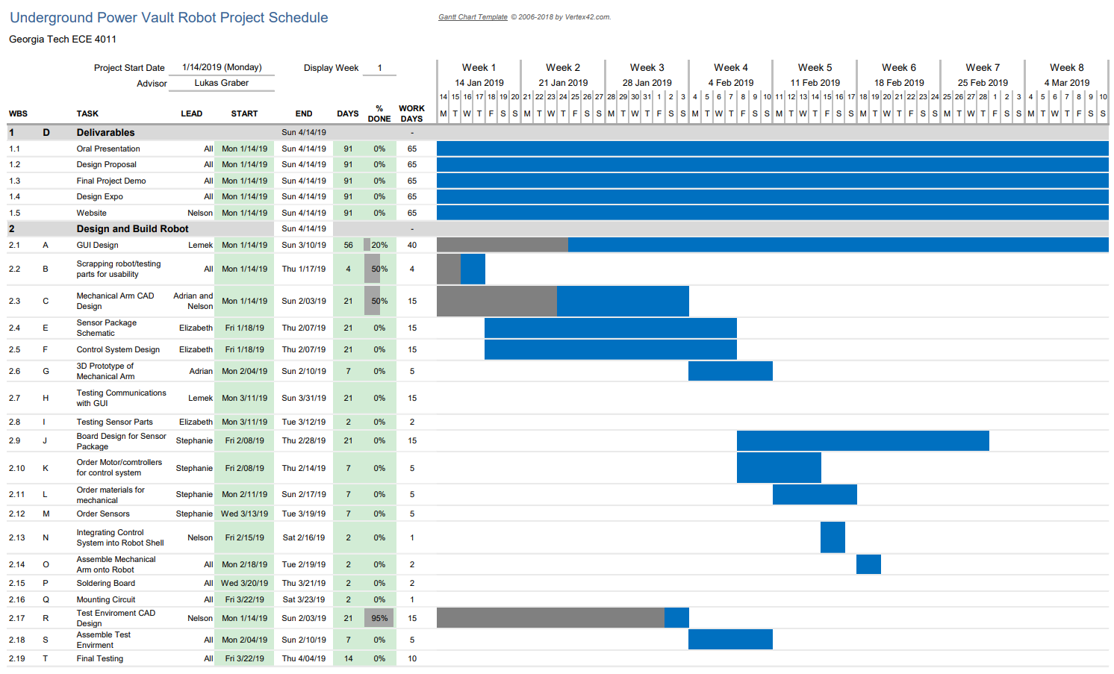

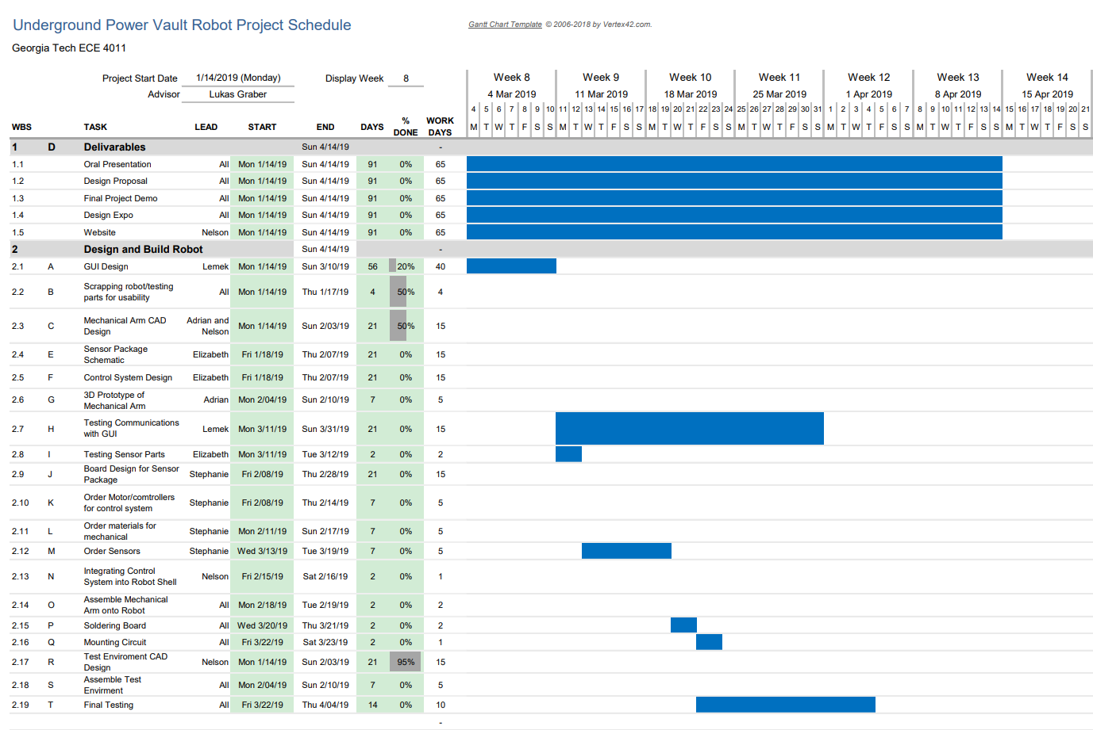

**Appendix B - Project PERT Chart**

See next page for project PERT Chart

Note:

Deliverables include Oral Presentation, Final Design Proposal, Final Project Demo, and Design Expo

